Opioid Recovery & Remediation Fund Advisory Council
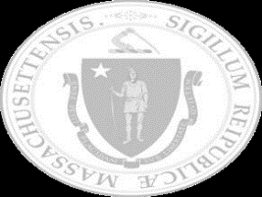

Executive Office of Health & Human Services

Text Box:
Wednesday, December 10, 2025

The ORRF Team
SmartArt: Bending Picture Caption List with Eight Pictures

Image 1
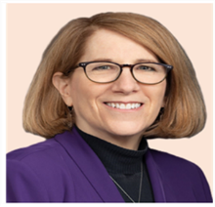
Text: Joanne Marqusee (EHS)
Assistant Secretary

Image 2

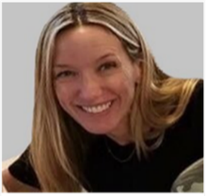
Text: Deirdre Calvert (BSAS)
BSAS Director

Image 3
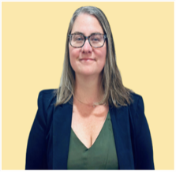
Text: Nicole Schmitt (BSAS)
Director of Strategy & Innovation

Image 4

Text: Julia Newhall (BSAS)
Director of Opioid Abatement Strategy & Implementation

Image 5
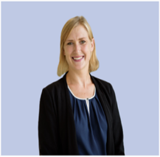
Text: Casey Leon (BSAS)
Epidemiologist

Image 6

Text: Millie Bhatia (EHS)
Health Policy Manager

Image 7
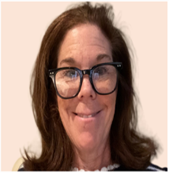
Text: Susan Weiss (BSAS)
Executive Assistant

Today’s Agenda
SmartArt: Captioned Pictures with Four Icons

Icon 1. Meeting

Text: Welcome New Members


Icon 2. Stopwatch

Text: Approval of 06/04/25 Meeting Minutes
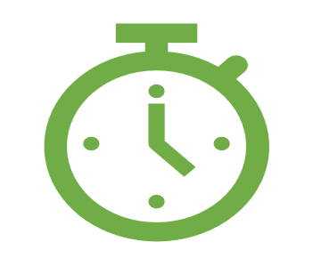

Icon 3. Megaphone

Text: Important Announcements


Icon 4. Report

Text: Spotlight: Review of States' Advisory Councils
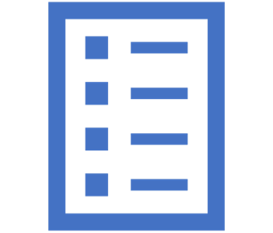

Welcome New Member
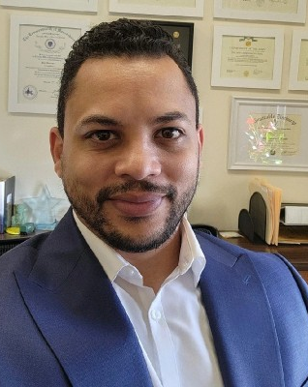

Text Box:

Alex Arriaga

City of Worcester

Health &Human Services

Text Box:

Thank you, Maddie Castiel, for your service!

Vote on 09/10/25 Meeting Minutes

Important Announcements
SmartArt: Alternating Picture Blocks

Icon 1. Ear

Text: Regional Listening Sessions
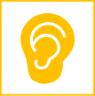

Icon 2. Information

Text: Mosaic Information Session


Icon 3. Calendar

Text: ORRF Advisory Council March Meeting


Western, MA Listening Session
SmartArt: Three-Level Vertical Block List
Level 1. Franklin County
- Franklin Regional Council of Governments
- October 6th - Key Takeaways
Level 2. Berkshire County
- Berkshire Overdose Addiction Prevention Collaborative
- March 12th (Tentative)
Level 3. Hampden County
- Hampden County Addiction Task Force
- Date TBD

Recap of September Meeting

Mentimeter Results
Text Box:
Key Takeaways that Reveal the Council…
Role of Council
- Broadly understood, but could be clearer on the specifics
Areas of Interest
- Data Analysis & Evaluation
- Strategic Planning
Needs
- Data Sharing
- Formalize Decision-Making
Capacity
- Dedicate 3-4 Hours Per Month
- 75% willing to serve on subcommittee
Skills
- Data Analysis & Evaluation
- Lived Experience
Success
- Decrease fatal overdose, access to care, results-driven solutions, destigmatization
Positioned to take on a more formal role
Interested in making data-driven investments
Seeking performance-related data and a formal decision-making process
Willing and able to increase level of involvement
Possesses diverse skillsets and relevant expertise
Aims to achieve population, systems, and process level outcomes, and to shift cultural values and beliefs

Financial Data

BSAS FY25 Budget

Text Box:

Total Budget = $392.8 million
SmartArt: Four-Level Vertical Bullet List
Level 1. State Appropriation: $206.2 million with $111.4 million Available
- Legislative earmarks of $5.8 million
- $24 million in other programmatic earmarks
- $65 million sent to MassHealth for Residential Treatment cost-sharing
Level 2. Federal Appropriation: $111.6 million
- $44 million in Substance Use Prevention and Treatment Block Grant
- $59.5 million State Opioid Response (SOR) Grant
- $70.7 million in COVID/ARPA supplemental funds available 2021-2025 now exhausted
Level 3. ORRF Inter-Agency Service Agreement (ISA): $59.5 million
- Opioid Recovery & Remediation Trust Fund
Level 4. Other Inter-Agency Service Agreements (ISA): $15.2 million
- Other ISAs that BSAS receives

Image 1. Pie Chart of Percentage Rating of BSAS Funding Sources
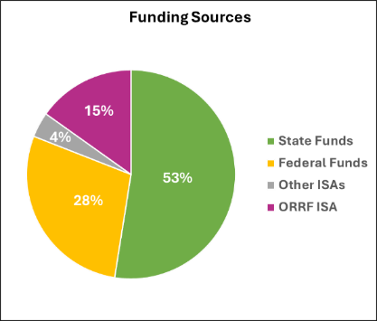

BSAS Budget Cont.

Text Box:

BSAS functions as the state’s SUD treatment Payor of Last Resort
- Coverage for uninsured and underinsured individuals
- Required but not fully funded in BSAS appropriations
- Recent increases in billing to BSAS amid funding reductions

Potential Medicaid cuts will likely cause some individuals to lose their insurance coverage that will result in an increased burden on BSAS.

ORRF Financial Overview
Fiscal Year | Funds Available | Cumulative Spending | End of Fiscal Year Balance
2023 | $90.30 million | $5.02 million | $85.27 million
2024 | $184.29 million | $25.35 million | $163.96 million
2025 | $209.60 million | $88.03 million | $146.92 million
2026 | $182.80 million | $145.81 million | $125.03 million

Image 1. Line Chart of ORRF Cumlative Spending from FY23 – FY26
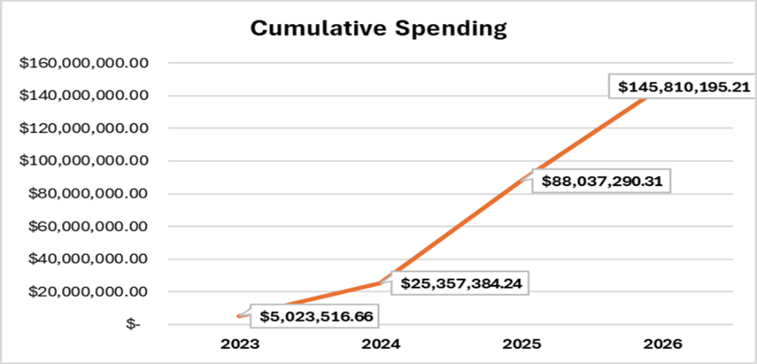

Text Box:

FY28 - FY32 Estimates $30 - $40 million (+ Purdue Dollars)

FY25 ORRF Funded Projects
Projects | Total
Access to Recovery | $1.31 million
Black and Latino Men Re-Entry Program | $2.68 million
Community Innovation - Responding to Youth Substance Use | $1.92 million
Hospital-Based SUD Care Integration | $14.18 million
Low-Barrier Housing & Homeless Supports | $7.69 million
Mobile Addiction Services | $5.05 million
Mosaic Opioid Recovery Partnership | $6.58 million
Peer Family & Grief Supports | $1.46 million
Redefining Community Wellness | $2.99 million
Research & Data Analysis | $2.77 million
Staffing & Administrative Costs | $1.03 million
Strategies to Enhance SUD Services | $2.08 million
Strengthening SUD Workforce | $8.25 million
Supporting Syringe Service Programs | $3.68 million
Youth Engagement & Intervention | $496.5K
Grand Total | $62.67 million

Proposed Process

Text Box:
- Meeting Format
- Purpose of Meeting
- Planning Process
- Post-Meeting Activities
- How to Prepare

BSAS is Investing in Prevention, Treatment, Recovery, & Harm Reduction that Works!

Text Box:
- ORRF-Funded Projects Across the Care Continuum

Primary Prevention

Text Box:
- BSAS’s Prevention Framework is shifting toward a strength-based focus on positive childhood experiences to counter-balance adverse childhood experiences and build resilience.
Image 1. SAMHSA Strategic Prevention Framework

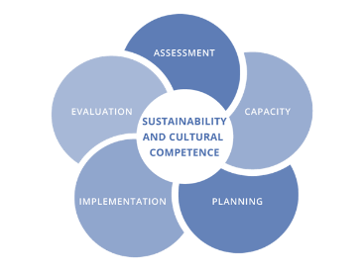

Text Box:
- SAMHSA’s Strategic Prevention Framework

Image 2. Promoting Resilience for Now and Forever – A Family Guide for Supporting the Social and Emotional Development of Infants and Toddlers

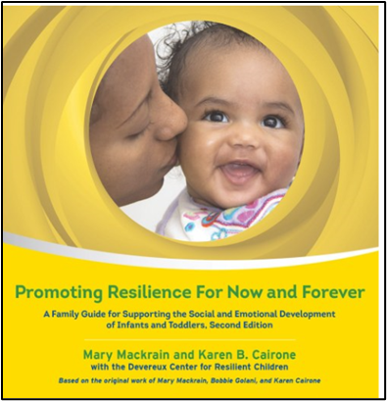

Text Box:
- BSAS also funds community-based efforts that implement upstream prevention in early childhood strategies.

ORRF-Funded Projects – Prevention
SmartArt: Three-Level Tab List with Two Tabs

Tab 1: Community Innovation Responding to Youth Substance Use
- FY25 - $1.03 million
- Support to increase the capacity of 17 community-based youth-serving organizations to identify and engage young people at increased risk for developing substance use disorder through community partnerships that encourage positive youth development

Tab 2: Youth Engagement & Intervention
- FY25 - $283K
- Six organizations funded to implement Project Amp, a youth engagement and intervention model that identifies adolescents who may be at risk of SUD early on to help them build awareness and motivation to change, and develop the skills, strategies, and support needed to do so

Harm Reduction & Overdose Prevention
SmartArt: Five-Level Vertical Curved List
Level 1.
- 405,278 doses of naloxone to 496 entities
Level 2.
- 362,000 fentanyl test strips
Level 3.
- 6 comprehensive mobile addiction service programs
Level 4.
- 22,038 use events supervised through SafeSpot
Level 5.
- 650 placements in permanent, low-threshold housing
Image 1. Mobile Addiction Services’ Community Care In Reach Van
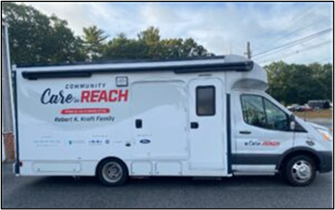

Image 2. Safe Spot Logo

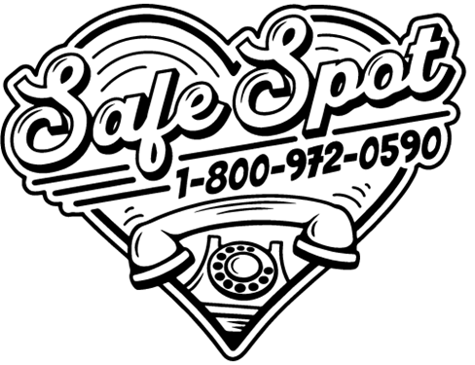

ORRF-Funded Projects – Harm Reduction
SmartArt: Three-Level Tab List with Three Tabs

Tab 1: Mobile Addiction Services
- FY25 - $5.5 million
- Six harm reduction organizations funded to implement an innovative partnership with The Kraft Center for Community Health to support mobile health units that engage individuals at high risk of fatal overdose and/or not receiving care to provide integrated services aimed at preventing death, supporting long-term recovery, and improve health and quality of life

Tab 2: Supporting Syringe Service Programs
- FY25 - $3.68 million
- Nineteen syringe service programs funded to reduce the harms associated with injection drug use by providing comprehensive, evidence-based services that prevent overdose deaths and the transmission of infectious diseases
Tab 3: Low Barrier Housing & Homeless Supports
- FY25 - $7.69 million
- Twenty programs funded to increase access to permanent, stable housing for individuals experiencing homelessness—without preconditions such as sobriety or participation in treatment

Treatment
SmartArt: Picture Accent List with Four Icons

Text Box:
- BSAS funds, licenses, and oversees a comprehensive statewide treatment and recovery services across Massachusetts.

Icon 1. Heart
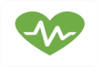

Icon 2. Provider


Icon 3. Hospital
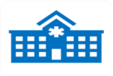

Icon 4. Stethoscope

Image 1. Line Chart of BSAS Enrollments of People with Opioid Use Disorder (OUD)
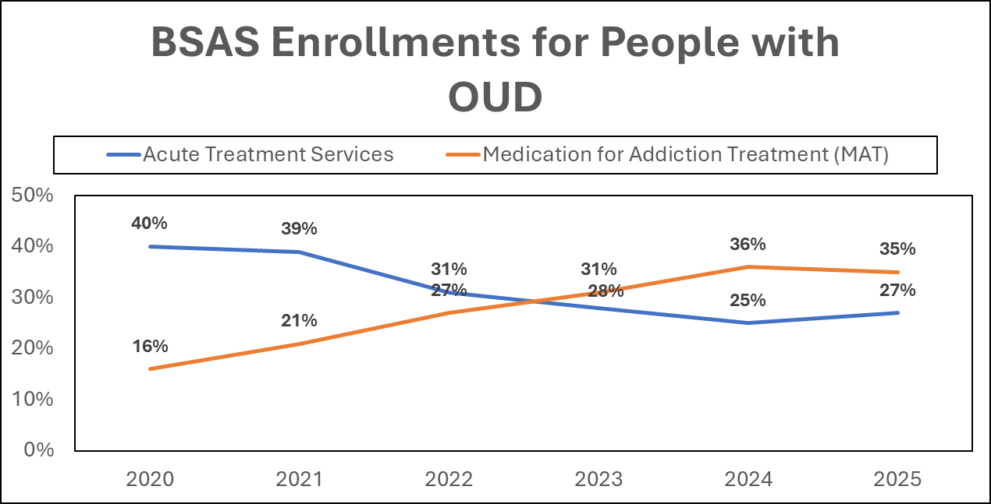

ORRF-Funded Projects – Treatment
SmartArt: Three-Level Tab List with Two Tabs

Tab 1: Hospital-Based SUD Care Integration
- FY25 - $14.32 million
- Funded 15 hospitals across 24 sites to provide access to compassionate, trauma-informed substance use disorder services within hospital settings and continuity of care in the community for patients with SUD-related concerns

Tab 2: Strategies to Enhance Services
- FY25 - $679K
- Enhance services to increase access to medications for opioid use disorder and stimulant use disorder to underserved and/or high need populations based on available data and promising practices

Recovery & Peer Support

Text Box:
- 39 Peer Recovery Support Centers statewide
- Launch of the Recovery Education Collaborative
- Licensing and overseeing Recovery Coaches
Image 1. New Beginnings Peer Recovery Support Center
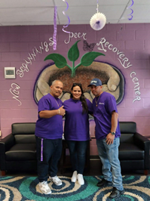
Image 2. Recovery Exchange Peer Recovery Support Center
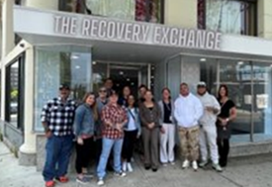
Text Box:
Peer Recovery Support Centers (PRSC) are free, peer-led spaces for individuals in recovery from substance use, as well as families and loved ones affected by addiction, the opportunity to both offer and receive support in their community environment. They provide a welcoming space focused on recovery values and Multiple Pathways, promoting hope, belonging, and empowerment.

ORRF-Funded Projects – Recovery & Peer Supports
SmartArt: Three-Level Tab List with Two Tabs

Tab 1: Access to Recovery
- FY25 - $1.31 million
- Support individuals in early recovery in achieving their individualized recovery goals through care coordination, job training, and the provision of supportive services with an emphasis on addressing barriers to employment

Tab 2: Peer Family & Grief Support
- FY25 - $1.46 million
- Expand and strengthen peer-led family and grief support services to foster connection, healing and resilience, and strengthen capacity to effectively respond to the ongoing challenges facing communities

Treatment & Recovery Workforce
SmartArt: Two-Level Vertical Picture List with Two Images
Image 1. Support Workforce
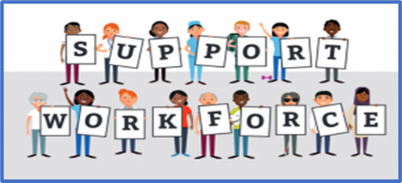
Text: BSAS licenses 1,688 Licensed Alcohol and Drug Counselors (LADCs)
Image 2. Rules & Regulations
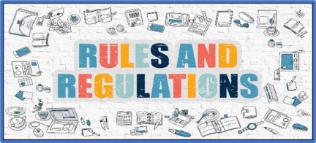
Text: Developing regulations for the new Licensed Recovery Coach credential March 12th (Tentative)

ORRF-Funded Projects – Workforce
SmartArt: Three-Level Tab List with One Tab

Tab 1: Strengthening SUD Workforce
- FY25 - $8.25 million
- Administer the Substance Use Provider Loan Repayment Initiative Loan Repayment Program through the MA-Repay Program that offers loan repayment awards for SUD-related healthcare professionals in exchange for four years of service in Massachusetts

Community Engagement & Equity

Text Box:

Increasing diversity and representation of DPH-funded community organizations:
- Supporting Collective UpLIFT to provide leadership and organizational development skill-building to BIPOC-identifying leaders of community-based organizations
- Holding Community Office Hours to bring together community members with municipal and state government staff to share information and resources

Launching the Living Expertise Advisory Pool (LEAP) in FY26 engage and compensate community members with lived and living experience who contribute to BSAS initiatives

Image 1. Andrea Macone, Director of Community Health & Engagement


Image 2. Dan Howell, Director of Equity
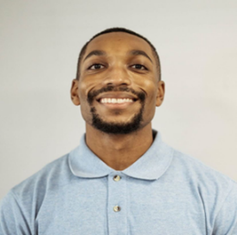

Image 3. Tyshaun (Tye) Perryman, Community Engagement Strategist
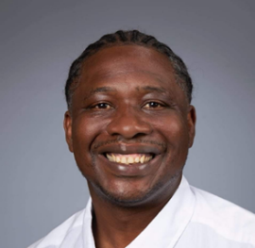

ORRF-Funded Projects – Engagement & Equity
SmartArt: Three-Level Tab List with Three Tabs

Tab 1: Redefining Community Wellness
- FY25 - $2.99 million
- Community grant-making initiative that funds community-led interventions that prevent and address a variety of intersecting public health issues
Tab 2: Mosaic Opioid Recovery Partnership
- FY25 - $6.58 million
- A public-private collaboration designed to support CBOs and municipalities through grant-making and technical assistance to build their capacity to address and abate the harms of the overdose epidemic at the local and regional level
Tab 3: Black & Latino Men’s Re-Entry
- FY25 - $2.68 million
- Culturally responsive re-entry services that provide Black and Latino Men in carceral and community settings with the resources and tools they need to support community integration and prevent fatal overdose

Questions & Answers

Image 1. Group of People
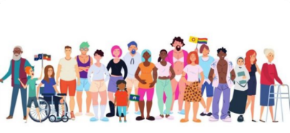

Icon 1. Email Envelope



Text Box

OpioidRecoveryandRemediationFund@mass.gov

