Opioid Recovery & Remediation Fund Advisory Council


Executive Office of Health & Human Services
Wednesday, September 10, 2025

The ORRF Team
SmartArt: Bending Picture Caption List with Eight Pictures

Picture 1
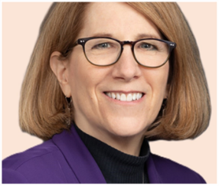
Text: Joanne Marqusee (EHS)
Assistant Secretary

Picture 2


Text: Deirdre Calvert (BSAS)
BSAS Director

Picture 3
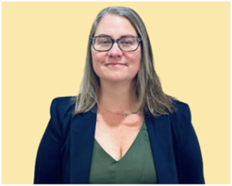
Text: Nicole Schmitt (BSAS)
Director of Strategy & Innovation

Picture 4

Text: Julia Newhall (BSAS)
Director of Opioid Abatement Strategy & Implementation

Picture 5

Text: Casey Leon (BSAS)
Epidemiologist

Picture 6

Millie Bhatia (EHS)
Health Policy Manager

Text: Millie Bhatia (EHS)
Health Policy Manager

Picture 7
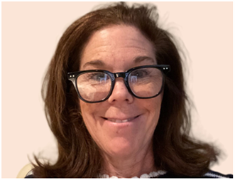
Text: Susan Weiss (BSAS)
Executive Assistant

Picture 8
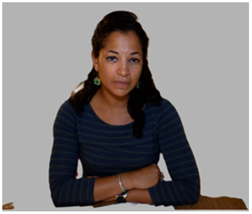
Text: Casey Chamberlain (EHS)
Executive Assistant

Today’s Agenda
SmartArt: Captioned Pictures with Four Icons

Icon 1. Meeting

Text: Welcome New Members


Icon 2. Stopwatch

Text: Approval of 06/04/25 Meeting Minutes


Icon 3. Megaphone

Text: Important Announcements


Icon 4. Report

Text: Spotlight: Review of States' Advisory Councils


Welcome New Members


Text Box:

Taylor McAndrew

City of Northampton

Health &Human Services



Text Box:

Stephanie Tonelli

City of Springfield

Springfield Police Department


Text Box:

Patrick M. O’Connor

1st Norfolk and Plymouth

House of Representatives


Text Box:

Tess Curran

City of Fall River

Health &Human Services

Text Box:

Thank you, Jeffrey Olmstead, Maureen Cavanaugh, Lindsay Hackett, and John Rosenthal for your service!

Vote on 06/04/25 Meeting Minutes

Important Announcements
SmartArt: Alternating Picture Blocks

Icon 1. Microphone

Text: Regional Listening Sessions


Icon 2. Information

Text: Re-launch of Municipal TTA Program


Icon 3. Clapping

Text: Mosaic One-Year Anniversary Event


Icon 4. House

Text: Mosaic Family Resilience Grant


Icon 5. Dollar Sign

Text: Modified Municipal Reporting Requirements


Regional Listening Session

Text Box:
Upcoming: Western MA
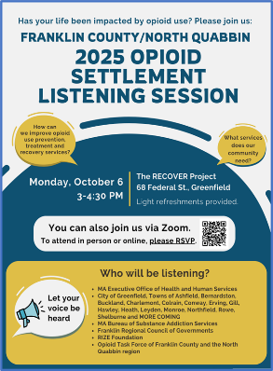

Text Box:
Takeaways: Southeast MA

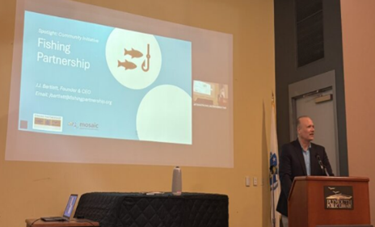



Text Box:

Attendee Quote

“An overdose prevention site would give us a safe place to monitor and care for our participants—so many of the overdoses we’ve responded to could have been prevented if we had a space like that. People deserve safety and dignity, not death in an alley.”

Municipal Training & Technical Assistance Program
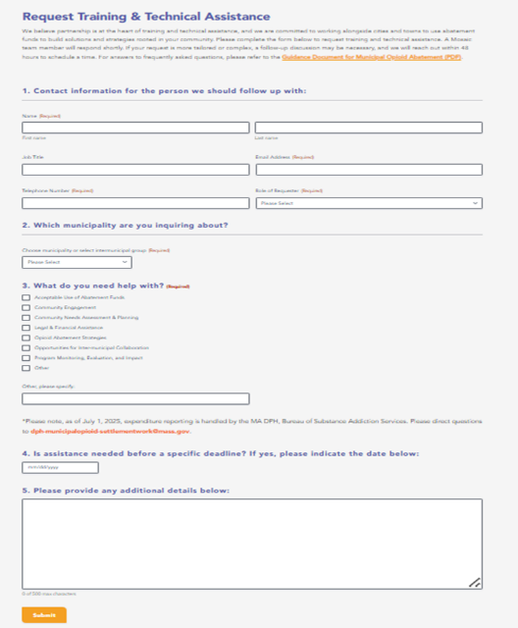
Link: Municipal TTA Request Form

Mosaic Celebration Event
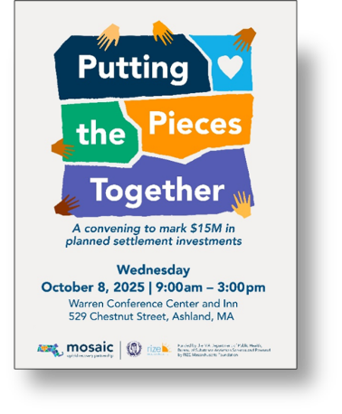

Family Resilience Grant

Text Box:
The Family Resilience Grant Program will award $7.5 million over three years to community-based organizations that are building comprehensive support systems for families across Massachusetts

Text Box:
Regional Funding Allocation
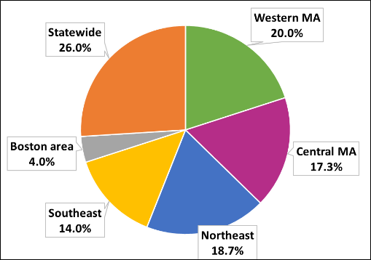

Text Box:
Focus Area
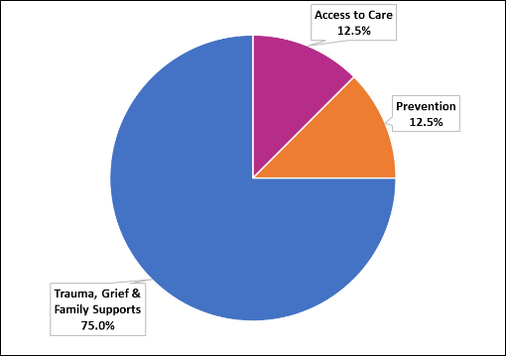

Muncipal Reporting Changes
SmartArt: Smart Chart - Two-level Horizontal Bullet List with three boxes

Box 1:
Process
- Reporting requirement threshold removed
- Tailored experience based on collaboration status
- User-friendly software
- Embedded quality assurance

Box 2:

Report
- Simpler structure
- Removed strategy implementation
- Line-item expenditure table

Box 3:

Resources
- Detailed guidance document
- Demonstrative videos
- One-on-one support meetings

Spotlight: Shaping a Path Forward

Today’s Presentation

SmartArt: Two-level Vertical Box list with three icons

Icon 1. Pathway

Text: What do we mean by Shaping a Path Forward?


Icon 2. Magnifying Glass

Text: Review of States’ Advisory Councils


Icon 3. Group feedback

Text: Interactive Survey


How we Selected States: Prerequisites

SmartArt: Two-level Vertical Box list with three boxes

Box 1:
Decision-Making Structure
- Advisory-Only
- Shared Decision-Making
- Binding Authority
Box 2:
Lead Agency
- Executive Office (Health & Human Services)
- Other Executive Offices and Legislative Branches of Government
- Independent Governing Bodies
Box 3:

Council Composition
- Size
- Appointing Authorities
- Membership Representation

State Advisory Councils

State | Allocation Formula | Responsibilities | Subcommittees
Connecticut | Local – 15%  State – 85% | - Recommends and approves policies, procedures for administration, and criteria for awarding and disbursing funds  - Non-members able serve on subcommittees  - Must align with statewide plan | - Data & Research  - Finance  - Referral
Illinois | Local – 33%  State – 67% | - Makes advisory recommendations to the Governor's Opioid Prevention and Recovery Steering Committee  - Must align with statewide plan | - Access & Equity  - Data & Research  - Infrastructure & Workforce
Massachusetts | Local – 40%  State – 60% | - Makes recommendations upon a majority vote to the chair of the council  - Requirement that no less than three members must be PWLLE | N/A
New Jersey | Local – 50%  State – 50% | - Engages the community to develop and provide recommendations on the allocation and distribution of the State’s share  - Develop strategic plan | N/A
New York | Local – 46.1%  Regional – 16.4%  State Abatement – 20%  State Enforcement – 17.5% | - Makes evidence-based recommendations on how funding is spent  - Member votes recorded and published  - Must align with statewide plan | N/A
Rhode Island | Local – 80%  State – 20% | - Makes formal recommendations to the EOHHS on the use of the statewide share  - Members must serve on at least one subcommittee  - Alignment with statewide plan | - Communications  - Data & Research  - Governance  - Harm Reduction  - Prevention  - Recovery  - Treatment

Key Themes
SmartArt: One-level Vertical Curved list

Text: Clear Mandate

Text: Governance Structure

Text: Strategic Planning & Investments

Member Survey
Text box: Join using your phone or laptop!

Next Steps

SmartArt: Two-level Basic Timeline with four boxes

Box 1:
Share Results
- Dec 25
Box 2:
Propose Options
- March 26
Box 3:

Present Blueprint
- June 26
Box 4:

Initiate Rollout
- Sep 26

Questions and Answers





Icon – Envelope

Text Box: OpioidRecoveryandRemediationFund@mass.gov

2025 Meeting Schedule
Quarter | Date | Format | Initiative Spotlight
Q1 | Wed. 03/12/25 | Virtual (Zoom) | Black and Latino Men's Re-Entry
Q2 | Wed. 06/04/25 | Virtual (Zoom) | Mobile Addiction Services
Q3 | Wed. 09/10/25 | Hybrid (Central Region) | Shaping a Path Forward
Q4 | Wed. 12/10/25 | Virtual (Zoom) | TBD

