Opioid Recovery & Remediation Fund Advisory Council

Executive Office of Health & Human Services

Text Box:
Tuesday, March 31, 2026

The ORRF Team
SmartArt: Bending Picture Caption List with Eight Pictures

Image 1
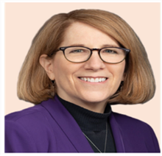
Text: Joanne Marqusee (EHS)
Assistant Secretary

Image 2

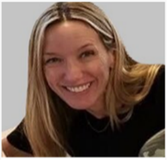
Text: Deirdre Calvert (BSAS)
BSAS Director

Image 3

Text: Nicole Schmitt (BSAS)
Director of Strategy & Innovation

Image 4

Text: Julia Newhall (BSAS)
Director of Opioid Abatement Strategy & Implementation

Image 5

Text: Casey Leon (BSAS)
Epidemiologist

Image 6

Text: Millie Bhatia (EHS)
Health Policy Manager

Image 7
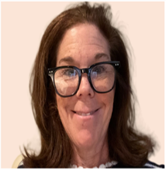
Text: Susan Weiss (BSAS)
Executive Assistant

Agenda

Text Box:
Five-Level Bullet Point List
- Welcome (EOHHS, - 10 minutes)
- Background and Introductions (Aligned Solutions, - 40 minutes)
- Discussion on ORRF Portfolio (Aligned Solutions, - 55 minutes)
- Next Steps (Aligned Solutions, - 10 minutes)
- Close Out (EOHHS, - 5 minutes)

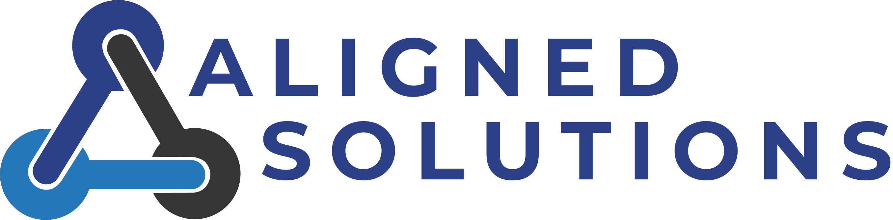

Housekeeping

Text Box:
One-Level Bullet Point List
- Vote on 12/10/2025 Meeting Minutes

December 2025 Recap

Text Box:
Recap of ORRF Council Meeting held on December 12, 2025
- Discussion of what ORRF performance management and decision-making looks like for current and future portfolio of funded projects
- Goal setting for March meeting
  - Review of current portfolio
  - Review of guiding principles and priorities
  - Align on decision-making framework

Meet the Aligned Solutions ORRF Team

Image 1: Aligned Solutions Team

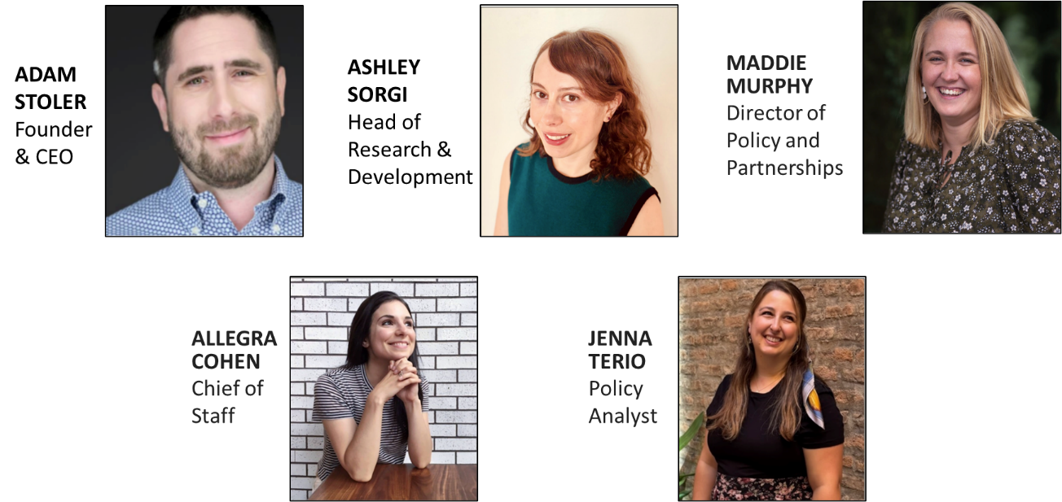

Aligned Solutions’ Role in ORRF Planning and Facilitation

Text Box:
Aligned Solutions was charged to provide the following:
- Gathering background information and overarching themes from individual ORRF Council meetings (pre-read materials)
- Clarifying current portfolio and available ORRF funds (pre-read materials)
- Communicating a timeline for ORRF strategic portfolio beginning in FY28
- Continuing discussion on past and future ORRF portfolio vision, goals, and investment priorities
- Initiating conversation and planning for measuring success

Council Member Introductions

Text Box:
Round Robin (1 minute each)
- Name
- Organization
- Why does this work matter to you?
- What brought you to this work?

ORRF Advisory Council Strategic Planning Timeline

Image 1: Strategic Planning Timeline

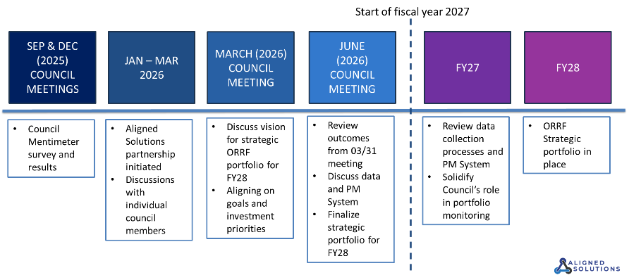

Total ORRF Payments Received & Projected

Image: Annualized Settlement Fund Dashboard

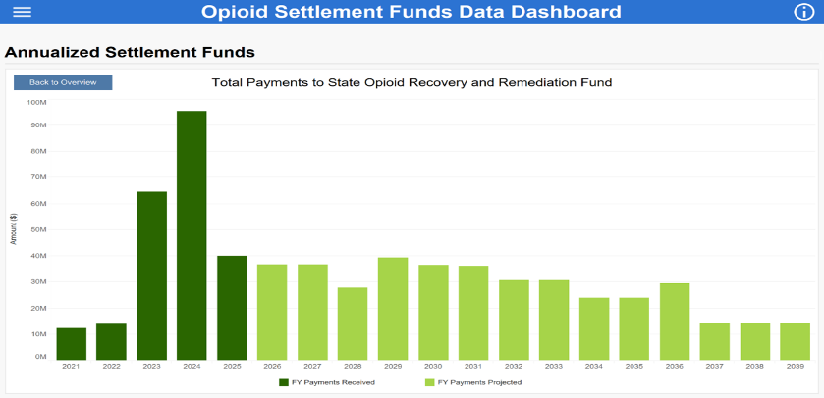

Roadmap for Today
Text Box:
Participation Expectations
- Time keeping
  - 1 minute per response
- Tilt name card when you would like to speak
- Take care of your needs, but try to limit disruptions (i.e., taking phone calls)
Text Box:
Group Norms
- Active listening
- Assuming best intentions
- “3-before-me” rule
- Active engagement
  - Group norms discussion can be continued in a future Council meeting

Grounding on Current ORRF Strategic Priorities (2023-Current)

Text Box
Service Expansion/Enhancement
Strengthening the statewide continuum of care by expanding access to harm reduction, treatment, and recovery services and improving the quality and coordination of existing programs. Investments may focus on closing service gaps, enhancing care integration, integrating wraparound supports, and supporting innovative models that improve outcomes.

Text Box
Equity
Ensuring that investments address disparities in substance use disorder outcomes and prioritize communities and populations disproportionately impacted by the overdose crisis. This includes promoting equitable access to prevention, harm reduction, treatment, and recovery services and supporting initiatives that elevate the voices of people with lived and living experience. This also includes addressing structural issues within the SUD system.

Text Box
Workforce Development
Investing in strategies to recruit, train, and retain a strong substance use disorder workforce across the Commonwealth. This includes supporting peer recovery specialists, clinicians, harm reduction staff, and other professionals while strengthening career pathways, training opportunities, and workforce sustainability.

Text Box
Social Determinants of Health (SDOH)
Supporting initiatives that address the broader social and economic conditions that influence substance use and recovery outcomes, such as housing stability, employment opportunities, transportation access, and community support systems. These investments help create environments that support long-term recovery and prevention.

Text Box
Data Collection/Analysis
Strengthening the use of data, insights, and shared learning to guide decision-making, inform priorities, and improve outcomes across the Commonwealth. This includes promoting transparency, identifying needs and gaps, integrating information across systems, and using evidence to drive more effective, coordinated, and responsive opioid abatement efforts. This also includes building data collection and analytic infrastructure. Supporting initiatives that address the broader social and economic conditions that influence substance use and recovery outcomes, such as housing stability, employment opportunities, transportation access, and community support systems. These investments help create environments that support long-term recovery and prevention.

Text Box
Supporting Families
Supporting programs and services that strengthen families impacted by substance use disorder. State investments may focus on initiatives that support caregivers, children, and families navigating treatment and recovery, as well as programs that help stabilize families and reduce the intergenerational impacts of substance use.

Text Box
Capacity Building
Investing in the people, processes, and systems required to translate funding into effective action. This includes strengthening the collective capacity of the substance use disorder (SUD) ecosystem by providing the ability to improve workforce, include training, technical assistance, and support that enables state and local government, community groups and organizations, and healthcare and behavioral health providers to effectively implement strategies and solutions that drive long-term system improvements across the Commonwealth.
*Low threshold housing and Mosaic training and technical assistance (TTA) are committed for the entirety of ORRF funding.

Grounding on Current Guiding Principles

Text Box
ORRF Guiding Principles (2022 Strategic Plan-Current)
- Focus on historically underserved populations suffering from and/or impacted by opioid use disorder
- Incorporate health equity and community engagement into each funded initiative
- Prioritize localized, community focused efforts where possible
- Drive funding decisions based on current data and evidence-based research
- Focus on sustainability concepts of funded activities from the beginning
- Prioritize innovative and nontraditional solutions
- Fund solutions and programs that do not have alternative funding sources

Current Strategic Priorities and Projects
Strategic Priorities and Projects
Service Expansion and Enhancement
Hospital-Based SUD Integration
Strategies to Enhance Services
Mobile Addiction Services
Supporting Syringe Service Programs
Access to Recovery
Equity
Mosaic – Community Grant-Making
Redefining Community Wellness
Black and Latino Men Re-Entry Program
Workforce Development
Expanding SUD Workforce (Student Loan Repayment)
Social Determinants of Health (SDOH)
Low-Barrier Housing & Homeless Supports
Data Collection and Analysis
Research & Data Analysis
Family Supports
Peer Family & Grief Supports
Community Innovation & Prevention
Youth Engagement & Intervention
Administrative Costs
Staffing & Administrative Costs
Attorney General’s Office Additional Remediation
Capacity Building and Supports
Care Mass – Municipal TTA
Mosaic – Municipal TTA

Group Discussion: Future Vision for ORRF

Text Box:
Mentimeter Activity and Live Discussion
What would a news headline look like in 2038 if we use ORRF funds effectively?
What does success look like for ORRF spending?

Group Discussion: Evaluation of Current Investments

Text Box:
Question:
How do we evaluate whether the current investments move us towards these headlines?

Group Discussion: Prioritization of Future Investments

Text Box:
Question:
How would you prioritize future funds between these three important areas?

Image 1: Triangle - Three Questions
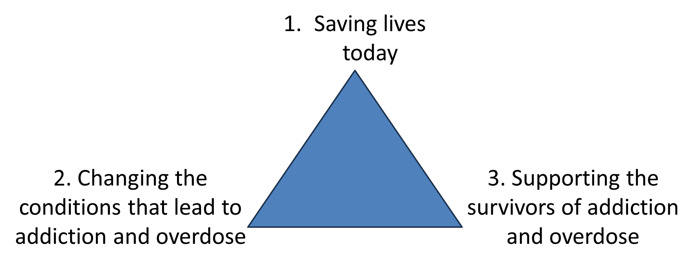

Group Discussion: Future Vision for ORRF

Text Box:
Question:
How do we evaluate whether future investments move us towards these headlines?

Wrap Up

Text Box:
What we achieved during today’s meeting
- Gathering background information and overarching themes from individual ORRF Council meetings (pre-read materials)
- Clarity on current portfolio and available ORRF funds (pre-read materials)
- Communication of a timeline for ORRF strategic portfolio beginning in FY28
- Continued discussion on past and future ORRF portfolio vision, goals, and investment priorities
- Initiating conversation and planning for measuring success

Next Steps

Image: Actions Items
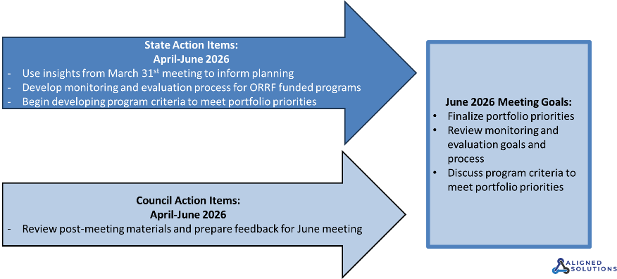

ORRF Advisory Council Strategic Planning Timeline

Image 1: Strategic Planning Timeline

Thank You

Text Box
Email Questions & Comments to:
OpioidRecoveryandRemediationFund@mass.gov

