Opioid Recovery & Remediation Fund Advisory Council

Executive Office of Health & Human Services

Text Box:
Wednesday, June 10, 2026

The ORRF Team
SmartArt: Bending Picture Caption List with Eight Pictures

Image 1

Text: Joanne Marqusee (EHS)
Assistant Secretary

Image 2


Text: Deirdre Calvert (BSAS)
BSAS Director

Image 3

Text: Nicole Schmitt (BSAS)
Director of Strategy & Innovation

Image 4

Text: Julia Newhall (BSAS)
Director of Opioid Abatement Strategy & Implementation

Image 5

Text: Casey Leon (BSAS)
Epidemiologist

Image 6

Text: Millie Bhatia (EHS)
Health Policy Manager

Image 7

Text: Susan Weiss (BSAS)
Executive Assistant

Agenda

Text Box:
Eight-Level Bullet Point List
- Welcome (EOHHS, - 10 minutes)​
- Important Announcements (EOHHS, - 5 minutes)​
- Listening Session Results Overview (EOHHS - 10 minutes)​
- March Council Meeting Overview (Aligned Solutions, -10 minutes)​
- Fiscal Overview and FY28-FY32 Strategic Portfolio (Aligned Solutions, - 30 minutes)​
- Data and Performance Management System (Aligned Solutions, - 10 minutes)​
- Next Steps (Aligned Solutions, - 10 minutes)​
- Close Out (EOHHS, - 5 minutes)



Housekeeping

Text Box:
One-Level Bullet Point List
- Vote on 03/31/2026 Meeting Minutes

Welcome New Members


Text Box:

Cedric Woods​

Director ​

Institute for New England Native American Studies



Text Box:

Jennifer Michaels​

Medical Director​

Brien Center​

Text Box:

Thank you, Carla B. Monteiro and Alyssa Peterkin for your service!​

MA Opioid Overdose Death Trend Update

Chart 1 - Age-Adjusted Opioid Overdose Death Rate

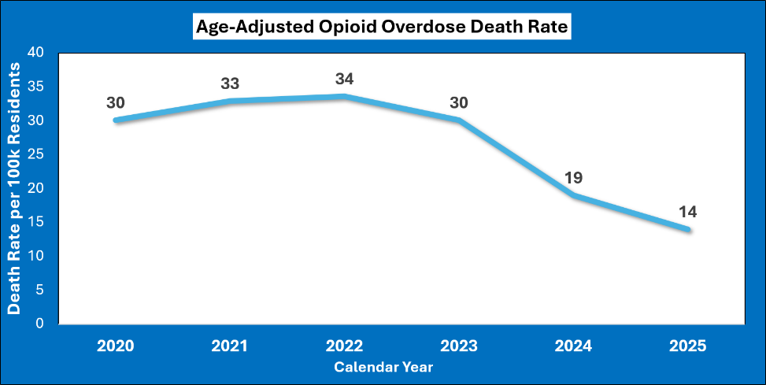

Opioid Settlement Funds – Listening Session Feedback

Image 1 – Thought Bubble
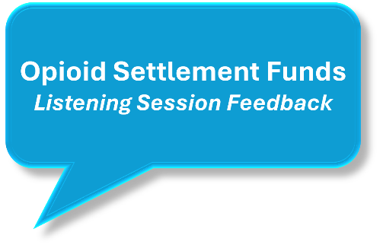

Listening Sessions Map

Image 2 – Listening Session Map
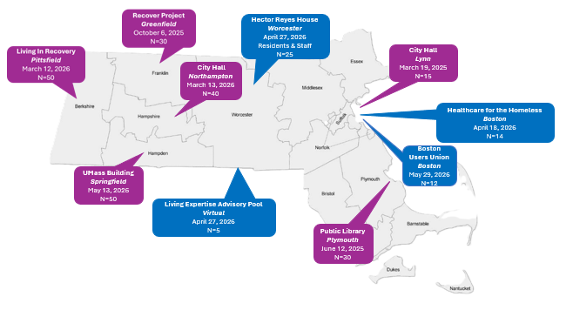

Regional Distinctions

Image 3 – Western MA Feedback
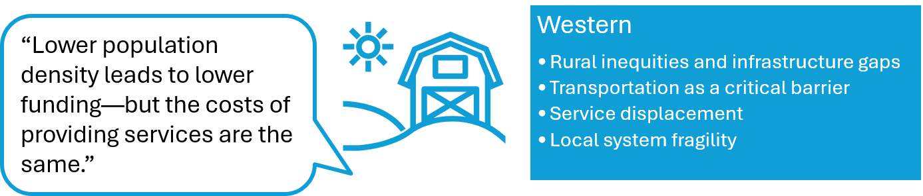

Image 4 – Northeast Feedback
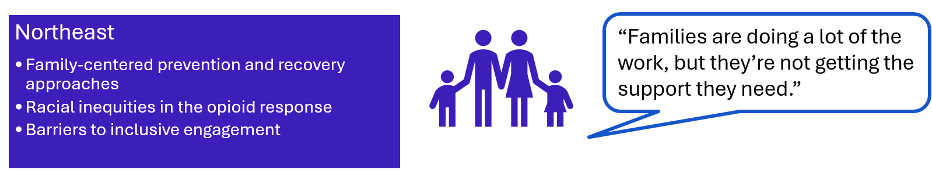

Image 5 – Southeast Feedback
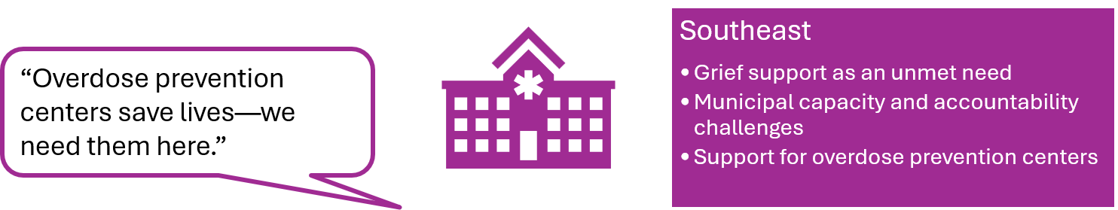

Statewide Themes

Image 6 – State Themes
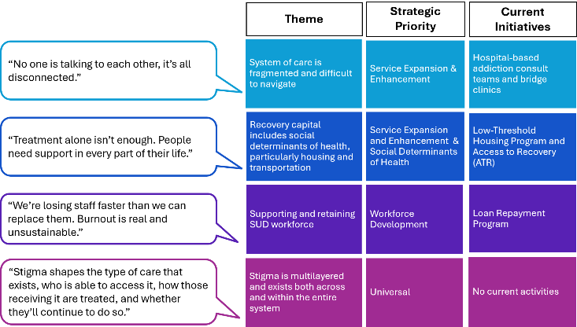

Consumer Perspectives

Image 7 – Consumer Themes

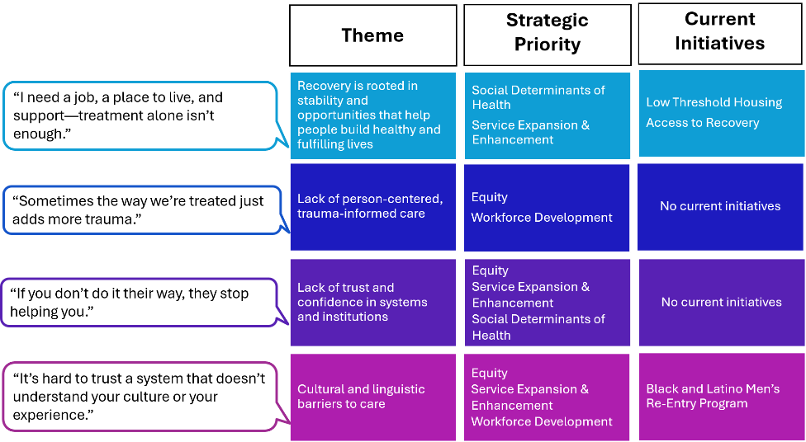

Conclusions & Recommendations

Image 8 – Recommendations

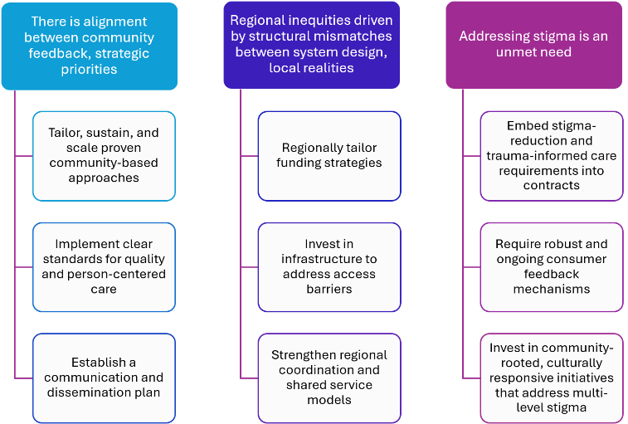

Meet the Aligned Solutions ORRF Team

Image 9 – Aligned Solutions Team





Roadmap for Today

Text Box 1:
Participation Expectations
- Camera on
- Time keeping
  - 1 minute per response
- Raise virtual hand when you would like to speak

Text Box 2:
Group Norms
- Active listening
- Assuming best intentions
- “3-before-me” rule
- Active engagement
*Group norms discussion can be continued in a future Council meeting

ORRF Advisory Council Strategic Planning Timeline
Image 10: Strategic Planning Timeline

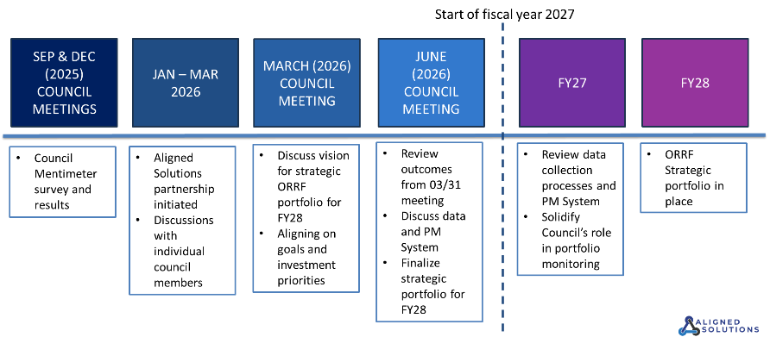

Grounding on Current Principles
Text Box:
ORRF Guiding Principles (2022 Strategic Plan-Current)
- Focus on historically underserved populations suffering from and/or impacted by opioid use disorder
- Incorporate health equity and community engagement into each funded initiative
- Prioritize localized, community focused efforts where possible
- Drive funding decisions based on current data and evidence-based research
- Focus on sustainability concepts of funded activities from the beginning
- Prioritize innovative and nontraditional solutions
- Fund solutions and programs that do not have alternative funding sources

Text Box:
Group Norms
- Active listening
- Assuming best intentions
- “3-before-me” rule
- Active engagement

March 2026 ORRF Council Meeting Overview
Image 11: Overview of March 2026 Meeting
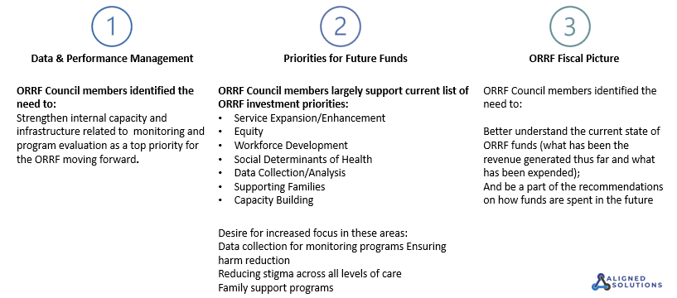
Total ORRF Payments Received & Spent
Image 12: ORRF Payments
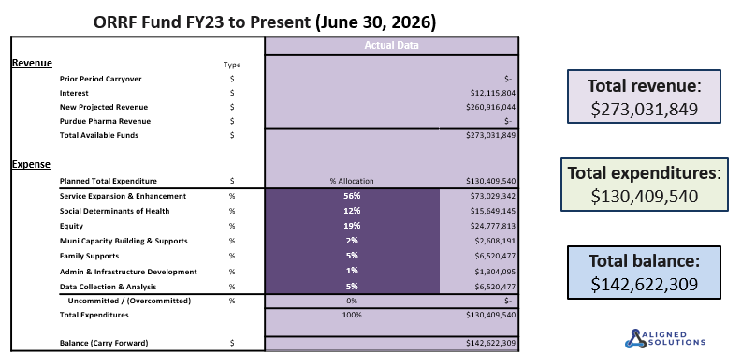


Snapshot of Current Priority Areas Fund Distribution
Image 13: Current Priority Areas

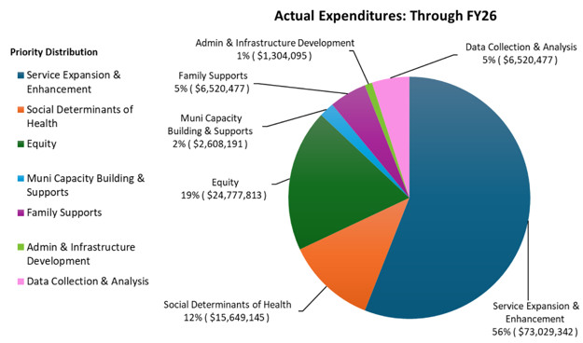

Key ORRF Fund Changes
Text Box:
Key changes to support increased investments in Data Infrastructure for Program Monitoring & Accountability, Harm Reduction, Stigma Reduction, and Family Supports include:
Wind down or scale back ORRF dollars on activities where other funding and billing mechanisms can be leveraged (i.e. MAT enhanced, contingency management, hospital reductions)
Additional funds expected to come in from Purdue (~4 million per year)

Table 1
Activity | Action | Dollar Reduction Amount (annually)
MOUD Enhanced | Sunset | $3,100,000
Hospital SUD | Reductions | $4,000,000
Contingency Management | Sunset | $2,000,000
Community Innovations | Sunset with exceptions | $3,000,000
Total |  | $12,100,000

FY28-FY32 ORRF Fund Opportunity
Table 2
Available ORRF Funds | Annual | 5-Year Total
Available Funds From Sunsetting Projects | $12,100,000 | $60,500,000
Available Funds from Purdue Settlement | $4,000,000 | $20,000,000
Total Available for New Investment in FY28 | $16,100,000 | $80,500,000

FY28-FY32 Priority Investment Areas

SmartArt – Four-Leveled Grouped List

Text Box:
BSAS will provide updates to the ORRF council throughout FY27 on the progress of this work. ORRF funding will remain the same in the other priority areas not explicitly mentioned.
FY28-FY32 Proposed Budget Plan
Image 14: Five-Year Budget Plan
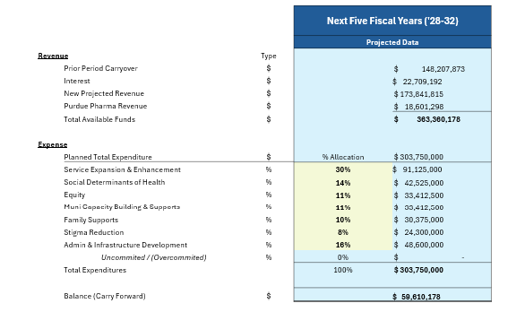
Priority Area Allocations
Current and Future (FY28-FY32) Comparison
Image 15: Clustered Column Chart
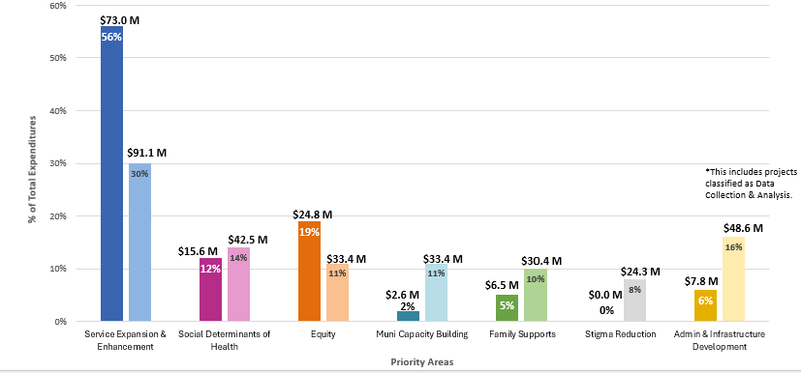
Comparison of Projected ORRF Income & Expenditures

FY2023 –FY2038
Image 16: Line Chart
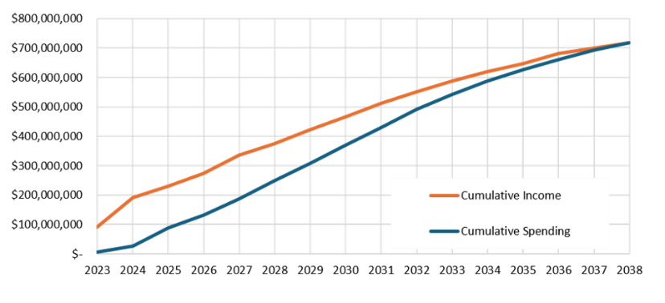
Questions, Reflections, and Discussion
Image 17: Question Mark Icon



Data and Performance Management

Text Box
Challenges Identified by ORRF Council

Text Box
- A lack of clarity on what success looks like at a granular level (e.g. how many people were impacted by XYZ program; how many Narcan kits were distributed, etc.)
- Limited visibility into program performance and outcomes
- Lack of clarity about what data is being collected
- A desire for increased data transparency and accessibility
- Consideration of geographic differences and how to equitably evaluate and monitor

Data and Performance Management

Text Box
Recommendations

Text Box
- Establish shared indicators across programs, with opportunities to scale across BSAS contracts/funding
- Invest in infrastructure to support rigorous evaluation and monitoring including development of systems to monitor, track and report on KPIs
- Develop and implement a comms strategy related to data related to ORRF funded programs to increase visibility and knowledge
- Data infrastructure and performance management system will inform decision making criteria in the selection process of recipients of ORRF funds

Data and Performance Management Next Steps

SmartArt – Three-Level Horizontal Bullet List

Wrap Up

Text Box

What we achieved during today’s meeting:

☐ Reviewed key outcomes of the March Council Meeting

☐ Discussed current fiscal state of ORRF dollars

☐ Discussed possible recommendations and paths forward for FY28-FY32 strategic portfolio

☐ Discussed plans for data and performance management system
Next Steps
Image 17: Arrows

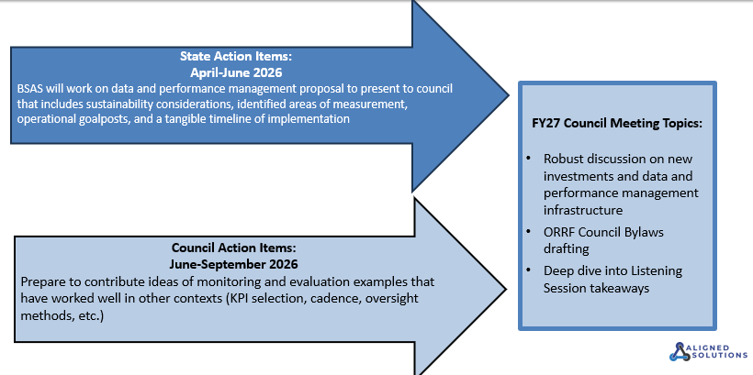
Closing

Text Box

Closing

