Commonwealth of Massachusetts
Executive Office of Health and Human Services

Office of Medicaid
www.mass.gov/masshealth

MassHealth
Orthotics Provider Bulletin 6
September 2016

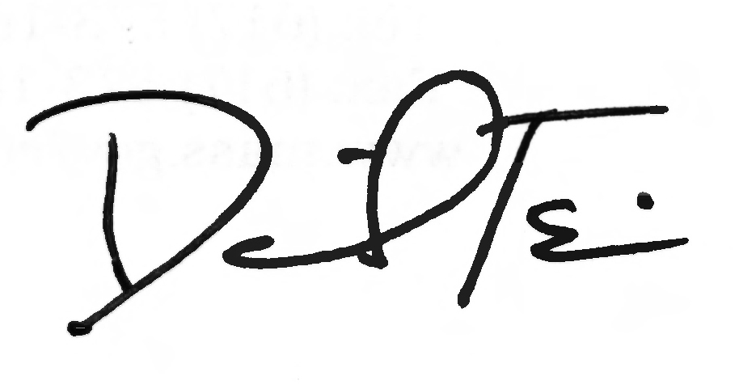

TO: Orthotics Providers Participating in MassHealth

FROM: Daniel Tsai, Assistant Secretary for MassHealth

RE: Dual Eligible MassHealth Members: Coordination of Medicare and Medicaid Coverage

Reminder: MassHealth is the Payer of Last Resort

MassHealth members who have Medicare and MassHealth are known as Dual Eligibles. Federal and state requirements provide that MassHealth is the payer of last resort for any MassHealth member with other insurance—including Dual Eligibles. This means that a provider must generally make “diligent efforts” to first identify and obtain payment from all other liable parties, including Medicare, before billing MassHealth. See 130 CMR 450.316(A). This includes, among other things, complying with all of Medicare’s billing and authorization requirements, and appealing a denied claim when the service is payable in whole or in part by Medicare.

MassHealth providers are reminded that third party liability requirements, including MassHealth’s regulations concerning Medicare crossover payments, apply to services provided to Dual Eligibles. See 130 CMR 450.318. Specifically, a crossover payment applies “where Medicare has made a payment or has approved an amount that was applied to the member’s deductible.” See 130 CMR 450.318(A).

Pursuant to 130 CMR 450.205, MassHealth providers must maintain adequate documentation to substantiate payment of claims by MassHealth, and make such records available to the MassHealth agency upon request. MassHealth may, for instance, request documentation of a provider’s diligent efforts to collect payment from Medicare on behalf of Dual Eligibles, including documentation of compliance with Medicare’s billing and authorization requirements. If the requested documentation is not received within the timeframe specified by MassHealth, or the documentation received is incomplete or otherwise does not support payment by MassHealth, the associated claims will be denied.

Reminder: MassHealth Prior Authorization Does Not Guarantee Payment

Providers are also reminded that MassHealth prior authorization for a MassHealth-covered service is a determination of medical necessity only and does not establish or waive any other prerequisites for payment, such as member eligibility or third-party liability, including making diligent efforts to first obtain payment from Medicare. See 130 CMR 450.303.

(continued on next page)

MassHealth

Orthotics Provider Bulletin 6

September 2016

Page 2

MassHealth Coverage of Non-Medicare Covered Orthotics (ORT)

If Medicare does not cover the ORT, but MassHealth does, MassHealth will cover the ORT, subject to all MassHealth requirements, including any applicable prior authorization requirements.

Additional Resources

Additional information regarding coordination of Medicare and Medicaid coverage for Dual Eligibles can be found at

www.medicare.gov
How Medicare works with other insurance

or 1-800-Medicare (1-800-633-4227).
Questions

If you have any questions about the information in this bulletin, please contact the MassHealth Customer Service Center at 1-800-841-2900, e-mail your inquiry to providersupport@mahealth.net, or fax your inquiry to 617-988-8974.

