Positive Youth
Development Resource Guide:
A Multimedium Resource Guide for

Youth-Serving Providers

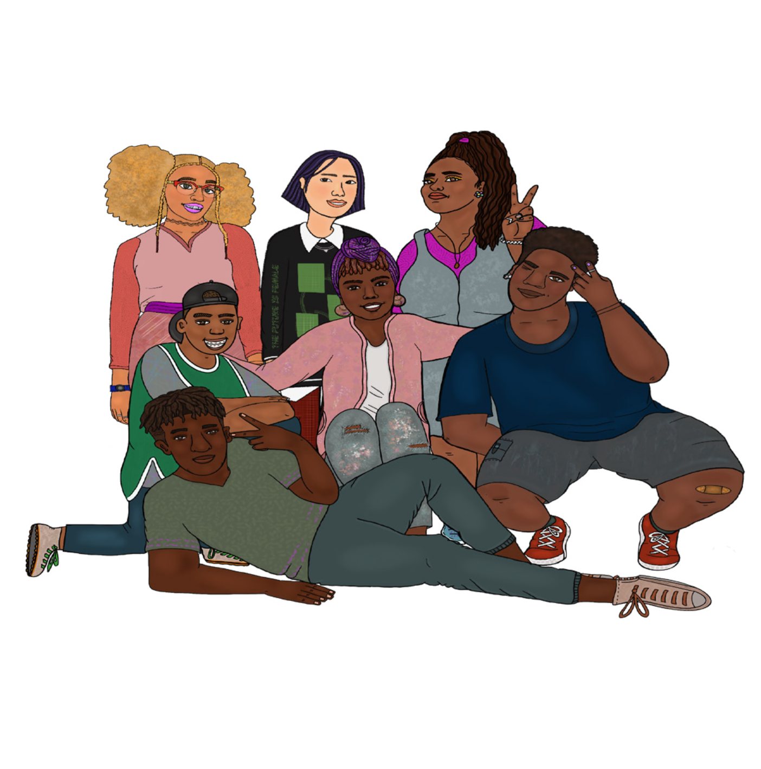Office of Sexual Health and Youth Development Massachusetts Department of Public Health August 2020

Table of Contents

Overview 4
Webinars 5
LGBTQ Youth 5
Inclusive Programming 5
Racial Justice 5
Inequities vs. Disparities 5
Racial Inequities 5
Sexual Health 6
PrEP & PEP 6
Violence & Harassment 7
Teen Dating Violence 7
Trauma-Informed Care/Healing Centered Approach 7
Youth Development 7
Positive Youth Development 7
Achievement Outcomes 8
Implementation & Skills 8
Making Curriculum Adaptations for Youth with IDD 8
Making Curriculum Adaptations for ELL Youth 9
Building Rapport with Youth 9
Supporting Young Pregnant & Parenting Moms 10
Engaging Quiet/Withdrawn Participants & High Energy Participants 10
Online Learning 11
Healthy Relationships 11
Trust in Relationships 11
Sexual Health 11
Puberty 11
STD Prevention & Treatment 11
LGBTQ Youth 12
Gender Identity 12
Violence & Harassment 12
Sexual Violence 12
Teen Dating Violence 13
Trauma-Informed Care/Healing Centered Approach 13
Youth Development 13
Positive Youth Development 13
Implementation & Skills 14
Adapting Curriculum for LGBTQ Inclusivity 14
Choosing Educational Materials 14
Recruitment & Retention 14
Building Rapport with Youth 15
Answering Difficult Questions 15
Classroom Management 16
Evaluation 16

Fact Sheets 17
LGBTQ Youth 17
Gender Identity 17
Sexual Identity 17
Sexual Health 18
Puberty 18
Youth Development 19
Risk & Protective Factors 19
Implementation & Skills 19
Making Curriculum Adaptations for Youth with IDD 19
Referrals to Sexual and Domestic Violence Services 19
Classroom Management 20
Toolkits 21
Healthy Relationships 21
Communication 21
Sexual Health 21
PrEP & PEP 21
STD Prevention & Treatment 22
Implementation & Skills 22
Supporting Youth Pregnant & Parenting Moms 22
Supporting Young Dads 22
Recruitment & Retention 22
Supervision of Youth Employees 23
Making Curriculum Adaptations for ELL Youth 23
Evaluation 23
Briefs & Reports 24
Racial Justice 24
Racial Inequities 24
Violence & Harassment 24
Teen Dating Violence 24
Youth Development 24
Achievement Outcomes 24
Implementation & Skills 25
Making Curriculum Adaptations for LGBTQ Inclusivity 25
Supporting Youth Pregnant & Parenting Moms 25
Supervision of Youth Employees 25
Guidelines 26
Implementation & Skills 26
Responding to Disclosures of Abuse and/or Sexual Violence 26
Making Curriculum Adaptations for ELL Youth 26
Building Rapport with Youth 26
Making Curriculum Adaptations for a Virtual Environment 27
Creating Brave Spaces 27
Appendix A – DPH Programs & Evidence-Based Curricula 28
Appendix B – Additional Resource Websites 29
Appendix C – Consultants 30

Overview

The Positive Youth Development Resource Guide is a resource for youth-serving providers that features webinars, online training modules, fact sheets, reports and briefs, toolkits, and guidelines. The resource guide originated from the Training and Knowledge Assessment in 2019, a survey that captured the learning needs of youth-serving providers. Youth-serving providers often face several barriers in accessing quality trainings and tools, including cost and scheduling conflicts. As a result of the survey, the Office of Sexual Health and Youth Development (OSHYD) recognized the importance of having a centralized resource that removed barriers to accessing quality professional development.

OSHYD has six core values: positive youth development, reproductive justice, health equity,
data-driven, sustainability, and trauma-informed care. The resource guide provides materials that explore and elevate these values and helps providers and programs practice them within youth-serv- ing programs.

Acknowledgements
The resource guide was created in the summer of 2020 thanks to the hard work of graduate intern
Lucienne Veilleux, MPPA (c), MPH (c). The artwork was created by local artist, Farah Jeune.

For additional information about this resource guide, please contact: Stephanie Campbell, Director, Office of Sexual Health & Youth Development Stephanie.Campbell@mass.gov

WEBINARS

LGBTQ Youth
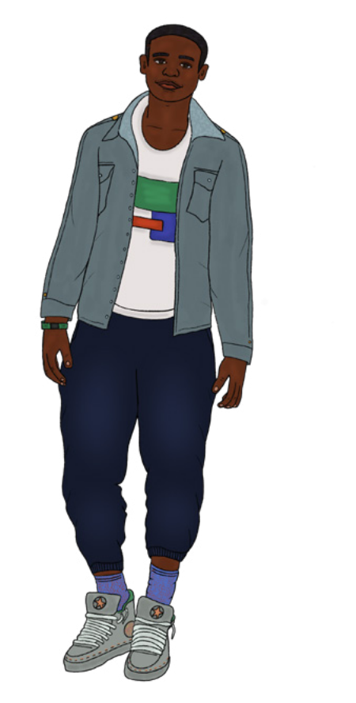Inclusive Programming W: LGBTQ Best Practices: Classroom Culture and Curriculum Description: This webinar models how to create an inclusive class- room culture and build an intersectional curriculum that
incorporates queer history and perspectives.
Audience: Program instructors/facilitators, other educators
Source: Teaching Tolerance
Time Commitment: 46 mins
Link: https://www.tolerance.org/professional-development/webi- nars/lgbtq-best-practices-classroom-culture-and-curriculum

Racial Justice
Inequities vs. Disparities
W: Equity 101: Starting the Equity Conversation Description: This webinar explores creating conditions for people to make sense of what equity means, why it’s important,
and how to approach it together. This webinar aims to provide new insights and some concrete tools for getting the equity conversa- tion started in the context of your organization or program Audience: General
Source: National Equity Project
Link: https://www.nationalequityproject.org/webinar-recordings

Racial Inequities

W: “Black Girls Matter: Pushed Out, Overpoliced, and Underprotected” – Report Launch Webinar Description: In this webinar, panelists including Kimberlé Crenshaw discuss “Black Girls Matter: Pushed Out, Overpoliced, and Underprotected”, a report from the African American Policy Forum and Coumbia Law School’s Center for Intersectionality and Social Policy Studies which brings attention to the impact of overly punitive school discipline policies on Black girls and other girls of color.
Source: African American Policy Forum
Link: https://vimeo.com/119582353
Audience: Educators, general
Time Commitment: 1hr, 18mins

W: Why Black Girls are Targeted for Punishment at School- and How to Change That
Description: In this TedTalk, Monique W. Morris uncovered the causes of “pushout”, which occurs when Black girls are pushed out of schools because of policies that target them for punishment, and shows how we can work to turn all schools into spaces where Black girls can heal and thrive.
Time Commitment: 13 mins
Audience: Educators, general
Link: https://www.ted.com/talks/monique_w_morris_why_black_girls_are_targeted_for_punishment_
at_school_and_how_to_change_that

Sexual Health
PrEP & PEP

W: PrEP and Gender Diverse Communities
Audience: Clinical, community health work
Description: This brief talk covers topics such as the intersectionality of identities and health dispar- ities for gender diverse people and recent results from the U.S. transgender survey. This webinar is prerecorded but you must “register” to access the video.
Source: New England AIDS Education and Training Center
Time commitment: 7 mins
Link: https://www.neaetc.org/events/view/15919

W: PrEP for Adolescents
Description: This video covers the specific health disparities and considerations for the adolescent LGBTQ community and best practices for engaging youth in prevention through delivery of PrEP HIV intervention. This webinar is prerecorded but you must “register” to access the video.
Audience: Clinical
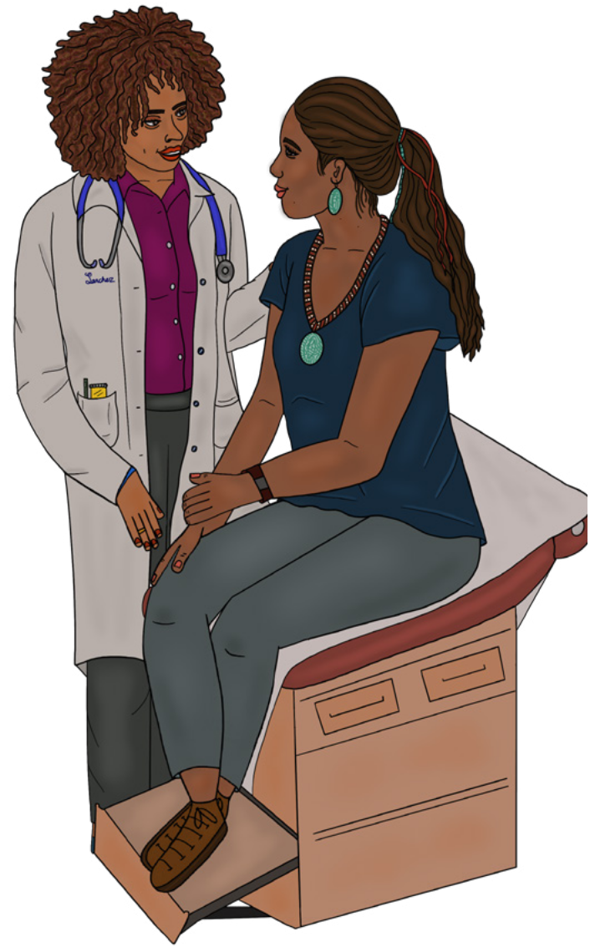Source: New England AIDS Education and Training Center
Time Commitment: 15 mins
Link: https://www.neaetc.org/events/view/15916

W: PrEP and PEP
Description: This segment covers PrEP
(pre-exposure prophylaxis) and PEP (post-expo- sure prophylaxis, the difference between the two, and best practices for prescribing and monitoring. This video is prerecorded but you must “register” to access the webinar.
Audience: Clinical, community health work
Source: New England AIDS Education and Training
Center
Time commitment: 7 minutes
Link: https://www.neaetc.org/events/view/15921

W: That’s Not Cool
Violence & Harassment
Teen Dating Violence
Description: This webinar uses digital tools to promote healthy relationships and prevent teen dating abuse. That’s Not Cool provides resources for both teens and adult allies and providers, including culturally responsive prevention and intervention strategies, as well as youth-driven prevention pro- grams.
Audience: Youth workers, providers, general
Source: Futures Without Violence
Time Commitment: 1 hr 10 mins
Link: https://www.futureswithoutviolence.org/thats-not-cool-teen-dating-violence-healthy-relation- ships-digital-age/
Trauma-Informed Care/Healing Centered Approach

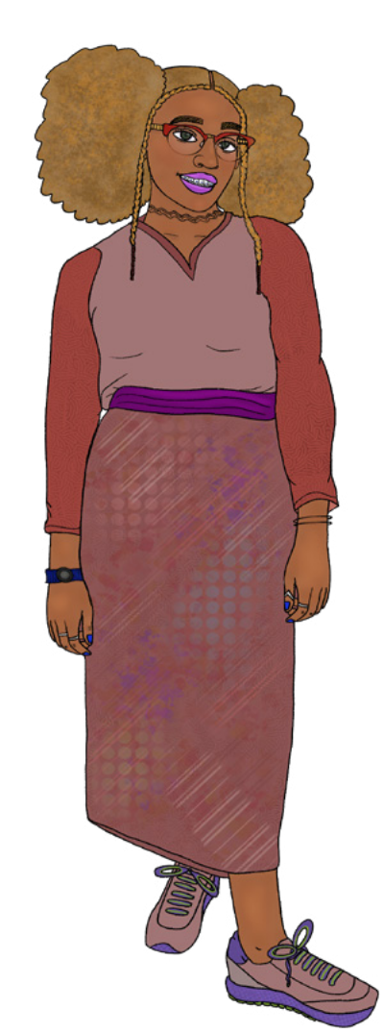W: Trauma-Informed Care for Transgender and Gender-Diverse People
Audience: Clinical, care providers
Source: National LGBT Health Education Center
Description: In this talk, Dr. Jennifer Potter discusses how traumatic ex- periences can intervene with the formation of therapeutic patient-provider relationships, and describes how a universal trauma-informed approach can enhance engagement of transgender and gender diverse patients
into care. Participants must click “Log on to enroll” to view the webinar. Time commitment: 56 mins
Link: https://www.lgbthealtheducation.org/courses/trauma-informed-care- for-transgender-and-gender-diverse-people-2020/

Youth Development

Positive Youth Development

W: Positive Youth Development: Motivation and Goals
Description: This webinar provides theory and background about motiva- tion and goal setting in youth, as well as some practical tools and tips. Time Commitment: 45 mins (motivation & goal related content begins around min. 7)
Source: Act for Youth
Link: https://vimeo.com/304232046/c82337afa1

Achievement Outcomes

W: From Surviving to Thriving: Supporting Transformation, Reentry and Connections to Employment for Young Adults
Description: This webinar focuses on supporting young adults with transformation, reentry, and con- nections to employment. Presenters discuss how communities are connecting young adults who have been impacted by the criminal justice system to employment, education pathways, and supportive services.
Time Commitment: 1 hr
Audience: Educators, community health workers, other providers
Link: https://www.clasp.org/publications/presentation/webinar/webinar-surviving-thriving-support- ing-transformation-reentry-and

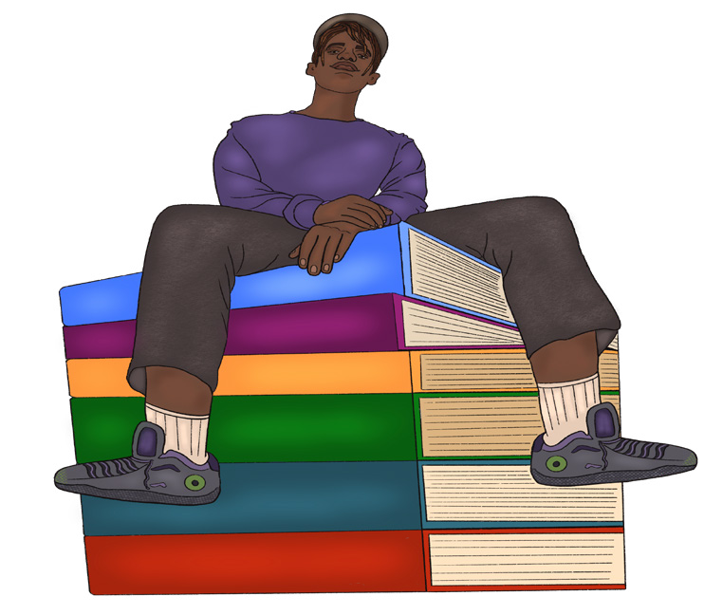

Implementation & Skills

Making Curriculum Adaptations for Youth with IDD

W: Inclusive Program Environments for Youth with Different Abilities
Description: This supplemental presentation to the Act for Youth training manual, Creating Inclusive Program Environments for Youth with Different Abilities, provides additional background information about different disabilities, how they affect youth, and approaches for creating inclusive program envi- ronments.
Audience: Educators, facilitators, program leaders
Time Commitment: 23 mins
Link: https://vimeo.com/392044905/97e26bc585

W: Disability Legislation: IDEA and ADA
Description: This supplemental presentation to the Act for Youth training manual, Creating Inclusive Program Environments for Youth with Different Abilities, provides a closer look at key points of import- ant legislation related to disabilities and serving students with disabilities.
Time Commitment: 15 mins
Source: Act for Youth
Audience: Educators, facilitators
Link: https://vimeo.com/393032379/e8c0b0fba9

Making Curriculum Adaptations for ELL Youth

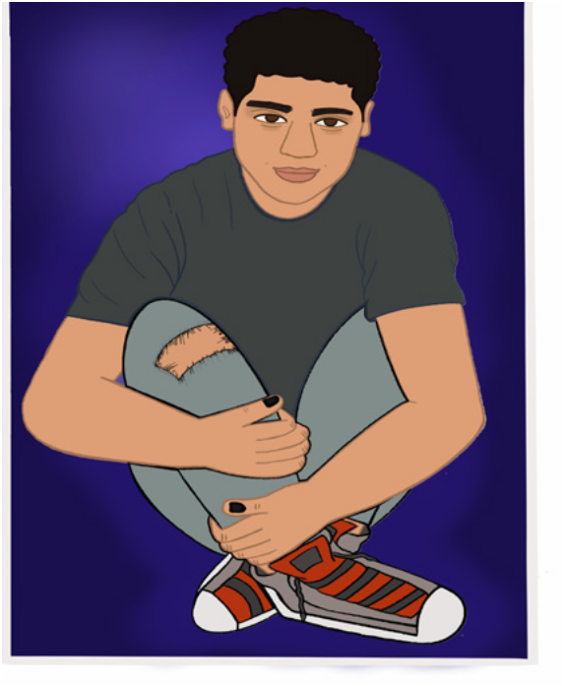W: Creating a Welcoming Environment for ELLs and
Immigrant Students
Description: In this video, ELL middle school teacher
Amber Prentice describes strategies that teachers can
use to create a welcoming classroom environment for ELL
students.
Time commitment: 5 mins Source: Colorin Colorado Audience: Educators, facilitators
Link: https://www.youtube.com/watch?list=PLoU659hwTd- DZ_1Vy7iW_V8zEt3vaf1EqC&time_continue=63&v=uh-
19gewSNFg

Building Rapport with Youth
W: What We Say and How We Say It Matter: Teacher Talk that Improves Student Learning and
Behavior
Description: Many common, well-intentioned statements may actually lead students to disengage
and learn less. This webinar examines several common language habits and patterns that educators and youth workers find themselves in and explores better alternatives.
Time Commitment: 1 hr, 6 mins
Audience: Educators, facilitators
Link: http://www.ascd.org/professional-development/webinars/what-we-say-webinar.aspx

Supporting Young Pregnant & Parenting Moms
W: Listening to Youth Parents: The Multigenerational Making of Mental Health
Description: This webinar from CLASP is about parental mental health, and focuses specifically on young parents. This webinar considers the unique experiences of young parents of color and the role of inter-generational trauma in shaping families’ relationships to mental health.
Time Commitment: 1 hr Source: CLASP Audience: General
Link: https://www.clasp.org/publications/presentation/webinar/webinar-listening-young-parents-multi- generational-making-mental

Engaging Quiet/Withdrawn Participants & High Energy Participants
W: Motivating and Managing Difficult Students: A Discipline with
Dignity Approach
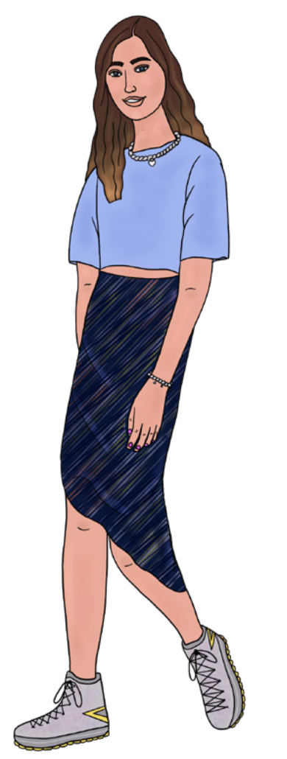Description: This webinar explores ways to motivate and respond to students/participants who are hard to reach, uninterested, or disruptive and provides an overview and examples of effective discipline and mo- tivation. This webinar emphasizes the importance of strong relation- ships, diffusing inappropriate behavior quickly and with dignity, making curriculum relevant, empowering and involving students, and learning and using effective discipline to solve problems. Click “watch now” on the webpage to register and view the webinar.
Time Commitment: 1 hr 20 mins
Source: Association for Supervision and Curriculum Development
Audience: Educators, facilitators
Link: http://www.ascd.org/professional-development/webinars/motivat- ing-and-managing-difficult-students-webinar.aspx

ONLINE LEARNING

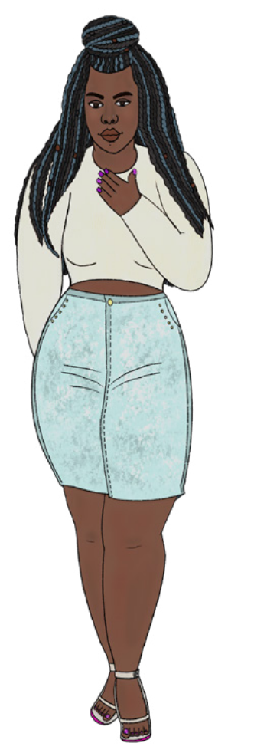Healthy Relationships

Trust in Relationships

O: The Teacher’s Guide to Sex Ed- Lesson 8: Talking About Getting Along: The Basics of Teaching Students about Healthy Relationships
Description: This is one specific unit of a larger e-learning course. This unit covers how to teach about healthy relationships when teaching sexual health education, HIV/STI prevention, and/or family life education.
Time commitment: About 30-40 mins. Source: Healthy Teen Network Audience: Educators
Link: https://www.healthyteennetwork.org/wp-content/uploads/scorm/talking- about-getting-along/story_html5.html

Sexual Health
Puberty
O: The Teacher’s Guide to Sex Ed Lesson 1: Puberty & the Reproductive
System
Description: This specific unit of a larger e-learning course covers pointers for teaching about puberty and reproduction.
Time Commitment: 30-40 mins
Source: Healthy Teen Network
Audience: Sex educators, health educators
Link: https://www.healthyteennetwork.org/wp-content/uploads/scorm/Puber- ty%20Repro%20System/story_html5.html

STD Prevention & Treatment
O: The Teacher’s Guide to Sex Ed Lesson 2: Preventing Pregnancy & Infection: The Basics of Keep- ing Safe
Description: This specific unit of a larger e-learning course covers learning about condoms and con- traception when teaching sexual health education, HIV/STI prevention, and/or family life education. Time Commitment: 30-40 mins
Source: Healthy Teen Network
Audience: Sex educators, health educators
Link: https://www.healthyteennetwork.org/wp-content/uploads/scorm/preventing-pregnancy/story_
html5.html

O: The Teacher’s Guide to Sex Ed Lesson 3: HIV & STIs: Making Sense of Being Safe
Description: This unit of a larger e-learning course covers learning about HIV and STIs when teaching sexual health education, HIV/STI prevention, and/or family life education. Understanding how HIV
and STIs are spread is critical information for students to learn. It can also be a challenging topic to understand and teach about.
Time Commitment: 30-40 mins
Source: Healthy Teen Network
Audience: Sex educators, health educators
Link: https://www.healthyteennetwork.org/wp-content/uploads/scorm/HIV-STIs/story_html5.html

LGBTQ Youth
Gender Identity
O: The Teacher’s Guide to Sex Ed Lesson 7: Sexuality & Gender 101: Explaining Concepts of Gen- der & Sexuality
Description: This unit of a larger e-learning course covers how to talk about gender and sexual orien- tation particularly when teaching sexual health education, HIV/STI prevention, and/or family life edu- cation.
Time Commitment: 30-40 mins
Source: Healthy Teen Network
Audience: Sex educators, health educators
Link: https://www.healthyteennetwork.org/wp-content/uploads/scorm/sexuality-gender-101/story_
html5.html

Violence & Harassment
Sexual Violence

O: Human Trafficking 101
Description: This interactive, self-paced e-learning unit explores critical elements of sex and labor trafficking and steps you can take to support victims and survivors in your community.
Audience: General
Time Commitment: About 20 mins per module (includes 1 sex traffick- ing & 1 labor trafficking module)
Source: Healthy Teen Network
Audience: General
Link: https://www.ssw.umaryland.edu/pari/resources/elearning-units/
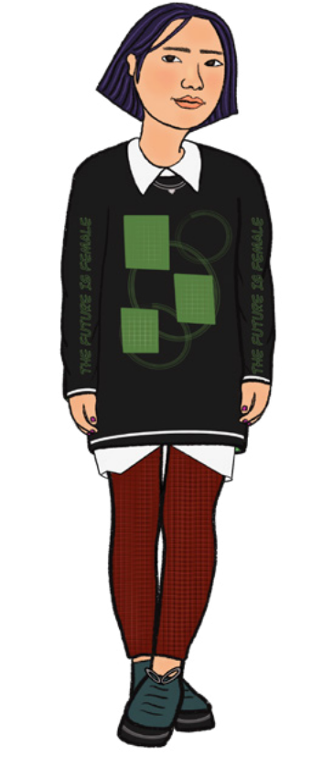ht101/

O: Working with Patients Experiencing Human Trafficking
Description: This follow-up to Human Trafficking 101 explores the signs that may indicate a patient is experiencing human trafficking and what you can do to help them.
Time Commitment: 1 hr
Source: Healthy Teen Network
Audience: Clinicians, medical care providers
Link: https://www.ssw.umaryland.edu/pari/resources/elearning-units/
working-with-patients-experiencing-human-trafficking/

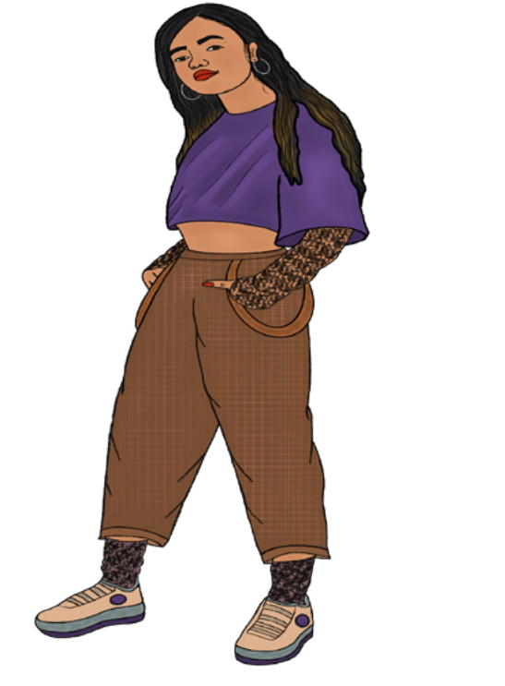Teen Dating Violence O: Dating Matters: Understanding Teen Dating Violence Prevention
Description: This online training demonstrates characteristics
of healthy and unhealthy teen relationships; early warning signs that may increase a teen’s risk for dating violence, sta- tistics, examples, and consequences of teen dating violence; and ways to promote healthy relationships and prevent un- healthy and violent ones.
Time commitment: 1 hr
Source: Centers for Disease Control and Prevention Audience: Teachers/instructors, youth leaders, other youth serving workers
Link: https://vetoviolence.cdc.gov/apps/datingmatters/

Trauma-Informed Care/Healing Centered Approach
O: Connecting the Dots
Description: This online learning explores how different types of violence are connected and also share the same root cause, as well as how different types of violence can take place in the same house, in the same neighborhood, at the same time, or at different stages of life. This training is meant to help you understand the overlapping causes of different types of violence and what can protect against violence.
Time commitment: 40 mins
Source: Centers for Disease Control and Prevention
Audience: General
Link: https://vetoviolence.cdc.gov/apps/connecting-the-dots/node/4

Youth Development
Positive Youth Development
O: Positive Youth Development 101
Description: This is a series of short, online courses intended to introduce PYD. The courses are designed to provide participants with knowledge to identify the principles of the PYD approach and strategies for ways for put these principles into action.
Time Commitment: 6 courses, 30 mins each (can be taken in any order) Source: Act for Youth
Audience: New youth work professionals, volunteers, advocates
Link: https://www.pyd101.net

Implementation & Skills

Adapting Curriculum for LGBTQ Inclusivity

O: Serving Everyone: Providing Sexual & Reproductive Health Services to LGBTQ+ Youth Description: This e-learning provides info about what can be done to ensure youth who identify as LGBTQ+ are being treated with respect and dignity by health center staff and providers while receiv- ing sexual and reproductive health services.
Time commitment: 30-40 mins Source: Healthy Teen Network Audience: Clinicians, providers
Link: https://www.healthyteennetwork.org/resources/serving-everyone/

Choosing Educational Materials

O: Engaging Curriculum
Description: This resource provides information and suggestions for how to choose educational mate- rials that will engage students and foster learning.
Time Commitment: Approx 25 mins. Source: Teaching Tolerance Audience: Teachers, educatros
Link: https://www.tolerance.org/professional-development/engaging-curriculum

Recruitment & Retention

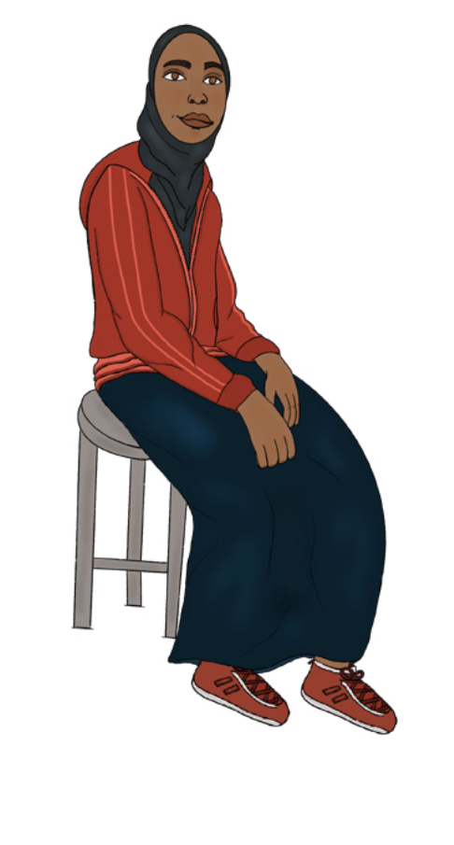O: Internet Advertising to Recruit Youth
Description: This e-learning provides info and lessons learned for how to effectively recruit youth into programs using internet advertising.
Time commitment: 2-3 mins per lesson, 35 mins for entire e-learning
Source: Healthy Teen Network
Audience: Program leaders, coordinators, outreach workers Link: https://www.healthyteennetwork.org/resources/internet-ad- vertising-recruit-youth/

Building Rapport with Youth
O: The Teacher’s Guide to Sex Ed Lesson 4: It’s Not Just What You Say: Techniques & Approaches for a Healthy Sex Ed Class
Description: This unit of a larger e-learning course covers learning about how to create and maintain a comfortable environment teaching sexual health education, HIV/STI prevention, and/or family life education.
Time Commitment: 30-40 mins
Source: Healthy Teen Network
Audience: Sex educators, health educators
Link: https://www.healthyteennetwork.org/wp-content/uploads/scorm/not-just-what-say/story_html5. html

O: The Teacher’s Guide to Sex Ed Lesson 5: Knowing the Law: Laws and Policies Related to Teach- ing Sex Ed
Description: This unit of a larger e-learning course covers learning about the laws and policies that are relevant to teaching sexual education, HIV/STI prevention, and/or family life education.
Time Commitment: 30-40 mins
Source: Healthy Teen Network
Audience: Sex educators, health educators
Link: https://www.healthyteennetwork.org/wp-content/uploads/scorm/knowing-law/story_html5.html

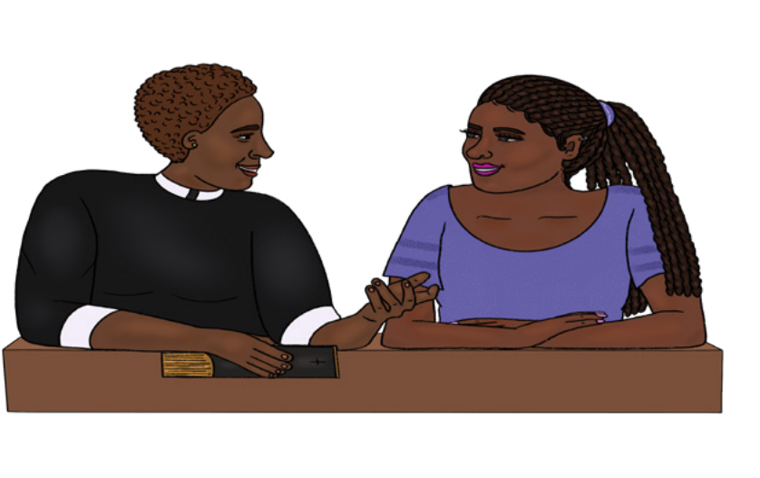Answering Difficult Questions

O: The Teacher’s Guide to Sex Ed- Lesson 6: Responding with Confidence: Answering Sensitive
Questions & Maintaining Boundaries
Description: This is one specific unit of a larger e-learning course. This unit covers how to answer sensitive or challenging questions from students when teaching sexual health education, HIV/STI prevention, and/or family life education.
Time commitment: About 30-40 mins. Source: Healthy Teen Network
Audience: Sex educators, health educators
Link: https://www.healthyteennetwork.org/wp-content/uploads/scorm/responding-with-confidence/sto- ry_html5.html

Classroom Management

O: Unlocking the Secrets of Classroom Management: A Terrible, No Good, Very Bad Sex Ed Lesson Description: This e-learning explores essential classroom management techniques for the sex educa- tion classroom, as well as a number of challenging behaviors and techniques to address them.
Time Commitment: 20-25 mins
Source: Healthy Teen Network
Audience: Educators, sex ed teachers/instructors/facilitators
Link: https://www.healthyteennetwork.org/resources/unlocking-secrets-classroom-management/

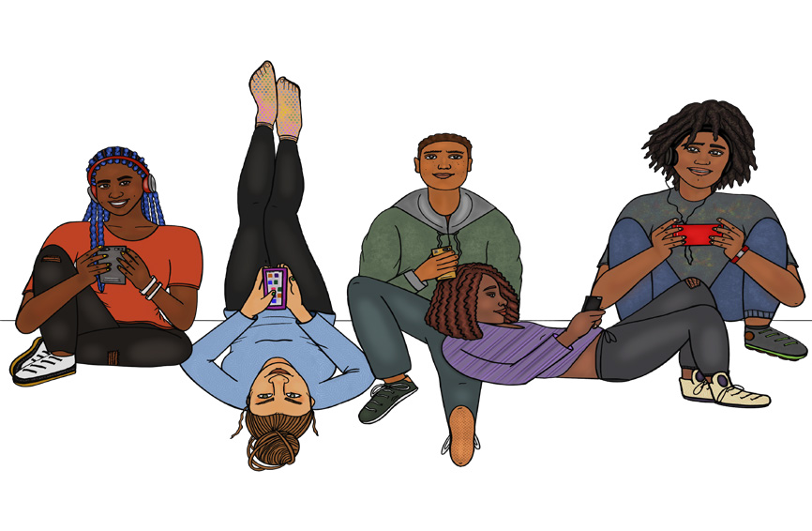

O: Evaluaction: Putting Evaluation to Work
Evaluation
Description: This e-learning is designed to help evaluate violence prevention programs and help you identify what is working and what isn’t. This tool explains program evaluation and how you can apply it to your work, as well as help you plan and track your progress.
Time Commitment: 30 mins
Source: Centers for Disease Control and Prevention
Audience: Program coordinators, managers
Link: https://vetoviolence.cdc.gov/apps/evaluaction/

FACT SHEETS

F: I Think I Might Be Transgender

LGBTQ Youth
Gender Identity
Description: Written by transgender youth, this downloadable packet provides answers for young people who find that the gender to which they were born, or assigned at birth, does not fit them. This information is also valuable to educators or providers working with these youth, to help understand their questions and experiences, including safety, coming out, healthy relationships, and safer sex practices.
Source: Advocates for Youth
Audience: Youth, educators, youth and health workers
Link: https://advocatesforyouth.org/resources/health-information/i-think-i-might-be-transgender/

F: Gender Expansive Students at Higher Risk for Suicidal Behavior
Description: This fact sheet provides information and data about gender expansive students and the increased risk of suicidal behavior they may face, as well as recommendations for educators and public health pracitioners.
Source: Advocates for Youth
Audience: Educators, public health practiioners
Link: https://advocatesforyouth.org/wp-content/uploads/storage//advfy/documents/Factsheets/Final_ Trevor_AFY_GE_and_Suicide.pdf

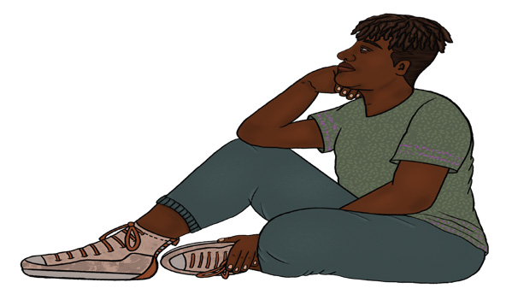
Sexual Identity

F: I Think I Might Be Bisexual + Pansexual
Description: Written by bisexual youth, this downloadable packet provides answers for young people with questions about sexual orientation.
This information is also valuable to educators or providers working with these youth, to help under- stand their questions and what they might be experiencing.
Source: Advocates for Youth
Audience: Youth, educators, youth and health workers
Link: https://advocatesforyouth.org/resources/health-information/i-think-i-might-be-bi-pan/

F: I Think I Might Be Lesbian
Description: Written by young lesbians, this downloadable packet provides answers for young people questioning their sexual orientation. This information is also valuable to educators or providers work- ing with these youth, to help understand their questions and what they might be experiencing. Source: Advocates for Youth
Audience: Youth, educators, youth and health workers
Link: https://advocatesforyouth.org/resources/health-information/i-think-i-might-be-lesbian/

F: I Think I Might Be Gay
Description: Written by young gay men, this downloadable packet provides answers for young people with questions about sexual orientation. This information is also valuable to educators or providers working with these youth, to help understand their questions and what they might be experiencing. Source: Advocates for Youth
Audience: Youth, educators, youth and health workers
Link: https://advocatesforyouth.org/resources/health-information/i-think-i-might-be-gay/

F: Understanding Sexual Development
Sexual Health
Puberty
Description: This page explores the different aspects of healthy sexual development for adolescents and the different processes that are occurring between puberty, identity development, socio-cultural influences, and sexual behaviors
Source: Act for Youth
Audience: Educators, youth workers
Link: http://actforyouth.net/sexual_health/sexual_development.cfm

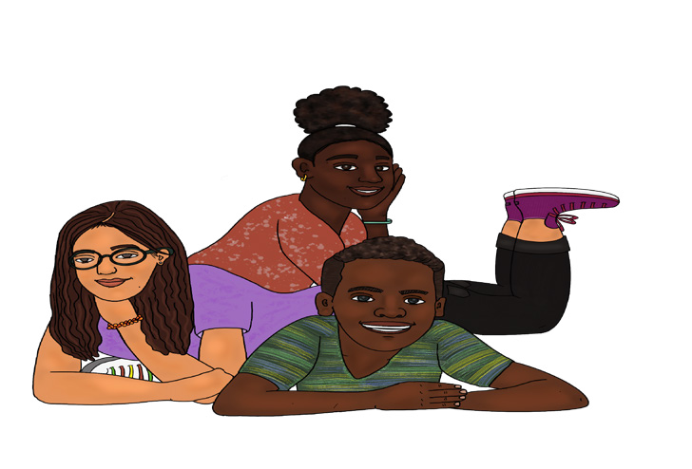

Youth Development
Risk & Protective Factors

F: Adverse Childhood Experiences: Looking at How ACEs Affect Our Lives & Society
Description: This infographic sheet covers what adverse childhood experiences are and how they can affect individuals in their youth and throughout their lives.
Source: Centers for Disease Control and Prevention
Audience: General
Link: https://vetoviolence.cdc.gov/apps/phl/resource_center_infographic.html

Implementation & Skills
Making Curriculum Adaptations for Youth with IDD

F: Sexual Health Education for Young People With Disabilities – Research and Resources for
Educators
Description: This fact sheet provides a few statistics on disability among U.S youth and an overview of myths and facts about the sexuality of people with disabilities. The document also inclides general guidelines for educators and offers a select, annotated bibliography of sexual education materials and resources.
Source: Advocates for Youth
Audience: Educators, general
Link: https://advocatesforyouth.org/wp-content/uploads/storage//advfy/documents/Factsheets/sexu- al-health-education-for-young-people-with-disabilities-educators.pdf

Referrals to Sexual and Domestic Violence Services

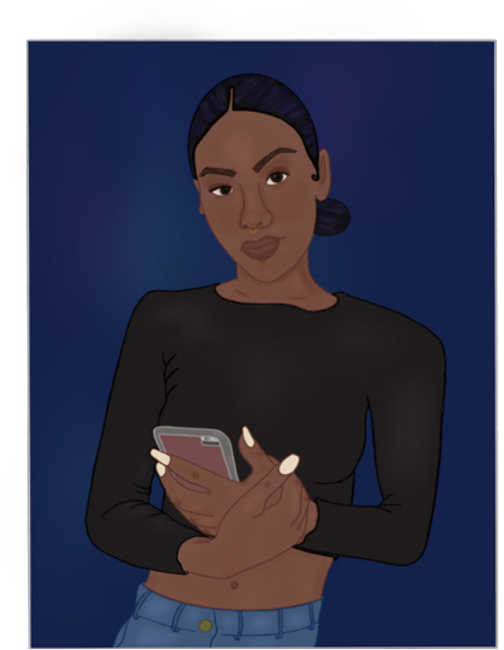F: Rape Crisis Centers
Description: This list provides location and contact informa- tion for Rape Crisis Centers across Massachusetts. These Rape Crisis Centers offer free services for adolescent and adult sexual assault survivors, and for people who care about survivors of all ages.
Source: Mass.gov
Audience: General
Link: https://www.mass.gov/service-details/rape-crisis-cen- ters

F: Facilitation Tips

Classroom Management
Description: This page provides bulleted tips with more in-depth handouts about certain facilitation topics. This page covers preparing space, enhancing participation, handling disruptive behavior, and general presentation skills.
Source: Act for Youth
Audience: Facilitators, educators
Link: http://actforyouth.net/youth_development/professionals/facilitation.cfm

F: Teaching Techniques
Description: This page demonstrates a few of the most common pedagogical techniques used in youth programming: brainstorming, small group activities, and role playing. Videos are included for examples of both weak and strong facilitation.
Source: Act for Youth
Audience: Facilitators, educators
Link: http://actforyouth.net/youth_development/professionals/teaching.cfm

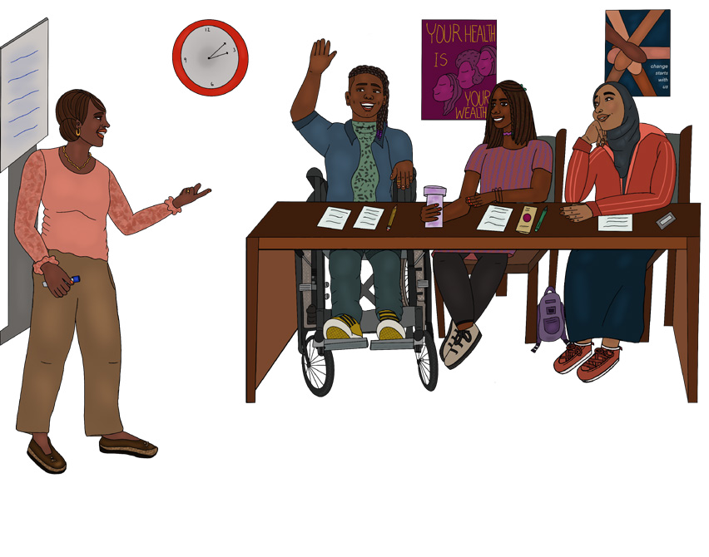

TOOLKITS

Healthy Relationships
Communication

T: Healthy Relationship Middle School Educators Toolkit
Description: This toolkit provides resources to help young people better understand healthy relation- ships and learn to recognize the signs of an unhealthy or abusive relationship. This toolkit provides guidance about theories and practical tips for educators and program leaders who want to lead these discussions in their organization for middle school-aged youth, including warning signs, ways to help, and activities.
Audience: Educators, program leaders, service providers working with middle school-aged youth
Source: LoveIsRespect.org
Link: https://www.loveisrespect.org/wp-content/uploads/2016/08/middle-school-educators-toolkit.pdf

T: Healthy Relationship High School Educators Toolkit
Description: This toolkit provides resources to help young people better understand healthy relation- ships and learn to recognize the signs of an unhealthy or abusive relationship. This toolkit provides guidance for educators and program leaders who want to lead these discussions in their organization for high school-aged youth. This toolkit contains some additional information to the middle school tool- kit and is tailored to apply more specifically to high school youth.
Audience: Educators, program leaders, service providers working with high school-aged youth
Source: LoveIsRespect.org
Link: https://www.loveisrespect.org/wp-content/uploads/2016/08/highschool-educators-toolkit.pdf

Sexual Health
PrEP & PEP

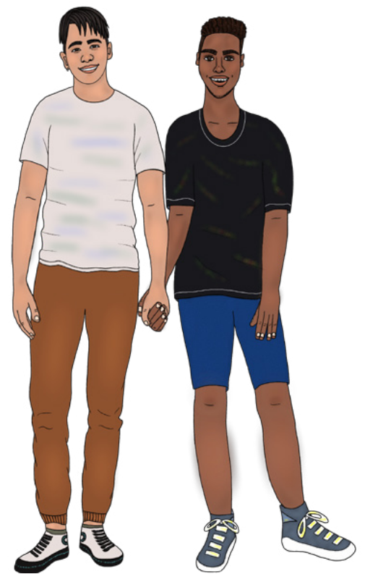T: PrEP Action Kit
Description: This downloadable action kit includes clinical resources to help providers incorporate PrEP into their practic- es. Including helpful resources such as tips on taking a com- prehensive sexual history, frequently asked questions about PrEP and information on PrEP prescribing and monitoring. This action kit is a resource for all providers treating LGBTQIA+ patients or patients at risk of HIV infection.
Source: National LGBT Health Education Center
Audience: Clinical
Link: https://www.lgbtqiahealtheducation.org/wp-content/up- loads/2020/06/PrEPActionKit_Updated-Spring-2020.pdf

STD Prevention & Treatment

T: Priority Resource Dissemination Toolkit
Description: This toolkit includes priority resources and examples of social media posts related to youth sexual health.
Source: National Coalition of STD Directors
Audience: Medical providers, educators
Link: https://www.ncsddc.org/wp-content/uploads/2019/03/f1-NCSD-DASH_Priority_Resource_Tool- kit_Final.pdf
Implementation & Skills
Supporting Young Pregnant & Parenting Moms

T: Supporting Young Mothers
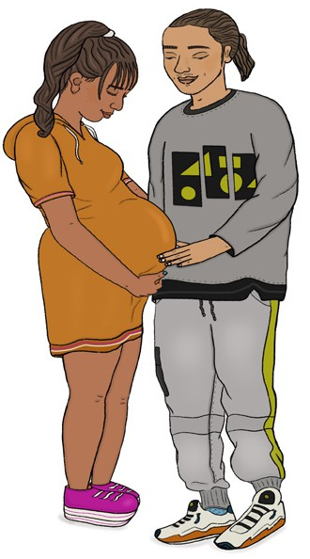Description: This toolkit provides resources to help young moms with pregnancy, birth, and the first years of parenthood, as well as sexual and reproductive health services. Resources specifically for single moms are also included.
Source: Act for Youth
Audience: Medical providers, educators, other providers working with young parents and families
Link: http://actforyouth.net/youth_development/professionals/yp/
mothers.cfm

T: Supporting Young Fathers
Supporting Young Dads
Description: Fathers are an important part of developing healthy and self-sufficient young families. The resources in this toolkit can aid efforts to engage and serve young fathers in your community. Source: Act for Youth
Audience: Medical providers, educators, other providers working with young parents and families
Link: http://actforyouth.net/youth_development/professionals/yp/fa- thers.cfm

Recruitment & Retention

T: Youth-Adult Partnerships: A Training Manual
Description: This toolkit offers lessons and advanced training for people in the field of youth and community work. The goal is to strengthen and promote individuals, groups, and organizations in their practice of youth-adult partnerships. The toolkit includes training essentials for groups, teams, and or- ganizations that are relatively new to youth-adult partnerships, and information and activities to better understand assets and barriers to effective partnerships.
Source: Innovation Center for Community and Youth Development
Audience: Facilitators, youth and community workers
Link: https://fyi.extension.wisc.edu/youthadultpartnership/files/2015/03/Youth-AdultPartnershipsTrain- ingManual.pdf

T: Youth Engagement Toolkit
Description: This toolkit is designed to help adult facilitators engage youth people, allowing youth to serve as true leaders for programs that affect them. This toolkit is tailored for involving youth in local adolescent health programs.
Source: Wisconsin Department of Public Health
Audience: Facilitators, program coordinators, outreach workers
Link: https://www.dhs.wisconsin.gov/publications/p02250.pdf

Supervision of Youth Employees

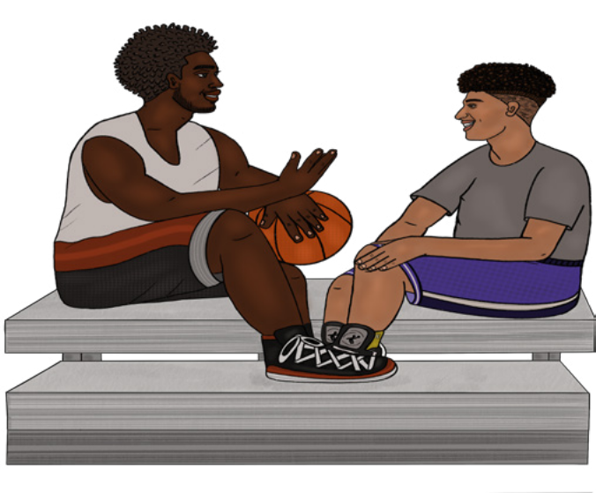T: Designing and Managing Youth Internship Programmes with Impact: A Handbook for Employers
Description: This guide provides information about the values of internships for both participating youth and employers, as well as strategies for making
your internship program as effective and valuable as possible. This toolkit is written from an interna- tional perspective but has useful implications for organizations in the U.S.
Source: International Youth Foundation
Audience: Youth organizations
Link: https://www.iyfnet.org/sites/default/files/library/ Internship_Handbook_for_Employers.pdf

Making Curriculum Adaptations for ELL Youth

T: Diversity Toolkit: English Language Learners (ELLs)
Description: This section of a diversity toolkit from the National Education Association provides strate- gies for schools and educators to effectively address the needs of ELL students.
Source: National Education Association
Audience: Educators
Link: http://www.nea.org/tools/30405.htm

Evaluation

T: Personal Responsibility Education Program (PREP): Tools and Guidance Documents Description: This toolkit includes tools and guidance documents for collecting and reporting PREP (State, Tribal, Competitive, and PREIS) performance measures. Measures include structure, cost,
and support for implementation; attendance, reach, dosage, and participants’ characteristics and pro- gram experiences.
Source: PMAPS
Audience: PREP program providers
Link: https://www.prepeval.com/DataCollectionToolsAndGuidance.html

BRIEFS & REPORTS

Racial Justice
Racial Inequities

R: Black Girls Matter: Pushed Out, Overpoliced, and Underprotected
Description: This report, written by Kimberlé Crenshaw with Priscilla Ocen and Jyoti Nanda, discuss- es the impact of overly punitive school discipline policies on Black girls and other girls of color. The report discusses the intersection of race and gender for Black girls and girls of color, examines the consequences of these policies, and provides recommendations for what can be done.
Source: African American Policy Forum
Audience: Educators, general
Link: https://static1.squarespace.com/static/53f20d90e4b0b80451158d8c/t/54dcc1ece-
4b001c03e323448/1423753708557/AAPF_BlackGirlsMatterReport.pdf

Violence & Harassment
Teen Dating Violence

B: Recognizing and Addressing Intimate Partner Violence in Relationships of LGBTQ People: A Primer for Health Centers
Description: This publication discusses intimate partner violence in sexual and gender minority com- munities. Intimate partner violence is defines and the particular circumstances that impact IPV within sexual and gender minority communities is addressed. This publication provides guidance on how to talk with patients who may be experiencing IPV, and offer resources for helping sexual and gender minorities in unsafe relationships.
Source: National LGBT Health Education Center
Audience: Clinicians
Link: https://www.lgbtqiahealtheducation.org/wp-content/uploads/2020/04/TFIR-158_Intimate-Part- ner-Violence-Brief_web_spreads.pdf

Youth Development
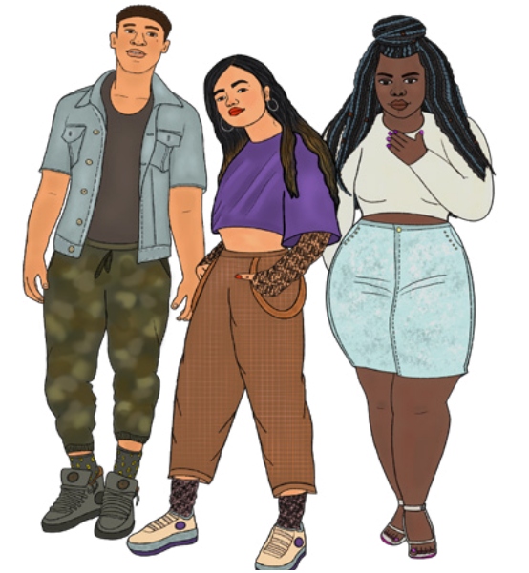Achievement Outcomes R: From Surviving to Thriving: Supporting Transformation, Reentry and Connections to Employment for Young Adults Description: This downloadable report, written by Kisha
Bird, discusses how communities are connecting young
adults who have been impacted by the criminal justice system to employment, education pathways, and supportive services. The report features insights and best practices from 9 communities.
Source: CLASP Audience: General
Link: https://www.clasp.org/publications/report/brief/surviv- ing-thriving-supporting-transformation-reentry-and-connec- tions

Implementation & Skills
Making Curriculum Adaptations for LGBTQ Inclusivity

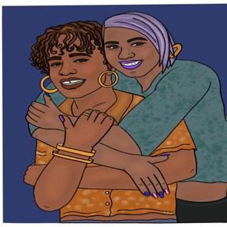B: LGBTQ Inclusion in Youth Program Environments
Description: This article/brief by L. Maurer outlines strategies for making program environments and curriculum more inclusive to LGBTQ youth. Audience: Educators, facilitators program coordinators
Source: Act for Youth
Link: http://www.actforyouth.net/resources/pm/pm_lgbtq_0613.pdf

Supporting Young Pregnant & Parenting Moms
B: Looking at Life Different: Equitable Mental Health Support for Young
Adult Parents
Description: This downloadable brief from CLASP, written by Nia West-Bey, explains how we can best help young adults by recognizing parenthood as a valued, central identity that can spur growth and development in other key areas. This brief explores conversations with young adult parents of color, and offers recommendations for supporting the mental health of young adult parents.
Source: CLASP Audience: General
Link: https://www.clasp.org/publications/report/brief/looking-life-different-equitable-mental-health-sup- port-young-adult-parents
Supervision of Youth Employees
R: Youth Speak: By Young People. For Young People.
Description: This report contains the results of a youth survey and focus group discussions conducted with students and graduates of vocational and entrepreneurship training. Participants discuss their employment and self-employment goals, barriers they face in reaching them, and their experiences with and preferences for youth engagement. This report hopes to inform the design of programs and activities to be more responsive to the wants and needs of young people. This report is written from
an international perspective but has useful implications for organizations in the U.S. Source: International Youth Foundation
Audience: Employment supervisors, program coordinators
Link: https://www.iyfnet.org/sites/default/files/library/Youth_Speak_Final_Report.pdf
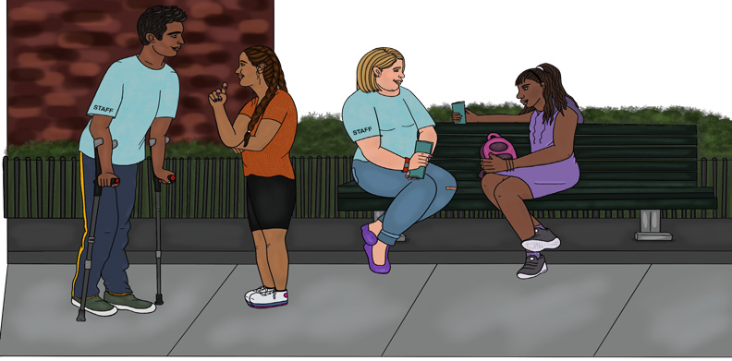

GUIDELINES

Implementation & Skills

Responding to Disclosures of Abuse and/or Sexual Violence
G: First Response: A Guide for Sexual Assault Disclosures
Description: This 2-page guide provides key components of appropriately responding to a disclosure of sexual assault, and provides an activity for rethinking common well-intentioned responses to make them more empowering and supportive.
Audience: Youth workers, healthcare providers, educators
Source: Boston Area Rape Crisis Center
Link: https://barcc.org/assets/docs/SEEK_handout_and_worksheet.pdf

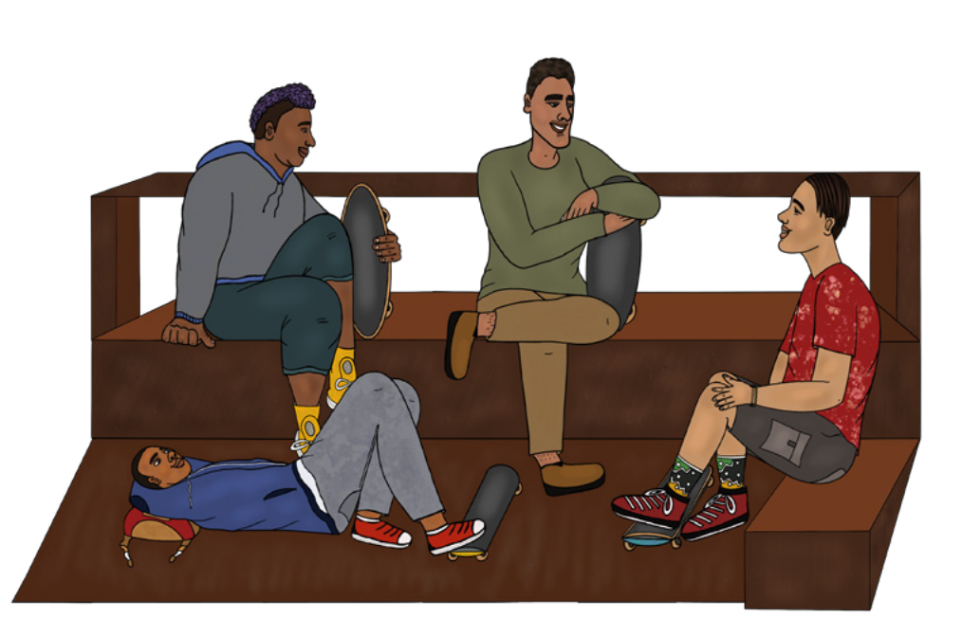Making Curriculum Adaptations for ELL Youth

G: How to Create a Welcoming Classroom Environment
Description: This page provides insights about challenges ELL students might face as they experi- ence stages of cultural accommodation and strategies for helping ELL students adjust to new sur- roundings.
Audience: Educators, facilitators
Source: Colorín Colorado
Link: https://www.colorincolorado.org/article/how-create-welcoming-classroom-environment

Building Rapport with Youth
G: Cultural Synchronization Questions
Description: These guidelines provide examples of questions you might ask students in an informa- tional one-to-one, to better connect, understand, and built rapport with your student/participant. Source: National Equity Project
Audience: Educators, counselors
Link: https://static1.squarespace.com/static/5e32157bff63c7446f3f1529/t/5f173d7d7d2c-
0c271703d543/1595358590081/Building-Rapport-Cultural-Synchronization-Questions.pdf

Making Curriculum Adaptations for a Virtual Environment

G: Virtual Vitality: Adapting Sexual Health Education for a Virtual Environment
Description: This document provides tips and strategies for effective provision of virtually delivered sexual health education, whether it is delivered live and/or through self-paced delivery.
Audience: Sex educators, health educators
Source: ETR
Link: https://www.etr.org/default/assets/File/projects/ETR-VirtualVitality-TipSheet-2.pdf

Creating Brave Spaces

G: Moving from Safe Classrooms to Brave Classrooms
Description: These guidelines explain the differences between a “safe” space and a “brave” space, and the benefits of establishing a brave space to foster an inclusive and equitable environment for your classroom or group space. This page also provides strategies for setting up brave guidelines in your classroom or group.
Audience: Educators, facilitators
Source: Antidefamation League
Link: www.adl.org/media/12532/download

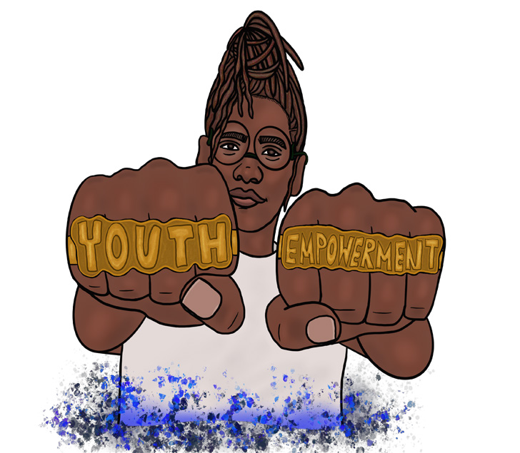

Appendix A: DPH Programs & Evidence-Based Curricula

DPH Program Link

Adolescent Sexuality Education (ASE) https://www.mass.gov/service-details/
about-the-massachusetts-adolescent-sexuali- ty-education-ase

Personal Responsibility Education Program
(PREP)
https://www.mass.gov/service-details/
about-the-personal-responsibility-education-pro- gram-prep

Sexual and Reproductive Health Program
(SRHP)
https://www.mass.gov/sexual-and-reproduc- tive-health-program-srhp

Curriculum Name Link

¡Cuídate! https://www.etr.org/ebi/programs/cuidate/

Get Real: Comprehensive Sexuality Education that Works
https://www.getrealeducation.org

Making Proud Choices https://www.etr.org/ebi/programs/mak- ing-proud-choices/

Project AIM https://www.chla.org/project-aim

Relationship Smarts https://www.dibbleinstitute.org/our-programs/rela- tionship-smarts-plus-sra/

Teen Outreach Program https://wymancenter.org/top/

Name of Website Topics Covered Link
The Center for Law & Social
Policy (CLASP)

Healthy Teen Network Re- sources for Young People who are Pregnant/Parenting
Children, youth, and famiilies, health and men- tal health, income and work supports, job training and education, and racial equity
Young parents, young people who are pregnant or parenting, rights and laws, support resource
https://www.clasp.org

https://www.healthyteen- network.org/teens/re- sources-pregnant-parent- ing-teens/

Love is Repect Teen dating abuse, domestic violence
https://www.loveisrespect. org

Massachusetts Immigrant and Refugee Advocacy Coalition
Immigration policies, serving and advocating
for immigrant and refugee populations
https://miracoalition.org

National Alliance on Mental
Illness (NAMI)
Mental health education, advocacy, services, and resources
https://www.nami.org/Home

Planned Parenthood
League of Massachusetts
Promoting and providing sexual & reproductive health and freedom of choice in Massachusetts
https://www.plannedparent- hood.org/planned-parent- hood-massachusetts

Sex Is.... Sex positivity, talking to youth about sex, sexual health, sex and technology
https://sexisdc.org

Name: Dr. Nicole Christian-Brathwaite, MD Contact: info@wellmindsconsulting.com
Description of expertise: Dr. Nicole Christian-Brathwaite is the founder of Well Minds Psychiatry, which specializes in providing consultation and trainings to organizations, schools, and individuals on trauma-informed schools and work environments, the intersection of trauma and racism, institutional and implicit bias, and racism in healthcare.
Website: www.wellmindsconsulting.com

Name: Chrislene DeJean
Contact: chrislene.dejean@gmail.com
Description of expertise: Chrislene specializes in facilitation, reproductive health, racial justice, arts and culture, and social design.
Website https://www.linkedin.com/in/chrislenedejean/

Name: Joanna Gattuso
Contact: https://www.joannagattuso.com/contact
Description of expertise: Joanna is a facilitator that works in the areas of organizational change and organizational culture, helping teams to align their values with their practice.
Website: https://www.joannagattuso.com

Farah Jeune
Contact: Farenheight55@gmail.com
Description of expertise: Farah is a multimedia artist specializing in illustrations, artist-led classes, and video production.
Website: https://www.farenheighttv.com

Name: Aida Manduley, LCSW
Contact: http://aidamanduley.com/contact/
Description of expertise: Aida is a presenter, therapist, educator, activist, and consultant with exper- tise in mental health, sex and sexuality, anti-oppression, anti-violence, engaging technology, and digital literacy.
Website: http://aidamanduley.com

