3.11 OTHER DIAGNOSES / MEDICATIONS / REFERRALS

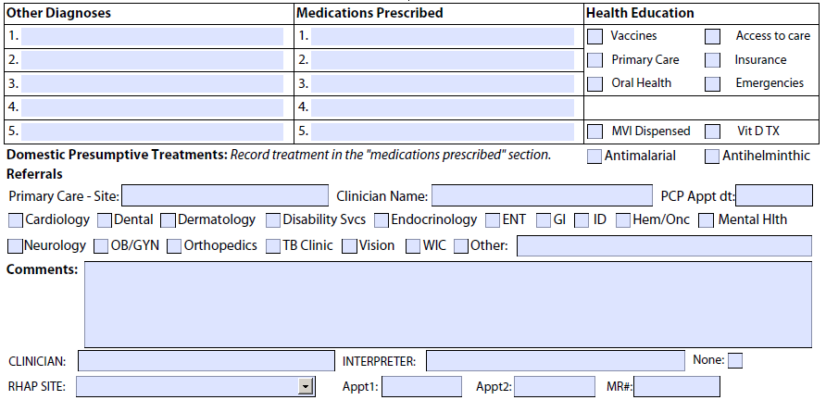

PURPOSE To record abnormal or significant findings and diagnoses,
medications prescribed, referrals for primary care and other appointments, and health education content

DOCUMENTATION Record diagnoses other than those listed elsewhere
OTHER DIAGNOSES in the health assessment form under “Other Diagnoses”.

Do not record normal findings or non-specific symptoms which do not strongly suggest a significant clinical diagnosis.

Record the diagnosis (as opposed to the symptoms which led to the diagnosis) and any appropriate referrals, follow-up, or interventions needed; i.e., record your assessment and plan and not your subjective and objective findings. Examples:
- Record “Probable peptic ulcer disease” rather than “chronic epigastric pain, dyspepsia, nocturnal exacerbation;”
- Record “Upper respiratory infection” rather than “3 day history of clear rhinorrhea and occasional cough.”
An exception to recording symptoms would be a symptom that is considered a diagnosis by itself. An example of this is “headaches.” Even in this case, however, it is preferable to use a more specific diagnosis, such as “migraine headaches.”

MEDICATIONS Record medications that are prescribed or dispensed

PRESCRIBED for the treatment of parasitic infections and other conditions. For example, if a clinician diagnoses otitis media and prescribes amoxicillin, he/she should record the dose, frequency, and duration of treatment on the core form. Treatment for conditions identified through targeted tests are recorded on the Targeted Test Form.

Whenever possible, all prescriptions reimbursed by the RHAP should be pre-filled and available at the second visit for review with the health assessment patient. This is required for anti-parasitic medications prescribed to treat pathological parasites identified in the O & P. It is recommended that, as appropriate, the first dose be taken during the second visit.

COMMENTS/REFERRALS

Primary Care Referral All refugees should be referred to a primary care provider.

All providers should schedule a primary care appointment for refugees with their consent either at the RHAP site or elsewhere. Record the name of the primary care provider (and/or clinic site), the date, and the time of the appointment on the health assessment form.

Many refugees with chronic conditions are likely to be aware that they have a health problem or even have had it diagnosed or treated in the past. Refugees will often be relieved to receive medical care for conditions which they have neglected, often knowingly because of the disruption to their lives which caused them to flee their home countries.

The U.S. Citizenship and Immigration Services (USCIS) requires immunization documentation with applications for legal permanent residence. All refugees will need to have documentation of completed primary series’ for all vaccines currently recommended in the United States. In addition to initiating vaccination during the health assessment, all refugees are likely to need follow-up for vaccination which can be completed by primary care providers. Community Health Workers with the MDPH Division of Global Populations and Infectious Disease Prevention also provide refugees with information on the importance of primary care and other referral appointments.

Other Referrals Make referrals, as appropriate, for urgent matters.

Record referral information on the health assessment form.

The decision to make a referral is up to the RHAP provider. Providers must use their judgment as to what constitutes an “urgent” or “emergent” matter. For medical conditions, referrals should be made if the condition poses a threat to life or a serious health risk which could result in permanent damage. For example, it is common to encounter refugees with chronic ear infections and perforated tympanic membranes. Given the risks of suppurative complications, especially in younger children, and hearing impairment, it would be appropriate to begin a course of antibiotics and refer the patient to an otolaryngologist for evaluation rather than leave the referral up to the primary care physician, a decision which could add up to several months to the process, an unacceptable delay for a child in a developmental phase of rapid language acquisition or entering school, or an adult trying to learn English and enter the job market.

Make referrals, as appropriate, for other medical, dental and support services.

Instruct and refer refugees as appropriate to the following services:

- Dental care services
- Appropriate medical sub-specialty referrals for initiation or continuation of care of identified medical conditions
- Local community resources, such as WIC, the Special Supplemental Nutrition Program for Women, Infants, and Children
- Educational evaluations: Early Intervention Programs for children with, or at risk of, developmental delay, up to age 2 years and 9 months, after which age, a referral should be made to local public schools for a Chapter 766/CORE evaluation for special educational services
- Mental health services

NOTE:
All refugees who are pregnant or lactating women or children age 5 years or less will generally be eligible for WIC and should be referred, if not already referred by the resettlement agency. MDPH Community Health Workers and resettlement case managers may be able to assist with such referrals.

In considering child development issues, the RHAP encourages providers to be aggressive. While a refugee child’s culture may play a great role in determining developmental stage, it must be remembered that the child will now be measured against and expected to meet developmental standards of the US. For example, it would be appropriate in the case of a 24 month old who is not talking to refer the child for audiologic testing and an Early Intervention program. Refugee children are at increased risk of school failure and mental health issues; therefore, interventions aimed at expediting child development or educational interventions to maximize school readiness and addressing mental health issues should be prioritized.

MassHealth Most refugees will have their MassHealth cards by the time
of a referral appointment, and concerns about coverage should not prevent referrals.

Refugees who have not received their MassHealth cards should be eligible for MassHealth either retroactively to the date of application (usually within the first week of resettlement) or through a temporary number.

Mental Health Providers can obtain information about multicultural mental
health services, particularly for immigrants and refugees, from the Massachusetts Department of Mental Health. The Office of Refugee Resettlement provides funding for a comprehensive program of support for survivors of torture living in the United States. Grantees in Massachusetts include:

Boston Center for Refugee Health and Human Rights
Boston Medical Center
http://www.bcrhhr.org/

Harvard Program in Refugee Trauma
Massachusetts General Hospital
http://www.hprt-cambridge.org/

In addition to providing direct services, clinicians with these programs are available for training and technical assistance to RHAP providers relative to serving torture survivors.

Health Education Detailed information on health education that is considered

integral to the health assessment is found in Section 3.10.

Record (by check-off) topics that are reviewed with refugee patients.

RESOURCES Massachusetts Women, Infant and Children (WIC) Nutrition
Program

Early Intervention Program
Massachusetts Department of Public Health

Massachusetts Department of Mental Health

