GEOGRAPHIC ACCESS TO COMMUNITY-BASED OPIOID TREATMENT PROGRAMS (OTPs), BOSTON, MASSACHUSETTS, 2023-2024
Using Location-Allocation Analysis to Identify Optimal Placement for New OTPs

Olivia Lewis, Sumeeta Srinivasan, Jack Cordes, Ric Bayly, Shikhar Shrestha, Max O’Reilly, and Thomas J. Stopka

In 2023 and 2024, we analyzed geographic access to community-based OTPs (i.e., methadone clinics) across Massachusetts, identifying areas in need of increased walk and drive-time access to methadone treatment. Boston faces significant fatal opioid-related overdose burden and has six OTPs within its city limits (Massachusetts report on overdose deaths, 2023). In this addendum, we expand upon our statewide OTP access report by conducting neighborhood-level analyses to identify areas in Boston that could benefit from the implementation of additional OTP treatment service locations based on local treatment need. We modeled the locations of opioid-related incidents (ORIs) associated with emergency medical service and ambulance responses and walk-time access to existing Boston OTPs.

We employed location-allocation analyses to model the placement of five new OTP treatment service locations in areas with a high concentration of ORIs further than 15-minute walk-times from existing OTPs (Figure). We avoided placing OTPs in residential parcels or within 500 feet of a school and used address-level ORI locations as a proxy for treatment need. We juxtaposed suggested sites with the locations of current OTP services, including brick-and-mortar, mobile unit, and medication unit to show existing geographic access to OTPs. We overlaid the density of ORIs per square mile to visualize local opioid-related overdose burden.

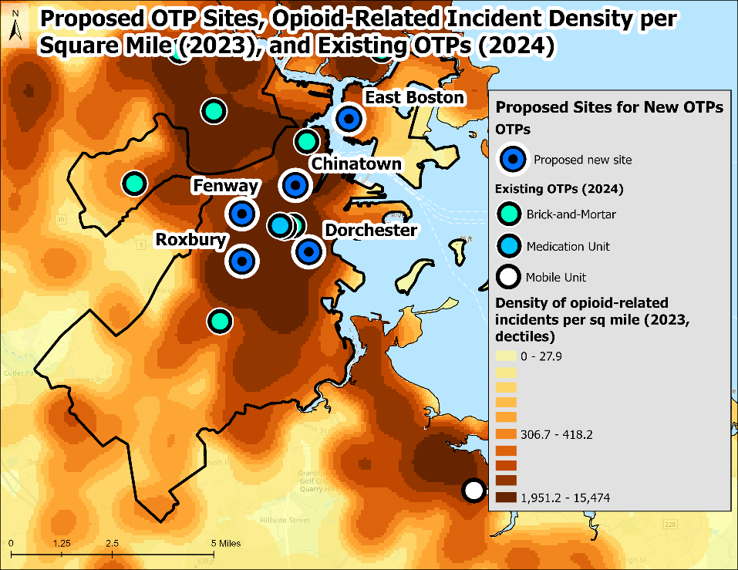
When modeling 15-minute walk-time access to existing OTPs, new OTP treatment service locations were suggested in Chinatown, Dorchester, East Boston, Fenway, and Roxbury. All of the suggested locations were in areas with high ORI densities. The recommended locations in Chinatown, Dorchester, Fenway, and Roxbury have the potential to expand access to methadone treatment in areas where existing OTPs, although relatively nearby, are not currently meeting overall treatment needs.

Based on our location-allocation analyses and the goal of enhancing 15-minute walk-time access to methadone treatment, Chinatown, Dorchester, East Boston, Fenway, and Roxbury would benefit from the implementation of new OTP service locations to meet OUD treatment needs. Expansion of services at existing OTPs may also improve access to treatment, diminishing waitlists. While recent statewide decreases in opioid-related overdoses have been promising, it is as important as ever to increase access to OUD treatment and harm reduction services to drive further declines in nonfatal and fatal opioid-related overdose morbidity and mortality across Boston.

