GEOGRAPHIC ACCESS TO COMMUNITY-BASED OPIOID TREATMENT PROGRAMS (OTPs), WESTERN MASSACHUSETTS, 2023-2024
Using Location-Allocation Analysis to Identify Optimal Placement for New OTPs

Max O’Reilly, Olivia Lewis, Jack Cordes, Ric Bayly, Shikhar Shrestha, Sumeeta Srinivasan, and Thomas J. Stopka

In 2023 and 2024, we analyzed geographic access to community-based OTPs (i.e., methadone clinics) across Massachusetts (MA), identifying areas in need of improved drive-time access to methadone treatment. Western MA contains 15 OTPs (including 2 mobile units) and four counties, three of which (Hampden, Hampshire, and Berkshire) have a fatal opioid-related overdose rate above the statewide average (MA Report on Overdose Deaths by County, 2024). In this addendum, we expand upon our statewide OTP access report, conducting regional analyses to propose new OTP services based on locations of opioid-related incidents (ORIs) associated with emergency medical service responses and drive-time access to existing OTPs in Western MA.

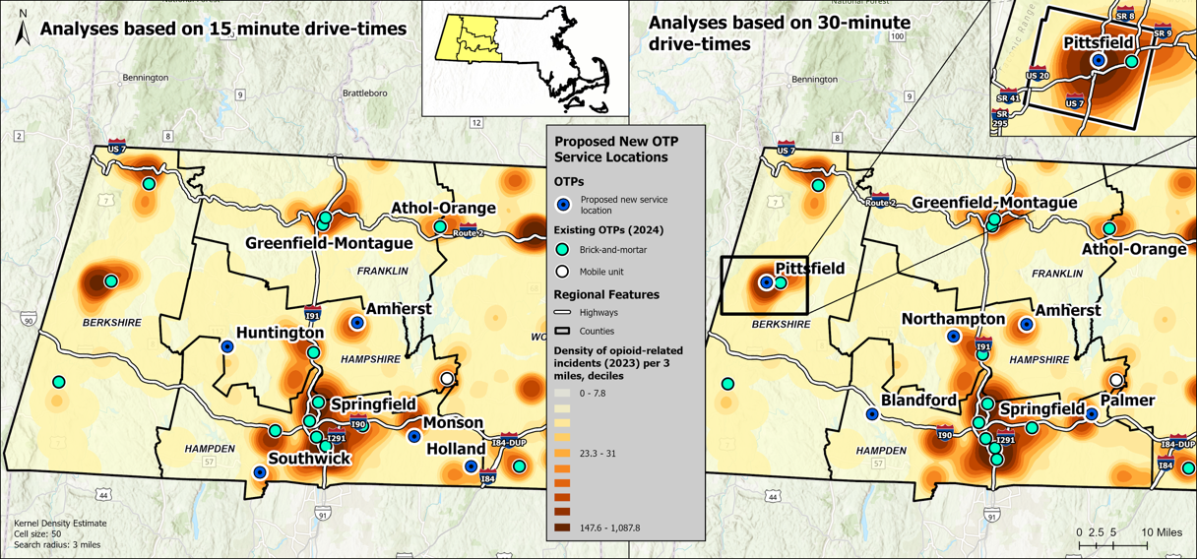
We employed location-allocation analyses to model the placement of five new OTP service locations for both a 15- and 30-minute drive-times. The models used address-level ORI locations as a proxy for unmet treatment demand, in addition to the locations of current OTPs (n = 15) to account for geographic access to existing OTPs. New sites were suggested in locations where they would maximize geographic access for ORIs that are not already within 15- or 30-minute drives of an OTP. We avoided placing OTPs in residential parcels, within 500 feet of a school, and in forested areas. We overlaid the density of ORIs per three square miles to visualize local opioid-related overdose burden.

For a 15-minute drive-time to OTPs, new OTP service locations were suggested in Huntington, Amherst, Southwick, Monson, and Holland. For a 30-minute drive-time, new OTP service locations were suggested in Pittsfield, Northampton, Amherst, Blandford, and Palmer. A new OTP service location was suggested in Amherst for both 15- and 30-minute drive-times. The proximity of the suggested service locations shown in Monson (15-minute map) and Palmer (30-minute map) suggest an area of need.

New OTP service locations in the aforementioned communities may enhance access to methadone treatment and help meet OUD treatment needs in Western MA. Expansion of treatment services in existing OTPs may also be worthwhile. In rural areas, an extended travel time to an OTP is frequently highlighted as a barrier to care (Passman et al., 2022). Western MA contains many rural areas, and implementation of new OTPs may lower the travel burden for patients in rural areas who have poor access to OTPs. Increasing access to OTPs to meet treatment need is vital in Western MA, where three of these four included counties have seen increased or consistent fatal overdose rates in recent years.

