A New Day in OTPs!

# New federal rules can improve your patient experience

## BSAS wants you to know there are NEW federal rules for opioid treatment programs (OTPs) that are designed to improve your experience as a patient.

Important Things to Know

# New Take‐Home Dosing Schedule

— You May Be Eligible For:

Up to 7 take‑home doses if you’ve been in treatment 0–14 days

Up to 14 take‑home doses if you’ve been in treatment 15–30 days

Up to 28 take‑home doses if you’ve been in treatment 31+ days

## How Take‑Home Decisions are Made:

Current substance use Attendance at the OTP Safe medication storage Other factors as determined by the OTP

All take‑home decisions are made by your OTP treatment team under medical leadership, considering current substance use, attendance, safe storage, and other relevant criteria.

BSAS encourages you to meet with OTP staff at admission and monthly to learn if you qualify—and what you need to do to get them.

# Telehealth

Your OTP may offer some services through telehealth. Check with them to learn more.

# Counseling

Requirements have changed. Your OTP must still offer counseling, which may benefit you. Talk with your care team about what they recommend for your treatment plan.

To report concerns or learn more, call the BSAS Complaint Line: (617) 624-5171

More information from SAMHSA

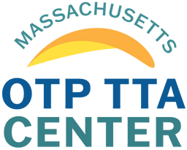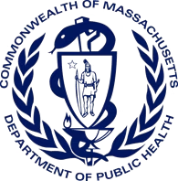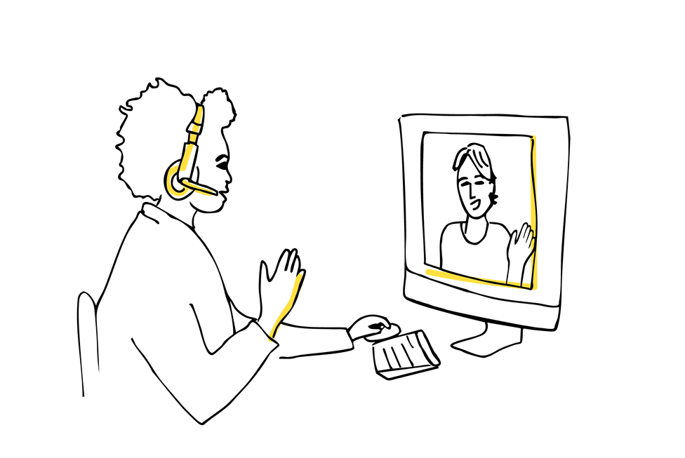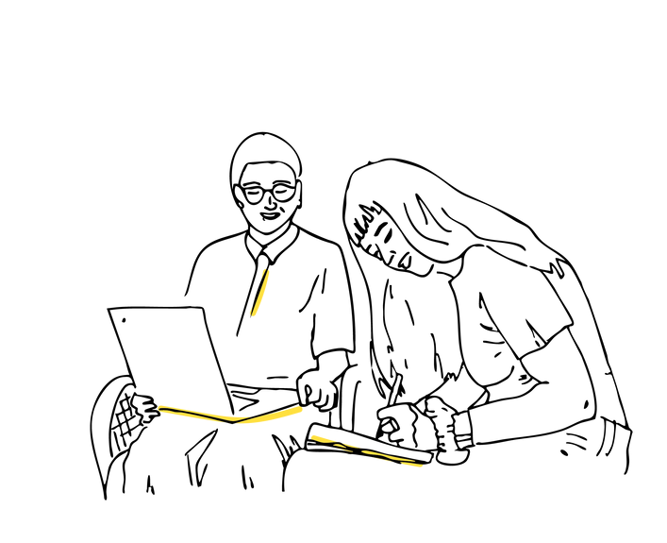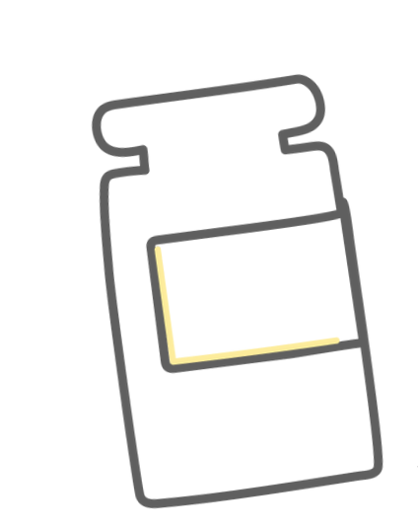

More information

from BSAS