NEW FEDERAL REGULATIONS IN OPIOID TREATMENT PROGRAMS:

1

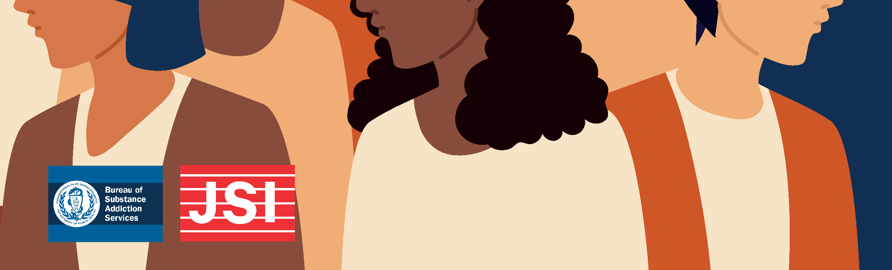

**WHAT DOES THIS MEAN FOR MASSACHUSETTS?**

**DIGITAL WEBINAR GUIDE**

JUNE 2024

**INTRODUCTION**

This companion guide offers webinar and round table attendees a resource to supplement the information covered during the webinar and extend the webinar’s benefits beyond the allotted presentation time. It contains:

* Presentation slides and additional detail
* Frequently Asked Questions
* Future events and resources

The Bureau of Substance Addiction Services (BSAS) has contracted with JSI to start a new training and technical assistance center specifically for opioid treatment programs (OTPs). Now is a critically important time for OTPs and we are excited to support OTPs through implementing the new regulatory changes and other promising practices that will help increase access to medications for opioid use disorder.

By the end of this webinar, participants will be able to:

* Describe the MA Waiver from Certain Regulatory Requirements and Guidance
* State how the waivers and guidance apply within the OTP setting
* Provide suggestions and feedback regarding what topics in the new regulations and may require training and technical assistance



New Federal Regulations in Opioid Treatment Programs

**What does this mean for Massachusetts?**



MA OTP TTA Team

Today’s Presenters

**Melissa Schoemmell**

**Jo Morrissey**

**Lili Njeim**

**Nadia Syed**

**2**

The Bureau of Substance Addiction Services (BSAS) has contracted with our public health consulting organization, JSI, to start a new training and technical assistance center specifically for opioid treatment programs (OTPs). We just concluded our needs assessment, which included a review of patient satisfaction data, focus groups with staff, a literature review, and consultation with a staff advisory committee. We know that now is a critically important time for OTPs and we are excited to support you through implementing the new regulatory changes and other promising practices that will help increase access to medications for opioid use disorder (MOUD).



Agenda

1. **Welcome and Introductions**
2. **Background Information**
3. **Overview of the *Waiver from Certain Regulatory Requirements and Guidance***
4. **Evaluation Survey and Available Resources**
5. **Wrap Up and Upcoming Opportunities**

**3**

|  |  |
| --- | --- |
| Federal Regulations | DPH BSAS  Regulations |
| [42 CFR Part 8](https://www.federalregister.gov/documents/2024/02/02/2024-01693/medications-for-the-treatment-of-opioid-use-disorder) | [105 CMR 164.000](https://www.mass.gov/regulations/105-CMR-16400-licensure-of-substance-use-disorder-treatment-programs) |
| [**Massachusetts Waiver from Certain Regulatory Requirements and Guidance**](https://www.mass.gov/doc/waiver-from-certain-regulatory-requirements-and-guidance-42-cfr-part-8-and-105-cmr-164000-pdf) | |

For the purpose of this presentation, we may denote:



Regulations At‐a‐Glance

**4**

# 42 CFR part 8 as “federal regulations”

* + U.S. Department of Health and Human Services (HHS) & the Substance Abuse and Mental Health Services Administration (SAMHSA) developed the “Final Rule”.
  + The “Final Rule” modifies 42 CFR Part 8.

# 105 CMR 164.000 as “DPH BSAS regulations”

* + The Massachusetts Department of Public Health (DPH) BSAS has issued guidance and specific regulatory waivers to align with changes to 42 CFR Part 8.



Today’s Objectives

***By the end of today’s session, participants will be able to:***

1. Describe the [MA Waiver from Certain Regulatory Requirements and](https://www.mass.gov/doc/waiver-from-certain-regulatory-requirements-and-guidance-42-cfr-part-8-and-105-cmr-164000-pdf) [Guidance](https://www.mass.gov/doc/waiver-from-certain-regulatory-requirements-and-guidance-42-cfr-part-8-and-105-cmr-164000-pdf)
2. State how the waivers and guidance apply within the OTP setting
3. Provide suggestions and feedback regarding what topics in the new regulations may require training and technical assistance

**5**



Timeline: New Federal OTP Regulations

**Released**

**Went into effect**

**Full compliance**

**expected by**

January 2024

April 2, 2024

October 2, 2024

**6**

The new federal regulations are the first significant change to OTP treatment and methadone medication delivery standards in over 20 years. They are supported by evidence-based research and draw on lessons learned from necessary policy and guideline changes, as well regulatory exemptions, initiated during the COVID-19 Public Health Emergency.



A New Day in Opioid Treatment Programs

**Underlying values and principles of SAMHSA’s Revised Rule:**

* Shared practitioner‐patient decision‐making
* Practitioners’ clinical judgment
* Responsive, flexible OTP services
* Evidence‐based practices
* Non‐stigmatizing language

7

These shared values create opportunity to:

* See more patients
* Improve retention in care
* Expand the reach of OTPs with mobile units
* Expand the reach of OTPs with medication units in other services

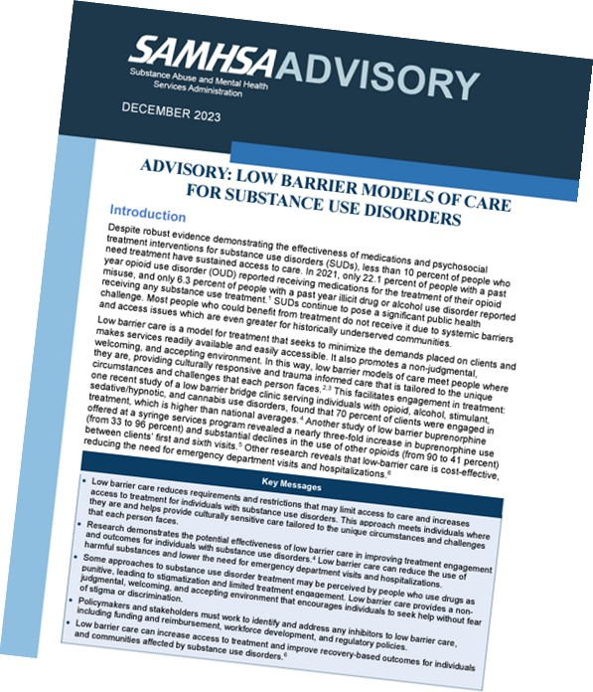

**Low Barrier Care**

**Reduces requirements and restrictions** that may limit access to care and **increases access to treatment** for people with Substance Use Disorder (SUD).

**Meets individuals where they are** and helps provide **culturally sensitive care tailored** to the challenges they face.

8

BSAS aligns with SAMHSA’s revised rule which supports low barrier access to care by increasing access to treatment for people with SUD. The revised rule:

* Supports people by helping prevent injury, infectious disease transmission, and death
* Meets people where they are and promotes any positive change
* Addresses social determinants of health and focuses on increasing protective factors

# [SAMHSA’s Advisory: Low Barrier Models of Care for Substance Use Disorders | SAMHSA Publications and Digital Products](https://store.samhsa.gov/sites/default/files/advisory-low-barrier-models-of-care-pep23-02-00-005.pdf)

* While primary audiences may be primary care providers, federally qualified health centers, or other health care settings and focusing on buprenorphine, the sentiments in this advisory echo those in the Final Rule.



So what does this mean for your OTP?

Let’s get into it!

**9**

**02.**

**Waivers from Certain Regulatory Requirements**

**01.**

**Guidelines for Licensed and/or Approved Providers**

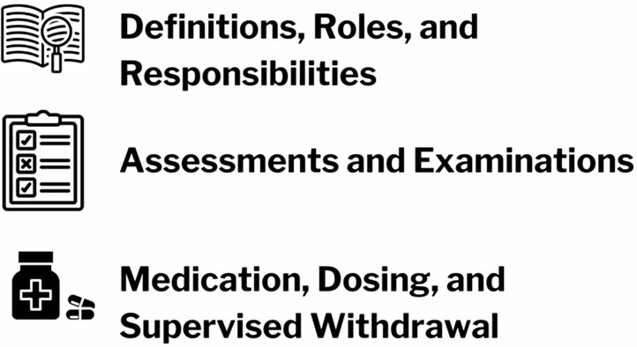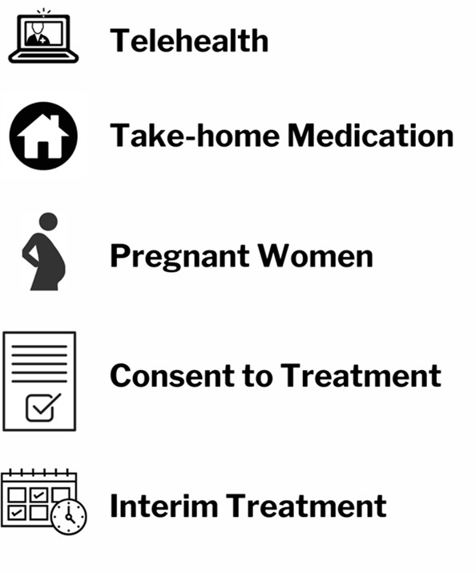

New Regulations by Topic Area

**10**



Required Services

**Provide adequate:**

medical, counseling, vocational, educational, and other screening, assessment, and treatment services

**Meet patient needs with:**

combination and frequency of services tailored to each patient based on an individualized assessment.

**11**



Definitions, Roles, and Responsibilities

**Medical Directors**

* Must be physicians
* Responsible for all medical and behavioral health services
* Can now delegate specific responsibilities to mid‐level practitioners

**Practitioners**

* Physicians, Physician Assistants, or Advanced Practice Registered Nurses acting within the scope of service pursuant to state and federal law
* Can initiate and make all MOUD dosing decisions and review laboratory results

12

The Department is issuing a blanket waiver from the requirements that only a medical director shall ensure all dosing of an opioid agonist treatment medication is ordered. Prior to the federal regulation changes, only physicians could initiate and make dosing changes in an OTP. The Final Rule allows for practitioners to initiate and make dosing changes and to write all medication orders in an OTP. A midlevel waiver exemption submission is no longer needed from SAMHSA or the State Opioid Treatment Authorities (SOTA). Therefore, Mid-level Exemption applications are no longer accepted by BSAS as of April 2, 2024.

Appropriately licensed mid-level practitioners are now able to order all medications for opioid use disorder in an OTP.



Assessments and Examinations

1. **A screening examination**
   * Ensures that the patient meets the **criteria** for admission
   * Ensures no contraindications to treatment with MOUD
2. **A full history and examination**
   * Full in‐person physical and behavioral health assessment within 14 days of admission

13

The updates to the new regulations clear a path for removing barriers and expediting OTP admissions ultimately benefiting the program and patients in reducing the time to get into treatment. The next several slides discuss these changes and options.

To help expedite & streamline OTP admissions, the updated regulations separate the admissions intake into two sections. The first section is the screening exam and allows for medication to commence at the time of initial intake; SAMHSA and BSAS recommend methadone medication induction **not** be delayed until the full examination is completed.

**Initial medical examination** must be completed by an appropriately *licensed practitioner* (as defined in federal and Massachusetts regulations) this is updated language to reflect the additional scope of practice granted mid-level practitioners in OTPs.

**For a screening examination,** refusal of lab testing for co-occurring physical health conditions should not preclude a patient from access to treatment, provided such refusal does not have the potential to negatively impact treatment with medications.

**As for a full history and examination**

* It should be noted that serology testing and other testing deemed medically appropriate by the licensed OTP practitioner based on the screening or full history and examination, and drawn not more than 30 days prior to admission to the OTP, may form part of the full history and examination.
* BSAS has recently learned that only the screening portion of the medical intake can be done by telehealth with caveats.
* The physical examination must be done in person within 14 days of admission. BSAS consulted with SAMHSA seeking clarification regarding this and whether an in-person exam versus the use of telehealth is required. SAMHSA stated they intend on providing further guidance on this soon. BSAS will keep OTPs updated as we learn more.



Assessments and Examinations

**What if the licensed practitioner is not an OTP practitioner?**

The screening examination must be completed **no more than seven days prior** to OTP admission

**What if the examination is performed outside of the OTP**?

The written results and narrative of the examination, as well as available lab testing results, must be transmitted, consistent with applicable privacy laws, to the OTP, and verified by an OTP practitioner

**14**

Another change which can help expedite the OTP admission process is the new federal regulations that allow for a practitioner outside of the OTP to complete the screening examination. This is an opportunity to decrease the amount of time a patient may wait to get into treatment as the OTP can now review a non-OTP practitioner’s examination results, document that they reviewed and agree, and use that as the required screening exam prior to writing the medication order.

It is recommended that OTPs collaborate with their referral partners to discuss what information is needed and helpful in order to expedite the admissions process for patients.

* If the practitioner is not an OTP practitioner, the screening and full examination must be done no more than 7 days prior to admission.
* The written results and narrative of the examination, as well as available lab testing results, must be transmitted, consistent with applicable privacy laws, to the OTP, and verified by an OTP practitioner.



Assessments and Examinations

Annual Medical Exam – Completed by an OTP Practitioner

OTHER

ASSESSMENTS

Periodic Behavioral Health Assessment Services

Minimum of 8 random drug screens per year*

**15**

The annual medical exam must be completed by a OTP practitioner in addition to periodic behavioral health assessments.

* The combination and frequency of various services should be dictated by an individualized assessments and shared decision-making between the patient and clinical team.
* The plan must be reviewed and updated to reflect responses to treatment and recovery support services.
* Adjustments are made to the plan that reflect changes in the context of the person’s life, including their current needs for and interests in medical, psychiatric, social, and psychological services. Additionally, current needs for and interests in education, vocational training, and employment services should be assessed.

*Drug screens shall, at a minimum, test for opioids including, but not be limited to, buprenorphine, methadone, and fentanyl. Screens can also test for cocaine; benzodiazepines; alcohol; and any other drugs that the licensed or approved provider determines are clinically indicated, or as approved by the Commissioner of the DPH and listed in BSAS guidance.

* Drug screening does not preclude distribution of legal harm reduction supplies that allow an individual to test their personal drug supply for adulteration with substances that increase the risk of overdose.
* Drug screening is to be used as a clinical tool to aid in treatment decisions.
* Trauma-informed care and measures should be incorporated into program policies and decision-making.



Assessments and Examinations

**Requirements removed for admission:**

* Determining that the patient has a current physiological dependence on opioid for at least a 12‐month duration
* Adult patients with two or more unsuccessful episodes of supervised withdrawal within a 12‐month period
* Patients under 18 have two documented unsuccessful attempts at short‐term withdrawal or drug‐free treatment within a 12‐month period

**16**

The new federal regulations removed these potential barriers to accessing OTP treatment. BSAS has aligned with these changes through the provision of the regulatory waivers.

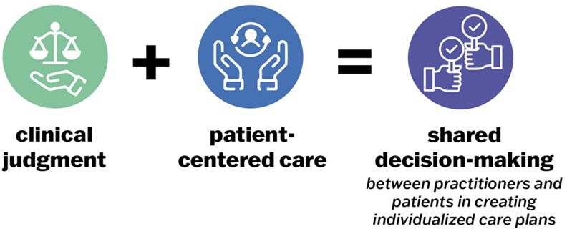

Assessments and Examinations

**17**

Care Planning

Treatment plans are referred to as **care plans** within the Final Rule.

**Shared decision‐making** is emphasized.

As mentioned, the underlying spirit of the new regulations call for individualized treatment and shared decision-making to meet each patient’s needs. This new paradigm prioritizes the need for patients to get and stay in treatment.

Note: the term treatment plan has been changed to **care plan**. This demonstrates the shared decision-making which should occur when developing each patient’s plan to reflect their own specific goals, needs, and circumstances. There should not be a one size fits all approach to care planning.

Care plans should be:

* Based on individualized assessment
* Created using shared decision-making between patient and clinical team
* Updated, reviewed with the patient, and amended as necessary
* Tailored to meet each patient’s needs
* Reflective of each patients’ individualized counseling needs and ability to engage in counseling
* Prepared within 14 days of admission and include the initial psycho social evaluation

One important update to the federal regulations is that patients should not be discharged from treatment for not attending counseling. Medication should not be contingent upon attending counseling.



Medication, Dosing, and Supervised Withdrawal

* In addition to physicians, **practitioners can now initiate and make dosing decisions in OTPs.**
* Choice of medication and the initial dose of medication should be individually determined
* Total dose is at the discretion of the practitioner

**18**

As a reminder, medical orders and dosing initiation decisions can be determined by a ‘practitioner’ who can be either a physician, physician’s assistant, or advanced practice registered nurse.

In line with providing individual care and not a one size fits all approach, the new regulations allow for the use of practitioner’s clinical discretion when admitting patients. Specifically, initial dosing caps for the first day of treatment have been increased to a cap of 50 mg. These initial caps can be increased if the OTP practitioner finds sufficient medical rationale which must be recorded in the patient's medical record. Examples include transfer of a patient from another OTP, or the initial dose does did not alleviate withdrawal symptoms.



Medically Supervised Withdrawal

* The Department waived the requirement that a waiting period of at least one week is required between withdrawal attempts
* Practitioners are expected to determine the rate of decrease for each patient
* The Department waived the requirement for monthly drug screens if the withdrawal period extends beyond 30 days
* The Department waived the requirement prohibiting take‐home medication for withdrawal management

**19**

In alignment with the changes to the Federal Rule, the Department waived the one- week waiting period requirement between withdrawal attempts. Providers should use clinical judgment in consultation with the patient when deciding on supervised withdrawal, and the rationale for the decision should be recorded in the patient's file.

The Department waived the requirement that a **physician** determine rate of decreased dosing. Instead, either a program physician or a practitioner make that determination for each patient.

The Department waived the requirement for licensed or approved providers to obtain at least one drug screen per month if the withdrawal management period extends beyond 30 calendar days. As per 42 CFR § Part 8.12(f)(6), it's expected that a program physician or practitioner will decide on the frequency of drug screens for each patient in medically supervised withdrawal based on clinical judgment, ensuring that the minimum number of random drug screens is met.

The Department waived the requirement prohibiting licensed or approved providers from providing take-home medication for withdrawal management. This adjustment aligns with the new federal OTP regulations on take-home medications at 42 CFR § 8.12(i). Additionally, licensed or approved OTPs are expected to evaluate each patient's eligibility for take-home medication upon admission and monthly during treatment.



Telehealth

* Audio/Visual telehealth platforms are allowable for screening
  + *Acceptable to use audio‐only devices for methadone*

***only*** *if the patient is in the presence of a licensed practitioner registered to prescribe & dispense controlled medications*

* If the patient is appropriate for MOUD via the screening, the physical exam needs to be performed in person

**20**

The expansion of the use of telehealth is another example of the intention of these federal regulatory changes to provide opportunities to increase immediate access to treatment and make treatment more easily accessible to patients whether it is through the admission process or receiving counseling via telehealth.

As discussed in the previous slide, the physical exam needs to be performed in person, therefore the use of audio-visual telehealth only applies to the screening aspect of the evaluation; meaning the patient is screened and deemed an appropriate candidate for MOUD. As discussed earlier, a non-OTP practitioner can conduct the physical exam.

BSAS has consulted with SAMHSA seeking clarification regarding the use of telehealth for the entire medical intake including the screening and the physical.

Each program is expected to:

* + Develop telehealth policies and protocols
  + Provide appropriate training to staff
  + Abide by all relevant privacy laws in implementing this feature of the new regulation

# [Resource: Telehealth Use in the Commonwealth and Policy Recommendations - January 2023](https://www.mass.gov/doc/telehealth-use-in-the-commonwealth-and-policy-recommendations/download)



Take‐Home Medication

**NEW: Revised criteria for dispensing MOUD to patients for unsupervised use ‐**

**Risk/Benefit analysis**

**Risk of overdose or**

**ability to function safely.**

**Attendance at**

**supervised medication administration.**

**Absence of serious**

**behavioral problems**

**that endanger the patient, the public or others.**

**No known recent**

**diversion activity.**

**Medication can be**

**safely transported and stored.**

**Any other criteria**

**relevant to the patient's safety and the public's health.**

**21**

Unsupervised or “take-home” medication doses may be provided under the circumstances listed on the slide.

Risk/benefit analysis should consider:

* Absence of active substance use disorders, other physical or behavioral health conditions that
* Increase in the potential for overdose, or the ability to function safely;
* Regularity of attendance for supervised medication administration;
* Absence of serious behavioral problems that endanger the patient, the public, or others;
* Absence of known recent diversion activity;
* Whether take-home medication can be safely transported and stored
* Any other criteria that the medical director or medical practitioner considers relevant to the patient’s safety and the public’s health

Decisions on dispensing MOUD to patients for unsupervised use shall be determined by an appropriately licensed OTP medical practitioner.

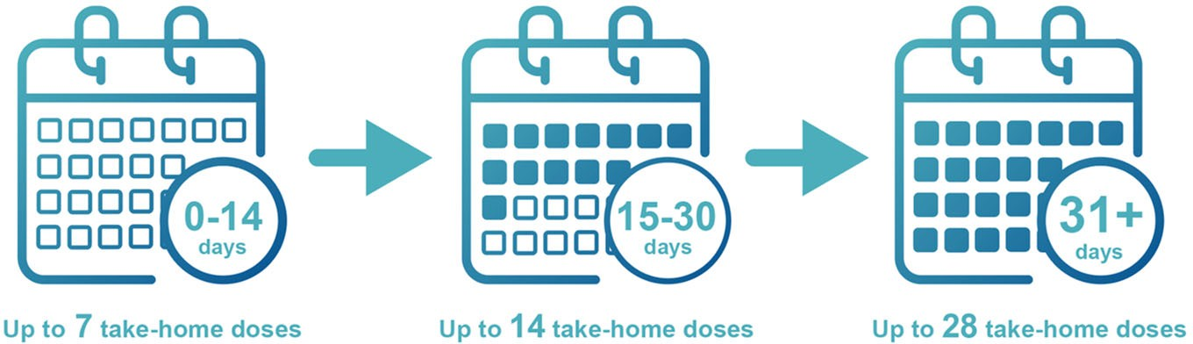

Take‐Home Medication

and Time in Treatment

**22**

Besides the revised criteria moving toward more of an in individual risk / benefit analysis, time in treatment requirements have also changed. The changes allow for patients to receive methadone take homes earlier in treatment and a higher number of take-homes.

This more “patient-centered” approaches that consider patient preferences, needs, and values and allows take-home decisions to be individualized.

In order to align with the new take home regulations, the Department waived specific regulations including:

* Requirement for licensed or approved providers to dispense opioid agonist treatment medications daily under direct supervision at the facility. This aligns with the new federal OTP regulations on take-home medications.
* The requirement prohibiting licensed or approved providers from providing take-home medication for withdrawal management. This adjustment aligns with the new federal OTP regulations on take-home medications.
* The requirement for the medical director to solely reduce the number of times patients must present themselves for observed medication ingestion by providing take-home doses.



Take‐Home Medication

**Eligibility assessments must be completed regularly, at minimum:**

1. Upon admission
2. Monthly following admission dependent on each patient’s schedule and need

**Documentation must include:**

* 1. Why the patient is deemed ineligible (if need be)
  2. Why the patient’s number of take‐home doses has increased or decreased
  3. The individualized education, guidance, and support provided to the patient to be eligible for initial or increases in take‐homes
  4. Evidence that the patient was educated on the safekeeping of take‐home medication

**23**

In order to ensure that each patient is assessed for the amount of take-homes that they’re eligible for, it is the Department’s expectation that OTPs assess each patient's eligibility for take-home medication upon admission and monthly during

treatment. The spirit and the intention of this requirement is to ensure that the OTP is assessing for the eligibility but not mandate that the patient attend the assessment session. The BSAS guidance discusses this minimally and this training is now outlining the spirit and explanation.

The cadence of the meeting schedule for the assessment should be discussed with the patient and the patient should be offered a meeting schedule and cadence that works for their specific situation.

For example, if a patient receives 14 take-homes and it’s documented in the patient record that they want to stay on this amount for three months, that patient should not be required to come in monthly for the assessment because the record clearly states that this is a mutual decision.

The rationale for providing take-home doses should be documented in the patient's clinical record.



Take‐Home Medication

OTPs are expected to:

* Create opportunities for touchpoints with patients
* Support discussions on treatment progress
* Educate patients on what is needed to advance in their care
* Revise take‐home policies
* Educate the patient on safekeeping of take‐home medication

**24**

The spirit of this guidance is to ensure that each patient is being assessed for take- home eligibility based on the new regulations at admission and monthly thereafter.

The expectation is to create opportunities for patients regardless of where they are in their course of treatment to have a touch-point to engage with OTP staff to discuss their treatment progress and to learn what is needed to advance in take-homes.

SAMHSA is setting the foundational expectations that BSAS is building off to ensure that there is individualized care.

If the patient does not receive take homes or does not meet eligibility status, the patient record should clearly indicate the reason, and there should be evidence that the patient understands the reason, including how to work toward getting take- homes or more take-homes, and when they can meet with the team again.

Programs should be taking the time now to revise their take-home policies and incorporate all of these changes and requirements.



Pregnant People

* Prioritize admission
* Pregnancy should be confirmed
* Evidence‐based treatment protocols for pregnant patients, such as split dosing regimens, may be instituted
* Prenatal and other sex‐specific services, including reproductive health services for pregnant and postpartum patients, must be provided (directly or through a referral)

**25**

OTPs must maintain current policies and procedures that reflect the special needs and priority for treatment admission of patients with opioid use disorder who are pregnant after assessment by an OTP practitioner and documentation that confirms the clinical appropriateness of such an evidence-based treatment protocols.



Consent to Treat Policies

Program policies must ensure:

* **Patients** are informed of their consent options and relevant facts concerning the use of MOUD
* **Program staff** clearly record when consent is given either verbally or electronically

**26**

In addition, a health care practitioner shall ensure that each patient voluntarily chooses treatment with MOUD and that all relevant facts concerning the use of MOUD are clearly and adequately explained to the patient, and that each patient provides informed consent to treatment.

Whenever possible, written consent should be gathered. When not possible and if it presents a barrier to access, verbal consent is acceptable. Evidence of verbal consent must documented in the patient record. Programs must include verbal/electronic consent to treatment in policies and protocols.



Interim Treatment

**Interim treatment:** *Interim treatment* means that on a temporary basis, a patient may receive some services from an OTP, while awaiting access to more comprehensive treatment services. The duration of interim treatment is limited to 180 days.

* Maximum time for interim treatment increased from **120 days** to **180 days and allows for‐profit OTPs to utilize interim maintenance**

**27**

The final rule extends the potential duration of interim treatment from 120 days to 180 days. It also clarifies the circumstances in which interim treatment may apply and maintains priority access to comprehensive services for pregnant individuals.

The rule finalizes removal of the requirement for observation of all daily doses during interim treatment. It also finalizes the expectation that crisis services and information pertaining to locally available, community-based resources for ancillary services be made available to individual patients in interim treatment. A requirement of a plan for continuing treatment beyond 180 days of interim services is also a requirement.

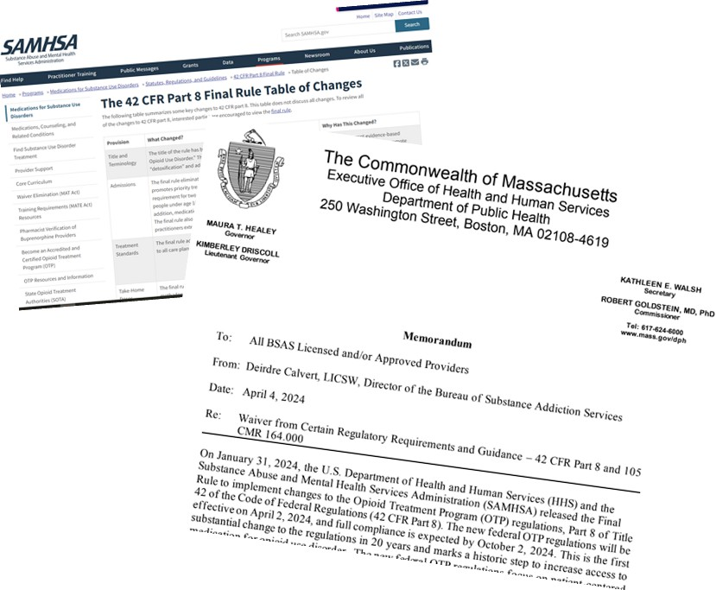

Resources

[42 CFR Part 8 Regulations](https://www.samhsa.gov/medications-substance-use-disorders/statutes-regulations-guidelines/42-cfr-part-8)

* [Table of Changes](https://www.samhsa.gov/medications-substance-use-disorders/statutes-regulations-guidelines/42-cfr-part-8/final-rule-table-changes)
* [FAQs](https://www.samhsa.gov/medications-substance-use-disorders/statutes-regulations-guidelines/42-cfr-part-8/faqs)

[DPH BSAS Regulations](https://drive.google.com/file/d/1DB9f5lDXuOfVDqBC9ve9Ppaw3V8w-L86/view?usp=sharing) [Provider and Patient Letters](https://www.mass.gov/info-details/information-for-licensed-substance-use-disorder-treatment-programs)

**28**

[42 CFR Part 8 Regulations](https://www.samhsa.gov/medications-substance-use-disorders/statutes-regulations-guidelines/42-cfr-part-8)

* [Table of Changes](https://www.samhsa.gov/medications-substance-use-disorders/statutes-regulations-guidelines/42-cfr-part-8/final-rule-table-changes)
* [FAQs](https://www.samhsa.gov/medications-substance-use-disorders/statutes-regulations-guidelines/42-cfr-part-8/faqs)

[DPH BSAS Regulations](https://drive.google.com/file/d/1DB9f5lDXuOfVDqBC9ve9Ppaw3V8w-L86/view?usp=sharing) [Provider and Patient Letters](https://www.mass.gov/info-details/information-for-licensed-substance-use-disorder-treatment-programs)



Thank you!

**Questions? Ideas?**

Email us at otptta‐[ma@jsi.com](mailto:ma@jsi.com)

Subscribe to our listserv for updates!

**29**

**FREQUENTLY ASKED QUESTIONS**

# 42 CFR Part 8 Regulatory Webinars | June 2024

|  |  |
| --- | --- |
| **QUESTIONS AND ANSWERS** | |
| **Intake Assessment and Examination** | |
| 1. Can the initial screening be done by a non-opioid treatment program (OTP) provider? | Yes, the screening can be conducted by a non-OTP provider. If the licensed practitioner is not an OTP practitioner, the screening examination must be completed no more than seven days before OTP admission.  Please refer to the [Revised Waiver from Certain](http://www.mass.gov/doc/dph-bsas-revised-waiver-from-certain-regulatory-requirements-and-guidance-42-cfr-part-8-and-105-cmr-164000/download)  [Regulatory Requirements and Guidance – 42 CFR Part 8](http://www.mass.gov/doc/dph-bsas-revised-waiver-from-certain-regulatory-requirements-and-guidance-42-cfr-part-8-and-105-cmr-164000/download)., [105 CMR 164.000](http://www.mass.gov/doc/105-cmr-164-licensure-of-substance-use-disorder-treatment-programs/download), and [42 CFR Part 8 Final Rule](https://www.samhsa.gov/medications-substance-use-disorders/statutes-regulations-guidelines/42-cfr-part-8). |
| 2. Can the physical be done by a non-OTP provider? | The full examination can be completed by a non-OTP practitioner if the exam is verified by a licensed OTP practitioner as being true and accurate and transmitted in accordance with applicable privacy laws.  Please refer to the [Revised Waiver from Certain](http://www.mass.gov/doc/dph-bsas-revised-waiver-from-certain-regulatory-requirements-and-guidance-42-cfr-part-8-and-105-cmr-164000/download)  [Regulatory Requirements and Guidance – 42 CFR Part 8](http://www.mass.gov/doc/dph-bsas-revised-waiver-from-certain-regulatory-requirements-and-guidance-42-cfr-part-8-and-105-cmr-164000/download)., [105 CMR 164.000](http://www.mass.gov/doc/105-cmr-164-licensure-of-substance-use-disorder-treatment-programs/download), and [42 CFR Part 8 Final Rule](http://www.samhsa.gov/medications-substance-use-disorders/statutes-regulations-guidelines/42-cfr-part-8). |
| 3. If a patient comes directly from an emergency department  or medically-supervised withdrawal program, can an examination taken  by practitioner cover the requirement for an initial physical examination and assessment if the OTP physician deems it sufficient? | The full examination can be completed by a non-OTP practitioner if the exam is verified by a licensed OTP practitioner as being true and accurate and transmitted in accordance with applicable privacy laws.  Please refer to the [Revised Waiver from Certain](http://www.mass.gov/doc/dph-bsas-revised-waiver-from-certain-regulatory-requirements-and-guidance-42-cfr-part-8-and-105-cmr-164000/download)  [Regulatory Requirements and Guidance – 42 CFR Part 8](http://www.mass.gov/doc/dph-bsas-revised-waiver-from-certain-regulatory-requirements-and-guidance-42-cfr-part-8-and-105-cmr-164000/download)., [105 CMR 164.000](http://www.mass.gov/doc/105-cmr-164-licensure-of-substance-use-disorder-treatment-programs/download), and [42 CFR Part 8 Final Rule](http://www.samhsa.gov/medications-substance-use-disorders/statutes-regulations-guidelines/42-cfr-part-8). |

|  |  |
| --- | --- |
| 4. Can the initial screening be done via telehealth? | Yes, the initial screening can be done via telehealth for all forms of medication for opioid use disorder (MOUD) if the practitioner or primary care provider (PCP) determines that an adequate evaluation of the patient can be accomplished via telehealth. The use of audio-visual telehealth may only be used for the screening exam to treat with methadone.  Please refer to the [Revised Waiver from Certain](http://www.mass.gov/doc/dph-bsas-revised-waiver-from-certain-regulatory-requirements-and-guidance-42-cfr-part-8-and-105-cmr-164000/download)  [Regulatory Requirements and Guidance – 42 CFR Part 8](http://www.mass.gov/doc/dph-bsas-revised-waiver-from-certain-regulatory-requirements-and-guidance-42-cfr-part-8-and-105-cmr-164000/download)., [105 CMR 164.000](http://www.mass.gov/doc/105-cmr-164-licensure-of-substance-use-disorder-treatment-programs/download), and [42 CFR Part 8 Final Rule](http://www.samhsa.gov/medications-substance-use-disorders/statutes-regulations-guidelines/42-cfr-part-8).  The Substance Abuse and Mental Health Services Administration (SAMHSA) has indicated that further guidance will be issued regarding telehealth. |
| 5. Can the full medical exam for intake be done via audio-video telehealth? | Federal and state OTP regulations allow for the initial screening to be completed via telehealth for  patients admitted for treatment at the OTP with either buprenorphine or methadone if the practitioner or PCP determines that an adequate evaluation of the patient can be accomplished via telehealth.  The full physical exam must be performed in person to treat a patient with methadone. To treat with buprenorphine, the screening and full exam may be conducted using audio-visual or audio-only platforms.  SAMHSA has indicated that further guidance will be issued regarding telehealth. |
| 6. For the medical history and physical exam, are there any specific topics that must be completed if the exam is completed outside the OTP? | All of the intake requirements per the regulations must be completed regardless of who conducts the intake. Where the examination is performed outside of the OTP, the written results and narrative of the examination, as well as available lab testing results, must be transmitted,  consistent with applicable privacy laws, to the OTP, verified by an OTP practitioner, and documented in the patient record. |

|  |  |
| --- | --- |
| 7. What is the suggested process when a patient refuses or is  a repeated “no-show” for the physical exam or behavioral health assessment? | It is the expectation that the program has policies and procedures in place to determine if a patient meets the criteria for admission.  If the program is unable to determine whether the patient meets the criteria for admission to the OTP, the patient should not be admitted to the OTP.  Best practice would include educating the patient on  the risks and benefits of not participating in an OTP. Additionally, education about other MOUD services such as office-based addiction treatment (OBAT) and office- based opioid treatment (OBOT) should be provided. Harm reduction and other referrals should be provided. |
| 8. Can you provide a checklist for the behavioral health assessment and physical exam? | Please refer to [TIP 63](https://store.samhsa.gov/product/tip-63-medications-opioid-use-disorder/pep21-02-01-002) and the [Federal Guidelines for](https://store.samhsa.gov/sites/default/files/guidelines-opioid-treatment-pep15-fedguideotp.pdf)  [Opioid Treatment Programs](https://store.samhsa.gov/sites/default/files/guidelines-opioid-treatment-pep15-fedguideotp.pdf).  See also 105 CMR 164.072 & 164.305 (D) within [105 CMR](http://www.mass.gov/doc/105-cmr-164-licensure-of-substance-use-disorder-treatment-programs/download)  [164.000 Licensure of Substance Use Disorder Treatment](http://www.mass.gov/doc/105-cmr-164-licensure-of-substance-use-disorder-treatment-programs/download)  [Programs](http://www.mass.gov/doc/105-cmr-164-licensure-of-substance-use-disorder-treatment-programs/download). |
| 9. Can mid-level practitioners prescribe the initial dose upon admission? | The new federal OTP regulations permit practitioners in addition to physicians to initiate and make dosing decisions in OTPs.  It is the expectation of the Department of Public Health Bureau of Substance Addiction Services (DPH BSAS) that the medical director is responsible for overall medical oversight of the OTP, however, a program practitioner or physician may ensure that all dosing of an opioid agonist  treatment medication is ordered in accordance with federal requirements. |
| 10. Are we meant to perform an in-person physical exam in addition to the assessment if the medical provider feels and  documents that the assessment  was sufficient? | All of the intake requirements per the regulations must be completed regardless of who conducts the intake. |

|  |  |
| --- | --- |
| 11. Are OTPs required to meet monthly with patients to assess their take-home eligibility? | In order to ensure that each patient is assessed for the amount of take-homes for which they are eligible, it is the Department’s expectation that OTPs assess each patient’s eligibility for take-home medication upon admission and monthly during treatment. The spirit and the intention of this requirement is to ensure that the OTP is assessing  for eligibility but not mandate that the patient attend the assessment session. The cadence of the meeting schedule for the assessment should be discussed with the patient and the patient should be offered a meeting schedule and cadence that works for their specific situation.  **Case Example** - If a patient receives 14 take-homes and it’s documented in the patient record that they want to stay on this amount for three months, that patient should not be required to come in monthly for the assessment because the record clearly states that that’s the mutual decision.  The expectation is to create opportunities for patients regardless of where they are in their course of treatment to have a touchpoint to engage with OTP staff to discuss their treatment progress and to learn what is needed to advance in take-homes. If the patient does not receive take-homes or does not meet eligibility status, the patient record should indicate the reason.  Take-home policies should include processes to ensure these eligibility assessments occur. |
| 12. With respect to the duration of OTP orders, our current system requires us to re-enter orders every 90 days. Is that a requirement? For example,  we have a patient in long-term remission on methadone x 10 years who has 27 take-homes monthly. Does their order need to be re-entered every 90 days or can it be re-entered annually if no changes occur? | There are no state or federal OTP regulations regarding  this specific question. |

|  |  |
| --- | --- |
| **Annual Physical Exams** | |
| 13. For the annual physical exam, can those be done via audio- visual telehealth? | The full physical exam must be performed in person to treat a patient with methadone.  To treat with buprenorphine, the screening and full exam may be conducted using audio-visual or audio-only platforms.  Please refer to the [Revised Waiver from Certain](https://www.mass.gov/doc/dph-bsas-revised-waiver-from-certain-regulatory-requirements-and-guidance-42-cfr-part-8-and-105-cmr-164000/download)  [Regulatory Requirements and Guidance – 42 CFR Part 8.](https://www.mass.gov/doc/dph-bsas-revised-waiver-from-certain-regulatory-requirements-and-guidance-42-cfr-part-8-and-105-cmr-164000/download), [105 CMR 164.000](https://www.mass.gov/doc/105-cmr-164-licensure-of-substance-use-disorder-treatment-programs/download), and [42 CFR Part 8 Final Rule](https://www.samhsa.gov/medications-substance-use-disorders/statutes-regulations-guidelines/42-cfr-part-8). |
| 14. Can the annual physical exam be conducted by a non-OTP provider? For instance, by their PCP? | No, the annual physical exam must be completed by an OTP practitioner.  Please refer to the [Revised Waiver from Certain](https://www.mass.gov/doc/dph-bsas-revised-waiver-from-certain-regulatory-requirements-and-guidance-42-cfr-part-8-and-105-cmr-164000/download)  [Regulatory Requirements and Guidance – 42 CFR Part 8](https://www.mass.gov/doc/dph-bsas-revised-waiver-from-certain-regulatory-requirements-and-guidance-42-cfr-part-8-and-105-cmr-164000/download)., [105 CMR 164.000](https://www.mass.gov/doc/105-cmr-164-licensure-of-substance-use-disorder-treatment-programs/download), and [42 CFR Part 8 Final Rule](https://www.samhsa.gov/medications-substance-use-disorders/statutes-regulations-guidelines/42-cfr-part-8). |
| **Other Comments and Questions** | |
| 15. **Comment:** Update the patient- facing letter to reflect the change to a care plan instead of a treatment plan. | The DPH BSAS will consider this change. Another letter may be issued in the future incorporating additional updates. |
| 16. **Comment:** I would recommend eliminating the language referring to pregnant people  as women. It is more inclusive to use language like “pregnant people” or “birthing people” to make sure that all genders are represented. Thank you for considering this. | In future training offerings and resources, the Opioid Treatment Program Training and Technical Assistance (OTP TTA) Center and DPH BSAS will incorporate this language. |

|  |  |
| --- | --- |
| 17. **Request for a resource:** Outline the differences with the Final Rule, providing examples of what exceptions are needed for take-homes for those who normally do not receive take- homes. | Exception Requests are required when an OTP treatment team proposes a deviation from limitations or protocols established by regulation [42 CFR Part 8](https://www.samhsa.gov/medications-substance-use-disorders/statutes-regulations-guidelines/42-cfr-part-8) and [105 CMR](https://www.mass.gov/doc/105-cmr-164-licensure-of-substance-use-disorder-treatment-programs/download)  [164.300](https://www.mass.gov/doc/105-cmr-164-licensure-of-substance-use-disorder-treatment-programs/download). OTPs should be revising their take-home policies based on the waiver and guidance. |
| 18. **Question**: If we have a community-based medication unit that has been Drug Enforcement Administration (DEA) approved to hold medication at the community- based site, do we need a nurse to go to the site to dispense  or can another staff member dispense? | See [DEA Regulation Chapter 21 Title II 1301.74(i)](https://www.ecfr.gov/current/title-21/chapter-II/part-1301/subject-group-ECFRa7ff8142033a7a2/section-1301.74#p-1301.74(i)):  Narcotics dispensed or administered at a narcotic treatment program will be dispensed or administered directly to the patient by either   1. the licensed practitioner, 2. a registered nurse under the direction of the licensed practitioner, 3. a licensed practical nurse under the direction of the licensed practitioner, or 4. a pharmacist under the direction of the licensed practitioner.   Per the Final Rule, OTPs must ensure that MOUD are administered or dispensed only by a practitioner licensed under the appropriate state law and registered under  the appropriate state and federal laws to administer or dispense MOUD, or by an agent of such a practitioner, supervised by and under the order of the licensed practitioner and if consistent with federal and state law. |

**ACRONYM LIST**

**OTP** - Opioid Treatment Program

**MOUD** - Medications for opioid use disorder

**SAMHSA** - Substance Abuse and Mental Health Services Administration

**MASAM** - Massachusetts Society of Addiction Medicine

**SUD** - Substance use disorder

**BSAS** - Bureau of Substance Addiction Services

**TTA** - Training and Technical Assistance

**EVALUATION LINKS**

**Your feedback will:**

* Inform future session topics and discussion
* Be used to develop new trainings and technical assistance resources
* Refine our delivery of information to best suit your needs

Click [HERE](https://survey.alchemer.com/s3/7879338/OTP-TTA-Post-Webinar-Attendee-Evaluation) or scan the QR code to complete the Evaluation Survey!

**TRAINING AND TECHNICAL ASSISTANCE RESOURCES**

[42 CFR Part 8 Regulations](https://www.samhsa.gov/medications-substance-use-disorders/statutes-regulations-guidelines/42-cfr-part-8)

* [Table of Changes](https://www.samhsa.gov/medications-substance-use-disorders/statutes-regulations-guidelines/42-cfr-part-8/final-rule-table-changes)
* [FAQs](https://www.samhsa.gov/medications-substance-use-disorders/statutes-regulations-guidelines/42-cfr-part-8/faqs)

[DPH BSAS Regulations](https://drive.google.com/file/d/1DB9f5lDXuOfVDqBC9ve9Ppaw3V8w-L86/view?usp=sharing) [Provider and Patient Letters](https://www.mass.gov/info-details/information-for-licensed-substance-use-disorder-treatment-programs#opioid-treatment-information-)

**UPCOMING EVENTS**

**MASAM’s SUD Pearls for Practice -** [**Click here to register!**](https://www.masam.org/events.html)

September 13th and September 14th

**Need More?**

Stay in touch! [Sign up](https://list-manage.us14.list-manage.com/subscribe?u=6a8848fef60f32f33a84d334e&id=aa75620736) for our listserv to receive up-to-date information about new resources and upcoming learning opportunities.

**Thank you for your participation!**

**About the MA Opioid Treatment Program Training & Technical Assistance Center (MA OTP TTA Center):**

The Bureau of Substance Addiction Services (BSAS) has contracted with JSI Research & Training Institute, Inc., to start a new training and technical assistance center specifically for opioid treatment programs (OTPs). Now is a critically important time for OTPs and we are excited to support OTPs through implementing the new regulatory changes and other promising practices that will help increase access to medications for opioid use disorder.