INDOOR AIR QUALITY ASSESSMENT

Ottoson Middle School
63 Acton St
Arlington, MA

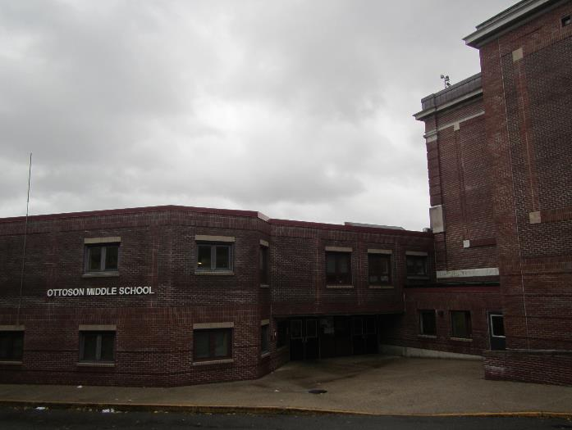

Prepared by:
Massachusetts Department of Public Health
Bureau of Environmental Health
Indoor Air Quality Program
January 2019

Background

Building: | Ottoson Middle School
Address: | 63 Acton St, Arlington MA
Assessment Coordinated Through: | Natasha Waden, Director of Public Health
Reason for Request: | General indoor air quality (IAQ) concerns
Date of Assessment: | November 2, 2018
Massachusetts Department of Public Health/Bureau of Environmental Health (MDPH/BEH) Staff Conducting Assessment: | Sharon Lee, Environmental Analyst,  IAQ Program
Date of Building Construction: | 1921
Building Description: | Brick and concrete construction with a complex shape
Building Population: | Approximately 1260 students in grades 6 to 8 with a staff of approximately 110
Windows: | Openable

IAQ Testing Results
Please refer to the IAQ Manual for methods, sampling procedures, and interpretation of results (MDPH, 2015). The following is a summary of indoor air testing results (Table 1).
- Carbon dioxide levels were above 800 parts per million (ppm) in about three quarters of the locations assessed, indicating that additional air exchange is warranted.
- Temperature was within or slightly below the recommended range of 70°F to 78°F on the day of assessment. Staff reported excessive heat/lack of temperature control.
- Relative humidity was above the recommended range of 40 to 60% in the majority of areas assessed.
- Carbon monoxide levels were non-detectable in all indoor areas tested.
- Fine particulate matter (PM2.5) concentrations measured were below the NAAQS limit of 35 μg/m³ in all areas but one area examined. Room 230, which is used for consumer sciences, had a PM2.5 measurement of 48 μg/m³ due to a cooking stove.

Ventilation
A heating, ventilating, and air conditioning (HVAC) system has several functions. First, it provides heating and, if equipped, cooling. Second, it is a source of fresh air. Finally, an HVAC system will dilute and remove normally occurring indoor environmental pollutants by not only introducing fresh air but also filtering the airstream and ejecting stale air to the outdoors via exhaust ventilation. Even if an HVAC system is operating as designed, point sources of respiratory irritation may exist and cause symptoms in sensitive individuals.
Fresh air in individual classrooms is provided by unit ventilators (univents; Picture 1). Univents draw fresh air through a vent on the exterior wall (Picture 2). Air is mixed with return air from the room, filtered, heated (if needed), and delivered back to the room (Figure 1). Many univents were not operating at the time of the assessment, preventing the circulation of fresh air into the building. In addition, many univents were obstructed by items placed on top or blocking the front of the units (Pictures 1 and 3). In some instances, pencil and paper debris was observed in the supply diffusers of univents (Picture 4). Some of this debris was also observed inside a univent cabinet (Picture 5). When univents are operating, these materials can be aerosolized and cause irritation. Both the top and the return vent at the bottom need to be kept clear of obstructions for the units to operate as designed.
Univent filters are reported to be changed twice a year. In examining the filters, MDPH/IAQ staff determined the filters to be a type that provides minimal filtration (Picture 6). Pleated filters with a minimum efficiency reporting value (MERV) of 8 are recommended because they can adequately filter out pollen and mold spores (ASHRAE, 2012). Note, however, that an increase in filtration can cause stress on equipment. The univents should be evaluated to determine if the higher-rated filters will allow adequate function. In a few areas, the louver cover at the bottom of the univent was missing (Picture 7). Additionally, all univent filters, covers, and louvers should be installed and present to ensure air is drawn through the filters, rather than by-passing the filter.
Exhaust vents in classrooms are located on walls or ceilings (Picture 8). Air is removed from classrooms via rooftop exhaust fans. In many instances, wall exhaust vents were blocked by furniture and boxes or sealed with paper, preventing removal of air (Pictures 9 and 10). Some exhaust vents were not drawing air at the time of assessment, which indicates that a rooftop fan is not operating (Picture 11). In some instances, exhaust vents could not be identified in classrooms (Table 1).
Rooftop air-handling units (AHUs) provide fresh air to central areas such as the gym, cafeteria, and office areas (Picture 11). Air from the AHUs is filtered, heated, and delivered to rooms via ducted supply vents (Picture 12). Air is returned to AHUs via ceiling- or wall-mounted return vents (Picture 13). In many areas, fresh air supply could not be detected, and thermostats indicated the system was off. Some supply vents appeared dusty at the time of the assessment. Additionally, a few return diffusers lacked louvered covers, which can present a hazard.
An examination of rooftop HVAC equipment indicated that some exhaust fans were not operating at the time of the assessment. If exhaust fans are not operating as designed, backdrafting can occur, allowing ductwork to channel moisture, odors, and debris into a room. In some cases, sealant around ductwork was damaged (Picture 14), which can allow moisture or pests to enter the building and cause equipment damage. Additionally, miscellaneous items were stored in openings under HVAC equipment. These items, which can attract birds and pests, should be removed or discarded. Filters for the rooftop AHUs should also be changed a minimum of two times a year.
Some areas, such as the wood shop and kiln room, have dedicated exhaust equipment. These exhaust systems remove pollutants created by specific activities; vents may be directly ducted to source pollutant or in proximity from the source. Please note, consumer sciences room 230 lacked dedicated mechanical exhaust. As a result, cooking-generated pollutants tend to accumulate, resulting in elevated PM2.5 readings (Table 1).
Window-mounted air-conditioning units were observed in a few areas (Table 1). These units have filters that should be cleaned regularly. Additionally, these units can be used as a fan to provide filtered air during warmer days to increase air movement.
Some areas lacked mechanical supply ventilation, relying on openable windows as the sole source of fresh air. Use of cross-ventilation can aid in air movement in these areas and throughout the school (Figures 2 and 3).
In order to have proper ventilation with a mechanical supply and exhaust system, these systems must be balanced to provide an adequate amount of fresh air while removing stale air from a room. It is recommended that existing ventilation systems be re-balanced every five years to ensure adequate air systems function (SMACNA, 1994). It is unknown the last time these systems were balanced.

Microbial/Moisture Concerns
Both historic and active leaks were reported throughout the building. Water-damaged, ajar, missing, and bowing ceiling tiles were observed in many classrooms and hallways (Picture 15; Table 1). These conditions indicate leaks from the building envelope or plumbing system. Tiles should be replaced after a leak is found and repaired.
Water damage was also observed on ceilings and walls (Picture 16). At the time of the assessment, pooling water and bubbling membrane was observed on the roof, particularly near the building edges and skylights, as well as the membrane lifting away from the roof (Pictures 17 and 18). Pooling water is an indication of poor drainage due to pitch and/or location of roof drains. Bubbles on the roof indicate water is seeping below the membrane. Repairs to the roof membrane, decking and edges is required to prevent continued water infiltration and damage to ceilings. Please note, some roof drains were missing covers (Picture 19). An appropriate cover is important to prevent debris from clogging drain pipes.
The building has a complex shape, with some classrooms built below grade due to the elevation of the ground. As a result, some classrooms reportedly experience mold growth associated with increased indoor humidity, particularly during the summer months. Arlington Health Department staff reported that items were cleaned or removed following mold growth concerns. Dehumidifiers were also provided to some areas experiencing excess humidity and related mold growth. Dehumidifiers should be operated as much as practicable during times of high humidity. Dehumidifiers should be emptied regularly, and the water collection containers should be cleaned to prevent odors. When mold growth occurs, cleanup activities should be consistent with those recommended in the US Environmental Protection Agency’s Mold Remediation for Schools and Commercial Buildings guidance document (US EPA, 2008).
Plants were observed in a few areas, including on top of univents (Picture 1; Table 1). Plants can be a source of pollen and mold, which can be respiratory irritants to some individuals. Plants should be properly maintained and equipped with drip pans and should be located away from air diffusers to prevent the aerosolization of dirt, pollen, and mold.
Breaches were observed between the counter and sink backsplashes in some classrooms (Picture 20; Table 1). If not watertight, water can penetrate through these seams. Water damage was also observed in sink cabinets. Water penetration and chronic exposure of porous and wood-based materials can cause these materials to swell and show signs of water damage, which can subsequently lead to mold growth.
A number of breaches and gaps were observed around the building exterior.
- Light could be seen penetrating around the exterior door in the Custodial office (Picture 21). These gaps should be sealed to prevent water or pest entry to the building.
- Damaged mortar was present in exterior brick work (Picture 22).
- Sealant was missing in the expansion joint between two brick wall sections (Picture 23).
- Gaps in the roof to the loading dock were noted, due to repeated damage from oversized trucks backing into it (Picture 24).
Measures should be taken to seal these breaches to prevent water penetration and/or pest entry. In addition, consider installing sensors and reflective materials to alert truck drivers to low height of loading dock roof.
Plants were growing in close proximity of the building (Picture 25), and vines were also growing on the building exterior (Picture 26). Over time, plant roots can cause fissures in the mortar, causing damage and allowing water to enter the building.

Other IAQ Evaluations
Exposure to low levels of total VOCs (TVOCs) may produce eye, nose, throat, and/or respiratory irritation in some sensitive individuals. To determine if VOCs were present, BEH/IAQ staff examined rooms for products containing VOCs. BEH/IAQ staff noted hand sanitizers, cleaning products, air fresheners, and dry erase materials in use within the building (Pictures 27 through 29; Table 1). All of these products have the potential to be irritants to the eyes, nose, throat, and respiratory system of sensitive individuals. Note that an essential oil diffuser was observed in one area (Picture 29). These units are designed release a mist infused with fragrant oil. Synthetic and natural fragrances can trigger irritation in more sensitive individuals. Furthermore, the water wells can be a source for bacterial growth if not cleaned regularly.
Photocopiers were observed in a few areas. Photocopiers can emit ozone and TVOCs, especially when they are older or heavily used. Exhaust ventilation can help reduce the accumulation of heat, odor, and pollutants.
Many classrooms had personal fans. Some of these had dusty blades (Picture 30; Table 1). Some supply and exhaust vents were also observed to be dusty (Picture 12, Table 1). This dust can be reaerosolized when the equipment is activated.
In many areas, items, including books, papers, toys and decorative items were observed on floors, windowsills, tabletops, counters, bookcases, and desks (Table 1), which can make it more difficult for custodial staff to clean. In a few classrooms, items were hanging from the ceiling, which can collect dust. Disruption of the ceiling tile system, including hanging items and missing tiles, can allow unconditioned air and debris from above the ceiling to enter occupied spaces.
Many classrooms have area rugs, which should also be cleaned regularly and discarded when too worn out or soiled to be cleaned. Plush and upholstered items such as couches, pillows, and toys were also observed. These items should be cleaned regularly to remove the build-up of oils and debris.
High efficiency particulate arrestance (HEPA)-filtered air purifiers were observed in some areas (Table 1). These appliances should be maintained in accordance with manufacturers’ instructions including filter changes. The units should also be moved off the ground and in the breathing zone of occupants.
Food appliances, including small refrigerators, coffee makers, and microwaves were observed in a few areas. These should be maintained and cleaned to prevent pests, odors, and mold.
In some classrooms, tennis balls had been sliced open and placed on table/chair footings to reduce noise (Picture 31; Table 1). Tennis balls are made of a number of materials that are a source of respiratory irritants. Constant wearing of tennis balls can produce fibers and lead to off-gassing of VOCs. Tennis balls are made with a natural rubber latex bladder, which becomes abraded when used as a chair leg pad. Use of tennis balls in this manner may introduce latex dust into the school environment. Some individuals are highly allergic to latex (e.g., spina bifida patients) (SBAA, 2001). It is recommended that the use of materials containing latex be limited in buildings to reduce the likelihood of symptoms in sensitive individuals (NIOSH, 1997; NIOSH, 1998).
Note that univent fresh air intakes in close proximity to parked cars in the parking lot (Picture 32). Exhaust from idling vehicles can be drawn in through the fresh air intakes, and the odors and pollutants can be distributed into the classrooms. Measures should be taken to reduce vehicle idling when they are parked near the fresh air intakes.
Damage to the brick stairwell around the exterior of the building was observed (Picture 33). In some areas, rebar is exposed. Repeated exposure to freezing and thawing of water can accelerate damage to the stairs. These conditions should be examined to prevent injury.
Note that EPA conducted a National School Radon Survey in which it discovered nearly one in five schools had “…at least one frequently occupied ground contact room with short-term radon levels above 4 [picocuries per liter] pCi/L” (US EPA, 1992). The BEH/IAQ Program therefore recommends that every school be tested for radon, and that this testing be conducted during the heating season while school is in session in a manner consistent with USEPA radon testing guidelines. Radon measurement specialists and other information can be found at www.nrsb.org and http://aarst-nrpp.com/wp, with additional information at: http://www.mass.gov/eohhs/gov/departments/dph/programs/environmental-health/exposure-topics/iaq/radon.

Conclusions/Recommendations
The following recommendations are made to assist in improving IAQ:
- Operate all supply and exhaust ventilation equipment continuously during occupied periods. Consider adjusting univent dampers to increase fresh air to the building.
- Use openable windows to supplement fresh air during temperate weather. During winter, consider opening windows slightly to increase air movement. Cross ventilation (e.g., opening windows and classroom doors on opposing sides of the building) can rapidly increase air circulation in a building. Ensure all windows are tightly closed at the end of the day.
- Investigate/adjust thermostats and controls to allow for unheated air to be circulated in classrooms when the temperature is at or above the set point.
- Remove items and furniture blocking univents and exhaust vents.
- Ensure univent tops and interiors are vacuumed during filter changes. Similarly, clean exhaust vents to prevent build up of dirt, dust, and debris.
- Consider upgrading to a pleated filter of MERV 8 in univents and AHUs, if these can be used with the current equipment. Continue to change filters 2-4 times a year.
- Repair all rooftop exhaust vent fans and ductwork, and ensure all exhaust vents have appropriate covers. Check exhaust vents for air draw periodically.
- Regularly clean/vacuum univent cabinets, supply/return vents and fans to avoid aerosolizing accumulated particulate matter. For areas with hard to reach vents, lights and ceiling tiles, consider coordinating use of a lift to address multiple issues at the same time.
- Ensure dedicated exhaust ventilation in areas such as the wood shop and kiln room is operating as designed.
- Consider installing dedicated exhaust ventilation (e.g., hood range ducted outside or exhaust fan in window) in the consumer science room to remove cooking odors and pollutants.
- Consider adopting a balancing schedule of every 5 years for all mechanical ventilation systems, as recommended by ventilation industrial standards (SMACNA, 1994).
- Ensure filters for window-mounted air conditioning units are cleaned regularly.
- Examine the roof and ensure the rubber membrane roof and roof drains are intact. Make repairs as needed to prevent leakages and poor drainage.
- Ensure roof and plumbing leaks are repaired and replace water-damaged ceiling tiles.
- Use dehumidifiers during periods of increased humidity, particularly in below grade areas. Install additional units as necessary. Ensure dehumidifiers are emptied regularly and water collection wells are disinfected periodically to prevent odors.
- Consider repointing the exterior brick and repairing other breaches identified to prevent water and pest infiltration.
- Remove shrubs and vines growing against the building.
- Repair water-damaged building materials in classrooms, hallways, and activity areas after repairs to the building exterior are made.
- Properly maintain indoor plants, including drip pans, to prevent water damage to porous materials. Plants should also be located away from air diffusers to prevent the aerosolization of dirt, pollen, and mold.
- Use caulking to seal gap between sink backsplash and countertop.
- Reduce use of products and equipment that create VOCs and ozone and only use in well-ventilated areas. Avoid the use of air freshening products including plug-ins and sprays.
- Ensure exhaust ventilation is operating in areas with photocopiers and laminators.
- Consider removing essential oil diffusers to prevent the dissemination of potential respiratory irritants in the air and addition of moisture into a classroom.
- Remove pencil sharpeners away from univents and air supply stream.
- Consider reducing the amount of items stored in classrooms to make cleaning easier. Periodically move items to clean flat surfaces.
- Avoid hanging items from the ceiling tile system. Ensure all tiles are flush with the ceiling tile grid.
- Clean upholstered and plush items regularly to remove oils, dust, and debris.
- Clean carpeting and area rugs regularly and discard those that are worn out or too soiled to be cleaned.
- When using HEPA-filtered air purifiers, place them in the breathing zone of occupants to improve equipment efficiency.
- Ensure all refrigerators are kept clean to prevent microbial growth and odors. Clean gaskets and other surfaces with a mild antimicrobial solution to remove debris and mold. Clean in and around food appliances regularly.
- Replace tennis balls on chair/table footings with latex-free glides.
- Avoid idling of vehicles parked near univent fresh air intakes. Post signs which discourage idling to eliminate migration of combustion products into building. M.G.L. c. 90:16A restricts idling of vehicles to no more than five minutes unless absolutely necessary (MGL, 1986).
- Ensure the integrity of the brick staircase around the exterior of the building.
- Continue to adopt the US EPA (2000) document, “Tools for Schools”, as an instrument for maintaining a good IAQ environment in the building available at: http://www.epa.gov/iaq/schools/index.html.
- The school should be tested for radon by a certified radon measurement specialist during the heating season when school is in session. Radon measurement specialists and other information can be found at: www.nrsb.org, and http://aarst-nrpp.com/wp/.
- Refer to resource manual and other related IAQ documents located on the MDPH’s website for further building-wide evaluations and advice on maintaining public buildings. These documents are available at: http://mass.gov/dph/iaq.

References
ASHRAE. 2012. American Society of Heating, Refrigeration and Air Conditioning Engineers (ASHRAE) Standard 52.2-2012 -- Method of Testing General Ventilation Air-Cleaning Devices for Removal Efficiency by Particle Size (ANSI Approved). 2012.
MDPH. 2015. Massachusetts Department of Public Health. “Indoor Air Quality Manual: Chapters I-III”. Available at: http://www.mass.gov/eohhs/gov/departments/dph/programs/environmental-health/exposure-topics/iaq/iaq-manual/.
MGL. 1986. Stopped motor vehicles; Operation of Engine; Time Limit; Penalty. Massachusetts General Laws. M.G.L. c. 90:16A.
NIOSH. 1997. National Institute for Occupational Safety and Health. Alert Preventing Allergic Reactions to Natural Rubber latex in the Workplace. National Institute for Occupational Safety and Health, Atlanta, GA.
NIOSH. 1998. National Institute for Occupational Safety and Health. Latex Allergy A Prevention. National Institute for Occupational Safety and Health, Atlanta, GA.
SBAA. 2001. Latex In the Home And Community Updated Spring 2001. Spina Bifida Association of America, Washington, DC.
SMACNA. 1994. HVAC Systems Commissioning Manual. 1st ed. Sheet Metal and Air Conditioning Contractors’ National Association, Inc., Chantilly, VA.
US EPA. 1992. Radon Measurement in Schools, Revised Edition. Office of Air and Radiation, Office of Radiation and Indoor Air, Indoor Environments Division (6609J). EPA 402-R-92-014. https://www.epa.gov/sites/production/files/2014-08/documents/radon_measurement_in_schools.pdf
US EPA. 2000. Tools for Schools. Office of Air and Radiation, Office of Radiation and Indoor Air, Indoor Environments Division (6609J). EPA 402-K-95-001, Second Edition. http://www.epa.gov/iaq/schools/index.html.
US EPA. 2008. Mold Remediation in Schools and Commercial Buildings. US Environmental Protection Agency, Office of Air and Radiation, Indoor Environments Division, Washington, D.C. EPA 402-K-01-001. http://www.epa.gov/mold/mold-remediation-schools-and-commercial-buildings-guide.
Picture
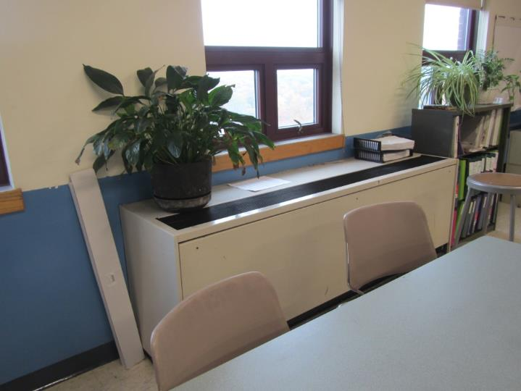
Classroom univent, note plant on unit
Picture
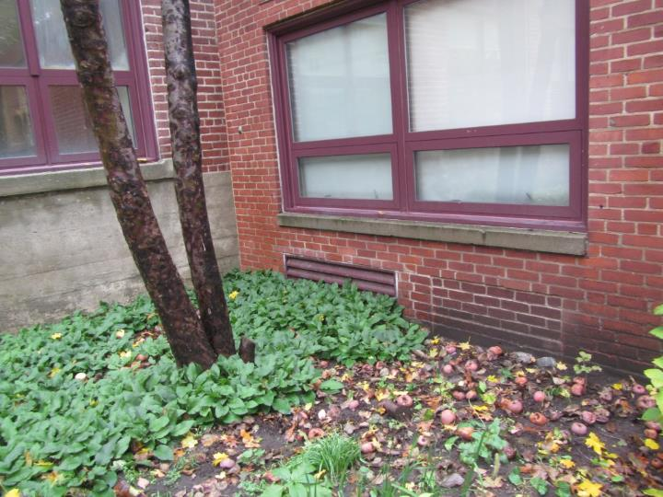
Univent fresh air intake, note plants
Picture
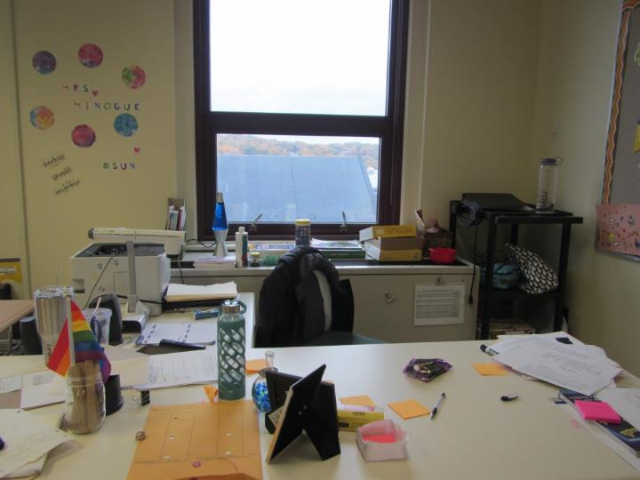
Items placed on top of univent
Picture
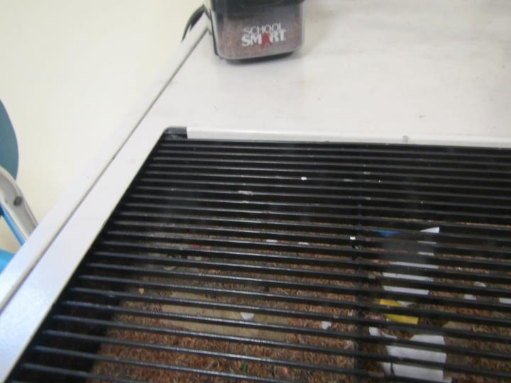
Pencil shavings and debris in univent
Picture
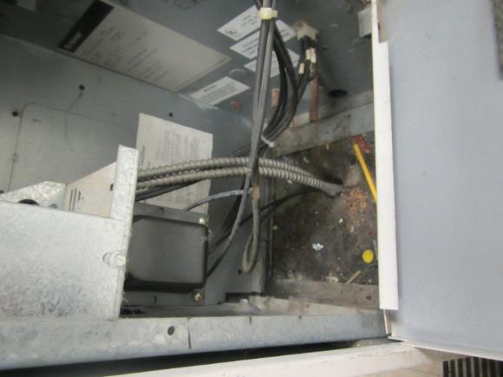
Pencil shavings and debris inside univent cabinet
Picture
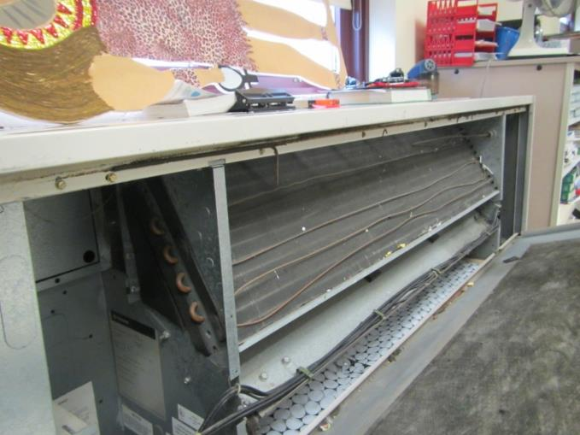
Univent filter
Picture
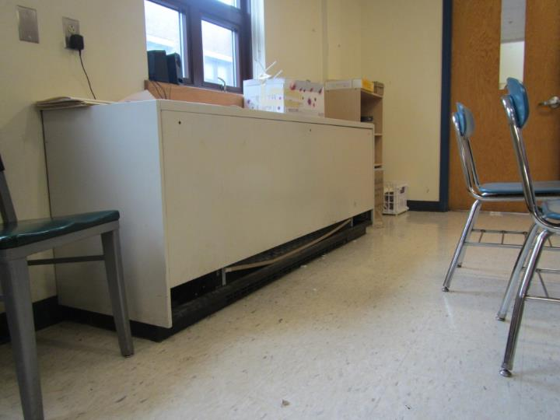
Univent with missing louver cover at bottom
Picture
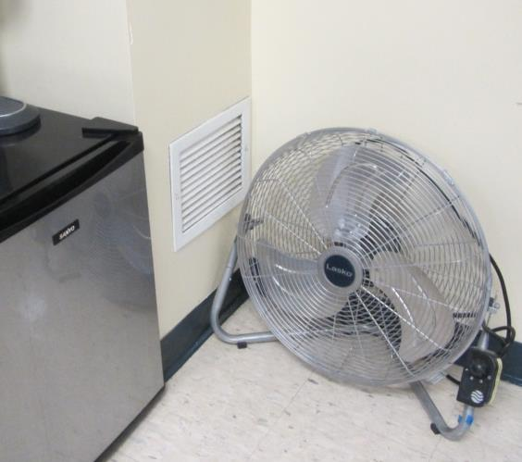
Wall-mounted return vent
Picture
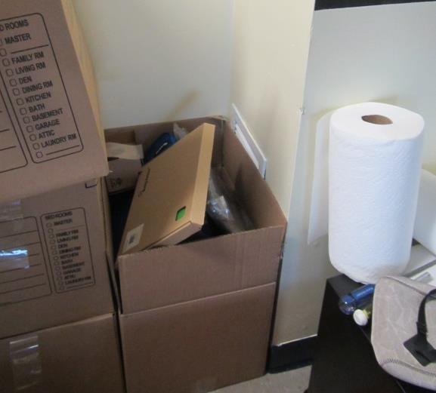
Blocked wall-mounted return vent (arrow)
Picture
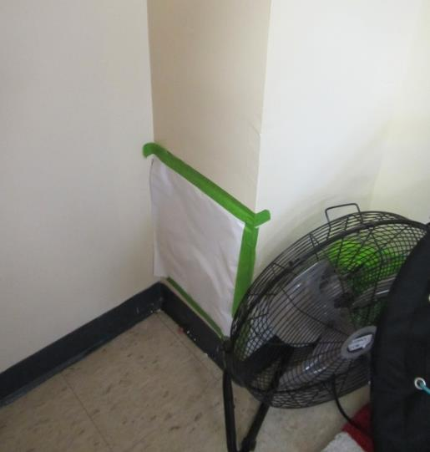
Sealed wall-mounted exhaust vent
Picture
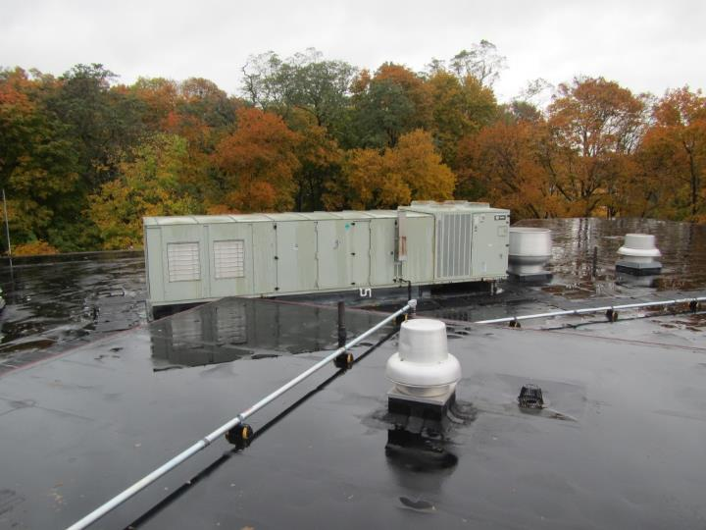
Rooftop air-handling unit and exhaust fan
Picture
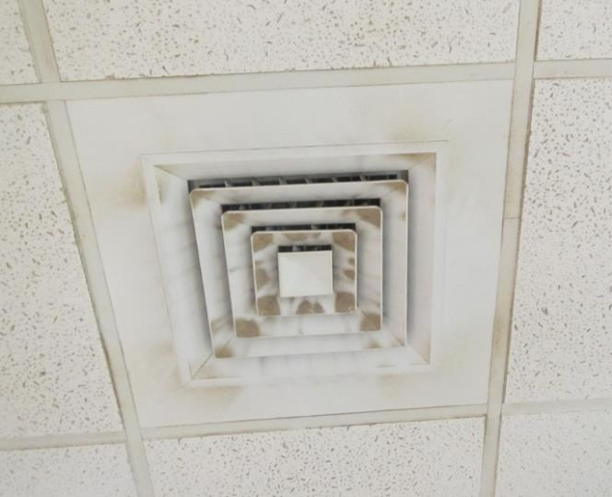
Ceiling-mounted supply vent, note dust accumulation
Picture
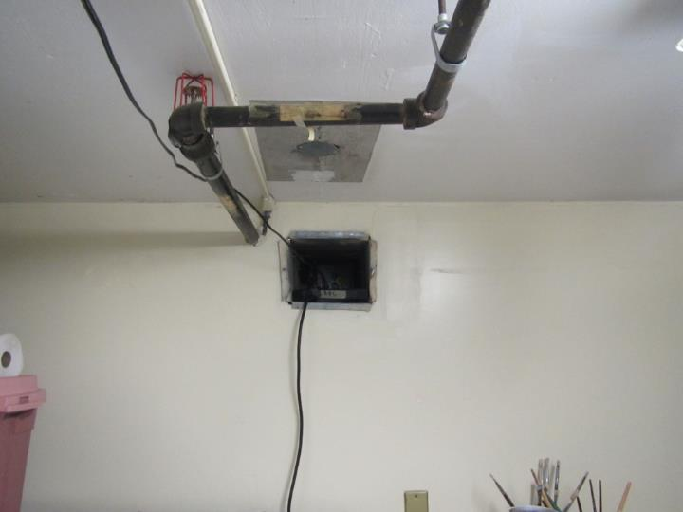
Wall-mounted return vent with missing cover
Picture
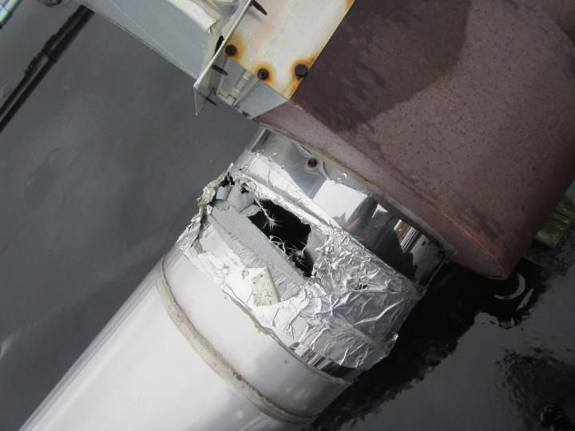
Damaged ductwork joint
Picture
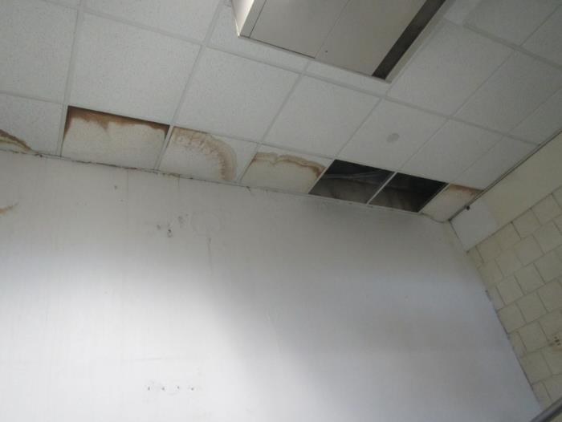
Water-damaged and missing ceiling tiles
Picture
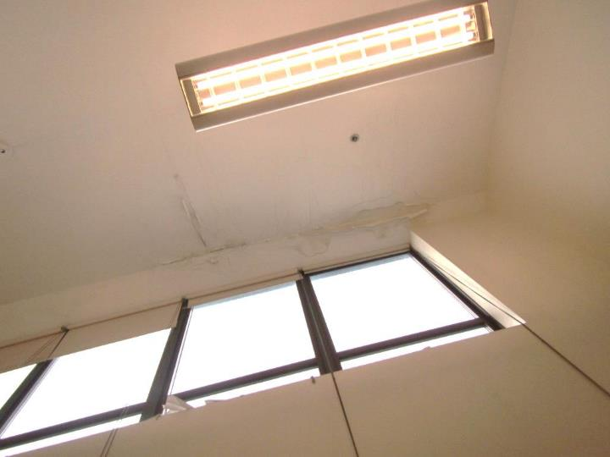
Water-damaged ceiling and wall
Picture
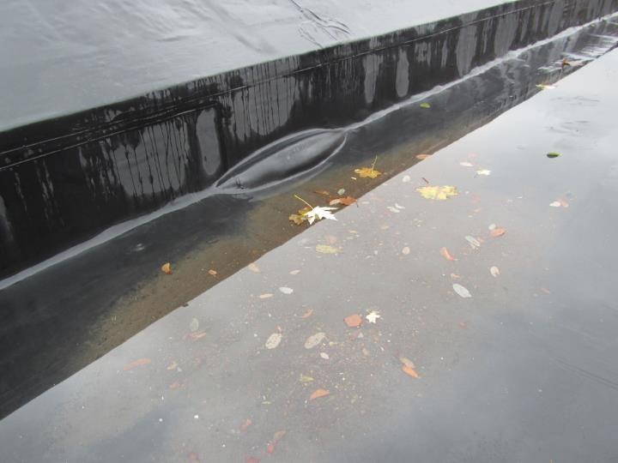
Pooling water and bubbling of roof membrane
Picture
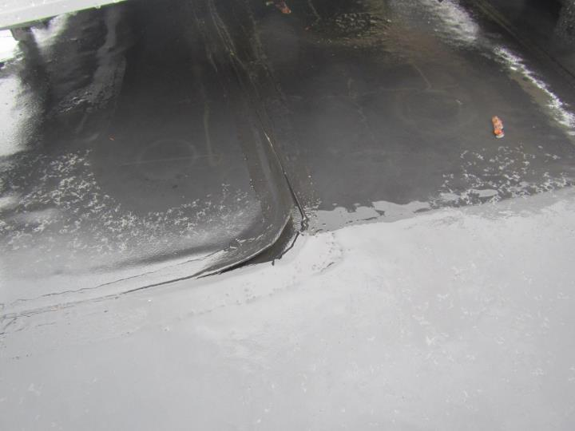
Membrane patch seam lifting from roof
Picture
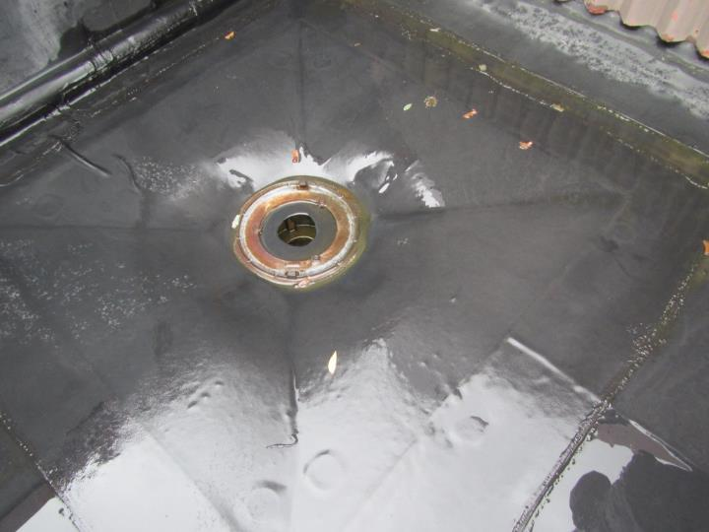
Roof drain with missing cover
Picture
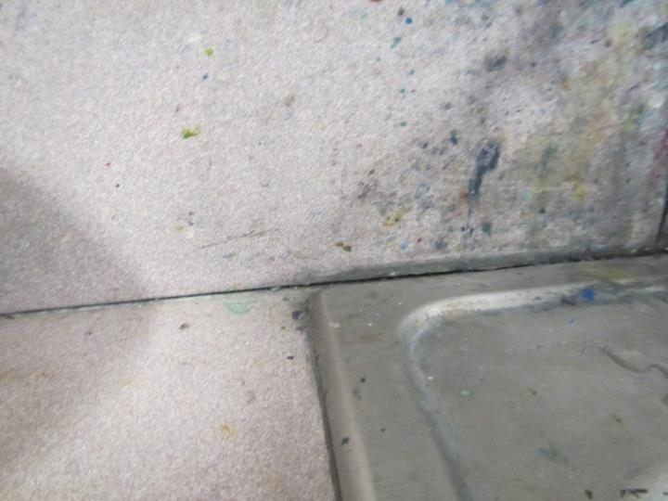
Gap between sink backsplash and countertop
Picture
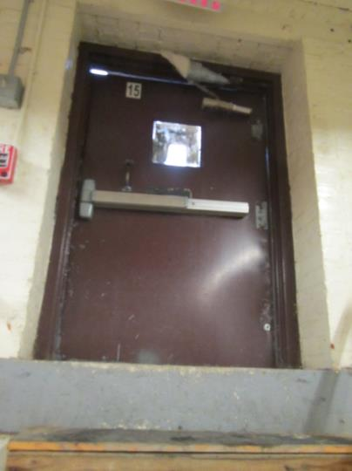
Light visible around door
Picture
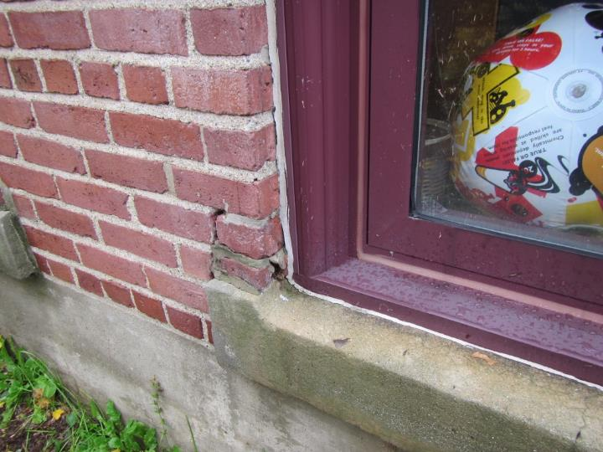
Damaged brick and mortar around window
Picture
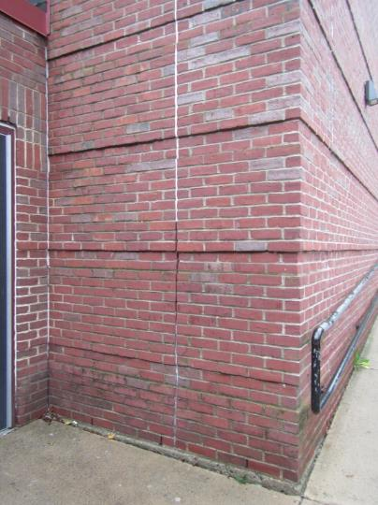
Missing sealant in expansion joint
Picture
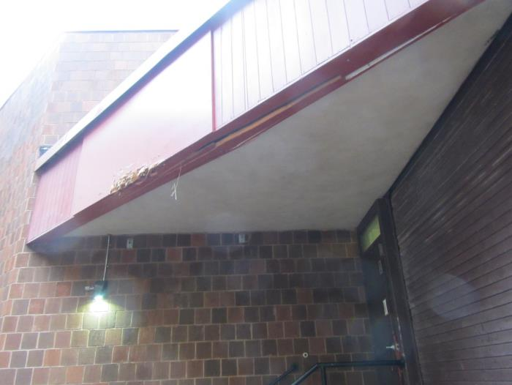
Damaged roof covering over loading dock
Picture
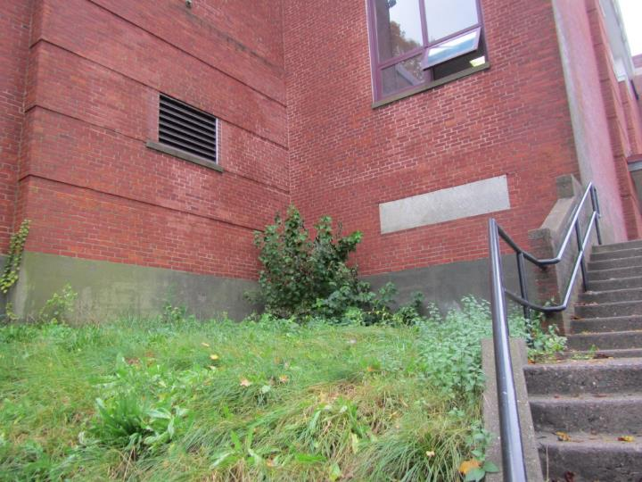
Shrub growing against building
Picture
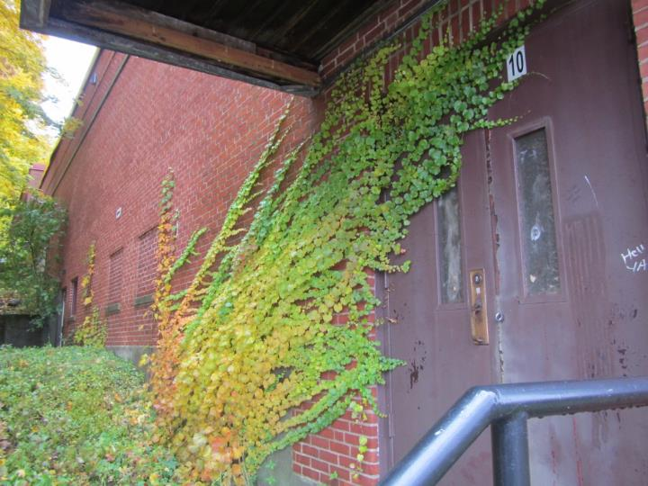
Vine growing in brickwork
Picture
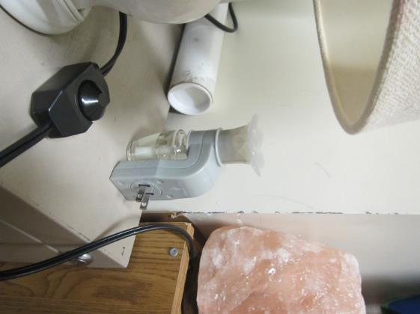
Plug-in air deodorizer
Picture
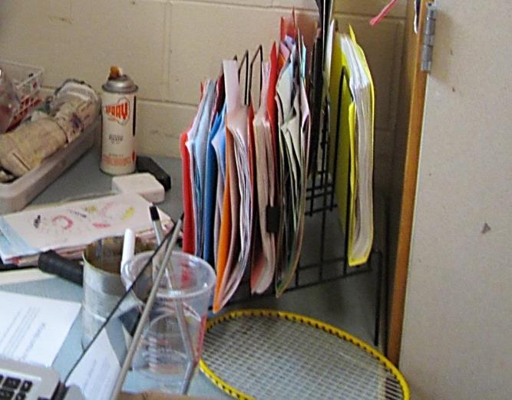
Spray mastic in classroom
Picture
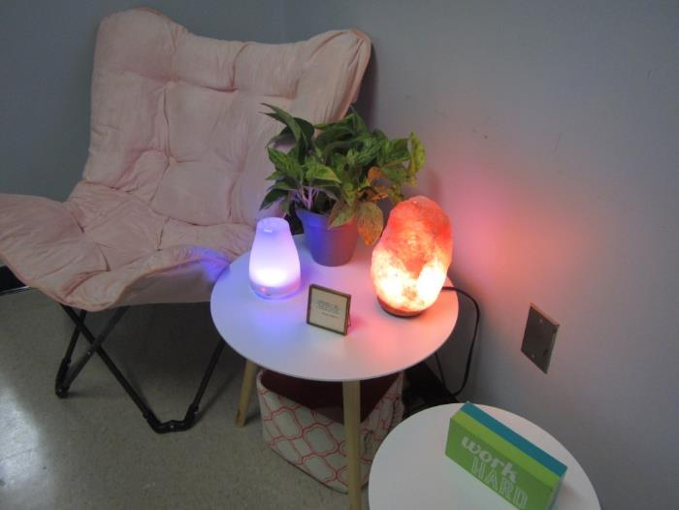
Essential oil diffuser
Picture
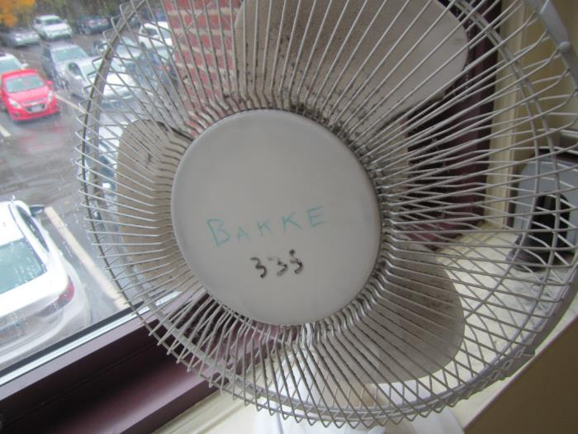
Dusty fan blades
Picture
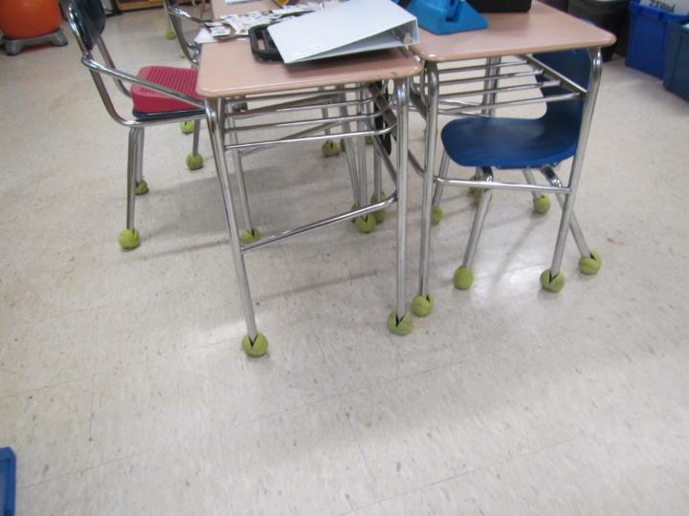
Tennis balls used as chair glides
Picture
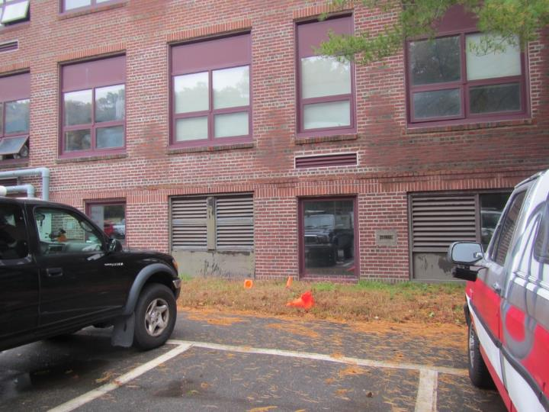
Vehicles near univent fresh air intakes
Picture
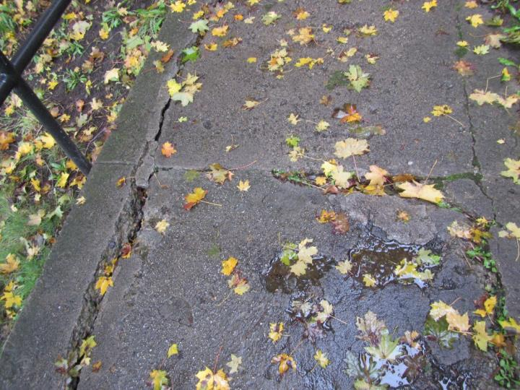
Damaged walkway around exterior of building

Location | Carbon  Dioxide  (ppm) | Carbon Monoxide  (ppm) | Temp  (°F) | Relative  Humidity  (%) | PM2.5  (µg/m³) | Occupants  in Room | Windows  Openable | Ventilation |  | Remarks
 |  |  |  |  |  |  |  | Supply | Exhaust
Background | 395 |  | 70 | 76 | 13
440 | 1161 | ND | 73 | 67 | 9 | 23 | Y | Y  Off | Y  Blocked | PF, DEM, aquarium, MT, ATs
441 | 1597 | ND | 73 | 64 | 7 | 23 | Y | Y  Off | Y  Blocked | PF, DEM
442 | 819 | ND | 72 | 71 | 13 | 25 | Y  Open | Y  Off | Y | PF, plants, DEM, DO
443 | 895 | ND | 72 | 68 | 8 | 24 | Y  Open | Y  Off | Y  Blocked | PF, WD-CTs, DEM
444 | 891 | ND | 72 | 65 | 11 | 4 | Y  Open | Y  Off | Y  Blocked | PF, DO, DEM
445 | 736 | ND | 72 | 63 | 10 | 5 | Y  Open | Y  Off | Y | DEM, PF, UF
446 | 882 | ND | 72 | 63 | 11 | 0 | Y | Y | Y | UF, DEM, DO, PF
449 | 748 | ND | 71 | 67 | 9 | 1 | Y  Open | Y  Items | Y | Plants, copier, DO, food equipment, CPs
452 | 756 | ND | 71 | 65 | 13 | 0 | Y | N | Y  Blocked | DEM, items
455 | 864 | ND | 71 | 65 | 11 | 27 | Y  Open | Y  Items, off | Y  Dusty | DO, PF, CPs, WD-CTs, DEM, PF
456 | 762 | ND | 71 | 72 | 12 | 27 | Y  Open | Y  Off | Y  Blocked | DEM, PF
457 | 1312 | ND | 71 | 65 | 11 | 27 | Y | Y  Plants, off | Y  Dusty | CPs, plants, DEM, WD-CTs, aquarium, WAC, DO
458 | 870 | ND | 71 | 63 | 13 | 16 | Y | Y  Items, dusty, off | Y  Sealed | PF, DEM, WAC, plants, HS, DO
480 | 820 | ND | 71 | 64 | 27 | 0 | Y | N | Y  Blocked | Plants, PF
Guidance (Christie) | 931 | ND | 73 | 64 | 5 | 1 | Y | Y | Y | MT, WD-CT, PF, air purifier
Guidance (Manke) | 1149 | ND | 75 | 60 | 3 | 1 | Y | Y | Y | HEPA-air purifier (on floor), WD-CTs
Guidance conference room | 946 | ND | 75 | 58 | 4 | 0 | N | Y | Y | DO
Guidance small conference room | 810 | ND | 74 | 58 | 4 | 0 | Y | Y  Off | Y  Off | DO
Guidance Bistran | 852 | ND | 74 | 59 | 4 | 0 | Y | Y  Off | Y  Off | Plants, WD-CTs
Guidance main | 843 | ND | 74 | 59 | 4 | 0 | N | Y  Off | Y | WD-CTs
Guidance conference room | 789 | ND | 74 | 59 | 4 | 0 | N | Y  Off, dusty | Y | DEM, DO
Guidance triangle | 772 | ND | 73 | 60 | 4 | 0 | Y | Y | Y | DO, PF
Guidance admin | 774 | ND | 73 | 60 | 4 | 0 | Y | Y | Y | AD, MT, DO, PF
Principal | 792 | ND | 72 | 61 | 4 | 1 | Y | Y | Y | DO, DEM, CPs
301 | 980 | ND | 76 | 62 | 5 | 0 | Y | Y  Off | Y | Food equipment, DO
302 | 767 | ND | 72 | 66 | 5 | 0 | Y | Y  Off | Y | DEM, DO, MT
303 | 600 | ND | 72 | 77 | 9 | 1 | Y  Open | Y  Off | Could not identify | PF, WD-CTs, DEM, CPs
304 | 807 | ND | 73 | 74 | 10 | 18 | Y  Open | Y  Off | Y  Blocked | DEM
305 | 1220 | ND | 72 | 73 | 7 | 1 | y | Y  Off, debris | Y | DEM, CPs, DO
306 | 1810 | ND | 74 | 72 | 8 | 23 | Y | Y  Off | Y  Wall | Plants, PF, DEM, DO
307 | 1806 | ND | 75 | 71 | 7 | 23 | Y | Y  Off, items | Y  Blocked | DEM, PF, CPs
308 | 1789 | ND | 75 | 70 | 7 | 22 | Y | Y  Off | Y  Dusty | DEM, PF
309 | 1001 | ND | 75 | 71 | 10 | 26 | Y  Open | Y  Off | Y  Blocked | PF, WD-CT, DEM, DO, CPs
310 | 1783 | ND | 75 | 68 | 7 | 25 | Y | Y  Items, off | Y  Blocked | PF, DEM, CPs
311 | 1501 | ND | 75 | 71 | 11 | 27 | Y  Open | Y  Items, off | Y  Blocked | DEM, PF, DO
312 | 868 | ND | 75 | 67 | 7 | 25 | Y | Y  Plant, off | Y | PF, plants, DEM, CPs
313 | 2130 | ND | 76 | 67 | 9 | 25 | Y | Y  Off | Y  Blocked | PF, DEM, CPs, DEM
314 | 1128 | ND | 75 | 66 | 8 | 11 | Y | Y  Items, off | Y  Blocked | DEM, items
315 | 1309 | ND | 74 | 54 | 5 | 0 | N | N | Y | DEM, AT
316 | 747 | ND | 73 | 57 | 3 | 0 | Y | N | Y  Dusty | Plug in AD, DEM
317 | 623 | ND | 76 | 61 | 2 | 0 | Y | Y  Dusty | N
318 | 601 | ND | 73 | 71 | 8 | 2 | Y  Open | N | Y  Dusty | DEM, DO
319 | 590 | ND | 75 | 63 | 2 | 0 | Y | Y  Dusty | N | WD-CTs
320 | 1332 | ND | 75 | 63 | 7 | 12 | Y | Y  Off | Y  Dusty | DEM, CPs, PF, DO
321 | 703 | ND | 74 | 65 | 2 | 1 | Y | Y  Dusty | N | WD-CTs
322 | 936 | ND | 71 | 63 | 3 | 2 | Y | Y | Could not identify | MT, WD-CTs, AT, breach between sink backsplash and countertop
323 | 615 | ND | 75 | 61 | 2 | 0 | N | Y | Y  dusty | WD-CTs, AT, MT
324 | 863 | ND | 75 | 65 | 6 | 10 | Y | Y  Blocked, missing cover | Y | WD CTs, DEM, DO
325 | 1111 | ND | 75 | 61 | 3 | 0 | N | Y | Y  Dusty | WD CTs, AT, DEM
326 | 1457 | ND | 74 | 59 | 5 | 19 | Y  Open | Y  Off, debris | Y | DEM, WD-CTs, WD ceiling, breach between sink backsplash and countertop
328 | 651 | ND | 76 | 64 | 5 | 8 | Y  Open | Y  Off | Y | WD-CTs, DEM, PF
329 | 1068 | ND | 74 | 61 | 4 | 1 | N | N | N | Air purifier – floor, WD-CTs, DO, CPs
330 | 507 | ND | 73 | 61 | 9 | 0 | Y  Open | Y | Y  Dusty | Bowing CTs, MT, DEM
331 | 1565 | ND | 73 | 67 | 6 | 19 | Y | Y  Items, off | Y | Plants, PF, DEM
332 | 588 | ND | 73 | 68 | 9 | 2 | Y  Open | Y | Y  Dusty | WD-CTs, MTs, DEM
333 | 836 | ND | 73 | 76 | 9 | 20 | Y  Open | Y  Debris, items, off | Y | Plants, DEM, UF, PF, CPs
334 | 801 | ND | 74 | 64 | 7 | 5 | Y | Y | Y | DO, DEM
335 | 661 | ND | 74 | 67 | 8 | 19 | Y  Open | Y  Dusty, off | Y | DEM, HS, PF
336 | 762 | ND | 74 | 66 | 8 | 9 | Y | Y  Dusty | Y  Dusty | DEM, CPs, WD-CTs
337 | 1067 | ND | 75 | 63 | 7 | 21 | Y | Y  Off, pencil debris | Could not identify | CPs, CP odors, AT, DEM, PF
339 | 751 | ND | 75 | 63 | 8 | 3 | Y  Open | Y  Off | Could not identify | WD-CT, DEM, CPs
340 | 854 | ND | 74 | 65 | 8 | 0 | Y | N | N | PF, DO
342 | 933 | ND | 74 | 56 | 9 | 0 | Y | N | Y | AD-odor, plants, WD-CTs
344 | 1059 | ND | 73 | 60 | 19 | 0 | Y | N | Y | Plants, humidifier/mister, DEM
355 | 1459 | ND | 74 | 62 | 14 | 0 | Y | Y  Debris, off | Y | DEM
356 | 1539 | ND | 74 | 62 | 13 | 1 | Y | Y | Y  Dusty | Items, DEM, PF, CPs
357 | 1667 | ND | 74 | 61 | 10 | 1 | Y | Y  Off | Y  Dusty | AD odor, DEM, HS, PF, DO
358 | 1333 | ND | 73 | 64 | 14 | 1 | Y  Open | Y  Items, off | Y  Dusty | PF, DEM, CPs
Media center | 921 | ND | 74 | 62 | 3 | 30 | Y | Y | Y | WD-CTs, AT
Media book room | 1075 | ND | 74 | 60 | 4 | 2 | N | Y  Off | Y  Off | CPs, DO
Media studio | 1017 | ND | 74 | 52 | 2 | 0 | N | Y | N
PE men’s office | 628 | ND | 72 | 65 | 2 | 0 | N | Y  Dusty |  | PF, CPs, sink does not turn off, exhaust in bathroom
Lower blue gym A | 1025 | ND | 71 | 63 | 3 | 1 | Y | Y  Off, dusty | Y
Boys’ locker room | 654 | ND | 71 | 63 | 2 | 0 | N | Y |  | MT, WD-CTs, leaks from courtyard
Lower blue gym B&C | 1078 | ND | 70 | 63 | 3 | 0 | N | Y | Y | Dusty CTs, MT
Girls’ locker room | 695 | ND | 69 | 58 | 4 | 0 | N | Y | Y  Dusty | WD ceiling
PE women’s office | 775 | ND | 69 | 61 | 3 | 1 | N | Y | Y | CPs, AD
Wood gym | 688 | ND | 70 | 60 | 5 | 20 | Y | Y | Y | WD ceiling
Main lobby | 724 | ND | 71 | 74 | 2 | 30 | N | Y | Y  Passive | MT, WD-CTs
Cafeteria | 529 | ND | 71 | 70 | 2 | 16 | Y | Y | Y | WD-CTs
Custodian | 951 | ND | 71 | 68 | 7 | 0 | Y | N | N | DO, gaps around doors
201 | 876 | ND | 73 | 64 | 6 | 0 | Y | N | Y | DEM, DO, food equipment
202 | 897 | ND | 73 | 64 | 6 | 0 | Y | Y | Y | DEM, CPs
203 | 802 | ND | 73 | 71 | 13 | 24 | Y  Open | Y  Off | Y  Blocked | DEM, CPs, PF
204 | 1418 | ND | 74 | 72 | 9 | 1 | Y  Open | Y  Off | Y  Blocked | DEM, PF, CPs
205 | 1441 | ND | 74 | 72 | 10 | 27 | Y | Y  Off, items | Y | DEM, HS, DO
206 | 968 | ND | 74 | 70 | 10 | 1 | Y  Open | Y  Off | Y  Blocked | DEM, PF, CPs
207 | 961 | ND | 74 | 66 | 6 | 1 | Y | Y  Off | Y  Blocked | CPs, AD, DEM, PF, DO
208 | 674 | ND | 73 | 70 | 9 | 1 | Y | Y  Items, off | Y  Blocked | DEM, CPs, DO
209 | 1071 | ND | 74 | 70 | 8 | 1 | Y | Y  Items, off | Y  Blocked | PF, CPs, DEM, DO
210 | 902 | ND | 74 | 66 | 8 | 0 | Y  Open | Y  Off | Y | Plants
211 | 1619 | ND | 74 | 74 | 12 | 27 | Y  Open | Y  Items | Y | DEM, plants, PF, DO
212 | 897 | ND | 73 | 72 | 9 | 21 | Y  Open | Y  Off | Y  Dusty | DEM, CPs, PF
213 | 1131 | ND | 74 | 67 | 7 | 5 | Y | Y  Off | Y  Dusty | DEM, CPs, PF
214 | 978 | ND | 73 | 64 | 8 | 2 | Y  Open | Y  Items, off | Y  Blocked | MT, WD-CTs
215 | 644 | ND | 73 | 76 | 2 | 0 | Y | Y  dusty | Y | MT, DEM, DO
216 | 846 | ND | 73 | 65 | 3 | 4 | Y | N | Y  Dusty | DEM, plants, DO
217 | 715 | ND | 73 | 67 | 3 | 5 | N | Y  Off | Y  Off | DEM, HS
218 | 792 | ND | 73 | 61 | 3 | 0 | Y | N | Y | WD-CTs
219 | 715 | ND | 73 | 67 | 3 | 2 | N | Y  Off | Y  Off | DEM, plants, CPs
220 | 906 | ND | 73 | 64 | 7 | 1 | Y | N | Y | CPs
221 | 616 | ND | 73 | 67 | 3 | 2 | N | Y  Off | Y  Off | AT, CPs, DO
222 | 894 | ND | 72 | 60 | 4 | 0 | Y | N | Y  Dusty | DEM
223 | 1029 | ND | 74 | 60 | 3 | 4 | N | Y  Off | Y  Off | DEM
225 | 1417 | ND | 74 | 61 | 3 | 4 | N | Y  Off | Y  Off | PF, CPs
226 | 612 | ND | 71 | 62 | 4 | 0 | N | Y | Y
227 | 879 | ND | 72 | 66 | 3 | 0 | Y | Y | Y  Dusty | DO, plants, dedicated exhaust
227 upper | 769 | ND | 72 | 61 | 5 | 0 | Y | N | N
228 (wood shop) | 685 | ND | 72 | 72 | 8 | 13 | N | Y | Y | PF, dedicated exhaust
229 | 801 | ND | 72 | 67 | 5 | 1 | N | N | Y  Dusty | DEM, PF
229 inner | 890 | ND | 72 | 66 | 5 | 0 | N | N | Y  Missing grate
230 | 1250 | ND | 71 | 68 | 48 | 1 | Y | Y | Y  Blocked | Washer & dryer, plants, cooking stove, CPs
231 | 982 | ND | 72 | 63 | 14 | 0 | N | N | Y  Dusty | TB, PF
232 | 1280 | ND | 71 | 69 | 15 | 20 | Y | Y | Y | DEM, breach between sink backsplash and countertop, dehumidifier
233 | 815 | ND | 71 | 69 | 5 | 0 | Y | Y | Y | TB, MT, DEM
235 | 868 | ND | 71 | 72 | 7 | 4 | Y | Y | Y | TB, dehumidifier
237 | 878 | ND | 70 | 55 | 3 | 0 | Y | Y  Off | Y  Dusty | DEM, WD-CTs (active leak)
239 | 1482 | ND | 71 | 61 | 6 | 30 | Y | Y  Off | Y  Dusty | DO
241 | 572 | ND | 71 | 60 | 9 | 0 | Y | Y  Off | Y | DEM
101 | 593 | ND | 72 | 68 | 2 | 1 | Y | Y | Y  Positive | MT, WD-CTs
102/103 | 645 | ND | 72 | 70 | 2 | 17 | N | Y | N | Dehumidifier, MT/AT, WD-CTs, DEM
Faculty dining | 651 | ND | 70 | 68 | 1 | 0 | Y | Y | N | Plants
Administration – lower waiting area | 655 | ND | 74 | 69 | 2 | 0 | Y | Y | Y | CF
Main office | 677 | ND | 71 | 69 | 2 | 4 | Y | N | N | Plants
Nurses main office | 862 | ND | 72 | 65 | 4 | 3 | N | N |  | DO, CPs
Nurses patient (middle) room | 920 | ND | 73 | 63 | 4 | 0 | N | N | Y | WD-CT, DO
Nurses patient (left) room | 946 | ND | 74 | 63 | 3 | 0 | N | N | Y | UF, sliding window, DO
Nurses patient (right) room | 927 | ND | 74 | 62 | 3 | 0 | N | N | Y | CPs, AD

