The Commonwealth of Massachusetts
Executive Office of Health and Human Services
Department of Public Health
Bureau of Health Care Safety and Quality
67 Forest Street, Marlborough MA 01752
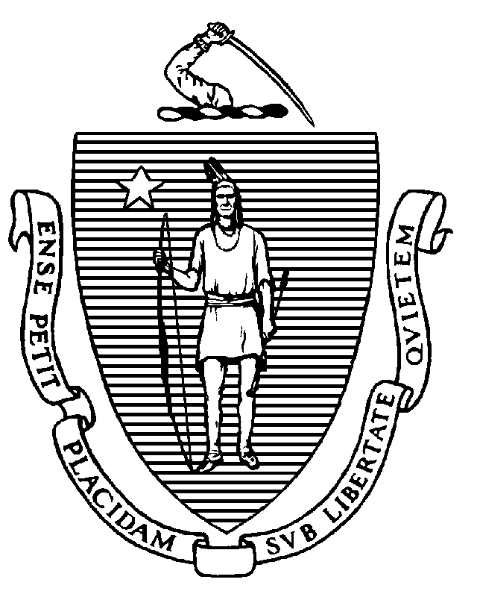

KATHLEEN E. WALSH
Secretary
ROBERT GOLDSTEIN, MD, PhD Commissioner

Tel: 617-624-6000
www.mass.gov/dph

MAURA T. HEALEY
Governor
KIMBERLEY DRISCOLL
Lieutenant Governor

Memorandum

TO: Out-of-hospital Dialysis Facility Administrators
FROM: Elizabeth Daake Kelley, MPH, MBA, Director
Bureau of Health Care Safety and Quality
SUBJECT: Out-of-hospital Dialysis Personnel Vaccination for COVID-19 and Influenza
DATE: November 6, 2023

The purpose of this memorandum is to inform Massachusetts out-of-hospital dialysis facilities of the steps needed to fulfill the Massachusetts Department of Public Health (DPH) requirement to vaccinate healthcare personnel (HCP) for influenza and COVID-19 and to submit these data in accordance with DPH guidelines outlined in this memorandum.

COVID-19 and Influenza Vaccination Requirement:

As a condition of licensure, DPH out-of-hospital dialysis facilities are required to comply with licensing and administrative procedures outlined in 105 CMR 140.101 to 140.150, which include the requirement to ensure all HCP are vaccinated annually with seasonal influenza vaccine and are up to date with vaccine doses for COVID-19 as recommended by the Centers for Disease Control and Prevention (CDC), unless an individual is exempt from vaccination. For the purposes of this memo, being up to date with vaccine doses for COVID-19 means that HCP must receive one updated COVID-19 vaccine, at least two months after getting the last dose of any COVID-19 vaccine. An individual who has not previously received any doses of COVID-19 vaccine but who receives one dose of the updated COVID-19 vaccine is also up-to-date.

HCP means an individual or individuals who either work at or come to the licensed site and who are employed by or affiliated with the facility, whether directly, by contract with another entity, or as an independent contractor, paid or unpaid including, but not limited to, employees, members of the medical staff, contract employees or staff, students, and volunteers, whether or not such individual(s) provide direct care.

All HCP, who are not subject to an exemption, must be up to date with COVID-19 vaccine no later than December 31, 2023. In alignment with the CDC and the Centers for Medicare and Medicare Care Services (CMS), all HCP, who are not subject to an exemption, must have received the 2023-2024 seasonal influenza vaccine no later than March 31, 2024.

For any individual that is subject to the vaccine exemption, the out-of-hospital dialysis facility may choose to require such individual to take mitigation measures in addition to continuing to self-assess for any signs or symptoms of illness. Mitigation measures that the out-of-hospital dialysis facility may require an individual to take if they are exempt from vaccination include, but are not limited to:
- wearing a facemask during all patient care encounters for the duration of the respiratory illness season; and
- avoiding direct patient care.
DPH continues to recommend staff using personal protective equipment consistent with the Department’s Comprehensive PPE Guidance.

Facility Documentation:

The regulation requires out-of-hospital dialysis facilities maintain for each individual proof of seasonal influenza vaccination and being up-to-date with COVID-19 vaccination or the individual’s declination statement should the HCP decline vaccination. This must be maintained via a central system to track the vaccination status of all personnel and available to DPH upon request. Examples of individual proof of current vaccination include but are not limited to:
- Copy of CDC Vaccination Card
- Copy of MA Immunization Information System (MIIS) Vaccination Record
- Copy of vaccination from an electronic health record
- COVID-19 SmartHealthcard from the Commonwealth’s MyVaxRecords public portal
Declination statements from personnel must a signed statement certifying they received information about the risks and benefits of COVID-19 and/or influenza vaccine.

Out-of-hospital Dialysis Reporting:

To comply with the regulation, all Massachusetts out-of-hospital dialysis facilities must annually report its aggregate HCP COVID-19 and influenza vaccination summary data via CDC’s National Health Safety Network (NHSN) and make the data available to DPH in NHSN. NHSN training materials are located at: http://www.cdc.gov/nhsn/training/index.html

In alignment with CDC and CMS, out-of-hospital dialysis facilities must submit HCP COVID-19 vaccination data to CDC’s NHSN by February 15, 2024 and HCP influenza vaccination data to CDC’s NHSN by May 15, 2024.

To assist facilities in documenting, monitoring and tracking HCP COVID-19 & influenza vaccination data throughout the respiratory season, DPH has developed a Facility COVID-19 & Flu Tracking Tool, available at the following link: Health Care Personnel Influenza Vaccination References and Resources | Mass.gov

Note that the requirements under 105 CMR 140.150 apply to out-of-hospital dialysis facilities licensed under 105 CMR 145.000 pursuant to 105 CMR 145.900.
Updated COVID-19 vaccine means one dose of the updated Pfizer-BioNTech, Moderna, or Novavax COVID-19 vaccine. https://www.cdc.gov/coronavirus/2019-ncov/vaccines/stay-up-to-date.html

