Outlook Web Access
If you have any issues with your Outlook client, you can access OWA while the helpdesk resolves the issue. See below instructions.
 | Steps | Process | Image
 |  | To access Outlook Online, the old URL will not work. You must use https://outlook.office.com/owa/ | 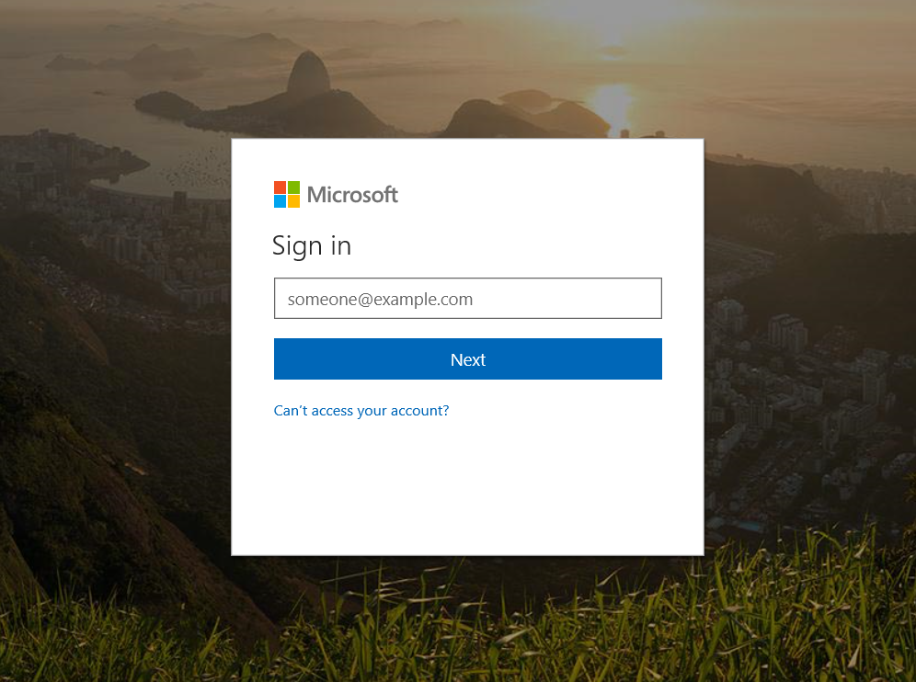
 |  | Sign in to Outlook Online with your email address with the @mass.gov extension. | 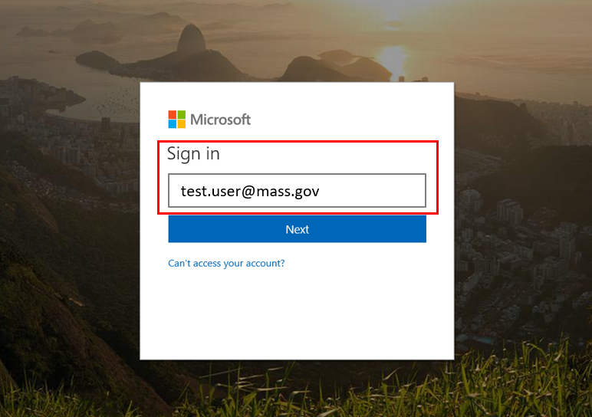
 |  | After entering your email address, you will automatically be directed to another page where you must enter you network password for authentication. | 