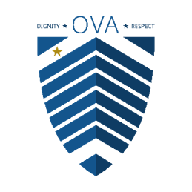

THE COMMONWEALTH OF MASSACHUSETTS
Bob Notch, Veteran Advocate

OFFICE OF THE
VETERAN ADVOCATE
STRATEGIC PLAN

FISCAL YEARS 2027 – 2031
October 2026

Vox Veteranorum | The Voice of Veterans

www.mass.gov/OVA

TABLE OF CONTENTS

Letter from the Veteran Advocate 2

About This Strategic Plan 3

Who We Are & What We Do 4

Our Vision, Mission and Values 7

How the OVA Executes Its Mission 8

How the OVA Prioritizes Its Work 9

Strategic Plan Priorities — Overview 10

Priority 1: Build Capacity 11

Priority 2: Benefits and Services 12

Priority 3: Housing 13

Priority 4: Employment 14

Priority 5: Build Trust and Collaboration 15

Conclusion and Acknowledgements 16

Definitions 17

Letter from the Veteran Advocate

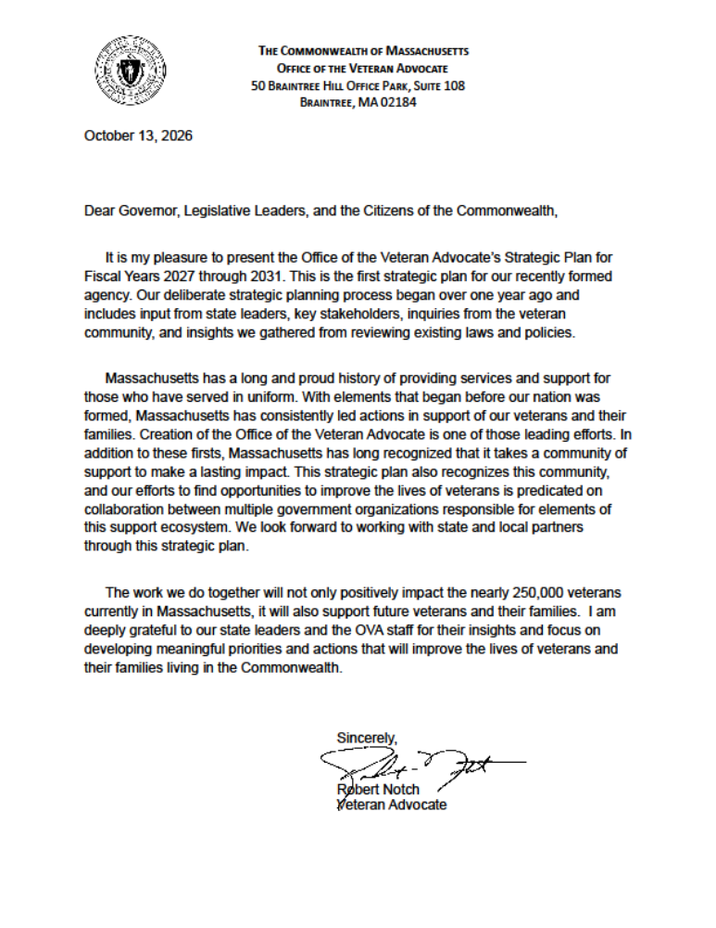

About This Strategic Plan

The Office of the Veteran Advocate (OVA) is pleased to present its first multi-year Strategic Plan, covering Fiscal Years 2027 through 2031. This plan builds upon the foundation established during FY2025 and FY2026, translating our statutory responsibilities and initial agency assessments into a clear, actionable roadmap for the years ahead.
The OVA recognizes that there are many issues affecting Massachusetts veterans and their families, and there are several agencies responsible for supporting veterans and their families—both veteran-serving organizations and others providing services veterans do or could access. OVA itself does not provide direct services to veterans. It is, however, well positioned to aid, support and coordinate with others who do serve veterans by providing information, assistance, referrals and navigation support to those agencies and organizations. It is also statutorily required to respond to concerns about the care and treatment veterans in the care of the Commonwealth receive, and to investigate incidents where those veterans suffer a fatality, near fatality, or serious bodily or emotional injury, or are put at risk of death or serious injury. OVA is developing its capacity to do all of this and will continue to be responsive to these various requests, recognizing that it may need to prioritize which requests it handles and/or responds to because of current agency capacity limitations.
OVA believes that its highest impact can be achieved when it utilizes one or more of the multiple approaches (described later in How the OVA Executes its Mission) to address a system-wide issue. Therefore, OVA plans that over the next five years it will build the capacity, credibility, relationships, and trust to leverage all those approaches, and it will focus this multi-prong approach in three areas – Benefits and Services, Housing, and Employment--which stakeholders have identified as critical to veterans across the Commonwealth. Within each of these three broad areas, OVA has identified a specific, tangible, and measurable priority to address, along with key actions necessary to fulfill each priority.
Of course, there are other state and local agencies and veteran serving organizations supporting veterans in each of these areas. In recognition of this, the OVA intends to enhance and utilize its capabilities and its relationships to play a meaningful role in improving the resources available to veterans in each of these areas while not duplicating the work of these other agencies and organizations.
The OVA will take a consistent approach to issues or activities under each of its five strategic priorities: it will compile the data and research necessary to understand the issue, identify if there is a need or opportunity for change, identify collaborators already working to address the issue and specify the role/value add that OVA will bring, commit to specific deliverables and timelines, and continually learn from and adapt its approach as needed.
The OVA recognizes that serving veterans requires flexibility and responsiveness. This plan establishes intent and direction while acknowledging that new actions may be added, and existing efforts amended, in response to changing circumstances throughout the plan’s period.
By the Numbers

2027 2031
238,176 | Veterans in Massachusetts (VA NCVAS data estimate) | 208,041

127,674 | Veterans age 65 and older in Massachusetts (VA NCVAS estimate) | 113,599

10 of 11 | State Executive Offices with responsibilities for veteran-related programs, benefits and services

Who We Are & What We Do

About the Office of the Veteran Advocate
The Office of the Veteran Advocate (OVA) is an independent state agency established by Chapter 144 of the Acts of 2022, codified in Massachusetts General Laws Chapter 115B. The OVA is charged with ensuring that veterans under the care of the Commonwealth receive dignified treatment, timely, safe and effective services, as well as access to all available benefits and services. The OVA works collaboratively with its partners, providing policy analysis and recommendations. When necessary, the OVA conducts investigations into fatalities and other critical incidents.

The OVA is designed to operate independently of any executive agency’s supervision or control, allowing it to serve as a trusted, objective advocate and stewardship body for veterans and their families across the Commonwealth.

During initial analysis of responsibilities to establish the agency, the OVA determined a minimum requirement of twelve full-time positions (FTE = Full Time Equivalent) to meet statutory mandates. These positions are organized into six divisions carrying out their mission across all statutory areas of responsibility. These divisions form the backbone of day-to-day operations and long-term advocacy.

OVA Staffing FY2027

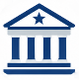  Administration (3.5* FTE)  Conducts management and administrative functions of the agency, including human resources management, financial management, procurement, training, policy development, legal reviews, compliance functions, and recurring office tasks. |   Liaison (4.5* FTE)  Provides aid and coordination to local veteran service officers and acts as a bridge between the local veteran communities and non-profit organizations, executive agencies and federal partners, including the Dept. of Veterans Affairs
*The OVA Chief of Staff has an additional responsibility to lead and manage the Liaison Division.
  Policy and Research (1 FTE)  Examines veteran-centered systems and recommends improvements to programs, benefits, and services for veterans and their families using peer-reviewed research, recurring observations, reviews of laws, regulations and policies, and best practices. |   Communications (1 FTE)  Provides clarity and consistency in communications external to the OVA, including legislative liaison, webpage management, document control, all forms of media content, and relationship maintenance and development.
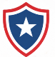  Veteran Safety and  Investigations (1 FTE)  Ensures humane and dignified treatment and timely, safe and effective care of veterans in Commonwealth facilities and under executive agency supervision, focusing on the most vulnerable populations.  Conducts thorough, independent and objective investigations into fatalities, near-fatalities, and serious injuries of veterans in state care; reporting findings and making corrective recommendations. |   Data and Information (1 FTE)  Defines the core purpose, strategies, and value of the organization’s data assets, focusing on how data supports the broader vision of the Agency through governance, management, quality control and analytics.  Analyzes veteran data collected at the Federal, State, and Municipal level and seeks to make its products accessible and comprehensible to a variety of stakeholders across the Commonwealth.

What We Do
The OVA carries out its mission through the following core functions, as established by MGL Chapter 115B, Section 2:

- Aid and coordinate with local Veterans Service Officers to ensure access to all state and federal benefits
- Examine, on a system-wide basis, the care and services that executive agencies provide veterans
- Act as liaison to all state agencies, the U.S. Department of Veterans Affairs, and other relevant federal agencies
- Assist in developing procedures for executive agencies to better serve the veteran community
- Advise the public and state leadership on how the Commonwealth may improve veteran services
- Oversee and monitor the treatment and services delivered to veterans by executive agencies
- Conduct investigations in cases of a veteran fatality, near fatality, or serious injury while receiving services from an executive agency or when an agency failed in its duty to care for the veteran

Who We Serve and Our Partners
The OVA serves all Massachusetts veterans and their families through the agencies who support them, including:
- Municipal Veterans Service Officers across Massachusetts
- State executive agencies and their constituent agencies with responsibilities to serve veterans
- Other state agencies that serve or support veterans
- State elected leaders and the constituents they represent
- U.S. Department of Veterans Affairs and other relevant federal agencies

The agencies above are mandated by statute. The following are key agencies, organizations and associations that can play a critical role in understanding and supporting veterans and their families.

- Congressionally chartered Veterans Service Organizations and the members they represent
- Veteran-focused Nonprofit Organizations/Agencies that serve veterans and their families
- Other Nonprofit and Community Based Organizations that serve veterans and their families
- Associations, Coalitions, Collaboratives, and Resource Groups that lead, empower, and coordinate the effectiveness of their members

Our Vision, Mission & Values

OUR VISION

Every veteran in the Commonwealth receives the highest standard of care, enjoys the full spectrum of available benefits, and is treated with unwavering respect and dignity.

OUR MISSION

The Office of the Veteran Advocate (OVA) is dedicated to safeguarding the well-being and upholding the rights of veterans under the care of the Commonwealth. OVA ensures veterans and their families receive compassionate, timely, and effective services, while advocating for their rights, benefits, and dignified treatment. We strive to foster collaboration among state agencies, facilitate access to federal and state benefits, and conduct thorough investigations to enhance the quality of care provided to veterans.

Our Values
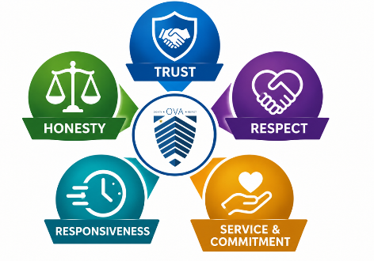

How the OVA Executes Its Mission

The OVA is charged with ensuring that veterans in the care of the commonwealth or receiving services under the supervision of an executive agency in any public or private facility receive timely, safe, and effective services, can access all the benefits available to them, and are treated humanely and with dignity and respect. OVA does this by focusing on the following:

- In cooperation with the owning agency whenever possible, examine, on a system-wide basis the care and services that executive agencies provide veterans, identify gaps in how state agencies serve veterans, and advise the public and those at the highest levels of state government about how the commonwealth may improve its services to and for veterans and their families;

- Empower Regional Liaisons to aid and coordinate with local veterans’ services officers to ensure that veterans and their families are aware of, and receive access to all the state and federal benefits available to them;

- Assign experienced staff to liaison, coordinate, and advocate with state and federal agencies providing services to veterans to ensure veterans receive the benefits and services to which they are eligible;

- Engage Policy and Research and Data and Information experts to provide data and research to support and collaborate with state and local officials and other organizations serving Massachusetts’ veterans to ensure that the Commonwealth provides quality and effective services to veterans and their families;

- Leverage highly trained staff to investigate incidents where a veteran suffered a fatality, near fatality or serious bodily or emotional injury while receiving services from an executive agency or in circumstances which result in a reasonable belief that an executive agency or a constituent agency failed in its duty to care for a veteran and, as a result, the veteran was at imminent risk of, or suffered serious bodily or emotional injury or death.

In all actions, the well-being and best interests of veterans and their families remain the top priority for the OVA.

As a new agency, it is critical over the next five years that OVA build the capacity, credibility,
relationships, and trust to leverage each of these approaches—often using them together—to execute its Mission.

How OVA Prioritizes Its Work

Given limited resources and a broad statutory mandate, the OVA applies the following criteria to determine which projects to pursue and the role it will play.
In most cases, unless a project meets all or most of the below criteria and falls within one of OVA’s strategic priorities, it will not be prioritized for action. These criteria will be reviewed annually to ensure that they support OVA’s goal of focusing on those issues which will have the most impact and leverage OVA’s and other agencies’ strengths.

- Statutory Mandate — Is the OVA required to do the work by MGL Chapter 115B? Does it fall within the defined scope of the office's authority?
- Impact on Veterans — Will the work result in improved outcomes, benefits access, or quality of care for veterans — particularly those most vulnerable, including veterans in Commonwealth’s care, aging veterans, women veterans, and justice-involved veterans? (If the OVA is not the appropriate agency, OVA will assist in identifying the appropriate agency / resource.)
- Systems-Level Focus — Does the work involve coordination across multiple agencies or address a gap that requires independent objectivity to examine?
- Readiness/Opportunity for Change — Is the relevant agency or system positioned to act? If not, does the OVA have a role in creating that readiness? Is there an opportunity to influence change?
- OVA's Unique Value — Is the OVA uniquely positioned to do this work? Could another agency or partner accomplish it more effectively? Are there only certain functions within an initiative/project for which OVA is uniquely positioned?
- Capacity — Does the OVA have, or can it reasonably obtain, the right capacity, relationships, and expertise to carry out the work well?

This plan is built on the understanding that the OVA must remain nimble. New actions may be added, and existing actions may be amended or paused, in response to emerging needs, legislative changes, and opportunities across fiscal year periods.

Strategic Plan Priorities: FY2027–2031

OVA will use the following framework of Priorities and Actions to focus its work over the next five years. Each year, OVA will develop annual action plans to implement these Priorities.
The OVA's FY2027–2031 Strategic Plan is organized around five priorities that reflect both our statutory responsibilities and the most pressing areas of concern for veterans and their families identified through our initial years of operation, stakeholder engagement, and data review. These priorities are long-term and while every initiative may not be completed within the plan period, each represents a meaningful step toward improved outcomes for veterans in Massachusetts. Some initiatives continue and expand work that began in FY2025 and FY2026.
Priority numbering provides a reference system and does not indicate any order of importance— all are considered essential to the OVA's mission.
REFERENCE | PRIORITY TITLE & SUMMARY
1 | Build Capacity  Continue to build OVA’s capacity to respond to any critical incident referral, concern, or request for support relating to any benefit or service for which a Massachusetts veteran is eligible, promote awareness of this capacity, and use the information gathered to identify any trends which can be addressed on a more system-wide basis.
2 | Review Benefits and Services  OVA will focus on (1) building awareness of the federal and state benefits and services available to veterans and their families; (2) supporting veterans service officers and state agencies wanting to improve veteran access to benefits and services; and (3) identifying alternatives to improve the benefits and services available to Massachusetts’ veterans.
3 | Review Housing Opportunities  OVA will focus on understanding the needs of aging Massachusetts veterans for safe and attainable housing, while researching and advising on alternative housing models which address those needs.
4 | Explore Employment Opportunities  OVA will explore options to increase veteran access to employment, and especially to those positions that both leverage veteran training and experience while in the military, and which also support the growth of Massachusetts’ economy.
5 | Build Trust and Collaboration  Enhance OVA’s expertise, reputation, relationships, capacity, and capabilities so that the OVA is relied upon as a trusted advisor, collaborator, and credible source of information on issues affecting Massachusetts’ veterans.
PRIORITY 1: Build Capacity

Continue to build OVA’s capacity to respond to any critical incident referral, concern, or request for support relating to any benefit or service for which a Massachusetts veteran is eligible, promote awareness of this capacity, and use the information gathered to identify any trends which can be addressed on a more system-wide basis.

Context
Once sufficient staff were hired, the OVA established a database system to record information about inquiries and requests to ensure responses were completed, track workload, and to facilitate tracking of trends which may indicate areas where systems may be improved. This priority includes internal agency actions intended to consistently improve processes, record keeping, and reporting to facilitate a better understanding of the veteran community needs and concerns.

Actions

ACTIONS | DESCRIPTION
Action 1.a | Document the number and types of inquiries and requests to OVA and the OVA response; analyze the trends identified across the various inquiries; and use these trends to prioritize research and identify potential areas for improvement.
Action 1.b | Negotiate agreements with key agencies to obtain reports (and records when necessary) of fatalities, near fatalities, or serious bodily or emotional injury.
Action 1.c | Periodically review and update criteria for prioritizing reported cases and the Standard Operating Procedures for handling Investigations.
Action 1.d | Develop and execute a multi-channel regular communication plan to promote awareness of OVA’s work and capacity to aid, support, respond to referrals, and investigate.

PRIORITY 2: Review Benefits and Services
OVA will focus on (1) building awareness of the federal and state benefits and services available to veterans and their families; (2) supporting veterans service officers and state agencies wanting to improve veteran access to benefits and services to which they are eligible; and (3) identifying alternatives to improve the benefits and services available to Massachusetts’ veterans.

Context
During stakeholder interviews, several individuals expressed interest in understanding multiple options to deliver benefits and services to veterans and their families. Gaining an understanding of what works in other locations can often spur new ideas and identify best practices. The OVA will continue to use research and develop tools to better understand the impacts, challenges, and opportunities associated with implementing benefits and services; then share those insights and options with the providers to improve outcomes for veterans.

Actions

ACTIONS | DESCRIPTION
Action 2.a | Compare state Veterans Benefits in Massachusetts to other states:  Phase 1: Start with California, Texas, Florida, North Carolina, and New York.  Phase 2: Add Rhode Island, Connecticut, Vermont, New Hampshire and Maine.
Action 2.b | Promote use of Value of a Veteran dashboard to support advocacy for increased benefits; and begin to measure success.
Action 2.c | Assess beneficiary access to TRICARE primary care providers.
Action 2.d | Work with stakeholders to improve processes and access to benefits and services for Justice Involved Veterans.
Action 2.e | Facilitate a municipal VSO and stakeholder working group to identify and recommend ways to improve local VSO effectiveness and efficiency.
Action 2.f | Upon passage of veteran related legislation, collaborate with executive agencies to facilitate implementation.

PRIORITY 3: Review Housing Opportunities

OVA will focus on understanding the needs of aging Massachusetts veterans for safe and attainable housing and researching and advising on alternative housing models which address those needs.

Context
The “By the Numbers” section of this plan highlights snippets of information for the current (2027) and future (2031) veteran population estimates. As the total veteran population declines, over half of the population remains age 65 and older. We expect these veterans to have increasing needs as they get older. Gaining a stronger understanding of the geographical density and needs of older veterans across the state will inform leaders in implementing appropriate options for housing locations that support those needs.

Actions

ACTIONS | DESCRIPTION
Action 3.a | Collaborate with Continuum of Care programs to improve homeless veteran access to shelters.
Action 3.b | Research and report on housing models which have been developed in Massachusetts and in other states for veterans over the age of 60.
Action 3.c | Create a density map of Massachusetts depicting where veterans over the age of 60 are living.
Action 3.d | Assess the assisted living, supportive and congregate housing options available in those geographies with high concentration of veterans over the age of 60.
Action 3.e | Review the process of using VA-backed Home Loans for affordable home-ownership opportunities in Massachusetts.

PRIORITY 4: Explore Employment Opportunities

OVA will explore options to increase veteran access to employment, and especially to those positions that both leverage veteran training and experience while in the military, and which also support the growth of Massachusetts’ economy.

Context
Veteran employment issues can affect veterans of any age, however veterans 64 years old and younger are more likely to need employment assistance. This age group accounts for less than half of the veteran population in Massachusetts and, as stated in the OVA FY2026 Annual Report, represents only two percent of that entire working age population. This low density of veterans, among other concerns, places them at a disadvantage in competing for employment. OVA’s actions in this priority focus on assessing whether established strategies are implemented in their fullest and if new opportunities can be leveraged to support veterans seeking employment.

Actions

ACTIONS | DESCRIPTION
Action 4.a | In collaboration with stakeholders, review and analyze available data to assess the success of professional licensing processes for veterans, as established in VALOR Act and HERO Act legislation.
Action 4.b | Revisit previous studies on ways to improve veteran access to state, county, and local jobs and careers.
Action 4.c | Consult Veterans’ Representatives from MassHire offices and other key stakeholders to share insights on the employment challenges and opportunities for veterans and what support or assessment the OVA could provide.

PRIORITY 5: Build Trust and Collaboration

Enhance OVA’s expertise, reputation, relationships, capacity, and capabilities so that the OVA is relied upon as a trusted advisor, collaborator, and credible source of information on issues affecting Massachusetts’ veterans.

Context
This priority is internally focused to ensure the OVA is recognized as a high quality, professional organization. The data and research focused actions are intended to locate, access and interpret sources of information to improve our understanding of the veteran ecosystem and eventually assist in capturing the outcomes of programs, benefits and services.

Actions

ACTIONS | DESCRIPTION
Action 5.a | Refine Standard Operating Procedures for handling requests of OVA aid and support and reports of critical incident.
Action 5.b | In cooperation with EOTSS, develop a secure database combining existing Massachusetts veteran data which can be used for demographic research and systemic analysis.
Action 5.c | Sign Statewide Data Sharing Agreement and coordinate veteran-related data protection and sharing agreements with key agencies.
Action 5.d | Enhance research capacity.
Action 5.e | Establish processes and tools for implementing productive relationship maintenance.
Action 5.f | Develop an accessibility and correspondence manual/guide for all internal and publicly shared information.
Action 5.g | Develop an annual budget proposal that incorporates strategic planned projects/actions.

Conclusions and Acknowledgements

In the Acts of 2022, state leaders made a promise of an additional layer of protection and support to veterans and their families living in the Commonwealth. Creation of the independent Office of the Veteran Advocate, the first in the nation, is tasked with fulfilling that promise. As the OVA has spent the last few years creating an agency, we've also been responding to inquiries, reviewing over 200 years of legislation and policies, and conversing with key stakeholders across the veteran community. That broad scope of work has identified numerous areas to review. As a small agency, the OVA must focus its efforts and build effective relationships to facilitate real improvements for veterans and their families. This strategic plan outlines that focus of effort.

This plan is a living document that allows efficient use of limited resources while remaining flexible to address emergent issues within the veteran space. No agency can affect significant changes on its own. The OVA’s goal is to build trust and develop working relationships that can affect lasting change. The OVA call to action is for federal, state and local agencies, community partners and the public to assist us in identifying systemic issues to consider for review and possible improvement. This is a mission we fulfil together.

The OVA would like to thank leaders from the following offices for considering our request for input: Office of the Governor and Lieutenant Governor, Office of the Attorney General, Office of the Auditor, Senate and House Chairs of Ways and Means Committees, House Chair of Veterans and Federal Affairs Committee, Senate Vice Chair of Veterans and Federal Affairs Committee, Executive Office of Public Safety and Security, Department of Public Health, and Massachusetts Veteran Services Officer Association. A special thank you to Mary Kay Leonard for her patience, dedication, and objectivity in serving as our guide throughout this effort.

Vox Veteranorum

Definitions

Benefit
A statutory or regulatory entitlement that provides an eligible veteran a direct financial advantage, tax relief, payment, fee reduction, or legally enforceable economic preference.

Key Elements
- Direct economic value to the veteran
- Non-discretionary once eligibility is verified
- No ongoing staff assistance required after approval

Examples
- Property tax exemption
- Tuition waiver
- Cash bonus
- State pension supplement
- License/registration fee waiver
- Hiring preference with measurable advantage

Recognition
A formal designation, honor, or symbolic acknowledgment provided to veterans that confers status or public recognition but provides no direct financial value or assistance.

Key Elements
- Honorary in nature
- Verification but not assistance
- No measurable economic gain

Examples
- Veteran designation on driver’s license
- Specialty license plate (full fee required)
- State medals or certificates
- Honor rolls
- Commemorative programs

Service
A programmatic activity delivered to veterans that provides assistance, intervention, care, counseling, coordination, or facilitated access to resources but does not itself provide a direct financial entitlement.

Key Elements
- Staff or provider interaction required
- Individualized or operational delivery
- May help obtain benefits
- No inherent monetary transfer

Examples
- Claims assistance
- Employment counseling
- Mental health counseling
- Housing navigation
- Legal aid clinics
- Outreach and case management

Program or Support Program
A state initiative that provides funding, grants, contracts, training, or institutional resources to organizations that deliver services to veterans rather than directly serving veterans.

Key Elements
- Recipient is an organization
- Indirect benefit to veterans
- Builds service delivery capacity

Examples
- Grants to veteran nonprofits
- Funding for county veteran service officers
- Contracts with behavioral health providers
- Training for accredited service officers
- Capital funding for shelters

