

POSTED: FEBRUARY 2018

Massachusetts Department of Public Health

**Number of Opioid1-Related Overdose Deaths, All Intents by County, MA Residents: 2000-20162**

|  |  |  |  |  |  |  |  |  |  |  |  |  |  |  |  |  |  |  |
| --- | --- | --- | --- | --- | --- | --- | --- | --- | --- | --- | --- | --- | --- | --- | --- | --- | --- | --- |
| **County3** | **2000** | **2001** | **2002** | **2003** | **2004** | **2005** | **2006** | **2007** | **2008** | **2009** | **2010** | **2011** | **2012** | **2013** | **2014** | **2015** | **2016** | **Total 2000-2016** |
| Barnstable | 12 | 19 | 21 | 15 | 17 | 20 | 24 | 31 | 22 | 21 | 20 | 19 | 24 | 43 | 53 | 70 | 80 | 511 |
| Berkshire | 2 | 3 | 1 | 2 | 6 | 9 | 1 | 8 | 3 | 8 | 4 | 9 | 18 | 22 | 29 | 32 | 38 | 195 |
| Bristol | 38 | 58 | 66 | 84 | 72 | 78 | 85 | 64 | 84 | 70 | 79 | 82 | 95 | 116 | 145 | 171 | 247 | 1,634 |
| Dukes | 1 | 0 | 1 | 0 | 1 | 2 | 0 | 3 | 1 | 2 | 0 | 0 | 0 | 1 | 5 | 7 | 3 | 27 |
| Essex | 51 | 65 | 55 | 81 | 68 | 80 | 87 | 89 | 65 | 74 | 51 | 57 | 94 | 119 | 207 | 241 | 280 | 1,764 |
| Franklin | 5 | 2 | 1 | 5 | 3 | 4 | 6 | 4 | 2 | 2 | 6 | 6 | 8 | 10 | 10 | 18 | 15 | 107 |
| Hampden | 32 | 37 | 42 | 46 | 32 | 36 | 46 | 38 | 48 | 46 | 48 | 45 | 59 | 69 | 63 | 99 | 131 | 917 |
| Hampshire | 5 | 5 | 5 | 12 | 8 | 3 | 10 | 14 | 11 | 10 | 12 | 10 | 11 | 30 | 26 | 16 | 36 | 224 |
| Middlesex | 64 | 86 | 92 | 115 | 105 | 122 | 118 | 110 | 112 | 124 | 94 | 130 | 122 | 155 | 271 | 346 | 412 | 2,578 |
| Nantucket | 0 | 1 | 0 | 0 | 0 | 0 | 0 | 1 | 0 | 1 | 1 | 0 | 0 | 1 | 1 | 1 | 2 | 9 |
| Norfolk | 29 | 42 | 44 | 43 | 40 | 53 | 49 | 54 | 73 | 65 | 60 | 64 | 71 | 83 | 126 | 165 | 214 | 1,275 |
| Plymouth | 23 | 25 | 29 | 47 | 28 | 38 | 49 | 52 | 48 | 53 | 41 | 67 | 57 | 86 | 109 | 173 | 191 | 1,116 |
| Suffolk | 49 | 87 | 98 | 106 | 83 | 66 | 107 | 103 | 74 | 95 | 64 | 85 | 91 | 111 | 144 | 205 | 246 | 1,814 |
| Worcester | 68 | 75 | 71 | 58 | 51 | 63 | 74 | 71 | 78 | 67 | 80 | 82 | 91 | 115 | 162 | 224 | 260 | 1,690 |
| **TOTAL DEATHS4** | **379** | **506** | **526** | **614** | **514** | **575** | **660** | **642** | **622** | **638** | **560** | **656** | **742** | **961** | **1,352** | **1,768** | **2,155** | **13,870** |

1 Opioids include heroin, opioid-based prescription painkillers, and other unspecified opioids.

2 Data for 2015-2016 deaths are preliminary and subject to updates. Case reviews of deaths are evaluated and updated on an ongoing basis. A large number of death certificates have yet to be assigned final cause-of-death codes. 2015-2016 counts are based on the estimates rather than confirmed cases. Data updated on 1/25/2018.

3 Numbers and calculations based on values less than 5 are suppressed for years in which the death file is not yet closed if they are based on pending cases.

# 4 Please note that some totals may not add up due to deaths with unknown city/town of residence and the rounding of counts for 2015-2016.

**Technical Notes:**

Cases were defined using the International Classification of Disease (ICD-10) codes for mortality. The following codes were selected from the underlying cause of death field to identify poisonings/overdoses: X40-X49, X60-X69, X85-X90, Y10-Y19, and Y35.2. All multiple cause of death fields were then used to identify an opioid-related death: T40.0, T40.1, T40.2, T40.3, T40.4, and T40.6. This report tracks all opioid-related overdoses due to difficulties in reporting heroin-associated overdoses separately. Many deaths related to heroin are not specifically coded as such due to the fast metabolism of heroin into morphine. To maintain consistency with NCHS reporting, DPH does not include the ICD-10 code F11.1, which may include opioid-related overdose death.

Beginning with the May 2017 report, DPH started reporting opioid-related deaths for all intents, which includes unintentional/undetermined and suicide.

**Source: Registry of Vital Records and Statistics, MDPH.**

**Opioid Overdose Death Rates, All Intents, by County Massachusetts: January 2011- December 2013 (reference time period)**

**vs. January 2014 - December 2016 (current time period)**

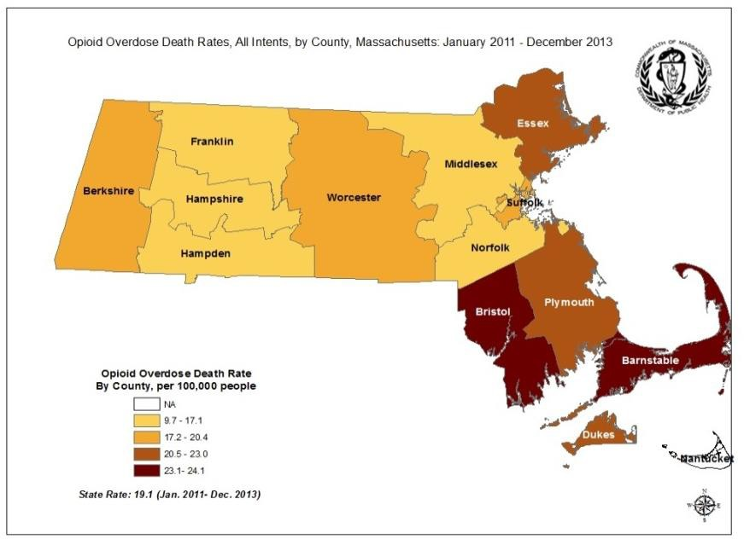

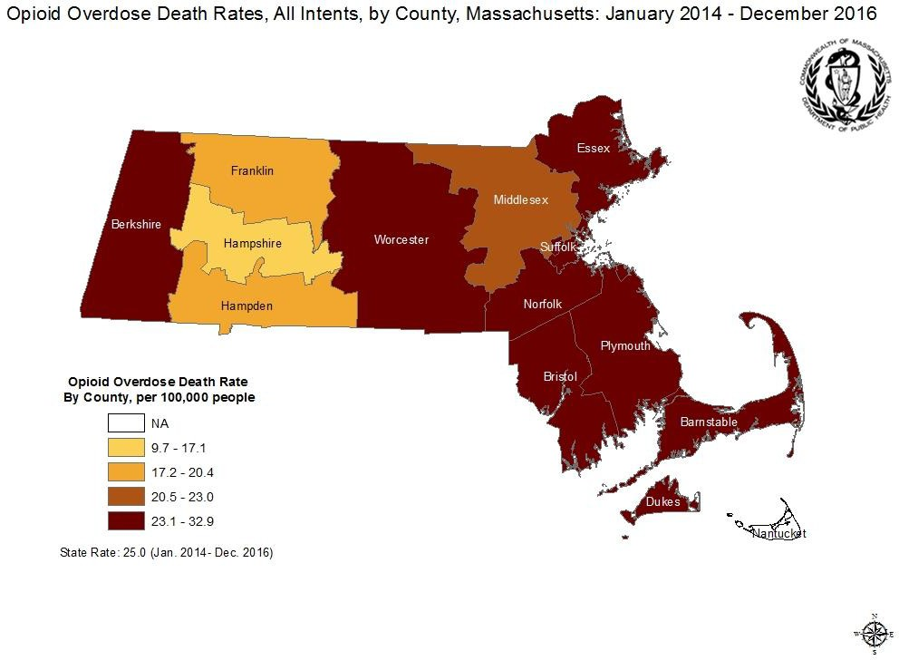

Notes:

1. All data updated on 1/25/18. Cases were defined using the International Classification of Disease (ICD-10) codes for mortality using the following codes in the underlying cause of death field: X40-X49, X60-X69, X85-X90, Y10-Y19, Y35.2. All multiple cause of death fields were then used to identify an opioid-related death, using the following ICD-10 codes: T40.0, T40.1, T40.2, T40.3, T40.4, and T40.6. Opioids include heroin, opioid-based prescription painkillers, and other unspecified opioids.

1. Please note that 2015-2016 death data are preliminary and subject to updates.
2. Rates computed for smaller counties (populations <10,000) are likely to vary significantly from year to year.
3. Low rates of opioid overdose deaths in a county should not be taken as an indication that there is no opioid abuse problem in that community.
4. County level opioid overdose death rates are computed by averaging the number of opioid-related deaths between January 2011 and December 2016 by the estimated population in the community in that same time period. County is based on county of residence for the decedent.
5. The rate is expressed as a value per 100,000 residents.
6. Beginning with the May 2017 report, DPH started reporting opioid-related deaths for all intents, which includes unintentional/undetermined and suicide