

POSTED: MAY 2017

Massachusetts Department of Public Health

**Number of Opioid1-Related Overdose Deaths, All Intents by County, MA Residents: 2000-20162**

**Note To Readers:** This is the first quarterly report for 2017. Please note that throughout all sections of this report there has been a change in the category of deaths that are included. Death data that were previously reported as “Unintentional/Undetermined” has been updated to include deaths of **“All Intents”**, which means that opioid-related deaths that have been determined by the Office of the Chief Medical Examiner as the result of suicide will now be included in the totals. This will not add significantly to the death totals, however it will allow for consistency in interpretation in the data that are presented.

|  |  |  |  |  |  |  |  |  |  |  |  |  |  |  |  |  |  |  |
| --- | --- | --- | --- | --- | --- | --- | --- | --- | --- | --- | --- | --- | --- | --- | --- | --- | --- | --- |
| **County** | **2000** | **2001** | **2002** | **2003** | **2004** | **2005** | **2006** | **2007** | **2008** | **2009** | **2010** | **2011** | **2012** | **2013** | **2014** | **20153** | **20163** | **Total 2000-2016** |
| Barnstable | 12 | 19 | 21 | 15 | 17 | 20 | 24 | 31 | 22 | 21 | 20 | 19 | 24 | 43 | 55 | 71 | 78 | 512 |
| Berkshire | 2 | 3 | 1 | 2 | 6 | 9 | 1 | 8 | 3 | 8 | 4 | 9 | 18 | 22 | 29 | 33 | 35 | 193 |
| Bristol | 38 | 58 | 66 | 84 | 72 | 78 | 85 | 64 | 84 | 70 | 79 | 82 | 95 | 116 | 144 | 172 | 233 | 1620 |
| Dukes | 1 | 0 | 1 | 0 | 1 | 2 | 0 | 3 | 1 | 2 | 0 | 0 | 0 | 1 | 5 | 7 | 33 | 27 |
| Essex | 51 | 65 | 55 | 81 | 68 | 80 | 87 | 89 | 65 | 74 | 51 | 57 | 94 | 119 | 208 | 240 | 284 | 1768 |
| Franklin | 5 | 2 | 1 | 5 | 3 | 4 | 6 | 4 | 2 | 2 | 6 | 6 | 8 | 10 | 10 | 19 | 14 | 107 |
| Hampden | 32 | 37 | 42 | 46 | 32 | 36 | 46 | 38 | 48 | 46 | 48 | 45 | 59 | 69 | 64 | 102 | 128 | 918 |
| Hampshire | 5 | 5 | 5 | 12 | 8 | 3 | 10 | 14 | 11 | 10 | 12 | 10 | 11 | 30 | 26 | 16 | 34 | 222 |
| Middlesex | 64 | 86 | 92 | 115 | 105 | 122 | 118 | 110 | 112 | 124 | 94 | 130 | 122 | 155 | 273 | 354 | 392 | 2568 |
| Nantucket | 0 | 1 | 0 | 0 | 0 | 0 | 0 | 1 | 0 | 1 | 1 | 0 | 0 | 1 | 1 | 13 | 23 | 9 |
| Norfolk | 29 | 42 | 44 | 43 | 40 | 53 | 49 | 54 | 73 | 65 | 60 | 64 | 71 | 83 | 126 | 166 | 202 | 1264 |
| Plymouth | 23 | 25 | 29 | 47 | 28 | 38 | 49 | 52 | 48 | 53 | 41 | 67 | 57 | 86 | 112 | 178 | 185 | 1118 |
| Suffolk | 49 | 87 | 98 | 106 | 83 | 66 | 107 | 103 | 74 | 95 | 64 | 85 | 91 | 111 | 145 | 210 | 253 | 1827 |
| Worcester | 68 | 75 | 71 | 58 | 51 | 63 | 74 | 71 | 78 | 67 | 80 | 82 | 91 | 115 | 162 | 223 | 226 | 1655 |
| **TOTAL DEATHS** | **379** | **5064** | **526** | **614** | **514** | **5754** | **6604** | **642** | **6224** | **638** | **560** | **656** | **7424** | **961** | **1,3614** | **1,793** | **2,069** | **13,818** |

1 Opioids include heroin, opioid-based prescription painkillers, and other unspecified opioids.

2 Please note that data for 2000-2014 have been updated following a review of cases that did not receive an official cause of death at the time the file was closed. Data for 2015-2016 death are preliminary and subject to updates. Case reviews of deaths are evaluated and updated on an ongoing basis. A large number of death certificates have yet to be assigned final cause-of-death codes. These counts are based on the estimates rather than confirmed cases. Data updated on 04/06/2017.

3 Numbers and calculations based on values less than 5 are suppressed for years in which the death file is not yet closed if they are based on pending cases. The deaths listed in Nantucket County for 2015 and 2016, and in Dukes County for 2016 are confirmed opioid overdose deaths.

4 2001, 2005, 2008, 2012, and 2014 include 1 death of a MA resident whose city/town of residence was not known; 2006 includes 4 deaths of a MA resident whose city/town of residence was not known. Also, total may not add up due to rounding.

# Please note that there is rounding of counts for 2015-2016.

**Technical Notes:**

Cases were defined using the International Classification of Disease (ICD-10) codes for mortality. The following codes were selected from the underlying cause of death field to identify poisonings/overdoses: X40-X49, X60-X69, X85-X90, Y10-Y19, and Y35.2. All multiple cause of death fields were then used to identify an opioid-related death: T40.0, T40.1, T40.2, T40.3, T40.4, and T40.6.

This report tracks all opioid-related overdoses due to difficulties in reporting heroin-associated overdoses separately. Many deaths related to heroin are not specifically coded as such due to the fast metabolism of heroin into morphine.

To maintain consistency with NCHS reporting, we do not include the ICD-10 code F11.1, which may include opioid-related overdose death.

**Source: Registry of Vital Records and Statistics, MDPH.**

**Opioid Overdose Death Rates, All Intents, by County Massachusetts: January 2011- December 2013 (reference time period)**

**vs. January 2014 - December 2016 (current time period)**

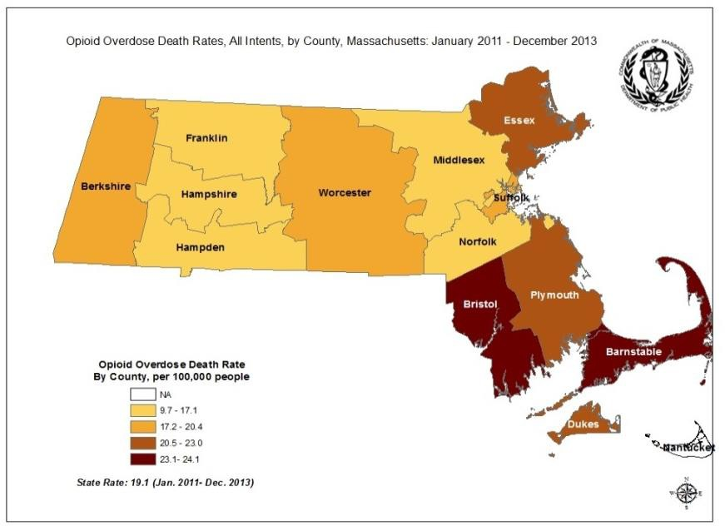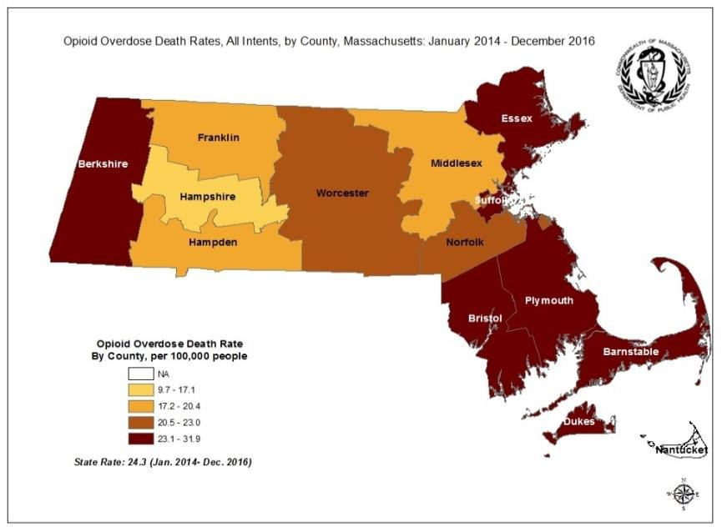

Notes:

1. All data updated on 04/06/17. Cases were defined using the International Classification of Disease (ICD-10) codes for mortality using the following codes in the underlying cause of death field: X40-X49, X60-X69, X85-X90, Y10-Y19, Y35.2. All multiple cause of death fields were then used to identify an opioid-related death, using the following ICD-10 codes: T40.0, T40.1, T40.2, T40.3, T40.4, and T40.6.
2. Opioids include heroin, opioid-based prescription painkillers, and other unspecified opioids.
3. Please note that 2015-2016 death data are preliminary and subject to updates.
4. Rates computed for smaller counties (populations <10,000) are likely to vary significantly from year to year.
5. Low rates of opioid overdose deaths in a county should not be taken as an indication that there is no opioid abuse problem in that community.
6. County level opioid overdose death rates are computed by averaging the number of opioid-related deaths between January 2011 and December 2016 by the estimated population in the community in that same time period. County is based on county of residence for the decedent.
7. The rate is expressed as a value per 100,000 residents.