INDOOR AIR QUALITY ASSESSMENT

Overlook Middle School
10 Oakmont Drive
Ashburnham, Massachusetts

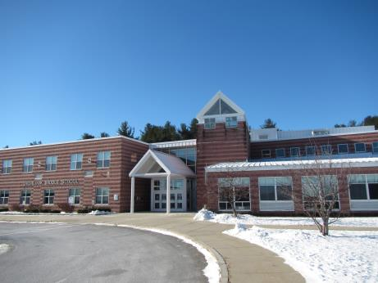

Prepared by:
Massachusetts Department of Public Health
Bureau of Environmental Health
Indoor Air Quality Program
March 2017

Background
Building: | Overlook Middle School (OMS)
Address: | 10 Oakmont Drive, Ashburnham, MA
Requested by: | Coordinated through OMS Principal, Phillip Saisa and Nashoba Associated Boards of Health
Reason for Request: | Mold concerns and general assessment
Date of Assessment: | December 16, 2016
Massachusetts Department of Public Health/Bureau of Environmental Health (MDPH/BEH) Staff Conducting Assessment: | Michael Feeney, Director, Indoor Air Quality (IAQ) Program  Jason Dustin, Environmental Analyst, IAQ Program
Building Description: | Two-story, concrete-faced school building that was constructed in 1995.
Building Population: | Approximately 565 students and 65 staff.
Windows: | Most are openable

Methods
Please refer to the IAQ Manual for methods, sampling procedures, and interpretation of results (MDPH, 2015).

IAQ Testing Results
The following is a summary of indoor air testing results (Table 1).
- Carbon dioxide levels were above 800 parts per million (ppm) in several areas assessed, indicating inadequate fresh air exchange in those areas (Table 1). The likely cause of this is discussed in the “Ventilation” section of the report.
- Temperature was within the recommended range of 70°F to 78°F in most areas assessed.
- Relative humidity was below the recommended range of 40% to 60% in all areas assessed as is typical during the heating season of the Northeast.
- Carbon monoxide levels were non-detectable (ND) in all indoor areas assessed.
- Fine particulate matter (PM2.5) concentrations measured were below the National Ambient Air Quality Standard (NAAQS) level of 35 μg/m³ in all areas assessed.

Background and Discussion
Recent renovations of the school reportedly include the installation of a new pellet-fired boiler, a new metal roof, and a complete building envelope weatherization project.

Asthma Rates
Asthma is an illness that affects the respiratory tract and airways that carry oxygen into and out of the lungs. During an asthma attack, these airways constrict, resulting in wheezing and difficulty breathing. Asthma can affect people of all ages. However, it often starts in childhood and is more common in children than adults.
Asthma is a common chronic disease that continues to increase in prevalence. It is the most common chronic disease in children. The state of Massachusetts has an elevated rate of asthma compared to the national prevalence rate.
Causes of asthma are unknown. However, episodes of asthma (asthma attacks) can be triggered by certain environmental pollutants such as air pollution, mold, pets/pet dander, and dust mites. A number of studies have reported links between exposure to air pollution and asthma. Reducing exposure to these pollutants can help prevent symptoms. Other factors are also linked with asthma. Therefore, when comparing asthma rates across geographic areas, factors such as access to medical care and health behaviors (e.g., diet or exercise) must also be considered. The MDPH participates in two programs associated with tracking asthma rates in the state.
To track asthma prevalence among children in Massachusetts, a state-wide surveillance program was implemented with participation from public and private schools serving grades kindergarten through eighth grade. Beginning in 2003 and continuing through the present, the MDPH has tracked the occurrence of pediatric asthma through school health records.
The MDPH/BEH has a program that compiles pediatric asthma data in schools for children in kindergarten through 8th grade. This data is provided to MDPH from school medical staff on an annual basis and is posted to the Massachusetts Environmental Public Health Tacking website. Pediatric asthma data is available for school year 2009-2010 through 2014-2015.
The OMS pediatric data reports for this six-year time period show that asthma rates were either statistically significant lower or not statistically different than the average rates found across all schools in Massachusetts (Table 2). Based on available data, the asthma rates reported at the OMS were either lower or comparable to the average rates reported for all Massachusetts schools.

Ventilation
Fresh air in most classrooms is supplied by a unit ventilator (univent) system which draws outside air from exterior vents (Picture 1) and mixes it with room air. The unit ventilators on outer classrooms have recently been replaced with new units. These units are still in the process of being commissioned and adjusted with the manufacturer. These unit ventilators provide heat-only and are not equipped with air conditioning. Some outer classrooms were noted to have portable air conditioning units ducted directly outside.
Rooms with univents do not share air flow with other rooms. Outdoor air flows from the windows/univents through the core of each room, then to the exhaust vent along the interior wall in the room (Figure 1). This type of system functions to isolate classrooms from each other. Therefore, if a condition that creates pollutants/odors exists within a room, it becomes isolated within that area and is directly vented by the exhaust system.
Interior rooms are supplied with fresh air by ceiling-mounted air diffusers (Picture 2). Some interior rooms are cooled with air conditioning. Exhaust vents are located on walls or ceilings (Picture 3). The BEH typically recommends that AHUs/unit ventilators are operated in the fan “on” mode to provide continuous fresh air circulation/filtration during occupied hours.
As mentioned above, carbon dioxide was elevated in some areas; mainly in 2nd floor classrooms with a full class size or where the students had just left the room. The temperature was below zero on the morning of the assessment and the unit ventilators are equipped with dampers to regulate the outside air flow into the units. When these units are in warm up mode the fresh air inlet louvers are closed to allow the recirculation of room air rather than bringing in the extremely cold fresh air. As a result of this extreme cold it is likely that the fresh air dampers to the units were not fully open and inadequate air exchange temporarily resulted in select classrooms.

Microbial/Moisture Concerns
BEH staff noted several water-damaged ceiling tiles (Pictures 4 and 5) in the OMS. These leaks were reported by OMS facilities staff to be historic in nature. As mentioned, the roof has been newly installed and the building envelope recently weatherized. However, water-damaged porous building materials (e.g., ceiling tiles) should be replaced if not properly dried within 24-48 hours of becoming wet (US EPA, 2008).
A slight musty odor was detected by BEH staff in room #213. No obvious water-damage or source of mold growth was visible. Based on this observation, the source of this odor could be the wall-to-wall carpeting in this classroom. Spills on carpeting or porous items/debris can allow microbial colonization and associated odors if not reported and cleaned promptly. This room should be inspected for water-damaged carpeting or moistened debris/porous items.
BEH staff noted the presence of at least two portable air conditioning (AC) units. These units are ducted directly outside and do not require condensate pumps. It is important to continue to maintain/clean the units according to manufacturer recommendations. Also, windows should not be opened when these units are operating in cooling mode to reduce the risk of any condensation on porous building materials in the rooms.
Plants were observed in a few areas (Picture 6; Table 1). Plants can be a source of pollen and mold, which can be respiratory irritants to some individuals. Plants should be properly maintained and equipped with drip pans and should be located away from air diffusers to prevent the aerosolization of dirt, pollen and mold.

Other Concerns
Exposure to low levels of total volatile organic compounds (TVOCs) may produce eye, nose, throat, and/or respiratory irritation in some sensitive individuals. To determine if VOCs were present, BEH/IAQ staff examined rooms for products containing VOCs. BEH/IAQ staff noted hand sanitizers, cleaners, air deodorizers, and dry erase materials in use within the building (Picture 7; Table 1). All of these products have the potential to be irritants to the eyes, nose, throat, and respiratory system of sensitive individuals.
Some univents were opened and found to have inefficient filters (Picture 8). MDPH typically recommends having a MERV 9 or higher pleated filter to reduce particulate matter in the building. The univent manufacturer should be consulted prior to increasing filter efficiency.
In some classrooms, items were observed on windowsills, tabletops, counters, desks, and floors (Picture 9). The large number of items stored in classrooms provides a source for dusts to accumulate. These items, (e.g. papers, folders, boxes) make it difficult for custodial staff to clean. Dust can be irritating to eyes, nose, and respiratory tract. Items should be relocated and/or be cleaned periodically to avoid excessive dust build up. No items should be placed on or in front of unit ventilators (Picture 10) as this will interfere with the proper operation or contribute to particulate matter in the air stream.
Some univent cabinets were noted to have gaps around utilities penetrating the cabinet (Picture 11). These gaps should be sealed using an appropriate sealant/insulation to prevent the univent from drawing odors or particulate matter from unconditioned areas.
The Institute of Inspection, Cleaning and Restoration Certification (IICRC), recommends that carpeting be cleaned annually (or semi-annually in soiled high traffic areas) (IICRC, 2012). OMS facilities staff reported that this as well as daily HEPA vacuuming is being performed. It was also reported by facilities staff that carpeting throughout the OMS was approximately 20 years old. Since the average lifespan of carpeting is approximately eleven years (Bishop, 2002), consideration should be given to planning for the installation of new flooring.

Conclusions/Recommendations
Based on observations at the time of assessment, there are no unusual conditions in the OMS related to water damage or mold colonization that are a building-wide problem. Possible sources of mold growth, water-damaged ceiling tiles and musty carpet, were observed in isolated areas. Other conditions that can affect IAQ were noted in the building, The following recommendations are made to improve IAQ in the building:
- Continue to work with the univent manufacturer/HVAC vendor to make necessary modifications to unit ventilators (e.g., dampers, warm up times, etc.) to ensure adequate fresh air exchange in the classrooms even during extreme weather events.
- Operate supply and exhaust ventilation continuously in all occupied areas during school hours. Ensure that all mechanical ventilation units are in proper working order and make repairs/adjustments as necessary.
- Investigate the source of the slight musty odor in room #213 and remedy as needed.
- Replace any water-damaged porous building materials (e.g., ceiling tiles) if they were not properly dried within 24-48 hours of becoming wet.
- Continue to maintain/clean the portable AC units according to manufacturer recommendations. Also, windows should not be opened when these units are operating in cooling mode to reduce the risk of any condensation on porous building materials in the rooms.
- Change filters regularly in univents (2 to 4 times a year), and vacuum the cabinets of debris each time the filters are changed. Consider upgrading to a minimum of MERV 9 filter. Consult manufacturer to ensure that univents are capable of operating with the higher-efficiency filters.
- Eliminate/reduce the use of hand sanitizers, fragrances, harsh or scented cleaning products and dry erase materials in the school since all of these products have the potential to be irritants to the eyes, nose, throat, and respiratory system of sensitive individuals.
- Plants should be properly maintained and equipped with drip pans and should be located away from air diffusers to prevent the aerosolization of dirt, pollen and mold.
- Accumulated items (e.g., papers, folders, boxes) on flat surfaces make it difficult for custodial staff to clean. Items should be relocated and/or be cleaned periodically to avoid excessive dust build up and allow for regular wet-wiping of surfaces.
- Avoid storing items on or in front of univents or exhaust vents since this may interfere with proper operation of the units or add particulate matter to the air stream.
- Since the lifespan of the carpeting has been exceeded, consider planning for the future installation of new flooring.
- For buildings in New England, periods of low relative humidity during the winter are often unavoidable. Therefore, scrupulous cleaning practices should be adopted to minimize common indoor air contaminants whose irritant effects can be enhanced when the relative humidity is low. To control for dusts, a high efficiency particulate arrestance (HEPA) filter equipped vacuum cleaner in conjunction with wet wiping of all surfaces is recommended. Avoid the use of feather dusters. Drinking water during the day can help ease some symptoms associated with a dry environment (throat and sinus irritations).
- Refer to resource manual and other related IAQ documents located on the MDPH’s website for further building-wide evaluations and advice on maintaining public buildings. These documents are available at: http://mass.gov/dph/iaq.

References

Bishop. 2002. Bishop, J. & Institute of Inspection, Cleaning and Restoration Certification. A Life Cycle Cost Analysis for Floor Coverings in School Facilities.
IICRC. 2012. Institute of Inspection, Cleaning and Restoration Certification. Carpet Cleaning: FAQ. Retrieved from http://www.iicrc.org/consumers/care/carpet-cleaning.
MDPH. 2015. Massachusetts Department of Public Health. Indoor Air Quality Manual: Chapters I-III. Available at: http://www.mass.gov/eohhs/gov/departments/dph/programs/environmental-health/exposure-topics/iaq/iaq-manual/.
US EPA. 2008. “Mold Remediation in Schools and Commercial Buildings”. Office of Air and Radiation, Indoor Environments Division, Washington, DC. EPA 402-K-01-001. September 2008. Available at: http://www.epa.gov/mold/mold-remediation-schools-and-commercial-buildings-guide.
Figure 1
One-way airflow contained in each classroom

Exhaust
Exhaust
Exhaust
Univent
Univent
Univent

Picture 1
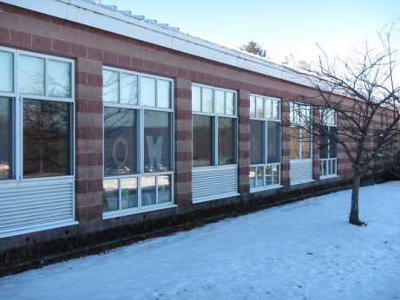
Unit ventilator fresh air intake vents (arrows)
Picture 2
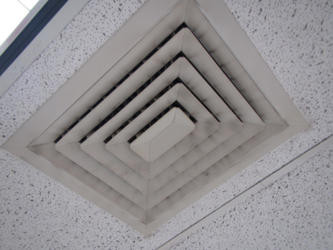
Interior room supply vent
Picture 3
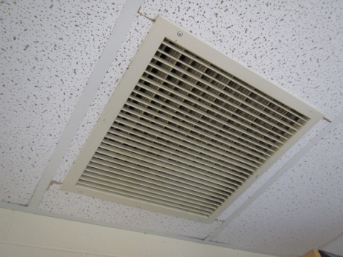
Ceiling-mounted exhaust/return vent
Picture 4
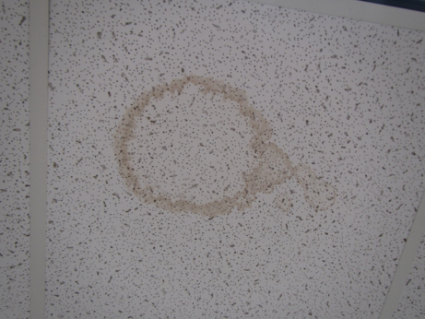
Water-damaged ceiling tile
Picture 5
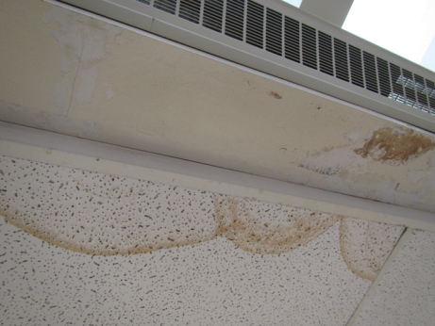
Water-damaged ceiling tiles beneath a window/radiator
Picture 6
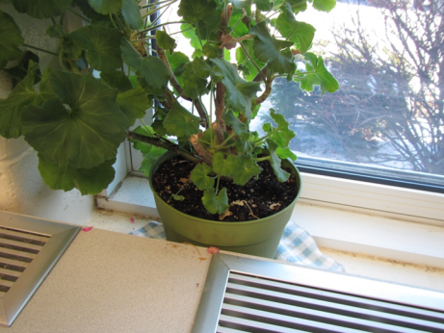
Plant located on porous cloth near unit ventilator
Picture 7
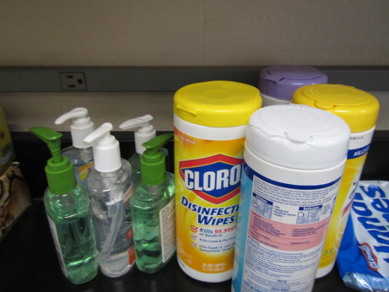
Scented cleaning products and hand sanitizers
Picture 8
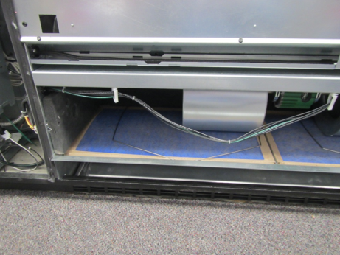
Univent showing inefficient filters
Picture 9
Accumulated items in classroom
Picture 10
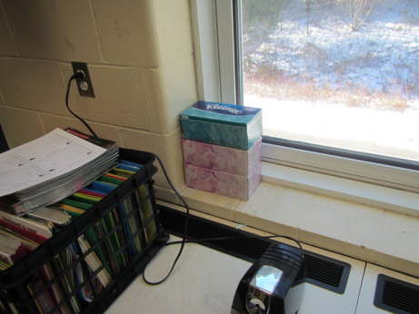
Pencil sharpener and other items on unit ventilators
Picture 11
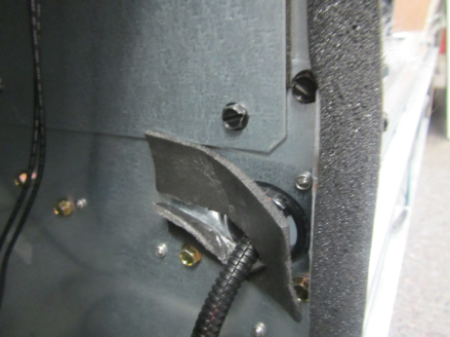
Univent cabinet showing gaps around wiring

Location | Carbon  Dioxide  (ppm) | Carbon Monoxide  (ppm) | Temp  (°F) | Relative  Humidity  (%) | PM2.5  (µg/m³) | Occupants  in Room | Windows  Openable | Ventilation |  | Remarks
 |  |  |  |  |  |  |  | Supply | Exhaust
Background | 356 | ND | 6 | 4 | 8 |  |  |  |  | Cold, clear
Main office | 554 | ND | 66 | 17 | 5 | 6 | N | Y | Y | carpet
106 Nurse | 507 | ND | 70 | 6 | 4 | 3 | N | Y | Y | HS
106 rear | 494 | ND | 70 | 6 | 4 | 1 | N | Y | Y
110 | 926 | ND | 71 | 10 | 4 | 25 | Y | Y | Y | carpet
111 | 711 | ND | 71 | 8 | 4 | 19 | Y | Y | Y
112 | 568 | ND | 70 | 7 | 4 | 7 | Y | Y | Y
113 | 512 | ND | 75 | 8 | 4 | 0 | Y | Y | Y
117 Art | 653 | ND | 73 | 7 | 4 | 3 | Y | Y | Y | Kiln w/vented flue and exhaust hood
140 | 781 | ND | 70 | 9 | 5 | 27 | N | Y | Y | DEM, HS, 3D printer (vented)
118 | 552 | ND | 72 | 7 | 6 | 3 | Y | Y | Y | DEM, Chalk board
120 | 627 | ND | 71 | 8 | 5 | 3 | Y | Y | Y | HS
141 | 550 | ND | 70 | 8 | 4 | 0 | N | Y | Y | WD CTs x 3
121 | 491 | ND | 70 | 6 | 4 | 3 | Y | Y | Y | carpet
122 | 622 | ND | 70 | 8 | 5 | 0 | Y | Y | Y | DEM
123 | 531 | ND | 70 | 6 | 6 | 0 | Y | Y | Y | DEM
124 | 541 | ND | 69 | 7 | 4 | 0 | Y | Y | Y | carpet
125 | 756 | ND | 70 | 8 | 5 | 7 | Y | Y | Y | carpet
126 | 581 | ND | 71 | 6 | 5 | 0 | Y | Y | Y | Carpet, DEM, HS
159 | 581 | ND | 71 | 6 | 5 | 0 | Y | Y | Y | Carpet
Cafeteria-175 | 492 | ND | 70 | 7 | 7 | 5 | Y | Y | Y
201 | 1008 | ND | 70 | 10 | 4 | 18 | Y | Y | Y | CPs, HS
202 | 610 | ND | 70 | 8 | 5 | 15 | Y | Y | Y | DEM, HS
203 | 680 | ND | 70 | 7 | 4 | 18 | Y | Y | Y | CPs
204 | 720 | ND | 71 | 8 | 5 | 21 | Y | Y | Y | HS, CPs, DEM
205 | 925 | ND | 71 | 10 | 4 | 11 | Y | Y | Y | Chalk dust
231 | 646 | ND | 71 | 8 | 4 | 7 | N | Y | Y | Upholstered furniture, DEM
207 | 981 | ND | 71 | 11 | 4 | 18 | N | Y | Y | MT to be replaced
209 | 782 | ND | 72 | 9 | 4 | 17 | N | Y | Y | Plants, AI
210 | 832 | ND | 71 | 9 | 5 | 5 | N | Y | Y
212 | 658 | ND | 72 | 7 | 6 | 12 | N | Y | Y
213 | 1277 | ND | 72 | 12 | 6 | 19 | Y | Y | Y | Carpet, musty odor
214 | 1174 | ND | 72 | 10 | 5 | 15 | Y | Y | Y | CPs, cleaning odor
221- computers | 494 | ND | 71 | 6 | 4 | 1 | N | Y | Y | HS, split AC
215 | 937 | ND | 71 | 10 | 4 | 3 | Y | Y | Y | CPs, HS, DEM
216 | 1268 | ND | 71 | 14 | 4 | 4 | Y | Y | Y | Portable AC unit, carpet
217 | 1306 | ND | 71 | 10 | 6 | 18 | Y | Y | Y | Carpet, chalk & DEM
218 | 1035 | ND | 71 | 9 | 4 | 11 | Y | Y | Y | Carpet, CPs
259 Auditorium |  |  |  |  |  |  |  |  |  | WD CT
265 | 492 | ND | 71 | 5 | 5 | 5 | N | Y | Y | Carpet
263 | 598 | ND | 71 | 5 | 4 | 1 | N | Y | Y | CPs, carpet, DEM

School Year | Overlook Middle School |  | MA | COMPARISON
 | Student Enrollment Count | Prevalence  (%) | Statewide Prevalence  (%) | School prevalence is…
2009-2010 | 565 | 3.5 | 11.5 | Statistically significantly lower
2010-2011 | 596 | 4.7 | 11.7 | Statistically significantly lower
2011-2012 | 582 | 9.5 | 11.9 | Not statistically significantly different
2012-2013 | 595 | 13.9 | 12.1 | Not statistically significantly different
2013-2014 | 565 | 13.3 | 12.4 | Not statistically significantly different
2014-2015 | 570 | 12.6 | 12.4 | Not statistically significantly different
 | (Source: Massachusetts Environmental Public Health tracking, https://matracking.ehs.state.ma.us/)
- | U or Unstable indicates that a rate is unstable, because it has a relative standard error > 30%, and should be interpreted with caution.
- | NS indicates number/prevalence not shown due to small numbers. These data are suppressed for confidentiality reasons.
- | NA indicates insufficient school enrollment data available to calculate prevalence. NA for both student case count and student enrollment may indicate the school location is no longer in use.
- | School list is based on the current data provided by the Massachusetts Department of Education http://www.doe.mass.edu/
- | When comparing prevalence across geographic areas, a variety of non-environmental factors can impact asthma prevalence.
- | Asthma and diabetes prevalence are only for children enrolled in grades Kindergarten through 8th grade.
- | Statistical significance indicates that prevalence is different from the state prevalence and the difference is unlikely due to chance.
- | School-based prevalence is based on the number of student cases attending the school and not necessarily the location of the source of exposure.
- | Data source: Bureau of Environmental Health Massachusetts Department of Public Health.
- | Numbers and prevalence may differ slightly from those contained in other publications. These differences may be due to file updates, differences in calculating prevalence and updates in population estimates.

