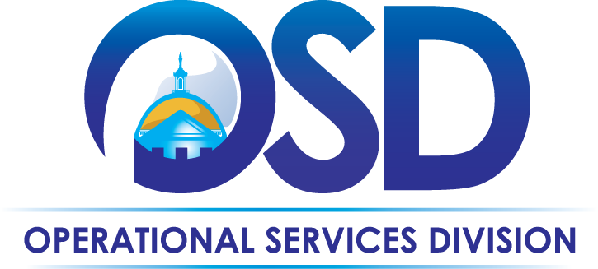
The Commonwealth of Massachusetts
Operational Services Division
Office of Vehicle Management

OVM Services Overview

The Executive Office for Administration and Finance Operational Services Division’s Office of Vehicle Management (OVM) provides oversight, support and services to Commonwealth Agencies and/or Departments whose vehicles fall under the purview of the OVM Policies and Procedures. OVM’s oversight includes promotion of best practices, safety protocols and cost effective, fuel efficient vehicle utilization and management.

Executive Branch Agencies (excluding law enforcement or those with independent authority) fall under OVM purview in accordance with Massachusetts General Laws. Other departments or agencies may choose to fall under OVM purview by leasing vehicles through the OVM Lease Program or receiving OVM services (beyond registration) for their “owned” vehicles. Currently, OVM oversees more than 2,500 vehicles across 42 Agencies.

A per vehicle administrative fee is applied annually to all applicable vehicles to help offset the costs of providing these services, which include, but are not limited to, the following:

- Vehicle purchasing through statewide contracts
  - Liaise with OSD Sourcing to define and shape vehicle purchase contracts
  - Audit and quality check all vehicle acquisitions to assure that data matches up with statewide contract pricing and specifications
  - Make recommendations for most economical and fuel-efficient vehicle purchases that meet the stated business needs
  - Obtain confirmation communication from agency that appropriated funds are being used for vehicle acquisitions
  - As an alternative to a department fully funding a vehicle purchase, OVM offers a lease program in which OVM funds the initial purchase price and the department repays OVM over 60 months
    - Additional information regarding the OVM Lease Program is located on the OVM home page
- The receipt and inspection of all new light duty and passenger vehicles
  - Act as liaison with dealer to coordinate delivery of new vehicles to the OVM holding lot
  - Review and inspection of delivered vehicles to ensure that the vehicle specifications match the originally ordered vehicles
  - Removal of all OEM stickers, inspection to ensure that there is no damage, and installation of all applicable decals to ensure compliance with the OVM policies and procedures
  - Coordination of new vehicle pick-up with recipient agencies, including documentation of same
- Registrations, titles and plates (including renewals and duplicates)
  - Audit and quality check all new, duplicate & renewal registration paperwork from dealers and agencies to assure vehicle data matches
  - Process paperwork into registrations, including obtaining appropriate signatures, liaising with the Registry, obtaining and distributing plates, and maintaining accurate records of same
  - Assist agency personnel with additional information and understanding regarding registration process and/or policies
- Fuel card management (statewide contract for Fuel Card and Fuel Management Services)
  - Order new and replacement fuel cards for all managed vehicles, including PINs
    - The new card process is initiated by OVM when the vehicle is picked up by the agency from the OVM Westborough holding lot
  - Terminate fuel cards, as appropriate, to help prevent fraudulent charges
  - Review exception reporting for policy compliance
  - Review, audit and approve payment for OSD vehicle fuel purchases
- Coordination of maintenance, repair (including tires) and accident subrogation services and provision of vehicle packets (statewide contracts for Maintenance Management, Tires & Accident Subrogation Services)
  - Provision of preventive maintenance schedule upon delivery of new vehicle
  - Act as liaison between agency and vendor when repairs are required, including initial review of repair items for appropriateness
  - Review, audit and approve payment for OSD leased vehicles
- Driver accident reporting, monitoring, and follow-up
  - Review accident reports and classifications to determine if follow-up with agency is required for at-fault drivers
  - Isolate and distribute quarterly at-fault driver reporting to track accidents and provide information to agencies so the appropriate corrective actions can be implemented to mitigate risk/liability
  - Oversee the accident management process with departments, including facilitating communications and documenting same
  - Maintain all accident information within the fleet database
- Fleet inventory and data system management
  - Maintain accurate records of all state vehicles in one place, to assist with policy compliance, utilization and replacement scheduling
  - Capture vehicle specification information; such as GVW, Drive Train, Primary and Secondary Fuel Type to facilitate more efficient reporting
  - Assist MIS with website link testing
- Vehicle redeployment or disposition management
  - Receive all excess or end-of-life vehicles at the OVM holding lot, conduct a thorough review of their condition and determine remaining usefulness
  - Work with agencies to fulfill vehicle requests with excess vehicles located at the OVM holding lot
  - Process vehicle auctions to dispose of vehicles that have reached end-of-life status
- Assisting department fleet managers
  - Act as liaison between agencies, cities, towns and vendors, as appropriate
  - Identify appropriate recipient for all toll violations, parking tickets, excise tax bills and recall notices and forward for resolution
  - Coordinate excise tax bill process with cities and towns, including the abatement process, for state vehicles
  - Assist with the leased vehicle request, order and delivery process
  - Education on various fleet policies, processes, services and requirements
  - Respond to public record requests related to state vehicles
- Compliance and auditing
  - Conduct periodic vehicle reviews to ensure policy compliance and appropriate vehicle utilization and replacement scheduling
  - Determine fleet needs of agencies reviewed; make recommendation in regard to fleet size and type
  - Accurately document audit findings and rectify any discrepancies related to agency vehicle inventories
- Management of the 1-800-How Am I Driving program and other citizen complaints
  - Identify legitimate complaints from overall calls and forward to appropriate agency for resolution
  - Track and identify repeat offenders to departments for corrective action
- Domicile approval process and IRS reporting services
  - Thorough review of all domicile requests to ensure appropriateness of domicile assignments
  - Assist with process of calculating the personal use of state vehicles that must be reported to the IRS as fringe benefit income
- Management of federal reporting and alternative fuel mandates
  - Annual EPAct and EIA-886 reporting for DOE regarding Alternative Fueled Vehicles

