INDOOR AIR QUALITY ASSESSMENT

Oxford Elementary School
347 Main Street
Fairhaven, MA



Prepared by:
The Massachusetts Department of Public Health
Bureau of Environmental Health
Indoor Air Quality Program
February 2013

Background/Introduction
At the request of Dr. Robert N. Baldwin, Superintendant, Fairhaven Public Schools, the Massachusetts Department of Public Health (MDPH), Bureau of Environmental Health (BEH) conducted an indoor air quality (IAQ) assessment at the Oxford Elementary School (OES) located at 347 Main Street, Fairhaven, Massachusetts.
The request was originally prompted by mold concerns that occurred over the summer of 2012. Mike Feeney, Director of BEH’s IAQ Program, had previously visited the building on August 29, 2012 to address mold concerns and issued a report based on observations made at that time, with recommendations to improve air quality (MDPH, 2012).
On September 11, 2012 a visit to conduct a general IAQ assessment was made to the OES by Mr. Feeney and Cory Holmes, Environmental Analyst/Regional Inspector in BEH’s IAQ Program. BEH/IAQ staff were accompanied by Ms. Patricia Fowle, Health Agent, Fairhaven Board of Health during the assessment. Mr. Holmes returned on January 31, 2013 to conduct further testing to evaluate the building while the heating system was operating.
The original school is a two-story red brick building with basement completed in 1896. The second floor is primarily general classrooms. The first floor contains general classrooms and office space. The basement is unoccupied. A two-story red brick addition was made in 1951. The upper floor consists of general classrooms and office space, the lower floor contains the cafeteria and gymnasium. The school was closed in 2007; it is currently being used as swing space by the Leroy L. Wood Elementary staff and students while a new Wood school is being built.

Methods
Air tests for carbon monoxide, carbon dioxide, temperature and relative humidity were conducted with the TSI, Q-Trak, IAQ Monitor, Model 7565. Air tests for airborne particle matter with a diameter less than 2.5 micrometers were taken with the TSI, DUSTTRAK™ Aerosol Monitor, Model 8520. BEH/IAQ staff also performed visual inspection of building materials for water damage and/or microbial growth. Test results for the September 11, 2012 results are listed in Table 1; results for January 31, 2013 are listed in Table 2.

Results
This elementary school houses grades K through 5, with a student population of 235 and a staff of approximately 25. The tests were taken under normal operating conditions. Test results appear in Table 1.

Discussion

Ventilation
It can be seen from Table 1 that carbon dioxide levels were below 800 parts per million (ppm) in 15 of 18 areas surveyed on September 11, 2012. On January 31, 2013 carbon dioxide levels were below 800 parts per million (ppm) in 17 of 20 areas surveyed (Table 2). These results indicate that adequate air exchange existed in most areas of the building at the time of the assessments.
Fresh air in classrooms throughout the school is supplied by unit ventilator (univent) systems (Picture 1). It appears that univents were retrofitted into the original 1896 building at the time of the 1951 addition. A univent draws air from the outdoors through a fresh air intake located on the exterior wall of the building (Picture 2) and returns air through an air intake located at the base of the unit. Fresh and return air are mixed, filtered, heated and provided to classrooms through an air diffuser located in the top of the unit (Figure 1). At the time of the September 11, 2012 visit, univents were found deactivated throughout the building (several were reportedly on a repair list). As a result, there was no means to mechanically introduce fresh air in classrooms occurring at the time of assessment. Univents were also obstructed by items such as boxes, papers and books (Picture 1). In order to function as designed, univents must be activated and allowed to operate free of obstructions. At the time of the January 31, 2013 visit, all univents appeared to be operational, however many were obstructed and/or deactivated, including those in the cafeteria.
Exhaust ventilation for the original 1896 building was provided by a gravity-feed system that worked on heated air rising called the “stack effect”. This system has been largely abandoned with the wall grates sealed in the majority of classrooms (Pictures 3 and 4). The mechanical exhaust ventilation system in the 1951 wing consists of powered exhaust vents located in the ceiling of coat closets (Picture 5). Some exhaust vents were observed occluded with dust (Picture 5), which can impede airflow and reduce the effectiveness of the vent to exchange air. At the time of the September 11, 2012 assessment, the motor for the exhaust vents was being repaired by a heating, ventilation and air conditioning (HVAC) technician; therefore the vents were not functioning in classrooms. As with the univents, exhaust vents need to be activated to function as designed. Exhaust vents should also be free of debris to prevent re-aerosolization of these materials, particularly if backdrafting occurs when exhaust vents are not functioning as designed. Without adequate supply and exhaust ventilation, excess heat and environmental pollutants can build up and lead to indoor air/comfort complaints. At the time of the January 31, 2013 visit, the exhaust vents were operational.
Fresh air to the gymnasium is provided by air-handling units (AHU) via wall-mounted vents. Air is returned to the AHUs via ducted vents. This system was not operating at the time of January 31, 2013 assessment. The system should be operating during gym occupation to remove excess heat and odors.
To maximize air exchange, the MDPH recommends that both supply and exhaust ventilation operate continuously during periods of building occupancy. In order to have proper ventilation with a mechanical supply and exhaust system, the systems must be balanced to provide an adequate amount of fresh air to the interior of a room while removing stale air from the room.
Minimum design ventilation rates are mandated by the Massachusetts State Building Code (MSBC). Until 2011, the minimum ventilation rate in Massachusetts was higher for both occupied office spaces and general classrooms, with similar requirements for other occupied spaces (BOCA, 1993). The current version of the MSBC, promulgated in 2011 by the State Board of Building Regulations and Standards (SBBRS), adopted the 2009 International Mechanical Code (IMC) to set minimum ventilation rates. Please note that the MSBC is a minimum standard that is not health-based. At lower rates of cubic feet per minute (cfm) per occupant of fresh air, carbon dioxide levels would be expected to rise significantly. A ventilation rate of 20 cfm per occupant of fresh air provides optimal air exchange resulting in carbon dioxide levels at or below 800 ppm in the indoor environment in each area measured. MDPH recommends that carbon dioxide levels be maintained at 800 ppm or below. This is because most environmental and occupational health scientists involved with research on IAQ and health effects have documented significant increases in indoor air quality complaints and/or health effects when carbon dioxide levels rise above the MDPH guidelines of 800 ppm for schools, office buildings and other occupied spaces (Sundell et al., 2011). The ventilation must be on at all times that the room is occupied. Providing adequate fresh air ventilation with open windows and maintaining the temperature in the comfort range during the cold weather season is impractical. Mechanical ventilation is usually required to provide adequate fresh air ventilation.
Carbon dioxide is not a problem in and of itself. It is used as an indicator of the adequacy of the fresh air ventilation. As carbon dioxide levels rise, it indicates that the ventilating system is malfunctioning or the design occupancy of the room is being exceeded. When this happens, a buildup of common indoor air pollutants can occur, leading to discomfort or health complaints. The Occupational Safety and Health Administration (OSHA) standard for carbon dioxide is 5,000 parts per million parts of air (ppm). Workers may be exposed to this level for 40 hours/week, based on a time-weighted average (OSHA, 1997).
The MDPH uses a guideline of 800 ppm for publicly occupied buildings. A guideline of 600 ppm or less is preferred in schools due to the fact that the majority of occupants are young and considered to be a more sensitive population in the evaluation of environmental health status. Inadequate ventilation and/or elevated temperatures are major causes of complaints such as respiratory, eye, nose and throat irritation, lethargy and headaches. For more information concerning carbon dioxide, consult Appendix A.
Temperatures measured on September 11, 2012 ranged from 70°F to 79°F (Table 1) and on January 31, 2013 ranged from 69°F to 72°F (Table 2), which were within or very close to the MDPH recommended comfort range at the time of both assessments. The MDPH recommends that indoor air temperatures be maintained in a range of 70°F to 78°F in order to provide for the comfort of building occupants. In many cases concerning indoor air quality, fluctuations of temperature in occupied spaces are typically experienced, even in a building with an adequate fresh air supply.
The relative humidity measured in the building on September 11, 2012 ranged from 35 to 49 percent, which was within or slightly below the MDPH recommended comfort range (Table 1). The relative humidity measured in the building on January 31, 2013 ranged from 41 to 56 percent, which was within the MDPH recommended comfort range (Table 2). The MDPH recommends a comfort range of 40 to 60 percent for indoor air relative humidity. Relative humidity levels in the building would be expected to drop during the winter months due to heating. The sensation of dryness and irritation is common in a low relative humidity environment. Low relative humidity is a very common problem during the heating season in the northeast part of the United States.

Microbial/Moisture Concerns
As mentioned previously, the request for assessment was originally prompted by mold concerns that occurred over the summer of 2012. At the time of the September 11, 2012 visit, BEH/IAQ staff found all classrooms, offices and the gymnasium free of mold-contaminated materials, mold-colonized building components/structures and musty odors. However, visible mold growth was observed in the gaskets of the refrigerator and freezer in the teacher’s lounge (Picture 6).
The January 31, 2013 visit occurred after a period of heavy wind and rain. Pooling water was observed in the landing at the bottom of the exterior stairwell to the learning lab (Picture 7). Accumulated leaves and debris were noted at the bottom of the stairwell, likely clogging the drain. At the conclusion of the assessment, BEH/IAQ staff recommended that the drain be cleared to prevent rising water from entering the building underneath the exterior door to the learning lab.

Other Indoor Air Evaluations
Indoor air quality can be negatively influenced by the presence of respiratory irritants, such as products of combustion. The process of combustion produces a number of pollutants. Common combustion emissions include carbon monoxide, carbon dioxide, water vapor, and smoke (fine airborne particle material). Of these materials, exposure to carbon monoxide and particulate matter with a diameter of 2.5 micrometers (μm) or less (PM2.5) can produce immediate, acute health effects upon exposure. To determine whether combustion products were present in the indoor environment, BEH/IAQ staff obtained measurements for carbon monoxide and PM2.5.

Carbon Monoxide
Carbon monoxide is a by-product of incomplete combustion of organic matter (e.g., gasoline, wood and tobacco). Exposure to carbon monoxide can produce immediate and acute health affects. Several air quality standards have been established to address carbon monoxide and prevent symptoms from exposure to these substances. The MDPH established a corrective action level concerning carbon monoxide in ice skating rinks that use fossil-fueled ice resurfacing equipment. If an operator of an indoor ice rink measures a carbon monoxide level over 30 ppm, taken 20 minutes after resurfacing within a rink, that operator must take actions to reduce carbon monoxide levels (MDPH, 1997).
The American Society of Heating Refrigeration and Air-Conditioning Engineers (ASHRAE) has adopted the National Ambient Air Quality Standards (NAAQS) as one set of criteria for assessing indoor air quality and monitoring of fresh air introduced by HVAC systems (ASHRAE, 1989). The NAAQS are standards established by the US EPA to protect the public health from six criteria pollutants, including carbon monoxide and particulate matter (US EPA, 2006). As recommended by ASHRAE, pollutant levels of fresh air introduced to a building should not exceed the NAAQS levels (ASHRAE, 1989). The NAAQS were adopted by reference in the Building Officials & Code Administrators (BOCA) National Mechanical Code of 1993 (BOCA, 1993), which is now an HVAC standard included in the Massachusetts State Building Code (SBBRS, 2011). According to the NAAQS, carbon monoxide levels in outdoor air should not exceed 9 ppm in an eight-hour average (US EPA, 2006).
Carbon monoxide should not be present in a typical, indoor environment. If it is present, indoor carbon monoxide levels should be less than or equal to outdoor levels. Outdoor carbon monoxide concentrations were non-detect (ND) at the time of both assessments (Tables 1 and 2). No measurable levels of carbon monoxide were detected inside the building during either assessment (Tables 1 and 2).

Particulate Matter
The US EPA has established NAAQS limits for exposure to particulate matter. Particulate matter is airborne solids that can be irritating to the eyes, nose and throat. The NAAQS originally established exposure limits to particulate matter with a diameter of 10 μm or less (PM10). According to the NAAQS, PM10 levels should not exceed 150 micrograms per cubic meter (μg/m³) in a 24-hour average (US EPA, 2006). These standards were adopted by both ASHRAE and BOCA. Since the issuance of the ASHRAE standard and BOCA Code, US EPA established a more protective standard for fine airborne particles. This more stringent PM2.5 standard requires outdoor air particle levels be maintained below 35 μg/m³ over a 24-hour average (US EPA, 2006). Although both the ASHRAE standard and BOCA Code adopted the PM10 standard for evaluating air quality, MDPH uses the more protective PM2.5 standard for evaluating airborne particulate matter concentrations in the indoor environment.
On September 11, 2012 outdoor PM2.5 was measured at 6 μg/m³ (Table 1). PM2.5 levels measured indoors ranged from 6 to 11 μg/m³ (Table 1). On January 31, 2013, outdoor PM2.5 was measured at 7 μg/m³ (Table 1). PM2.5 levels measured indoors ranged from 4 to 11 μg/m³ (Table 1). All PM2.5 measurements were below the NAAQS PM2.5 level of 35 μg/m³ on both days of assessment.
Frequently, indoor air levels of particulates (including PM2.5) can be at higher levels than those measured outdoors. A number of mechanical devices and/or activities that occur indoors can generate particulate during normal operations. Sources of indoor airborne particulates may include but are not limited to particles generated during the operation of fan belts in the HVAC system, use of stoves and/or microwave ovens in kitchen areas; use of photocopiers, fax machines and computer printing devices; operation of an ordinary vacuum cleaner and heavy foot traffic indoors.
During the January, 31, 2013 assessment, the occupant of classroom 2L expressed concern over dark debris/particles found on flat surfaces near the univent diffusers (Picture 8). BEH/IAQ staff opened the univent to examine conditions and found accumulated dirt, dust and debris inside the univent cabinet and in particular, the cages that house the fans (Pictures 8 through 11). As the fans operate, this material would become aerosolized. At the time of the assessment BEH/IAQ staff recommended that the univent(s) be thoroughly cleaned over the up-coming February break. While the particles are unsightly and require cleaning, no elevated levels of PM2.5 were found in locations where the particles were present. Therefore, it appears that the particles are too heavy to be a source of airborne (i.e., respirable) pollutants. If the interiors of univents and internal components are cleaned thoroughly, this issue should likely be resolved.

Volatile Organic Compounds
Indoor air concentrations can be greatly impacted by the use of products containing volatile organic compounds (VOCs). VOCs are carbon-containing substances that have the ability to evaporate at room temperature. Frequently, exposure to low levels of total VOCs (TVOCs) may produce eye, nose, throat and/or respiratory irritation in some sensitive individuals. For example, chemicals evaporating from a paint can stored at room temperature would most likely contain VOCs. In an effort to identify materials that can potentially increase VOC concentrations, BEH/IAQ staff examined classrooms for products that may contain these respiratory irritants.
Several classrooms contained dry erase boards and dry erase board markers. Materials such as permanent markers, dry erase markers and dry erase board cleaners may contain VOCs, such as methyl isobutyl ketone, n-butyl acetate and butyl-cellusolve (Sanford, 1999), which can be irritating to the eyes, nose and throat.
In a few areas, BEH/IAQ staff observed tennis balls which had been sliced open and placed on chair and table legs, presumably to reduce noise. Tennis balls are made of a number of materials that are a source of respiratory irritants. Constant wearing of tennis balls can produce fibers and cause VOCs to off-gas. Tennis balls are made with a natural rubber latex bladder, which becomes abraded when used as a chair leg pad. Use of tennis balls in this manner may introduce latex dust into the school environment. Some individuals are highly allergic to latex (e.g., spina bifida patients) (SBAA, 2001). It is recommended that the use of materials containing latex be limited in buildings to reduce the likelihood of symptoms in sensitive individuals (NIOSH, 1997).

Other Conditions
Other conditions that can affect indoor air quality were observed during the assessment. In several classrooms, items were observed on the floor, windowsills, tabletops, counters, bookcases and desks. The large number of items stored in classrooms provides a source for dusts to accumulate. These items (e.g., papers, folders, boxes) make it difficult for custodial staff to clean. Items should be relocated and/or cleaned periodically to avoid excessive dust build up. A number of personal fans in classrooms were observed to have accumulated dust/debris (Picture 12). Re-activated fans can aerosolize dust accumulated on fan blades/housing.
The computer room contains an unused sink that likely has dry drain traps. Without water in the trap, sewer gas and other related odors may enter the computer room. This location appears to have previously been used as a restroom. Since the sink is not in use, abandoning it in place by sealing the drain openings with duct tape and disconnecting the sink water service (if not already done) is recommended.

Conclusions/Recommendations
In view of the findings at the time of the visit, the following recommendations are provided:
- Operate ventilation systems throughout the building (e.g., gymnasium, cafeteria, classrooms) continuously during periods of occupancy.
- Remove all blockages from univents and exhaust vents to ensure adequate airflow.
- Use openable windows in conjunction with classroom univents and exhaust vents to facilitate air exchange until repairs that are more permanent can be made. Care should be taken to ensure windows are properly closed at night and weekends to avoid the freezing of pipes and potential flooding.
- Ensure exhaust vents and the interiors of univent cabinets are thoroughly cleaned of dirt, dust and loose debris on a regular basis (e.g., during regular filter changes). As mentioned, univent interiors, particularly room 2L, should be thoroughly cleaned over the February vacation break, using high pressure air and/or high efficiency particulate arrestance (HEPA) filter equipped vacuum cleaners.
- For buildings in New England, periods of low relative humidity during the winter are often unavoidable. Therefore, scrupulous cleaning practices should be adopted to minimize common indoor air contaminants whose irritant effects can be enhanced when the relative humidity is low. To control dusts, use of a vacuum cleaner equipped with a HEPA filter in conjunction with wet wiping of all surfaces is recommended. Drinking water during the day can help ease some symptoms associated with a dry environment (throat and sinus irritation).
- Consider replacing tennis balls with latex-free tennis balls or glides.
- Clean accumulated dust and debris periodically from the blades of personal fans.
- Decommission the sink in the computer room as recommended.
- Clean mold from refrigerator/freezer in teacher's lounge with an appropriate antimicrobial, then rinse with clean water. If cannot be adequately cleaned, replace.
- Inspect exterior drains periodically and clear as needed to ensure proper drainage.
- Relocate or consider reducing the amount of materials stored in classrooms to allow for more thorough cleaning of classrooms. Clean items regularly with a wet cloth or sponge to prevent excessive dust build-up.
- Consider adopting the US EPA (2000) document, “Tools for Schools”, as an instrument for maintaining a good indoor air quality environment in the building. This document is available at: http://www.epa.gov/iaq/schools/index.html.
- Refer to resource manual and other related indoor air quality documents located on the MDPH’s website for further building-wide evaluations and advice on maintaining public buildings. These documents are available at: http://mass.gov/dph/iaq.

References
ASHRAE. 1989. Ventilation for Acceptable Indoor Air Quality. American Society of Heating, Refrigeration and Air Conditioning Engineers. ANSI/ASHRAE 62-1989.
BOCA. 1993. The BOCA National Mechanical Code/1993. 8th ed. Building Officials and Code Administrators International, Inc., Country Club Hill, IL.
MDPH. 1997. Requirements to Maintain Air Quality in Indoor Skating Rinks (State Sanitary Code, Chapter XI). 105 CMR 675.000. Massachusetts Department of Public Health, Boston, MA.
MDPH. 2012. Indoor Air Quality Assessment. Mold Investigation. Oxford Elementary School, Fairhaven, MA. Massachusetts Department of Public Health, Bureau of Environmental Health Boston, MA. September 2012.
NIOSH. 1997. NIOSH Alert Preventing Allergic Reactions to Natural Rubber latex in the Workplace. National Institute for Occupational Safety and Health, Atlanta, GA.
OSHA. 1997. Limits for Air Contaminants. Occupational Safety and Health Administration. Code of Federal Regulations. 29 C.F.R 1910.1000 Table Z-1-A.
Sanford. 1999. Material Safety Data Sheet (MSDS No: 198-17). Expo Dry Erase Markers Bullet, Chisel, and Ultra Fine Tip. Sanford Corporation. Bellwood, IL.
SBAA. 2001. Latex In the Home And Community Updated Spring 2001. Spina Bifida Association of America, Washington, DC.
SBBRS. 2011. Mechanical Ventilation. State Board of Building Regulations and Standards. Code of Massachusetts Regulations, 8th edition. 780 CMR 1209.0
Sundell, J., H. Levin, W. W. Nazaroff, W. S. Cain, W. J. Fisk, D. T. Grimsrud, F. Gyntelberg, Y. Li, A. K. Persily, A. C. Pickering, J. M. Samet, J. D. Spengler, S. T. Taylor, and C. J. Weschler. 2011. Ventilation rates and health: multidisciplinary review of the scientific literature. Indoor Air, Volume 21: pp 191–204.

US EPA. 2000. Tools for Schools. Office of Air and Radiation, Office of Radiation and Indoor Air, Indoor Environments Division (6609J). EPA 402-K-95-001, Second Edition. http://www.epa.gov/iaq/schools/actionkit.html.
US EPA. 2006. National Ambient Air Quality Standards (NAAQS). US Environmental Protection Agency, Office of Air Quality Planning and Standards, Washington, DC. http://www.epa.gov/air/criteria.html.
Picture 1

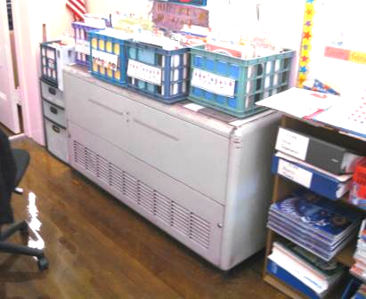

Classroom univent (1950’s vintage), note items on top of air diffuser

Picture 2

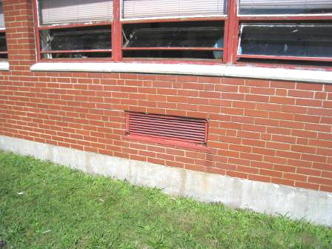

Univent fresh air intake

Picture 3

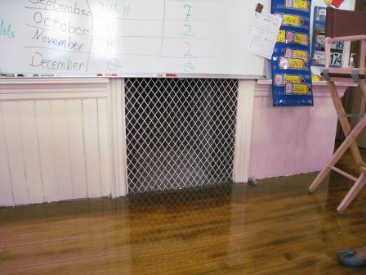

Wall-mounted gravity-feed exhaust vent in classroom

Picture 4

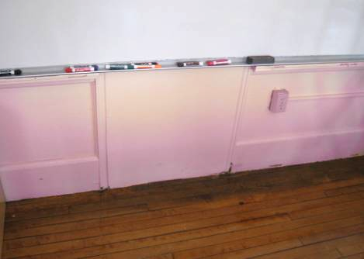

Wall-mounted gravity-feed exhaust vent sealed

Picture 5

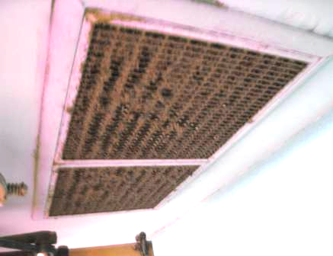

Exhaust vent for 1951 wing, note dust/debris accumulation

Picture 6

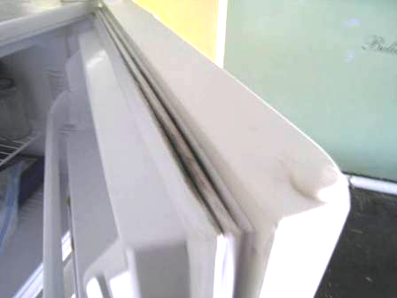

Visible mold growth in gasket of freezer in teacher’s lounge

Picture 7

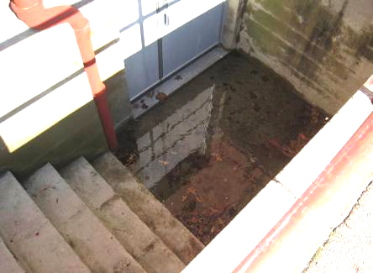

Pooling water and accumulated leaves/debris at bottom of stairwell
outside the learning lab

Picture 8

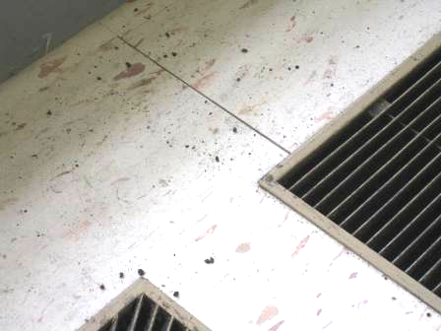

Debris/particles on surface of univent near air diffuser

Picture 9

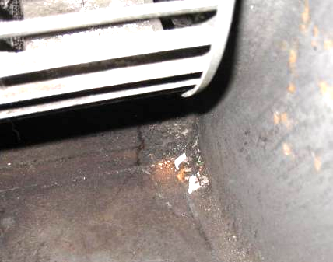

Small pile of dirt, dust and debris inside univent fan cage

Picture 10

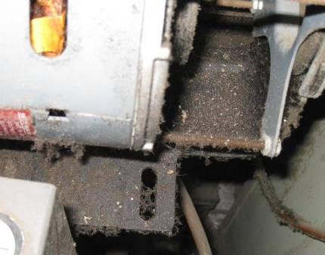

Accumulated dirt, dust and debris in univent

Picture 11

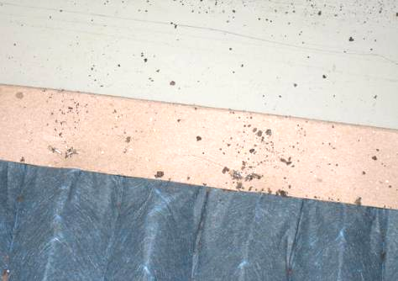

Debris/particles in univent

Picture 12

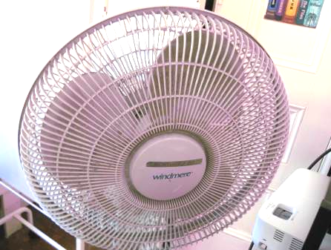

Accumulated dust/debris on fan blades
Location | Carbon  Dioxide  (ppm) | Carbon Monoxide  (ppm) | Temp  (°F) | Relative  Humidity  (%) | PM2.5  (μg/m³) | Occupants  in Room | Windows  Openable | Ventilation |  |  | Remarks
 |  |  |  |  |  |  |  | Intake | Exhaust |  | Remarks
Background | 331 | ND | 78 | 33 | 6
1L | 478 | ND | 72 | 38 | 8 | 0 | Y  Open | Y |  | Y | Exhaust sealed, 18 occupants gone 15 mins, DO, plants, PF-dusty
2A | 701 | ND | 74 | 39 | 9 | 16 | Y  Open | Y  Off |  | Y  Off | Window AC, coat closet exhaust, corn in UV
2D | 366 | ND | 73 | 36 | 8 | 14 | Y  Open | Y |  | Y | Exhaust vent-off/dusty , DO
3A | 747 | ND | 71 | 43 | 8 | 18 | Y | Y |  | Y | Books on UV, DO
3T | 874 | ND | 79 | 46 | 9 | 15 | Y | Y |  | N | Mop bucket, DO
4RK | 612 | ND | 73 | 39 | 8 | 0 | Y  Open | Y |  | Y | DO, PF-dusty
4RS | 498 | ND | 73 | 39 | 8 | 0 | Y  Open | Y |  | Y | Exhaust sealed, 20 occupants gone to specialist, TB, DO
5M | 705 | ND | 71 | 43 | 8 | 20 | Y  Open | Y |  | Y | DO, paper in/on UV
5S | 823 | ND | 71 | 46 | 7 | 19 | Y  Open | Y |  | N | DO, paper on UV
Basement | 474 | ND | 72 | 47 | 8 | 0 | Y | N |  | Y
Cafeteria | 843 | ND | 71 | 45 | 11 | ~100 | Y | Y |  | Y | Clogged water fountain-standing water
Computers | 597 | ND | 73 | 41 | 8 | 1 | Y  Open | N |  | Y | Exhaust off
Gym | 368 | ND | 70 | 38 | 7 | 21 | Y  Open | Y |  | Y
KB | 492 | ND | 73 | 41 | 6 | 21 | Y  Open | Y |  | Y | DO
KV | 462 | ND | 73 | 39 | 7 | 20 | Y  Open | Y |  | Y
Learning Lab | 598 | ND | 71 | 49 | 8 | 1 | Y | N |  | N | Ceiling fan on
Main Office | 433 | ND | 71 | 38 | 7 | 1 | N | N |  | N | DO, AC in window
Nurse | 412 | ND | 71 | 37 | 7 | 1 | Y  Open | N |  | N | DO

Location | Carbon  Dioxide  (ppm) | Carbon Monoxide  (ppm) | Temp  (°F) | Relative  Humidity  (%) | PM2.5  (μg/m³) | Occupants  in Room | Windows  Openable | Ventilation |  |  | Remarks
 |  |  |  |  |  |  |  | Intake | Exhaust |  | Remarks
Background | 371 | ND | 57 | 59 | 7 |  |  |  |  |  | Winds: SW 25-32 mph, gusts up to 51 mph, heavy rain in am clearing late am
1L | 898 | ND | 71 | 45 | 8 | 19 | Y | Y |  | Y | Exhaust sealed, UV off, items on/front of UV
1T | 766 | ND | 72 | 52 | 7 | 14 | Y | Y |  | Y | UV off, DO, items on/front of UV
2A | 630 | ND | 71 | 50 | 7 | 19 | Y | Y |  | Y | Window AC, coat closet exhaust
2L | 777 | ND | 70 | 51 | 5 | 0 | Y | Y |  | Y | UV off, dark debris reported from UV-observed on flat surfaces near air diffuser, accumulated dirt, dust and debris inside UV
2D | 684 | ND | 71 | 52 | 8 | 16 | Y | Y |  | Y | Exhaust vent-off/dusty , DO
3A | 450 | ND | 72 | 41 | 4 | 16 | Y  Open | Y |  | Y | UV off, items on UV, DO
3T | 506 | ND | 71 | 45 | 7 | 17 | Y | Y |  | N | UV off, DO
4RK | 752 | ND | 71 | 50 | 5 | 1 | Y | Y |  | Y | UV off, ~40 occupants gone ~ 20 mins, DO, PF-dusty
4RS | 524 | ND | 71 | 49 | 6 | 5 | Y | Y |  | Y | Exhaust sealed, 20 occupants gone ~ 5 mins, DO
5M | 950 | ND | 72 | 51 | 8 | 19 | Y | Y |  | Y | DO
5S | 873 | ND | 72 | 47 | 6 | 20 | Y | Y |  | N | DO, items on UV, PF dusty
Teacher’s Lounge | 543 | ND | 69 | 50 | 5 | 0 | Y | N |  | N | Visible mold on refrigerator/freezer gasket
Cafeteria | 727 | ND | 70 | 52 | 6 | 0 | Y | Y |  | Y | UVs off
Computers | 533 | ND | 69 | 45 | 4 | 1 | Y | N |  | Y | Exhaust off, DO
Gym | 503 | ND | 70 | 50 | 7 | 16 | Y | Y |  | Y | Ventilation off
KB | 778 | ND | 71 | 52 | 10 | 18 | Y | Y |  | Y | UV off
KV | 780 | ND | 70 | 56 | 11 | 20 | Y | Y |  | Y | AC, PF dusty
Learning Lab | 636 | ND | 69 | 49 | 6 | 2 | Y | N |  | N | Ceiling fan on
Main Office | 672 | ND | 70 | 52 | 6 | 2 | N | N |  | N | DO, air conditioner in window
Nurse | 647 | ND | 71 | 51 | 6 | 3 | Y | N |  | N | DO, AC

