INDOOR AIR QUALITY ASSESSMENT
MOLD INVESTIGATION

Oxford Elementary School
347 Main Street
Fairhaven, Massachusetts



Prepared by:
Massachusetts Department of Public Health
Bureau of Environmental Health
Indoor Air Quality Program
October 2012

Background/Introduction
At the request of Dr. Robert N. Baldwin, Superintendant, Fairhaven Public Schools, the Massachusetts Department of Public Health (MDPH), Bureau of Environmental Health (BEH) conducted an indoor air quality (IAQ) assessment at the Oxford Elementary School (OES) located at 347 Main Street, Fairhaven, Massachusetts. The request was prompted by mold concerns related to the reoccupancy of the OES for the 2012-2013 school year following several years of non-occupancy.
As reported by Fairhaven Public School officials, the Oxford School had been closed in 2007. It was used primarily for storage until the summer of 2012. During this time, a significant amount of materials were stored within the building’s gymnasium. Subsequent to closure the school was proposed for swing space to temporarily house students, faculty and staff of the L. L. Wood Elementary School, until construction of the new L. L. Wood School was complete (scheduled for summer of 2014). During the summer of 2012, cleaning and other activities took place to provide for OES to function as a school building; during this process, the stored materials in the gymnasium were found to be water-damaged and/or mold-colonized.
On August 29, 2012, Mike Feeney, Director of BEH’s IAQ Program visited the building to address mold concerns through the conduct of an assessment of building conditions that can lead to water damage/microbial growth. Mr. Feeney was accompanied by Ms. Patricia Fowle, Health Agent, Fairhaven Board of Health during the assessment. At the conclusion of the assessment, BEH/IAQ staff made a number of verbal recommendations to reduce moisture and improve air quality beyond the significant steps taken to clean the OES prior to the BEH visit.
The OES consists of two wings. The original building was constructed in 1896 as a free-standing, two-story schoolhouse (1896 wing). A two-level wing was added to the rear of the original building during the 1950s (1950s wing). The upper level contains classrooms and offices. The lower level contains the cafeteria. The gymnasium is attached to the 1896 wing opposite the 1950s wing. Windows are openable throughout the building.

Methods
Air tests for relative humidity were conducted with the TSI, Q-Trak, IAQ Monitor, Model 7565. BEH/IAQ staff also performed visual inspection of building materials for water damage and/or microbial growth and examined the building for the presence of odors and/or other environmental concerns.

Results
Classrooms were not occupied at the time of the assessment; results appear in Table 1.

Discussion
At the time of the BEH assessment, all materials stored in the gymnasium had been removed (Picture 1). The building had been cleaned and the ventilation system in the gymnasium was operating to promote the exchange of air. BEH/IAQ staff found all classrooms, offices and the gymnasium free of mold-contaminated materials, mold-colonized building components/structures and musty odors, indicating that the building had been cleaned thoroughly.
The cafeteria, located on the ground level of the 1950s wing, was found to contain unusual construction details, which are likely to provide a significant source of water vapor in the 1950s wing. The south wall of the cafeteria had several doors: two opening into a storeroom and janitor’s closet respectively and two that open into a crawlspace with a dirt floor. Each door has a passive door vent (Picture 2). The door vents to the crawlspace were found sealed, but not rendered air-tight. Under certain conditions, water vapor and mold odors can readily enter the cafeteria from the crawlspace. A room along the east wall of the cafeteria also had two access doors with passive door vents (Picture 3); this room contained a sump pump in the floor (Picture 4). The room with the sump pump had no mechanical exhaust ventilation to remove water vapor nor odors from the sump so water vapor and odors may readily pass through the passive door vent into the cafeteria.
BEH/IAQ staff conducted relative humidity testing to determine whether humidity was elevated in the OES (Table 1). Humidity in classrooms in the 1896 wing, the upper floor of the 1950s wing, and the gymnasium were similar to outdoor relative humidity measurements. Relative humidity in these areas was between 38 to 40 percent (Table 1), indicating no unusual sources of water vapor. In the lower level of the 1950s wing, relative humidity levels elevated closer to the crawlspace. The crawlspace interior had the highest relative humidity of 55 percent, 17 percentage points higher than the outdoor measurement (Table 1). These measurements support the hypothesis that the unvented crawlspace provides a significant water source in the OES.
The sump pump itself also provides a significant moisture source. The purpose of the sump pump appears to be removal of condensate produced by the heating system; this condensate is typically above ambient temperature. Heated water vapor from the condensate would readily pass through the door vent next to the sump pump into the cafeteria near the base of the stairwell. Heat from this condensate pouring into the sump pump also may be a means to create humidity from the crawlspace rising up the adjacent stairwell by means of the stack effect. This excess moisture may then accumulate in the gymnasium.
Finally, high relative humidity during hot, humid, summer weather conditions contribute to mold-colonization of stored materials. The gymnasium had no climate control for summer months during the years that the building was closed. Hot, humid air from outdoors could have entered the gymnasium, moistening stored materials. According to the American Society of Heating Refrigeration and Air-Conditioning Engineers (ASHARE), sustained relative humidity indoors of 70 percent or greater can wet building components, resulting in fungal growth (ASHRAE, 1989).
In order for building materials to support mold growth, a source of water exposure is necessary. In this case the most likely source of moisture appears to be prolonged periods of elevated indoor relative humidity from the previously described sources coupled with a lack of operation of the mechanical ventilation system. This resulted in prolonged exposure to moisture and subsequent mold growth on stored materials (paper, cardboard, furniture, etc.), primarily in the gymnasium.
The US Environmental Protection Agency (US EPA) and the American Conference of Governmental Industrial Hygienists (ACGIH) recommends that porous materials be dried with fans and heating within 24 to 48 hours of becoming wet (US EPA, 2001; ACGIH, 1989). If porous materials (e.g., cardboard, paper) are not dried within this time frame, mold growth may occur. Water-damaged porous materials cannot be adequately cleaned to remove mold growth. The application of a mildewcide to moldy porous materials is not recommended.

Conclusions/Recommendations
Based on the observations made during the visit, the following recommendations were communicated at the time of the assessment to reduce moisture and improve IAQ and are reiterated below:
- Completely seal the door vents and frames of the crawlspace doors on both sides of each door.
- Install mechanical exhaust ventilation in the sump pump room. Seal the door vent nearest the sump pump. Prohibit storing any materials inside the room.
- Ensure all utility holes, penetrations and breaches in the floor between the first floor and crawlspace are sealed; particular attention should be paid to the inside of univent cabinets.
Building occupants should notify the maintenance department if mold/moisture issues occur so that prompt action may be taken.

References
ACGIH. 1989. Guidelines for the Assessment of Bioaerosols in the Indoor Environment. American Conference of Governmental Industrial Hygienists, Cincinnati, OH.
ASHRAE. 1989. ASHRAE Standard: Ventilation for Acceptable Indoor Air Quality. Sections 5.11, 5.12. American Society of Heating, Refrigerating and Air-Conditioning Engineers, Inc. Atlanta, GA.
US EPA. 2001. “Mold Remediation in Schools and Commercial Buildings”. Office of Air and Radiation, Indoor Environments Division, Washington, DC. EPA 402-K-01-001. March 2001. Available at: http://www.epa.gov/iaq/molds/mold_remediation.html.
Picture 1

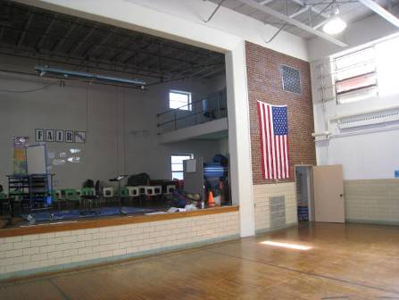

Gymnasium with materials removed

Picture 2

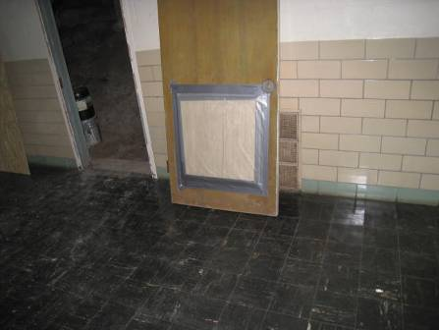

Crawlspace door, note sealed vent

Picture 3

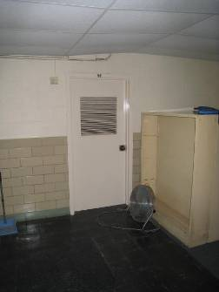

Door vent for sump pump room (door labeled 50)

Picture 4

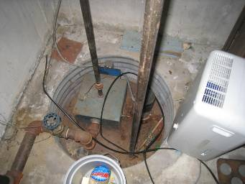

Sump pump
Location | Temp  (°F) | Relative  Humidity  (%)
Background | 75 | 38
1L | 73 | 40
1T | 73 | 40
2D | 78 | 39
3A | 73 | 38
3T | 72 | 38
4RS | 74 | 40
4RK | 75 | 40
5M | 73 | 37
5S | 74 | 38
KB | 73 | 40
KV | 73 | 40
Learning Lab | 77 | 43
Gym | 72 | 39
Cafeteria | 77 | 44
Computer Room | 77 | 42
Crawlspace | 75 | 55

