Background/Introduction

INDOOR AIR QUALITY ASSESSMENT

Oxford High School
495 Main Street
Oxford, MA

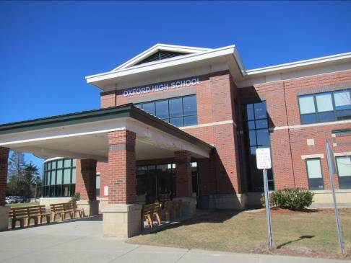

Prepared by:
Massachusetts Department of Public Health
Bureau of Environmental Health
Indoor Air Quality Program
June 2015
At the request of Richard Donais, Facilities Director for the Town of Oxford, the Massachusetts Department of Public Health (MDPH), Bureau of Environmental Health (BEH) provided assistance and consultation regarding indoor air quality (IAQ) concerns at Oxford High School (OHS) located at 495 Main Street, Oxford, MA. On April 15, 2015, Jason Dustin, Environmental Analyst/Inspector and Ruth Alfasso, Environmental Engineer/Inspector in BEH’s IAQ Program visited the OHS to conduct an IAQ assessment.
The school is a multi-story brick and concrete building, which was completed in 2002. Classrooms have tiled floors and drop ceiling tile systems. Most classrooms have openable windows.
It is important to note that the winter of 2014/2015 had record-breaking amounts of snow and days of cold/below freezing weather (NWS, 2015; WBZ, 2015). These conditions put unusual stresses on building structures and equipment, which may lead to an increase in roof and structural damage, water intrusion from snow and snowmelt and freezing-related damage to pipes and other heating, ventilating and air conditioning (HVAC) components. In addition, labor/time taken to remove snow and deal with damage may have resulted in a decrease in availability/resources for routine maintenance activities. These conditions have been experienced at many schools and other public buildings in Massachusetts.
On March 10, 2015, an environmental consulting company, Fuss & O’Neill (the consultant) performed an assessment at the school, limited to the library and some adjacent spaces. The consultant conducted testing for ventilation parameters, inspection for water damage and sampling for both airborne and surface fungi/molds. The consultant’s report had the following recommendations:
- Investigate and repair all water intrusions related to roof leaks.
- Repair/replace valves and/or piping causing the water leak affecting the ceiling tile adjacent to room 123.
- Investigate sprinkler in domed area of library to determine if a leak is present.
  - Clean areas of mold growth around sprinkler head.
- Clean HVAC supply/returns where accumulations of dust are present (Fuss & O’Neill 2015).

Methods
Air tests for carbon monoxide, carbon dioxide, temperature and relative humidity were conducted with the TSI, Q-Trak, IAQ Monitor, Model 7565. Air tests for airborne particle matter with a diameter less than 2.5 micrometers were taken with the TSI, DUSTTRAK™ Aerosol Monitor Model 8532. BEH/IAQ staff also performed a visual inspection of building materials for water damage and/or microbial growth.

Results
The school houses approximately 600 students in grades 9 through 12 with a staff of approximately 150. Tests were taken during normal operations and results appear in Table 1.

Discussion

Ventilation
It can be seen from Table 1 that carbon dioxide levels were below 800 parts per million (ppm) in 60 of 63 areas surveyed at the time of the assessment, indicating adequate air exchange in all but three areas surveyed. Please note however, that a few areas were empty or sparsely populated at the time tests were taken and a few areas had windows open, which can greatly reduce carbon dioxide levels. Carbon dioxide levels would be expected to be higher with full occupancy and windows closed.
Fresh air in most classrooms is supplied by unit ventilators (univents) (Picture 1). A univent is designed to draw air from outdoors through a fresh air intake located on the exterior wall of the building (Picture 2). Return air is drawn through an air intake located at the base of each unit where fresh and return air are mixed, filtered, heated and provided to classrooms through an air diffuser located in the top of the unit (Figure 1). Univents were found obstructed with items in a few areas (Picture 1) and turned off in many classrooms (Table 1). In order for univents to provide fresh air as designed, they must remain free of obstructions. Importantly, these units must remain on and be allowed to operate while rooms are occupied. Wall-mounted exhaust vents (Picture 3) remove stale air from classrooms.
Outside air for common areas such as the library, gymnasium and auditorium, as well as administrative areas, is provided by rooftop air handling units (AHUs, Picture 4). Fresh air is drawn in through intakes, where it is filtered, heated or cooled and ducted to ceiling-mounted supply diffusers (Picture 5). Only some of the AHUs are equipped to provide cooling (e.g., administrative areas and auditorium). Return air is drawn in through ceiling-mounted return vents and ducted back to AHUs.
Additional exhaust ventilation in restrooms and the kitchen is provided by exhaust vents that are directed to fans on the roof. Many restroom exhaust vents were not operational at the time of the assessment. Proper functioning of these exhaust vents is necessary to remove odors and moisture from restroom use.
HVAC control systems were replaced approximately 2 years ago. Controls for heating and cooling can be accessed from a computerized control panel, which can allow remote monitoring of room temperatures and the status of rooftop AHUs. This has reportedly improved temperature control in the building. However, the univents can still be deactivated in each room manually.
To maximize air exchange, the MDPH recommends that both supply and exhaust ventilation operate continuously during periods of occupancy. In order to have proper ventilation with a mechanical supply and exhaust system, the systems must be balanced to provide an adequate amount of fresh air to the interior of a room while removing stale air from the room. It is recommended that HVAC systems be re-balanced every five years to ensure adequate air systems function (SMACNA, 1994). The date of the last balancing was reportedly done after building completion in 2002.
Minimum design ventilation rates are mandated by the Massachusetts State Building Code (MSBC). Until 2011, the minimum ventilation rate in Massachusetts was higher for both occupied office spaces and general classrooms, with similar requirements for other occupied spaces (BOCA, 1993). The current version of the MSBC, promulgated in 2011 by the State Board of Building Regulations and Standards (SBBRS), adopted the 2009 International Mechanical Code (IMC) to set minimum ventilation rates. Please note that the MSBC is a minimum standard that is not health-based. At lower rates of cubic feet per minute (cfm) per occupant of fresh air, carbon dioxide levels would be expected to rise significantly. A ventilation rate of 20 cfm per occupant of fresh air provides optimal air exchange resulting in carbon dioxide levels at or below 800 ppm in the indoor environment in each area measured. MDPH recommends that carbon dioxide levels be maintained at 800 ppm or below. This is because most environmental and occupational health scientists involved with research on IAQ and health effects have documented significant increases in indoor air quality complaints and/or health effects when carbon dioxide levels rise above the MDPH guidelines of 800 ppm for schools, office buildings and other occupied spaces (Sundell et al., 2011). The ventilation must be on at all times that the room is occupied. Providing adequate fresh air ventilation with open windows and maintaining the temperature in the comfort range during the cold weather season is impractical. Mechanical ventilation is usually required to provide adequate fresh air ventilation.
Carbon dioxide is not a problem in and of itself. It is used as an indicator of the adequacy of the fresh air ventilation. As carbon dioxide levels rise, it indicates that the ventilating system is malfunctioning or the design occupancy of the room is being exceeded. When this happens, a buildup of common indoor air pollutants can occur, leading to discomfort or health complaints. The Occupational Safety and Health Administration (OSHA) standard for carbon dioxide is 5,000 parts per million parts of air (ppm). Workers may be exposed to this level for 40 hours/week, based on a time-weighted average (OSHA, 1997).
The MDPH uses a guideline of 800 ppm for publicly occupied buildings. A guideline of 600 ppm or less is preferred in schools due to the fact that the majority of occupants are young and considered to be a more sensitive population in the evaluation of environmental health status. Inadequate ventilation and/or elevated temperatures are major causes of complaints such as respiratory, eye, nose and throat irritation, lethargy and headaches. For more information concerning carbon dioxide, consult Appendix A.
Indoor temperature measurements the day of the assessment ranged from 67 °F to 77 °F (Table 1), which were within or close to the MDPH recommended comfort range. The MDPH recommends that indoor air temperatures be maintained in a range of 70 °F to 78 °F in order to provide for the comfort of building occupants. In many cases concerning indoor air quality, fluctuations of temperature in occupied spaces are typically experienced, even in a building with an adequate fresh air supply.
The relative humidity measured in the building during the assessment ranged from 12 to 26 percent, which was below the MDPH recommended comfort range in all areas surveyed (Table 1). The MDPH recommends a comfort range of 40 to 60 percent for indoor air relative humidity. Relative humidity levels in the building would be expected to drop during the winter months due to heating. The sensation of dryness and irritation is common in a low relative humidity environment. Low relative humidity is a very common problem during the heating season in the northeast part of the United States.

Microbial/Moisture Concerns
Several water-related issues have occurred in this building. Reportedly, pipe leaks from the sprinkler system occurred due to improper installation, which led to the pipes freezing and bursting in the library/media center. Several instances of leaks from this condition reportedly occurred during February and March of 2008. Each location was reportedly remediated by repairing the leaks and removing/replacing water-damaged items and building materials. According to building staff, previous to 2008 frozen sprinkler pipes had occurred when the building was newly opened. OHS staff reported that the sprinkler system was modified over the summer of 2009 to prevent future sprinkler pipe freezes.
Some water-damaged materials were observed in the library. For example, water stains were visible on carpet near the exterior door, which was reportedly due to snow melt over the winter of 2014/2015 (Picture 6). Drainage adjacent to this door may be inadequate to prevent water infiltration during severe weather. The removal of carpeting and replacement with tile in this location may mitigate future water damage impacts. The ceiling showed signs of recent repainting near sprinklers, possibly from repairs to water-damaged materials. In addition, the gaskets of skylights appear to have failed as indicated by condensation visible between the two sets of panes.
The roof has reportedly been subject to periodic leaks since the building was new, particularly the flat portion which is a ballasted rubber membrane. Although some repairs have been conducted, leaks continue to occur during severe weather and facilities staff are attempting to get the installer to perform warrantee repairs to the roof. It is important to note that continued chronic water infiltration should be avoided to prevent microbial growth and building material damage.
Due to the periodic roof leaks, water-damaged ceiling tiles and water-damaged walls/paint were observed in several classrooms and hallway areas (Pictures 7 through 9; Table 1). Some of these tiles appear to have been colonized by mold (Picture 10). Building occupants reported that the band instrument storage room had water-damaged instruments and other contents that were removed and replaced, water-damaged building materials were not remediated. Water damaged ceiling tiles were found in this location. Water-damaged ceiling tiles can provide a source of mold and should be replaced after a water leak is discovered and repaired. Areas of water-damaged paint should be scraped and repainted or replaced if needed.
As reported by staff, the force main that conducts building sewage from the building to the town gravity sewer system had frozen in February of 2015. Due to this condition, sewage was being pumped from the pump chamber by a hauler truck daily. The storage/pumping of sewage led to reports of sewer gas odors in the building. At the time of the visit, no sewer gas odors were reported by school staff or detected by BEH/IAQ staff.
Water dispensers and small refrigerators were located in several areas over carpeting (Table 1). Overflow/spills from water coolers/fountains and condensation from refrigerators can moisten carpeting. It is recommended that these appliances be located on non-porous flooring or a waterproof mat. It is also important that the catch basin of water coolers be cleaned regularly as stagnant water can be a source of odors.
The US EPA and the American Conference of Governmental Industrial Hygienists (ACGIH) recommend that porous materials be dried with fans and heating within 24 to 48 hours of becoming wet (US EPA, 2001; ACGIH, 1989). If porous materials are not dried within this time frame, mold growth may occur. Once mold has colonized porous materials, they are difficult to clean and should be removed and discarded. Any necessary mold remediation should be conducted following the US EPA’s “Mold Remediation in Schools and Commercial Buildings” guidance document available at: http://www.epa.gov/mold/mold_remediation.html.
The exterior of the building was examined for conditions that could lead to water infiltration or other sources of indoor air pollutants. Efflorescence was observed along many of the seams and edges of the brick and block facings (Pictures 11 and 12). Efflorescence is a characteristic sign of water damage to brick and mortar, but it is not mold growth. As moisture penetrates and works its way through mortar, brick or plaster, water-soluble compounds dissolve, creating a solution. As the solution moves to the surface of the material, the water evaporates, leaving behind white, powdery mineral deposits.
An exterior wall system should consist of an exterior curtain wall (Figure 2). Behind the curtain wall is an air space that allows for water to drain downward and for the exterior cladding system to dry. In order to allow for water to drain from the exterior brick system, a series of weep holes is customarily installed in the exterior wall, at or near the foundation slab/exterior wall system junction. Weep holes allow for accumulated water to drain from a wall system (Dalzell, 1955). Opposite the exterior wall and across the air space is a continuous, water-resistant material adhered to the back-up wall that forms the drainage plane. The purpose of the drainage plane is to prevent moisture that crosses the air space from penetrating the interior of the building. The plane also directs moisture downwards toward the weep holes. The drainage plane should be continuous. Where breaks exist in the drainage plane (e.g., window systems, door systems, air intakes), additional materials (e.g., flashing) are installed as transitional surfaces to direct water to weep holes. If the drainage plane is discontinuous, missing flashing or lacking air space, rainwater may accumulate inside the wall cavity and lead to moisture penetration into the building (Figure 3). Weep holes were found at the bottom edges of the building (Picture 13) but they may be undersized and/or clogged to efficiently remove moisture from the drainage plane.
Most of the roof drains were found to be in good condition, but some were broken or had water pooling adjacent to them (Picture 14). Improper function of roof drains can lead to water pooling on the roof and exacerbate any roof leaks.

Other IAQ Evaluations
Indoor air quality can be negatively influenced by the presence of respiratory irritants, such as products of combustion. The process of combustion produces a number of pollutants. Common combustion emissions include carbon monoxide, carbon dioxide, water vapor and smoke (fine airborne particle material). Of these materials, exposure to carbon monoxide and particulate matter with a diameter of 2.5 micrometers (μm) or less (PM2.5) can produce immediate, acute health effects upon exposure. To determine whether combustion products were present in the indoor environment, BEH/IAQ staff obtained measurements for carbon monoxide and PM2.5.

Carbon Monoxide
Carbon monoxide is a by-product of incomplete combustion of organic matter (e.g., gasoline, wood and tobacco). Exposure to carbon monoxide can produce immediate and acute health effects. Several air quality standards have been established to address carbon monoxide and prevent symptoms from exposure to these substances. The MDPH established a corrective action level concerning carbon monoxide in ice skating rinks that use fossil-fueled ice resurfacing equipment. If an operator of an indoor ice rink measures a carbon monoxide level over 30 ppm, taken 20 minutes after resurfacing within a rink, that operator must take actions to reduce carbon monoxide levels (MDPH, 1997).
The American Society of Heating Refrigeration and Air-Conditioning Engineers (ASHRAE) has adopted the National Ambient Air Quality Standards (NAAQS) as one set of criteria for assessing indoor air quality and monitoring of fresh air introduced by HVAC systems (ASHRAE, 1989). The NAAQS are standards established by the US EPA to protect the public health from six criteria pollutants, including carbon monoxide and particulate matter (US EPA, 2006). As recommended by ASHRAE, pollutant levels of fresh air introduced to a building should not exceed the NAAQS levels (ASHRAE, 1989). The NAAQS were adopted by reference in the Building Officials & Code Administrators (BOCA) National Mechanical Code of 1993 (BOCA, 1993), which is now an HVAC standard included in the Massachusetts State Building Code (SBBRS, 2011). According to the NAAQS, carbon monoxide levels in outdoor air should not exceed 9 ppm in an eight-hour average (US EPA, 2006).
Carbon monoxide should not be present in a typical, indoor environment. If it is present, indoor carbon monoxide levels should be less than or equal to outdoor levels. On the day of the assessment, outdoor carbon monoxide concentrations were measured at non-detectable (ND, Table 1). No measurable levels of carbon monoxide were detected inside the building (Table 1).

Particulate Matter
The US EPA has established NAAQS limits for exposure to particulate matter. Particulate matter includes airborne solids that can be irritating to the eyes, nose and throat. The NAAQS originally established exposure limits to PM with a diameter of 10 μm or less (PM10). In 1997, US EPA established a more protective standard for fine airborne particulate matter with a diameter of 2.5 μm or less (PM2.5). This more stringent PM2.5 standard requires outdoor air particle levels be maintained below 35 μg/m³ over a 24-hour average (US EPA, 2006). Although both the ASHRAE standard and BOCA Code adopted the PM10 standard for evaluating air quality, MDPH uses the more protective PM2.5 standard for evaluating airborne PM concentrations in the indoor environment.
Outdoor PM2.5 concentrations were measured at 3 μg/m³ (Table 1). PM2.5 levels measured in the building ranged from ND to 33 μg/m³ (Table 1), which were below the NAAQS PM2.5 level of 35 μg/m³. Frequently, indoor air levels of particulate matter (including PM2.5) can be at higher levels than those measured outdoors. A number of activities that occur indoors and/or mechanical devices can generate particulate matter during normal operations. Sources of indoor airborne particulate matter may include but are not limited to particles generated during the operation of fan belts in the HVAC system, use of stoves and/or microwave ovens in kitchen areas; use of photocopiers, fax machines and computer printing devices; operation of an ordinary vacuum cleaner and heavy foot traffic indoors.

Volatile Organic Compounds
Indoor air concentrations can be greatly impacted by the use of products containing volatile organic compounds (VOCs). VOCs are carbon-containing substances that have the ability to evaporate at room temperature. Frequently, exposure to low levels of total VOCs (TVOCs) may produce eye, nose, throat and/or respiratory irritation in some sensitive individuals. For example, chemicals evaporating from a paint can stored at room temperature would most likely contain VOCs. In an effort to identify materials that can potentially increase indoor VOC concentrations, BEH/IAQ staff examined rooms for products containing these respiratory irritants.
Classrooms contained dry erase boards and related materials. Materials such as dry erase markers and dry erase board cleaners may contain VOCs, such as methyl isobutyl ketone, n-butyl acetate and butyl-cellusolve (Sanford, 1999), which can be irritating to the eyes, nose and throat.
Hand sanitizer was also observed in several areas (Table 1); these products may contain ethyl alcohol and/or isopropyl alcohol, which are highly volatile and may be irritating to the eyes and nose. Sanitizing products may also contain fragrances to which some people may be sensitive.
There are several photocopiers in the building (Table 1). Photocopiers can be sources of pollutants such as VOCs, ozone, heat and odors, particularly if the equipment is older and in frequent use. Both VOCs and ozone are respiratory irritants (Schmidt Etkin, 1992). Photocopiers, large printers, laminators, shredders and other office equipment that may produce VOCs, dusts and odors should be kept in well ventilated rooms, and should be located near windows or exhaust vents.

Other Conditions
Other conditions that can affect IAQ were observed during the assessment. A typical classroom univent was opened for observation. It was noted that the type of filter medium for univents provides minimal filtration (Picture 15). It should be determined if filters with an increased dust spot efficiency can be installed. The dust spot efficiency is the ability of a filter to remove particulate matter of a certain diameter from air passing through the filter. Filters that have been determined by ASHRAE to meet its standard for a dust spot efficiency of a minimum of 40 percent would be sufficient to reduce airborne particulate matter (Thornburg, D., 2000; MEHRC, 1997; ASHRAE, 1992). Pleated filters with a Minimum Efficiency Reporting Value dust-spot efficiency of 9 or higher are recommended. Note that increasing filtration can reduce airflow (called pressure drop), which can subsequently reduce the efficiency of the unit due to increased resistance. Prior to any increase of filtration, each univent should be evaluated by a ventilation engineer to ascertain whether it can maintain function with more efficient filters. In addition, as shown in Picture 15, the filter is too small for the univent and therefore allows unfiltered air into the room. It was reported that when filters are changed, longer filters may be cut to fit smaller univents, leaving insufficient numbers of the longer filters for the larger univents. Univent filters should be the proper size and fit flush into the racks. Filters should be changed regularly, two to four times a year.
Several water fountains in hallways were found to be non-functional. It was reported by building staff that these were turned off due to vandalism. Without a source of water, the drain traps in these units can become dry and allow sewer gases to enter occupied areas. If the units cannot be used as is, consideration should be given to modifying them to bring them back to safe service or to having them properly capped and removed.
The wood shop was not accessible at the time of the assessment, but it was observed to be equipped with a wood-chip/sawdust collector (Picture 16). The portion of this collector outside the building had a large pile of wood chips next to it, while the receptacle (trash can) was empty inside. It was unclear if this device was malfunctioning and ejecting wood chips directly on the ground, or if these chips had been dropped during the last time the receptacle had been emptied. Proper maintenance/functioning of ventilation equipment is vital to good IAQ in shops and the rest of the building. In addition, improper disposal of wood chips on the ground next to the building can create a harborage for pests.
A kiln was observed in a small room inside the art classroom (Picture 17). This kiln was vented to the outdoors, which operates whenever the kiln is on. However, it was observed that the room also had a return vent for the general HVAC system, which may allow excess heat and any escaping odors to be recirculated to occupied areas. In addition, a ceiling tile was missing in this room, which would allow heat/odors to penetrate the plenum and possibly impact other occupied areas as well. Missing ceiling tiles, which were also found in several other areas (Picture 7; Table 1) should be replaced to prevent transfer of air into the plenum as well as prevent dust/debris in the plenum from entering occupied areas.
Storage areas adjacent to the music room had a large number of items such as uniforms, costumes, instruments/cases and other porous items. Some of these items appeared to be closely packed in racks and on shelves. Humidity control should be taken into account in storage areas. Infiltration of hot, humid air into storerooms with poor air circulation can lead to condensation and microbial growth on porous items. Items should be stored off the floor and away from walls to allow for air circulation and prevent moistening from condensation on surfaces. Storage of items sealed in plastic may be useful if humidity control is not feasible.
In some classrooms, items were observed on univent cabinets, floors, windowsills, tabletops, counters, bookcases and desks, which provide a source for dusts to accumulate (Picture 18). These items (e.g., papers, folders, boxes) make it difficult for custodial staff to clean. Items should be relocated and/or be cleaned periodically to avoid excessive dust build up. In addition, dust and debris can accumulate on flat surfaces (e.g., desktops, shelving and carpets) in occupied areas and subsequently be re-aerosolized causing further irritation.
A number of air diffusers, exhaust/return vents and personal fans were found to have accumulated dust/debris (Table 1). Re-activated univents/supply vents and fans can aerosolize dust/materials accumulated in equipment or on vents/fan blades. If exhaust vents are not functioning, backdrafting can occur, which can re-aerosolize accumulated dust particles.
Upholstered furniture was seen in several classrooms. Upholstered furniture, pillows and cushions are covered with fabric that comes in contact with human skin. This type of contact can leave oils, perspiration, hair and skin cells. Dust mites feed upon human skin cells and excrete waste products that contain allergens. In addition, if relative humidity levels increase above 60 percent, dust mites tend to proliferate (US EPA, 1992). In order to remove dust mites and other pollutants, frequent vacuuming of upholstered furniture is recommended (Berry, M.A., 1994). It is also recommended that upholstered furniture (if present in schools), be professionally cleaned on an annual basis. If outdoor conditions or indoor activities (e.g., renovations) create an excessively dusty environment, cleaning frequency should be increased (every six months) (IICRC, 2000).
Some areas in the school (e.g., the library) were carpeted. The Institute of Inspection, Cleaning and Restoration Certification (IICRC) recommends that carpeting be cleaned annually (or semi-annually in soiled high traffic areas) (IICRC, 2012). Regular cleaning with a high efficiency particulate air (HEPA) filtered vacuum in combination with an annual cleaning will help to reduce accumulation and potential aerosolization of materials from the carpeting.

Conclusions/Recommendations
In view of the findings at the time of the visit, the following recommendations are made:
- Complete recommendations from the Fuss & O’Neill report.
- Repair sewer pipe connections as soon as possible. Monitor affected women’s restroom for sewer gas odors.
- To avoid continued chronic water infiltration, it is strongly advised that strategies which provide for more immediate roofing repairs are considered.
- Ensure roof/plumbing leaks are repaired and replace any remaining water-damaged ceiling tiles and other building materials. Disinfect areas of water leaks with an appropriate antimicrobial, as needed.
- Any necessary mold remediation should be conducted following the US EPA’s “Mold Remediation in Schools and Commercial Buildings” guidance document available at: http://www.epa.gov/mold/mold_remediation.html.
- Operate all supply and exhaust ventilation systems throughout the building continuously during periods of occupancy to maximize air exchange.
- Change filters for air handling equipment (univents and AHUs) 2-4 times a year. Vacuum interior of units prior to activation to prevent the aerosolization of dirt, dust and particulate matter.
- Ensure that the appropriate size filters are used in univents. Ensure filters fit flush in their racks with no spaces in between allowing bypass of unfiltered air into the unit.
- Consider replacing existing univent filters with properly fitting filters with greater dust-spot efficiency (e.g., MERV 9). Prior to any increase of filtration, each piece of air handling equipment should be evaluated by a ventilation engineer as to whether it can maintain function with more efficient filters.
- Activate/repair exhaust ventilation for restrooms and ensure they are operating continuously during school hours.
- Consider adopting a balancing schedule of every 5 years for all mechanical ventilation systems, as recommended by ventilation industrial standards (SMACNA, 1994).
- For buildings in New England, periods of low relative humidity during the winter are often unavoidable. Therefore, scrupulous cleaning practices should be adopted to minimize common indoor air contaminants whose irritant effects can be enhanced when the relative humidity is low. To control dusts, a high efficiency particulate arrestance (HEPA) filter equipped vacuum cleaner in conjunction with wet wiping of all surfaces is recommended. Avoid the use of feather dusters. Drinking water during the day can help ease some symptoms associated with a dry environment (throat and sinus irritations).
- Monitor area next to library exterior door to prevent water penetration. Consider improving drainage and replacing carpeting in this area with tile and a weather-proof mat.
- Make repairs to skylights.
- Consider placing water dispensers and refrigerators in non-carpeted areas or on waterproof mats.
- Repair or remove inactive water fountains. If removed, ensure plumbing is properly capped/sealed. Until this action can be conducted, pour water down drains as needed (e.g., once/twice per week) to prevent dry drain traps.
- Have the exterior of the building examined by a building envelope specialist to determine the best way to correct water infiltration leading to efflorescence. Weep holes may need to be restored and flashing repaired.
- Repair broken roof drains.
- Investigate the functioning of the sawdust collector in the woodshop to ensure that it is properly collecting debris. Clean out this unit regularly and avoid dumping wood chips on the ground, especially in contact with the building.
- Consider installing additional direct venting exhaust for the kiln room. Also consider removing the return vent that connects to the general HVAC system from this room.
- Employ the use of dehumidifiers in band storage areas over the summer. Ensure that items stored over the summer are not in contact with floors/walls to prevent moistening from condensation. Consider the use of sealed plastic for summer storage of these items. If not feasible, consider storing porous items (e.g., instrument cases, uniforms) elsewhere.
- Replace missing ceiling tiles, especially in the kiln room.
- Consider moving photocopiers to well-ventilated areas, including dedicated exhaust vents. If not feasible, consider installing local exhaust vents in areas with photocopiers and laminators.
- Particular attention should be paid to thoroughly clean univents (interior/exterior) and flat surfaces (e.g., floors, shelves, table/cabinet tops) several times a year/as needed.
- Clean personal fans, ceiling fans, supply and exhaust/return vents on a regular basis.
- Relocate or consider reducing the amount of materials stored in classrooms to allow for more thorough cleaning of classrooms. Clean items regularly with a wet cloth or sponge to prevent excessive dust build-up.
- Clean upholstered furniture annually or more frequently if needed.
- Clean carpeting regularly in accordance with The Institute of Inspection, Cleaning and Restoration Certification (IICRC) recommendations (IICRC, 2012).
- Consider adopting or better publicizing a school-wide method for reporting and tracking requests involving maintenance issues, such as stained ceiling tiles, water leaks, noisy or non-functioning univents and other issues.
- Consider adopting the US EPA (2000) document, “Tools for Schools”, as an instrument for maintaining a good indoor air quality environment in the building. This document is available at: http://www.epa.gov/iaq/schools/actionkit.html.
- Refer to resource manual and other related indoor air quality documents located on the MDPH’s website for further building-wide evaluations and advice on maintaining public buildings. These documents are available at: http://mass.gov/dph/iaq.

References
ACGIH. 1989. Guidelines for the Assessment of Bioaerosols in the Indoor Environment. American Conference of Governmental Industrial Hygienists, Cincinnati, OH.
ASHRAE. 1989. Ventilation for Acceptable Indoor Air Quality. American Society of Heating, Refrigeration and Air Conditioning Engineers. ANSI/ASHRAE 62-1989.
ASHRAE. 1992. Gravimetric and Dust-Spot Procedures for Testing Air-Cleaning Devices Used in General Ventilation for Removing Particulate Matter. American Society of Heating, Refrigeration and Air Conditioning Engineers. ANSI/ASHRAE 52.1-1992.
Berry, M.A. 1994. Protecting the Built Environment: Cleaning for Health, Michael A. Berry, Chapel Hill, NC.
BOCA. 1993. The BOCA National Mechanical Code/1993. 8th ed. Building Officials and Code Administrators International, Inc., Country Club Hill, IL.
Dalzell, J.R. 1955. Simplified Masonry Planning and Building. McGraw-Hill Book Company, Inc. New York, NY.
Fuss & O’Neill. 2015. Limited Indoor Air Quality Assessment and Sampling: Oxford High School, 495 Main Street, Oxford, MA. Manchester, CT. March 20, 2015.
IICRC. 2000. IICRC S001. Reference Guideline for Professional On-Location Cleaning of Textile Floor Covering Materials. Institute of Inspection, Cleaning and Restoration Certification. Institute of Inspection Cleaning and Restoration, Vancouver, WA.
IICRC. 2012. Institute of Inspection, Cleaning and Restoration Certification. Carpet Cleaning: FAQ. Retrieved from http://www.iicrc.org/consumers/care/carpet-cleaning/#faq.
MDPH. 1997. Requirements to Maintain Air Quality in Indoor Skating Rinks (State Sanitary Code, Chapter XI). 105 CMR 675.000. Massachusetts Department of Public Health, Boston, MA.
MEHRC. 1997. Indoor Air Quality for HVAC Operators & Contractors Workbook. MidAtlantic Environmental Hygiene Resource Center, Philadelphia, PA.
NWS. 2015. Boston Breaks Seasonal Snowfall Record. National Weather Service, Taunton MA. March 15, 2015. http://www.weather.gov/box/BostonRecordSnow.
OSHA. 1997. Limits for Air Contaminants. Occupational Safety and Health Administration. Code of Federal Regulations. 29 C.F.R 1910.1000 Table Z-1-A.
Sanford. 1999. Material Safety Data Sheet (MSDS No: 198-17). Expo® Dry Erase Markers Bullet, Chisel, and Ultra Fine Tip. Sanford Corporation. Bellwood, IL.
SBBRS. 2011. Mechanical Ventilation. State Board of Building Regulations and Standards. Code of Massachusetts Regulations, 8th edition. 780 CMR 1209.0.
Schmidt Etkin, D. 1992. Office Furnishings/Equipment & IAQ Health Impacts, Prevention & Mitigation. Cutter Information Corporation, Indoor Air Quality Update, Arlington, MA.
SMACNA. 1994. HVAC Systems Commissioning Manual. 1st ed. Sheet Metal and Air Conditioning Contractors’ National Association, Inc., Chantilly, VA.
Sundell. 2011. Sundell, J., H. Levin, W. W. Nazaroff, W. S. Cain, W. J. Fisk, D. T. Grimsrud, F. Gyntelberg, Y. Li, A. K. Persily, A. C. Pickering, J. M. Samet, J. D. Spengler, S. T. Taylor, and C. J. Weschler. Ventilation rates and health: multidisciplinary review of the scientific literature. Indoor Air, Volume 21: pp 191–204.
Thornburg, D. 2000. Filter Selection: a Standard Solution. Engineering Systems 17:6 pp. 74-80.
US EPA. 1992. Indoor Biological Pollutants. US Environmental Protection Agency, Environmental Criteria and Assessment Office, Office of Health and Environmental Assessment, research Triangle Park, NC. EPA 600/8-91/202. January 1992.
US EPA. 2000. Tools for Schools. Office of Air and Radiation, Office of Radiation and Indoor Air, Indoor Environments Division (6609J). EPA 402-K-95-001, Second Edition. http://www.epa.gov/iaq/schools/tools4s2.html
US EPA. 2001. “Mold Remediation in Schools and Commercial Buildings”. Office of Air and Radiation, Indoor Environments Division, Washington, DC. EPA 402-K-01-001. March 2001. Available at: http://www.epa.gov/iaq/molds/mold_remediation.html.
US EPA. 2006. National Ambient Air Quality Standards (NAAQS). US Environmental Protection Agency, Office of Air Quality Planning and Standards, Washington, DC. http://www.epa.gov/air/criteria.html.
WBZ. 2015. Finishing Out The Coldest Month Ever Recorded in New England. CBS Boston. February 24, 2015. http://boston.cbslocal.com/2015/02/24/finishing-out-the-coldest-month-ever-recorded-in-new-england/.
Picture

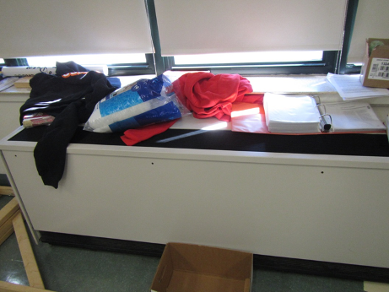

Unit ventilator (univent) in classroom with items on top

Picture 2

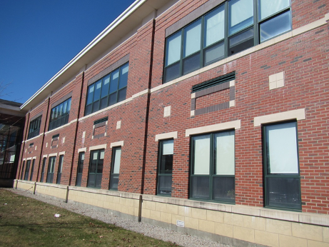

Univent air intakes outside of building
Picture 3

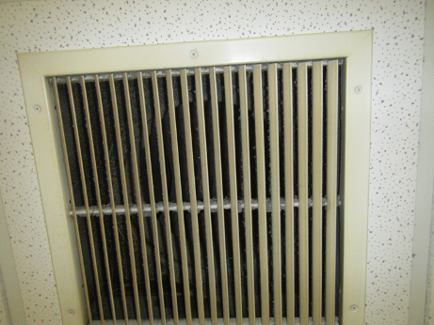

Ceiling-mounted exhaust vent

Picture 4

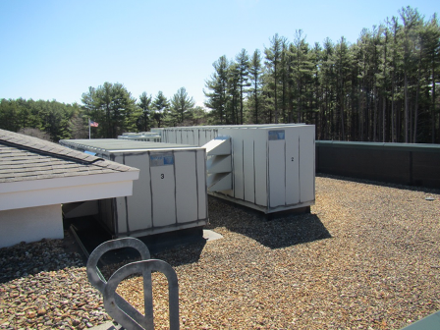

Some of the air handling units (AHU) on the roof
Picture 5

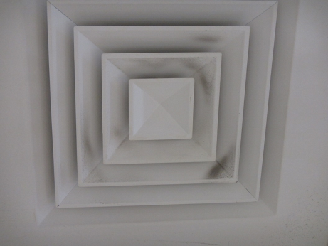

Ceiling-mounted supply vent (note dust on louvers)

Picture 6

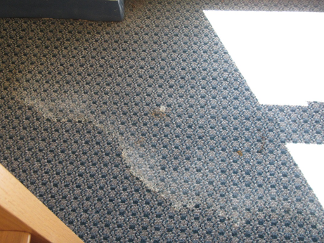

Water-stained carpeting in library
Picture 7

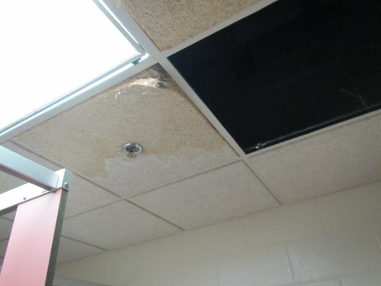

Water-damaged ceiling tile and missing tile

Picture 8

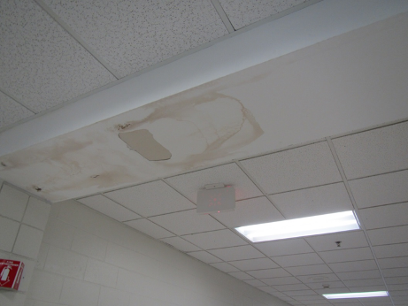

Water-damaged paint/plaster in hallway
Picture 9

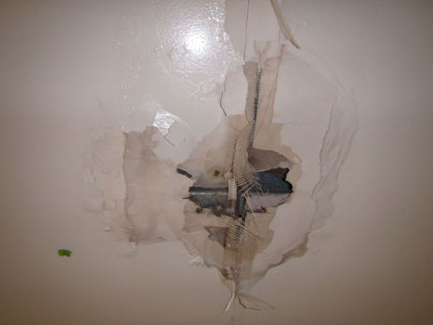

Water-damaged wall in hall just outside room D207
Picture 10

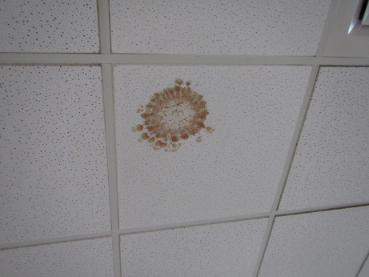

Likely mold-colonized ceiling tile

Picture 11

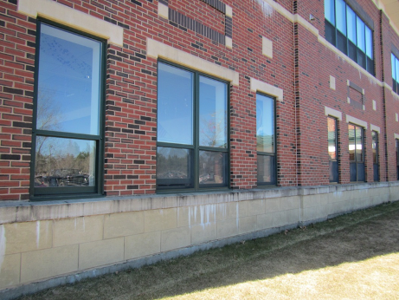

Efflorescence on building façade
Picture 12

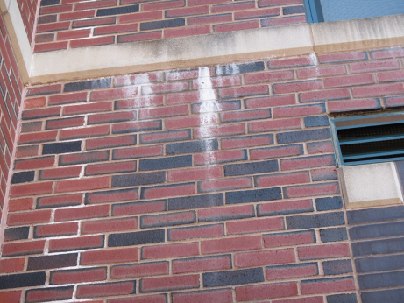

Efflorescence where concrete and brick meet on building façade

Picture 13

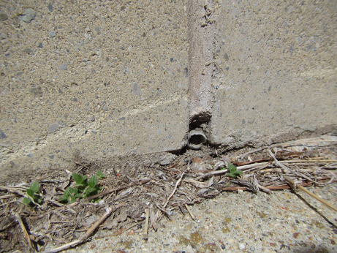

Weep hole at base of wall

Picture 14

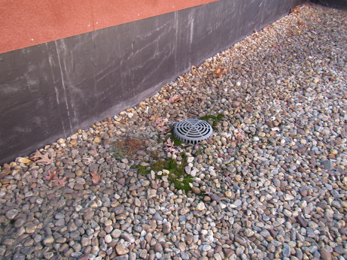

Moss growth next to roof drain indicating historic water pooling
Picture 15

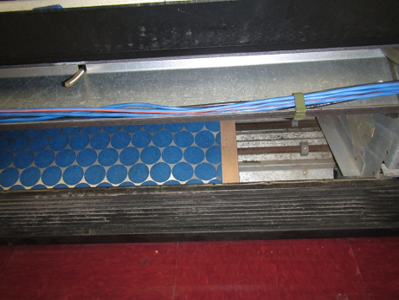

Filter in univent cabinet, note low-dust-spot efficiency filter and filter does not fit

Picture 16

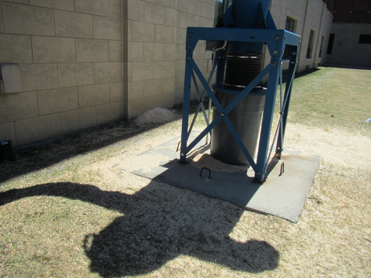

Wood chip/sawdust collector from wood shop; note piles of chips on ground
Picture 17

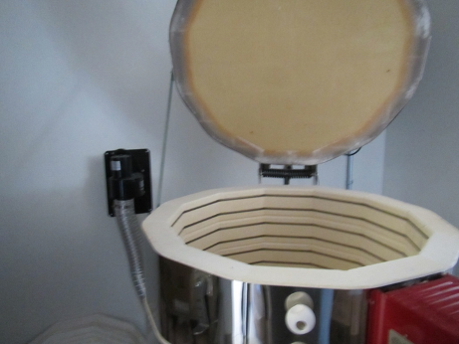

Kiln in art room

Picture 18

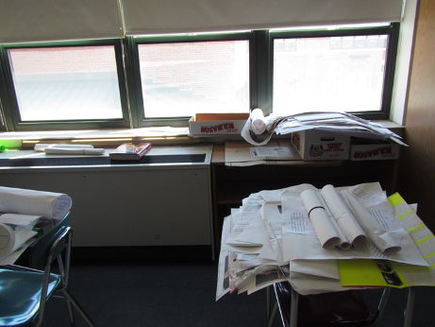

Papers and items on surfaces, including univent
Location | Carbon  Dioxide  (ppm) | Carbon Monoxide  (ppm) | Temp  (°F) | Relative  Humidity  (%) | PM2.5  (µg/m³) | Occupants  in Room | Windows  Openable | Ventilation |  |  | Remarks
 |  |  |  |  |  |  |  | Supply | Exhaust
Background | 394 | 0.6 | 59 | 25 | 3 |  |  |  |  |  | Clear, windy
Front office | 564 | ND | 67 | 26 | 3 | 3 | Y | Y |  | Y | Dusty exhaust vent
A101 | 551 | ND | 71 | 14 | 6 | 1 | Y | Y |  | Y | PC, carpet, WD materials
A108 | 533 | ND | 70 | 14 | ND | 1 | Y open | Y |  | Y dusty | Boxes on floor, carpet, plants
A109 | 577 | ND | 69 | 16 | 2 | 4 | Y | Y |  | Y | Carpet, plant
A110 | 514 | ND | 70 | 13 | 6 | 0 | N | Y |  | Y | WC on carpet, fridge on carpet
A111 | 533 | ND | 69 | 18 | 2 | 9 | Y | Y |  | Y | Pillows, blankets
A114 | 508 | ND | 68 | 14 | 2 | 0 | Y | Y |  | Y | DEM
A120 copy | - | - | - | - | - | - | - | - |  | - | Dusty exhaust vent
A125 | 533 | ND | 71 | 15 | 9 | 0 | Y | Y |  | Y | DEM, WC on carpet, conference room, microwave and fridge
A127 | 489 | ND | 70 | 15 | 2 | 0 | Y | Y |  | Y | Carpeted
A129 | 532 | ND | 71 | 15 | 7 | 0 | Y | Y |  | Y dusty | Nurse’s office, HS  Exhaust does not work in either restroom in the nurses’ suite
A131 | 525 | ND | 71 | 15 | 9 | 0 | Y | Y |  | Y
A201 | 553 | ND | 75 | 17 | 4 | 0 | Y | Y UV off |  | Y | DEM, HS
A202 | 642 | ND | 76 | 14 | 1 | 15 | Y 1 open | Y UV on |  | Y | DEM, bags of recycling, chalk, HS
A203 | 657 | ND | 75 | 19 | 2 | 16 | Y | Y UV off |  | Y | DEM, HS
A204 | 704 | ND | 76 | 19 | 1 | 12 | Y | Y UV off |  | Y | Solar gain, DEM, body odors
A205 | 634 | ND | 73 | 20 | 5 | 2 | Y | Y |  | Y | DEM, HS, AI
A206 | 582 | ND | 75 | 16 | 1 | 0 | Y | Y UV off |  | Y | DEM, PF – dusty, HS
A207 | 585 | ND | 73 | 19 | 2 | 1 | Y | Y UV off |  | Y | 40 min from last class, UV filter too small
A208 | 628 | ND | 74 | 15 | 1 | 0 | Y | Y UV off |  | Y | UV has items on it, DEM
B Wing Music storage |  |  |  |  |  |  |  |  |  |  | Uniforms, cloth items, leather goods, no musty odors
B Wing Instrument storage | 581 | ND | 71 | 17 | 15 | 6 | N | Y |  | Y | carpet, WD CT
B102 | 562 | ND | 74 | 16 | 13 | 19 | Y cracked open | Y |  | Y | band room, carpet slightly soiled
B106 | 544 | ND | 74 | 15 | 1 | 0 | Y | Y |  | Y | carpet, pencil shavings, AI
B109 | 521 | ND | 72 | 17 | 19 | 0 | Y | Y |  | Y | carpet, DEM, WD CT
B111 and B 112 |  |  |  |  |  |  |  |  |  |  | Locked – clothing and uniform storage, items
B115 media/library | 496 | ND | 73 | 15 | 3 | 30 | Y | Y |  | Y | Repainted areas in dome ceiling near sprinkler, WD carpeting near door, copier toner spill/stain, WD CT’s
Digital design | 468 | ND | 73 | 15 | 2 | 7 | Y | Y |  | Y | 20 computers, DEM, HS, door to roof reportedly leaks from snowmelt
B208 Art | 485 | ND | 72 | 17 | 3 | 12 | Y | Y |  | Y | DEM, paint/supplies, dusty supply vent
B208 Kiln room | - | - | - | - | - | - | - | Y |  | Y | Dusty return duct, MT, potential for entrainment
B211 Break room | 462 | ND | 73 | 16 | 1 | 0 | Y | Y UV on |  | Y | Tile flooring, 3 WD CT
B214 | - | - | - | - | - | 0 | Y | Y |  | Y | No class for hours, WD CT, possible microbial growth, dusty supply vent
C102 | 707 | ND | 74 | 17 | 20 | 14 | Y | Y UV on |  | Y | DEM, WD CT
C103? | 648 | ND | 73 | 16 | 1 | 7 | Y | Y |  | Y | computers (25), DEM
C104 | 603 | ND | 74 | 16 | 3 | 22 | Y | Y |  | Y | UV on, DEM
C105 | 554 | ND | 75 | 13 | 6 | 0 | Y | Y UV off |  | Y | mats and therapy equipment, UV off, windows blocked with blackout curtains
C108 | 493 | ND | 74 | 13 | 2 | 6 | Y | Y |  | Y | UV on
C109 | 538 | ND | 75 | 12 | 1 | 0 | Y open | Y UV off |  | Y | Physical therapy equipment, mats
C110 science | 573 | ND | 74 | 14 | 3 | 19 | Y | Y |  | Y | DEM, complaints of gas odors during labs
C111 | - | - | - | - | - | - | Y | Y UV off |  | Y | science sinks and gas spigots, sinks work, PF
C117 | 554 | ND | 74 | 13 | 1 | 16 | Y open | Y |  | Y
C118 | 610 | ND | 73 | 15 | 2 | 17 | Y | Y |  | Y | 3 WD CT, DEM
C202 | 528 | ND | 72 | 15 | 1 | 0 | Y | Y |  | Y | Carpeted, WC on carpet, 2 PC, DEM, WD CT, books and papers on floor
C204 | 773 | ND | 75 | 17 | 2 | 0 | Y | Y |  | Y | WD CT near hall and near window, DEM
C205 | 525 | ND | 76 | 13 | 3 | 0 | Y | Y UV off |  | Y
C206 | 671 | ND | 75 | 15 | 2 | 0 | Y | Y |  | Y | DEM
C207 | 428 | ND | 76 | 12 | 4 | 7 | Y | Y |  | Y | DEM
C208 | 624 | ND | 74 | 12 | ND | 0 | Y | Y UV on |  | Y | DEM
C209 | 554 | ND | 76 | 12 | 2 | 10 | Y | Y UV on |  | Y | DEM
C210 | 617 | ND | 75 | 14 | 7 | 10 | Y open | Y UV on |  | Y dusty | WD CT – 3, DEM
C211 | 687 | ND | 77 | 13 | 3 | 14 | Y | Y |  | Y | UV
C212 | 950 | ND | 76 | 17 | 2 | 19 | Y | Y UV on |  | Y dusty | DEM
C213 | 782 | ND | 77 | 15 | 3 | Class just ended | Y | Y UV obstr. |  | Y | 2 WD CT
C214 | 865 | ND | 75 | 19 | 5 | 0 | Y | Y UV off |  | Y | Chemical experiment on windowsill
CAF | 601 | ND | 72 | 14 | 1 | ~100 | Y and door | Y |  | Y
D107 | 511 | ND | 72 | 16 | 2 | 1 | Y | Y UV off |  | Y | UV off
D122 | 765 | ND | 70 | 24 | 2 | 2 | Y | Y |  | Y
D124 | 675 | ND | 71 | 17 | 20 | 6 | Y and window to hall | Y off |  | N
D207 | Locked | - | - | - | - | - | - | - |  | - | WD, wall board removed
D209 | 770-839 | ND | 76 | 20 | 1 | 2 | Y | Y UV off |  | N | WD CT, food
D211 | 558 | ND | 75 | 19 | 1 | 0 | Y | Y UV off |  | N
D213 | 551 | ND | 76 | 16 | 3 | 3 | Y | Y |  | Yon | DEM
Gym storage | - | - | - | - | - | - | - | - |  | - | Rubber items such as balls and mats in storage with rubber odors
Gym, left side | 438 | ND | 72 | 12 | ND | 17 | Y | Y |  | Y
Gym-bleacher side | 372 | ND | 72 | 12 | 3 | 12 | N | Y |  | Y
Ladies room next to gym | - | - | - | - | - | - | N | Y |  | Y | AT
Men’s room across from gym | - | - | - | - | - | - | - | - |  | Y off | Exhaust slight backdraft
Women’s room in C first floor area | - | - | - | - | - | - | N | - |  | - | Reported odors of sewer gas previously, nothing observed during visit
Basement
C05 | 625 | ND | 73 | 18 | 3 | 5 | Y | Y |  | Y | DEM, paints
C07 | 580 | ND | 75 | 17 | 3 | 5 | Y | Y |  | Y
C08 | 514 | ND | 72 | 16 | 21 | 0 | Y | Y UV off |  | Y | Exercise/training items, mats on floor
C10 | 550 | ND | 71 | 18 | 3 | 0 | Y | Y UV on |  | Y | PC, AI, microwave
C14 | 527 | ND | 72 | 15 | 23-33 | 6 | Y | Y UV obstructed |  | Y | CP, DEM, WD plaster and CT
C16 | 547 | ND | 72 | 16 | ND | 0 | Y | Y UV on |  | Y | storage

A principal conduit (as in a sewer system) through which water is pumped as distinguished from one through which it flows by gravity

