MassHealth
Transmittal Letter OXY-33
February 2019
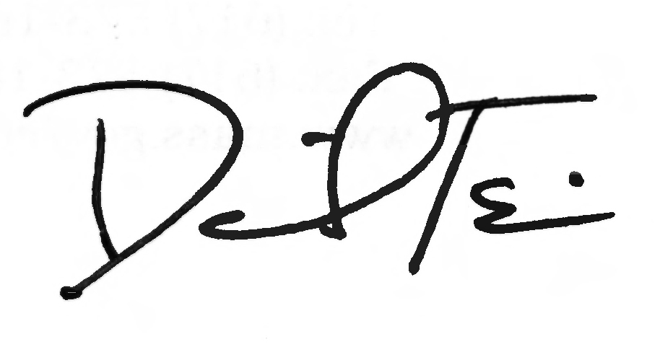
TO: Oxygen and Respiratory Therapy and Equipment Providers Participating in MassHealth
FROM: Daniel Tsai, Assistant Secretary for MassHealth
RE: Oxygen and Respiratory Therapy Equipment Manual (2018 HCPCS Updates)
This letter transmits revisions to the list of service codes described in Subchapter 6 of the Oxygen and Respiratory Therapy Equipment Manual. The Centers for Medicare & Medicaid Services (CMS) has revised the Healthcare Common Procedure Coding System (HCPCS) codes for 2018. The revised Subchapter 6 is effective for dates of service on or after March 1, 2018.
Providers may consult the CMS website at www.cms.gov for a full description of the service codes.
For prior-authorization (PA) requirements, service limits, and place-of-service codes, providers should refer to the updated version of the interactive MassHealth DME and Oxygen Payment and Coverage Guidelines Tool posted on the MassHealth website at:
www.mass.gov/service-details/masshealth-payment-and-coverage-guideline-tools.
Added Codes:
E0472
Deleted codes:
A7011
E0457
E0459
Updated Modifiers
The modifier KE has been replaced with KU per CMS guidance for items subject to CMS’s competitive bid program number 3 (refer to EOHHS administrative bulletin 18-09 for codes with the KU modifier at: https://www.mass.gov/files/documents/2018/03/27/ab-18-09.pdf).
MassHealth Website
This transmittal letter and attached pages are available on the MassHealth website at www.mass.gov/masshealth-transmittal-letters.
To sign up to receive email alerts when MassHealth issues new transmittal letters and provider bulletins, send a blank email to join-masshealth-provider-pubs@listserv.state.ma.us. No text in the body or subject line is needed.

Questions
LTSS providers should direct their questions about this transmittal letter or other questions to the MassHealth Long-Term Services & Supports (LTSS) Provider Service Center by phone at
(844) 368-5184 (toll-free) or via email at support@masshealthltss.com.
NEW MATERIAL
(The pages listed here contain new or revised language.)
Oxygen and Respiratory Therapy Equipment Manual
Pages vi, 6-1, and 6-2
OBSOLETE MATERIAL
(The pages listed here are no longer in effect.)
Oxygen and Respiratory Therapy Equipment Manual
Page vi — transmitted by Transmittal Letter OXY-30
Pages 6-1 and 6-2 — transmitted by Transmittal Letter OXY-32

6. Service Codes

601 Introduction 6-1
602 Service Codes 6-1

Appendix A. Directory A-1

Appendix C. Third-Party-Liability Codes C-1

Appendix T. CMSP Covered Services T-1

Appendix U. DPH-Designated Serious Reportable Events That Are Not Provider-Preventable Conditions U-1

Appendix V. MassHealth Billing Instructions for Provider Preventable Conditions V-1

Appendix W. EPSDT Services Medical and Dental Protocols and Periodicity Schedules W-1

Appendix X. Family Assistance Copayments and Deductibles X-1

Appendix Y. EVS Codes and Messages Y-1

Appendix Z. EPSDT/PPHSD Screening Services Codes Z-1

601 Introduction
MassHealth pays for the services for codes listed in section 602 in effect at the time of service, subject to all conditions and limitations in MassHealth regulations at 130 CMR 427.000 and 450.000. In addition, a provider may request prior authorization (PA) for any medically necessary oxygen and respiratory therapy equipment or supplies. Providers should consult Transmittal Letter OXY-33 for the specific effective dates of service for the service codes.
Providers should refer to the MassHealth DME and Oxygen Payment and Coverage Guidelines Tool for service descriptions, applicable modifiers, place-of-service codes, PA requirements, service limits, and pricing and markup information. For certain services that are payable on an individual consideration (I.C.) basis, the tool can calculate the payable amount, based on information entered into certain fields on the tool.
The MassHealth DME and Oxygen Payment and Coverage Guidelines Tool is on the MassHealth website at www.mass.gov/service-details/masshealth-payment-and-coverage-guideline-tools.
602 Service Codes
A4216
A4217
A4481
A4483
A4556
A4557
A4601
A4604
A4605
A4606
A4608
A4611
A4612
A4613
A4614
A4619
A4623
A4624
A4625
A4626
A4627
A4628
A4629
A7000
A7001
A7002
A7003
A7004
A7005
A7006
A7010
A7012
A7013
A7014
A7015
A7017
A7018
A7020
A7025
A7026
A7027
A7028
A7029
A7030
A7031
A7032
A7033
A7034
A7035
A7036
A7037
A7038
A7039
A7044
A7045
A7046
A7047
A7501
A7502
A7503
A7504
A7505
A7506
A7507
A7508
A7509
A7520
A7521
A7522
A7523
A7524
A7525
A7526
A7527
E0424
E0431
E0434
E0439
E0445
E0465
E0466
E0470
E0471
E0472
E0480
E0482
E0483
E0484
E0487
E0500
E0550
E0560
E0561
E0562
E0565
E0570
E0572
E0585
E0600
E0601
E0619
E1372
E1390
E1392
K0730
K0738
L8501
S8186
S8210
S899

This page is reserved.

