Office of Medicaid
Commonwealth of Massachusetts
Executive Office of Health and Human Services
www.mass.gov/masshealth

MassHealth
Durable Medical Equipment Bulletin 20
Oxygen and Respiratory Therapy Equipment Bulletin 16
August 2018

TO: Durable Medical Equipment (DME) Providers and Oxygen and Respiratory Therapy Equipment (OXY) Providers Participating in MassHealth

FROM: Daniel Tsai, Assistant Secretary for MassHealth 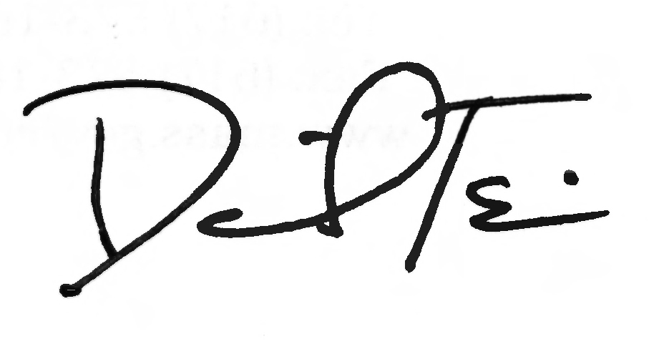

RE: New Policy for Home Use of Nebulizers

Summary

Effective Sept. 1, 2018, MassHealth is rescinding Durable Medical Equipment Provider Bulletin #18 (May 2012) concerning the provision of loaner nebulizers for home use. The bulletin discussed the provision of loaner nebulizers by DME and OXY providers to certain MassHealth prescribing provider locations for the purposes of temporarily loaning such devices to members with an immediate need for them at home.

The 2012 bulletin also set forth the agency’s expectation that DME and OXY providers would, upon delivery of a prescribed device to a member, retrieve and return such loaner equipment to the MassHealth prescribing provider location that lent it to the member.

New Revised Policy

Beginning Sept. 1, 2018, MassHealth will allow prescribing providers’ offices (also referred to as consignment closets/stock and bill) to supply nebulizers and related supplies to members on behalf of DME and OXY providers under the following conditions.
- The member has a medical need for home use of a nebulizer;
- The DME/OXY provider must have on file documentation that the member was trained by the prescribing provider on the portable nebulizer;
- The prescription must meet the applicable prescription and letter of medical necessity requirements of 130 CMR 409.416 or 130 CMR 427.408;
- The DME or OXY provider must comply with the provisions of 130 CMR 409.000 and 130 CMR 427.000, including regulations at 130 CMR 409.419 and 130 CMR 427.430 concerning delivery tickets;
- The prescribing provider and DME/OXY provider must comply with all other applicable provisions of 130 CMR 450.000, 130 CMR 409.000, and 130 CMR 427.000, including recordkeeping requirements; and
- The prescribing provider and the DME/OXY provider must comply with all other federal and state laws and regulations prohibiting illegal kickbacks and referrals.

(continued on next page)

MassHealth

Durable Medical Equipment Bulletin 20

Oxygen and Respiratory Therapy Equipment Bulletin 16

August 2018

Page 2

Claims Process

DME and OXY providers may submit claims for payment for delivery on their behalf of nebulizers to MassHealth members by a prescribing provider. The date of service on the claim must be the date on which the member received the nebulizer.

MassHealth will subject the billing code for nebulizers, E0570, to ongoing audits. DME/OXY providers who are not in compliance with the MassHealth requirements could be subjected to sanctions, including agency action to recover overpayments.

MassHealth Website

This bulletin is available on the MassHealth website at www.mass.gov/masshealth-provider-bulletins.

To sign up to receive email alerts when MassHealth issues new bulletins and transmittal letters, send a blank email to join-masshealth-provider-pubs@listserv.state.ma.us. No text in the body or subject line is needed.

Questions

If you have any questions about the information in this bulletin, please contact the MassHealth LTSS Provider Service Center at (844) 368-5184, or send an email to support@masshealthltss.com.

Follow us on Twitter @MassHealth.

