INDOOR AIR QUALITY ASSESSMENT

Page Elementary School
694 Main Street
West Newbury, MA

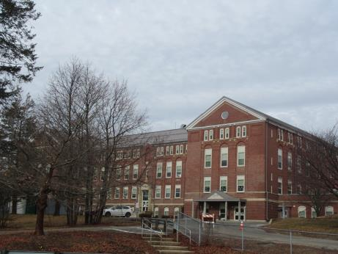

Prepared by:
Massachusetts Department of Public Health
Bureau of Environmental Health
Indoor Air Quality Program
May 2018

Background

Building: | Page Elementary School (PES)
Address: | 694 Main Street, West Newbury, MA
Assessment Requested by: | Paul Sevigny, Health Director, West Newbury
Reason for Request: | General indoor air quality (IAQ)
Date of Assessment: | April 10, 2018
Massachusetts Department of Public Health/Bureau of Environmental Health (MDPH/BEH) Staff Conducting Assessment: | Jason Dustin, Environmental Analyst, IAQ Program
Building Description: | The PES is a four story brick building built in 1929
Building Population: | Approximately 400 students and staff
Windows: | Windows are openable in some areas

IAQ Testing Results
Please refer to the IAQ Manual for methods, sampling procedures, and interpretation of results (MDPH, 2015). The following is a summary of indoor air testing results (Table 1).
- Carbon dioxide levels were above 800 parts per million (ppm) in about 8 of the 44 occupied areas tested, indicating a lack of air exchange in some areas of the building. Some areas were empty, which can reduce carbon dioxide levels.
- Temperature was within or close to the recommended range of 70°F to 78°F the day of assessment.
- Relative humidity was below the recommended range of 40 to 60% in all areas the day of assessment as is typical during the heating season.
- Carbon monoxide levels were non-detectable (ND) in all areas tested.
- Total Volatile Organic Compounds (TVOCs) were ND in all areas tested.
- Fine particulate matter (PM2.5) concentrations measured were below the National Ambient Air Quality (NAAQS) limit of 35 μg/m³ in all areas tested.

Ventilation
A heating, ventilating and air conditioning (HVAC) system has several functions. First it provides heating and, if equipped, cooling. Second, it is a source of fresh air. Finally, an HVAC system will dilute and remove normally occurring indoor environmental pollutants by not only introducing fresh air, but by filtering the airstream and ejecting stale air to the outdoors via exhaust ventilation. Even if an HVAC system is operating as designed, point sources of respiratory irritation may exist and cause symptoms in sensitive individuals.
Fresh air is provided by a combination of unit ventilators (univents) located in some individual classrooms and roof top air handling units (AHUs). The univents draw fresh air through a vent on the exterior wall (Picture 1). Air is mixed with return air from the room, filtered, heated (if needed) and delivered to the room (Figure 1). Some univents were obstructed by items placed on top or in front. Both the top and the vent at the bottom need to be kept clear of obstructions for the units to operate as designed. Air from the AHUs is filtered, heated or cooled as needed, and delivered to rooms via ducted supply vents (Picture 2).
It appears that the HVAC system fan operates intermittently according to the set point of the thermostat, which deactivates the HVAC system when it reaches a preset temperature, therefore, no mechanical ventilation is provided until the thermostat reactivates the system. To maximize air exchange, the MDPH recommends that both supply and exhaust ventilation operate continuously during periods of occupancy.
In most classrooms, air is returned to the AHUs through ceiling-mounted exhaust vents (Picture 3). Some classrooms were noted to only have supply vents and were not equipped with exhaust vents in the ceiling (Table 1). This condition, as well as the intermittent AHU ventilation setting, may help to explain why some of the carbon dioxide readings were slightly elevated in classes having full attendance. It appears that the PES utilizes a ceiling plenum exhaust/return system so that an HVAC specialist may easily remove a ceiling tile and install an exhaust/return grate to improve air flow in these classrooms.
In order to have proper ventilation with a mechanical supply and exhaust system, these systems must be balanced to provide an adequate amount of fresh air while removing stale air from a room. It is recommended that existing ventilation systems be re-balanced every five years to ensure adequate air systems function (SMACNA, 1994). It is unknown the last time these systems were balanced.

Microbial/Moisture Concerns
Water-damaged ceiling tiles were observed in a few areas (Pictures 4 and 5, Table 1), which indicate leaks from the building envelope or plumbing system. These tiles should be replaced after the leak is found and repaired. In most cases, these leaks were reported to be historic (i.e., inactive).
A slight musty odor was observed in room G53 (music). It appeared most building materials were non-porous (e.g., concrete, tile) in this room. However, porous items (e.g., books, boxes, etc.) stored on the floors or against exterior walls may be a source for microbial colonization if exposed to chronic moisture/condensation.
Indoor plants were observed in a few areas. Some of these plants were noted to be placed on porous materials that can grow mold. Plants can be a source of pollen and mold, which can be respiratory irritants to some individuals. Plants should be properly maintained and equipped with non-porous drip pans and should be located away from air diffusers to prevent the aerosolization of dirt, pollen and mold.
One classroom had small indoor greenhouses with humidifiers that were used to grow mushrooms (Picture 6). This condition may add excess humidity and allergens to the room. The use of the humidifiers/greenhouses was reportedly discontinued as a result of previous concerns.
Many classroom sinks were noted to have a gap between the counter and the backsplash (Picture 7; Table 1). This condition may allow chronic moisture to porous building materials or items stored beneath the sink.
During a perimeter inspection of the building exterior, several other issues were identified which could lead to water penetration, including some gutters overflowing and downspouts draining against the building foundation (Pictures 8 to 10). There were some holes/gaps noted in the brickwork (Picture 11). Also, vegetation was growing on or against the building some of which was growing in front of fresh air intakes for Univents (Picture 1). These conditions may introduce moisture, pollen, or pests into occupied areas.

Other IAQ Evaluations
Exposure to low levels of total volatile organic compounds (TVOCs) may produce eye, nose, throat, and/or respiratory irritation in some sensitive individuals. To determine if VOCs were present, BEH/IAQ staff examined rooms for products containing VOCs. BEH/IAQ staff noted hand sanitizers, cleaners/spray bottles, plug-in air fresheners, and dry erase materials in use within the building (Picture 12). All of these products have the potential to be irritants to the eyes, nose, throat, and respiratory system of sensitive individuals. Due to the pervasive use of these products in schools throughout Massachusetts, the MDPH has produced a guideline called “Clean Air Is Odor-Free” which is included as Appendix A.
A number of classrooms contained window-mounted air conditioners (ACs) or portable units (Table 1). Window units are equipped with filters that should be cleaned or changed regularly in accordance with manufacturer’s instructions to prevent the build-up of dust and debris.
Some classrooms had personal fans. Some of these had dusty blades/housings (Table 1). Some supply diffusers and exhaust/return vents were also observed to be dusty. This dust can be reaerosolized when the equipment is activated.
In many areas, accumulated items including books, papers, toys and decorative items were observed on floors, windowsills, tabletops, counters, bookcases, and desks (Picture 13; Table 1). Excess items on surfaces can make it more difficult for custodial staff to clean.
Many classrooms/areas had carpeting. Carpeting should be HEPA vacuumed daily and cleaned annually or semi-annually in soiled high traffic areas. Many classrooms had area rugs, which should also be cleaned regularly and discarded when too worn out or soiled to be cleaned.
Most of the above noted conditions are commonly found in schools throughout Massachusetts. The MDPH guideline “Indoor Air Quality in Schools” is included as Appendix B to explain in further detail how to remedy most commonly-found issues.
Note that the Environmental Protection Agency (EPA) conducted a National School Radon Survey in which it discovered nearly one in five schools had “…at least one frequently occupied ground contact room with short-term radon levels above 4 [picocuries per liter] pCi/L” (US EPA 1993). The BEH/IAQ Program therefore recommends that every school be tested for radon, and that this testing be conducted during the heating season while school is in session in a manner consistent with USEPA radon testing guidelines. Radon measurement specialists and other information can be found at www.nrsb.org and http://aarst-nrpp.com/wp, with additional information at: http://www.mass.gov/eohhs/gov/departments/dph/programs/environmental-health/exposure-topics/iaq/radon.

Conclusions/Recommendations
The following recommendations are made to assist in improving IAQ:
- Operate all supply and exhaust ventilation equipment continuously during occupied hours. Fresh air should be supplied even when the thermostat set points are met to avoid intermittent ventilation that may allow indoor pollutants to build up.
- Use openable windows to supplement fresh air during temperate weather. Ensure all windows are tightly closed at the end of the day or during the use of air conditioning.
- Remove items and furniture blocking univents both on top and along the front.
- Consult with an HVAC specialist to install exhaust/return grates in those rooms not currently equipped with them to improve air exchange.
- Check exhaust vents (in classrooms and restrooms) for draw periodically and repair any non-operating motors/vents.
- Consider adopting a balancing schedule of every 5 years for all mechanical ventilation systems, as recommended by ventilation industrial standards (SMACNA, 1994).
- For buildings in New England, periods of low relative humidity during the winter are often unavoidable. Therefore, scrupulous cleaning practices should be adopted to minimize common indoor air contaminants whose irritant effects can be enhanced when the relative humidity is low. To control dusts, a high efficiency particulate arrestance (HEPA) filter equipped vacuum cleaner in conjunction with wet wiping of all surfaces is recommended. Avoid the use of feather dusters. Drinking water during the day can help ease some symptoms associated with a dry environment (throat and sinus irritations).
- Ensure roof and plumbing leaks are repaired and replace any remaining water-damaged ceiling tiles and building materials.
- Inspect any stored supplies or porous items (e.g., books, papers, boxes, etc.) in areas noted to have musty odors. Discard any porous items noted to be water-damaged or have a musty odor.
- Consider contacting a building envelope specialist to examine/make repairs to gaps/holes in exterior walls as well as repair gutters to prevent further water infiltration. Extend downspouts to direct water away from the foundation.
- Remove any vegetation growing on or within 5 feet of the building.
- Properly maintain plants, including drip pans, to prevent water damage to porous materials. Plants should also be located away from air diffusers to prevent the aerosolization of dirt, pollen, and mold.
- Seal any gaps between the sink counter and backsplashes with appropriate caulking.
- Discontinue (as reported) the use of humidifiers and the growth of mushrooms in the classrooms to reduce the risk of condensation and allergens in these areas.
- Reduce the use of products and equipment that contain VOCs (e.g., air fresheners, scented cleaning wipes, scented hand sanitizer, etc.).
- Consider replacing the Blue window cleaner with a product that is free from ammonia, VOCs, and fragrances. Continue to use cleaning products with adequate ventilation and while building is unoccupied.
- Continue to change filters for HVAC equipment 2-4 times a year. The MDPH recommends using pleated filters of Minimum Efficiency Reporting Value (MERV) of 8, which are adequate in filtering out pollen and mold spores (ASHRAE, 2012), if these can be used with current equipment.
- Regularly clean/vacuum univent cabinets, supply/return/exhaust vents and fans to avoid aerosolizing accumulated particulate matter. To clean ceiling grills, remove and wash.
- Clean window-mounted/portable AC filters prior to the start of the cooling season and according to the manufacturer’s instructions.
- Consider reducing the amount of items stored in classrooms to make cleaning easier. Periodically move items to clean flat surfaces.
- Univent fresh air intakes on the exterior of the building should be monitored for debris and cleaned periodically. Ensure any vegetation is removed that is growing in front of these air intakes.
- HEPA vacuum carpeting daily and clean carpeting annually (or semi-annually in soiled high traffic areas). Clean area rugs similarly.
- The school should be tested for radon by a certified radon measurement specialist during the heating season when school is in session. Radon measurement specialists and other information can be found at: www.nrsb.org, and http://aarst-nrpp.com/wp.
- Consider adopting the US EPA (2000) document, “Tools for Schools”, as an instrument for maintaining a good IAQ environment in the building available at: http://www.epa.gov/iaq/schools/index.html.
- Refer to resource manual and other related IAQ documents located on the MDPH’s website for further building-wide evaluations and advice on maintaining public buildings. These documents are available at: http://mass.gov/dph/iaq.

References
ASHRAE. 2012. American Society of Heating, Refrigeration and Air Conditioning Engineers (ASHRAE) Standard 52.2-2012 -- Method of Testing General Ventilation Air-Cleaning Devices for Removal Efficiency by Particle Size (ANSI Approved).
MDPH. 2015. Massachusetts Department of Public Health. “Indoor Air Quality Manual: Chapters I-III”. Available at: http://www.mass.gov/eohhs/gov/departments/dph/programs/environmental-health/exposure-topics/iaq/iaq-manual/.
SMACNA. 1994. HVAC Systems Commissioning Manual. 1st ed. Sheet Metal and Air Conditioning Contractors’ National Association, Inc., Chantilly, VA.
US EPA. 1993. Radon Measurement in Schools, Revised Edition. Office of Air and Radiation, Office of Radiation and Indoor Air, Indoor Environments Division (6609J). EPA 402-R-92-014. https://www.epa.gov/sites/production/files/2014-08/documents/radon_measurement_in_schools.pdf
US EPA. 2000. Tools for Schools. Office of Air and Radiation, Office of Radiation and Indoor Air, Indoor Environments Division (6609J). EPA 402-K-95-001, Second Edition. http://www.epa.gov/iaq/schools/index.html.
Picture 1
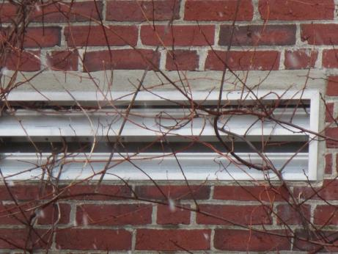
Univent fresh air intake (note vegetation growing over it)
Picture 2
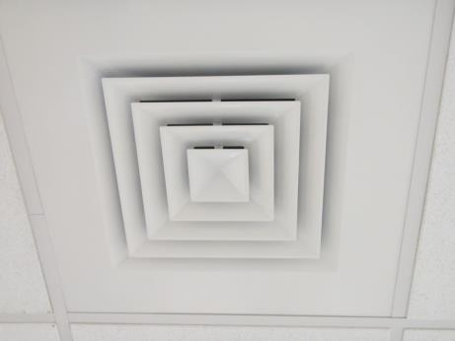
Ducted supply vent from air handling unit (AHU)
Picture 3
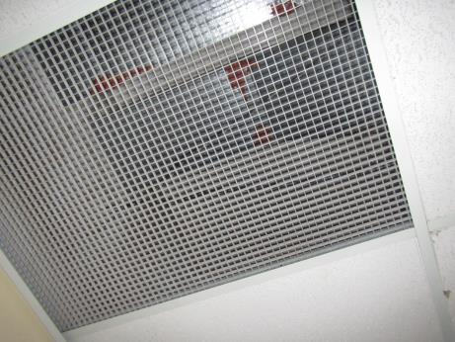
Ceiling-mounted exhaust/return grate
Picture 4
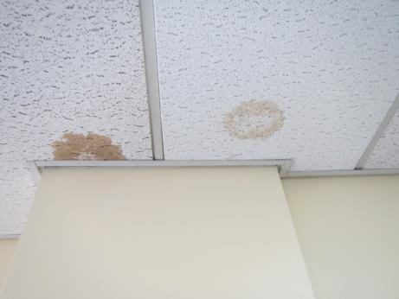
Water-damaged ceiling tiles
Picture 5
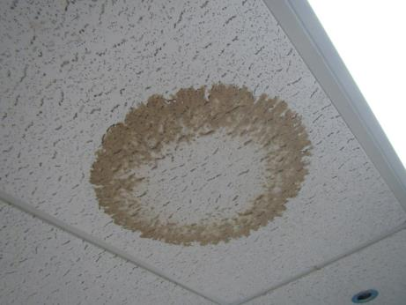
Water-damaged ceiling tile
Picture 6
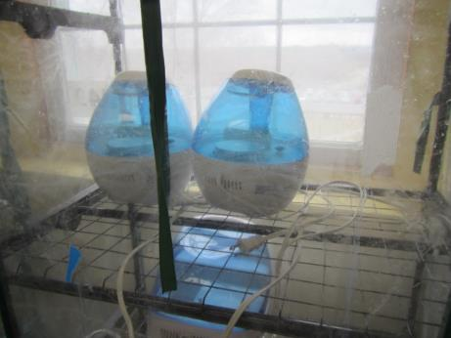
Small greenhouse with humidifiers formerly used to grow mushrooms
Picture 7
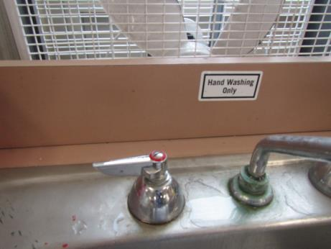
Gap in counter/backsplash joint
Picture 8
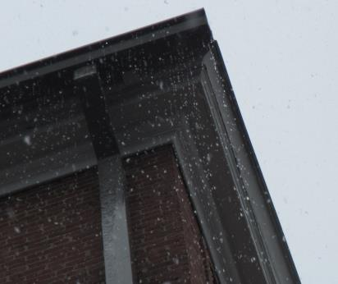
Water overflowing gutter system
Picture 9
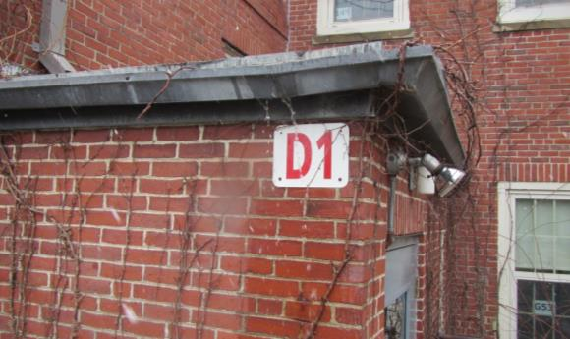
Water flowing over gutter against exterior of stairwell near G53 classroom
Picture 10
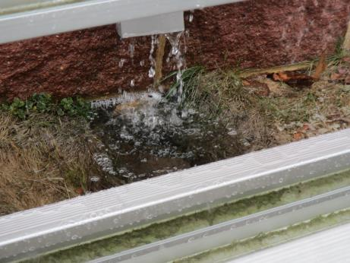
Downspout draining against foundation
Picture 11
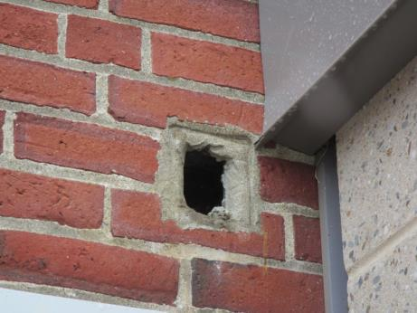
Hole in brick work adjacent to gymnasium
Picture 12
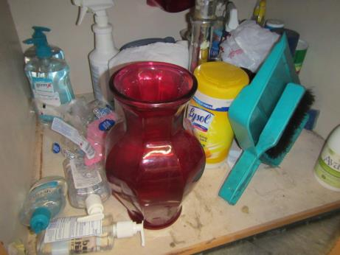
Scented cleaning wipes and hand sanitizer
Picture 13
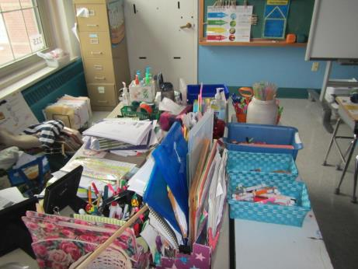
Accumulated items on surfaces

Location | Carbon  Dioxide  (ppm) | Carbon Monoxide  (ppm) | Temp  (°F) | Relative  Humidity  (%) | PM2.5  (µg/m³) | TVOCs  (ppm) | Occupants  in Room | Windows  Openable | Ventilation |  |  | Remarks
 |  |  |  |  |  |  |  |  | Intake | Exhaust
Background (outside) | 338 | ND | 45 | 37 | 5 | ND | - | - | - |  | - | snow
Front office | 641 | ND | 66 | 27 | 3 | ND | 3 | N | Y |  | Y | Intermittent AHU setting
Cafeteria | 381 | ND | 70 | 21 | 1 | ND | 2 | N | Y |  | Y
Gym | 474 | ND | 70 | 22 | 3 | ND | 5 | N | Y |  | Y | Recently renovated, new AHU and duct work
Nurse | 437 | ND | 71 | 21 | 1 | ND | 3 | N | Y |  | Y
Bat Cave | 335 | ND | 67 | 23 | 1 | ND | 2 | N | N |  | N | New tile, new paint
Ground floor hall | 426 | ND | 68 | 23 | 3 | ND | 2 | N | Y |  | Y
Hall near 103 | 373 | ND | 70 | 21 | 3 | ND | 2 | N | Y |  | Y
Hall near 127 | 541 | ND | 70 | 21 | 1 | ND | 2 | N | Y |  | Y
221 | 554 | ND | 72 | 20 | 3 | ND | 2 | Y | Y |  | N | Unoccupied, previous poor housekeeping, recently cleaned, cleaned AC filters, HS, CP wipes, DEM, AI
218A | 691 | ND | 72 | 20 | 4 | ND | 18 | Y | Y |  | Y
218B storage room | 647 | ND | 71 | 23 | 5 | ND | 0 | N | N |  | N | AT with stored items
Hall 225 | 608 | ND | 71 | 21 | 2 | ND | 5 | N | Y |  | Y
Hall Bottom Ramp (2nd Floor) | 797 | ND | 71 | 22 | 3 | ND | 4 | N | Y |  | Y | Former WD (remediated)
236 Teacher lounge | 526 | ND | 72 | 19 | 1 | ND | 2 | Y | Y |  | Y | WD CT
Library | 412 | ND | 72 | 16 | 3 | ND | 20 | Y | Y |  | Y | NC
242 Computer lab | 481 | ND | 72 | 16 | 4 | ND | 1 | Y | Y |  | Y | WD
327 | 891 | ND | 72 | 22 | 3 | ND | 21 | Y | Y |  | Y | NC, CP, HS, DEM, sink/backsplash gap
328 | 797 | ND | 72 | 21 | 4 | ND | 19 | Y | Y |  | Y | DEM, HS
332 | 675 | ND | 71 | 20 | 4 | ND | 0 | Y | Y |  | Y | WACs, unoccupied
334 | 491 | ND | 72 | 19 | 3 | ND | 5 | Y | Y |  | Y | WACs
Hall near 318 | 516 | ND | 72 | 19 | 4 | ND | 3 | N | Y |  | Y
308 | 454 | ND | 72 | 19 | 3 | ND | 2 | Y | Y |  | Y
304 | 709 | ND | 70 | 21 | 3 | ND | 15 | Y | Y |  | Y | CP, HS
303 | 856 | ND | 73 | 22 | 3 | ND | 19 | Y | Y |  | Y
309 | 797 | ND | 72 | 21 | 4 | ND | 21 | Y | Y |  | Y | Sink gap, CP
317 | 468 | ND | 71 | 19 | 2 | ND | 3 | Y | Y |  | Y
318 | 458 | ND | 71 | 19 | 4 | ND | 0 | Y | Y |  | Y
319 | 531 | ND | 72 | 20 | 4 | ND | 7 | Y | Y on |  | Y | Carpet, DEM
Red stairwell between 2nd-3rd | 523 | ND | 72 | 20 | 4 | ND | 2 | N | N |  | N
Red stairwell between 1st-2nd | 580 | ND | 72 | 20 | 3 | NnD | 2 | N | N |  | N
Red stairwell between G-1st | 759 | ND | 72 | 21 | 6 | ND | 15 | N | N |  | N
G31 M/N | 515 | ND | 71 | 20 | 4 | ND | 6 | Y | Y off |  | Y off | Newly renovated, new tile
G53 | 489 | ND | 69 | 24 | 3 | ND | 3 | Y | Y |  | Y | Slight musty odor, univent in ceiling, ducted fresh air
Hall outside G31/baths | 554 | ND | 70 | 23 | 3 | ND | 4 | Y | Y |  | Y
Blue stairwell between G-1st | 452 | ND | 70 | 22 | 3 | ND | 2 | N | N |  | N
Blue stairwell between 1st-2nd | 484 | ND | 71 | 22 | 3 | ND | 2 | N | N |  | N
Blue stairwell between 2nd-3rd | 502 | ND | 73 | 21 | 5 | ND | 2 | N | N |  | N
209 | 642 | ND | 72 | 20 | 4 | ND | 2 | Y | Y |  | N | No return vent, carpet cleaned, DEM, HS
208 | 1152 | ND | 72 | 22 | 3 | ND | 17 | Y | Y |  | N | No return, HS, CPs, DEM, intermittent AHU setting
205 | 738 | ND | 72 | 21 | 4 | ND | 17 | Y | Y |  | Y
204 | 518 | ND | 71 | 20 | 2 | ND | 2 | Y | Y |  | Y
203 | 506 | ND | 71 | 21 | 2 | ND | 4 | Y | Y |  | Y | PF, UF
202 | 522 | ND | 71 | 20 | 3 | ND | 2 | Y | Y |  | Y | Area rug
215 | 450 | ND | 70 | 22 | 2 | ND | 3 | Y | Y |  | Y | HS, CPs, AI
216 | 538 | ND | 72 | 20 | 3 | ND | 3 | Y | Y |  | Y | AI, plants
225 | 490 | ND | 74 | 22 | 2 | ND | 4 | Y | Y |  | N | CPs, HS, DEM
224 | 473 | ND | 72 | 20 | 3 | ND | 15 | Y | Y |  | Y | HS, sink/backsplash gap
145 | 872 | ND | 70 | 24 | 2 | ND | 23-gone 1hr | Y | Y |  | Y | Local exhaust on switch, UV with books on top
127 | 487 | ND | 70 | 24 | 4 | ND | 4 | Y | Y |  | Y | All new cabinets, ceiling, walls, etc.
121 | 382 | ND | 70 | 23 | 5 | ND | 2 | Y | Y |  | Y | All new GW, base cove, paint, etc.
120B | 415 | ND | 71 | 22 | 4 | ND | 2 | Y | N |  | N | DEM
120A | 402 | ND | 72 | 22 | 3 | ND | 5 | Y | Y |  | Y | Plant, HS
119 | 407 | ND | 72 | 21 | 2 | ND | 7 | Y | Y |  | Y | WD CT
113 | 613 | ND | 72 | 22 | 2 | ND | 4 | Y | Y |  | Y | Plants, HS
112 | 910 | ND | 72 | 24 | 14 | ND | 14 | Y | Y |  | Y | HS, mini greenhouses (empty), other plants
107 | 910 | ND | 72 | 24 | 3 | ND | 21 | Y | Y |  | Y | HS, AI, backsplash gap
104 | 372 | ND | 72 | 21 | 3 | ND | 21 | Y | Y |  | Y | HS, CP, plants, carpet
103 | 349 | ND | 72 | 21 | 2 | ND | 20 | Y | Y |  | Y | HS, carpet
102 | 340 | ND | 71 | 21 | 4 | ND | 2 | Y | Y |  | Y | WD CT x 2, DEM, carpet, WAC, HS
137B | 367 | ND | 73 | 22 | 3 | ND | 2 | Y | Y |  | N | AI, new GW
137A | 343 | ND | 73 | 22 | 4 | ND | 2 | Y | Y |  | Y | CPs, backsplash gap
135 | 355 | ND | 71 | 21 | 4 | ND | 2 | Y | Y |  | N | Slight musty odor, stored items
129 | 749 | ND | 71 | 20 | 3 | ND | 24 | Y | Y |  | Y
132 | 786 | ND | 70 | 25 | 4 | ND | 19 | Y | Y |  | Y | CPs, area rug
G34 | 455 | ND | 70 | 24 | 3 | ND | 3 | Y | Y |  | N | After school program
G04 | 370 | ND | 71 | 24 | 5 | ND | 3 | Y | Y |  | N | WD CT, HS
G18 | 375 | ND | 70 | 23 | 4 | ND | 3 | Y | Y |  | Y | Tiles, plants
136 | 440 | ND | 71 | 22 | 3 | ND | 3 | Y | Y |  | Y | New GW
Janitor’s area | 641 | ND | 69 | 22 | 4 | ND | 3 | Y | N |  | N
Yellow stairwell between G-1st | 841 | ND | 71 | 25 | 6 | ND | 2 | N | N |  | N
Principal | 1861 | ND | 69 | 31 | 5 | ND | 12 | Y | Y off |  | Y | Intermittent AHU setting
G31 | 827 | ND | 67 | 27 | 3 | ND | 2 | Y | Y |  | Y | DEM
Cleaning solutions:
Blue |  |  |  |  |  | 14 * |  |  |  |  |  | *Concentrated form. These cleaners are diluted and reportedly used while building is unoccupied.
Red |  |  |  |  |  | 2
Yellow |  |  |  |  |  | < 2
Work room | 630 | ND | 75 | 12 | 4 |  | 0 | N | Y |  | Y

