WATER DAMAGE INVESTIGATION

Page Elementary School
694 Main Street
West Newbury, Massachusetts

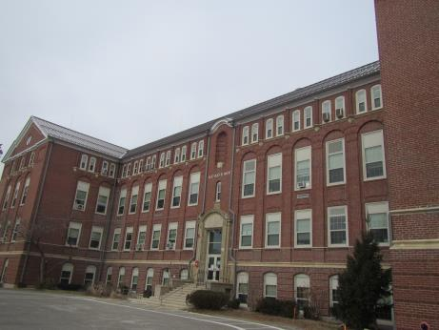

Prepared by:
Massachusetts Department of Public Health
Bureau of Environmental Health
Indoor Air Quality Program
February 2018

BACKGROUND
Building: | Page Elementary School (PES)
Address: | 694 Main Street, West Newbury, MA
Assessment Requested by: | Paul Sevigny, West Newbury Health Department
Reason for Request: | Water damage concerns
Date of Assessment: | January 16, 2018  February 6, 2018
Massachusetts Department of Public Health/Bureau of Environmental Health (MDPH/BEH) Staff Conducting Assessment: | Mike Feeney, Director, Indoor Air Quality (IAQ) Program and  Jason Dustin, Environmental Analyst/Inspector, IAQ Program
Building Description: | The PES is a four story brick building built in 1929.
Windows: | Windows are openable in some areas

IAQ Testing Results
Please refer to the IAQ Manual for methods, sampling procedures, and interpretation of results (MDPH, 2015). The following is a summary of indoor air testing results.
- Moisture Measurements were all dry (i.e., within normal parameters) at the time of assessment.
- Temperature was within or slightly below the recommended range of 70°F to 78°F the day of assessment.
- Relative humidity was below the recommended range of 40 to 60% in areas tested the day of the assessment, which is typical during the heating season. The low relative humidity was a result of using dehumidifiers as part of the mold remediation.

Background and Discussion
The BEH/IAQ Program was asked to examine the PES for the presence of water damage/mold growth in areas that were damaged by a broken sprinkler pipe that occurred on January 2, 2018. The leak reportedly resulted in approximately 2 inches of standing water in some areas. It was also reported that a flood restoration contractor (ServPro) was contacted to perform remediation activities within hours after discovery of the break. Remediation activities included: water extraction, mechanical drying with fans/dehumidifiers, removal of sections of gypsum wallboard (GW) (Pictures 1 and 2) and the removal of area rugs and personal items from affected areas. Water-damaged ceiling tiles were also removed in several areas below the area of the broken sprinkler pipe which has since been repaired (Picture 3).
No visible mold was reported in any offices or classrooms impacted by the flooding event according to West Newbury town officials. IAQ staff could not identify any mold growth in remaining GW in classrooms or offices during the January 16, 2018 visit. A small area of visible mold was observed on a wall cavity in the boys’ bathroom (Picture 4). This microbial growth appeared to be historic in nature and was likely caused by previous penetration of moisture into the wall cavity unrelated to the most recent pipe break incident. This wall is comprised of gypsum wallboard (GW) which is faced with paper and which may become moldy if exposed to moisture in a high water use area (e.g., mopping). For this reason, it is recommended that a material without paper (cement board) be used to repair this wall.
The US Environmental Protection Agency (US EPA) and the American Conference of Governmental Industrial Hygienists (ACGIH) recommends that porous materials (e.g., wallboard, carpeting) be dried with fans and heating within 24 to 48 hours of becoming wet (US EPA, 2008; ACGIH, 1989). If porous materials are not dried within this time frame, mold growth may occur.
It is important to note that relative humidity levels were maintained in a low range (between 17 to 26% in areas tested) by mechanical means. The low humidity combined with the use of fans, heating, and dehumidifiers during the remediation effort aids drying. IAQ staff checked room wall surfaces with a moisture meter and verified that no walls showed any remaining signs of elevated moisture. ServPro representatives also reported that moisture sampling was performed throughout the drying process and that any porous materials not thoroughly dried within 24 to 48 hours were removed per US EPA recommendations. The remaining gypsum wallboard was dried by removing one side of the wallboard to thoroughly dry the wall cavity (Picture 5). Other walls were composed of plaster, which is a masonry product much less susceptible to mold growth (Picture 6).
High efficiency particulate arrestance (HEPA) filter units were observed operating throughout the affected space (Picture 7). In addition, IAQ staff observed containment barriers in place at the time of this assessment (Picture 8) which prevents dust, debris and odors from the area undergoing remediation being spread to other areas.
Water-damaged materials (books, school supplies and furniture) were removed from damaged areas (Picture 9). Most of these items (e.g. books, fabric bean bags, and other paper/cardboard materials) are porous and if water damaged, can readily support mold growth. These items cannot be properly cleaned of mold and should be discarded. It is recommended that the water-damaged items be discarded.
IAQ staff returned to the school on February 6, 2018 to conduct a follow-up assessment with regard to the water damage remediation efforts. Water-damaged gypsum wallboard was removed and replaced (Pictures 10 and 11).

Conclusions/Recommendations
According to the US EPA, mold remediation project is complete when the following steps have taken place.
- You must have completely fixed the water or moisture problem.
- You should complete mold removal. Use professional judgment to determine if the cleanup is sufficient. Visible mold, mold-damaged materials and moldy odors should not be present.
- You should revisit the site(s) shortly after remediation, and it should show no signs of water damage or mold growth. (US EPA, 2008).
Steps 1 through 3 where completed by the time of the February 6, 2018 visit. Based on the observations made during the visit, the following additional recommendations are made:
- Continue with plans to work with professional flooding restoration or cleaning firm to finish remediation activities.
- Once remediation activities are concluded, clean all items and surfaces with a HEPA filtered vacuum combined with wet wiping prior to reoccupation.
- Refer to resource manuals and other related IAQ documents for further building-wide evaluations and advice on maintaining public buildings. Copies of these materials are located on the MDPH’s website: http://mass.gov/dph/iaq.

REFERENCES
ACGIH. 1989. Guidelines for the Assessment of Bioaerosols in the Indoor Environment. American Conference of Governmental Industrial Hygienists, Cincinnati, OH.
MDPH. 2015. Massachusetts Department of Public Health. “Indoor Air Quality Manual: Chapters I-III”. Available at: http://www.mass.gov/eohhs/gov/departments/dph/programs/environmental-health/exposure-topics/iaq/iaq-manual/.
US EPA. 2008. Mold Remediation in Schools and Commercial Buildings. US Environmental Protection Agency, Office of Air and Radiation, Indoor Environments Division, Washington, D.C. EPA 402-K-01-001. http://www.epa.gov/mold/mold-remediation-schools-and-commercial-buildings-guide.
Picture 1
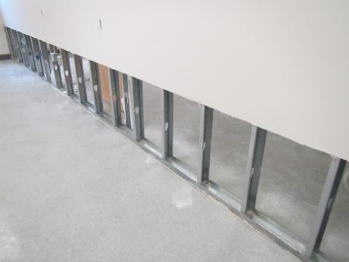
Water-damaged gypsum wallboard (GW) removed
Picture 2
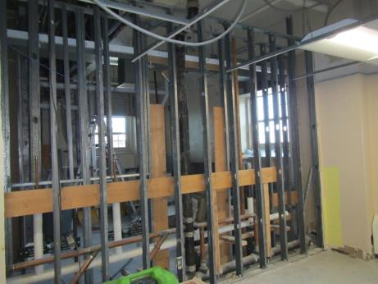
Ceiling tiles and GW removed in classroom adjacent to area of pipe burst
Picture 3
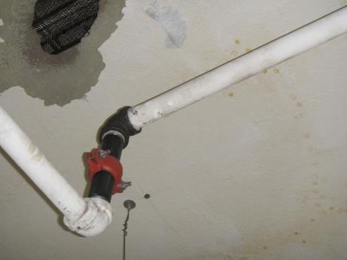
Newly repaired sprinkler pipe section where pipe had burst (above ceiling tile grid)
Picture 4
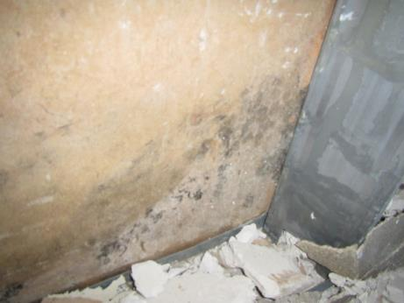
Small area of microbial growth in wall cavity of boys’ bathroom
Picture 5
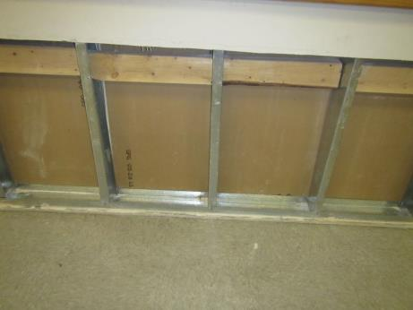
Some areas of GW that remained were dried by opening wall cavity on one side
Picture 6
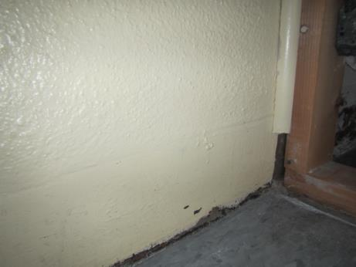
Other remaining walls were plaster (above) and not susceptible to mold growth
Picture 7
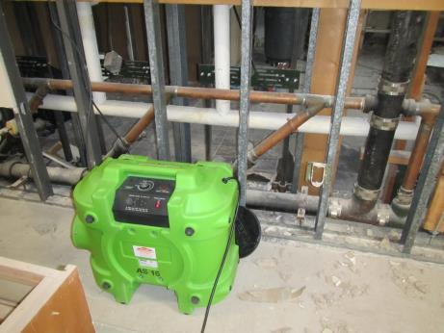
HEPA filters/scrubbers used in the remediation effort
Picture 8
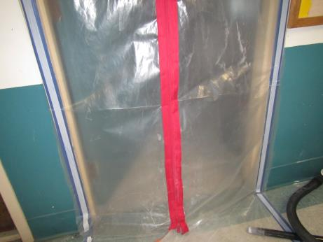
Containment barriers used during remediation
Picture 9
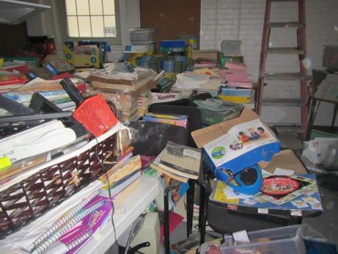
Stored water-damaged items that are to be itemized and then discarded
Picture 10
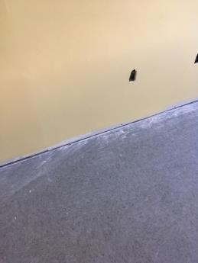
Repaired GW
Picture 11
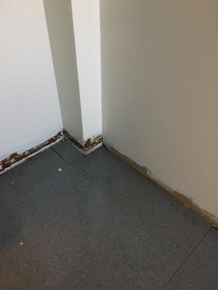
Repaired GW

