PANDAS/PANS Advisory Council Meeting
March 9, 2022, 4:00 – 6:00 PM
Via WebEx Event

Present: Elaine Gabovitch, PANDAS/PANS Advisory Council Chair & DPH Ex-Officio Member; Margaret Chapman, RN, MSN, PMHCNS-BC; Karen Colwell, PTA; Sylvia Fogel, MD; John Gaitanis, MD; Sheilah Gauch, LICSW; Melissa Glynn-Hyman, LICSW; Lisa Grisolia; Kathleen Maher, MS-PHCNS, RN; Melissa McCormack, MD, PhD; Mark Pasternack, MD; Michelle Pinto, MSN, RN; Blake Poggi, MA, CCC-SLP; Jennifer McCormack Vitelli, MBA; Kyle Williams, MD, PhD; Yujuan Julia Zhang, MD; Nicole Roos; Casey Hall, CHTA; Amy Benison, DPH

Meeting Agenda
- Review and approval of minutes from January 12, 2022
- Guidance for submitting public comments and concerns to DPH Essential Service Closure Process
- Discussion of possible advisory memo to DPH Commissioner
- Review Council work plan and next steps

Welcome and Agenda (slides 1,2)
Elaine Gabovitch, PANDAS/PANS Advisory Council Chair, called the meeting to order, welcomed the Advisory Council and reviewed the agenda.

Open Roll Call & Minutes Vote (slide 3)
Elaine Gabovitch managed the virtual open roll call and Amy Benison tracked this information for the meeting record. Elaine led the vote to approve the 1/12/22 meeting minutes. There was a quorum with 15 Advisory Council members in attendance, two members joined late and did not vote on the meeting minutes.

Rules and Culture (slide 4,5)
Elaine Gabovitch reviewed the meeting rules and agreed upon Council culture.

Statutory Authority (slide 6)
Elaine Gabovitch shared the following with the Advisory Council and emphasized the importance of knowing and adhering to the Council’s role and scope.

Statutory Authority, Section 26 of Chapter 260 of the Acts of 2020, Advisory Council to advise the Commissioner on research, diagnosis, treatment, and education relating to pediatric autoimmune neuropsychiatric disorder associated with streptococcal infections and pediatric acute neuropsychiatric syndrome (PANDAS/PANS).

Essential Services Closure Process (slides 7,8,9)
Elaine Gabovitch shared the following table and explained the essential services closure process and the mechanism is which the public (including individual members of the Council) can submit public comments. Elaine acknowledged the difficult time the PANDAS/PANS community is currently facing in Massachusetts, given the future of Tufts Children’s Hospital.

Key Points:

  - The DPH cannot legally require a hospital to remain open
  - Tufts must notify DPH, families, staff and local officials of hospital closure
  - The Council cannot address the closure as a group, but Council members as public citizens can provide written comments
  - Elaine recommended that comments should be detailed, specific and factual
  - Tufts providers should consult the Ethics Commission about their role and for advice about what is appropriate for them to discuss or advise on

Additional Notes:
  - Members expressed their concerns about the Tufts closure and how it may jeopardize access to IVIG treatment for the PANDAS/PANS community
  - Members discussed the possibility that Tufts would keep outpatient services available to PANDAS/PANS patients and only close inpatient services
  - Members discussed the number of PANDAS/PANS patients being treated at Tufts
    - Julia noted she had about 100 patients and 20 receiving IVIG
    - John noted he has about another 100 patients with 10-15 receiving IVIG
  - Members discussed wanting to collect data about PANDAS/PANS treating protocols across the state, especially at Boston Children’s Hospital

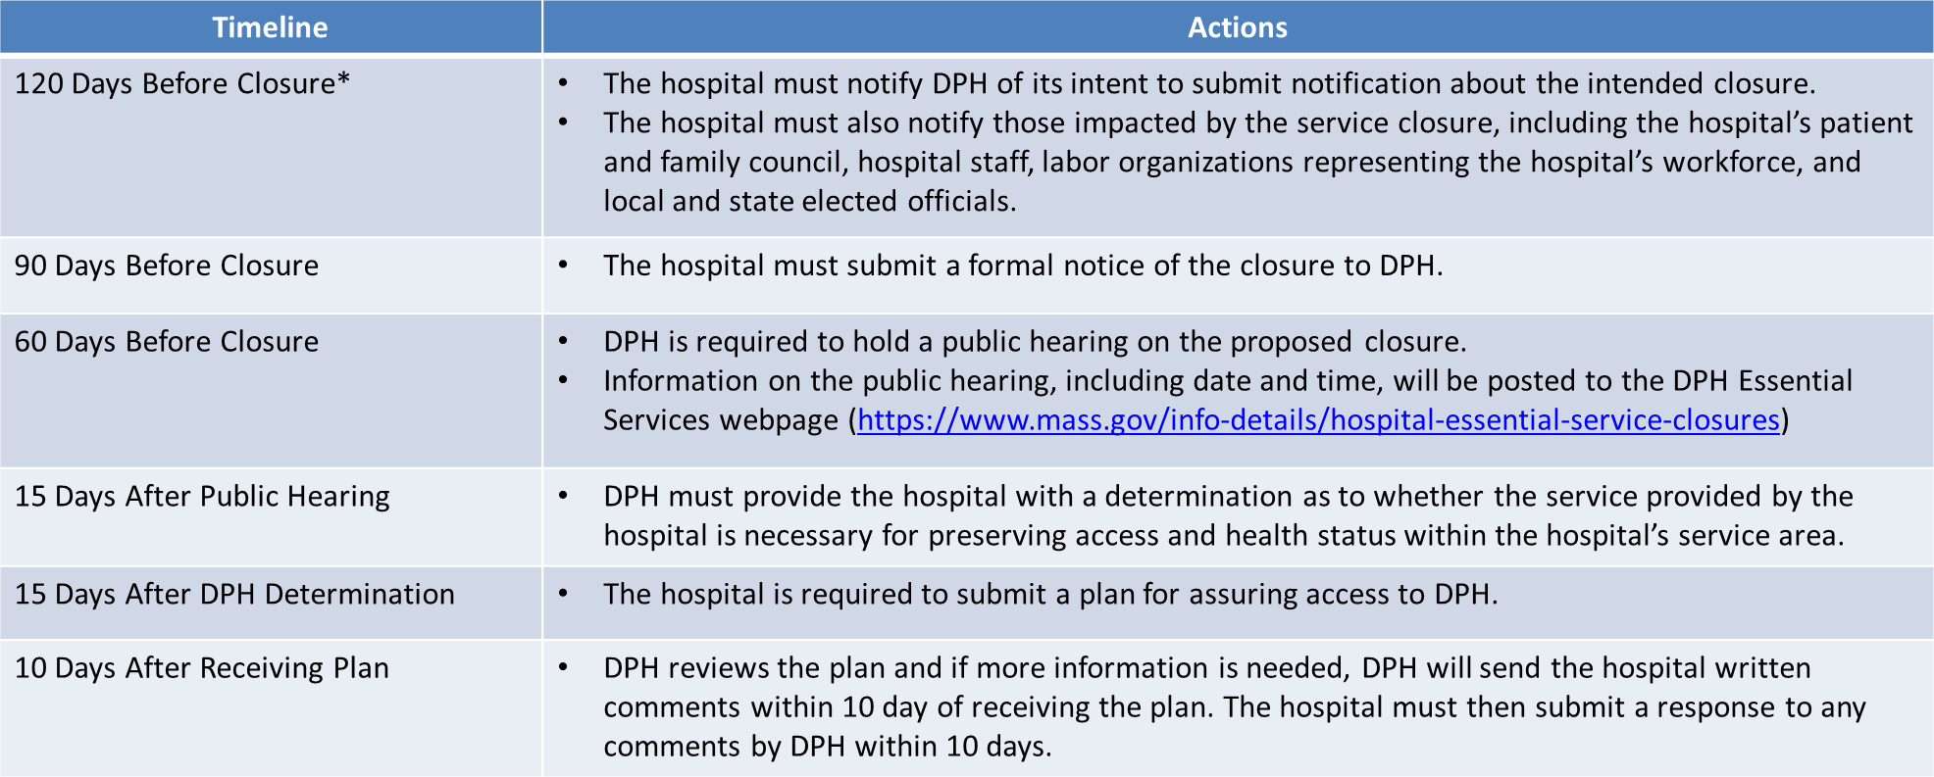

Advisory Letter/Memo (slide 10)
Elaine Gabovitch explained that along with the annual report the Council can submit formal advice to the Commissioner, but it must be within the scope laid out in the legislation. She discussed a possible memo that the Council could formally submit advising on how the Tufts closure will affect diagnosis and treatment of the PANDAS/PANS community. The memo would not request Tufts to remain open, but rather make the Commissioner aware of the affect the closure will have.

Jennifer Vitelli, co-facilitator, shared her thoughts behind the memo and that as a Council she agreed that they can and should advise the Commissioner on the impact of this closure.

Shelia Gauch read the proposed memo to the Council. The memo was reviewed and edited as a Council.

A vote was taken to approve the memo and send to the Commissioner. Thirteen Council members voted to move forward with and send the memo, two members (Tufts providers) abstained from the vote.

Workplan Review: Aim Statement, Why Statement, Target Audience (slides 11,12,13,14)
Elaine Gabovitch reviewed edits made to the workplan after the last Council meeting on January 12, 2022. She read through the current aim statement, why statement and target population.

Elaine explained that the Aim Statement heavily pulls from the legislation. She also noted that edits were made to the Why Statement based on key informant interviews from Council members.

The Council reviewed and made edits to the Why Statement and Target Audience.

Approach Re: Annual Report (slide 15)
Elaine Gabovitch proposed the option to start immediately on the first annual report, which would summarize Council activities and preliminary research from September 2021 through March 2022. This report would be written by Amy Benison and DPH staff and brought back to the Council for approval. Simultaneously, the Council could start their formal research for a more in depth second annual report to follow.

A vote was taken to start the first annual report now. All 15 members voted to start the first annual report.

Approach Re: Work Groups and/or Individual Work (slides 16,17,18)
Elaine Gabovitch talked through possible work options for the Council including workgroups, individual work or a combination of the two. Elaine detailed the responsibilities of workgroups and that the workgroup facilitator would have to uphold Open Meeting Law, while individuals would not have the same responsibilities.

The Council discussed the options and a negative poll was done, no one opposed to moving forward with the workgroups.

The Council discussed that the workgroups need to have clear guidelines about what will be researched and that the groups need to determine the goals for their work and the inclusion of their work in the annual report.

Elaine showed the current workgroups as of January 12, 2022 and questioned whether changes needed to be made. Edits to the groups were made and finalized. Elaine asked if the facilitators were still comfortable with their role and responsibilities within the workgroup. All workgroup facilitators agreed to remain facilitators.

Council Goals and Phases (slides 19, 20)
Elaine Gabovitch discussed additional elements of the work plan including the goals (both those that are complete and those that are pending) and the short term aims and phases for the Council.

Council Scope, Support Roles, Timeline (slide 21,22,23)
The Council ran out of time to review the Council Scope, Support Roles and Timeline. Elaine Gabovitch quickly reviewed the final three slides and suggested the Council review the slides on their own time and revisit them at the next meeting.

15. Closing (slide 24,25,26)
Elaine Gabovitch reviewed key votes throughout the meeting, next steps, shared resources about Open Meeting Law and subcommittees.

The next bi-monthly meeting is Wednesday May 11, 2022, 4-6 PM. A vote was taken to adjourn the meeting.

