BACKGROUND

INDOOR AIR QUALITY
ASSESSMENT

Pappas Rehabilitation Hospital for Children
Physical Therapy Office and Surrounding Locations
3 Randolph Street
Canton, Massachusetts

Prepared by:
Massachusetts Department of Public Health
Bureau of Environmental Health
Indoor Air Quality Program
January 2023
Building: | Pappas Rehabilitation Hospital for Children (the Hospital), Physical Therapy (PT) Office and surrounding locations
Address: | 3 Randolph Street  Canton, MA
Assessment Requested by: | Pamela Couchon, Facilities Project Manager for Public Health Hospitals
Reason for Request: | General IAQ concerns and water damage concerns
Date of Assessment: | December 29, 2022
Massachusetts Department of Public Health/Bureau of Environmental Health (MDPH/BEH) Staff Conducting Assessment: | Michael Feeney, Director, Indoor Air Quality (IAQ) Program
Building Description: | The PT office is a large room containing physical therapy equipment located in the Bradford Building on the Hospital campus. Partitions were built to create open-walled workspaces. The floor is carpeted.
Windows: | Openable

METHODS
MDPH IAQ staff conducted a series of visual assessments, and air testing for carbon dioxide, carbon monoxide, as well as temperature and relative humidity measurements to identify likely areas that could be prone to condensation in hot, humid weather. Please refer to the IAQ Manual for methods, sampling procedures, and interpretation of results (MDPH, 2015).

RESULTS and DISCUSSION
The following is a summary of indoor air testing results (Table 1).
- Carbon dioxide levels were below the MDPH guideline of 800 parts per million (ppm) in all occupied areas assessed.
- Carbon monoxide levels were equal to outdoor measurements. It is important to note that the assessment occurred during unusually warm weather (70°F) in December. This unusual temperature coupled with nearby exhaust from traffic and boiler plant emissions can indicate that conditions of temperature inversion existed, which can increase outdoor carbon monoxide levels.
- Temperature was within the recommended range of 70°F to 78°F.
- Relative humidity was below the recommended range of 40 to 60% in all areas assessed, which is typical of conditions during the heating season in New England.
- Fine particulate matter (PM2.5) concentrations measured were below the National Ambient Air Quality (NAAQS) limit of 35 μg/m³ in all areas tested.

Ventilation
The PT Office has a centralized heating, ventilating, and air-conditioning (HVAC) system that has a fresh air supply and return. In order to provide additional heating, radiators are installed along the PT Office exterior wall. In addition, a series of fan coil units (FCUs) are installed on the hallway wall of the PT office (Picture 1) to provide supplemental cooling during warm weather. It appears that the FCUs only provide cooling and are designed to recirculate air only. However, it was reported by hospital facilities staff that the HVAC system for the Bradford building was not operating/under repair the day of assessment.
To maximize air exchange, the IAQ program recommends that both supply and exhaust ventilation operate continuously during periods of occupancy. To have proper ventilation with a mechanical ventilation system, the systems must be balanced after installation to provide an adequate amount of fresh air to the interior of a room while removing stale air from the room. It is recommended that HVAC systems be re-balanced every five years to ensure adequate air systems function (SMACNA, 1994). Based on the age and condition of HVAC components, re-balancing of the system may not be possible.
It is important to note that the Bradford Building hallways do not have mechanical fresh air supply or return ducts. Unconditioned air likely enters hallways as individuals enter and exit hallways via exterior doors. In this configuration, unconditioned air can cause condensation/moisture problems in areas with operating fan coil units (FCUs) that chill air (during the cooling season).

Microbial/Moisture Concerns

Observable Water Damaged Materials
IAQ staff did not observe water-stained ceiling tiles in the Bradford Building hallways. Hospital staff reported the suspended ceiling tiles were replaced. Hospital staff reported that ceiling tiles were wet from condensation from chilled water pipes, as described below. IAQ staff did not observe or detect any mold growth or associated odors in the PT Office at the time of assessment.

Areas Prone to Moistening
It is important to note that Massachusetts has experienced extended periods of relative humidity during the summers of 2021 and 2022, with July 2021 being the wettest ever recorded in Massachusetts, and the three-month period from June through August 2021, known as the meteorological summer, was the fourth wettest on record, according to the National Oceanic and Atmospheric Administration’s Centers for Environmental Information. The three-month period also was the third warmest ever in the state and was tied for the warmest on record across the United States (HG, 2021, NOAA, 2021).
Based on the type of floor construction (carpet on cement), the PT Office may have floors that are prone to moistening during extended (> 48 hours) hot, humid weather. When warm, moist air passes over a porous material, moisture can be absorbed. According to American Society of Heating, Refrigerating and Air-Conditioning Engineers (ASHRAE), if relative humidity exceeds 70%, mold growth may occur due to wetting of building materials (ASHRAE, 1989). Due to the configuration and condition of exterior hallway doors it is likely to have relative humidity near or exceeding 70% in hallways in hot, humid weather during summer months. In these conditions, materials such as carpeting, cardboard, and other porous materials may become prone to developing mold colonization.
If porous materials are not dried within this time frame, mold growth may occur. Water-damaged porous materials cannot be adequately cleaned to remove mold growth. The United States Environmental Protection Agency (US EPA) and the American Conference of Governmental Industrial Hygienists (ACGIH) recommend that porous materials be dried with fans and heating within 24 to 48 hours of becoming wet (US EPA, 2008; ACGIH, 1989). If porous materials are not dried within this time frame, they should be removed and discarded.

Water damages building interior walls and ceiling tiles
Hospital facilities staff reported hallway ceiling tiles had become water-damaged from condensation during hot, humid weather. The Hospital has a new HVAC system chiller, which is reducing the temperature of chilled water to a point that exceeds the R-Value of insulated supply and return pipes.
The R-Value is a measure of insulation's ability to resist heat traveling through it. The higher the R-Value, the better the thermal performance of the insulation (EnergyStar, Unknown).
If the R-Value is exceeded resulting in the temperature of the pipe insulation reduced at or below the dew point, then the pipe and insulation (Picture 2) can drip water on suspended ceiling tiles, which can lead to water damage and mold growth.
As reported by Hospital staff, PT office doors appear to be propped open year-round in all-weather conditions. If doors are propped open, hot humid air from hallways can be drawn to the FCUs as they operate, which may have caused the following conditions:
- The exterior of FCU cabinets have signs of water accumulation/staining and/or rust (Picture 3).
- The interior of FCUs below the cooling coils and drip pans also have water accumulation/staining and/or rust.
- Hospital facility staff report that drip pans overflow in hot, humid weather. FCU drip pan drains appear to be sloped upwards (Picture 4), which will limit the rate of condensation drainage. Overflowing drip pans will cause moisture to accumulate within FCUs and wet carpeting beneath.
- The installation of the new chiller (Picture 5) can also result in FCUs operating at lower temperatures. This condition can cause the R-Value of interior insulation to be exceeded, leading to increased condensation and overflow of drip pans.

Based on these observations, reduction/elimination of pathways for hot, humid air entering the Bradford Building’s hallways and PT Office is recommended.
It is also important to note that despite ongoing maintenance and replacement of parts/components by Hospital facilities staff, the FCUs are at the end of their life cycle. Efficient function of equipment of this age (> 20 years old) is difficult to maintain, since compatible replacement parts are often unavailable. According to the American Society of Heating, Refrigeration, and Air-Conditioning Engineers (ASHRAE), the service life of this type of unit is 15-20 years, assuming routine maintenance of the equipment (ASHRAE, 1991). It was reported that currently two univents were on a repair list.

Carpeting
If relative humidity indoors is >70 %, that is a sufficient concentration that can cause building materials to become moistened and not dry (ASHRAE, 1989). A number of PT apparatus (Pictures 6 and 7) were observed on carpeting that can trap moisture and prevent drying. It is also important to note that the usable life of carpeting in schools is approximately 10-11 years (IICRC, 2002). Aging carpet can produce fibers that can be irritating to the respiratory system. Carpets should be cleaned annually (or semi-annually in soiled/high traffic areas) in accordance with Institute of Inspection, Cleaning and Restoration Certification (IICRC) recommendations, (IICRC, 2012). Regular cleaning with a high efficiency particulate air (HEPA) filtered vacuum in combination with an annual cleaning will help to reduce accumulation and potential aerosolization of materials from carpeting.

Crawlspace odors
The PT office floor rests above a crawlspace. Radiators are connected to heat supply lines that pass through the floor. Space exists between the heat pipe and floor hole, which may allow for crawlspace air to enter the PT Office via these openings.

CONCLUSIONS/RECOMMENDATIONS
The PT Office has a number of issues related to moisture as well as the HVAC system. One significant problem is relative humidity and condensation management of the building during hot, humid weather. The following documents can provide guidance that can be used to reduce the impact of hot, humid weather in buildings, even those with HVAC system chilling capacity.

- Mold growth Prevention during Hot, Humid Weather https://www.mass.gov/service-details/preventing-mold-growth-in-massachusetts-schools-during-hot-humid-weather
- Remediation and Prevention of Mold Growth and Water Damage in Public Schools https://www.mass.gov/service-details/remediation-and-prevention-of-mold-growth-and-water-damage-in-public-schools-and
- Methods for Increasing Comfort in Non-air-conditioned Schools https://www.mass.gov/doc/methods-for-increasing-comfort-in-non-air-conditioned-schools/download

To remedy building problems, two sets of recommendations are made: short-term measures that may be implemented as soon as practicable and long-term measures that will require planning and resources to address overall IAQ concerns. In view of the findings at the time of the visit, the following recommendations are provided:

Short Term Recommendations

Keep all PT office doors closed at all times.

Seal all spaces around FCUs and radiator supply pipes with fire-rated spray foam.

Repair the fresh air supply system.

Replace water-damaged pipe insulation with an adequate R-value for the chilled water provided by the campus HVAC chiller.
- Render all exterior doors as airtight as possible by installing door sweep and weather-stripping. Consider installing strip doors over exterior doors to prevent unconditioned air infiltration.
- Increase the set point for chilled water upwards to reduce condensation, if feasible.
- Clean carpeting annually or semi-annually in soiled high traffic areas as per the recommendations of the Institute of Inspection, Cleaning and Restoration Certification (IICRC, 2012).
- Consider replacing any carpeting that is beyond its service life (i.e., > 11 yrs.).

Long Term Recommendations
- Conduct a building-wide ventilation systems assessment. Based on historical issues regarding the HVAC system design, physical deterioration, and availability of parts for ventilation components, such an evaluation is necessary to determine the operability and feasibility of replacing existing HVAC system equipment, such as FCUs and chilled water pipe insulation.
- An evaluation of chilled water pipe insulation should be done building wide. If water-damaged, replacement of insulation with an appropriate R-value is recommended.
- Due to its age and moisture exposure, consideration should be given to replacing the PT Office carpet with tile or other appropriate materials.

REFERENCES
ACGIH. 1989. Guidelines for the Assessment of Bioaerosols in the Indoor Environment. American Conference of Governmental Industrial Hygienists, Cincinnati, OH.
ASHRAE. 1989. Ventilation for Acceptable Indoor Air Quality. American Society of Heating, Refrigeration and Air Conditioning Engineers. ANSI/ASHRAE 62-1989.
ASHRAE. 1991. ASHRAE Applications Handbook, Chapter 33 “Owning and Operating Costs”. American Society of Heating, Refrigeration and Air Conditioning Engineers, Atlanta, GA.
ASHRAE. 2012. American Society of Heating, Refrigeration and Air Conditioning Engineers (ASHRAE) Standard 52.2-2012 -- Method of Testing General Ventilation Air-Cleaning Devices for Removal Efficiency by Particle Size (ANSI Approved).
EnergyStar. Unknown. Recommended Home Insulation R–Values | ENERGY STAR
HG. 2021. Mold keeps South Hadley High School shuttered. Hampshire Gazette. https://www.gazettenet.com/South-Hadley-High-School-still-closed-amid-mold-remediation-42413519
IICRC. 2002. Institute of Inspection, Cleaning and Restoration Certification. A Life-Cycle Cost Analysis for Floor Coverings in School Facilities.
IICRC. 2012. Institute of Inspection, Cleaning and Restoration Certification. Carpet Cleaning: FAQ. MDPH. 2015. Massachusetts Department of Public Health. “Indoor Air Quality Manual: Chapters I-III”.
MDPH. 2015. Massachusetts Department of Public Health. Indoor Air Quality Manual: Chapters I-III. Available at: Indoor Air Quality - Facts and Resources | Mass.gov
NOAA. 2021. Summer 2021 neck and neck with Dust Bowl summer for hottest on record. National Oceanic and Atmospheric Administration, 1401 Constitution Avenue NW, Room 5128, Washington, DC 20230 https://www.noaa.gov/news/summer-2021-neck-and-neck-with-dust-bowl-summer-for-hottest-on-record
SMACNA. 1994. HVAC Systems Commissioning Manual. 1st ed. Sheet Metal and Air Conditioning Contractors’ National Association, Inc., Chantilly, VA.
US EPA. 2008. “Mold Remediation in Schools and Commercial Buildings”. Office of Air and Radiation, Indoor Environments Division, Washington, DC. EPA 402-K-01-001. September 2008. Available at: http://www.epa.gov/mold/mold-remediation-schools-and-commercial-buildings-guide

Picture 1

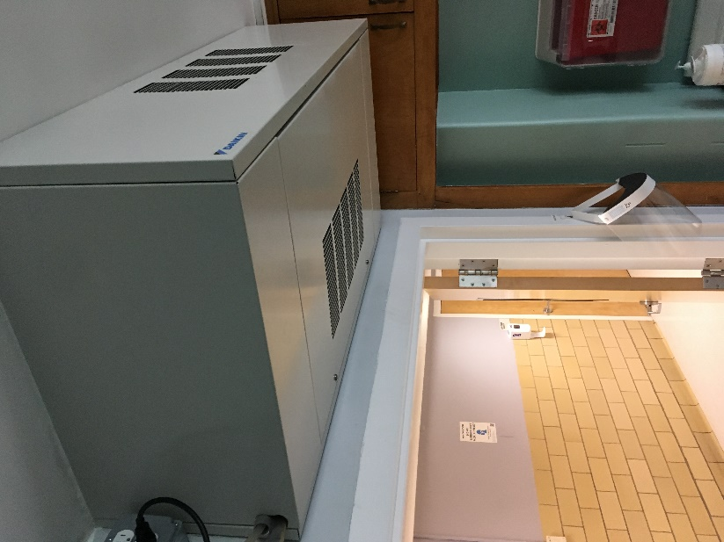
FCU in PT Office

Picture 2
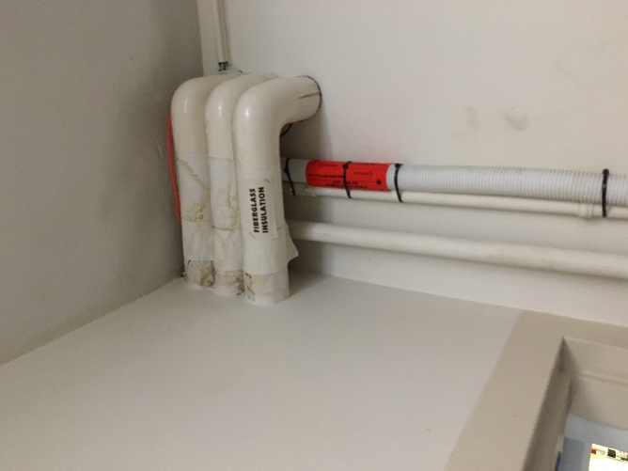
Water-damaged pipe insulation

Picture 3

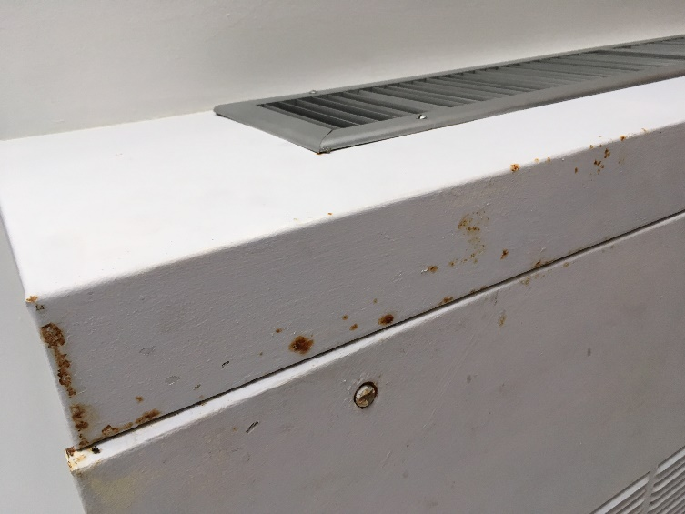
Rust/water damage to FCU exterior

Picture 4

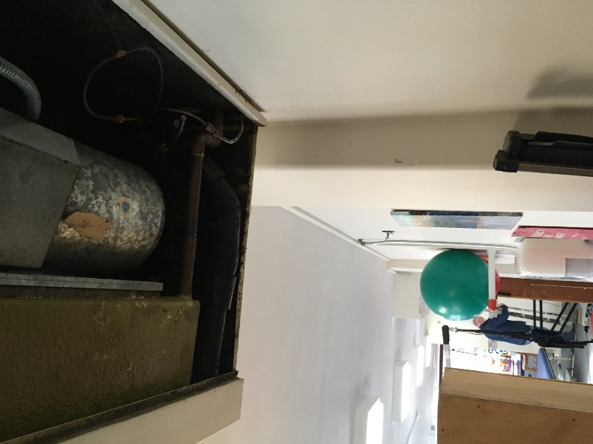
Drip pan drains appear to be sloped upwards

Picture 5

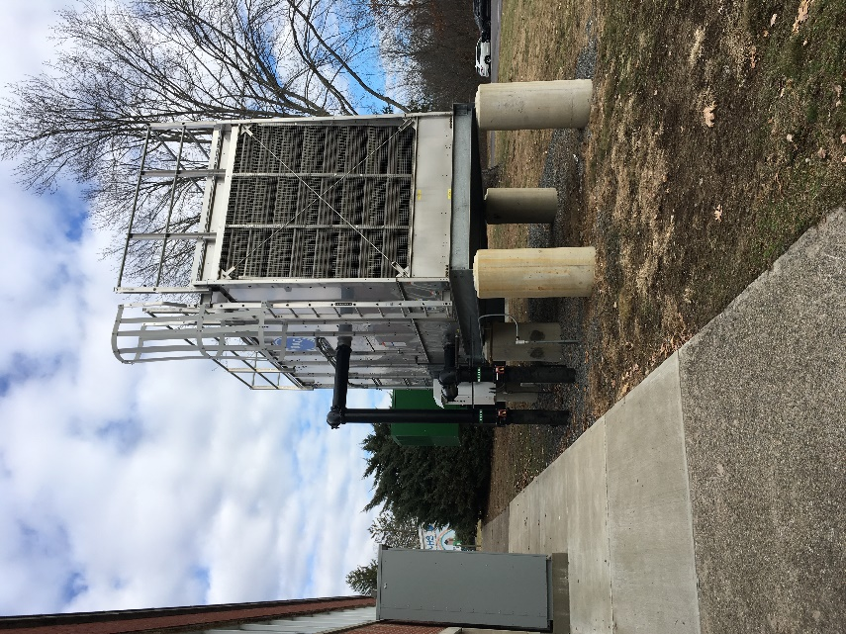
New HVAC Chiller

Picture 6

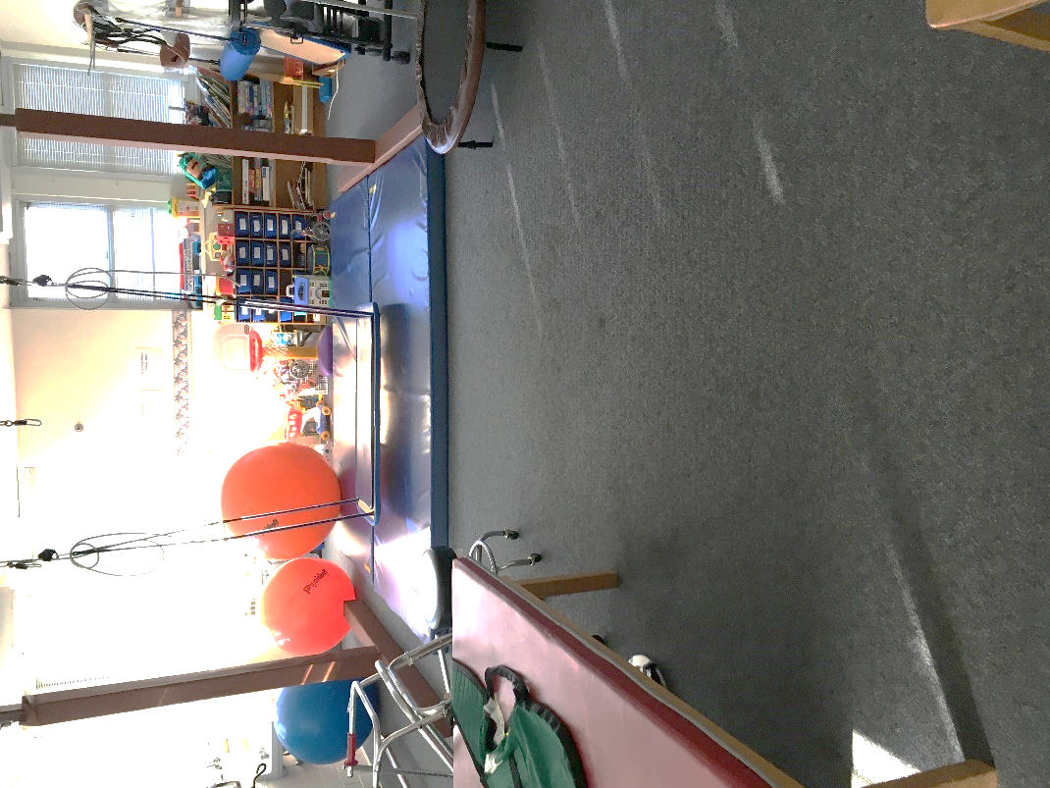
Mats covering carpeting can prevent drying
Picture 7

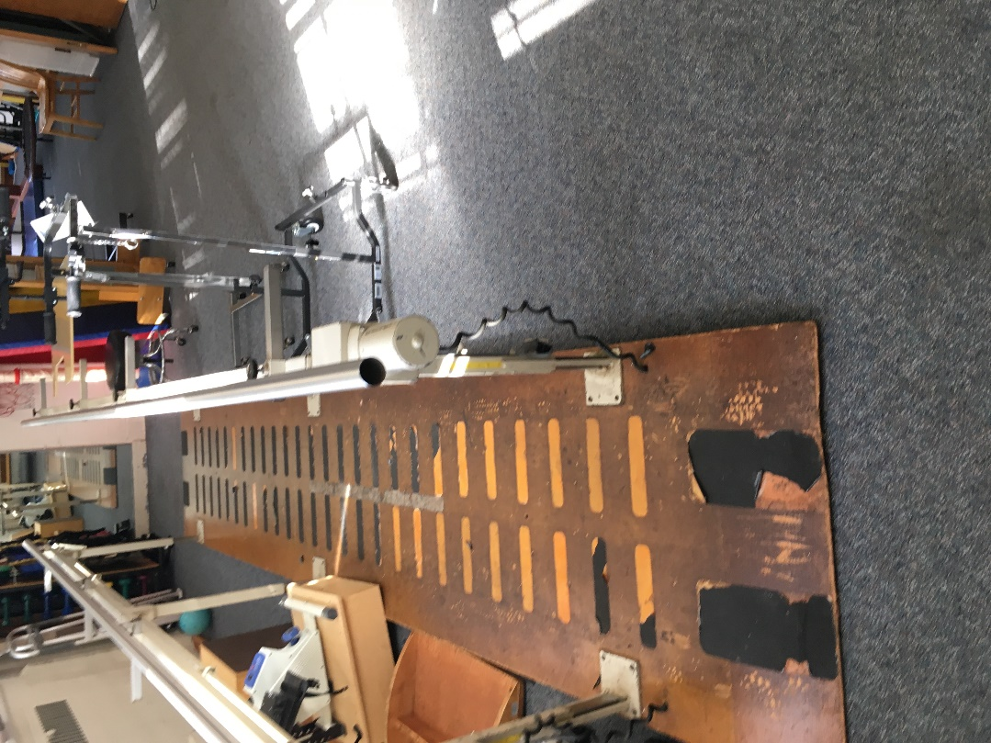
Space beneath parallel bars can trap moisture on carp

Location | Carbon  Dioxide  (ppm) | Carbon Monoxide  (ppm) | Temp  (°F) | Relative  Humidity  (%) | PM2.5  (µg/m³) | Occupants  in Room | Windows  Openable | Ventilation |  | Remarks
 |  |  |  |  |  |  |  | Supply | Exhaust
Outdoor (Background) | 411 | 9-17 | 70 | 33 | 17 |  |  |  |  | Outdoor carbon monoxide levels due to boiler plant stack emissions and temperature inversion/weather conditions
PT room Space 1 | 494 | 9 | 71 | 32 | 9 | 1 | Y | N | N | Carpet, wall-mounted radiator
PT Room Space 2 | 499 | 16 | 75 | 30 | 16 | 0 | Y | N | N | Carpet, wall-mounted radiator
Whirlpool | 500 | 16 | 75 | 28 | 16 | 0 | Y | N | N | Carpet, ceiling-mounted fan coil unit
Parallel bars | 508 | 17 | 75 | 28 | 17 | 0 | Y | Y | N | Carpet, ceiling-mounted fan coil unit
Trapeze | 527 | 17 | 75 | 28 | 17 | 0 | Y | N |  | Ceiling-mounted fan coil unit
Indoor therapeutic garden | 440 | 17 | 73 | 33 | 17 | 0 | Y | Y | N | Ceiling-mounted fan coil unit

The service life is the median time during which a particular system or component of … [an HVAC] … system remains in its original service application and then is replaced. Replacement may occur for any reason, including, but not limited to, failure, general obsolescence, reduced reliability, excessive maintenance cost, and changed system requirements due to such influences as building characteristics or energy prices (ASHRAE, 1991).

