INDOOR AIR QUALITY ASSESSMENT

Department of Public Health
Pappas Rehabilitation Hospital, Nelson Building
3 Randolph Street
Canton, MA

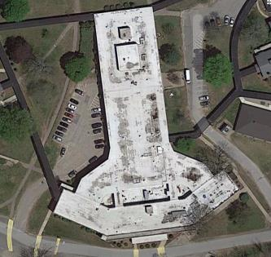

Prepared by:
Massachusetts Department of Public Health
Bureau of Environmental Health
Indoor Air Quality Program
November 2016

Background
Building: | The Pappas Rehabilitation Hospital (PRH) for Children/Nelson Building (NB)
Address: | 3 Randolph Street, Canton, MA
Assessment Requested by: | Katherine Mick, Chief Operating Officer, PRH
Reason for Request: | Concerns about indoor air quality (IAQ) and chronic illness. This report focuses on the PRH; assessments of the Gates and Ellis Buildings will be scheduled in the future.
Date of Assessment: | August 19, 2016 (initial meeting and site visit)  September 8, 2016 (in-person health interviews)  September 27, 2016 (IAQ site visit)
Massachusetts Department of Public Health/Bureau of Environmental Health (MDPH/BEH) Staff Conducting Assessment: | IAQ Program staff:  - Michael Feeney, Director  - Ruth Alfasso Environmental Engineer/Inspector  - Sharon Lee, Environmental Analyst/Inspector  Community Assessment Program staff:  - Brenda Netreba, Environmental Analyst  - Carolyn Ariori, Environmental Analyst  - Melanie Jetter, Environmental Analyst
Building Description: | A two-story concrete and brick building with a flat roof connected to the adjacent Bradford Building.
Year Built: | 1964
Building Population: | The NB serves as residential care for students of the PRH along with outpatient and occupational therapy. The building houses a number of patients/residents and support staff.
Windows: | Openable

Methods
Please refer to the IAQ Manual for methods, sampling procedures, and interpretation of results (MDPH, 2015).

IAQ Testing Results
The following summarizes indoor sampling results for the PRH at the time of assessments (Tables 1 and 2).
- Carbon dioxide levels were below 800 parts per million (ppm) in all areas tested throughout the building.
- Temperature was within the recommended range of 70°F to 78°F in all areas tested.
- Relative humidity was within or close to the recommended range of 40 to 60% in most of the areas tested.
- Carbon monoxide levels were non-detectable (ND) in all areas tested.
- Fine particulate matter (PM2.5) concentrations measured were below the National Ambient Air Quality Standard (NAAQS) level of 35 μg/m³ in all areas tested.
- Total Volatile Organic Compounds (TVOCs) levels were ND in areas tested.

Ventilation
A heating, ventilating, and air conditioning (HVAC) system has several functions. First it provides heating and, if equipped, cooling. Second, it is a source of fresh air. Finally, an HVAC system will dilute and remove normally occurring indoor environmental pollutants by not only introducing fresh air, but by filtering the airstream and ejecting stale air to the outdoors via exhaust ventilation. Even if an HVAC system is operating as designed, point sources of respiratory irritants may exist and cause symptoms in sensitive individuals.
The NB has a number of different HVAC systems. Patient rooms and many common spaces have fan coil units (FCUs) located above or next to doors (Picture 1). These systems use heated water and a chilled water/glycol mixture to provide heated and cooled air respectively; the systems are switched over twice a year. Connected to the FCU system are ducted return vents located nearby in the room (Picture 2). FCUs are controlled by thermostats. Because the systems were still in cooling mode at the time of the visit and the outdoor weather was cool, these systems were not operating since no cooling was needed.
Exhaust ventilation in bathrooms are provided by exhaust vents connected to fans on the roof (Picture 3). Exhaust vents in about half the rooms in the Nelson II portion of the building were not drawing air (Table 2). During the visit, facility staff worked to determine the cause for lack of air removal. Without operable exhaust ventilation, bathroom-related odors and moisture cannot be removed and fresh air from open windows and hallways cannot be drawn into rooms. Note that although the patient bedrooms were unoccupied at the time of the visit, many of rooms had carbon dioxide levels close to 800 ppm; levels would be expected to be higher during occupancy. Other exhaust vents in areas such as the nurses’ station were also not operating at the time of the assessment.
Many rooms are equipped with unit ventilators (univents, Picture 4), which draw air directly from a vent in the outside wall (Picture 5). Air drawn into the unit is filtered, heated (if needed), and circulated throughout the room. A univent also has a return vent along the bottom that draws in air that is mixed with fresh air before the being circulated. At the time of the visit, only one of these units was operating. Staff report univents are operational and sometimes used for supplemental heating. It may be helpful to operate these units without heating during the spring/fall when FCUs are not needed for cooling or heating. Additional cooling and circulation in some areas is provided by window-mounted air conditioners (ACs, Picture 6) and portable ACs (Picture 7).
It is recommended that HVAC systems be re-balanced every five years to ensure adequate air systems function (SMACNA, 1994). It is unknown when the last time these systems were balanced.
The lower level of the Nelson Building contains an abandoned operating suite, which is now used for storage. The operating suite has a ventilation system that is entirely self-contained and was/is separate from the rest of the Nelson Building. Due to the design of the building as well as the abandoned operating suite ventilation system, it is highly unlikely any airflow from the basement impacts the patient floor.
It was noted that the Dental Reception Office does not have fresh air or exhaust ventilation. There is a small transom-style vent in the wall into the adjoining room that was blocked from the reception office side (Picture 8). The adjoining room is used for dental equipment sterilization, which requires use of chemicals that produce odor. This vent should be sealed thoroughly from both sides. Methods to provide air circulation or ventilation to the Dental Reception Office includes fresh air ventilation from the general HVAC system, a passive vent in the wall shared with the waiting room, or a through-wall fan that moves air in from the waiting room to the office. In addition, measures should be taken to ensure that the exhaust vent in the sterilization room is operational and on at all times chemicals are in use.

Microbial/Moisture Concerns
Water-damaged ceiling tiles were observed in several areas (Pictures 9 and 10). These indicate that leaks from the building envelope, plumbing, or HVAC system are occurring. The leaks should be addressed and the ceiling tiles replaced as they can be a source of mold if chronically moistened. Note that some of the water-damaged tiles are of an interlocking type that may be glued directly to the ceiling; these may be difficult to replace.
Water-damaged plaster was observed in a stairwell (Picture 11) to the lower level. This indicates that this wall, which is partly below-grade, is chronically damp. Improving drainage outside may reduce the amount of water infiltrating through the wall in this area.
Outside the building, plants were observed next to the foundation (Picture 12) which can hold moisture against the side of the building and lead to deterioration as well as damage due to root infiltration. In addition, nearby plants can be a source of pollen and debris which can clog univent filters and infiltrate through open windows. Trees were also observed overhanging the roof, which can lead to debris that can clog roof/storm drain systems (Picture 13).
Note that the roof is a complex shape, with interior areas such as that shown in Picture 13. Seams where roof areas join walls can be a source of leaks if the roof and flashing are not maintained in good condition. The seam where the Nelson Building connects to the Bradford Building (Picture 14) may also be a source of leaks as the buildings settle. These areas should be periodically inspected for damage and deterioration. In addition, some doors to the exterior lacked weather stripping (Picture 15), which can allow moisture and pests into the building.
Floor drains are present in many areas of the NB. In some areas, these are clearly regularly used, but in others, they may not be regularly filled with water. For example, the old nurses’ bathroom on the lower level appears to be used for storage (Picture 16); therefore, drains in this bathroom will likely become dry, which can allow sewer gases to infiltrate into occupied areas. Floor and other drains that are not regularly used should be periodically filled with water to maintain an intact trap seal. If these drains will not be used in the foreseeable future, they should be sealed.
Indoor plants were observed in several areas (Table 2). Plants, soil, and drip pans can serve as sources of mold/bacterial growth. Plants should be properly maintained, over-watering of plants should be avoided, and drip pans should be inspected periodically for mold growth. In addition, plants should not be placed on top of or in the airstream of HVAC equipment such as univents.
Refrigerators in some areas, including the nurses’ station, had evidence of spills (Picture 17), which can be a source of odors and microbial growth. Refrigerators should be kept clean. Refrigerators and water dispensers were observed on top of carpet. Spills and leaks from these appliances can moisten the carpet and lead to microbial growth.
In the lower level, boxes and other porous items were observed on the floor in some storage areas. Since these are below grade, the floors may be subject to condensation on hot, humid days. Porous items should be kept off of floors to prevent water damage from condensation. Note that in the mechanical room there was evidence of water leaks and condensation on the floors (Picture 18) and some water-damaged boxes and other materials were found there (Picture 19). These should be discarded.

Volatile Organic Compounds (VOCs)
Exposure to low levels of total VOCs (TVOCs) may produce eye, nose, throat, and/or respiratory irritation in some sensitive individuals. To determine if VOCs were present, BEH/IAQ staff measured TVOCs in some of the areas assessed; no measureable levels were observed. Good ventilation is required to remove irritants from cleaning chemicals. BEH/IAQ staff also examined rooms for products containing VOCs. BEH/IAQ staff noted hand sanitizers, cleaners, air deodorizers and dry erase materials in use within the building (Table 2). All of these products have the potential to be irritants to the eyes, nose, throat, and respiratory system of sensitive individuals.

Other IAQ Evaluations
Staff in the NB reported foul odors in and around restrooms of the NB nurses station. A conference room near the nurse’s station is currently used as a breakroom; the room has two refrigerators. During the initial August 2016 visit, the conference room/breakroom had a significant number of flies (Picture 20) that could be attributed to the amount of food observed in the breakroom. Since the break room and restroom are in proximity, it is likely that the foul odors from restroom (Picture 21) result from the use of the restroom sinks for beverage disposal and dishware cleaning. Food residue accumulated in the sink trap will cause foul odors. Of note during the initial visit to the NB were open food containers in the breakroom (Picture 22), food refrigerators (Picture 23), as well as food waste (e.g. such as a chicken bone on a desk in the front waiting room) in non-cafeteria areas (Picture 24).
Flies can be a source of spread of bacteria and other microorganisms and must be eradicated from patient care areas. House flies tend to breed in warm, moist areas. Refrigerator condensation pans and open plumbing drains are likely locations for house fly breeding. Of note is that hallways contain abandoned water bubblers that appear to have open drains (Picture 25). The water bubbler drains should be sealed to eliminate potential house fly breeding locations and odors.
No flies were observed during the September 2016 visit. Note that wall-mounted light-based fly traps were in use in several areas of the Nelson Building (Picture 26); these traps were reportedly installed recently. These units need to be cleaned and maintained in accordance with manufacturer’s instructions. If flies reoccur, the services of a licensed pest control professional should be used to develop a control program using the principles of Integrated Pest Management (IPM), which include exclusion of pests (e.g., tightly-sealed doors and window screens), removal of attractants (food and water) and harborage, and regular thorough cleaning.
AC units are typically equipped with filters. Filters for AC units should be cleaned prior to and periodically during the cooling season. Air filters were also found in use in some offices (Table 2); they should be maintained, including cleaning and filter changes, in accordance with manufacturer’s instructions.
Some flat surfaces, supply and exhaust vents, and personal fans were found to be dusty (Table 2). Dust can be reaerosolized and cause irritation; flat surfaces, vents, and items should be cleaned regularly with a high-efficiency particulate arresting (HEPA) vacuum or wet wiped.
Some areas of the NB were carpeted. The Institute of Inspection, Cleaning, and Restoration Certification (IICRC) recommends that carpeting be cleaned annually (or semi-annually in soiled high traffic areas) (IICRC, 2012). Regular cleaning with a high efficiency particulate arrestance (HEPA) filtered vacuum in combination with an annual cleaning will help to reduce accumulation and potential aerosolization of materials from the carpeting.

Health Concerns
At the request of employees of the Pappas Rehabilitation Hospital for Children, BEH staff from the Community Assessment Program (CAP) and the Indoor Air Quality Program (IAQ) attended a meeting on August 4, 2016 with nine members of the Nursing Department who had health and building concerns. This meeting was also attended by representatives of the Massachusetts Nursing Association and the Environment of Care Committee. In response to the specific concerns that were raised at the meeting, CAP staff conducted in-person interviews with interested employees of the Nursing Department on September 8, 2016 and also offered to conduct interviews over the phone for those unable to attend on that day. As stated earlier, IAQ staff conducted an indoor air quality assessment of the Nelson building on August 19, 2016 and September 27, 2016.
The interviews included the administration of a questionnaire by BEH/CAP staff to obtain information on the type and frequency of symptoms experienced by some hospital employees as well as employment history and residential history. The questionnaire was closely modeled on surveys used previously by BEH as well as those used by the National Institute of Occupational Safety and Health (NIOSH) and the US EPA. The questionnaire elicited information on specific symptoms that have been reported in the scientific/medical literature as commonly experienced by occupants of buildings with indoor air quality problems as well as information on perceived air quality and personal health factors. These types of questionnaires are used to systematically collect building-related health and environmental complaints. The information collected, in conjunction with the assessment of the indoor environment, can be used to evaluate possible associations between indoor air quality and health and to recommend appropriate follow-up, if warranted.
The hospital has a Nursing Department with an employee population of approximately 105 individuals. Six individuals (6%) chose to participate in the BEH interview. All responses were reviewed to identify the types of diseases and symptoms that were reported, their frequency of occurrence, and whether any unusual patterns emerged suggestive of a possible association with indoor environmental conditions at the rehabilitation hospital (Appendix A).

Employee Interview Results
A total of six individuals participated in the interviews - five current employees and one former employee. Information about health effects and indoor air quality concerns experienced within the last 4 weeks (of the time of the interview) is summarized for the five current employees. Information about other additional health and building related concerns is summarized for all six participants. Under both state and federal regulations, personally-identifying information shared by employees is confidential; therefore, the following discussion provides summary information only.

Health Effects
The average age of the five current employees who participated in the interviews was approximately 53 years old and the average length of employment at the hospital was 15 years. Smoking status was obtained in the interviews due to the role of smoking in respiratory health. Among the five current employees, four reported that they were current or former smokers, and one had never smoked.
The most commonly reported symptoms (with at least three of the five current employees reporting that they experienced the symptom at least once in the four weeks prior to the interview) were: dry, itching, burning, watering, or irritated eyes; sore, hoarse or dry throat; stuffy or runny nose or sinus congestion not related to an infection; and sneezing. Respondents were asked if they experienced these symptoms primarily inside the building, outside the building, or both. The majority of the employees who reported experiencing these four conditions reported experiencing the symptoms primarily inside the building. Respondents were asked if there was a particular time of day or week when their symptoms became worse or occurred more frequently. Overall, there did not appear to be a consistent pattern among respondents with most employees reporting no observable pattern.
Concerned employees were also asked if they had been diagnosed by a doctor with any of the following conditions: asthma, eczema, hay fever, or migraine headaches. Of the five current employees, one reported being diagnosed with asthma, one with migraines, and one with hay fever. All three individuals reported to MDPH that they had been diagnosed with their condition prior to working at the Pappas Rehabilitation Hospital for Children.

Building Concerns
BEH/CAP staff also asked the Nursing Department employees several questions about their perceptions of environmental conditions in their work surroundings. The most commonly reported conditions as reported by at least three of the five current employees were as follows: unusual dust, moldy odors, air was too dry, air was too humid, air was too stuffy, indoor air temperatures were too cold, and indoor air temperatures were too hot.
All six employees who participated in the interviews were asked if they had any other health or building related concerns at the Pappas Rehabilitation Hospital for Children that had not yet been discussed. A variety of concerns were raised, including the following:
- The presence of flies in the Ellis and Nelson buildings (particularly in patient rooms)
- Leaks from the AC units located in patient rooms in the Gates building and infrequent changing of filters
- Ongoing water leaks in the ceiling tiles in the 2nd floor of the Nelson building
- Poor ventilation in all buildings
- Possible effects of old pipes on water quality
- Potential health effects from use of the X-ray machine located on the first floor of the Nelson building
- Lead or asbestos exposure due to peeling paint in the Gates building and loose plaster on the ceiling and walls in the Ellis building
- Basic building upkeep and housekeeping

Symptomology and Building Location
The five current employees reported spending their time at one or more of the following buildings within the hospital campus: Baylies, Ellis, Gates, Nelson, and Ross. Two individuals reported working primarily in one building throughout the course of a given day while three individuals reported having two or more buildings they frequented throughout a typical month. The specific locations where current employees reported working in the Nelson building and their health concerns were evaluated with respect to the results of the indoor air quality assessment conducted by BEH/IAQ staff.

Health Discussion
The respiratory/irritant and other symptoms reported among participants in this health investigation are generally those most commonly experienced in buildings with indoor air quality problems. These included itchy, runny, or watery eyes; sore, hoarse or dry throat; and stuffy or runny nose or sinus congestion not related to an infection. Such symptoms are commonly associated with ventilation problems in buildings, although other factors (e.g., odors, microbiological contamination) may also contribute (Passarelli, 2009; Norbäck, 2009; Burge, 2004; Stolwijk, 1991).
Results from environmental sampling indicate a number of opportunities for exposure to allergens, i.e., mold growth from water damage and dust. Given that exposure to excessive dust and mold can exacerbate pre-existing symptoms (e.g., asthma, allergies) and promote skin irritation, it is possible that some individuals may be reacting to mold and excessive dust differently than the general population. Allergic responses include hay fever type symptoms such as runny nose and red eyes. It is important to note that the onset of allergic reaction to triggers such as mold/moisture can be either immediate or delayed.

Cancer and Other Health Concerns
Concerns about cancer were raised by many of the individuals who attended the initial meeting on August 04, 2016 and by a few of the individuals interviewed on September 08, 2016. According to the American Cancer Society, one out of three women and one out of two men develop cancer in their lifetime, and cancer will affect three out of every four families (ACS 2016). For this reason, cancers often appear to occur in “clusters,” and it is understandable that someone may perceive that there are an unusually high number of cancer diagnoses in their neighborhood, workplace, or town. Upon close examination, many of these “clusters” are not unusual increases, as first thought, but are related to such factors as local population density or a concentration of individuals who possess related behaviors or risk factors for cancer. Some, however, are unusual; that is, they represent a true excess of cancer in a workplace, a community, or among a subgroup of people. A suspected cluster is more likely to be a true cancer cluster if it involves a high number of diagnoses of one type of cancer in a relatively short time period rather than several different types diagnosed over a long period of time (i.e., 20 years), a rare type of cancer rather than common types, and/or a large number of diagnoses among individuals in age groups not usually affected by that cancer. These types of clusters may warrant further public health investigation.
The Massachusetts Cancer Registry (MCR), a division in the MDPH Office of Data Management and Outcomes Assessment, is a population-based surveillance system that has been monitoring cancer incidence in the Commonwealth since 1982. All new diagnoses of invasive cancer, along with several types of in situ (localized) cancer, occurring among Massachusetts residents are required by law to be reported to the MCR within six months of the date of diagnosis (M.G.L. c.111. s 111b). This information is collected and kept in a confidential database. Data are collected and reviewed for accuracy and completeness. Individuals diagnosed with cancer in Massachusetts are reported to the MCR based on their residence at diagnosis and not their workplace. For that reason, calculating an expected rate of cancer is difficult at best for a place of employment, such as a hospital. The most practical first step in evaluating cancer in the workplace is to determine the types of cancer reported and whether they represent an unusual pattern.
While all cancers have the characteristic of abnormal and invasive cell growth, “cancer” is a general term that describes a group of different diseases with separate causes and risk factors. A risk factor is anything that increases a person’s change of developing cancer. The cancer types that were reported to be of concern among employees of the Nursing Department were a mix of types that occurred over a long period of time. Although CAP staff collected residential and employment history from participants, no specific details are provided in this report due to small numbers in order to protect privacy and confidentiality.
Cancer, in general, has a long period of development or latency period. The latency period is the time interval between exposure to a cancer-causing agent (i.e., a carcinogen) and the appearance of symptoms of the disease or its diagnosis. Cancers that are solid tumors are believed to have a long latency period, estimated to be no shorter than 10 years and possibly as long as 30 years or more. For hematopoietic or blood-related cancers, such as leukemia and lymphoma, experts think that the general latency period may be shorter, on the order of 5 to 10 years (Bang 1996; Frumkin 1995). Due to the long latency period for most types of cancer, it is difficult to identify exposures that may have contributed to an individual’s cancer development. It is likely that multiple risk factors influence the development of most cancers. In addition, an individual’s risk of developing cancer may change over time and may depend upon a complex interaction between their genetic makeup and exposure to a cancer-causing agent.

Other Building Concerns
The possible impact of old pipes on the quality of the drinking water at the Pappas Rehabilitation Hospital for Children was raised as a concern. The drinking water for the hospital is supplied by the town of Canton, which receives about 80% of their water from local wells and 20% from the Massachusetts Water Resources Authority (MWRA) regional water system. A review of the 2014 Water Quality Report revealed no violations of state and federal drinking water standards in the municipal water supply (Town of Canton DPW, 2015). It should be noted, however, that lead can get into water through plumbing and some service lines. As part of the hospital’s quality control measures, drinking water is tested regularly on the hospital campus. In May 2016, testing results showed that lead and copper levels were below EPA’s action levels for these metals (Canton Water Department, 2016).
The x-ray machine located in the Nelson building was also raised as a concern. X-rays are a form of ionizing radiation, which can be a risk factor for certain types of cancer. It should be noted, however, that there is little danger of developing cancer from a typical diagnostic medical x-ray. Radiation therapy is used to treat some types of cancer and involves dosages many thousand times higher than those used in diagnostic x-rays (ACS, 2015). CAP staff contacted the MDPH/BEH Radiation Control Program, which reported that this machine was last inspected in May 2012 and was compliant with their regulations.

Conclusions/Recommendations

Health Conclusions
The respiratory/irritant and other symptoms reported among participants in this health investigation included itchy, runny, or watery eyes; sore, hoarse or dry throat; and stuffy or runny nose or sinus congestion not related to an infection. These symptoms generally are those most commonly experienced in buildings with indoor air quality problems and are commonly associated with ventilation problems in buildings.
Although the incidence of cancer among employees of the Nursing Department at the Pappas Rehabilitation Hospital for Children was a concern expressed by several of those who attended the meeting on August 04, 2016 and by a few of the individuals interviewed on September 08. 2016, it is important to consider the following:
- Different types of cancer are individual diseases with separate causes and risk factors.
- Cancers in general have long latency or development periods that can range from 10 to 30 years in adults, particularly for solid tumors.
The cancer types that were reported to CAP to be of concern among employees of the Nursing Department represented a mix of different types of cancer.

Indoor Air Quality Conclusions
The following recommendations are made to assist in maintaining IAQ:
- Remove food refrigerators from the nurse’s station to the cafeteria.
- Limit food consumption in the nurse’s station.
- Thoroughly clean the break room in the nurse’s station to remove food residue.
- Once cleaned, restore the use of the break room to a consolation room.
- Limit the consumption of cafeteria prepared food to the cafeteria.
- Seal the drains on abandoned water bubblers.
- Use the HVAC system, including FCUs and univents, to provide fresh, tempered air to occupied areas.
- Ensure exhaust vents are operational in all restrooms and other areas.
- Use open windows (weather permitting), to temper rooms and provide fresh air. Keep windows closed during hot, humid weather to maintain indoor temperatures and to avoid condensation problems when air conditioning is activated.
- Block from both ends or remove the vent in the wall of the Dental Reception Office shown in Picture 8 and install a transom vent in the wall leading to the waiting area or another source of fresh air.
- Ensure that the dental sterilization room has operable exhaust that is activated anytime chemicals are used in that room.
- For buildings in New England, periods of low relative humidity during the winter are often unavoidable. Therefore, scrupulous cleaning practices should be adopted to minimize common indoor air contaminants whose irritant effects can be enhanced when the relative humidity is low. To control for dusts, a high efficiency particulate arrestance (HEPA) filter equipped vacuum cleaner in conjunction with wet wiping of all surfaces is recommended. Avoid the use of feather dusters. Drinking water during the day can help ease some symptoms associated with a dry environment (throat and sinus irritations).
- Remediate leaks leading to water-damaged ceiling tiles and replace the tiles when possible.
- Consider means to improve drainage around the building to prevent water infiltration leading to water damage such as shown in Picture 11, including removing and trimming back plants from around the building. Clean and patch the plaster in the stairwell to prevent dust generation.
- Trim trees from overhanging the roof and remove leaves/debris from roof segments to prevent clogging of drain systems.
- Periodically inspect the seams between roof and wall segments and between the Nelson and Bradford buildings for damaged sealant and flashing and repair as necessary.
- Install or replace weather stripping on exterior doors so that no light is visible beneath or around them.
- Catalog and inspect floor drains and unused plumbing fixtures. For those which are not regularly used, develop a program of watering on a regular basis to maintain the trap seal. If the drains are not likely to be used again, seal permanently.
- Indoor plants should be properly maintained and equipped with drip pans to prevent water damage to porous building materials and be located away from ventilation sources to prevent the aerosolization of dirt, pollen, or mold. Do not rest plants on porous materials (e.g., cloth, paper).
- Keep refrigerators clean to prevent odors.
- Consider moving water dispenser and refrigerators to areas without carpeting.
- Install a device on the equipment shown in Picture 18 to collect condensation and direct it to a drain. Discard any water-damaged porous materials in the basement.
- Avoid storage of porous items such as boxes directly on below-grade floors.
- Maintain wall-mounted light-based fly traps in accordance with manufacturer’s instructions.
- Use the principles of Integrated Pest Management (IPM) to deal with any future fly infestations including consulting a licensed pest control professional. More information for facility managers can be found here: http://massnrc.org/ipm/docs/ipmkitforbuildingmanagers.pdf
- Clean window and portable AC filters prior to and periodically/as needed during the cooling season.
- Clean and maintain air filters in accordance with manufacturer’s instructions.
- Clean supply and exhaust vents and personal fans regularly to prevent aerosolization of debris.
- Clean carpeting annually or semi-annually in soiled high traffic areas as per the recommendations of the Institute of Inspection, Cleaning, and Restoration Certification (IICRC, 2012).
- Reduce the use of air deodorizers, cleaning products, sanitizers, and other products containing VOCs. Considering adopting green cleaning procedures. Ensure cleaning products are properly labeled, and keep material safety sheets on file.
- Refer to resource manual and other related IAQ documents located on the MDPH’s website for further building-wide evaluations and advice on maintaining public buildings. These documents are available at: http://mass.gov/dph/iaq.

References
American Cancer Society (ACS). 2015. X-rays, Gamma Rays, and Cancer Risk. Available at www.cancer.org.
American Cancer Society (ACS). 2016. Cancer Facts & Figures. Available at www.cancer.org
Burge, PS. 2004. Sick building syndrome. Occupational and Environmental Medicine 61:185-190.
Canton Department of Public Works (DPW). 2015. 2014 Drinking Water Quality Report. Available at http://www.town.canton.ma.us/261/Water-Sewer-Division.
Canton Water Department. 2016. Certificate of Analysis 3-4.
Institute of Inspection, Cleaning and Restoration Certification (IICRC). 2012.Carpet Cleaning: FAQ. Retrieved from http://www.iicrc.org/consumers/care/carpet-cleaning.
Massachusetts Department of Public Health (MDPH). 2015. Massachusetts Department of Public Health’s Indoor Air Quality Manual: Chapters I-III. Available at: http://www.mass.gov/eohhs/gov/departments/dph/programs/environmental-health/exposure-topics/iaq/iaq-manual/.
Norbäck, D. 2009. An update on sick building syndrome. Current Opinion in Allergy and Immunology 9:55-59.
Passarelli, GR. 2009. Sick building syndrome: an overview to raise awareness. Journal of Building Appraisal 5(1):55-66.
Sheet Metal and Air Conditioning Contractors’ National Association (SMACNA). 1994. HVAC Systems Commissioning Manual. 1st ed. Sheet Metal and Air Conditioning Contractors’ National Association, Inc., Chantilly, VA.
Stolwijk, J. 1991. Sick-building syndrome. Environmental Health Perspectives 95:99-100.
Picture 1
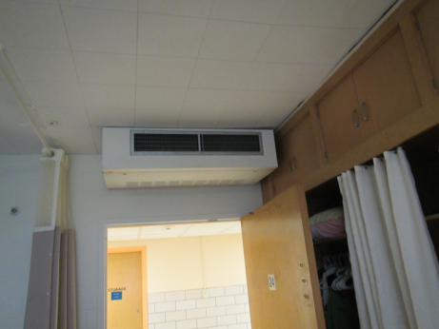
Fan coil unit above door in patient room
Picture 2
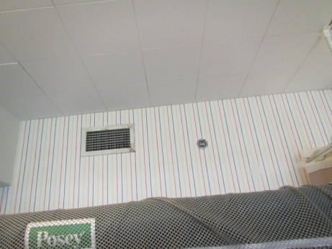
FCU return vent
Picture 3
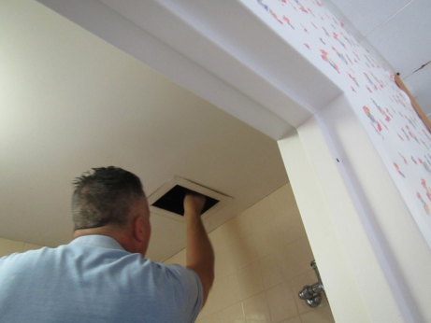
Restroom exhaust vent not drawing air
Picture 4
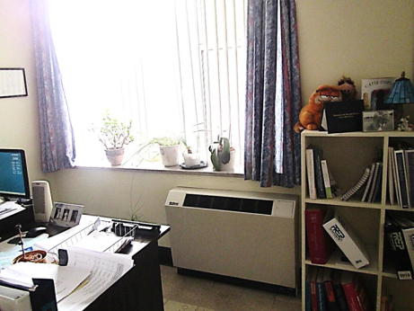
Unit ventilator (univent)
Picture 5
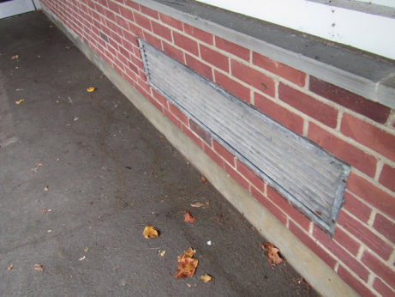
Univent fresh air intake
Picture 6
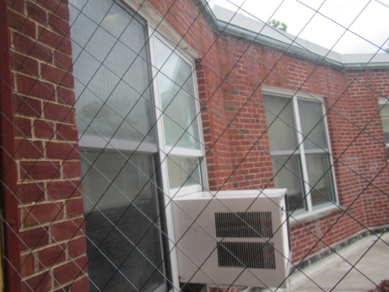
Window air conditioner
Picture 7
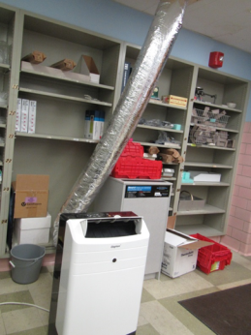
Portable air conditioner
Picture 8
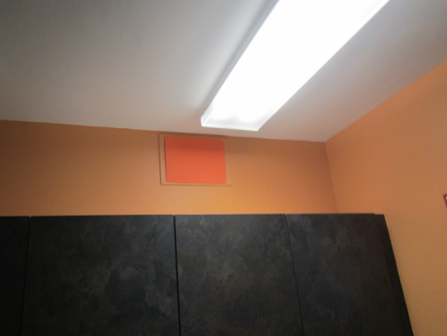
Covered vent in the Dental Office Reception leading to the sterilization room
Picture 9
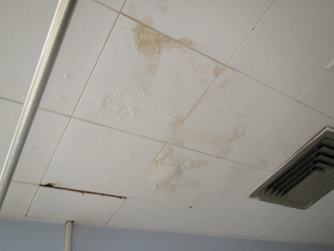
Water-damaged interlocking ceiling tiles
Picture 10
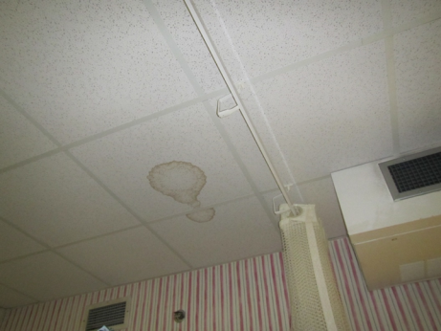
Water-damaged ceiling tile
Picture 11
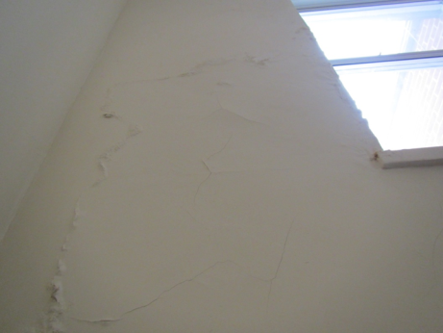
Wall in stairwell with cracked and spalling water-damaged plaster
Picture 12
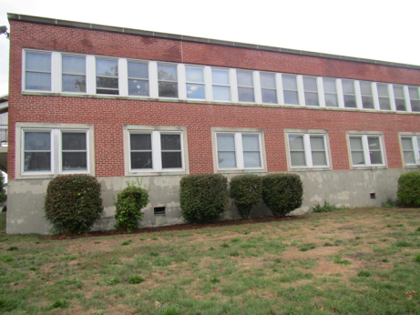
Shrubs next to exterior of building
Picture 13
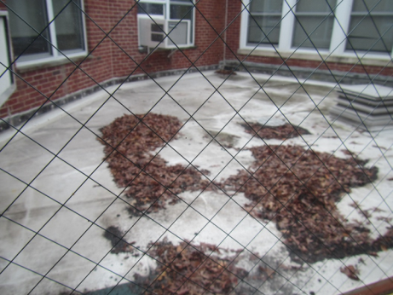
Leaves/debris on small roof segment including around storm drain (arrow)
Picture 14
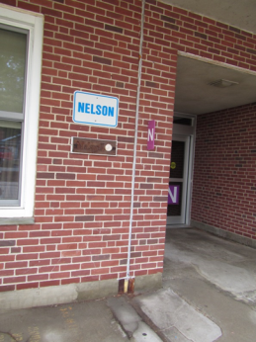
Seam between Nelson and Bradford buildings
Picture 15
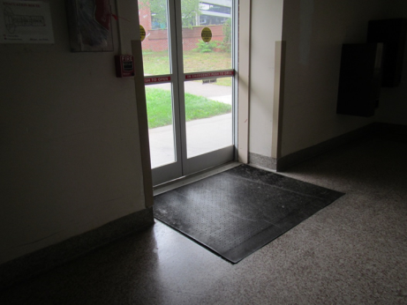
Light visible beneath door showing lack of weather stripping
Picture 16
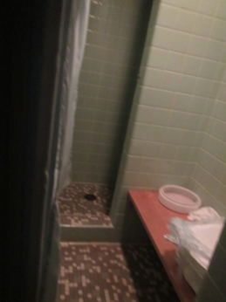
Floor drain in disused shower on the lower level
Picture 17
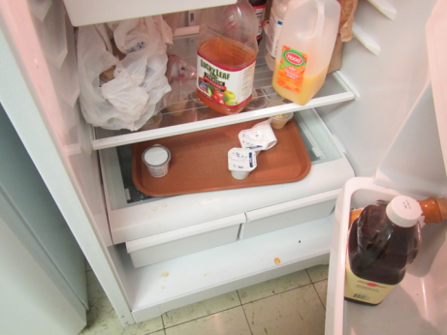
Spills inside fridge in nurses’ area breakroom
Picture 18
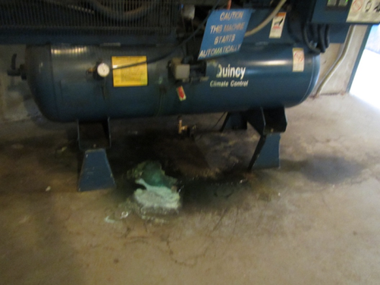
Condensate water from equipment on the floor of the mechanical room
Picture 19
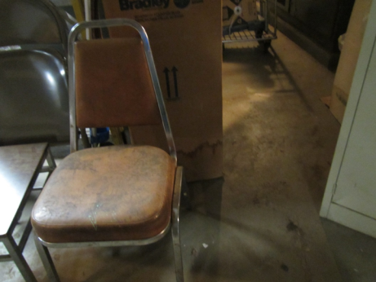
Water-damaged box and leather seat in mechanical room
Picture 20
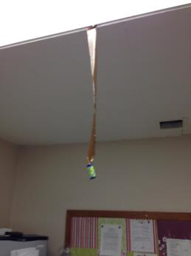
Flies adhered to a fly trap in breakroom
Picture 21
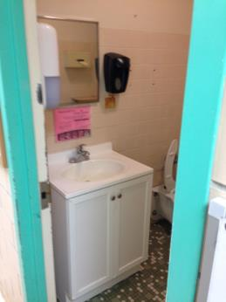
Restroom with reported foul odors in nurse’s station
Picture 22
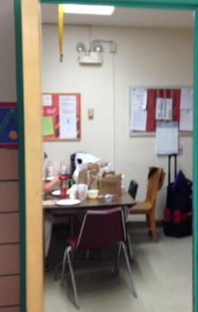
Open food containers in break room
Picture 23
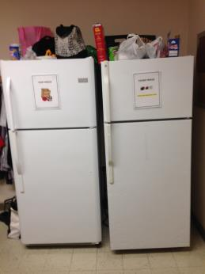
Food refrigerators in break room
Picture 24
Chicken bone on a desk in the front waiting room
Picture 25
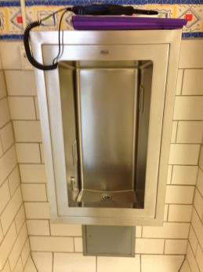
Abandoned water bubbler that appears to have open drains
Picture 26
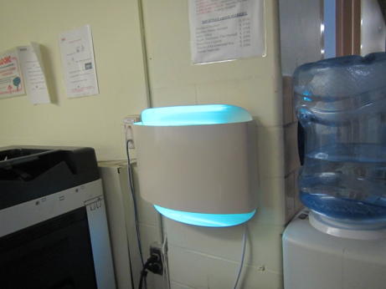
Wall-mounted light-based fly trap
Location | Carbon  Dioxide  (ppm) | Carbon Monoxide  (ppm) | Temp  (°F) | Relative  Humidity  (%) | PM2.5  (µg/m³) | TVOCs  (ppm) | Occupants  in Room | Windows  Openable | Ventilation |  |  | Remarks
 |  |  |  |  |  |  |  |  | Intake | Exhaust
Background | 453 | ND | 78 | 54 | 4 | ND
Nurse’s break room | 606 | ND | 78 | 54 | 4 | ND | 1 | N | Y |  | Y | 3 Refrigerators  Microwave
Nurse’s station restroom |  |  |  |  |  |  |  | N | N |  | Y | Exhaust off
Nurse’s station restroom |  |  |  |  |  |  |  | N | N |  | Y | Exhaust off
Nurse’s station | 652 | ND | 77 | 47 | 6 | ND | 3 | N | Y |  | Y
Medical supplies | 570 | ND | 78 | 53 | 4 | ND | 0 | N | N |  | N
Linen | 523 | ND | 77 | 53 | 2 | ND | 0 | N | N |  | N
Store room | 549 | ND | 77 | 53 | 2 | ND | 0 | N | N |  | N
Nelson dining room | 665 | ND | 72 | 45 | 11 | ND | 2 | Y | Y |  | Y | Ceiling fan

Location | Carbon  Dioxide  (ppm) | Carbon Monoxide  (ppm) | Temp  (°F) | Relative  Humidity  (%) | PM2.5  (µg/m³) | Occupants  in Room | VOCs  (ppm) | Windows  Openable | Ventilation |  | Remarks
 |  |  |  |  |  |  |  |  | Supply | Exhaust
Background | 363 | ND | 66 | 73 | 8 |  |  |  |  |  | Recent rain, cloudy
First Floor
01 | 527 | ND | 71 | 53 | 4 | 0 | ND | Y | Y | Y | DO
02 | 589 | ND | 71 | 54 | 5 | 0 | ND | Y | Y | Y
03 | 586 | ND | 71 |  | 9 | 0 |  | Y | Y | Y | WD CT
04 | 589 | ND | 72 | 50 | 8 | 0 |  | Y | Y | Y
05 | 520 | ND | 72 | 58 | 8 | 0 | ND | Y open | Y | Y | DO
06 | 568 | ND | 72 | 57 | 8 | 0 | ND | Y open | Y | Y | DO
07 | 716 | ND | 73 | 60 | 13 | 0 | ND | Y | Y | Y | DO
09 | 673 | ND | 74 | 59 | 13 | 0 |  | Y | Y | Y on | Floor just mopped
09 (laundry) |  |  | 73 | 64 | 5 | 0 | ND | Y | Y air intake dusty | Y | DO
10 | 655 | ND | 74 | 62 | 7 | 0 | ND | Y | Y | Y | DO
16 | 739 | ND | 74 | 57 | 8 | 1 |  | Y | Y | Y | DEM
21 | 582 | ND | 72 | 51 | 7 | 0 | ND | Y | Y | Y off | AT
22 | 584 | ND | 72 | 50 | 9 | 0 |  | Y | Y | Y off
23 | 562 | ND | 72 | 48 | 12 | 0 |  | Y | Y | Y off | CF, NC, area rug
23 | 583 | ND | 71 | 51 | 11 | 0 |  | Y | N | Y | DO
24 | 601 | ND | 71 | 50 | 13 | 0 |  | Y | Y | Y off
25 | 609 | ND | 71 | 51 | 10 | 0 |  | Y | Y | Y off | Double room
27 | 661 | ND | 72 | 56 | 13 | 0 |  | Y | Y | Y off
28 | 790 | ND | 74 | 56 | 11 | 0 |  | Y | Y | Y off | Bathroom odor
29 | 742 | ND | 73 | 55 | 10 | 0 |  | Y | Y | Y | DO
30 | 698 | ND | 74 | 52 | 11 | 0 |  | Y | Y | Y on
31 | 569 | ND | 74 | 53 | 8 | 0 |  | Y | Y | Y | Double room, DO
32 | 591 | ND | 73 | 54 | 7 | 0 |  | Y | Y | Y | DO
Bath/shower room | 488 | ND | 74 | 53 | 8 | 0 |  | N | N | Y off | Floor drains
Classroom | 584 | ND | 74 | 54 | 7 | 3 |  | Y | Y | N | DO
Corner room | 395 | ND | 74 | 64 | 7 | 1 |  | Y open | N | Y | Ceiling can
Dental reception office | 701 | ND | 74 | 56 | 7 | 2 |  | N | N | N | Transom/vent blocked as it connects to room with sterilization chemicals
Dental waiting | 533 | ND | 73 | 56 | 7 | 0 |  | Y | Y | Y | Upholstery
Files/storage |  |  |  |  |  |  |  |  |  |  | Items on pallets
Janitor |  |  |  |  |  |  |  |  |  |  | Floor drains
Lobby (rear of building) | 511 | ND | 72 | 47 | 6 | 0 |  | Y and door | Y | Y dusty, off
Nelson I bath/shower |  |  | 74 | 57 | 7 | 0 | ND | N | N | Y
Nelson I Hallway bed | 650 | ND | 73 | 55 | 10 | 0 |  | Y | Y | Y | Has outside door
Nelson II Clean utility |  |  |  |  |  |  |  |  |  | Y
Nelson II hallway, across from nurses’ station) | 669 | ND | 71 | 55 | 11 | 0 |  | N | N | N
Nelson II playroom | 504 | ND | 73 | 60 | 7 | 0 |  | Y, open | Y, off, dusty | Y, off, blocked | WD CT, DO
Nelson II Treatment | 593 | ND | 74 | 53 | 9 | 0 |  | N | N | N | NC, floor fan
Nelson II Utility | 670 | ND | 74 |  |  |  |  |  | N | Y | Cleaner/mop odor
Night pharmacy | 567 | ND | 74 | 52 | 4 | 1 |  | N | Passive | Y
Nurse admin | 488 | ND | 74 | 59 | 7 | 1 |  | Y | Y | Y | Plants, floor fan – dusty
Nurses’ kitchen | 688 | ND | 73 | 55 | 13 | 0 |  | N | Y | Y dusty, off | 2 refrigerators, one needs cleaning, microwave, DEM
Nurses’ restroom | 682 | ND | 72 | 56 | 11 | 0 |  | N | N | Y off
Nurses’ second restroom |  |  |  |  |  |  |  | N | Y | Y dusty | Cleaner odor
Nurses’ station | 756 | ND | 72 | 55 | 30 | 3 |  | N | Y off, dusty | Y off | Damaged floor
Sensory room | 606 | ND | 74 | 55 |  | 0 |  | Y | Y | Y on | Mats, beanbags, upholstered items
Staff education office | 514 | ND | 73 | 67 | 4 | 1 | ND | AC | Y | Y
Staff education suite | 565 | ND | 72 | 63 | 4 | 0 | ND | N | N | Y | DO
Basement
1 | 649 | ND | 73 | 58 | 6 | 0 | ND | Y | Y | Y | DO
2 | 686 | ND | 73 | 58 | 7 | 0 | ND | Y | Y | Y | DO
Central supply area desk | 413 | ND | 72 | 47 | 2 | 0 | ND | N | Y | Y
Central supply room C | 339 | ND | 72 | 46 | 5 | 0 |  | n | Y | Y | Boxes, some on floor
Clinic conference room | 377 | ND | 74 | 60 | 4 | 0 |  | N | Y | Y | Carpeted, WD CT, fridge and microwave
Clinic office | 372 | ND | 74 | 60 | 4 | 1-2 |  | N | Y
Clinic outpatient exam room 3 | 350 | ND | 74 | 60 | 4 | 0 |  | N | Y
Clinic outpatient exam room 2 | 351 | ND | 74 | 60 | 4 | 0 |  | N | Y | N
DC café | 583 | ND | 73 | 56 | 4 | 0 | ND | Y | Y | Y
Doctors Office 2 | 530 | ND | 73 | 49 | 8 | 1 | ND | Y | Y | N | PF, plants, DO
Doctors Office 5 | 465 | ND | 74 | 46 | 7 | 0 | ND | Y | Y | N | Plants, DO
HISQ Director’s office | 496 | ND | 75 | 43 | 7 | 1 | ND | N | Y | N | PF, food
Mechanical room |  | ND |  |  |  |  |  |  |  |  | Leaking condensate from equipment
Medical library | 745 | ND | 76 | 47 | 4 | 0 | ND | Y | Y, off | Y
Medical records | 425 | ND | 75 | 43 | 5 | 4 |  | N | Y | Y | Carpeted, area rug, PF, air filter, sink, plants
Medical records | 475 | ND | 76 | 42 | 9 | 0 | ND | N | N | N | AD, musty, reported periodic water, PF
Nelson clinic classroom | 395 | ND | 72 | 53 |  | 0 |  | Y | Y | Y | WD CT (a few)
Office in old operating room |  |  |  |  |  |  |  |  |  |  | Old shower and drains
Office next to central supply | 404 | ND | 72 | 48 | 5 | 1 |  | Y | N | Y | Air filter, plants
OT (occupational therapy) kitchen | 558 | ND | 74 | 63 | 4 | 0 |  | N | Y on | Y on, weak | Fridge needs cleaning, WD CT
OT area ladies room |  |  |  |  |  |  |  |  |  |  | Storage of paper products in old shower area, may have unused floor drains
OT Dept. staff office | 402 | BD | 75 | 54 | 4 | 0 | ND | N | Y | Y | PF, HS, CPs, DO
OT inner office | 438 | ND | 74 | 51 | 4 | 0 |  | N | N | Y dusty
OT office bathroom | 384 | ND | 75 | 53 | 5 | 0 |  | N | N | Y on
OT room | 490 | ND | 74 | 52 | 8 | 1 | ND | Y | Y | Y | WD CTs, PF, univent on
OT staff office | 480 | ND | 74 | 54 | 8 | 0 | ND | N | N | N | Portable AC
OT supply room | 473 | ND | 74 | 51 | 8 | 0 | ND | N | N | N | WD CT
Outpatient 5 | 384 | ND | 74 | 62 | 8 | 0 | ND | N | Y | Y | DO
Outpatient 6 | 431 | ND | 74 | 62 | 8 | 0 | ND | N | Y | Y | DO
Pediatrics office 1 | 467 | ND | 76 | 44 | 4 | 1 |  | Y | Y | Y | Plants, air filter
Pediatrics office 2 | 411 | ND | 76 | 45 | 5 | 1 |  | Y | Y | Y | Plants, air filter
Pediatrics open area | 416 | ND | 76 | 43 | 5 | 0 |  |  |  |  | Fridge and microwave
Pharmacy | 424 | ND | 76 | 61 | 4 | 1 |  | N | Y | Y | Portable AC, WD CT (several)
Sensory integration | 318 | ND | 74 | 43 | 5 | 0 |  | N | Y | Y | Mats and balls
Speech and therapy office | 501 | ND | 76 | 57 | 7 | 0 | ND | N | Y | Y | WD CT: active leak; DO
Sterilization room | 375 | ND | 71 | 50 | 1 | 0 | ND | N | Y | Y | DO
X-ray storage | 404 | ND | 76 | 43 | 5 | 0 |  | N | Y | Y
X-ray area bathroom | 399 | ND | 74 | 47 | 5 | 0 |  | N | N | Y
X-ray room | 402 | ND | 76 | 41 | 7 | 0 | ND | N | Y | Y
X-ray tech office | 547 | ND | 76 | 43 | 8 | 0 | ND | N | Y | N
X-ray waiting area | 422 | ND | 75 | 46 | 7 | 0 | ND | N | Y | N

 | Skin Irritation, Dryness, Redness or Rash |  |  |  | Pain or Stiffness in the Back, Shoulders or Neck
 | Response | Number | Percent |  | Response | Number | Percent
 | Yes | 2 | 40% |  | Yes | 2 | 40%
 | No | 3 | 60% |  | No | 3 | 60%
 | Total | 5 | 100% |  | Total | 5 | 100%
 | Dry, Itching, Burning, Watering or Irritated Eyes |  |  |  | Difficulty Remembering Things or Concentrating
 | Response | Number | Percent |  | Response | Number | Percent
 | Yes | 5 | 100% |  | Yes | 0 | 0%
 | No | 0 | 0% |  | No | 5 | 100%
 | Total | 5 | 100% |  | Total | 5 | 100%
 | Stuffy or Runny Nose or Sinus Congestion not related to an Infection |  |  |  | Ear Problems such as Pain, Ringing, or Difficulty Hearing not related to an Infection
 | Response | Number | Percent |  | Response | Number | Percent
 | Yes | 3 | 60% |  | Yes | 2 | 40%
 | No | 2 | 40% |  | No | 3 | 60%
 | Total | 5 | 100% |  | Total | 5 | 100%
 | Shortness of Breath |  |  |  | Wheezing in your Chest
 | Response | Number | Percent |  | Response | Number | Percent
 | Yes | 0 | 0% |  | Yes | 1 | 20%
 | No | 5 | 100% |  | No | 4 | 80%
 | Total | 5 | 100% |  | Total | 5 | 100%
 | Sore, Hoarse or Dry Throat |  |  |  | Tightness across the Chest
 | Response | Number | Percent |  | Response | Number | Percent
 | Yes | 5 | 100% |  | Yes | 1 | 20%
 | No | 0 | 0% |  | No | 4 | 80%
 | Total | 5 | 100% |  | Total | 5 | 100%
 | Tingling in the Hands and Feet |  |  |  | Coughing
 | Response | Number | Percent |  | Response | Number | Percent
 | Yes | 0 | 0% |  | Yes | 2 | 40%
 | No | 5 | 100% |  | No | 3 | 60%
 | Total | 5 | 100% |  | Total | 5 | 100%
 | Headaches |  |  |  | Sneezing
 | Response | Number | Percent |  | Response | Number | Percent
 | Yes | 2 | 40% |  | Yes | 3 | 60%
 | No | 3 | 60% |  | No | 2 | 40%
 | Total | 5 | 100% |  | Total | 5 | 100%
 | Dizziness, Lightheadedness, or Loss of Balance |  |  |  | Unusual Tiredness, Fatigue or Drowsiness
 | Response | Number | Percent |  | Response | Number | Percent
 | Yes | 0 | 0% |  | Yes | 2 | 40%
 | No | 5 | 100% |  | No | 3 | 60%
 | Total | 5 | 100% |  | Total | 5 | 100%
 | Nausea or Upset Stomach
 | Response | Number | Percent
 | Yes | 2 | 40%
 | No | 3 | 60%
 | Total | 5 | 100%

