INDOOR AIR QUALITY ASSESSMENT

Westford Parks, Recreation & Cemetery Department
35 Town Farm Road
Westford, Massachusetts



Prepared by:
Massachusetts Department of Public Health
Bureau of Environmental Health
Indoor Air Quality Program
July 2010

Background/Introduction
At the request of the Westford Parks, Recreation and Cemetery Department and the Westford Board of Health, the Massachusetts Department of Public Health (MDPH), Bureau of Environmental Health (BEH) provided assistance and consultation regarding indoor air quality concerns at the Westford Parks, Recreation and Cemetery Department offices located at 35 Town Farm Road, Westford, MA.
On March 30, 2010, a visit to conduct an assessment was made to this building by Cory Holmes, Environmental Analyst/Regional Inspector for BEH’s Indoor Air Quality (IAQ) Program. The assessment was prompted by concerns of respiratory symptoms, exacerbation of allergies and possible mold growth due to water infiltration. A preliminary report detailing conditions with recommendations for addressing what is believed to be asbestos-containing material in the basement was previously issued (MDPH, 2010). This report focuses on general IAQ conditions throughout the building.
The building is a three-story, red brick structure constructed in the mid 1800s, reportedly as a lodging house. The building has undergone renovations and additions over the years and had served as the Westford Police Department in the 1950s, and, following that, by the Westford School Department. The Westford Parks, Recreation and Cemetery Department has occupied the building since 2006. The building consists of offices, common work areas and meeting space. The building contains a basement and an attic which is used for storage and exercise equipment. Attached to the building is a one-story community room that is used for multiple purposes. Carpets were replaced in 2002 and a new roof was installed in 2006. Some windows are openable in the building.

Methods
Air tests for carbon monoxide, carbon dioxide, temperature and relative humidity were conducted with the TSI, Q-Trak, IAQ Monitor, Model 7565. Air tests for airborne particle matter with a diameter less than 2.5 micrometers were taken with the TSI, DUSTTRAK™ Aerosol Monitor Model 8520. BEH staff also performed visual inspection of building materials for water damage and/or microbial growth. Moisture content of porous building materials were measured with Delmhorst, BD-2000 Model, Moisture Detector with a Delmhorst Standard Probe.

Results
The building has an employee population of 6 and can be visited by up to 25-50 members of the public daily. Test were taken during normal operations and results appear in Table 1.

Discussion

Ventilation
It can be seen from Table 1 that carbon dioxide levels were below 800 parts per million (ppm) in all but one area surveyed, indicating adequate air exchange in the building at the time of the assessment (Table 1). It is important to note, that it was unclear if the building’s heating, ventilation and air conditioning (HVAC) system was equipped to introduce fresh air. It is likely that the system recirculates air only. If so, then the building relies solely on the use of openable windows to introduce fresh air.
The HVAC system for the main building consists of an air handling unit (AHU) located at the exterior of the building (Picture 1). Conditioned air is distributed to occupied areas via ducted supply diffusers and returned to the AHU by return vents. Digital wall-mounted thermostats control the heating, ventilating and air-conditioning (HVAC) system and have fan settings of “on” and “automatic”. Thermostats were set to the “automatic” setting during the assessment. The automatic setting on the thermostat activates the HVAC system at a preset temperature. Once the preset temperature is reached, the HVAC system is deactivated. Therefore, no mechanical ventilation is provided until the thermostat re-activates the system. In the fan “on” mode air will be continuously circulated and filtered, which should improve temperature/comfort control.
A separate AHU is located in the community room. BEH staff inspected the filter for this unit and found it to be occluded with dust and debris (Picture 2). Once a filter becomes saturated with debris, it can serve as a source of particulates that may become re-aerosolized into the airstream by the AHU. Lack of proper filtration can accelerate the degradation of HVAC equipment, making the equipment work harder to draw air through clogged filters.
Several areas utilize window-mounted air conditioners (ACs) to supplement cooling. ACs examined were equipped with a “fan only” or “exhaust open” setting. In this mode of operation air conditioning units can provide air circulation by delivering limited outside air into the space without cooling (i.e., air provided by unit equals that of outside temperature).
To maximize air exchange, the MDPH recommends that both supply and exhaust ventilation operate continuously during periods of occupancy. In order to have proper ventilation with a mechanical supply and exhaust system, the systems must be balanced to provide an adequate amount of fresh air to the interior of a room while removing stale air from the room. It is recommended that HVAC systems be re-balanced every five years to ensure adequate air systems function (SMACNA, 1994). The date of the last balancing of these systems was not available at the time of the assessment.
The Massachusetts Building Code requires that each room have a minimum ventilation rate of 20 cubic feet per minute (cfm) per occupant of fresh outside air or openable windows (SBBRS, 1997; BOCA, 1993). The ventilation must be on at all times that the room is occupied. Providing adequate fresh air ventilation with open windows and maintaining the temperature in the comfort range during the cold weather season is impractical. Mechanical ventilation is usually required to provide adequate fresh air ventilation.
Carbon dioxide is not a problem in and of itself. It is used as an indicator of the adequacy of the fresh air ventilation. As carbon dioxide levels rise, it indicates that the ventilating system is malfunctioning or the design occupancy of the room is being exceeded. When this happens, a buildup of common indoor air pollutants can occur, leading to discomfort or health complaints. The Occupational Safety and Health Administration (OSHA) standard for carbon dioxide is 5,000 parts per million parts of air (ppm). Workers may be exposed to this level for 40 hours/week, based on a time-weighted average (OSHA, 1997).
The MDPH uses a guideline of 800 ppm for publicly occupied buildings. A guideline of 600 ppm or less is preferred in schools due to the fact that the majority of occupants are young and considered to be a more sensitive population in the evaluation of environmental health status. Inadequate ventilation and/or elevated temperatures are major causes of complaints such as respiratory, eye, nose and throat irritation, lethargy and headaches. For more information concerning carbon dioxide, please see Appendix A.
Temperature readings in the building ranged from 65º F to 74 º F, which were below the MDPH recommended comfort guidelines in a few areas the day of the assessment. The MDPH recommends that indoor air temperatures be maintained in a range of 70 º F to 78 º F in order to provide for the comfort of building occupants. In many cases concerning indoor air quality, fluctuations of temperature in occupied spaces are typically experienced, even in a building with an adequate fresh air supply.
The relative humidity measured in the building ranged from 39 to 47 percent, which was within or very close to the lower end of the MDPH recommended comfort range in all areas surveyed. The MDPH recommends a comfort range of 40 to 60 percent for indoor air relative humidity. Relative humidity levels in the building would be expected to drop during the winter months due to heating. The sensation of dryness and irritation is common in a low relative humidity environment. Low relative humidity is a very common problem during the heating season in the northeast part of the United States.

Microbial/Moisture Concerns
In order for building materials to support mold growth, a source of water exposure is necessary. It was reported that the building has had chronic issues with water penetration through the building envelope, mainly in the form of roof leaks and water penetration through the foundation. Roof repairs appear to have eliminated leaks, as noted by BEH staff during the assessment, which was conducted during heavy wind and rain conditions. Building occupants reported that ceiling leaks occurred in Sandra’s office during a previous heavy rain and wind storm. No visible leaks, however, were observed during the assessment of this area. BEH staff conducted moisture measurements of carpeting and ceiling plaster in areas of previous leaks, as indicated by occupants. No elevated moisture measurements or visible mold growth associated with exterior leaks were observed/detected during the assessment (Table 1).
Elevated moisture measurements were detected on ceiling plaster in the 1st floor restroom (Table 1). BEH staff examined conditions in the 2nd floor restroom above this area and found that the toilet was leaking wetting the plaster below (Pictures 3and 4).
BEH staff examined the exterior of the building to identify breaches in the building envelope and/or other issues that could provide a source of water penetration. Several potential sources were identified:
- Damaged bulkhead (Picture 5);
- Gutters/downspouts emptying against foundation (Pictures 5 and 6);
- Missing/damaged mortar around exterior brick and foundation stone (Pictures 7 and 8);
- Missing/damaged basement windows sealed with plywood (Picture 9); and
- Missing/damaged window caulking, joint sealant and damage/breaches in wooden window frames (Pictures 10 and 11). Window and expansion joint sealant may be composed of regulated materials [(e.g., asbestos, polychlorinated biphenyls (PCBs)]. For information regarding PCBs, please consult MDPH guidance (Appendix B).
These conditions can undermine the integrity of the building envelope and provide a means of water entry by capillary action into the building through exterior walls, foundation concrete and masonry (Lstiburek & Brennan, 2001). In addition, these breaches in exterior areas can provide a means of drafts and pest entry into the building.
The US Environmental Protection Agency and the American Conference of Governmental Industrial Hygienists (ACGIH) recommends that porous materials (carpeting, ceiling tiles, etc.) be dried with fans and heating within 24 to 48 hours of becoming wet (US EPA, 2001; ACGIH, 1989). If porous materials are not dried within this time frame, mold growth may occur. Water-damaged porous materials cannot be adequately cleaned to remove mold growth. The application of a mildewcide to moldy porous materials is not recommended.

Other IAQ Evaluations
Indoor air quality can be negatively influenced by the presence of respiratory irritants, such as products of combustion. The process of combustion produces a number of pollutants. Common combustion emissions include carbon monoxide, carbon dioxide, water vapor and smoke (fine airborne particle material). Of these materials, exposure to carbon monoxide and particulate matter with a diameter of 2.5 micrometers (μm) or less (PM2.5) can produce immediate, acute health effects upon exposure. To determine whether combustion products were present in the building, BEH staff obtained measurements for carbon monoxide and PM2.5.

Carbon Monoxide
Carbon monoxide is a by-product of incomplete combustion of organic matter (e.g., gasoline, wood and tobacco). Exposure to carbon monoxide can produce immediate and acute health affects. Several air quality standards have been established to address carbon monoxide and prevent symptoms from exposure to these substances. The MDPH established a corrective action level concerning carbon monoxide in ice skating rinks that use fossil-fueled ice resurfacing equipment. If an operator of an indoor ice rink measures a carbon monoxide level over 30 ppm, taken 20 minutes after resurfacing within a rink, that operator must take actions to reduce carbon monoxide levels (MDPH, 1997).
The American Society of Heating Refrigeration and Air-Conditioning Engineers (ASHRAE) has adopted the National Ambient Air Quality Standards (NAAQS) as one set of criteria for assessing indoor air quality and monitoring of fresh air introduced by HVAC systems (ASHRAE, 1989). The NAAQS are standards established by the US EPA to protect the public health from six criteria pollutants, including carbon monoxide and particulate matter (US EPA, 2006). As recommended by ASHRAE, pollutant levels of fresh air introduced to a building should not exceed the NAAQS levels (ASHRAE, 1989). The NAAQS were adopted by reference in the Building Officials & Code Administrators (BOCA) National Mechanical Code of 1993 (BOCA, 1993), which is now an HVAC standard included in the Massachusetts State Building Code (SBBRS, 1997). According to the NAAQS, carbon monoxide levels in outdoor air should not exceed 9 ppm in an eight-hour average (US EPA, 2006).
Carbon monoxide should not be present in a typical, indoor environment. If it is present, indoor carbon monoxide levels should be less than or equal to outdoor levels. On the day of assessment, outdoor carbon monoxide concentrations were non-detect (ND) (Table 1). No measurable levels of carbon monoxide were detected in the building at the time of the assessment (Table 1).

Particulate Matter (PM2.5)
The US EPA has established NAAQS limits for exposure to particulate matter. Particulate matter is airborne solids that can be irritating to the eyes, nose and throat. The NAAQS originally established exposure limits to particulate matter with a diameter of 10 μm or less (PM10). According to the NAAQS, PM10 levels should not exceed 150 micrograms per cubic meter (μg/m³) in a 24-hour average (US EPA, 2006). These standards were adopted by both ASHRAE and BOCA. Since the issuance of the ASHRAE standard and BOCA Code, US EPA established a more protective standard for fine airborne particles. This more stringent PM2.5 standard requires outdoor air particle levels be maintained below 35 μg/m³ over a 24-hour average (US EPA, 2006). Although both the ASHRAE standard and BOCA Code adopted the PM10 standard for evaluating air quality, MDPH uses the more protective PM2.5 standard for evaluating airborne particulate matter concentrations in the indoor environment.
Outdoor PM2.5 concentrations were measured at 4 μg/m³ (Table 1). PM2.5 levels measured indoors ranged from 2 to 5 μg/m³ (Table 1), which were below the NAAQS PM2.5 level of 35 μg/m³. Frequently, indoor air levels of particulates (including PM2.5) can be at higher levels than those measured outdoors. A number of mechanical devices and/or activities that occur in buildings can generate particulate during normal operations. Sources of indoor airborne particulates may include but are not limited to particles generated during the operation of fan belts in the HVAC system, cooking in stoves and microwave ovens; use of photocopiers, fax machines and computer printing devices; operation of an ordinary vacuum cleaner and heavy foot traffic indoors.

Other Conditions
Other conditions that can affect indoor air quality were observed during the assessment. Evidence of rodent/pest infestation was observed in the form of mice droppings under the cabinet in the kitchen (Picture 12) and large deposits of fecal matter in the basement (Picture 13). The waste products in the basement appeared to be from an animal larger than mice, such as a feral cat, raccoon or possum. Rodent infestation can result in indoor air quality related symptoms due to materials in their wastes. Mouse urine contains a protein that is a known sensitizer (US EPA, 1992). A three-step approach is necessary to eliminate rodent infestation:
- Removal of rodents/pests;
- Cleaning of waste products from the interior of the building; and
- Reduction/elimination of pathways/food sources that are attracting rodents.
To eliminate exposure to allergens, rodents must be removed from the building. Please note that removal, even after cleaning, may not provide immediate relief since allergens can exist in the interior for several months after rodents are eliminated (Burge, 1995). A combination of cleaning, increase in ventilation and filtration should serve to reduce rodent associated allergens once the infestation is eliminated.
Restrooms are equipped with mechanical exhaust vents. The vents were not drawing air at the time of the assessment. Exhaust ventilation is necessary in restrooms to remove excess moisture and to prevent odors from penetrating into adjacent areas.
Open utility holes were observed throughout the building (e.g., around radiator pipes). Open utility holes can provide a means of egress for odors, fumes, dusts and vapors between rooms and floors. In addition, these breaches can allow for migration of pests/rodents betweens rooms and floors.
Many areas of the building contain wall to wall carpeting. It was unclear if a regular carpet cleaning program was in place. The Institute of Inspection, Cleaning and Restoration Certification (IICRC), recommends that carpeting be cleaned annually (or semi-annually in soiled high traffic areas) (IICRC, 2005).
Finally, an abandoned toilet and urinal were observed in the basement, which formerly served as a jail cell for the police department. Instead of properly sealing the drain (or removing the toilet) rags were inserted into the drain (Picture 14). Drains are usually designed with traps in order to prevent sewer odors/gases from penetrating into occupied spaces. When water enters a drain, the trap fills and forms a watertight seal. Without a periodic input of water (e.g., every other day), traps can dry, breaking the watertight seal. Without a watertight seal, odors or other material can travel up the drain and enter the occupied space.

Conclusions/Recommendations
To improve indoor environmental conditions in the building, a two-phase approach is recommended. This approach consists of short-term measures to improve air quality that can be implemented as soon as practicable and long-term recommendations that will require planning and resources to adequately address overall indoor air quality concerns.

Short Term Recommendations
- Work with town officials to develop a preventative maintenance program for all HVAC equipment.
- Have HVAC engineer determine if AHUs are equipped with the capabilities to introduce fresh air or if they can be retro-fitted to introduce fresh air and exhaust stale air. In the case where windows were rendered unopenable, they need to be restored to working order or fresh air must be provided via mechanical means.
- Open windows (weather permitting) to temper rooms and provide fresh air. As discussed, this building was designed to use windows to provide air circulation. Care should be taken to ensure windows are properly closed at night and on weekends to avoid the freezing of pipes and potential flooding.
- Set the thermostat to the fan “on” position to operate the ventilation system continuously during business hours.
- Supplement fresh air by operating window-mounted air conditioners in the "fan only" “fresh air” mode, which introduces outside air by mechanical means.
- Change filters for air-handling equipment (e.g., AHUs and ACs) as per the manufacturers’ instructions or more frequently if needed. Vacuum interior of units prior to activation to prevent the aerosolization of dirt, dust and particulate matter. Ensure filters fit flush in their racks with no spaces in between allowing bypass of unfiltered air into the unit.
- For buildings in New England, periods of low relative humidity during the winter are often unavoidable. Therefore, scrupulous cleaning practices should be adopted to minimize common indoor air contaminants whose irritant effects can be enhanced when the relative humidity is low. To control for dusts, a high efficiency particulate arrestance (HEPA) filter equipped vacuum cleaner in conjunction with wet wiping of all surfaces is recommended. Drinking water during the day can help ease some symptoms associated with a dry environment (e.g., throat and sinus irritations).
- Make temporary repairs to seal breaches in building envelope (e.g., around windows, bulkhead) to prevent drafts, access by pests/rodents and further water penetration and damage to building materials. Address deteriorated window/joint sealant in accordance with EPA regulations/MDPH guidance.
- Ensure toilet leak in 2nd floor restroom is repaired.
- Make repairs to water-damaged ceiling plaster. Seal and repaint to prevent flaking.
- Ensure all leaks in the building are repaired.
- Extend downspouts to empty at least 5 feet away from the foundation (if possible).
- Consider removing carpeting from around radiators and replace with tile, to prevent chronic moistening of porous materials and potential mold growth conditions.
- Seal basement windows to prevent water penetration and rodent/pest entry.
- Remove rodent/animal droppings and clean/disinfect interior of kitchen cabinets and basement.
- Investigate and repair restroom exhaust vents as necessary.
- Seal all open utility holes and breaches on the exterior to eliminate moisture sources and rodent pathways into the building.
- Seal all open utility holes and breaches in interior spaces (e.g., around radiator pipes).
- Remove or properly seal drains for abandoned toilets in the basement.
- Contract with a licensed pest control firm to eliminate rodents from the building. For additional advice regarding pest control contact the Massachusetts Department of Agricultural Resources, Pesticide/IPM Program at (617) 626-1700 http://www.mass.gov/agr/
- Clean carpeting annually or semi-annually in soiled high traffic areas as per the recommendations of the Institute of Inspection, Cleaning and Restoration Certification (IICRC). Copies of the IICRC fact sheet can be downloaded at: http://www.cleancareseminars.com/carpet_cleaning_faq4.htm (IICRC, 2005)
- Make repairs to local exhaust vents in restrooms to remove excess moisture and odors.
- Refer to resource manuals and other related indoor air quality documents for further building-wide evaluations and advice on maintaining public buildings. Copies of these materials are located on the MDPH’s website: http://mass.gov/dph/iaq.

Long-Term Recommendations
- Consider consulting with an architect, masonry firm or general contractor regarding the integrity of the building envelope, primarily concerning water penetration through the roof/exterior walls.
- Consider a long-term plan to replace all windows in the building as funds become available.

References
ACGIH. 1989. Guidelines for the Assessment of Bioaerosols in the Indoor Environment. American Conference of Governmental Industrial Hygienists, Cincinnati, OH.
ASHRAE. 1989. Ventilation for Acceptable Indoor Air Quality. American Society of Heating, Refrigeration and Air Conditioning Engineers. ANSI/ASHRAE 62-1989.
BOCA. 1993. The BOCA National Mechanical Code-1993. 8th ed. Building Officials & Code Administrators International, Inc., Country Club Hills, IL.
Burge, H.A. 1995. Bioaerosols. Lewis Publishing Company, Boca Raton, FL.
IICRC. 2005. Carpet Cleaning FAQ 4 Institute of Inspection, Cleaning and Restoration Certification. Institute of Inspection Cleaning and Restoration, Vancouver, WA.
Lstiburek, J. & Brennan, T. 2001. Read This Before You Design, Build or Renovate. Building Science Corporation, Westford, MA. U.S. Department of Housing and Urban Development, Region I, Boston, MA.
MDPH. 1997. Requirements to Maintain Air Quality in Indoor Skating Rinks (State Sanitary Code, Chapter XI). 105 CMR 675.000. Massachusetts Department of Public Health, Boston, MA.
MDPH. 2010. Letter to Patricia Savage, Director Westford Recreation Department, Regarding Damaged Pipe Insulation, 35 Town Farm Road, Westford, MA. Massachusetts Department of Public Health, Bureau of Environmental Health, Boston, MA. Dated April 6, 2010.
OSHA. 1997. Limits for Air Contaminants. Occupational Safety and Health Administration. Code of Federal Regulations. 29 C.F.R 1910.1000 Table Z-1-A.
SBBRS. 1997. Mechanical Ventilation. State Board of Building Regulations and Standards. Code of Massachusetts Regulations. 780 CMR 1209.0.
US EPA. 1992. Indoor Biological Pollutants. US Environmental Protection Agency, Environmental Criteria and Assessment Office, Office of Health and Environmental Assessment, research Triangle Park, NC. EPA 600/8-91/202 January 1992.
US EPA. 2001. “Mold Remediation in Schools and Commercial Buildings”. Office of Air and Radiation, Indoor Environments Division, Washington, DC. EPA 402-K-01-001. March 2001. Available at: http://www.epa.gov/iaq/molds/mold_remediation.html
US EPA. 2006. National Ambient Air Quality Standards (NAAQS). US Environmental Protection Agency, Office of Air Quality Planning and Standards, Washington, DC. http://www.epa.gov/air/criteria.html
Picture 1

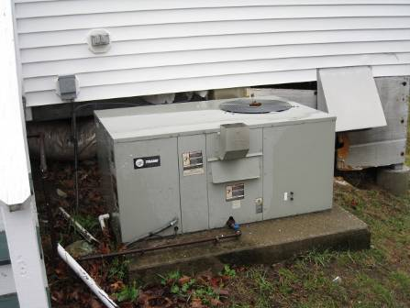

AHU for HVAC System

Picture 2

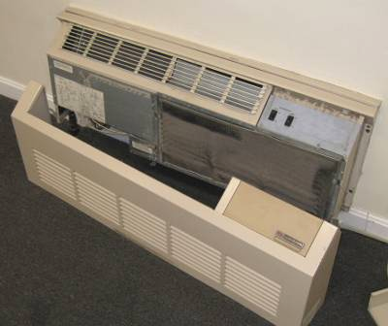

AHU for Community Room, Note Filter Clogged with Dust/Debris

Picture 3

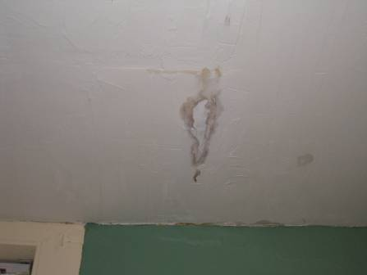

Water-Damaged Ceiling Plaster in 1st Floor Restroom

Picture 4

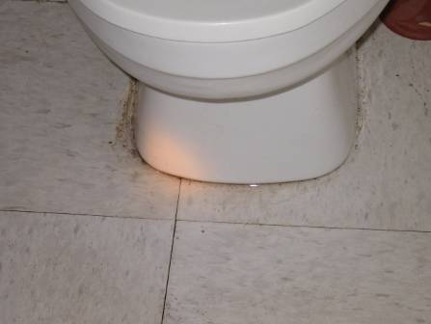

Leaking Toilet in 2nd Floor Bathroom

Picture 5

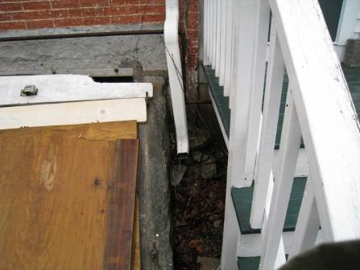

Damaged Bulkhead and Downspout Emptying Water against Foundation

Picture 6

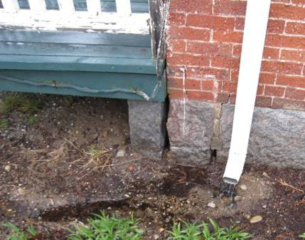

Downspout Emptying Water against Foundation, Note Spaces in Foundation

Picture 7

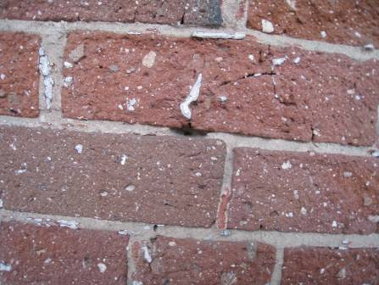

Damaged Exterior Brick

Picture 8

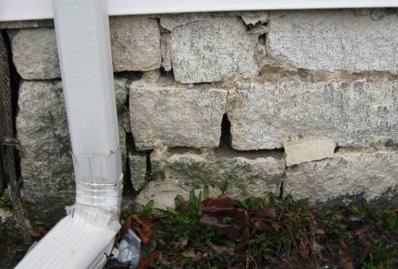

Missing/Damaged Mortar around Foundation Stone

Picture 9

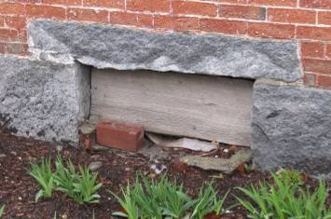

Window Sealed with Plywood, Note Spaces around Wood

Picture 10

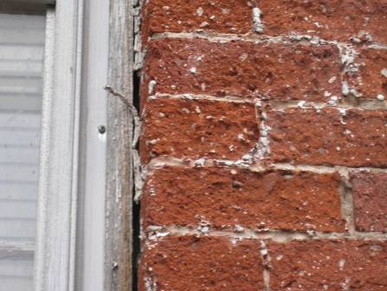

Missing/Damaged Caulking around Window Frame

Picture 11

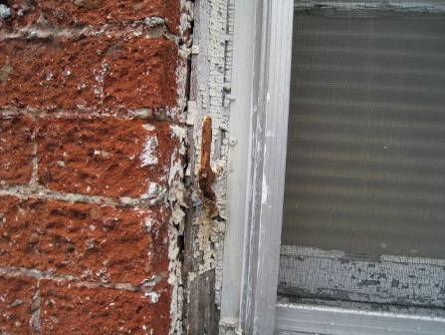

Missing/Damaged Caulking around Window Frame

Picture 12

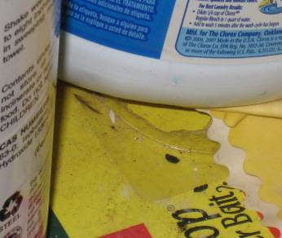

Mice Droppings beneath Kitchen Sink

Picture 13

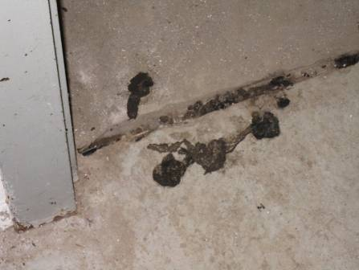

Large Deposits of Fecal Matter in Basement

Picture 14

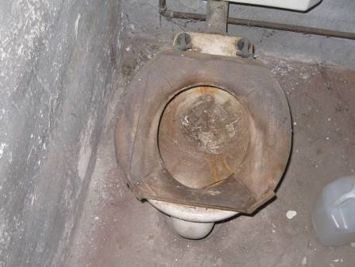

Abandoned Toilet in Basement, Note Rags Stuffed into Drain
Location | Occupants  in Room | Temp  (°F) | Relative  Humidity  (%) | Carbon  Dioxide  (ppm) | Carbon Monoxide  (ppm) | PM2.5  (µg/m3) | Windows  Openable | Ventilation |  | Remarks
 |  |  |  |  |  |  |  | Supply | Exhaust | Remarks
Outside  (Background) |  | 69 | 100 | 351 | ND | 4 |  |  |  | Heavy wind (NNE 11-23 mph) and rain with gusts up to 33 mph
WPC Mail room | 0 | 68 | 41 | 377 | ND | 3 | Y |  |  | Broken window
WPC Storage | 0 | 65 | 43 | 363 | ND | 3 | Y
Community Room | 0 | 65 | 43 | 365 | ND | 4 | Y |  |  | AHU-filter dusty
Director’s Office | 2 | 72 | 47 | 851 | ND | 3 | Y |  |  | Utility holes
1st Floor Restroom | 0 | 74 | 45 | 761 | ND | 2 | Y |  | Y | Exhaust not operating, WD ceiling plaster moisture measurement = high/saturated (leaking toilet above)
Storage File Room | 0 | 74 | 41 | 573 | ND | 2 | Y
Main Hallway |  |  |  |  |  |  |  |  |  | Area of chronic leaks around radiator, moisture measurements carpet/ceiling plaster = dry/normal, recommend removing carpet around radiator
Reception Area | 0 | 73 | 41 | 573 | ND | 4 | Y |  |  | Utility holes/spaces floor
Sandra’s Office | 0 | 71 | 41 | 532 | ND | 4 | Y |  |  | Water penetration, ceiling plaster-last storm, moisture measurements carpet/ceiling plaster = dry/normal
Hallway
Danielle’s Office | 1 | 74 | 40 | 557 | ND | 3 | Y
Kristin’s Office | 1 | 74 | 40 | 583 | ND | 3 | Y
Lois’s Office | 1 | 73 | 39 | 506 | ND | 5 | Y
Kitchen | 1 | 70 | 41 | 477 | ND | 3 | Y |  |  | Rodent droppings under sink/cabinet
Rowing Room | 0 | 69 | 44 | 481 | ND | 3 | Y
Rowing Storage Room |  |  |  |  |  |  |  |  |  | Missing/cracked window pane

An Information Booklet Addressing PCB-Containing Materials in the Indoor Environment of Schools
and Other Public Buildings



Prepared by

Bureau of Environmental Health
Massachusetts Department of Public Health
December 2009
INTRODUCTION
The purpose of this information booklet is to provide assistance to school and public building officials and the general public in assessing potential health concerns associated with polychlorinated biphenyl (PCB) compounds in building materials used in Massachusetts and elsewhere. Recently, the U.S. Environmental Protection Agency (EPA) provided broad guidance relative to the presence of PCBs in building materials, notably PCBs in caulking materials. The most common building materials that may contain PCBs in facilities constructed or significantly renovated during the 1950s through the 1970s are fluorescent light ballasts, caulking, and mastic used in tile/carpet as well as other adhesives and paints.
This information booklet, developed by the Massachusetts Department of Public Health’s Bureau of Environmental Health (MDPH/BEH), is designed to supplement guidance offered by EPA relative to potential health impacts and environmental testing. It also addresses managing building materials, such as light ballasts and caulking, containing PCBs that are likely to be present in many schools and public buildings across the Commonwealth. This is because the Northeastern part of the country, and notably Massachusetts, has a higher proportion of schools and public buildings built during the 1950s through 1970s than many other parts of the U.S. according to a 2002 U.S. General Accounting Office report. The Massachusetts School Building Authority noted in a 2006 report that 53 percent of over 1,800 Massachusetts school buildings surveyed were built during the 1950s through 1970s. This information booklet contains important questions and answers relative to PCBs in the indoor environment and is based on the available scientific literature and MDPH/BEH’s experience evaluating the indoor environment of schools and public buildings for a range of variables, including for PCBs as well as environmental data reviewed from a variety of sources.
1. What are PCBs?
Polychlorinated biphenyl (PCB) compounds are stable organic chemicals used in products from the 1930s through the late 1970s. Their popularity and wide-spread use were related to several factors, including desirable features such as non-flammability and electrical insulating properties. Although the original use of PCBs was exclusive to closed system electrical applications for transformers and capacitors (e.g., fluorescent light ballasts), their use in other applications, such as using PCB oils to control road dust or caulking in buildings, began in the 1950s.
2. When were PCBs banned from production?
Pursuant to the Toxic Substance Control Act (TSCA) of 1976 (effective in 1979), manufacturing, processing, and distribution of PCBs was banned. While the ban prevented production of PCB-containing products, it did not prohibit the use of products already manufactured that contained PCBs, such as building materials or electrical transformers.
3. Are PCBs still found in building materials today?
Yes. Products made with PCBs prior to the ban may still be present today in older buildings. In buildings constructed during the 1950s through 1970s, PCBs may be present in caulking, floor mastic, and in fluorescent light ballasts. Available data reviewed by MDPH suggests that caulking manufactured in the 1950s through 1970s will likely contain some levels of PCBs. Without testing it is unclear whether caulking in a given building may exceed EPA’s definition of PCB bulk product waste of 50 parts per million (ppm) or greater. If it does, removal and disposal of the caulk is required in accordance with EPA’s TSCA regulations (40 CFR § 761).
4. Are health concerns associated with PCB exposure opportunities?
Although the epidemiological evidence is sometimes conflicting, most health agencies have concluded that PCBs may reasonably be anticipated to be a carcinogen, i.e., to cause cancer.
PCBs can have a number of non-cancer effects, including those on the immune, reproductive, neurological and endocrine systems. Exposure to high levels of PCB can have effects on the liver, which may result in damage to the liver. Acne and rashes are symptoms typical in those that are exposed to high PCB levels for a short period of time (e.g., in industry / occupational settings).
5. If PCBs are present in caulking material, does that mean exposure and health impacts are likely?
No. MDPH/BEH’s review of available data suggests that if caulking is intact, no appreciable exposures to PCBs are likely and hence health effects would not be expected. MDPH has conducted indoor tests and reviewed available data generated through the efforts of many others in forming this opinion.
6. How can I tell if caulking or light ballasts in my building may contain PCBs?
If the building was built sometime during the 1950s through 1970s, then it is likely that the caulking in the building and/or light ballasts may contain some level of PCBs. Light ballasts manufactured after 1980 have the words “No PCBs” printed on them. If the light ballast does not have this wording or was manufactured before 1980, it should be assumed that it contains PCBs.
7. What are light ballasts?
A light ballast is a piece of equipment that controls the starting and operating voltages of fluorescent lights. A small capacitor within older ballasts contains about one ounce of PCB oil. If light bulbs are not changed soon after they go out, the ballast will continue to heat up and eventually result in the release of low levels of PCBs into the indoor air.
8. Does the presence of properly functioning fluorescent light ballasts in a building present an environmental exposure concern?
No appreciable exposure to PCBs is expected if fluorescent light ballasts that contain PCBs are intact and not leaking or damaged (i.e., no visible staining of the light lenses), and do not have burned-out bulbs in them.

9. Should I be concerned about health effects associated with exposure to PCBs as a result of PCB-containing light ballasts?
While MDPH has found higher PCB levels in indoor air where light bulbs have burned-out, the levels are still relatively low and don’t present imminent health threats. A risk assessment conducted recently at one school did not suggest unusual cancer risks when considering a worst case exposure period of 35 years for teachers in that school. Having said this, MDPH believes that facility operators and building occupants should take prompt action to replace bulbs and/or ballasts as indicated to reduce/eliminate any opportunities for exposure to PCBs associated with PCB-containing light ballasts.
10. When should PCB-containing light ballasts be replaced?
If ballasts appear to be in disrepair, they should be replaced immediately and disposed of in accordance with environmental regulatory guidelines and requirements. However, if light bulbs burn out, the best remedy is to change them as soon as possible. If light bulbs are not changed soon after they go out, the ballast will continue to heat up and eventually result in the release of low levels of PCBs into the indoor air. Thus, burned-out bulbs should be replaced promptly to reduce overheating and stress on the ballast. As mentioned, ballasts that are leaking or in any state of disrepair should be replaced as soon as possible.
It should be noted that although older light ballasts may still be in use today, the manufacturers’ intended lifespan of these ballasts was 12 years. Thus, to the extent feasible or in connection with repair/renovation projects, the older light ballasts should be replaced consistent with the intended lifespan specified by the manufacturers.
11. Does MDPH recommend testing of caulking in buildings built during the 1950s -1980?
Caulking that is intact should not be disturbed. If caulking is deteriorating or damaged, conducting air and surface wipe testing in close proximity to the deteriorating caulking will help to determine if indoor air levels of PCBs are a concern as well as determining the need for more aggressive cleaning. Results should be compared with similar testing done in an area without deteriorating caulking. In this way, a determination can be made regarding the relative contribution of caulking materials to PCBs in the general indoor environment.
12. What if we determine that caulking in our building is intact and not deteriorating?
Based on a review of available data collected by MDPH and others, the MDPH does not believe that intact caulking presents appreciable exposure opportunities and hence should not be disturbed for testing. As with any building, regular operations and maintenance should include a routine evaluation of the integrity of caulking material. If its condition deteriorates then the steps noted above should be followed. Consistent with EPA advice, if buildings may have materials that contain PCBs, facility operators should ensure thorough cleaning is routinely conducted.
13. Should building facilities managers include information about PCB-containing building materials in their Operations and Maintenance (O&M) plans?
Yes. All buildings should have an O&M plan that includes regular inspection and maintenance of PCB building materials, as well as thorough cleaning of surfaces not routinely used. Other measures to prevent potential exposure to PCBs include increasing ventilation, use of HEPA filter vacuums, and wet wiping. These O&M plans should be available to interested parties.
14. Are there other sources of PCBs in the environment?
Yes. The most common exposure source of PCBs is through consumption of foods, particularly contaminated fish. Because PCBs are persistent in the environment, most residents of the U.S. have some level of PCBs in their bodies.
15. Where can I obtain more information?
For guidance on replacing and disposing of PCB building materials, visit the US EPA website: http://www.epa.gov/pcbsincaulk/. For information on health concerns related to PCBs in building materials, please contact MDPH/BEH at 617-624-5757.

