‘Partnership’ Opportunities
Contained in the New
Massachusetts Cost Containment
Law

Paul Hattis MD, JD, MPH Health Policy Commission Tufts Medical School Paul.hattis@tufts.edu
Paul.hattis@Massmail.state.ma.us

January 31, 2013
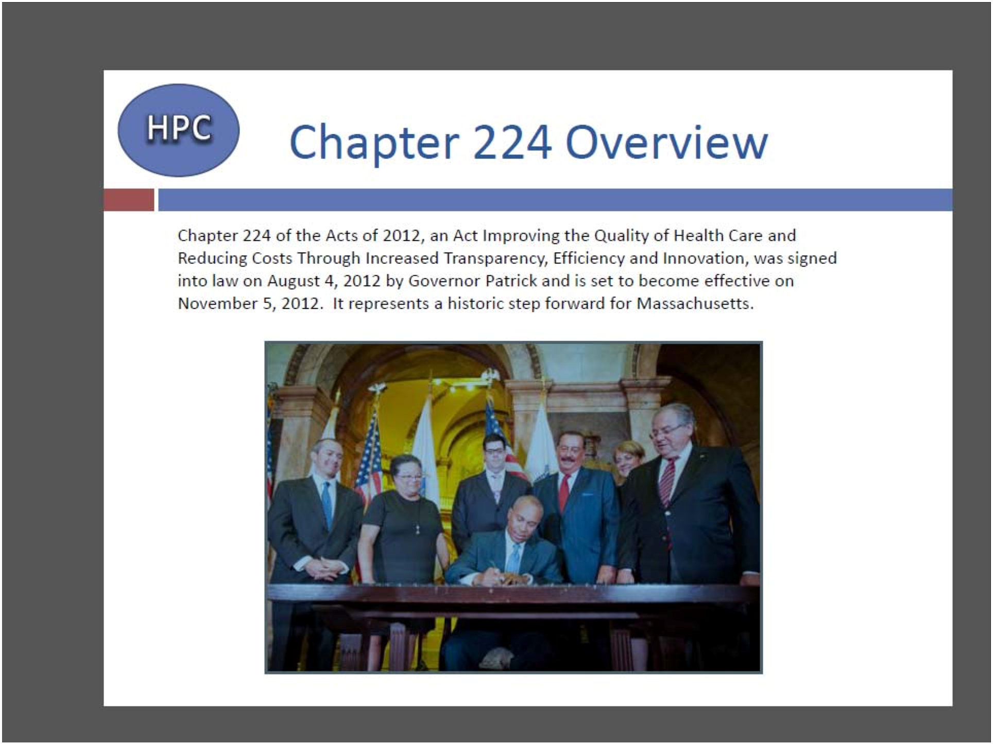

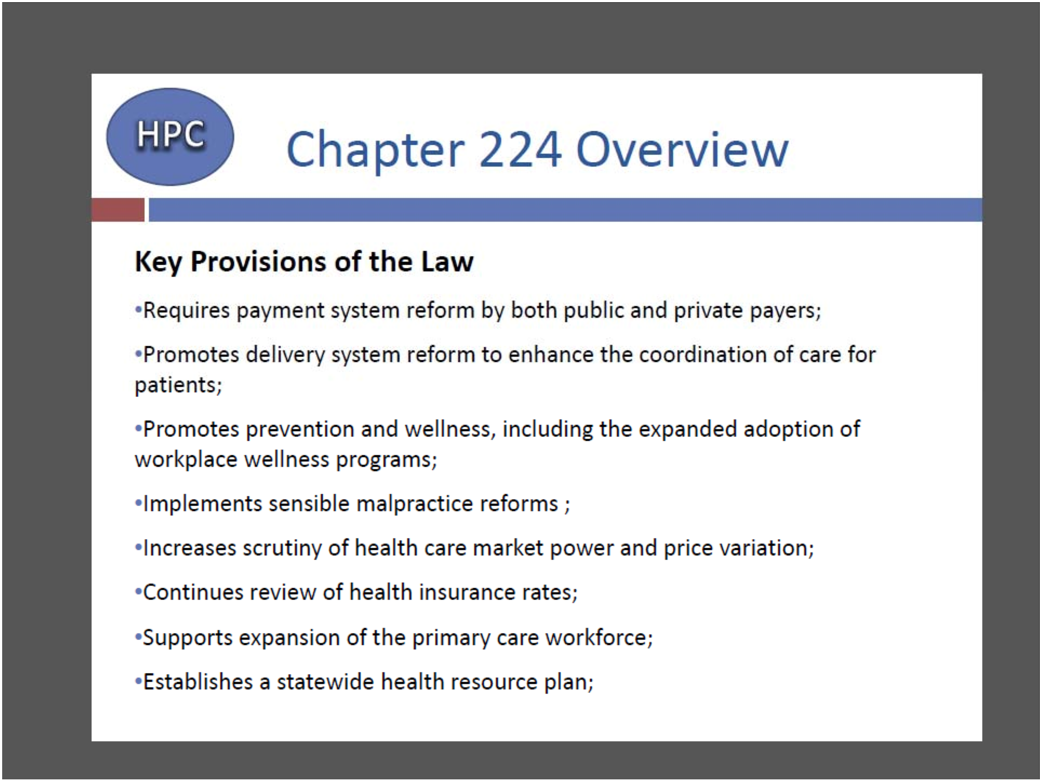

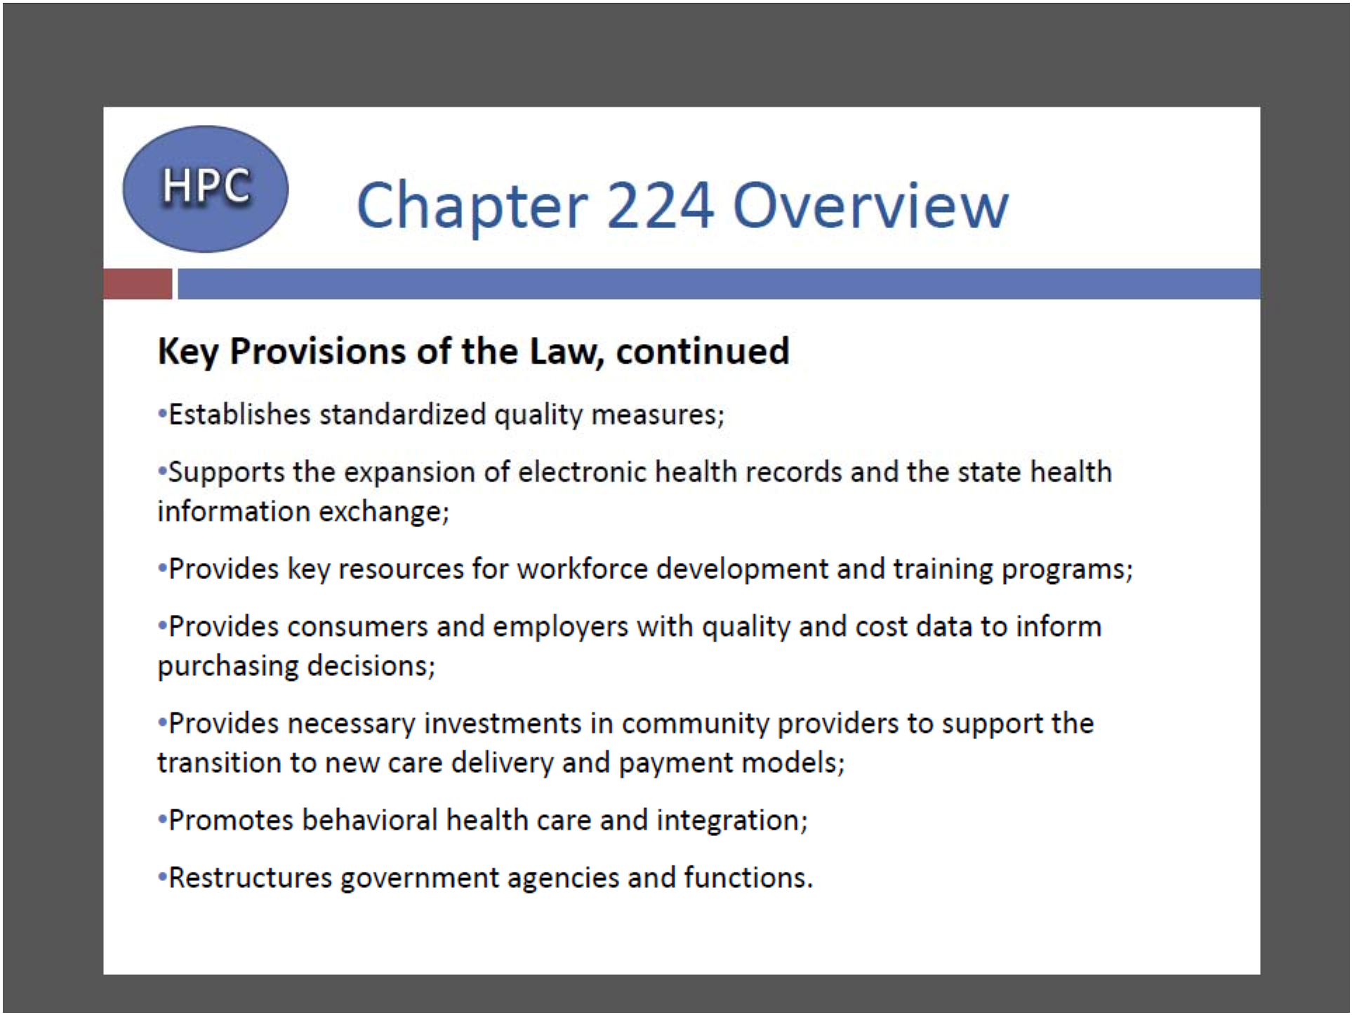

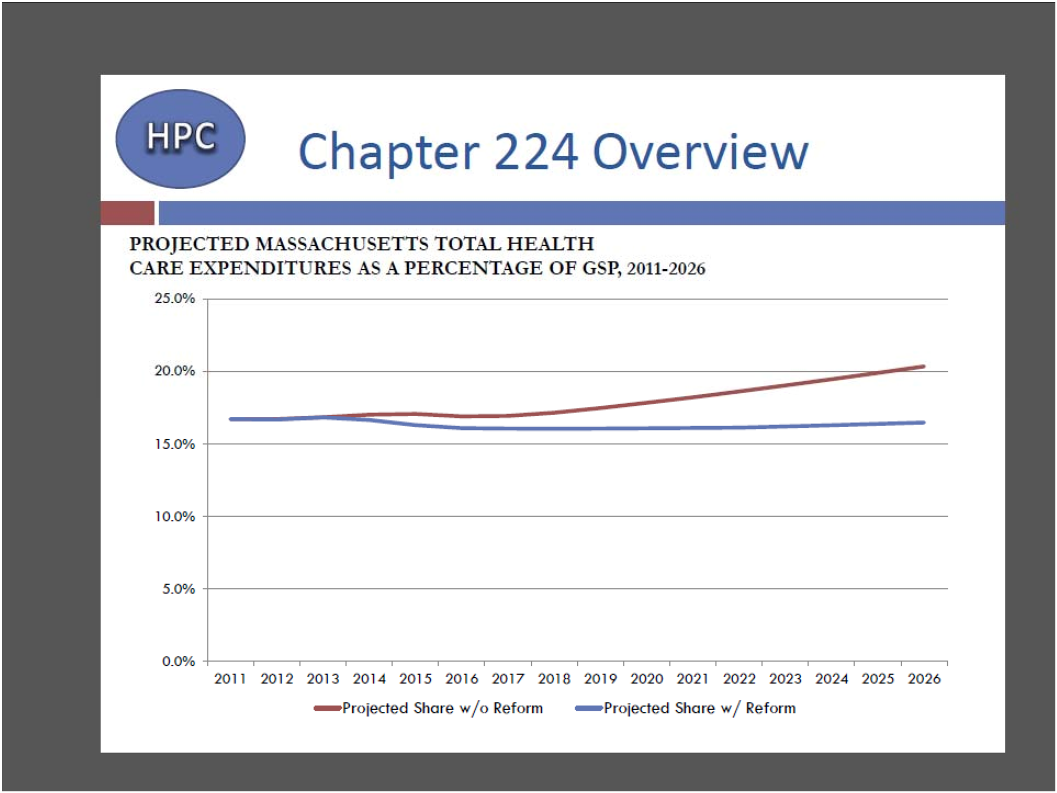

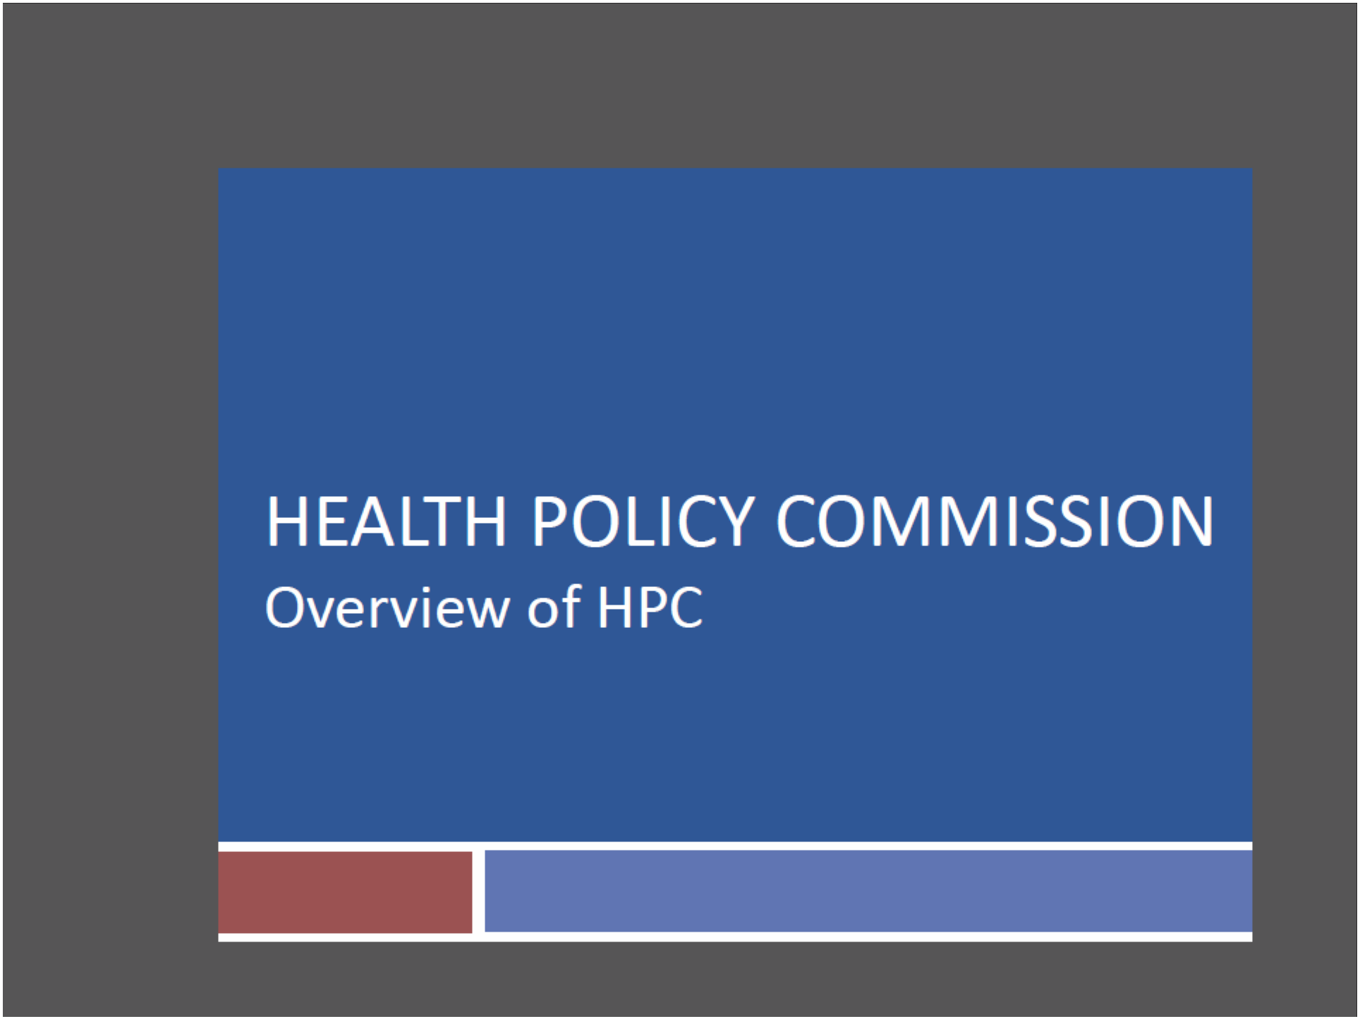

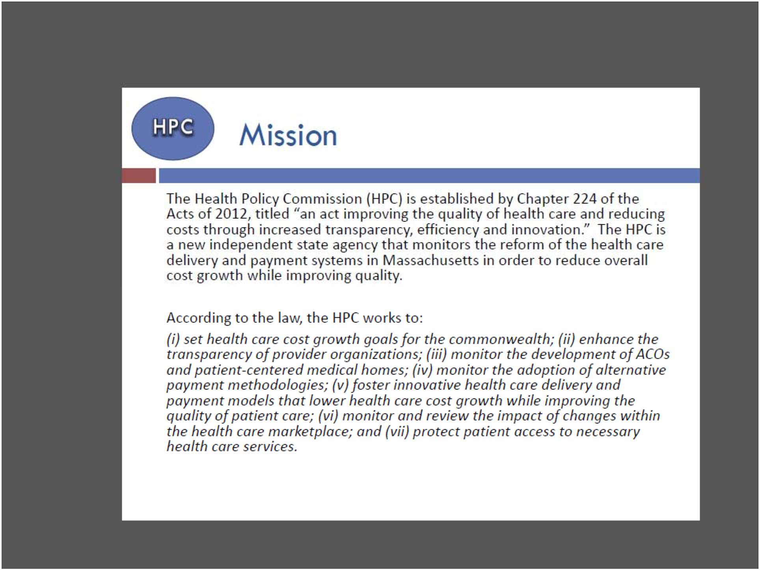

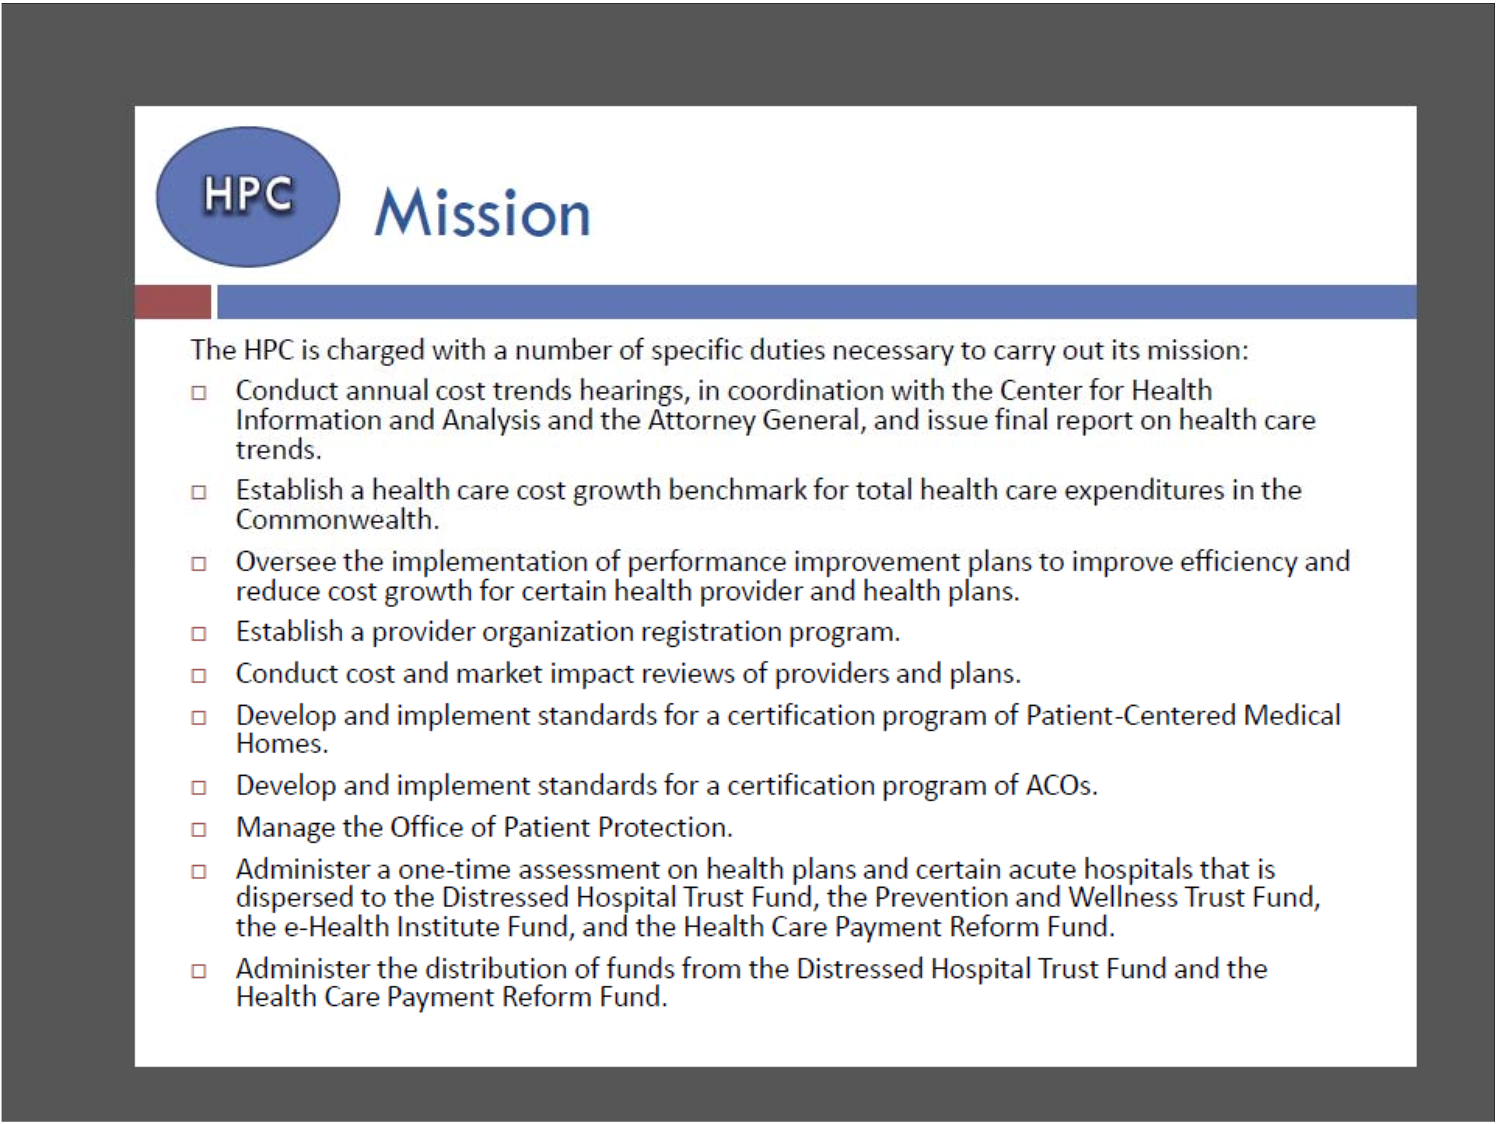

X

X

X

X

A. Distressed Hospital Funding
Distressed Hospital Funding

• Advocate to HPC to create ‘eligibility’ criteria for giving out monies which includes tangible efforts by hospitals to help advance public health efforts consistent with
‘Partnership/Community of Practice’ goals.

• Start with the Community Health Care Investment and Community Involvement Subcommittee—likely chaired by someone you know………..

B. PCMH standards for
Certification
Chapter 224 PCMH related statutory
provisions:
From Chapter 224‐‐The standards developed by the HPC shall be based on the following criteria:
…
(4) ensuring that patient‐centered medical homes develop and maintain appropriate comprehensive care plans for their patients with complex or chronic conditions, including an assessment of health risks and chronic conditions.
(5) such other criteria as the commission deems appropriate.

(j) The HPC shall develop and distribute a directory of key existing referral systems and resources that can assist patients in obtaining housing, food, transportation, child care, elder services, long‐term care services, peer services and other community‐based services. This directory shall be made available to patient‐centered medical homes in order to connect patients to services in their community.

C. ACO Standards for
Certification
Chapter 224 ACO statutory language

The commission may establish additional standards for an ACO. In developing additional standards for ACO certification, the commission shall consider the following goals for ACOs:
…

(3) to ensure patient access to health care services across the care continuum, including, but not limited to, access to: preventive and primary care services
(8) to promote patient‐centeredness by, including, but not limited to, establishing mechanisms to conduct patient outreach and education on the necessity and benefits of care coordination, including group visits and chronic disease self‐management programs…; demonstrating an ability to engage and activate patients at home, through methods such as home visits or telemedicine,
to improve self‐management;
(10) to demonstrate excellence in the area of managing chronic disease and care coordination, as managed by a physician, nurse practitioner, registered nurse, physician assistant or social
worker, and as evidenced by the success of previous or existing care coordination, pay for performance, patient centered medical home, quality improvement or health outcomes improvement initiatives, including, but not limited to, a demonstrated commitment to reducing avoidable hospitalizations, adverse events and unnecessary emergency room visits;
(12) to promote community‐based wellness programs and community health workers, consistent with efforts funded by the department of public health through the Prevention and Wellness Trust Fund established in section 2G of chapter 111 and to promote other activities that
integrate community public health interventions with an emphasis on the social determinants of health and which have been proven to improve health;

D. Provider Performance
Improvement Plans if they fail to
meet the Cost Growth Benchmark
What should be in a plan?

• Goal: To reduce per capita health care revenue growth

• Means: Need to get per capita health care spending lower

Could Mean: Doing the sort of wellness/prevention activities which can (in the shorter term…) reduce the need for acute medical care services??

