How to Renew your Registration with the

Medical Use of Marijuana Program:

Instructions for Patients

Renewing your registration online with the Medical Use of Marijuana Program (“Program”) is the fastest and most convenient way to register to possess marijuana for medical purposes.

If you are unable to renew your registration online, a more lengthy paper registration renewal process is available. Please call 617-660-5370 to request the paper registration renewal packet.

**Registrations expire annually.** You may re-apply for registration on an annual basis, up to 60 days before the date that your registration expires. It is highly recommended that applicants apply for a registration renewal at least 60 days prior to the expiration of their current Program ID card. This will ensure that there is no gap in the applicant’s active status.

**After your health care provider renews your certification**, you may log into the VG (<https://sso.hhs.state.ma.us/>) and renew your registration in the Medical Marijuana (MMJ) Online System by using the same username and password you used during your initial online registration. **Do not create a new account within VG if you already have an existing username. Creating a new account will delay your application processing time.**

# PREPARING FOR REGISTRATION RENEWAL

Before renewing your registration in the MMJ Online System, you will need to gather the following items:

* A copy of a valid form of identification (as explained below), if you have a change in information (e.g. name or address) from your previous registration or an updated form of ID;
* The same username and password used during your initial registration; *and*
* A form of payment, if not applying for a fee waiver.

*Please note, you do not need a new PIN from your health care provider to renew your registration.*

## FORGOTTEN PASSWORD OR USERNAME

**If you forgot your password**, click on the “Forgot Password” link on the Login page and follow the instructions.

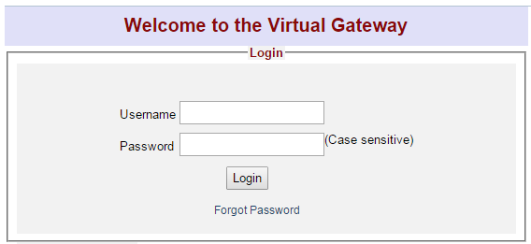

**If you forgot your username**, do not create a new username. You will need to call Virtual Gateway Customer service Monday through Friday (8:30 am – 5:00 pm) at 800-421-0938 (voice) or 617-847-6578 (TTY).

## VALID FORM OF IDENTIFICATION

If there are any changes to your information from your previous registration in regards to your name or address, make sure you provide a current valid form of identification (ID) reflecting these changes.

If there are no changes to your name or address, please skip to the next section.

*Valid forms of ID include:*

* + Massachusetts driver’s license;
  + Massachusetts ID card (with a photograph of yourself);
  + U.S. passport and another document that proves your Massachusetts residency; *or*
  + U.S. military ID andanother document that proves your Massachusetts residency.

**If submitting a driver’s license or Massachusetts ID card:**

If you submit a driver’s license or Massachusetts ID card as your valid form of ID, the name and address on your renewal application form must match the name and address on your driver’s license or Massachusetts ID card. It must be a current driver’s license that is not expired.

For more information on how to update the name and address on your ID, contact the RMV or visit their website at [www.massrmv.com](http://www.massrmv.com).

**If submitting a passport or US military ID:**

If you submit a passport or US military ID as your valid form of ID, please also submit a document that proves that you are a resident of Massachusetts (as outlined below). The name and address on your renewal application form must match the name and address on the document that you submit to prove your Massachusetts residency.

*Submit one of the following to prove your residency:*

* Utility bill (gas, electric, telephone, cable, or heating oil), that is less than 60 days old and must contain your name and address;
* Current Massachusetts motor vehicle registration card with your current address;
* Tuition bill with a due date of less than 6 months ago and addressed to your current address;
* Car insurance policy or bill that is dated less than 60 days old;
* Home mortgage, lease or loan contracts dated within 6 months of today with your name, address and signature;
* Certified U.S. Marriage Certificate dated within the past 6 months;
* Property tax or excise tax bill for the current year with your name and address;
* First-class mail dated less than 60 days old from any federal or state agency that displays your name and address; *or*
* Current Massachusetts-issued Professional License with your address.

## FORM OF PAYMENT

There is a $50 yearly fee to complete the annual registration renewal.

*Acceptable forms of payment include:*

* Credit card;
* Debit card; *or*
* Electronic Funds Transfer (by providing a bank account number and bank routing number).

*Prepaid cards (e.g. Visa gift cards) are not an acceptable form of payment.*

## PROOF OF VERIFIED FINANCIAL HARDSHIP

If you have a verified financial hardship, you may qualify for a waiver of the $50 annual registration renewal fee. You are considered to have a verified financial hardship if you are a current recipient of MassHealth or Supplemental Security Income (SSI), or if your household income does not exceed 300% of the federal poverty level (see table below).

**300% of Federal Poverty Level**

| **Family Size** | **Annual Income** |
| --- | --- |
| 1 | $36,180 |
| 2 | $48,720 |
| 3 | $61,260 |
| 4 | $73,800 |
| 5 | $86,340 |
| 6 | $98,880 |
| 7 | $111,420 |
| 8 | $123,960 |
| Each Additional | $12,540 |

*From the U.S. Department of Health & Human Services2017 Poverty Guidelines*

To apply for a waiver of the registration renewal fee, you must submit proof of verified financial hardship. Only the documents from the list below will be accepted.

*Proof of verified financial hardship includes a* ***copy*** *of one of the following*:

* Official MassHealth acceptance letter for the current year, OR official MassHealth redetermination letter for the current year, OR official MassHealth card;
* Supplemental Security Income (SSI) benefit verification letter for the current year;
  + SSI is not the same program as Social Security
  + SSI is not the same as SSDI (Social Security Disability Insurance)
* Supplemental Nutrition Assistance Program (“SNAP”) statement from the current year; *or*
* Complete State or Federal tax return from this year or last year, including all attachments (all schedules and forms such as Form W-2, Form 1099, etc.).

# PERSONAL CAREGIVER INFORMATION

## You may designate up to two personal caregivers who are not currently designated by another patient, unless that personal caregiver is your immediate family member.

## Please note that you may also select a personal caregiver at any time after renewing your registration by logging in to VG (<https://sso.hhs.state.ma.us/>) and clicking on “My Caregivers” on the top right of your homepage.

## 

You may also designate a caregiver or renew a previous caregiver’s registration during your renewal application by clicking on “My Caregivers” as shown above. Then follow the steps described on the screen.

# OTHER IMPORTANT INFORMATION ABOUT REGISTRATION

## IMPORTANT

Patients must maintain an active certification from their health care provider and an active registration with the Medical Use of Marijuana Program in order to be protected for medical use of marijuana under Massachusetts Law.

## PROGRAM ID CARD

You must carry your Program ID Card **at all times** while you are in possession of marijuana for medical use.

Program ID Cards are issued every three (3) years. However, you are required to renew your registration with the program every year in order to remain active.

Notify the Medical Use of Marijuana Program within **five business days** after discovering that your Program ID Card is lost, stolen, or destroyed by calling 617-660-5370.

There is a $10 fee to replace a Program ID Card.

## VALID FORM OF IDENTIFICATION

After renewing your registration with the Program, your current valid form of ID on file with the Medical Use of Marijuana Program must remain active and not expired in order to access a Registered Marijuana Dispensary (RMD) or obtain marijuana for medical use from an RMD.

For more information on how to renew your Massachusetts driver’s license or state ID, contact the RMV, or visit their website at [www.massrmv.com](http://www.massrmv.com).

## CHANGE OF INFORMATION

If, at any time, there is any change to the information you submitted for registration (such as a change in your name, address, email, or phone number), you must update this information in the MMJ Online System within five business days of the change.

*To update your registration information, please follow these steps:*

* **Step 1:** Log in to the VG at <https://sso.hhs.state.ma.us> and select “Medical Use of Marijuana System.”
* **Step 2:**  Click on the “My Registration” link at the top of the screen.
* **Step 3:** To update your information, click “Edit” at the left side of the screen. Edit the necessary information and click the “Update” button.

## ACCESSING A REGISTERED MARIJUANA DISPENSARY

In order to access a Registered Marijuana Dispensary (RMD), or obtain marijuana for medical use from an RMD, an adult patient must:

* Present their Program ID Card and their valid form of ID;
* Have an active certification from their health care provider;
* Have an active registration with the Medical Use of Marijuana Program; *and*
* Maintain on file with the Program a valid form of ID that is active and not expired.

## QUESTIONS

Should you have questions regarding the registration renewal process, please contact the Medical Use of Marijuana Program at 617-660-5370.

*The following pages provide detailed step-by-step instructions on how to register with the Program using the MMJ Online System.*

Step-By-Step Registration Renewal Instructions

**STEP 1:** Scan and save on to your computer:

* A copy of a valid form of identification (as explained below), if you have a change in information (e.g. name or address) from your previous registration or an updated form of ID.
  + If you have written your new address on the back of your MA driver’s license, be sure to copy the front *and* back of the card.

If you are applying for a registration fee waiver, scan and save the proof of verified financial hardship onto your computer. These documents will be uploaded to the MMJ Online System during the registration renewal process.

* If uploading a US military ID, scan and upload the front *and* the back of the card. Be sure to have the copy of the front and back of the card saved on one file.

**STEP 2:** Enter your user name and password, and click “Login” to enter Virtual Gateway.

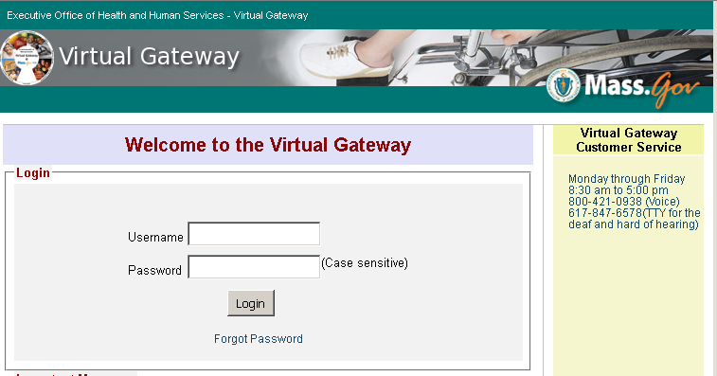

**STEP 3:** Click on the link for the “Medical Use of Marijuana System”.

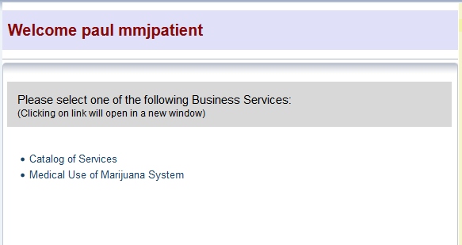

**STEP 4:** If it is within 60 days of your registration’s expiration date you will see a “Renew Registration” link near the bottom of the page. Click this link to begin the registration renewal process.

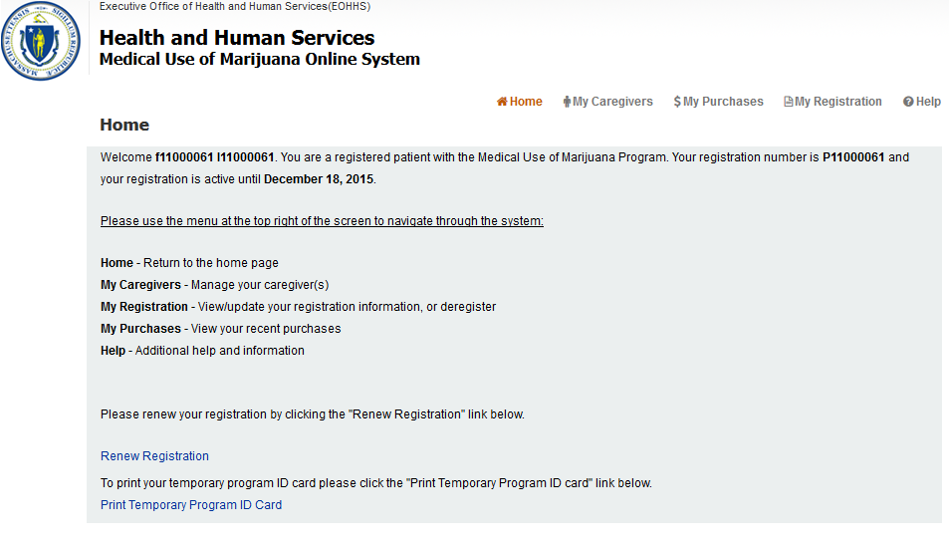

When you are signed in to the MMJ Online System, you may use the “Help” link in the top right corner for further detailed instructions.

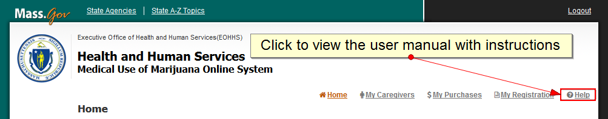

**STEP 5:** Proceed through the registration renewal application following the instructions provided on the screen. The registration renewal application will be prepopulated with the information from your existing patient record.

**STEP 6:** Form of Payment

* There is a $50 fee to complete a patient’s registration renewal
* *Acceptable forms of payment include:*
  + Credit card;
  + Debit card; *or*
  + Bank account number and bank routing number (This can be found on your check as shown below.)

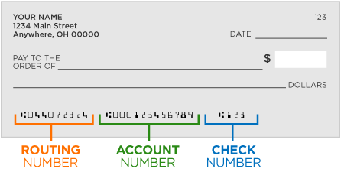

*Prepaid cards (e.g. Visa gift cards) are not an acceptable form of payment.*

**Fee waiver:** If you have a verified financial hardship, you may be qualified for a registration fee waiver. You are considered to have a verified financial hardship if you are a current recipient of MassHealth, or Supplemental Security Income (SSI), or your income does not exceed 300% of the federal poverty level. In order to apply for a registration fee waiver, you must submit proof of verified financial hardship. Only the documents from the list below will be accepted.

*Proof of verified financial hardship includes a copy of one of the following:*

* Official MassHealth acceptance letter for the current year, or official MassHealth redetermination letter for the current year;
* Supplemental Security Income (SSI) benefit verification letter for the current year;
  + SSI is not the same program as Social Security
  + SSI is not the same as SSDI (Social Security Disability Insurance)
* Supplemental Nutrition Assistance Program (“SNAP”) statement from the current year; *or*
* Complete State or Federal tax return from this year or last year, including all attachments (all schedules and forms such as Form W-2, Form 1099, etc.).

To apply for a fee waiver check the “Apply for Registration Fee Waiver” box, and then click the “Proceed” button.

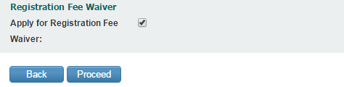

You will be taken to the “Fee Waiver Application” page, which will ask a series of questions. Answer the questions and upload the requested documents. Once this information is submitted, the information will be reviewed by the Program to determine your eligibility for a registration fee waiver. *Please note this request may take several weeks to process.*

**STEP 7:** Once you have completed your payment or submitted your proof of financial hardship, you will then be brought to the “Review and Submit Renewal” page to review and confirm your registration information.

* If you need to correct any information, you may click the associated field on the right side of the screen and edit your information, or you may click the “Back” button until you reach the correct screen and edit your information.
* After you have verified that the information is correct, click the “Proceed” button until you return to the Review and Submit Application screen.
* Once you have verified that the information is correct, click on the “Submit” button.

**STEP 8:** You will then be taken to the Home screen with a message stating that you have submitted an application. Your application will then be reviewed by the Program.