Water Damage Investigation

Pawtucketville Memorial Elementary School
425 West Meadow Road
Lowell, Massachusetts

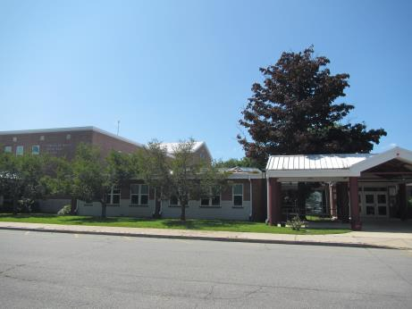

Prepared by:
Massachusetts Department of Public Health
Bureau of Environmental Health
Indoor Air Quality Program
August 2018

Background
Building: | Pawtucketville Memorial Elementary School (PMES)
Address: | 425 Meadow Road, Lowell
Assessment Requested by: | Rick Underwood, Director of Operations,  Lowell Public Schools
Reason for Request: | Water damage/mold concerns on ceiling tiles/items in particular classrooms (1022, Kitchen, 1072, 1068, 1066, 1078, 1108, 1041, and some second floor classrooms); several other classrooms were also observed for comparison.
Date of Assessment: | August 23, 2018
Massachusetts Department of Public Health/Bureau of Environmental Health (MDPH/BEH) Staff Conducting Assessment: | Jason Dustin, Environmental Analyst/Inspector, IAQ Program
Building Description: | The PMES is a two-story brick structure reportedly built in the 1960’s and extensively renovated in 2000-2002.
Windows: | Openable

Methods
BEH/IAQ staff conducted a visual assessment of suspect classroom items for water damage and possible mold colonization. Please refer to the IAQ Manual and appendices for methods, sampling procedures, and interpretation of results (MDPH, 2015).

Results and Discussion
A heating, ventilating, and air conditioning (HVAC) system has several functions. First it provides heating and, if equipped, cooling. Second, it is a source of fresh air. Finally, an HVAC system will dilute and remove normally occurring indoor environmental pollutants by not only introducing fresh air, but also filtering the airstream and ejecting stale air to the outdoors via exhaust ventilation. The act of cooling/providing air conditioning is two-fold; the system chills the air via cooling coils while also typically removing moisture from the air.
Moisture removal is important since the sensation of heat conditions increases as relative humidity (RH) increases (the relationship between temperature and RH is called the heat index). As indoor temperatures rise, the addition of more RH will make occupants feel hotter. If moisture is removed, the comfort of the individuals is improved.
While temperature is mainly a comfort issue, RH in excess of 70 percent for extended periods of time can provide an environment for mold and fungal growth (ASHRAE, 1989).Visual inspection of classrooms indicates that elevated indoor RH levels experienced over the summer have resulted in some ceiling tiles, fabric chairs, and area rugs becoming moistened, which has led to mold growth. In addition, condensation moistening dust and debris collected on non-porous surfaces, including metal air diffusers, nonporous pipe insulation connectors, and concrete block (e.g., kitchen wall) can become a source of mold growth.

- Office 1022: One ceiling tile was reported to have visible mold growth; this tile had already been discarded at the time of the assessment, however, there appeared to be some spots of colonization on the rigid pipe insulation above this area likely on dust/debris on the insulation (Picture 1).
- Kitchen: One small area of a concrete block wall appeared to be colonized with visible mold growth on dust/debris (Picture 2). This area is nonporous and will reportedly be cleaned with a mild detergent.
- Classroom 1072: No visible mold was observed on porous surfaces. Occupants had concerns relative to dust/debris on the surface of the metal ceiling panels. This surface is non-porous and had reportedly already been cleaned prior to the assessment. The same condition was observed in a number of rooms with similar metal ceiling panels. Moisture meter measurements showed that an area rug was still moist, likely from condensation due to chilling from the concrete slab foundation.
- Classroom 1068: Dust/debris accumulation on the metal ceiling panels was observed in a small area (Picture 3). At the time of assessment it was recommended that this debris be thoroughly cleaned with a mild detergent since in the presence of chronic moisture it can be a medium for mold growth. The area carpet in this room did not show any signs of water damage and the moisture meter indicated it was dry.
- Classroom 1066: This room had similar debris accumulation on small areas of the metal ceiling panels (Picture 4) and should be cleaned with a mild detergent. The area carpet in this room tested positive for moisture at the time of the assessment.
- Classroom 1078: Dust/debris was noted on the metal ceiling panels in some small areas of this classroom as well. These areas should also be cleaned thoroughly with a mild detergent The area carpet in this room did not show any signs of water damage and the moisture meter indicated it was dry.
- Room 1108: This room had two water-damaged ceiling tiles, most likely from condensation in cooling lines above. Facilities staff reported that the tiles are to be removed and the area above will be inspected to ensure adequate insulation around the lines. There have been reports of an episodic odor reported as “like a dead animal” prior to the water damage. In the hallway just outside this room, PMES and BEH staff noted an area of chronic water damage and mold colonization on the cooling line insulation (Picture 5). This area also had a foul odor.
- Room 1041: This area had several bowed ceiling tiles and one ceiling tile that appeared to be mold-colonized (Pictures 6 and 7).
- Second floor areas: Numerous bowed ceiling tiles were observed in these areas. There appeared to be some active roof leaks as well as some leaks due to the recent condensation event. Mold-colonized ceiling tiles (Picture 8) were observed and were planned to be discarded prior to the opening of school.

The US Environmental Protection Agency (US EPA) and the American Conference of Governmental Industrial Hygienists (ACGIH) recommends that porous materials (e.g., ceiling tiles, carpeting) be dried with fans and heating within 24 to 48 hours of becoming wet (US EPA, 2008; ACGIH, 1989). If porous materials are not dried within this time frame, mold growth may occur. If porous materials become mold-colonized they should be discarded as they cannot be effectively cleaned.
Symptoms commonly associated with molds include allergic reactions and respiratory irritation. Some people with chronic respiratory conditions, such as asthma, are more likely to experience health symptoms. Controlling moisture is the key to preventing mold growth and potential health symptoms.

Other Conditions
Other conditions that can affect IAQ were observed during the assessment. Some areas have area rugs. The Institute of Inspection, Cleaning, and Restoration Certification (IICRC) recommends that carpeting be cleaned annually (or semi-annually in soiled high traffic areas) (IICRC, 2012). Regular cleaning with a high efficiency particulate air (HEPA) filtered vacuum in combination with an annual cleaning will help to reduce accumulation and potential aerosolization of materials from carpeting.
Floor temperatures were taken with an infrared thermometer; all were between 75°F and 76°F. These temperatures were well above the dew point temperature of 60°F which will prevent any further condensation barring another extreme weather event.

Conclusions and Recommendations
In view of the findings at the time of the visit, the following recommendations are made:
- Continue to discard any remaining porous items found to be colonized with mold (e.g., ceiling tiles, seat cushions, area rugs).
- Clean metal ceiling panels of accumulated dust/debris. As previously mentioned, dust/debris can serve as a medium for mold colonization even on nonporous surfaces.
- Clean supply and exhaust/return vents of accumulated debris regularly.
- Change all water-damaged ceiling tiles even if they are not colonized with mold. Monitor these areas for continued leaks and make repairs as necessary.
- Discard area rugs found to be still moist during this assessment (classrooms 1072, 1066) and any other area rugs which are moist or water-damaged.
- Consider using dehumidifiers in areas prone to excessive moisture/condensation especially during forecasted extended high humidity weather events. Ensure dehumidifiers are monitored and maintained to prevent stagnant water and odors.
- Ensure that procedures are in place and encourage occupants to report HVAC/maintenance issues so that they can be logged and repaired promptly.
- Clean other nonporous surfaces with accumulated debris/mold (e.g., kitchen concrete wall and cooling line insulation connectors).
- Inspect the water-damaged cooling line insulation closely. If colonization appears to be on the surface then these areas may be cleaned with mild detergent. If the colonization has penetrated the nonporous coating and entered into the fabric wrapping or insulation, then the insulation would need to be cut out, discarded and replaced with new insulation
- Remove the mold-colonized cooling line insulation outside of room 1108, thoroughly clean the area and inspect for further sources/pathways for odors. Replace the discarded insulation with new materials.
- Clean carpeting and area rugs annually or semi-annually in soiled high traffic areas as per the recommendations of the Institute of Inspection, Cleaning and Restoration Certification (IICRC, 2012).
- For more information about mold/remediation consult Mold Remediation in Schools and Commercial Buildings” published by the US Environmental Protection Agency (US EPA, 2008).
- Refer to resource manual and other related indoor air quality documents located on the MDPH’s website for further building-wide evaluations and advice on maintaining public buildings. These documents are available at http://mass.gov/dph/iaq.

REFERENCES
ACGIH. 1989. Guidelines for the Assessment of Bioaerosols in the Indoor Environment. American Conference of Governmental Industrial Hygienists, Cincinnati, OH.
ASHRAE. 1989. Ventilation for Acceptable Indoor Air Quality. American Society of Heating, Refrigeration and Air Conditioning Engineers. ANSI/ASHRAE 62-1989.
IICRC. 2012. Carpet Cleaning FAQ 4 Institute of Inspection, Cleaning and Restoration Certification. Institute of Inspection Cleaning and Restoration, Vancouver, WA.
MDPH. 2015. Massachusetts Department of Public Health. Indoor Air Quality Manual: Chapters I-III. Available at: http://www.mass.gov/eohhs/gov/departments/dph/programs/environmental-health/exposure-topics/iaq/iaq-manual/.
US EPA. 2008. Mold Remediation in Schools and Commercial Buildings. US Environmental Protection Agency, Office of Air and Radiation, Indoor Environments Division, Washington, D.C. EPA 402-K-01-001. http://www.epa.gov/mold/mold-remediation-schools-and-commercial-buildings-guide.

Picture 1
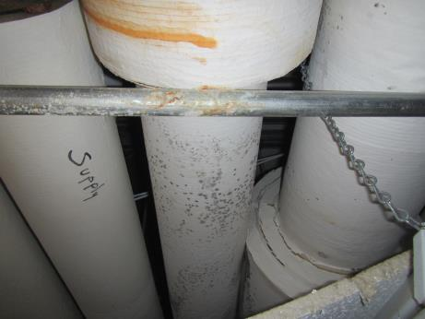
Spots of apparent mold colonization on outside surface of cooling line insulation
Picture 2
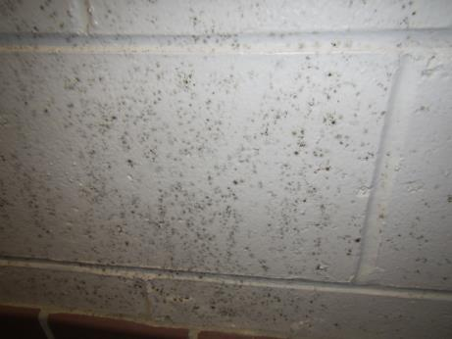
Mold growth on surface debris of concrete block in kitchen
Picture 3
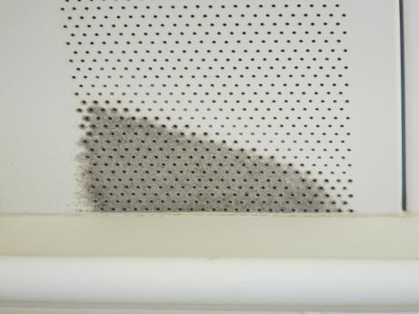
Small area of debris on metal ceiling panel
Picture 4
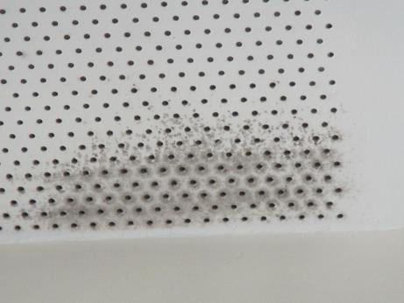
Small area of debris on metal ceiling
Picture 5
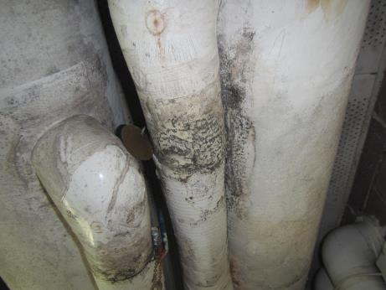
Mold-colonized cooling line insulation outside of room 1108
Picture 6
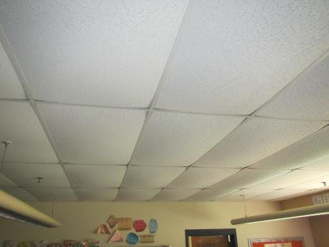
Bowed ceiling tiles
Picture 7
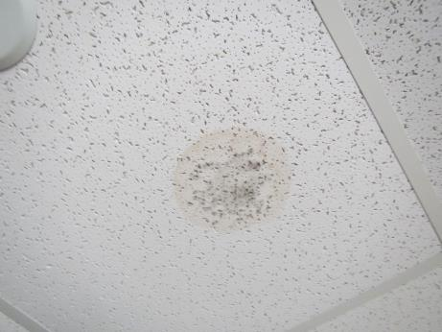
Small area of likely mold colonization on ceiling tile
Picture 8
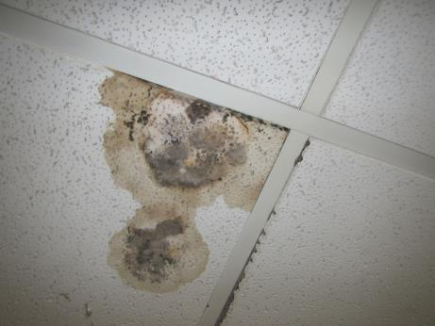
Mold-colonized ceiling tile in second floor area

