INDOOR AIR QUALITY ASSESSMENT

Pawtucketville Memorial Elementary School
425 West Meadow Road
Lowell, MA

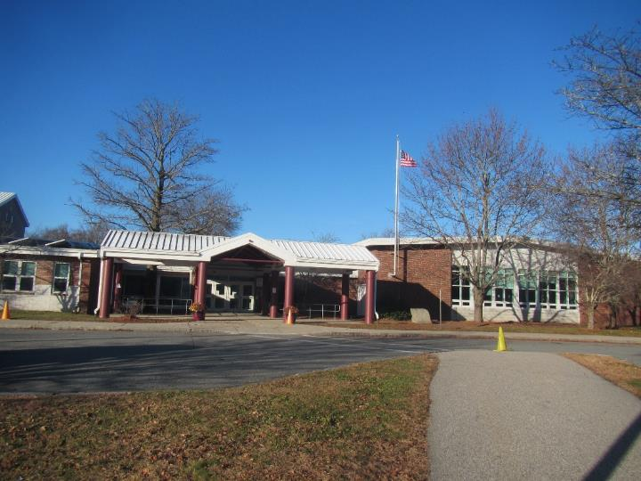

Prepared by:
Massachusetts Department of Public Health
Bureau of Climate and Environmental Health
Indoor Air Quality Program
December 2023

EXECUTIVE SUMMARY
The Pawtucketville Memorial Elementary School has had chronic issues with water damage that has led to mold growth on building materials. This led to a delayed opening so the school could be cleaned by a professional restoration/cleaning contractor. These conditions appear to have to have been brought on this past summer by a combination of: lack of heating, ventilation, and air conditioning (HVAC) system controls, due to a cyberattack of the City of Lowell’s computer systems (https://www.cbsnews.com/boston/news/cyberattack-lowell-city-government/), building materials that are prone to condensation (i.e., metal ceiling panels, cinderblock walls, and tile floors), and one of the wettest seasons on record (BG, 2023) where many buildings throughout the Commonwealth and the New England region experienced similar issues with mold growth. It is also important to note that most of the HVAC equipment that supplies fresh air and air conditioning dates back to the late 1990’s/early 2000’s (> 20 years old), which is towards the end of its service life.
At the time of assessment, several plans were in place to investigate and prevent this occurrence from happening again, these include:
- A plan to repair/replace all rooftop exhaust vents,
- A vote by the Lowell School Committee to conduct monthly mold testing by an environmental consultant,
- The employment of a professional cleaning/restoration firm to conduct remediation as needed,
- Training of school and city maintenance staff in mold remediation,
- The use of pleated filters in classroom univents to filter out pollen and mold spores (discussed further in the report,) supplemented by portable air purifying units and dehumidifiers in classrooms,
- Ongoing replacement of automated building management systems to control HVAC components,
- The hiring of a Building Forensic Firm to evaluate plans, roofs, and building systems/materials, and
- Capital plans for full replacement of the chronically leaking gymnasium roof.
As climate change and global warming intensifies, the urgent need for modern, energy-efficient solutions becomes clear. Without significant upgrade of HVAC controls, technology, and other interior components, building conditions and indoor air quality will continue to degrade.
Please note: this report contains a series of recommendations that should serve as Best Practices that apply to most public school buildings across the Commonwealth, and should be shared amongst other buildings in the Lowell School District.

BACKGROUND
Building: | Pawtucketville Memorial Elementary School (PMES)
Address: | 425 West Meadow Road, Lowell
Assessment Requested by: | Dr. Jim Hall, Esq., Chief Operating Officer, Lowell Public Schools
Reason for Request: | General Indoor Air Quality (IAQ) assessment following occupant concerns from water damage and mold growth
Dates of Assessment: | November 28, 2023
Massachusetts Department of Public Health/Bureau of Climate and Environmental Health (MDPH/BCEH) Staff Conducting Assessment: | Cory Holmes, Assistant Director, IAQ Program, and Ruth Alfasso, Environmental Engineer/Inspector, IAQ Program
Building Description: | The PMES is a brick and metal school building originally constructed in the 1960s with an addition and significant renovations in the late 1990s/early 2000s. The building has both flat and peaked metal roof segments, some skylights, and other architectural features. The design of the school includes an interior courtyard. The school contains classrooms, offices, and accessory areas like a gym, library and cafetorium.
Building Population: | Approximately 460-465 students in grade pre-K through 4, with 90-95 staff members
Windows: | Windows are openable in most areas of the school

METHODS
Please refer to the IAQ Manual for methods, sampling procedures, and interpretation of results (MDPH, 2015). Note that this building was visited for a water damage assessment in August of 2018 and the report from that visit can be downloaded from: https://www.mass.gov/info-details/indoor-air-quality-reports-cities-and-towns-l#lowell-.

RESULTS AND DISCUSSION
The following is a summary of testing results (Table 1).
- Carbon dioxide was above the MDPH guideline of 800 parts per million (ppm) in about half of the areas visited, indicating that many occupied classrooms were in need of more fresh air. As discussed, the new rooftop exhaust vents were being brought online and the HVAC controls were being restored at the time of assessment, which should both facilitate air exchange.
- Temperature ranged from below to above the recommended comfort range of 70°F to 78°F. Many occupants complained of temperature issues, both too cold or too hot. In particular, rooms 1024 and 1108 ranged from 80°F to 86°F and reported chronic heat conditions.
- Relative humidity measurements were all below the recommended range of 40% to 60% in the areas assessed. This is typical of the heating season in New England.
- Carbon monoxide levels were non-detectable (ND) in all areas assessed.
- Fine particulate matter (PM2.5) concentrations were below the National Ambient Air Quality Standard (NAAQS) level of 35 μg/m³.

Ventilation
A Heating, Ventilation, and Air Conditioning (HVAC) system has several functions. First it provides heating and, if equipped, cooling. Second, it is a source of fresh air. Finally, an HVAC system will dilute and remove normally-occurring indoor environmental pollutants by not only introducing fresh air, but by filtering the airstream and ejecting stale air to the outdoors via exhaust ventilation.
Work was being performed on control systems for the HVAC system before and during the assessment. As previously noted, control systems had been offline due to a cyber-attack in the spring, and contractors were on site to reconnect and reconfigure the systems and improve control of ventilation and temperature in the school. The work on these systems may have impacted conditions noted during the assessment.
Fresh air in many classrooms is supplied by unit ventilators (univents, Picture 1). Univents draw air from the outdoors through a fresh air intake located on the exterior wall of the building (Picture 2) and return air through an air intake located at the base of the unit. Fresh and return air are mixed, filtered, heated or cooled and provided to rooms through an air diffuser located in the top of the unit (Figure 1). In some classrooms, univents were blocked with items or furniture on top or in front (Picture 3). This limits the amount of fresh air that can be circulated into the room. The area on top and in front of univents should be kept free of obstructions. Many univents were not operating at the time of the assessment. While some of these may have been due to the control system work noted above, teachers in some areas reported that they deactivated univents due to temperature issues (e.g., blowing excessively hot or cold air). The occupant in room 1038 reported that the univent was inoperable, but on a repair list for later that day.
Fresh air for some classrooms and common areas is provided by air handling units (AHU) through ducted supply vents in ceilings (Picture 4). The AHUs are located on the roof of the building. Many of these had control issues as well as evidenced by interior rooms 1024 and 1108 which had temperatures from 80°F to 86°F (Table 1).
Mechanical exhaust ventilation in most classrooms is provided by either wall-mounted (Picture 5) or ceiling-mounted (Picture 6) exhaust vents, connected to rooftop motors. Due to the location of these vents, most of them could not be accessed during the assessment to check airflow. As previously noted, work on all the exhaust motors was being completed and brought online at the time of assessment. Classroom, as well as restroom exhaust vents should be checked for draw on a regular basis and repaired as needed. In some rooms served by rooftop AHUs, all vents appeared to be the same type, with the design of a multi-directional/louvered supply vent similar to Picture 4, so it was not possible to determine if these rooms had both supply and return/exhaust ventilation.
In many rooms, the exhaust vent is located near the classroom door (Picture 7). When the door is open, the vent may draw air from the hallway into the classroom rather than removing stale air from the room. For better operation in these rooms, classroom doors should be closed.
It is also important to note that despite ongoing maintenance and replacement of parts/components by PMES facilities staff and contractors, many of the HVAC units are at the end of their life cycle. According to the American Society of Heating, Refrigeration, and Air-Conditioning Engineering (ASHRAE), the service life of this type of unit is 15-20 years, assuming routine maintenance of the equipment (ASHRAE, 1991).

The MDPH IAQ Program recommends that supply and exhaust ventilation operate continuously during occupied periods to provide air exchange and filtration. Without sufficient supply and exhaust ventilation, normally occurring environmental pollutants can build up and lead to indoor air quality/comfort complaints. To have proper ventilation with a mechanical ventilation system, the systems must be balanced after installation to provide an adequate amount of fresh air to the interior of a room while removing stale air from the room. It is recommended that HVAC systems be re-balanced every five years to ensure adequate air systems function (SMACNA, 1994).
Facility staff report that univents and AHUs in the PMES were originally equipped to supply chilled air during the warmer months. This is further indicated by the presence of condensation drains outside each univent air intake, as shown in Picture 2. However, it was unclear if the air conditioning components were fully operational. In this situation, univents operating during warm weather directly introduce unconditioned outdoor air into classrooms. A univent was opened in one classroom, and corrosion was noted on components inside (Picture 8). This indicates chronic exposure to moisture or water vapor as may occur during operations in cooling mode with ineffective condensation drainage. If corrosion gets bad enough, it may impair the functioning of the univent, and repairs should be made to the greatest extent possible. This material is not, however, mold.
The filters inside univents reportedly have a minimum efficiency rating value (MERV rating) of 8 and are reportedly changed multiple times a year. The MDPH/IAQ Program recommends a minimum of a MERV 8 filter, which is adequate to filter out pollen and mold spores (ASHRAE, 2012), and that schools use the highest MERV rating filters that can operate properly with the existing equipment. Facility staff report that due to age and design of the HVAC equipment, filters higher than a MERV 8 would not allow equipment to operate properly and would limit fresh air supply.
Many classrooms were equipped with window-mounted air conditioners (Picture 2), and ducting for portable air conditioners was also noted in some rooms (Table 1). Window-mounted and portable air conditioners need to be cleaned periodically, including any dust filters, and should be mounted/places so that any condensation can be properly drained.

The PMES has openable windows in most classrooms and offices which can be an additional source of fresh air. Windows should not be opened when air conditioning is operating to prevent condensation, or extreme cold to prevent freezing of pipes, both of which can lead to water damage and mold growth.

Microbial/Moisture Concerns

Extreme weather conditions
Hot humid summers are becoming more frequent due to climate change. Massachusetts has experienced hot, humid, and rainy summers in 2018, 2021, and 2023. Extended periods of hot, humid weather were experienced in the summer of 2021. July of 2021 was the wettest ever recorded in Massachusetts, and the three-month period from June through August, known as the meteorological summer, was the fourth wettest on record, according to the National Oceanic and Atmospheric Administration’s (NOAA) Centers for Environmental Information (HG, 2021, NOAA, 2021). The summer of 2023 was also hot, and wet, being measured as the second rainiest on record (BG, 2023). These conditions are challenging for buildings, particularly those without air conditioning (or lacking proper controls).

During the summers of 2018, 2021 and 2023, extended periods of outdoor relative humidity above 70% occurred. Under these weather periods, public buildings experienced extended periods of water vapor exposure from high relative humidity. When exposed to these conditions, porous materials such as gypsum wallboard, cardboard, and other materials may become prone to developing mold colonization, particularly if located in areas that are prone to developing condensation on floors and walls (e.g., below grade space). According to the American Society of Heating, Refrigerating and Air-Conditioning Engineers (ASHRAE); if relative humidity exceeds 70%, mold growth may occur due to wetting of building materials (ASHRAE, 2022) even in the absence of liquid water.

Water-damaged ceiling tiles and roof leaks

Multiple classrooms and offices had water-damaged ceiling tiles (Table 1, Pictures 9 through 11). Water-damaged ceiling tiles indicate a leak from the roof, or from plumbing or HVAC equipment. The building is known to have some roof leaks, particularly at joints in the metal roofing. Chronic roof leaks were reported in the gym, where they are collected by buckets and other receptacles. However, the gym roof and beams are metal, the walls are cinder block (Picture 12), and the floor is rubber, which are materials not conducive to mold growth. As previously stated, roof evaluation and repair projects are currently in the planning process. In addition, it was reported by Department of Public Works Director, Paul Cyr, that the gym roof is slated for replacement on a forthcoming capital repair project.

Water-damaged ceiling tiles should be changed when they are found. This both prevents any chronically-moistened tiles from becoming a source of mold, but allows for detection of new or repeated leaks. The area above and around water-damaged ceiling tiles should be inspected for additional water damage and cleaned/remediated as needed. In areas where there are frequent roof leaks that are waiting to be addressed, affected ceiling tiles can be replaced with plastic units that sit in the ceiling tile system and funnel water to a collection vessel. This prevents ceiling tiles from getting moistened and prevents potential slippery conditions due to wet floors. Collection vessels need to be emptied as needed and kept clean.

Water-damaged ceiling tiles were noted in room 1084, upon removal of the ceiling tiles visible mold was observed on the metal ceiling above (Picture 13). It was recommended at the time of discovery that the school’s professional cleaning/restoration contractor clean this area as soon as practicable.
Ceiling tiles were removed in classroom 1045 to observe conditions in the ceiling plenum. Spotting, indicating light mold growth was noted on the surface of pipe insulation (Picture 14). This should also be addressed by the school’s professional cleaning/restoration contractor as a temporary measure by:
- Vacuuming surface mold using a high efficiency particulate arrestance (HEPA) filter equipped vacuum cleaner,
- Sealing affected area using a anti-microbial spray/sealant,
- Periodic monitoring to determine if remediation measures were effective.

These conditions indicate that this space has been subject to chronic high humidity or moistening. As discussed at the time these conditions were found, the metal ceiling can be cleaned to remove mold, while the insulation may ultimately need to be replaced with a non-porous insulation material if remediation measures are not effective.

Building materials subject to excess humidity

In many classrooms and hallways, ceiling tiles were sagging slightly or bowed in the tile grid (Picture 6; Table 1). As ceiling tiles become moistened by high relative humidity, the wetting can cause ceiling tiles to distend (bow) while sitting in the suspended ceiling rails. While unstained, bowed tiles are not a source of mold, this is an indication that high relative humidity has occurred for a significant period. Therefore, other materials that remain in classrooms during hot humid weather, particularly when the school is unoccupied, may be subject to moistening and water damage. This includes carpeting/area rugs, furniture, and stored items such as boxes, paper, and clothing. As noted above, water-damaged and bowed ceiling tiles should be used as a guide for looking for additional water damage in the ceiling plenum.

Occupants also report that mold had grown on other surfaces over the previous years, particularly at the end of summer. This indicates that conditions reoccur where hot, humid air meets porous materials and a temperature gradient. This school may be vulnerable to these conditions for the following reasons:
- Exterior drainage issues and other building envelope issues, discussed in the next section (“Building Exterior”).
- Condensation on surfaces that are cooler than the ambient temperature in the room. This may include floors in contact with the ground, exterior walls in the shade, and building components chilled by air conditioning.
- A lack of exhaust ventilation, allowing humidity to build up.
- Activities in classrooms that may increase humidity.
- A lack of airflow to dry surfaces that have been exposed to humidity. This is a common issue in closets and behind furniture. Covering walls with impermeable posters also increases the chance of mold growth.
- A buildup of dust and debris on surfaces. Mold can only grow on porous materials that contain organic matter. Solid and inorganic surfaces such as metal, hard plastic, solid wood, floor tile, and brick do not provide a substrate for mold to grow, but mold can colonize the material in a layer of dust on surfaces that may be nearly invisible to the eye.
- Also note that if the building was designed to use air conditioning, and the air conditioning is currently not functioning, the lack of dehumidification that comes with use of air conditioning may be worsening the problem.

A key concept in dealing with condensation-related water damage is that of “dew point.” The dew point temperature is the temperature at which air with a given amount of water becomes saturated with water and water begins to condense out as a liquid. For example, at 75°F and 70% relative humidity, the dew point temperature would be 64°F. That means that any surface at or below that temperature in contact with that air will start to generate condensation. In very humid conditions, surfaces do not have to be cooled much below ambient temperature to go below the dew point. Dehumidification, either through air conditioning or through stand-alone dehumidifiers, can reduce the chances of condensation. Monitoring areas of the building that may be colder than the rest of the room (e.g., floors, exterior walls in shade, and chilled plumbing and HVAC components) can lead to discovery of the areas that are most likely to be a problem during humid weather.

Building exterior
IAQ staff examined the building envelope to identify possible sources of water outside, breaches, and/or other conditions that could provide a source of moisture that can adversely affect indoor air quality.
Plants were observed in contact with and near the foundation. Plants near the building can cause water damage to brickwork and mortar. In addition, plants shading exterior walls can slow drying. Water can eventually penetrate the brick, subsequently freezing and thawing during the winter. This freezing/thawing action can weaken and damage bricks and mortar. Plants near air intakes (Picture 15) can also be a source of pollen, moisture, and odors to the interior.
There are also large trees near the building, including in a courtyard (Picture 16). The presence of large trees is likely enhancing water retention and affecting drainage as well as overhanging the roof. These trees pose several hazards:
- Leaves and other debris accumulate around roof drains, which inhibits rainwater drainage from the roof. Ineffective drains can lead to water running off the roof to moisten exterior walls.
- Trees prevent sunlight from drying walls.
- The trees are a possible danger due to the distance from exterior walls:
  - The recommended safe distance that any tree should be planted is the minimum of the expected maximum growth height of the species from the exterior of a building (BI, 2015).
- Soil subsidence may also be caused by tree roots, which can undermine the structure of a building to cause wall and floor cracking and related damage. To prevent subsidence, a sufficient distance appropriate for the tree species is recommended (Williams, 2006).
- Severe weather may result in the tree falling onto the building or the tree roots damaging the foundation.
- The Department of Homeland Security’s (DHS’s) READY.GOV website provides several recommendations in order to prepare for severe thunderstorms. Of note DHS recommends “Cut down or trim trees that may be in danger of falling on your [building]” (DHS, 2023). Given the proximity to exterior walls, removal of trees from the exterior of the building including the courtyard should be strongly considered.

Downspouts were damaged or missing in some areas (Picture 17). This will allow water from the roof to drain onto the building exterior or the ground at the foundation. Excess water may damage the building envelope or penetrate the exterior of the building. Buildings of this type are typically constructed in layers, with a drainage plane inside to direct water to weep holes (Figure 2). If the drainage system inside the wall is not complete, water can wet the interior of the building instead of draining. Conditions that can render the drainage system inoperable may include blocked or missing weep holes (Figure 3), improperly installed flashing, or an improperly installed or damaged impermeable layer. Increases in the frequency and amount of torrential rains can also overwhelm the original design of the drainage layer. Dampness that penetrates the interior of the building can moisten interior surfaces and increase interior humidity.
The broken downspouts may also indicate that underground portions of the building storm drainage system are not in good condition. Leaking stormwater pipes would be an additional source of water to the building foundation.
Some exterior doors had light visible beneath them (Picture 18) indicating that the weatherstripping was missing or worn out. Doors to the exterior should be made weather-tight to prevent the entry of unconditioned air, moisture, and pests.
Bird nesting materials were found in vents along the west side of the building (Picture 19). This material may introduce odors, mold, and other microbes into the indoor environment and should be removed and the area cleaned/disinfected with a mild antimicrobial.
In several areas, dark staining was noted on the exterior of the building (Picture 20). These stains indicate that water has passed through building materials and deposited dissolved minerals or products of corrosion, and may also indicate moss, lichen, or other organic matter growing on the surface of the building. This material can be cleaned using pressure washing, and the locations where this occurs most strongly should be examined for signs of deterioration to the building exterior that can be fixed.

Other moisture issues
Sinks were noted in many classrooms (Table 1). Sinks should be well maintained to avoid leaks and odors. Several of the sinks examined were dripping (Table 1), and some were in need of cleaning. The area under sinks is a moist environment, so porous items should not be stored there (Picture 21). Some sinks in the building may not be used regularly and may be subject to dry drain traps. If the U- or P-trap seals on plumbing become dry, sewer gases can enter occupied spaces. Unused sinks and other plumbing fixtures should be wetted periodically to prevent dry traps, or, if no longer needed, should be properly removed.
Aquariums were noted in some areas (Table 1). Aquariums, terrariums, and similar items should be kept clean to prevent odors and microbial growth. Plants were also noted in some classrooms and offices (Table 1). Indoor plants should be well maintained and not overwatered to prevent water damage and pests. This includes plants used for science experiments. Plants, aquariums, terrariums, and other sources of odors should be kept away from the airstream of univents and other ventilation equipment.

Other issues
It was reported that the school uses an electronic reporting system called “SchoolDude” for occupants to express maintenance needs (e.g., broken windows, ventilation problems). The procedure in place at PMES, is for teachers to report issues to the school custodian, who enters them into the system. However, occupants reported dissatisfaction due to a perceived lack of response due to the large backlog of work orders.
Exposure to low levels of total volatile organic compounds (TVOCs) may produce eye, nose, throat, and/or respiratory irritation in some sensitive individuals. Testing for TVOCs was not conducted, however BCEH/IAQ staff examined rooms for products containing VOCs. BCEH/IAQ staff noted hand sanitizers, cleaners, dry erase materials, and a variety of scented products/air fresheners (Pictures 22 and 23; Table 1) in use within the building. These products have the potential to be irritants to the eyes, nose, throat, and respiratory system of sensitive individuals. Consult “Clean Air Is Odor Free” for more information on fragrances in schools and other building.
Laminators and plastic sealing units were observed in several rooms (Table 1). These devices give off waste heat and plastic odors when in use, and should be used with good ventilation.
Tennis balls were used as chair glides in a few classrooms (Picture 24; Table 1). Tennis balls are made of materials that may be a source of respiratory irritants. Constant wearing of tennis balls can produce fibers and off-gas VOCs. Tennis balls are made with a natural rubber latex bladder, which becomes abraded when used as a chair leg pad. Use of tennis balls in this manner may introduce latex dust into the school environment. Some individuals are highly allergic to latex (e.g., spina bifida patients) (SBAA, 2001). It is recommended that the use of materials containing latex be limited to reduce the potential for symptoms in sensitive individuals (NIOSH, 1997). Latex-free glides should be used for this purpose. It is noted that some of what appear to be tennis balls may be specially-designed for use as chair glides.
An electric kiln was present in the art room (Picture 25). The kiln has a large exhaust hood over it to remove heat, odors and gases from kiln operation. This vent should be used every time the kiln is in use until it has cooled down. Occupants should be kept away from the kiln when it is in operation. Boxes and other flammable materials were noted on top of the kiln (Picture 25). All materials, especially flammable materials and those that may emit odors when heated, should be kept away from the kiln when it is in operation and the area should be kept clean and free from dust.
Air purifiers, heaters, and fans were noted in many classrooms (Table 1). Some of the fans had visibly dusty blades. Fans should be cleaned periodically to remove dust that can become airborne when they are used. Air purifiers should be cleaned and maintained in accordance with manufacturers’ instructions. Air purifiers that may produce ozone should not be used in occupied areas as ozone is a respiratory irritant (US EPA, 2003). Ozone-producing air purifiers are often sold to remove odors. One such device, an “EdenPURE Thunderstorm Oxileaf” unit, was noted in a classroom. Note that the product webpage indicates this device cannot be shipped to California, as the California Air Resources Board (CARB) has a program which certifies all air treatment devices for ozone safety (https://ww2.arb.ca.gov/our-work/programs/air-cleaners-ozone-generating-products). This device should not be used in a school.
In many areas, supply and return/exhaust vents had accumulations of dust and debris (Table 1, Picture 4). This material should be cleaned periodically to prevent it becoming airborne, or becoming a growth medium for mold.
Food and food-storage and preparation equipment were noted in classrooms and offices such as refrigerators, toaster ovens, and coffee makers. Food should be kept in tightly-sealed pest-proof containers. Food preparation equipment should be kept clean to prevent smoke and odors.

Some offices, the library, and other areas were carpeted. Area rugs were also found in many classrooms (Table 1). Carpets should be vacuumed regularly using a high-efficiency particulate arrestance (HEPA)-equipped vacuum cleaner to prevent aerosolization of dusts. Area rugs should also be cleaned regularly and should be stored off the floor during the summer months to prevent water damage. Used area rugs should not be brought into the school from outside, as these may be contaminated with allergens such as pet dander.

Radon
The Environmental Protection Agency (EPA) conducted a National School Radon Survey in which it discovered nearly one in five schools had “…at least one frequently occupied ground contact room with short-term radon levels above 4 [picocuries per liter] pCi/L” (US EPA, 1993). The BCEH/IAQ Program therefore recommends that every school be tested for radon, and that this testing be conducted during the heating season while school is in session in a manner consistent with USEPA radon testing guidelines. Radon measurement specialists and other information can be found at www.nrsb.org and http://aarst-nrpp.com/wp, with additional information at: http://www.mass.gov/eohhs/gov/departments/dph/programs/environmental-health/exposure-topics/iaq/radon.

CONCLUSIONS AND RECOMMENDATIONS
The following documents can provide guidance that can be used to reduce the impact of hot, humid weather in buildings.
- Mold Growth Prevention During Hot, Humid Weather https://www.mass.gov/service-details/preventing-mold-growth-in-massachusetts-schools-during-hot-humid-weather
- Remediation and Prevention of Mold Growth and Water Damage in Public Schools https://www.mass.gov/service-details/remediation-and-prevention-of-mold-growth-and-water-damage-in-public-schools-and
- Methods for Increasing Comfort in Non-air-conditioned Schools https://www.mass.gov/doc/methods-for-increasing-comfort-in-non-air-conditioned-schools/download

As stated in the Executive Summary, please note: this report contains a series of recommendations that should serve as “Best Practices” that apply to most public school buildings across the Commonwealth, and should be shared amongst buildings in the Lowell School District.
To remedy building problems, two sets of recommendations are made: short-term measures that may be implemented as soon as practicable and long-term measures that will require planning and resources to address overall IAQ concerns.

Short-term recommendations

Ventilation Recommendations
- Continue with work on restoring control system functionality to HVAC equipment.
- Once automated control systems are operational, adjust fresh air intakes to increase air exchange, where needed.
- Run supply and exhaust systems continuously when the school is occupied.
- Avoid blocking univents with furniture and items.
- Periodically check both classroom and restroom exhaust vents for draw of air and repair when needed. Continue with project to repair/replace all rooftop exhaust units.
- Close classroom doors for more effective operation of exhaust vents/air exchange.
- Continue with regular filter changes for HVAC equipment using the best quality/highest minimum efficiency rating value (MERV) that can be used. During filter changes, vacuum debris from univent and AHU cabinets.
- Use openable windows for additional fresh air during temperate weather. Tightly close windows at the end of the day and avoid opening windows when air conditioning is in use or during extreme cold to prevent freezing of pipes.
- Consider having the HVAC system balanced if it has been more than 5 years since the last balancing.
- Maintain portable and window air conditioners in accordance with manufacturer’s instruction including regular cleaning of filters and louvers. Ensure condensation can drain properly from all air conditioning equipment.

Water damage recommendations
- Remove or clean any mold-contaminated material in accordance with the US EPA’s “Mold Remediation in Schools and Commercial Buildings”. Available at: http://www.epa.gov/mold/mold-remediation-schools-and-commercial-buildings-guide
- If not complete, have the school’s professional cleaning/restoration contractor clean the ceiling in room 1084. Leave ceiling tiles out or remove to check periodically to ensure no further mold growth.
- For surface mold on pipe insulation in classroom 1045, as a temporary measure:
  - Vacuum surface mold using a HEPA filter equipped vacuum cleaner,
  - Seal affected area of pipe insulation using an anti-microbial spray/sealant,
  - Follow this pipe, and others of similar function to determine if occurring in additional areas for treatment,
  - Monitor periodically to determine if remediation measures were effective,
  - If mold conditions reoccur, replace insulation with a non-porous, mold-resistant material of a sufficient R-value to prevent condensation on the exterior during humid weather.
- Replace water-damaged ceiling tiles once leaks from plumbing, HVAC or building envelope have been resolved.
- Until roof repairs can be made, consider using plastic ceiling tile leak diverters (funnels) in areas with ongoing leaks. Empty collection vessels as needed and clean them periodically to prevent odors. Assess the condition of the plastic and tubing periodically as well.
- Because classrooms may have high humidity in the summer months, particularly when the school is closed, avoid storage of large amounts of porous materials over the summer.
- Take all porous items, such as area rugs, boxes, and decorative items, off the floors before the end of the school year.
- Put other porous items in water resistant totes or store in a climate-controlled area until the following autumn.
- Pull furniture away (1 to 2-inches) from walls and remove impermeable wall coverings such as laminated posters.
- Consider using dehumidifiers and fans in rooms where humidity and mold growth have been an issue in the past. Maintain, empty, and clean these units regularly to prevent odors.
- Continue with roof repair plans. Regularly remove debris from in and around roof drains and inspect the condition of the roof periodically.
- Trim plants at least 5 feet away from the building, including in the courtyard.
- Add or repair weatherstripping on exterior doors to maintain weathertightness and prevent the introduction of unconditioned outside air.
- Trim trees and branches away from overhanging the roof and exterior walls.
- Repair downspouts to direct roof drainage away from the building.
- Inspect weep holes and drainage plane/exterior curtain wall for proper function.
- Remove bird nesting material from vents, clean and disinfect with an antimicrobial agent. Inspect periodically and remove/clean as needed.
- Consider having the exterior walls pressure washed to remove staining. Inspect areas of heavy staining for deteriorated brick, flashing and other materials and repair as needed.
- Ensure that all sink and floor drains have sufficiently wetted traps. Pour water into each drain a minimum of once a week to maintain trap integrity. Consider sealing or properly abandoning any sinks and drains that are no longer needed.
- Repair faucets so they no longer drip.
- Avoid storing materials under sinks, particularly large amounts of porous materials.
- Keep aquariums and terrariums clean to prevent odors.
- Keep indoor plants in good condition, avoid overwatering, and keep them away from univents and other sources of airflow.
- It is recommended that porous material be dried with fans and heating within 24 to 48 hours of becoming wet (US EPA, 2008). If porous materials are not dried within this time frame, mold growth may occur. Water-damaged porous materials cannot be adequately cleaned to remove mold growth. If porous materials are not dried within this time frame, they should be removed and discarded.

Other recommendations
- Re-evaluate the use of electronic reporting system SchoolDude to be more proactive in the service/maintenance needs of PMES students and staff.
- Avoid using latex-containing tennis balls as chair or table glides. Replace with latex-free glides or other materials.
- Keep the kiln area clean, free of items, and keep students and staff away when the kiln is in operation. Use the exhaust vent during the entire kiln cycle.
- Maintain air purifiers in accordance with manufacturer's instructions. Keep air purifiers and fans clean and free from dust. Do not use air purifiers that may produce ozone.
- Clean supply and return vents periodically to remove dust and debris.
- Keep food in tightly closed pest-proof containers and keep food preparation equipment clean and free of spills and crumbs.
- Clean area rugs and carpets in accordance with IICRC recommendations, annually (or semi-annually in soiled/high traffic areas).
- Store area rugs rolled up and off the floor in a dry area during summer break.
- The school should be tested for radon by a certified radon measurement specialist during the heating season when school is in session. Radon measurement specialists and other information can be found at: www.nrsb.org, and http://aarst-nrpp.com/wp.
- To learn more about radon, review the MDPH’s Radon in Schools and Child Care Programs factsheet, with additional information at: https://www.mass.gov/radon.
- Consider including an IAQ component in the school’s Wellness Advisory Committee program. An IAQ plan should have an IAQ liaison/teacher representative, a member of maintenance/facilities and administration that conduct regular walk-throughs to identify on-going and/or potential environmental issues.
- Utilize the US EPA’s (2000), “Tools for Schools”, as an instrument for maintaining a good IAQ environment in the building available at: https://www.epa.gov/iaq-schools.
- For guidance on maintaining an asthma-friendly healthy school environment, please consult the MDPH Asthma Prevention and Control Program’s Clearing the Air: An Asthma Toolkit for Healthy Schools.
- Refer to resource manual and other related IAQ documents located on the MDPH’s website for further building-wide evaluations and advice on maintaining public buildings. These documents are available at: http://mass.gov/dph/iaq.

Long Term Recommendations
- Continue with capital projects to work on the roof and HVAC system.
- Consider returning air conditioning functionality to the HVAC system. Ensure that there is sufficient capacity for draining condensation from univents.
- Consider having the storm drainage system inspected for proper function.
- Consider removing trees from the courtyard and those in close proximity to the outside of the building.
- Consider having the building envelope assessed by a specialist to determine if the drainage layers and weep holes are installed and functioning correctly.
- Install wire mesh over air intakes to prevent bird roosting.
- Since the HVAC system is likely beyond its service life contact an HVAC engineering firm for advice regarding conditions noted, including a building-wide HVAC equipment assessment to determine:
  - Whether the existing HVAC system can be balanced as recommended.
  - The operability and feasibility repairing the existing equipment.
  - If the equipment should be replaced due to age, physical deterioration and availability of parts for ventilation components.
- Install sensor technology in classrooms to provide continuous monitoring of the following indoor air parameters (particularly temperature and relative humidity). Sensors should be re-calibrated quarterly or according to manufacturer’s specifications and building management software updated as per manufactures instructions, industrial standards, and/or change in operating systems. For an example, the following link illustrates how this technology is serving Boston Public Schools to improve air quality COVID-19 Health & Safety Information / Indoor Air Quality Sensor Dashboard (bostonpublicschools.org)
  - Carbon dioxide
  - Temperature
  - Relative Humidity
  - Carbon monoxide, and
  - Particulate matter (PM2.5).
- Replace carpeting that is beyond its service life (i.e., > 11 yrs.).

REFERENCES
ASHRAE. 1991. ASHRAE Applications Handbook, Chapter 33 “Owning and Operating Costs”. American Society of Heating, Refrigeration and Air Conditioning Engineers, Atlanta, GA.
ASHRAE. 2012. American Society of Heating, Refrigeration and Air Conditioning Engineers (ASHRAE) Standard 52.2-2012 -- Method of Testing General Ventilation Air-Cleaning Devices for Removal Efficiency by Particle Size (ANSI Approved).
ASHRAE. 2022. American Society of Heating, Refrigeration and Air Conditioning Engineers (ASHRAE) Ventilation for Acceptable Indoor Air Quality. ANSI/ASHRAE Standard 62.1-2022. Atlanta, GA.
BG. 2023. Summer of 2023 goes down as second rainiest on record in Boston, forecasters say. Summer 2023 ranks as second-rainiest on record in Boston, forecasters say (bostonglobe.com)
BI. 2015. A List of Trees and the Recommended Safe Distance from Buildings. Bickers Insurance, Littlehampton, West Sussex, UK. https://www.bickersinsurance.co.uk/about-us/latest-news/property-owners-news/a-list-of-trees-and-the-recommended-safe-distance-from-buildings/
DHS. 2023. Thunderstorms & Lightning. Department of Homeland Security, READY.GOV. August 8. 2023. https://www.ready.gov/thunderstorms-lightning.
HG. 2021. Mold keeps South Hadley High School shuttered. Hampshire Gazette. https://www.gazettenet.com/South-Hadley-High-School-still-closed-amid-mold-remediation-42413519.
MDPH. 2015. Massachusetts Department of Public Health. “Indoor Air Quality Manual: Chapters I-III”. Available at: https://www.mass.gov/lists/indoor-air-quality-manual-and-appendices.
NOAA. 2021. Summer 2021 neck and neck with Dust Bowl summer for hottest on record. National Oceanic and Atmospheric Administration, 1401 Constitution Avenue NW, Room 5128, Washington, DC 20230 https://www.noaa.gov/news/summer-2021-neck-and-neck-with-dust-bowl-summer-for-hottest-on-record
NIOSH. 1997. NIOSH Alert Preventing Allergic Reactions to Natural Rubber latex in the Workplace. National Institute for Occupational Safety and Health, Atlanta, GA.
SBAA. 2001. Latex In the Home And Community Updated Spring 2001. Spina Bifida Association of America, Washington, DC.
SMACNA. 1994. HVAC Systems Commissioning Manual. 1st ed. Sheet Metal and Air Conditioning Contractors’ National Association, Inc., Chantilly, VA.
US EPA. 1993. Radon Measurement in Schools, Revised Edition. Office of Air and Radiation, Office of Radiation and Indoor Air, Indoor Environments Division (6609J). EPA 402-R-92-014
US EPA. 2000. Tools for Schools. Office of Air and Radiation, Office of Radiation and Indoor Air, Indoor Environments Division (6609J). EPA 402-K-95-001, Second Edition. https://www.epa.gov/iaq-schools.
US EPA. 2003. “Ozone Generators that are Sold as Air Cleaners: An Assessment of Effectiveness and Health Consequences”. United States Environmental Protection Agency, Office of Air and Radiation, Indoor Environments Division, Washington, DC. Last updated on June 27, 2023. https://www.epa.gov/indoor-air-quality-iaq/ozone-generators-are-sold-air-cleaners
US EPA. 2008. “Mold Remediation in Schools and Commercial Buildings”. Office of Air and Radiation, Indoor Environments Division, Washington, DC. EPA 402-K-01-001. September 2008. Available at: http://www.epa.gov/mold/mold-remediation-schools-and-commercial-buildings-guide
Williams, A. 2006. The Distance at Which Trees Can Affect a Building is Quite Significant. The Architects’ Journal. https://www.architectsjournal.co.uk/home/the-distance-at-which-trees-can-affect-a-building-is-quite-significant/130858.article
Figure 1

Unit Ventilator (Univent)

Mixed Air

Air Diffuser

Outdoors Indoors

Fan

Heating/Cooling Coil

Air Mixing Plenum

Filter

Outdoor Return
Air Air

Air
Flow
Control
Louvers

Air Flow

= Fresh Air/Return Air

= Mixed Air

Figure 2

Drainage Plane Function: Weep Holes Drain Water from the Wall System to

Prevent Moisture Penetration into the Interior

Drainage Plane

Driving Rain

Water
Movement

Exterior Curtain Wall

Weep Hole

Figure 3

Figure 3

Blocked Weep Hole and Water Accumulation in the Drainage Plane

Drainage Plane

Exterior Curtain Wall

Accumulated Water

Moisture Weep Hole Blocked with Wick

Picture 1
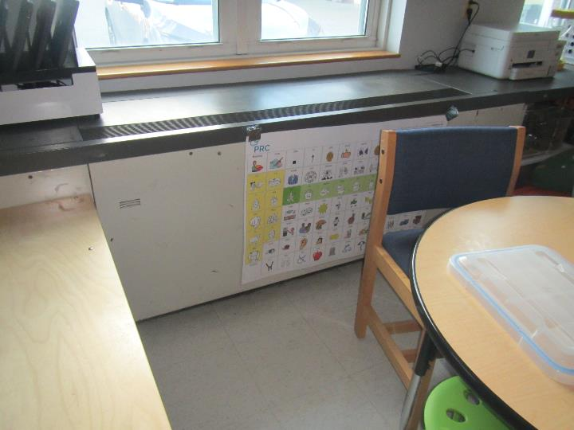
Classroom univent
Picture 2
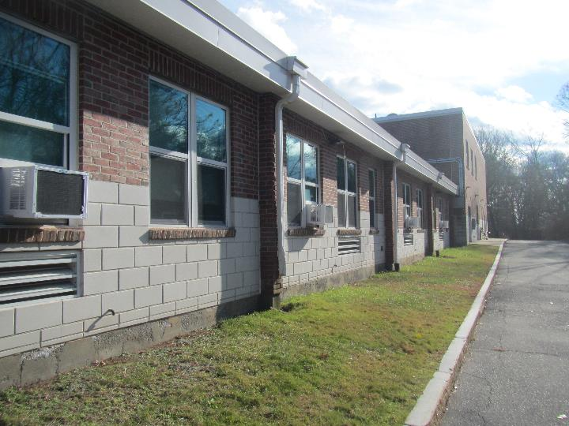
Univent air intakes on the side of the building, note condensation drains (arrow) and window air conditioners

Picture 3
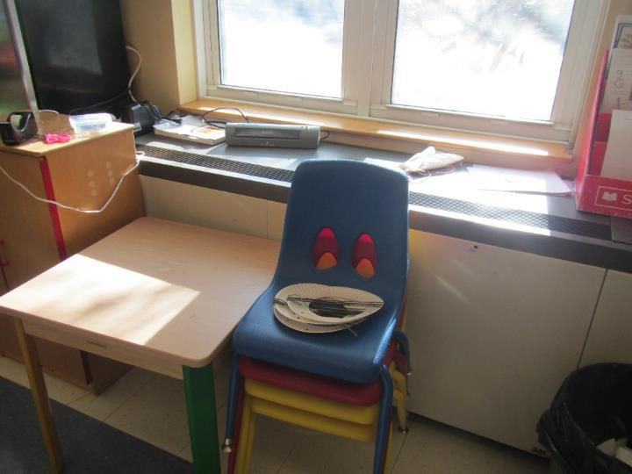
Univent partly blocked by furniture
Picture 4
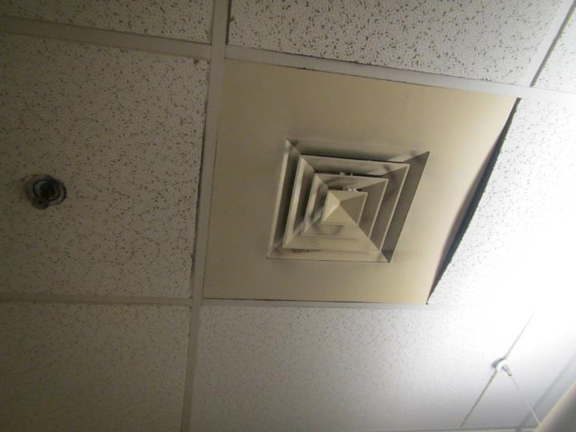
Supply vent in an interior room, note dust on vent louvers

Picture 5

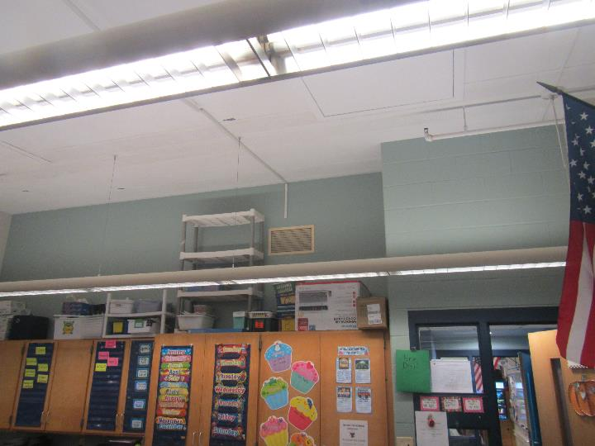
Wall-mounted exhaust vent
Picture 6
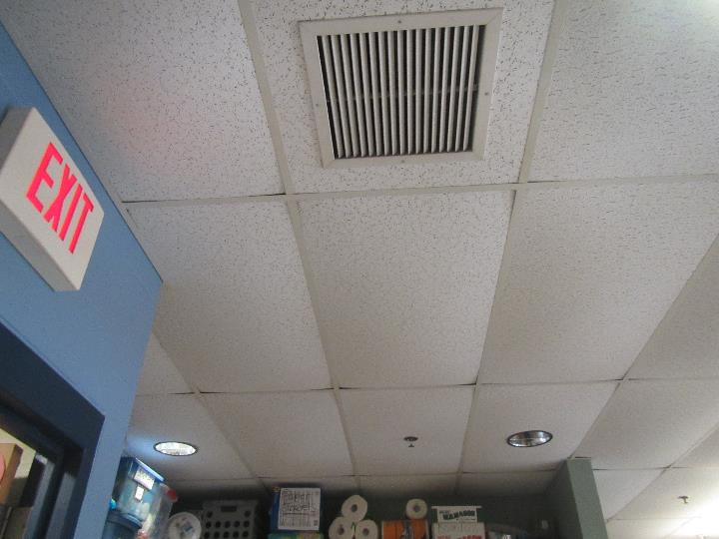
Ceiling-mounted exhaust vent and bowed ceiling tiles
Picture 7
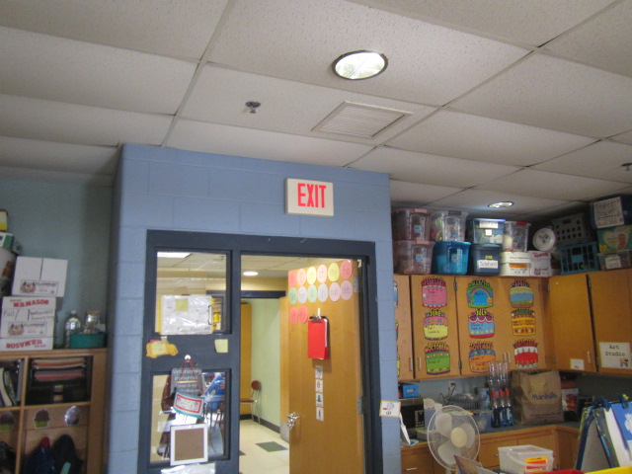
Proximity of exhaust vent to open hallway door, arrow indicates airflow

Picture 8
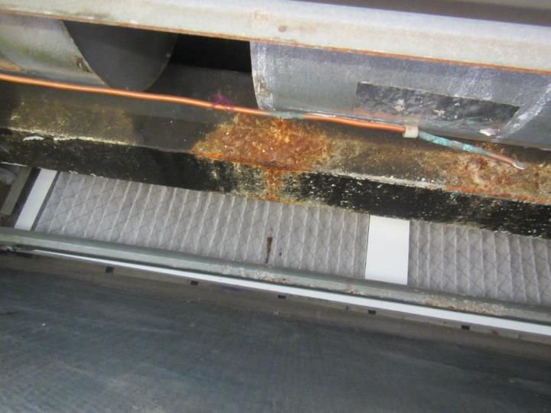
Corrosion inside univent
Picture 9
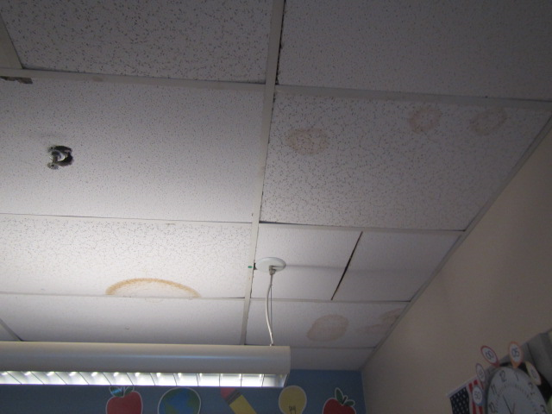
Water-damaged ceiling tiles

Picture 10
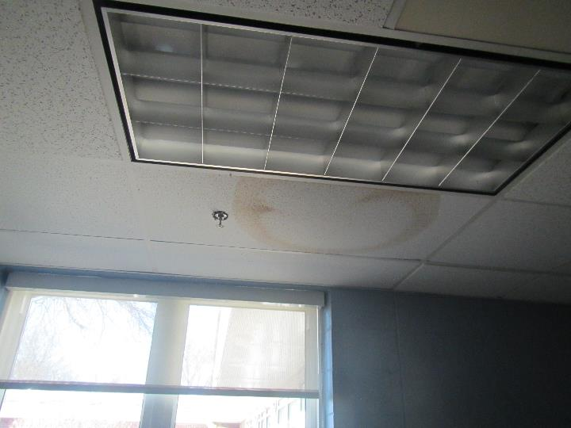
Water-damaged ceiling tiles
Picture 11
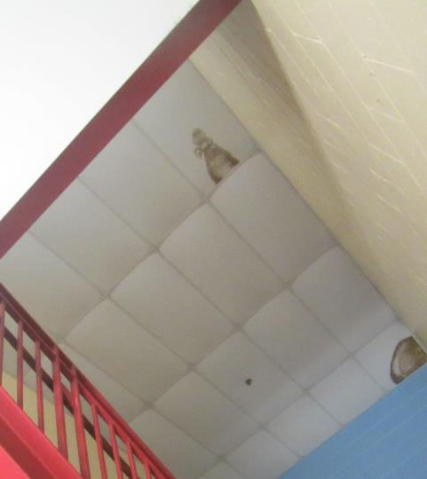
Water-damaged ceiling tiles in a stairwell

Picture 12
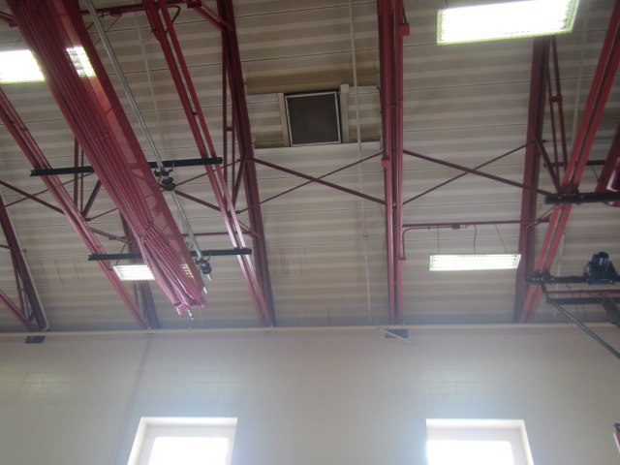
Metal gym ceiling and beams, and cinderblock walls
Picture 13
Spotting on metal ceiling in room 1084 indicating mold growth
Picture 14

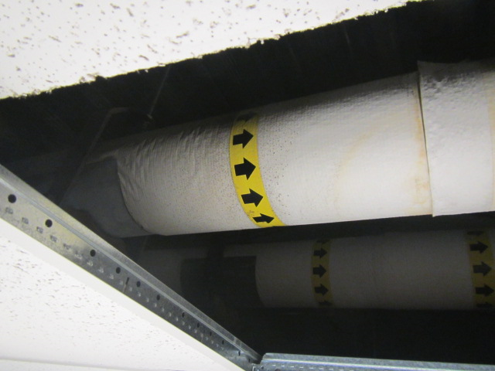
Pipe in ceiling plenum of room 1045 with spots indicating mold growth
Picture 15

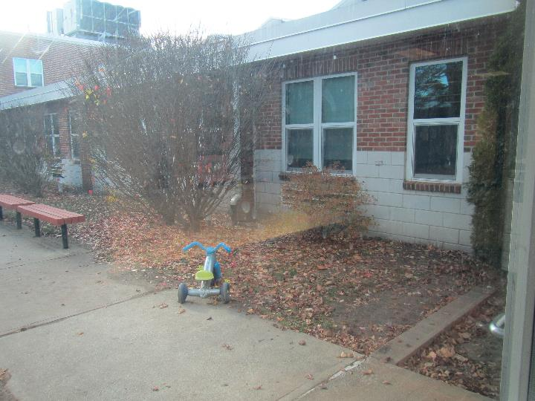
Plants in the courtyard, including a bush in front of univent air intake

Picture 16
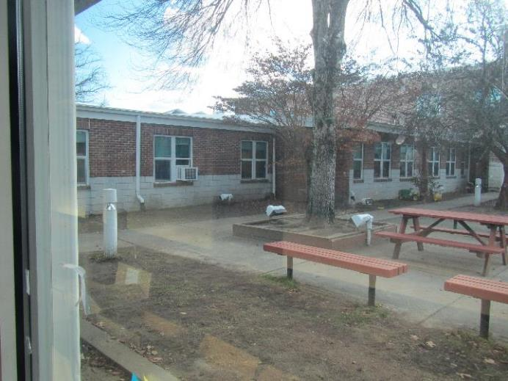
Large tree in the courtyard
Picture 17
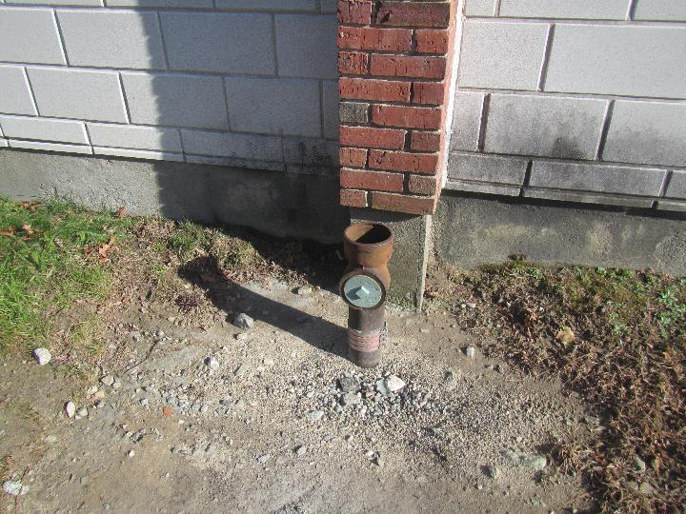
Missing downspout

Picture 18
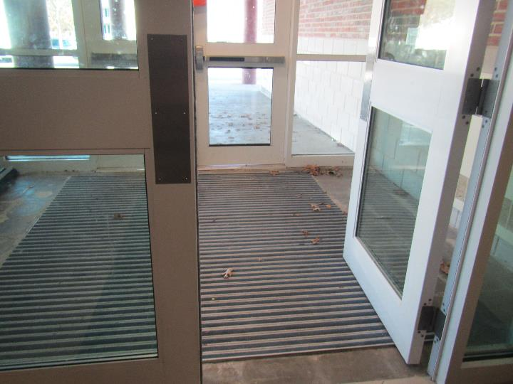
Damaged weatherstripping on the underside of the exterior door
Picture 19
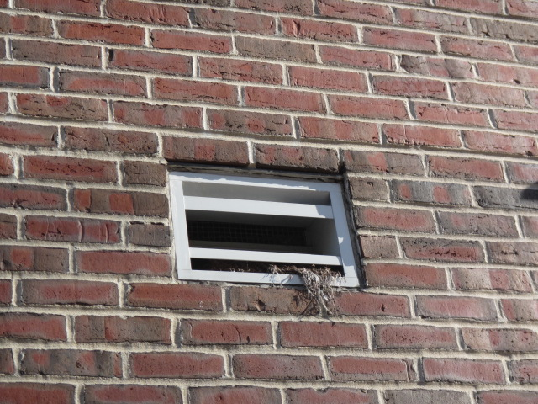
Bird nesting materials in a vent
Picture 20
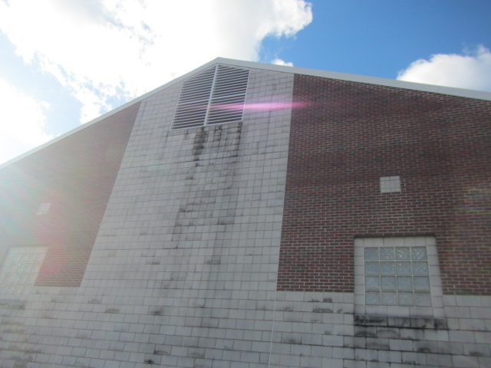
Dark staining on building exterior

Picture 21
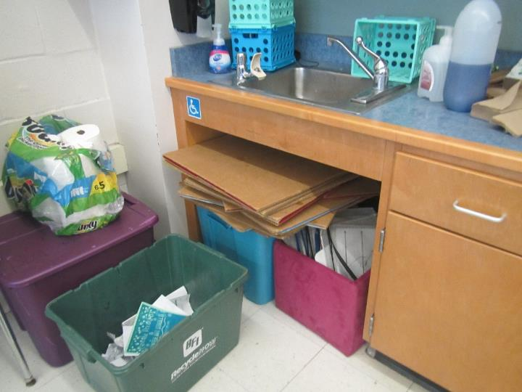
Large amounts of items under a sink
Picture 22
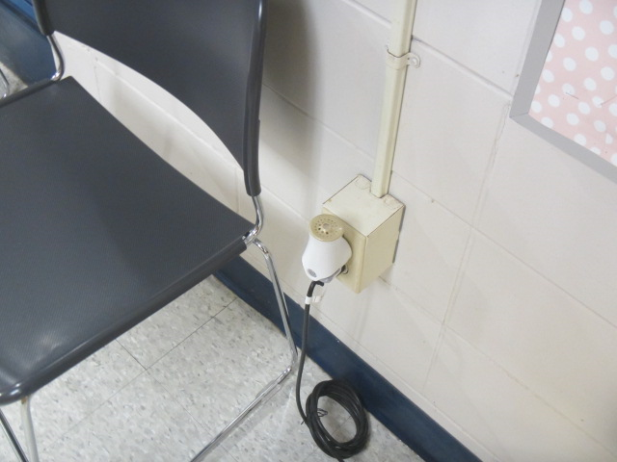
Plug-in air freshener

Picture 23
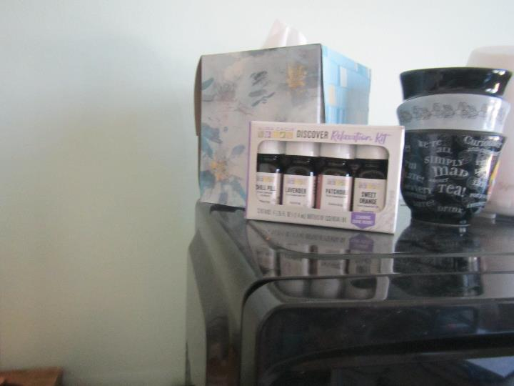
Scented oils
Picture 24
Tennis balls being used as chair glides

Picture 25
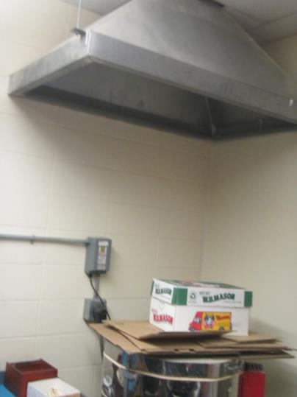
Electric kiln with exhaust vent

Location/ Room | Carbon  Dioxide  (ppm) | Carbon Monoxide  (ppm) | Temp  (°F) | Relative  Humidity  (%) | PM2.5  (µg/m³) | Occupants  in Room | Windows  Openable | Ventilation |  | Remarks
 |  |  |  |  |  |  |  | Supply | Exhaust
Background (outside) | 370 | ND | 40 | 37 | 2 |  |  |  |  | Clear and cold
First Floor
Nurse’s restroom |  |  |  |  |  |  |  |  | Y
Main office | 515 | ND | 66 | 26 | ND | 3 | Y | Y | Y | Bowed CT, area rug, DEM, laminator and PC, plant
Stage | 416 | ND | 70 | 21 | ND | 0 | N | Y | N | PF, curtain, office items
Women’s restroom |  |  |  |  |  | 0 | N | N | Y | Scented product
Gym | 616 | ND | 74 | 23 | 1 | 11 | N | Y | Y | Chronic roof leaks reported, metal celling, block walls, rubber floor
1st Floor Staff Men’s Restroom |  |  |  |  |  |  | N | N | Y, Off
1004 | 480 | ND | 64 |  | ND | 0 | Y | Y | Y | Plants, NC, WD CT, bowed CT
1005 | 495 | ND | 66 | 26 | ND | 0 | Y | Y | Y | Food, NC, HS, CP
1012 | 526 | ND | 66 | 29 | ND | 1 | Y | Y |  | Heater, NC
1013 nurse | 555 | ND | 66 | 29 | ND | 2 | Y | Y | ? | Sink, fridge, NC, heater, all supply vent style
1014 | 575 | ND | 69 | 27 | ND | 5 | Y | Y |  | AP, toaster oven, heater, NC
1016 conference | 948 | ND | 65 | 35 | ND | 8 | N | Y | ? | Bowed CT, AP (not plugged in), dusty vents, all supply vent style
1016A | 525 | ND | 74 | 21 | ND | 0 | Y open and door | N | N | Area rug, tarp over books, plant, CP, NC
1018 | 643 | ND | 66 | 30 | ND | 2 | Y | Y |  | Plant, scent dispenser, books, ND, WD floor area behind cabinet, bowed CT
1018A |  |  |  |  |  |  | N | N | N | Storage, NC, fridge and microwave
1019 | 622 | ND | 65 | 31 | ND | 0 | Y | Y | ? | Plants, heaters, fridge and microwave, area rugs, scented product
1020 | 637 | ND | 66 | 30 | ND | 0 | Y | Y | ? | Heater – on, NC, bowed CT
1021 | 824 | ND | 68 | 33 | 1 | 3 | N | Y | Y | DO, AP
1022 | 1100 | ND | 67 | 36 | 1 | 2 | N | Y | Y | AP, dust /debris on vents
1024 Conference Room 2 | 674 | ND | 80 | 24 | 1 | 2 | N | Y | Y | Chronic heat issues, AP
1038 | 1128 | ND | 75 | 31 | 1 | 17 | Y | Y, Off | Y, Off | UV-not operating (on repair list), shades missing (solar glare), area rug, 1 WD CT, PF, CP, AP
1041 | 709 | ND | 75 | 25 | 1 | 20 | Y, Open | Y | Y | PF (2), area rug, AP, DO, TB
1043 | 976 | ND | 76 | 25 | ND | 20 | Y | Y | Y | PF on, NC, plush items, TBs, 1 WD CT, bowed CTs
1045 | 885 | ND | 77 | 25 | ND | 18 | Y | Y | Y | UV is blocked, area rug, PF, bowed CT
1051 custodian | 609 | ND | 74 | 23 | ND | 1 | N | N | Y | NC, fridge, portable AC duct
1054 | 2193 | ND | 75 | 37 | 1 | 6 | N | Y | Y | AP, area rug, PF
1061 | 528 | ND | 76 | 21 | ND | 0 | N | Y dusty | Y | AP, sinks, DEM, NC, fridge
1063 pre-K | 697 | ND | 73 | 23 | ND | 10 | Y 1 open | Y | Y | Sink, APs, toilet room, NC, bowed CTs, MT
1066 | 1156 | ND | 72 | 30 | 1 | 21 | Y | Y | Y | UV was off, reactivated by occupant, TB, AC, DO, area rug
1067 | 1069 | ND | 73 | 28 | ND | 19 | Y | Y | Y wall | UV, items, HS, area rug, PF, metal ceiling, TBs, DEM
1068 | 1156 | ND | 72 | 30 | 1 | 21 | Y | Y | Y | Area rug, AC, AP
1069 | 1165 | ND | 73 | 29 | ND | 17 | Y | Y | Y wall | Metal ceiling, area rug, fridge, sink
1071 | 1079 | ND | 74 | 28 | 1 | 21 | Y | Y Off | Y | DO, PF, area rug, plug-in AF, pillows on floor
1072 | 925 | ND | 83 | 23 | ND | 15 | Y | Y | Y wall | Area rug, sink (dripping), HEPA AP
1073 | 1462 | ND | 74 | 29 | 1 | 20 | Y | Y Off | Y | PF, AP, area rug, TB, fridge, microwave
1074 | 976 | ND | 78 | 24 | ND | 15 | Y | Y | Y wall | Area rug, sink, DEM
1075 | 1047 | ND | 71 | 30 | 1 | 20 | Y | Y Off | Y | 19 occupants gone 2 mins, AP, area rug
1076 | 766 | ND | 73 | 25 | ND | 0 | Y | Y | Y wall | Area rug, window AC, fridge and microwave
1077 | 785 | ND | 73 | 24 | ND | 2 class just left | Y | Y | Y | AC window, area rug, blower off on purpose
1078 | 748 | ND | 74 | 25 | ND | 0 | Y | Y | Y | AC window, sink with items underneath, area rug
1079 | 880 | ND | 73 | 23 | ND | 9 | Y | Y | Y | AC window, DEM, AP, sink, area rug
1081 | 913 | ND | 71 | 24 | ND | 9 | Y | Y | Y wall | UV being worked on, area rug, AP, AC window, sink dripping, microwave
1082 | 576 | ND | 74 | 23 | ND | 3 | Y | Y | Y wall | AP, sink, area rug
1083 | 714 | ND | 74 | 23 | ND | 13 | Y | Y | Y wall | NC, area rug, sink (dripping)
1084 |  |  |  |  |  |  |  |  |  | WD CT corner, visible mold growth on metal ceiling above suspended ceiling tile system
1093 Art |  |  |  |  |  |  |  |  |  | 2 aquariums, plants, DO, TB, PF, peeling paint on metal ceiling, kiln – vented (hood)
1094 practice 1 |  |  |  |  |  |  |  | N |  | MT, cloth walls, WD CT, wood floor
1097 music | 652 | ND | 74 | 25 | ND | 0 | Door | Y |  | Skylights, peeling ceiling paint, sink, wood floor, area rug
1108 | 944 | ND | 84-86 | 27 | 1 | 6 | N | Y | Y | Chronic heat issues, DO
1112 cafeteria | 427 | ND | 70 | 22 | ND | 0 | Y | Y | Y | Vents have been off
Second Floor
2001 | 573 | ND | 79 | 18 | ND | 1 | Y 3 open | Y | Y | PFs, WD CT, scented product, area rug, portable AC (hose disconnected and not on)
2002 | 869 | ND | 76 | 23 | ND | 20 | Y 1 open | Y blocked | Y | Plants, sink, items, area rug, DEM, HS, scented product
2003 | 1273 | ND | 78 | 28 | ND | 20 | Y | Y blocked | Y | PFs, TBs, sink, area rig, DEM
2004 | 791 | ND | 74 | 23 | ND | 20 | Y open | Y | Y | Sink, backsplash damaged, bowed CT, TBs, DEM, AF, AP, area rug
2005 | 813 | ND | 74 | 23 | ND | 23 | Y 1 open | Y not on | Y ceiling | Sink, WD CT, DEM
2006 storage |  |  |  |  |  |  |  |  |  | Floor needs cleaning, most items on shelves
2012 | 620 | ND | 72 | 20 | 1 | 2 | Y Open | Y | Y | Chronic heat, TB, AP, 3 WD CTs
2017 | 899 | ND | 75 | 27 | 1 | 1 | N | Y | Y | 2 WD CTs
2018 Library | 936 | ND | 74 | 29 | 1 | 18 | Y | Y | Y | 3 WD CTs, wall to wall carpet, PF, AC, dust/debris on vents
2027 | 642 | ND | 77 | 20 | ND | 8 | Y 2 open | Y | Y | Sink, plant, TBs, area rug, PF
2028 | 672 | ND | 78 | 19 | ND | 7 | Y open | Y | Y | PF, NC, DEM, bowed CT
2nd Floor boys RR |  |  |  |  |  |  | N | N | Y, Off
Catie’s Closet | 872 | ND | 77 | 25 | 1 | 0 | N | N | N | 9 WD CTs, clothing storage
Girls’ restroom |  |  |  |  |  |  | N | N | Y (2) | Bowed CT
Teacher’s Lunch restroom |  |  |  |  |  |  |  |  | Y | WD CT next to vent
Teachers’ Lunch | 614 | ND | 77 | 19 | ND | 5 | Y open | Y | Y | WD CTs

The service life is the median time during which a particular system or component of …[an HVAC]… system remains in its original service application and then is replaced. Replacement may occur for any reason, including, but not limited to, failure, general obsolescence, reduced reliability, excessive maintenance cost, and changed system requirements due to such influences as building characteristics or energy prices (ASHRAE, 1991).

