Introduction
The Payment Detail by Client Report (formerly the Payment Detail by Service Code Report) has been changed to increase its user-friendliness and improve performance. This report may be used by provider or agency users to view the status of client services per day, by contract and/or PRC/CEC. This report provides the following information for each client:
- Date of service
- Service Code
- Amount billed
- Amount paid
- Claim status
- Error messages if the claim was adjusted or not ‘Paid’
To improve the time it takes for the report to run, specific search parameters are now required to enable more efficient data retrieval. Date ranges will be limited based on the type of contract selected. If the report is run for a single unit rate contract (sometimes referred to as provider specific contract if connected to a master agreement) the maximum date range is one year.
Users are encouraged to enter multiple parameters to narrow in on results and thereby increase report performance. The following message will appear at the top of the Report page to clarify which parameters are required:
One of the following search criteria must be entered:
- PRC/CEC Document ID Number
- Encumbrance Number and Service Date From/To Dates (a maximum date range of one month can be entered)
- Contract Number and Service Date From/To Dates (a maximum date range of one year can be entered)
The report has two versions: a version that displays client names, and a de-identified (DI) version which does not. Both reports are accessed on the same page in the Reports module, and the instructions for running the reports are the same.
Instructions for Running the Report With PRC/CEC Document ID
- Select the Reports module.
- From the Reports page, click the [Payment Detail by Client Report] or [Payment Detail by Client Report (DI)] link.
- Enter the entire 20-character PRC or CEC Document ID.
Reminder Notes:
- The PRC/CEC number must be entered exactly as it appears in the state system. Note – it is not required that the ‘INTF’ or any other letter(s) appearing in PRCs and/or CECs be capitalized to generate a report. The report will generate if letters are not capitalized.
  - Hint: Find the PRC on the billing module, highlight and copy the number and paste it into the field on the report screen to ensure accurate results.
- The Report can be run only with the entire PRC/CEC Document ID number. It is not required to add additional search parameters to generate a report.
Instructions for Running the Report by Contract
These instructions are for running the report by entering either a vendor-specific contract or a vendor’s pseudo contract that is associated with a master agreement.
- Select the Reports module:
- From the Reports page, click the [Payment Detail by Client Report] or [Payment Detail by Client Report (DI)] link.
- Enter the entire or part of the vendor contract number or into the [Contract Number Filter] field. Note: If using only part of the contract number, use the wildcard (%) symbol).
- Click [Filter] and select the desired [Contract Number] from the drop-down.
- Click [Select Contract].
- Select the desired [Activity Code]. (Optional)
Note: Users can select multiple activity codes by holding down ‘ctrl’ on their keyboard and selecting the desired activities.
- Enter [Service Date From] and [Service Date To].
Important: The maximum date range is one year and the date range may not span multiple fiscal years. If dates are not entered or entered incorrectly, the following error message will appear:
“If a contract number for a vendor-specific contract or pseudo contract is entered, the maximum date range is one year. A PRC/CEC number may be entered instead of contract number and/or date range.”
- Enter [PRC/CEC Document ID], if applicable. Note: The ‘INTF’ and any other letter(s) appearing in PRCs and/or CECs do not need to be capitalized to generate a report. The report will still generate if letters are not capitalized.
- Select [Report Format]. Defaults to PDF format. Excel format also available.
- Click the [Run Report] button.
Reminder Note on Adding or Changing Search Parameters between Report Requests:
- A user must always click the [Clear] button if adding or changing search parameters between report requests. This includes the PRC/CEC Document ID status and the HIPAA Batch ID field.
- Enter new criteria following steps outlined above.
Viewing Results – Understanding Results
This report provides details on payments by client, day, and service code along with any corresponding adjustments. This report can be used to explain the difference in ‘Claimed Amount’ versus the ‘Paid Amount’ displayed on SDRs or individual claims when contract or unit allocation balances exhaust. When a contract is exhausted, a message stating "Account Funding Exhausted" appears next to the claims (dates of service) which were partially paid or completely unpaid.
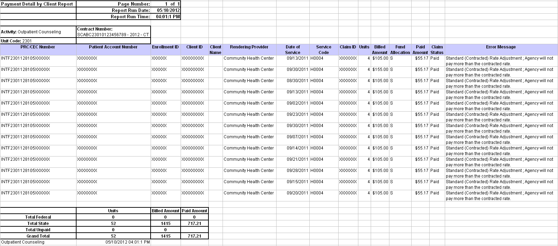
Fields found in the Payment Detail by Client Report (left to right)
PRC/CEC Number | Patient Account Number
Enrollment ID | Client ID
Client Name | Rendering Provider
Date of Service | Service Code
Claim ID | Units
Billed Amount | Fund Allocation
Paid Amount | Claim Status
Error Message

Questions or need assistance? Call Virtual Gateway Customer Service
1-800-421-0938 (617-847-6578: TTY people who are deaf, hard of hearing, or speech disabled)
8:30 am to 5:00 pm Monday through Friday
Email: Virtual Gateway Business Operations @ EHS-DL-EIM-ESMBusinessOperations@massmail.state.ma.us

