Table of Contents
Overview of Payment Tracking Report 1
Reports > Payment Tracking Report 1
Understanding the Payment Tracking Report 4
Information Regarding Payment Tracking Report 5

Overview of Payment Tracking Report
The Payment Tracking Report gives providers and agencies a simplified way to retrieve a snapshot of payments received, payments outstanding, and amount left to bill on a contract-by-contract basis.
The Payment Tracking Report is available for unit rate, cost reimbursement, accommodation rate, mixed contracts, and master agreements. This report will not work for contracts billing with HIPAA.
This report is run through the Reports Module in EIM/ESM and is generated using similar steps as other reports. The report can be run to display in Excel or as a PDF.

Reports > Payment Tracking Report
- Select the Reports module.
Figure 1: Image of the EIM/ESM Modules.
From the Report page,
- Select the [Payment Tracking Report] link.
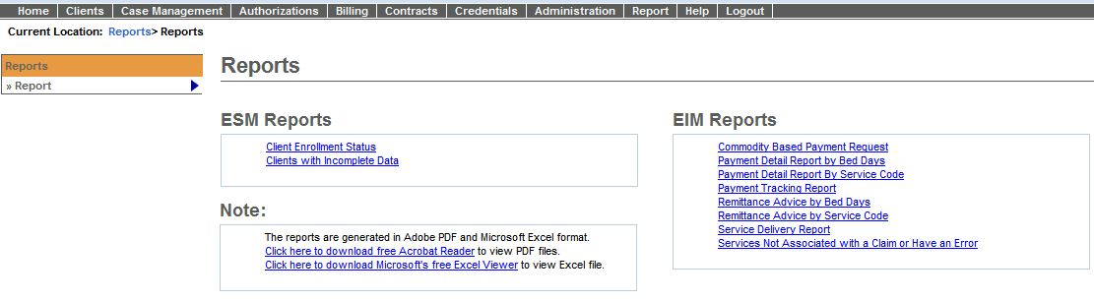
Figure 2: Image of the EIM/ESM Reports page.
- Using the Filter field, type in the entire or partial Contract Number. (See example in screen capture below.) You can search for a contract using the Filter field. The wildcard (%) symbol can also be used.
- Select the [Filter] button.
- Select the [*Contract Number] from the drop-down menu. (The Contract Number drop-down menu will only display contract numbers that meet the filtered criteria.)
- Optional field: Select the [Invoice/SDR Reference Number] from the drop-down menu. **
** Note: This field is optional and will only contain data if entered when the Invoice/SDR was in a Draft status in EIM.
- Select [*Report Format]. Defaults to PDF format.
- Optional field: If report results need to be emailed to recipients; select the Email Address field and type in the email addresses.
Note: Up to 10 email addresses can be added and each email address must be separated with a comma.
- Optional field: Report Comments can be added.
- Users now have options on how they can run certain reports in EIM/ESM:
  - Run Report: A report can be run and viewed during logged in session.
  - Run Report & Send Email: The selected report will be run and the results emailed to listed recipients. User can continue to use other functions of EIM/ESM while the report is being run and emailed.
  - Schedule Report: EIM/ESM allows users to choose various patterns in which a report needs to be scheduled, in order to be delivered on a later date/time.
    - The schedule type can be ‘Daily’, ‘Weekly – By Day of Week’ or ‘By Date of Month’.
Note: The Clear button clears all criteria on page.
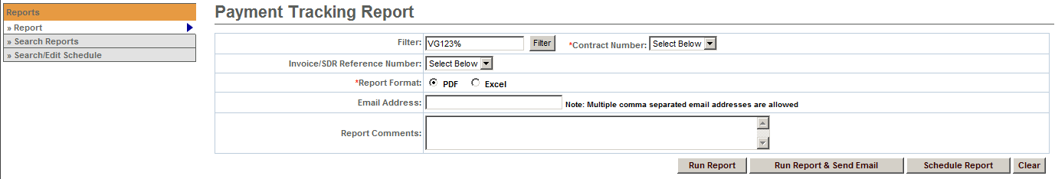
Figure 3: Example of Running a Report in EIM/ESM. This image is displaying the criteria needed to run the Payment Tracking Report.
If a user selects the option of Schedule Report additional fields must be completed in order for the selected report to run.
- Enter the Start Date or use the Calendar icon to select date.
- Enter the End Date or use the Calendar icon to select date.
- Select the Pattern: Daily, Weekly – By Day of Week, or By Date of Month.
- When Weekly – By Day of Week is selected as the Pattern, the user must specify the days of the week on which they want to schedule the report to run. This field is mandatory if the Pattern selected is ‘Weekly – By Day of Week’.
- When By Date of Month is selected as the Pattern, the user needs to select 29, 30 or 31 from ‘Date of Month’ dropdown menu. Note: EIM/ESM will consider the last day of the month, if a month does not have 29, 30 or 31 days. This field is mandatory if the Pattern selected is ‘By Date of Month.
- Select the Save Schedule button.
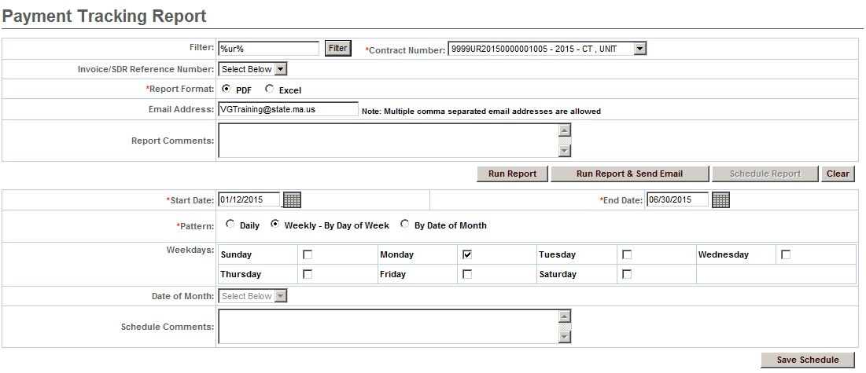
Figure 4: Example of Scheduling a Report to be run in EIM/ESM. This image is displaying the criteria needed to run the Payment Tracking Report.
Payment Tracking Report - Sample Output

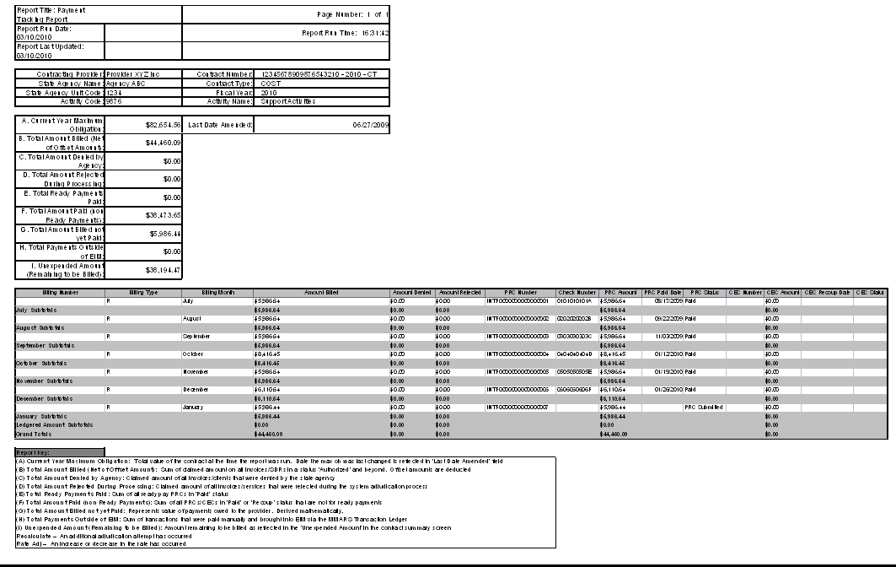
Figure 5: Image of the Payment Tracking Report - Sample Output

Understanding the Payment Tracking Report
How do I read the report – Top of Report?
The top half of the report contains contract information from the Contract Summary page in EIM. Information includes: Contracting Provider, Contract Number, State Agency Name, Contract Type, State Agency Unit Code, Fiscal Year, Activity Code, and Activity Name.
Important: This portion of the report will always display contract-wide, fiscal-year-to-date values, regardless of the date range selected when generating the report.
Report Key:
(A) Current Year Maximum Obligation: Total value of the contract at the time the report was run. Date the Max Ob was last changed is reflected in “Last Date Amended” field.
(B) Total Amount Billed (Net of Offset Amount): Sum of claimed amount on all invoices/SDRs in a status “Authorized” and beyond. Offset amounts are deducted.
(C) Total Amount Denied by Agency: Claimed amount of all invoices/SDRs that were denied by the state agency.
(D) Total Amount Rejected During Processing: Claimed amount of all invoices/services that were rejected during the system adjudication process.
(E) Total Ready Payments Paid: Sum of all ready pay PRCs in 'Paid' status.
(F) Total Amount Paid (non Ready Payments): Sum of all PRCs/CECs in 'Paid' or 'Recoup' status that are not for ready payments.
(G) Total Amount Billed not yet Paid: Represents value of payments owed to the provider. Derived mathematically.
(H) Total Payments Outside of EIM: Sum of transactions that were paid manually and brought into EIM via the MMARS Transaction Ledger.
(I) Unexpended Amount (Remaining to be Billed): Amount remaining to be billed as reflected in the 'Unexpended Amount' in the contract summary screen.
Recalculate – An additional adjudication attempt has occurred.
Rate Adj – An increase or decrease in the rate has occurred.
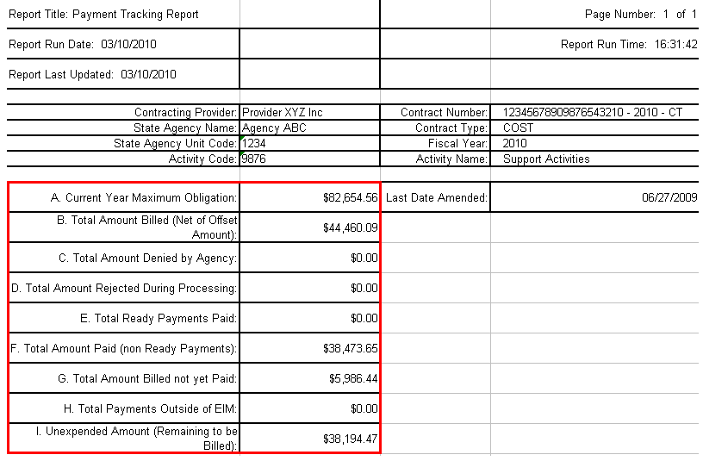
Payment Tracking Report - Sample Output
Top Half of Report
Figure 6: Image of the Payment Tracking Report - Sample Output
How do I read the report – Bottom of Report?
The bottom half of the report contains the payment details for the contract selected. This section of the report displays all PRCs and CECs associated with the contract by month, including Ready Payments, readjudications, and rate changes.
If SDRs and/or invoices are not associated to PRCs/CECs at the time the report is run, they will be labeled as ‘Billing In Progress.’
This section of the report indicates the amount of any services that rejected or were denied by the agency, and any payments that were made outside of EIM and brought in using the Ledger. All information displays by sub-total for each month. There is also a ‘Grand Totals’ field that calculates based on the monthly sub-totals.
Payment Tracking Report - Sample Output
Bottom Half of Report
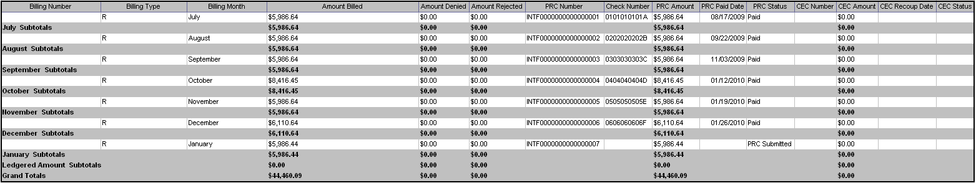
Figure 7: Image of the Payment Tracking Report - Sample Output

Information Regarding Payment Tracking Report
- For the report to be the most useful, it should be run by contract number, not by SDR/Invoice Number. It is recommended that the report be run by contract number since the contract balances, and other amounts that display at the top of the report are pulled from the Contract Summary Page (which displays the most current amounts.)
- For example, if you ran the report by SDR/Invoice Number, the bottom of the report would display the details by SDR/Invoice Number, but the balances at the top of the report would be the year-to-date balances of the contract.
- SDRs and invoices are referenced on this report only if they are associated with a PRC or CEC. If SDRs/Invoices are not yet associated to a PRC or CEC they will display as ‘Billing in Progress.’ This is so the top portion of the report (pulling information from the Contract Summary Page) and the bottom portion of the report (documents already associated to PRCs/CECs) will match.
Denials:
- Partial denials show in the 'Amount Denied' column. For example, an SDR is submitted for $500. The SDR has 2 clients: $275 for Client 1 and $225.00 for Client 2, and the Agency denies Client 1. The PRC Number column will reference $225, and the Amount Denied column will reference $275. Users are able to 'track' the $500 that was submitted on the SDR.
- Full denials do not display on the report. For example, an SDR is submitted for $500 and the Agency denies both clients. No PRC will generate in EIM. Therefore, the $500 will not show on the report because adjudication never occurred because the agency denied both clients.
- Rejections:
- Partial rejections that take place during adjudication show on the report in the 'Amount Rejected during Processing' column. For example, if an SDR is submitted for $500. The SDR has 2 clients: $175 for Client 1 and $325 for Client 2. $175 passes, but $325 rejects because the contract ran out of funds. The $325 will reject and show in the ‘Amount Rejected during Processing’ column. Users are able to 'track' the $500 that was submitted on the SDR.
- Full rejections (all services rejected during adjudication) do not appear on this report.
- EIM/ESM only allows one SDR or Invoice per PRC/CEC. When running this report, there may be instances when a PRC/CEC will have multiple SDRs or Invoices associated to them. In those cases, the same PRC or CEC document numbers will appear on the report for multiple months. Any PRCs/CECs that generated after November 2009 will only display once on this report.
- Please be aware that due to the amount of data that is being pulled for this report, the Payment Tracking Report may take several minutes to successfully generate.

Questions or need assistance? Call Virtual Gateway Customer Service
1-800-421-0938 (617-988-3301 - TTY for the deaf and hard of hearing)
8:30 am to 5:00 pm Monday through Friday

