Personal Care Attendant (PCA)
Program Enhancements
Public Listening Session
Executive Office of Health and Human Services
January 29, 2019

Today’s Agenda
- Personal Care Attendant (PCA) Program History
- Challenges Identified with Current PCA Program
- Intent of Public Listening Sessions
- Comment Period
- Future Listening Sessions

PCA Program History
The MassHealth PCA Program has been an extremely successful Consumer directed program enabling ever-increasing numbers of individuals to direct and manage their own services.

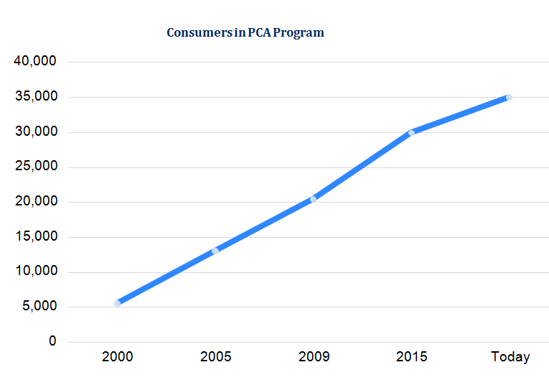

The MassHealth PCA Program has been in place for more than four decades and there have been significant shifts in the population it serves over that time.

The average Consumer in the PCA program has gotten older.

The needs of PCA Consumers have become increasingly diverse, with a variety of populations accessing services.
These include
- individuals with intellectual or developmental disabilities;
- individuals under 65 with physical disabilities; and
- individuals over 65.

Current PCA Program Focus Areas

Through earlier public listening sessions and stakeholder engagement initiatives, MassHealth has recognized that the current one-size-fits-all structure of the state plan PCA program needs to adapt to address flexibilities and supports requested by Consumers.

The key focus areas identified through stakeholder engagement initiatives include
- Some Consumers seek greater control in managing their PCA services

- Some Consumers seek greater support for their PCA services

- PCA employment, including recruitment and retention and scheduling

- Role and the high use of Surrogates

- Implementing Electronic Visit Verification (EVV) in a way that meets federal requirements and preserves Consumer independence and choice

- Role and key functions of PCMs and FIs

Process for Addressing PCA Program Challenges

Identifying program challenges
- Hosted public listening sessions
- Held stakeholder engagement meetings

Solicit input on solutions
- Formed PCA Enhancements Advisory Group
- Hosted public listening sessions
- Issued Request for Information (RFI)
Address input
- Review RFI
- Inform future policy decisions

Public Listening Sessions
The purpose of the public listening sessions is for MassHealth’s Office of Long-Term Services and Supports (OLTSS) to listen and gather input from PCA Program stakeholders on key focus areas within the PCA Program
- Public Listening Session are open to stakeholders and will allow an opportunity to provide comments about elements of the PCA Program.
- MassHealth will ask questions related to key areas of challenge to the PCA Program.
- Meetings will be held approximately every 6 weeks at various locations in the Commonwealth. Meeting location and times will be posted publicly.
- Written responses will be accepted at PCAfeedback@massmail.state.ma.us

Focus Areas for Today’s Meeting
- PCA Recruitment and Retention
- Surrogates
- PCA Directory

PCA Recruitment and Retention
- How do Consumers recruit PCAs? What is the most common method?
- Are there ways to improve the backup process? Would it be helpful to develop an emergency network of backup PCAs?
- What are the reasons that a Consumer may have high PCA turnover? What are the reasons that a Consumer may terminate many PCAs?
- What supports could help Consumers recruit and retain PCAs? Is there anything PCMs could do in the context of skills training?

Surrogates
- What are some challenges Consumers face with Surrogates?
- What are some challenges PCAs face with Surrogates?
- What qualifications, if any, should be required for an individual to serve as a Surrogate? How close should a Surrogate live to a Consumer?Consumer
- How can the State encourage active Surrogate participation?
- What supports could help Consumers in finding a Surrogate? How might an expanded PCM Agency role be helpful?

PCA Directory
- What works well with the PCA Directory?
- What are some challenges with the PCA Directory?
- How can the Directory be more accessible?
- What are some ways that the PCA Directory can be improved and be more useful to Consumers, PCAs and Surrogates?

Future Public Listening Sessions (Tentative)
Public Listening Session: Personal Care Attendant (PCA) Program Enhancements
Thursday, February 28, 2019, 1-3PM
Worcester Public Library, The Saxe Room
3 Salem Square
Worcester, MA 01608
Wednesday, April 10, 2019, 10AM-12PM
Pittsfield Public Library, Berkshire Athenaeum - Auditorium
One Wendell Avenue
Pittsfield, MA 01201
Wednesday, April 10, 2019, 2-4PM
Springfield City Library, Mason Square Branch, Community Room
765 State Street
Springfield, MA 01109

