Personal Care Attendant (PCA) Program Enhancements
Public Listening Session

Executive Office of Health and Human Services

November 1, 2019

Slide 1:

Personal Care Attendant (PCA) Program Enhancements

Today’s Agenda
- Personal Care Attendant (PCA) Program History
- Challenges Identified with Current PCA Program
- Intent of Public Listening Sessions
- Comment Period
- Future Listening Sessions

Slide 2:

PCA Program History

The MassHealth PCA Program has been an extremely successful consumer directed program enabling ever-increasing numbers of individuals to direct and manage their own services.
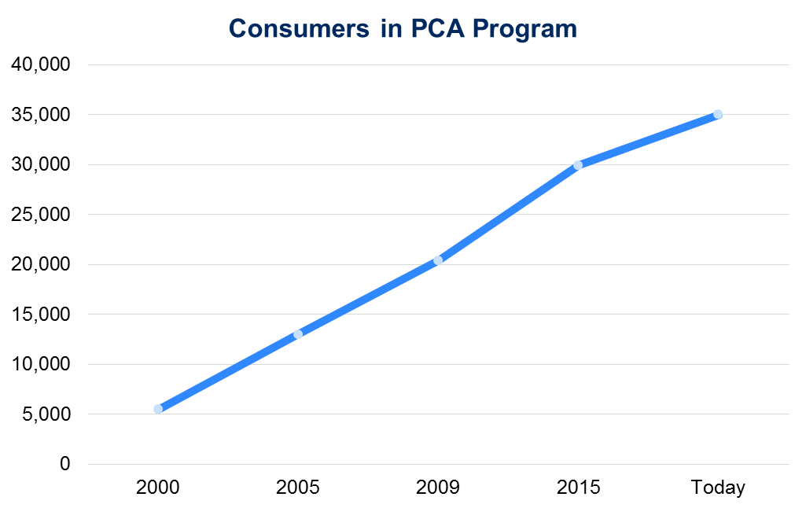

Slide 3:

PCA Program History

- The MassHealth PCA Program has been in place for more than four decades and there have been significant shifts in the population it serves over that time.
- The average consumer in the PCA program has gotten older.
- The needs of PCA consumers have become increasingly diverse, with a variety of populations accessing services. These include:
  - individuals with intellectual or developmental disabilities;
  - individuals under 65 with physical disabilities; and
  - individuals over 65.

Slide 4:

Current PCA Program Focus Areas

Through earlier public listening sessions and stakeholder engagement initiatives, MassHealth has recognized that the current one-size-fits-all structure of the state plan PCA program needs to adapt to address flexibilities and supports requested by consumers.
The key focus areas identified through stakeholder engagement initiatives include:
  - Some consumers seek greater control in managing their PCA services
  - Some consumers seek greater support for their PCA services
  - PCA employment, including recruitment and retention and scheduling
  - Role and the high use of surrogates
  - Implementing Electronic Visit Verification (EVV) in a way that meets federal requirements and preserves consumer independence and choice
  - Role and key functions of PCMs and FIs

Slide 6:

Process for Addressing PCA Program Challenges

Slide 7:

Public Listening Sessions

- The purpose of the public listening sessions is for MassHealth’s Office of Long-Term Services and Supports (OLTSS) to listen and gather input from PCA Program stakeholders on key focus areas within the PCA Program.
- As part of our regular operational activities, OLTSS will make changes to improve the PCA program; however, these listening sessions will provide OLTSS with valuable information for longer-term program enhancements.
  - Public Listening Session are open to stakeholders and will allow an opportunity to provide comments about elements of the PCA Program.
  - MassHealth will ask questions related to key areas of challenge to the PCA Program.
  - Meetings will be held approximately every 6 weeks at various locations in the Commonwealth. Meeting location and times will be posted publicly.
  - Written responses will be accepted at PCAfeedback@massmail.state.ma.us

Slide 8:

Key Focus Areas for Today’s Meeting

- PCA Recruitment and Retention
- PCA Program Structure
- Surrogates

Slide 9:

Topics for Today’s Meeting

PCA Recruitment and Retention

      - What program requirements or options could be added to improve the quality of PCAs?
      - Currently, background checks (CORIs) of PCAs are optional. Should the PCA program require consumers to conduct CORIs on their PCAs or provide more education around the existing CORI option? Would this be helpful, or would it create other challenges?
      - What are some ways the PCA Directory can be improved and be more useful to Consumers, PCAs, and Surrogates?
      - Have you experienced challenges with recruiting/hiring PCAs related to language or culture? Are there ways to help address these challenges through the PCA program?

Slide 10:

Topics for Today’s Meeting

PCA Program Structure

Goals of any future PCA Program Structure:
- Maintains commitment to consumer self-direction
- Supports continuity of care
- Increases the number of self-directed options
- Tailored to better suit consumer needs
- Improves PCA recruitment and retention issues; and
- Addresses challenges consumers may have with identifying a surrogate.

Slide 11:

PCA Program Structure

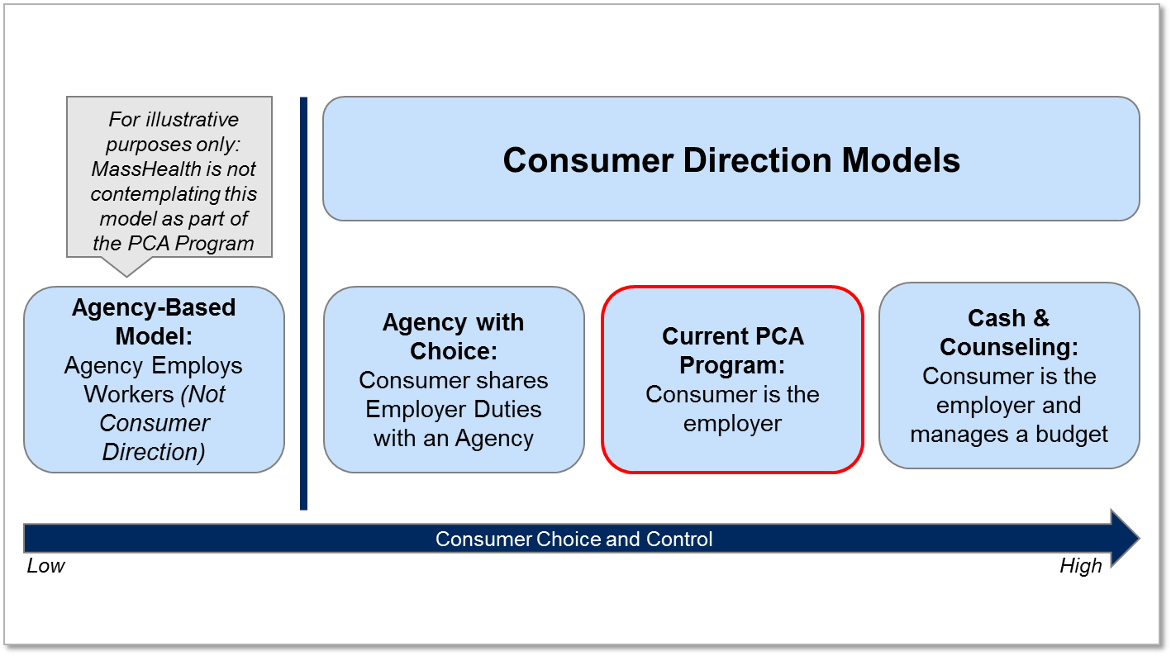

Slide 12:

PCA Program Structure

- If, in addition to the current program, EOHHS offered a model for receiving PCA services where consumers co-employed workers with a provider agency,
  - What challenges would the new model create?
  - What issues would it resolve?
- What employer responsibilities may be beneficial to be shared between a provider agency and a consumer while still maintaining consumer control over self-direction?
- If provider agencies co-employed workers with consumers, what safeguards should be implemented to maintain consumer control over self-direction?

Slide 13:

Surrogates

- What supports could help Consumers in finding a Surrogate? How might an expanded PCM Agency role be helpful?
- What qualifications are necessary for a Surrogate serving as an administrative proxy (completing administrative tasks on behalf of the consumer but not self-directing PCAs)? Could these qualifications be included in a Surrogate Assessment?
- What qualifications are necessary for a Surrogate self-directing on behalf of a consumer? Could these qualifications be included in a Surrogate Assessment?
- Are there supports/resources that could assist with Surrogate retention?

Slide 14:

Public Listening Sessions (Sessions without dates are tentative)

January 2019: Boston Public Library, January 29, 2019, 1-3PM
February 2019: Worcester Public Library, February 28, 2019, 1-3PM
April 2019: Pittsfield Public Library, April 10, 2019, 10AM-12PM; Springfield Public Library, April 10, 2019, 2-4PM
June 2019: Lawrence Public Library, May 30, 2019, 1-3pm
July 2019: New Bedford Public Library, July 24, 2019, 1:30-3:30pm
November 2019: Waltham Public Library, November 1, 2019, 11:30am-1:30pm

Slide 15:

Copies of this presentation can be found at:
https://www.mass.gov/service-details/pca-program-enhancements
Additional feedback can be submitted to MassHealth by emailing: PCAfeedback@massmail.state.ma.us

