Personal Care Attendant (PCA) Program Enhancements
Public Listening Session

Executive Office of Health and Human Services

February 28, 2019

Slide 1:

Personal Care Attendant (PCA) Program Enhancements

Today’s Agenda
- Personal Care Attendant (PCA) Program History
- Challenges Identified with Current PCA Program
- Intent of Public Listening Sessions
- Comment Period
- Future Listening Sessions

Slide 2:

PCA Program History

The MassHealth PCA Program has been an extremely successful consumer directed program enabling ever-increasing numbers of individuals to direct and manage their own services.
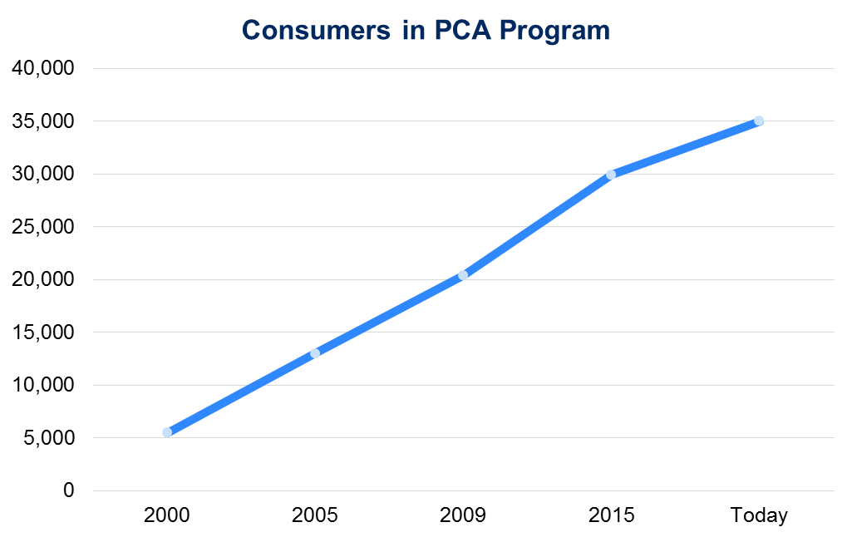

Slide 3:

PCA Program History

- The MassHealth PCA Program has been in place for more than four decades and there have been significant shifts in the population it serves over that time.
- The average consumer in the PCA program has gotten older.
- The needs of PCA consumers have become increasingly diverse, with a variety of populations accessing services. These include:
  - individuals with intellectual or developmental disabilities;
  - individuals under 65 with physical disabilities; and
  - individuals over 65.

Slide 4:

Current PCA Program Focus Areas

Through earlier public listening sessions and stakeholder engagement initiatives, MassHealth has recognized that the current one-size-fits-all structure of the state plan PCA program needs to adapt to address flexibilities and supports requested by consumers.
The key focus areas identified through stakeholder engagement initiatives include:
  - Some consumers seek greater control in managing their PCA services
  - Some consumers seek greater support for their PCA services
  - PCA employment, including recruitment and retention and scheduling
  - Role and the high use of surrogates
  - Implementing Electronic Visit Verification (EVV) in a way that meets federal requirements and preserves consumer independence and choice
  - Role and key functions of PCMs and FIs

Slide 6:

Process for Addressing PCA Program Challenges

Slide 7:

Public Listening Sessions

- The purpose of the public listening sessions is for MassHealth’s Office of Long-Term Services and Supports (OLTSS) to listen and gather input from PCA Program stakeholders on key focus areas within the PCA Program.
- As part of our regular operational activities, OLTSS will make changes to improve the PCA program; however, these listening sessions will provide OLTSS with valuable information for longer-term program enhancements.
  - Public Listening Session are open to stakeholders and will allow an opportunity to provide comments about elements of the PCA Program.
  - MassHealth will ask questions related to key areas of challenge to the PCA Program.
  - Meetings will be held approximately every 6 weeks at various locations in the Commonwealth. Meeting location and times will be posted publicly.
  - Written responses will be accepted at PCAfeedback@massmail.state.ma.us

Slide 8:

Key Focus Areas for Today’s Meeting

- Self-Direction Assessments and Clinical Evaluations
- PCA and Employer Skills Training
- Customer Service

Slide 9:

Topics for Today’s Meeting

Self-Direction Assessments and Clinical Evaluations

      - What works well with the self-direction assessment process?
      - How could the self-direction assessment be improved to better reflect an individual’s varying levels of ability to self-direct (versus requiring a surrogate)?
      - What works well with the clinical evaluation process?
      - What improvements could be made to the clinical evaluation process?
      - In situations where a consumer’s needs change, are there improvements that can be made to the clinical evaluation process?

Slide 10:

Topics for Today’s Meeting

PCA and Employer Skills Training

      - What are some ways to improve the New Hire Orientation for PCAs?
      - How can training around cultural competency be improved?
      - How can employer skills training be improved to better prepare Consumers to self-direct their PCA services?
      - Would it be helpful to provide Consumers with a list of topics that should be addressed when training PCAs? What topics would be most helpful?
      - What employer skills training topics have proven most valuable to Consumers?

Slide 11:

Customer Service

      - What improvements would you recommend to the Consumer and/or PCA paper processes?
      - What works well with PCM and Fiscal Intermediary customer service?
      - How could the PCM and Fiscal Intermediary customer service experience be improved?

Slide 12:

Public Listening Sessions (Sessions without dates are tentative)

January 2019: Boston Public Library, January 29, 2019, 1-3PM
February 2019: Worcester Public Library, February 28, 2019, 1-3PM
April 2019: Pittsfield Public Library, April 10, 2019, 10AM-12PM; Springfield Public Library, April 10, 2019, 2-4PM
June 2019: Lawrence Area
July 2019: Fall River/New Bedford area
September 2019: Metro-Boston area

Slide 13:

Thank You!

Copies of this presentation can be found at:
https://www.mass.gov/service-details/pca-program-enhancements
Additional feedback can be submitted to MassHealth by emailing: PCAfeedback@massmail.state.ma.us

