

Rate Development for

Social Service Programs

## Provider and Consumer Advisory Council Meeting

October 22, 2015

Agenda Introductions Project Description



Project Methodology

Discussion Next Steps

MA EOHHS Rate Development 2

Jim Waldinger Project Director



[jwaldinger@pcgus.com](mailto:ngrossman@pcgus.com)

(617) 717-1123

Lauren Rodrigues



Rate Development Team Lead [lrodrigues@pcgus.com](mailto:ngrossman@pcgus.com) (617) 717-1333

Jennifer MacBlane Project Manager [jmacblane@pcgus.com](mailto:jmacblane@pcgus.com) (617) 717-1251



James Kostecki



Rate Development Team Lead [jkostecki@pcgus.com](mailto:sgoscha@pcgus.com) (617) 717-1283

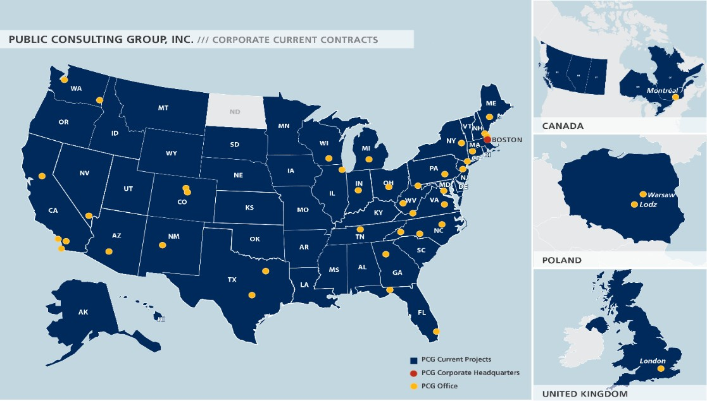

Current projects in 49 states, with current rate setting work in MI, CA, OH, IL, MA and others

# Project Description

August 2015 - October 2015

2015 Tier 1 and 2 Rate ***Reviews***

November 2015 – December 2016 Tier 3 Rate ***Development***

### The contractor shall work with EOHHS and EOHHS agency representatives to develop rates for the project categories listed in Tier 3. Rates must conform to all applicable provisions for social service program rates as provided under MGL Chapter 118E Section 13D (commonly referred to as “Chapter 257”) and in particular, rates must take into account factors, including, but not limited to: (a) the reasonable cost to social service program providers of any existing or new governmental mandate that has been enacted, promulgated or imposed by any governmental unit or federal governmental authority;

1. *a cost adjustment factor to reflect changes in reasonable costs of goods and services of social service programs including those attributed to inflation; and (c) geographic differences in wages, benefits, housing and real estate costs in each metropolitan statistical area of the commonwealth, and in any city or town therein where such costs are substantially higher than the average cost within that area as a* whole.

# Project Description – Tier 3 Rates

|  |  |  |
| --- | --- | --- |
| **Project** | **Dept.** | **Program Name** |
| PACT Program | DMH | Program of Assertive Community Treatment |
| Respite | DDS DMH | Emergency Stabilization Residential Respite Care Services |
| General Programs DCF/DYS | DCF  DYS | FBS Clinical  Young Parent Support; Community Connections Comprehensive Emergency Services  Protective Investigations Residential Shelter  Alternative Lock-up |
| Independent Living Centers | MCD MRC  DMH | Independent Living Service VR Independent Living  Recovery Learning Community |
| Clinical and Medical Services | DDS | Clinical Team – Mental Health Evaluations |

# Project Description – Tier 3 Rates

**Project Dept. Program Name**

General Programs - DPH DPH Teen Pregnancy Prevention

Recovery High School Environmental Health Assessment

Substance Abuse Case Management

DPH SASI – Substance Abuse Support for Individuals BSAS – Supportive Case Management Tewksbury – Stab and Trans

Youth Search

Youth Intervention Programs

Office Based Opioid Treatment Services

Family Stabilization DMH Day Services

Protective Services DDS Corporate Rep Payee ELD Guardianship

ELD Money Management Assistance

# Project Description – Tier 3 Rates

**Project Dept. Program Name**

Young Parents Program DTA ESP – Young Parents Program Violence and Injury Prevention DPH Batterer Intervention Program Violence and Injury Prevention DCF DV Community Based

DPH Sex Assault Prev. and Surv.

LGBT Domestic Violence Response Refugee and Immigrant Safety (RISE)

Community Based Flexible Supports

DMH Community Based Flexible Support Individual Support

Community Rehabilitative Support

Family Network Lead Agency DCF Family Network Lead Agency

Health-Related DPH HIV/AIDS Corrections to Community Reintegration Program

OHA/AIDS Case Mgmt. and Health Related Support HIV Prevention, Testing, and Referral Services

**Compile and analyze cost and program data**

* + Department meetings
  + Governmental mandates

**Follow up with Stakeholders**

* + Quality assurance
  + Program requirements
  + Provider meetings

**Conduct Market Research**

* + Cost of living
  + Salaries
  + Occupancy costs

**Develop Rate Methodologies**

* + Cost / Utilization
  + Compliance with regulations and Ch. 257
  + Public hearings

## In rate setting, there is often tension between four competing priorities:

What is important to you?

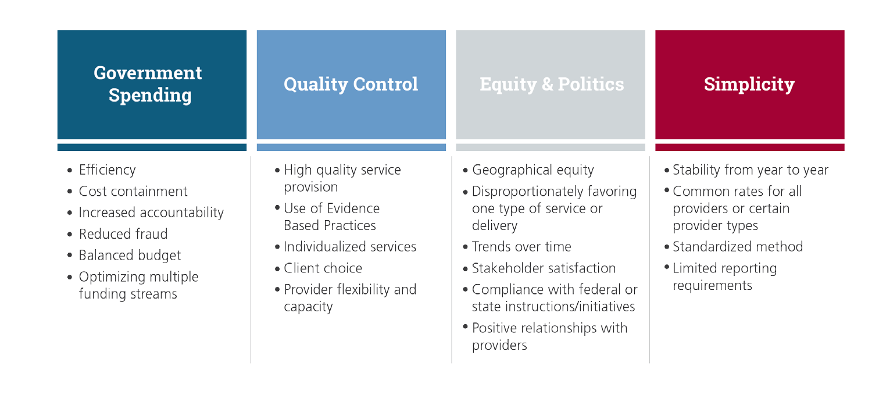

What do you want us to know before we start?

What is the best way to engage providers throughout the process?

Next Steps

* + - PCG is currently developing a project work plan with EOHHS
    - PCG is beginning to review rate setting materials

[www.publicconsultinggroup.com](http://www.publicconsultinggroup.com/)