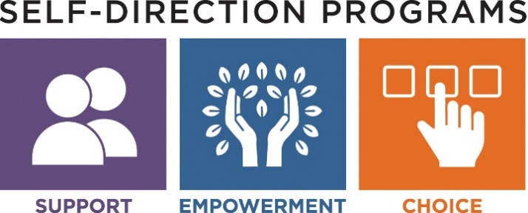

Frequently Asked Questions for Participant Directed Program

- Q: If I want to Self-Direct my DDS services with the Participant Directed Program how would I get started?
A: To be enrolled in the Participant Directed Program (PDP) you should contact your DDS Service Coordinator. A person must be eligible for adult DDS services, have an assessed need and be prioritized for DDS services with an allocation. You must be willing to work with a DDS Service Coordinator/Support Broker as needed to learn about the aspects of the PDP.

- Q: At what age, can someone enroll in the Participant Directed Program?
A: Typically, DDS adult services begin at age 22 when school services end. Individuals who are eligible for ASD (Autism Services without Intellectual Disability) can receive services when they are 18 and leave school. Individuals enrolled in the DESE program may choose the direct their services through PDP. Other situations should be discussed with your Service Coordinator or Area Office.

- Q: What is a Support Broker?
A: A Support Broker is typically a DDS Service Coordinator that helps you to define your vision and needs. They will help to create a budget and develop a network of services and supports. The DDS Support broker assist in many aspects of their Participant Directed Program.

- Q: What is the Financial Management Service and how will I use it with the Participant Directed Program?
A: DDS has a contract with a Financial Management Service called Public Partnerships LLC (PPL). PPL provides fiscal accountability by ensuring payments are consistent with what DDS has authorized and abides by state and federal requirements. They issue paychecks and/or make payments every two weeks, they perform CORI and National Background check, process the employee applications, withhold appropriate taxes at the state and federal level, issue W-2 and 1099 statements in January, provide payroll status reports throughout year and arranges for workmen’s comp for employees.

- Q: Do my employees have taxes withheld from their paychecks?
A: Yes, taxes are withheld for employees this includes: Social Security, Medicaid (FICA), and state and federal income taxes are withheld from each employee’s paycheck. PPL will prepare and mail a W‐2 Wage Statement to each employee in January.

- Q: How do I find the employees to work?
A: Many people are creative and find employees in their everyday network. It could be someone they knew in the school system, neighbor, friend of the family or a person who is found through advertisements or online websites like RewardingWork.org, Care.com, Indeed.com and others. Word of mouth and being open to sharing the job posting is very helpful.

- Q: Can I hire a family member to be an employee?
A: Participants may not hire their spouse, or their legal guardian for any services. Other family members may be hired as an employee and paid for providing certain services only if they meet certain requirements. You should speak with your DDS Support Broker about hiring other family members for specific guidance.

- Q: What do employees complete to become hired?
A: They must complete an employment application which includes a CORI and National Background Check request. These must be completed and approved before they can work.

- Q: Can my employee work before they do their CORI check?
A: Employees cannot begin to work prior to CORI approval, and PPL will not issue payments for time submitted prior to CORI approval. This rule is in place to protect you and your family from hiring someone who may not meet the state standards to provide services available in this program. The National Background Check is required as well; this is a federal review of fingerprints.

- Q: What if I my employee can’t come to work one day?
A: It is important to develop a backup plan as part of the Participant Directed Program, for when employee is unavailable. Hiring several employees is a consideration.

- Q: How is the budget determined?
A: Each budget is based on the unique needs of the individual, the supports that are needed and the frequency of these services. The DDS Area Director determines the general amount of the budget based on the information from assessments and available resources. A DDS approved budget is necessary for enrollment in the Participant Directed Program.

- Q: How will a participant be able to keep track of their budget?
A: Participants will have access to view their budget online in real time through the PPL Web Portal. Participants can also review and discuss their budgets with their DDS Support Broker.

- Q: If there are funds left at the end of the fiscal year, what happens?
A: The budget is developed for a fiscal year (July 1 to June 30), to provide the services and supports that a person needs. Unused funds cannot be carried over to the next fiscal year or given to the individual directly.

- Q: Can a participant purchase “Goods and Services” for example memberships or activities, classes etc.?
A: Yes, Goods and Services can be purchased, but should be discussed in advance with your DDS support Broker. A request for payment or reimbursement will only be paid with a completed PPL invoice and/or receipt. This option must follow DDS guidance and procedures which outlines the categories of allowable and disallowable expenditures, prior approval requirements and procedures, and other reporting and monitoring requirements.

- Q: Are there other Self-Directed options besides the Participant Directed Program?
A: Yes, the Agency with Choice Model offers the same ability to individualize supports and activities, but with the assistance of a qualified provider Agency knowledgeable about self-determination. Another option is to have a combination of traditional services and the Participant Directed Program.

MASSACHUSETTS DEPARTMENT OF DEVELOPMENTAL SERVICES

