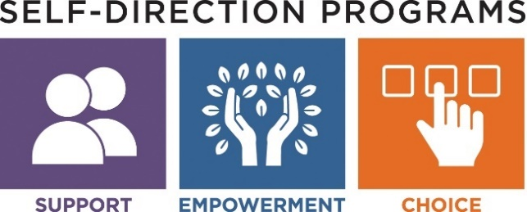

Participant Directed Program
The Participant Directed Program (PDP) offers the most flexibility, creativity and opportunity to individualize supports. This model allows participants and families the freedom to customize their activities and focus on their interests and needs.
In this model participants and their family identify and hire support staff of their choice. They will manage an individual DDS budget, and work with a financial management service to process payroll and invoices. Individuals may do this with the help of a guardian, family, friends, and will have the assistance of their DDS Service Coordinator/Support Broker.
Although this model offers the most flexibility, control and independence, DDS guidelines must be observed. The individual determines what supports will be provided based on specific needs identified in the Individual Support Plan (ISP).
The Participant Directed Program offers the following key components:
DDS SUPPORT BROKER
- Works in full partnership with the participant/family to customize a support arrangement that will meet the participant’s needs, and to develop an individualized budget. This may include assistance with the hiring process, developing job descriptions, creating interview questions, and supporting staff recruitment.
- May assist with the online registration and credentialing process for new employees.
- Assists in drafting, monitoring and revising the individual’s budget.
- Helps make adjustments to stay within the budget as necessary in accordance with changing needs.
FINANCIAL MANAGEMENT SERVICE
DDS contracts with Public Partnerships Limited (PPL) to provide this service:
- Responsible for processing completed employee registration, credentialing, CORI and National Background Check.
- Assists in the financial management and accountability of the individual’s DDS allocation, and assumes employer fiscal responsibility (e.g., payroll, taxes, worker’s compensation).
- Processes payroll as well as payment for approved goods and services.
- Provides a monthly financial report, as well as online access to review the individual’s budget.

MASSACHUSETTS DEPARTMENT OF DEVELOPMENTAL SERVICES

