**INDOOR AIR QUALITY ASSESSMENT**

**South Memorial Elementary School**

**16 Maple Street Extension**

**Peabody, MA**

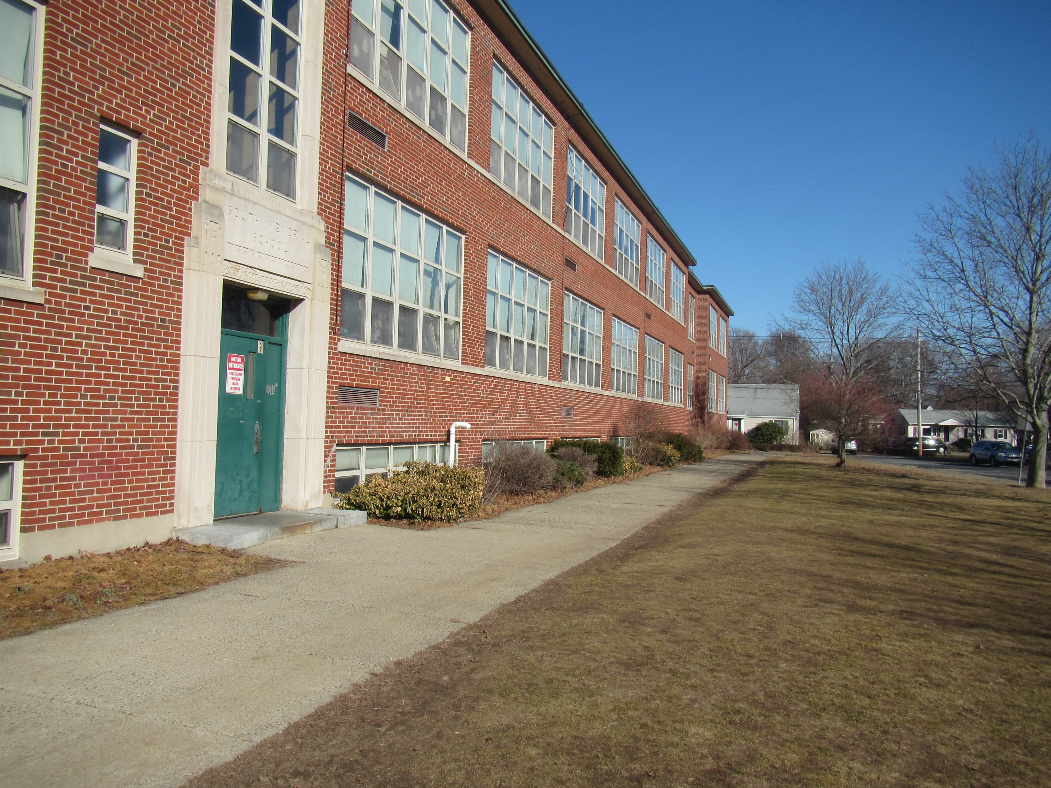

Prepared by:

Massachusetts Department of Public Health

Bureau of Environmental Health

Indoor Air Quality Program

February 2023

# BACKGROUND

|  |  |
| --- | --- |
| **Building:** | South Memorial Elementary School (SMES) |
| **Address:** | 16 Maple Street Extension, Peabody, MA |
| Assessment Requested Through: | Sharon Cameron, Director of Health and Human Services, City of Peabody and James Hafey, Facility Director, City of Peabody |
| **Reason for Request:** | Complaint by a parent regarding general indoor air quality (IAQ) issues, follow up during the heating season. |
| **Date of Assessment:** | February 15, 2022 |
| **Massachusetts Department of Public Health/Bureau of Environmental Health (MDPH/BEH) Staff Conducting Assessment:** | Ruth Alfasso Environmental  Engineer/Inspector, and Jen Lajoie,  Environmental Analyst/Inspector IAQ  Program |
| **Building Description:** | The SMES is a two-story brick building with an occupied basement originally constructed in 1950 with an addition in the 1990s. |
| **Windows:** | Windows in most areas are new and openable. |

# METHODS

Please refer to the IAQ Manual for methods, sampling procedures, and interpretation of results (MDPH, 2015). This building was assessed in the summer of 2022 while partially occupied with summer programs. A copy of that report is available here: <https://www.mass.gov/info-details/indoor-air-quality-reports-cities-and-towns-p#peabody->. This visit was a follow-up to the previous visit and see the building during the heating season.

# RESULTS and DISCUSSION

The following is a summary of indoor air testing results (Table 1). Note that only selected rooms were assessed during this visit:

* ***Carbon Dioxide*** was below the MDPH recommended guideline of 800 parts per million (ppm) in all but one of the rooms assessed. Some rooms had open windows which may contribute to lower carbon dioxide levels.
* ***Temperature*** was within the MDPH recommended range of 70°F to 78°F in all areas tested.
* ***Relative Humidity*** was slightly below the MDPH recommended range of 40 to 60% in the areas tested. Low relative humidity is typical during the heating season.
* ***Carbon Monoxide*** was not detected (ND) in any indoor areas assessed.
* ***Particulate matter (PM2.5)*** concentrations measured were below the National Ambient Air Quality (NAAQS) level of 35 μg/m3 in all areas tested.

## Ventilation

A heating, ventilating, and air conditioning (HVAC) system has several functions. First it provides heating and, if equipped, cooling. Second, it is a source of fresh air. Finally, an HVAC system will dilute and remove normally occurring indoor environmental pollutants by not only introducing fresh air, but by filtering the airstream and ejecting stale air to the outdoors via exhaust ventilation. Even if an HVAC system is operating as designed, point sources of respiratory irritation may exist and cause symptoms in sensitive individuals.

Fresh air in most rooms in the SMES is provided by unit ventilators (univents, Pictures 1 and 2). Most of the units appear to be original to the building, dating from the 1950s. Univents draw air from the outdoors through a fresh air intake located on the exterior wall of the building (Picture 3) and return air through an air intake located at the base of the unit. Fresh and return air are mixed, filtered, heated, and provided to rooms through an air diffuser located in the top of the unit (Figure 1). Thus, for proper operation, the top and front of the equipment should not be blocked. Some univents were blocked with furniture and items at the time of the assessment (Picture 1).

Mechanical exhaust ventilation in classrooms is provided by exhaust vents located along the hallway wall, sometimes located in “cubbies” (small insets into the wall) connected to fans on the roof (Picture 4). Some exhaust cubbies had items and furniture in front of them. Exhaust vents should also not be blocked. Many of the exhaust vents examined were either drawing weakly or not at all. This includes exhaust vents in the student bathrooms on the second floor which had no draw of air. Exhaust vents should be checked for airflow periodically to ensure they are on, and the fans are operable, and repaired as needed. Exhaust vents are particularly necessary in restrooms to remove moisture and odors generated there.

The MDPH IAQ Program recommends that supply and exhaust ventilation operate continuously during occupied periods to provide air exchange and filtration. Without sufficient supply and exhaust ventilation, normally occurring environmental pollutants can build up and lead to indoor air quality/comfort complaints.

It is important to note that the univents examined are well past the end of their life cycle. Efficient function of equipment of this age (greater than 50 years old in the case of the original part of the building) is difficult to maintain, since compatible replacement parts are often unavailable. According to the American Society of Heating, Refrigeration, and Air-Conditioning Engineering (ASHRAE), the service life of this type of unit is 15-20 years, assuming routine maintenance of the equipment (ASHRAE, 1991).

To have proper ventilation with a mechanical ventilation system, the systems must be balanced after installation to provide an adequate amount of fresh air to the interior of a room while removing stale air from the room. It is recommended that HVAC systems be re-balanced every five years to ensure adequate air systems function (SMACNA, 1994). Based on the age and condition of the univents, re-balancing of the HVAC system may not be possible.

Fresh air to classrooms is also supplied by openable windows, and the windows in the SMES are in good condition. Windows were open in many of the occupied areas of the building on the day of the assessment (Table 1). Windows should be tightly closed during severe weather and at the end of the school day.

Portable air conditioners and window-mounted air conditioners were noted in a few places (Picture 5). Note that windows should not be opened while air conditioning is operating. An influx of hot, humid outside air that contacts surfaces chilled by air conditioning can lead to condensation. Alternating opening windows and use of portable air conditioners can provide air exchange while minimizing the chance of condensation.

Univents have filters, which are reportedly changed 2-3 times a year during school breaks. One univent cabinet was opened and the filter examined (Picture 6). The filter was soiled and in need of changing; filter change was planned for school break the week after the visit. The univent cabinet also needs to be vacuumed out to remove accumulated debris. Note that this filter appears to be is of a low Minimum Efficiency Rating Value (MERV). The MDPH IAQ program recommends a MERV of 8 or higher if the equipment can handle the pressure reductions caused by more restrictive filters.

## Moisture/Microbial Issues

The IAQ program looked for water damage and sources of moisture that can impact indoor air quality. During the previous visit, water-damaged ceiling tiles were noted in classrooms and other areas suggesting leaks from plumbing and through the side of the building envelope. It appeared as though some water-damaged and missing tiles had been replaced since the visit over the summer. Water-damaged ceiling tiles should be removed and replaced once the source of the water damage is identified and repaired. Note that most of the ceiling tiles in the SMES are a type that adhere directly onto the ceiling. These can be difficult to replace, and tiles of this style may not be generally available. Basement areas have suspended ceiling tiles, which should be replaced promptly when missing, as gaps in a suspended ceiling tile grid can allow dust and debris from above the ceiling tiles into occupied space.

During the visit over the summer, facility staff reported that many of the sinks found in classrooms are unused or have been turned off. Plumbing that is not needed should be properly abandoned so it doesn’t become a source of leaks. Also, drains attached to unused plumbing need to be properly sealed or wetted periodically to avoid dry drain traps. If the P-trap seals on plumbing become dry, sewer gases can enter occupied spaces. Many of the sink countertops and cabinets were in poor condition, or had been repaired using contact paper, strips of wood, and other materials (Picture 7). Since the area around a sink is a moist environment, water-resistant materials should be used for repairs.

Aquariums were noted in some areas (Picture 8). Aquariums, terrariums, and similar items should be kept clean to prevent odors and microbial growth. If any indoor plants are present, they should be well maintained and not overwatered to prevent water damage and pests. This includes plants used for science experiments. Plants, aquariums, terrariums, and other sources of odors should be kept away from the airstream of univents and other ventilation equipment.

The exterior of the building was examined for potential sources of odors, pollutants, and water infiltration. Plants were noted close to the exterior of the building along one side (Picture 9). Plants can be a source of pollen, mold, and odors through univents or open windows. Plants can also hold moisture against the side of the building which increases deterioration of the building envelope. And plants can also be potential food and harborage for pests. Plants should be trimmed at least five feet from the exterior of the building.

Holes in dirt next to the foundation appeared to be rat burrows (Picture 10). Rats can be a source of allergens in dander and urine. In addition, rat activity can damage buildings, leading to water infiltration.

Light was visible beneath some exterior doors (Picture 11) indicating that the weather stripping is missing or worn out. Lack of weather stripping can allow unconditioned air, moisture, and pests into the building.

## Other issues

Exposure to low levels of total volatile organic compounds (TVOCs) may produce eye, nose, throat, and/or respiratory irritation in some sensitive individuals. BEH/IAQ staff examined spaces for products containing VOCs. BEH/IAQ staff noted hand sanitizers, cleaning products, and dry erase materials in some areas (Picture 12; Table 1). All of these products have the potential to be irritants to the eyes, nose, throat, and respiratory system of sensitive individuals. Scented products such as air fresheners should not be used in schools, as many people are sensitive to the chemical compounds used in them. Consult the document “[Clean Air Is Odor Free](https://www.mass.gov/doc/clean-air-is-odor-free-removing-fragrances-to-improve-indoor-air-quality-in-schools-and-0/download)” for more information on use of scented products. While hand sanitizers may be necessary, these should be used in areas with good ventilation, with the containers kept closed when not in use.

Photocopiers were noted in some office/staff areas. Photocopiers can be a source of odors, particulates, and VOCs, particularly if older or heavily used. Photocopiers should be placed in well-ventilated areas away from occupants and near an exhaust vent whenever possible. Laminators, 3-D printers, and other sources of plastic fumes should also be used away from occupants and with good ventilation, preferably a direct exhaust vent.

Air purifying units were noted a few areas. Air purifiers that have ionizing air settings may produce ozone should not be used in occupied areas (US EPA, 2003). Air purifiers using high-efficiency particulate arrestance (HEPA) filters are a good choice to remove suspended particles in the air. They should be used and maintained, including filter changes, in accordance with manufacturer's instructions.

In a few classrooms, tennis balls were found sliced open and placed on chair legs to reduce noise (Table 1). Tennis balls are made of a number of materials that are a source of respiratory irritants. Constant wearing of tennis balls can produce fibers and off-gas VOCs. Tennis balls are made with a natural rubber latex bladder, which becomes abraded when used as a chair leg pad. Use of tennis balls in this manner may introduce latex dust into the school environment. Some individuals are highly allergic to latex (e.g., spina bifida patients) (SBAA, 2001). It is recommended that the use of materials containing latex be limited to reduce the potential for symptoms in sensitive individuals (NIOSH, 1997). Latex-free glides should be used for this purpose.

Items were noted on surfaces in classrooms, including floors and univents (Picture 13). Items stored in classrooms, offices and storerooms provide a source for dusts to accumulate and make it difficult for custodial staff to clean. Items should be stored neatly and sorted frequently to remove items that are no longer needed.

Items were noted hanging from ceilings in some classrooms (Table 1). Hanging items can be difficult to clean of accumulated dust that may become airborne when they are disturbed.

Many classrooms had area rugs (Picture 13; Table 1). Facility staff reported that these are all purchased new for the school and kept off the floor during the summer. Carpets and area rugs should be vacuumed regularly with a high efficiency particulate arrestance (HEPA)-filter-equipped vacuum cleaner and cleaned annually (or semi-annually in soiled/high traffic areas) in accordance with Institute of Inspection, Cleaning and Restoration Certification (IICRC) recommendations (IICRC, 2012). Second-hand area rugs should not be used in classrooms, as they may bring allergens such as pet hair into the school.

Food and food preparation equipment such as microwaves and small refrigerators, were found in some classrooms and staff areas. Food can be attractive to pests. Debris inside food preparation equipment can give off smoke and odors when the equipment is used. Refrigerators and food preparation equipment should be kept clean to prevent odors and potential microbial growth.

The Environmental Protection Agency (EPA) conducted a National School Radon Survey in which it discovered nearly one in five schools had “…at least one frequently occupied ground contact room with short-term radon levels above 4 [picocuries per liter] pCi/L” (US EPA, 1993). The BEH/IAQ Program therefore recommends that every school be tested for radon, and that this testing be conducted during the heating season while school is in session in a manner consistent with USEPA radon testing guidelines. Radon measurement specialists and other information can be found at [www.nrsb.org](http://www.nrsb.org) and <http://aarst-nrpp.com/wp>, with additional information at: <http://www.mass.gov/eohhs/gov/departments/dph/programs/environmental-health/exposure-topics/iaq/radon>.

# CONCLUSION AND RECOMMENDATIONS

In view of the findings at the time of the visit, the following recommendations are made these recommendations are separated into short-term recommendations, and long-term recommendations that may require planning and capital funds to achieve.

Management of a building without air conditioning can be challenging. The following documents can provide guidance that can be used to reduce the impact of hot, humid weather in buildings:

* Preventing mold growth in Massachusetts schools during hot, humid weather: <https://www.mass.gov/service-details/preventing-mold-growth-in-massachusetts-schools-during-hot-humid-weather>
* Remediation and prevention of mold growth and water damage in public schools and buildings to maintain air quality: <https://www.mass.gov/service-details/remediation-and-prevention-of-mold-growth-and-water-damage-in-public-schools-and-buildings-to-maintain-air-quality>
* Methods for increasing comfort in non-air-conditioned schools: <https://www.mass.gov/doc/methods-for-increasing-comfort-in-non-air-conditioned-schools/download>

## Short-Term Recommendations

### Ventilation Recommendations

1. Operate supply and exhaust ventilation continuously when the building is occupied. Check univents and exhaust vents during occupied periods to ensure they are on and operating. This includes exhaust vents in restrooms.
2. Educate teachers and staff on the operation of univents so they can avoid blocking the operation of units and can report off or inoperable units to facility staff. If not already in use, consider using a tracking program to collect and administer work orders for mechanical systems such as classroom univents.
3. Avoid blocking the front and sides of univents and exhaust vents with furniture and items.
4. Continue with regular filter changes for HVAC equipment using the best quality/highest MERV rated filters that can be used with current equipment. During filter changes, vacuum debris from univent cabinets.
5. Use openable windows to supplement fresh air ventilation during periods of mild weather. Ensure all windows are closed tightly at the end of each day.
6. Avoid opening windows when air conditioning is operating in the room.
7. Maintain portable air conditioners, window air conditioners and air purifiers in accordance with manufacturer's instructions including cleaning.
8. Consider adopting a balancing schedule of every 5 years for all mechanical ventilation systems, as recommended by ventilation industrial standards (SMACNA, 1994) if this is possible with current equipment.

### Water Damage Recommendations

1. Determine the source of water-damaged ceiling tiles and repair leaks.
2. Replace ceiling-adhered tiles where possible. Repair or remove loose tiles to prevent them from falling and creating dust and debris.
3. Replace suspended water-damaged ceiling tiles to ensure a continuous ceiling plenum in these areas. Inspect the area above the stained tiles for other signs of water damage and clean/repair as needed. Use methods from US EPA’s “Mold Remediation in Schools and Commercial Buildings” during any mold removal activities (US EPA, 2008).
4. Examine the ceiling plenum above bowed/sagging suspended tiles for water damage and odors and repair if necessary. Note that areas where ceiling tiles are bowed have likely been exposed to long periods of high humidity. Porous items should not be stored in these areas, particularly on floors, during the summer months to prevent water damage.
5. If plumbing fixtures (e.g., classroom sinks) are no longer needed, have them properly cut and capped. Ensure seldom-used drains are wetted periodically to maintain the trap seal.
6. Ensure repairs to sink cabinets are made using water-resistant non-porous materials.
7. Ensure plants are well-maintained and not overwatered. Avoid placing plants on or in the airstream of univents.
8. Ensure any aquariums, terrariums and similar items are kept clean.
9. Avoid storage of porous materials or large amounts of items under sinks.
10. Trim plants and bushes away from the building a minimum of five feet, especially near windows and univent intakes.
11. Repair or replace weather stripping on doors where light is visible underneath.

### Other Recommendations

1. Use the services of a licensed pest control company to monitor for and control rodents on the exterior of the building. Removal of exterior plants as recommended above will reduce harborages. The location of the suspected rat burrows is also near the dumpsters. Dumpsters should be kept in good condition with no holes and tight-fitting lids that are kept closed to deter rodents, and should be emptied frequently.
2. Avoid bringing in scented products (e.g., air fresheners, candles). Use only school-provided cleaning materials to avoid potential product interactions.
3. Consider moving heavily used photocopiers away from occupants and to areas with exhaust ventilation.
4. Use laminators away from occupants; open the window adjacent to the laminator when it is in use.
5. Store items neatly and off the floor to assist with cleaning.
6. Avoid hanging items from the ceiling.
7. Keep food stored in tightly closed pest-proof containers.
8. Keep food preparation equipment clean.
9. Clean area rugs and carpets in accordance with IIRC recommendations. Store area rugs rolled up and off the floor in a dry area during summer break.
10. The school should be tested for radon by a certified radon measurement specialist during the heating season when school is in session. Radon measurement specialists and other information can be found at: [www.nrsb.org](http://www.nrsb.org), and <http://aarst-nrpp.com/wp>.
11. To learn more about radon, review the MDPH’s Radon in Schools and Child Care Programs factsheet, with additional information at: <http://www.mass.gov/eohhs/gov/departments/dph/programs/environmental-health/exposure-topics/iaq/radon>.
12. Consider including an IAQ component in the school’s Wellness Advisory Committee. An IAQ plan should have an IAQ liaison/teacher representative, a member of maintenance/facilities and administration that conduct regular walk-throughs to identify on-going and/or potential environmental issues.
13. Consider adopting the US EPA (2000) document, “Tools for Schools,” as an instrument for maintaining a good IAQ environment in the building available at: : [Creating Healthy Indoor Air Quality in Schools | US EPA](https://www.epa.gov/iaq-schools)
14. For guidance on maintaining an asthma-friendly healthy school environment, please consult the MDPH Asthma Prevention and Control Program’s [Clearing the Air: An Asthma Toolkit for Healthy Schools](https://www.maasthma.org/schooltoolkit).
15. Refer to the resource manual and other related indoor air quality documents located on the MDPH’s website for further building-wide evaluations and advice on maintaining public buildings. These documents are available at <http://mass.gov/dph/iaq>.

## Long-term recommendations

1. Contact an HVAC engineering firm for an assessment of the ventilation system’s control system (e.g., controls, air intake louvers, thermostats), units and components. Based on the age, physical deterioration, and availability of parts for ventilation components, such an evaluation is necessary to determine the operability and feasibility of repairing/replacing the equipment.

# REFERENCES

ASHRAE. 1991. ASHRAE Applications Handbook, Chapter 33 “Owning and Operating Costs”. American Society of Heating, Refrigeration and Air Conditioning Engineers, Atlanta, GA.

IICRC. 2012. Institute of Inspection, Cleaning and Restoration Certification. Carpet Cleaning: FAQ.

MDPH. 2015. Massachusetts Department of Public Health. Indoor Air Quality Manual: Chapters I-III. Available at: <https://www.mass.gov/lists/indoor-air-quality-manual-and-appendices#indoor-air-quality-manual->

NIOSH. 1997. NIOSH Alert Preventing Allergic Reactions to Natural Rubber latex in the Workplace. National Institute for Occupational Safety and Health, Atlanta, GA.

SBAA. 2001. Latex In the Home And Community Updated Spring 2001. Spina Bifida Association of America, Washington, DC.

SMACNA. 1994. HVAC Systems Commissioning Manual. 1st ed. Sheet Metal and Air Conditioning Contractors’ National Association, Inc., Chantilly, VA.

US EPA. 1993. Radon Measurement in Schools, Revised Edition. Office of Air and Radiation, Office of Radiation and Indoor Air, Indoor Environments Division (6609J). EPA 402-R-92-014

US EPA. 2003. “Ozone Generators that are Sold as Air Cleaners: An Assessment of Effectiveness and Health Consequences”. United States Environmental Protection Agency, Office of Air and Radiation, Indoor Environments Division, Washington, DC. Last updated September, 2018. <https://www.epa.gov/indoor-air-quality-iaq/ozone-generators-are-sold-air-cleaners>

US EPA. 2008. “Mold Remediation in Schools and Commercial Buildings”. Office of Air and Radiation, Indoor Environments Division, Washington, DC. EPA 402-K-01-001. September 2008. Available at: <http://www.epa.gov/mold/mold-remediation-schools-and-commercial-buildings-guide>

**Figure 1**

**Unit Ventilator (Univent)**

Mixed Air

Air Diffuser

**Outdoors Indoors**

Fan

Heating/Cooling Coil

Air Mixing Plenum

Filter

Outdoor Return

Air Air

Air

Flow

Control

Louvers

**Air Flow**

= Fresh Air/Return Air

= Mixed Air

**Picture 1**

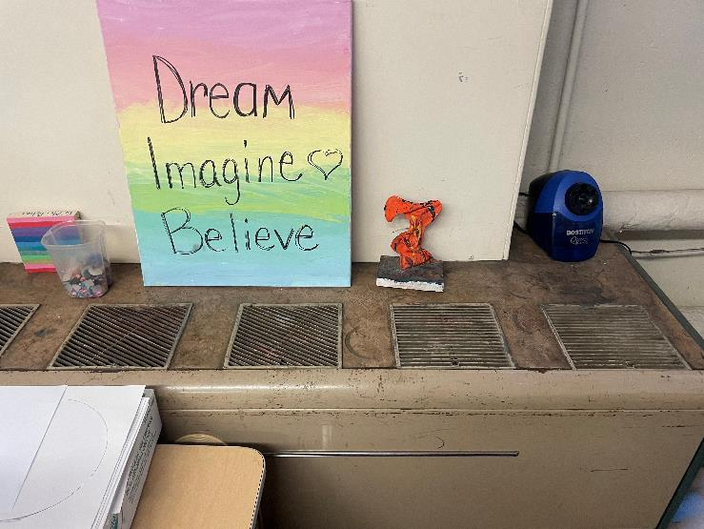

**Top of a classroom univent, note furniture in front**

**Picture 2**

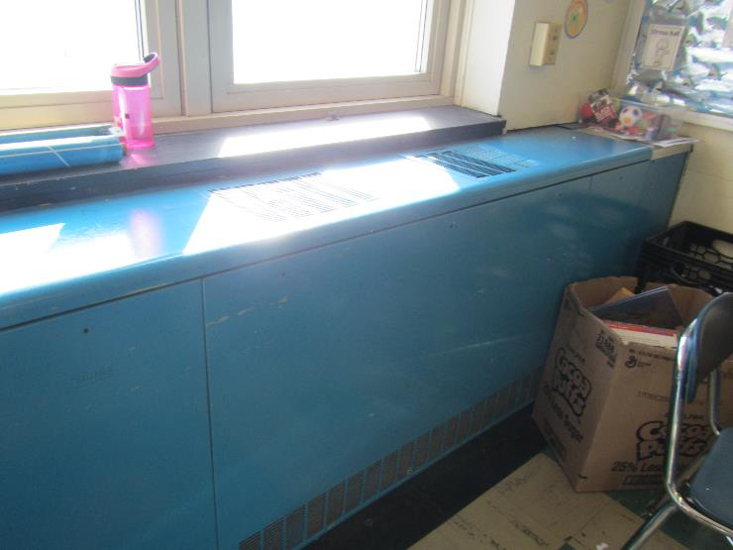

**Classroom univent in the newer wing**

**Picture 3**

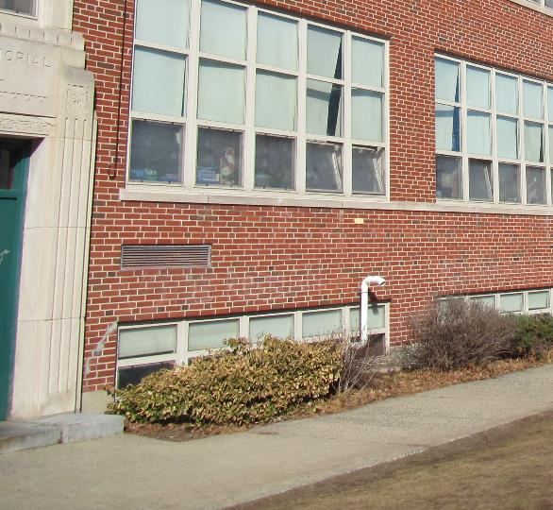

**Univent air intake on outside of building**

**Picture 4**

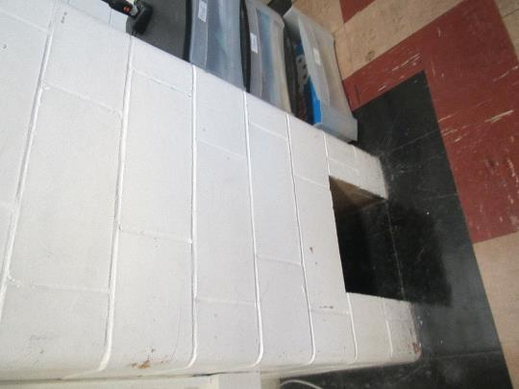

**Classroom exhaust “cubby”**

**Picture 5**

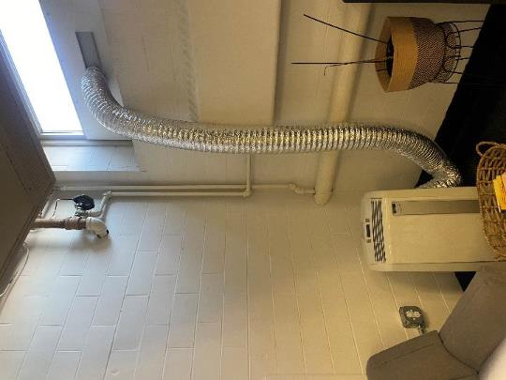

**Portable air conditioner in the teacher’s lunchroom**

**Picture 6**

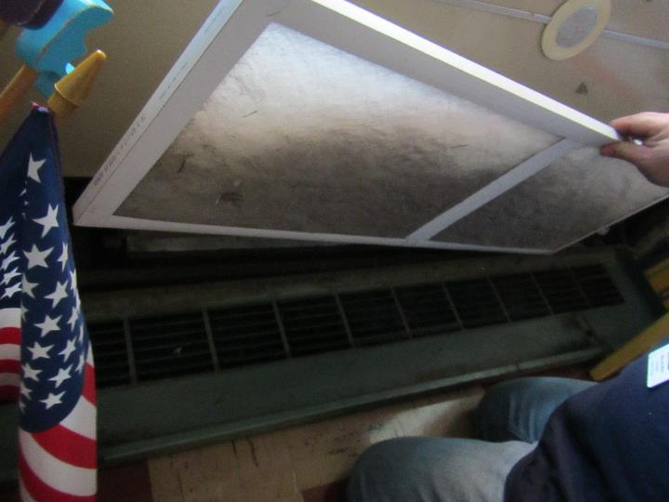

**Soiled univent filter**

**Picture 7**

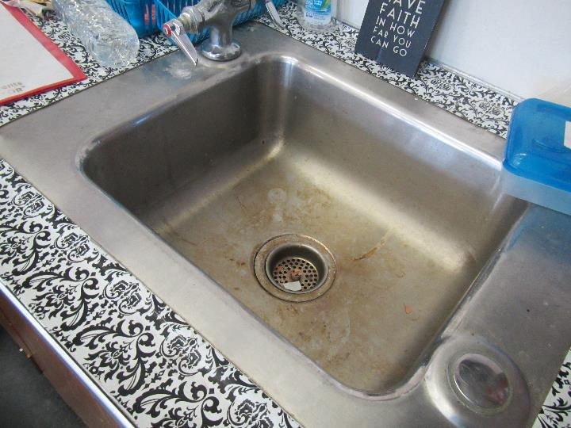

**Sink countertop repaired with contact paper**

**Picture 8**

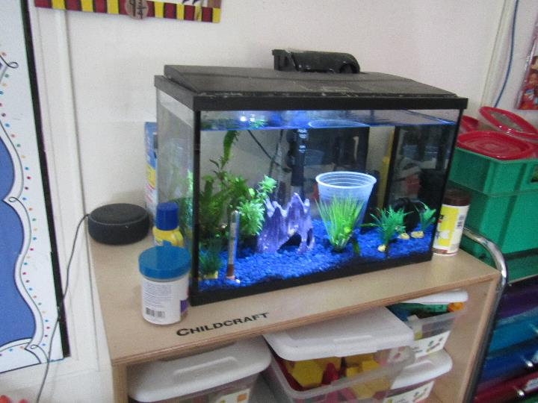

**Aquarium in a classroom**

**Picture 9**

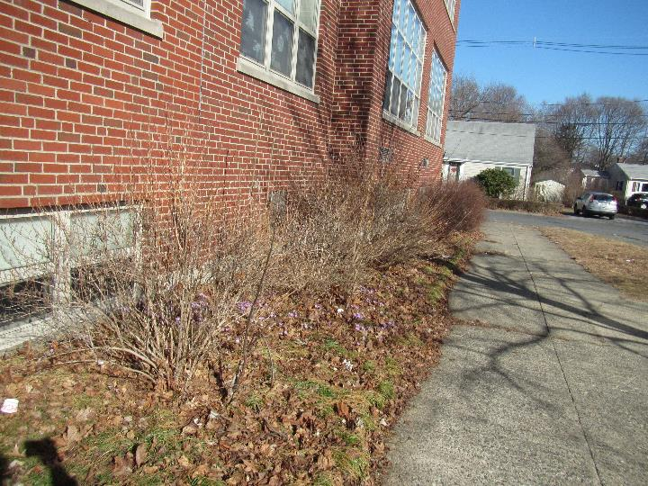

**Bushes and trees near the building, including below univent air intakes**

**Picture 10**

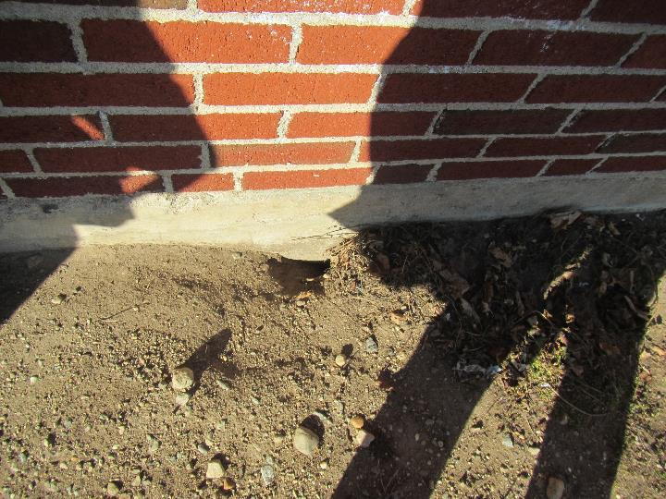

**Holes in soil next to building that may be rat burrows**

**Picture 11**

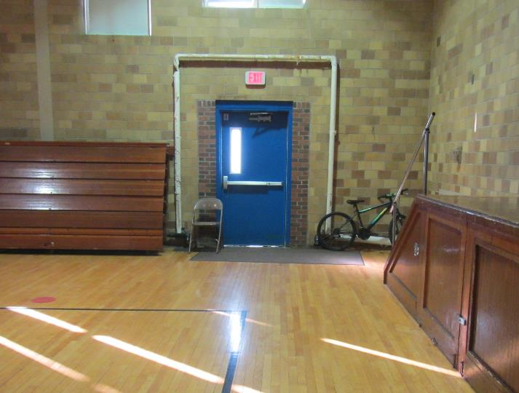

**Light visible beneath door to the outside**

**Picture 12**

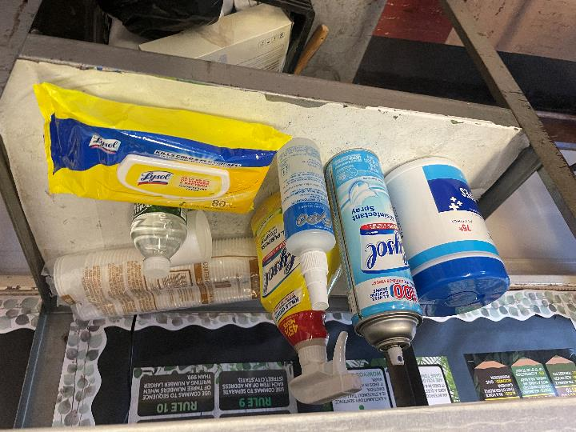

**Cleaning products and sanitizers in a classroom**

**Picture 13**

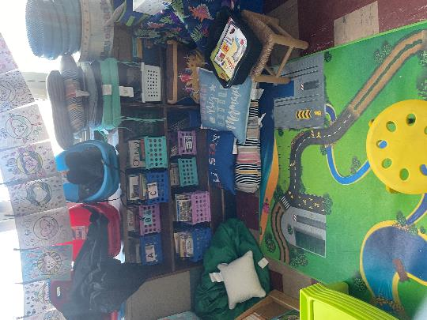

**Items in a classroom including area rugs**

| **Location/Room** | **Carbon**  **Dioxide**  **(ppm)** | **Carbon Monoxide**  **(ppm)** | **Temp**  **(°F)** | **Relative**  **Humidity**  **(%)** | **PM2.5**  **(µg/m3)** | **Occupants**  **in Room** | **Windows**  **Openable** | **Ventilation** | | **Remarks** |
| --- | --- | --- | --- | --- | --- | --- | --- | --- | --- | --- |
| **Supply** | **Exhaust** |
| Background (outside) | 396 | ND | 55 | 41 | ND |  |  |  |  | Sunny and breezy |
| Second Floor | | | | | | | | | | |
| 210 | 631 | ND | 72 | 30 | ND | 18 | Y | Y on | Y | Area rugs, tennis balls on chair legs, hanging items |
| 206 | 626 | ND | 73 | 36 | ND | 16 | Y open | Y | Y | Multiple Lysol products, area rugs, CTs falling down |
| 201 | 478 | ND | 71 | 32 | ND | 16 | Y open | Y | Y | Area rugs, vent blocked, CTs missing |
| 203 | 837 | ND | 74 | 39 | ND | 16 | Y | Y | Y | Area rugs, exercise balls used as chairs, missing CTs, hanging items |
| 2nd floor girls’ restroom |  |  |  |  |  |  | Y |  | Y | Exhaust off |
| First Floor | | | | | | | | | | |
| 104 | 752 | ND | 75 | 31 | 1 | 17 | Y open | Y | Half blocked |  |
| 102 | 730 | ND | 75 | 31 | 1 | 2 | Y open | Y | Y | Hanging items |
| 106 | 616 | ND | 73 | 30 | 1 | 0 | Y open | Y | Y | Hanging items, missing CTs, area rugs/pillows |
| Basement | | | | | | | | | | |
| Cafeteria | 598 | ND | 75 | 30 | ND | 0 | Y | Y | Y |  |
| Art | 703 | ND | 75 | 30 | 1 | 18 | Y open | Y | Y off | Floor temperature 72°F and higher, art supplies. Area rugs, vents blocked, CTs bowed |
| Teacher’s lunch | 753 | ND | 76 | 31 | 14 | 1 | Y open | Y | Y | Food, portable AC unit, fridge, microwave, toaster. Odor of food |
| Gym | 669 | ND | 76 | 30 | 3 | 20 | N | Y | Y on | Light visible under exterior door/weather stripping |