INDOOR AIR QUALITY ASSESSMENT

South Memorial Elementary School
16 Maple Street Extension
Peabody, MA

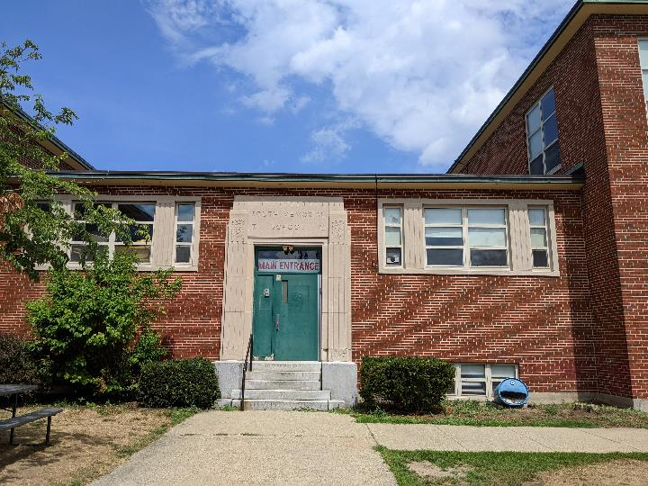

Prepared by:
Massachusetts Department of Public Health
Bureau of Environmental Health
Indoor Air Quality Program
October 2022

BACKGROUND
Building: | South Memorial Elementary School (SMES)
Address: | 16 Maple Street Extension, Peabody, MA
Assessment Requested Through: | Sharon Cameron, Director of Health and Human Services, City of Peabody and James Hafey, Facility Director, City of Peabody
Reason for Request: | Complaint by a parent regarding general indoor air quality (IAQ) issues
Date of Assessment: | August 9, 2022
Massachusetts Department of Public Health/Bureau of Environmental Health (MDPH/BEH) Staff Conducting Assessment: | Ruth Alfasso Environmental  Engineer/Inspector, IAQ Program
Building Description: | The SMES is a two-story brick building with an occupied basement originally constructed in 1950.
Windows: | Windows in most areas are new and openable.

METHODS
Please refer to the IAQ Manual for methods, sampling procedures, and interpretation of results (MDPH, 2015).

RESULTS and DISCUSSION
The following is a summary of indoor air testing results (Table 1):
- Carbon Dioxide was below the MDPH recommended guideline of 800 parts per million (ppm) in all but one of the rooms assessed. Note that only about 1/3 of the rooms tested were in use and occupancy in most was lower than during the normal school year. Carbon dioxide levels are likely to be higher with increased occupancy.
- Temperature was above the MDPH recommended range of 70°F to 78°F in all areas tested. This was due to high temperatures outside at the time of the assessment.
- Relative Humidity was within or above the MDPH recommended range of 40 to 60% in the areas tested. This was also reflective of outside conditions.
- Carbon Monoxide was not detected (ND) in any indoor areas assessed.
- Particulate matter (PM2.5) concentrations measured were below the National Ambient Air Quality (NAAQS) level of 35 μg/m³ in all areas tested.

Ventilation
A heating, ventilating, and air conditioning (HVAC) system has several functions. First it provides heating and, if equipped, cooling. Second, it is a source of fresh air. Finally, an HVAC system will dilute and remove normally occurring indoor environmental pollutants by not only introducing fresh air, but by filtering the airstream and ejecting stale air to the outdoors via exhaust ventilation. Even if an HVAC system is operating as designed, point sources of respiratory irritation may exist and cause symptoms in sensitive individuals.
Fresh air in the majority of rooms in the SMES is provided by unit ventilators (univents, Pictures 1 and 2). Most of the units appear to be original to the building, dating from the 1950s. Univents draw air from the outdoors through a fresh air intake located on the exterior wall of the building (Picture 3) and return air through an air intake located at the base of the unit. Fresh and return air are mixed, filtered, heated, and provided to rooms through an air diffuser located in the top of the unit (Figure 1). Thus, for proper operation, the top and front of the equipment should not be blocked with furniture or items. Some univents were blocked with furniture and items at the time of the assessment, however classrooms were not fully set up for the school year.
Mechanical exhaust ventilation in classrooms is provided by exhaust vents located along the hallway wall, sometimes located in “cubbies” (small insets into the wall) connected to fans on the roof (Pictures 4 and 5). There may also be exhaust vents located in larger insets in classrooms walls, but nearly all were blocked by filing cabinets which prevented observation (Picture 6). If currently used exhaust vents are located behind filing cabinets, these cabinets need to be removed to promote airflow in classrooms. Other exhaust vents should also not be blocked with furniture or items. Exhaust vents should be checked for airflow periodically to ensure they are on, and the fans are operable, and repaired as needed. Some classrooms and offices also had attached restrooms with exhaust vents, which should be on and operating during occupied hours to remove odors and moisture.
The MDPH IAQ Program recommends that supply and exhaust ventilation operate continuously during occupied periods to provide air exchange and filtration. Without sufficient supply and exhaust ventilation, normally occurring environmental pollutants can build up and lead to indoor air quality/comfort complaints.
It is important to note that the univents examined are well past the end of their life cycle. Efficient function of equipment of this age (greater than 50 years old) is difficult to maintain, since compatible replacement parts are often unavailable. According to the American Society of Heating, Refrigeration, and Air-Conditioning Engineering (ASHRAE), the service life of this type of unit is 15-20 years, assuming routine maintenance of the equipment (ASHRAE, 1991).
To have proper ventilation with a mechanical ventilation system, the systems must be balanced after installation to provide an adequate amount of fresh air to the interior of a room while removing stale air from the room. It is recommended that HVAC systems be re-balanced every five years to ensure adequate air systems function (SMACNA, 1994). Based on the age and condition of the univents, re-balancing of the HVAC system may not be possible.
Fresh air to classrooms is also supplied by openable windows. The windows in the SMES are recently installed and in good condition. Windows were open in many of the occupied areas of the building. Open windows are a good source of fresh air. Windows should be tightly closed during severe weather and at the end of the school day.
Portable air conditioners and window air conditioners were noted in many of the occupied rooms (classrooms used by the summer program, the pre-school, and office areas) (Pictures 1 and 7). Portable air conditioners do not supply any air exchange, and a minimal amount of air is exchanged during the operation of window air conditioners. However, windows should not be opened while air conditioning is operating. An influx of hot, humid outside air that contacts surfaces chilled by air conditioning can lead to condensation. Alternating opening windows and use of portable air conditioners can provide air exchange while minimizing the chance of condensation.
Univents have filters, which are reportedly changed 2-3 times a year. During filter changes, univent cabinets should be cleaned/vacuumed out to remove debris that may be a source of particulates and odors to the indoor air. Filters should be at least a Minimum Efficiency Rating Value (MERV) of 8, and higher if the equipment can handle the pressure reductions caused by more restrictive filters.

Moisture/Microbial Issues
The IAQ program looked for water damage and sources of moisture that can impact indoor air quality. Water-damaged ceiling tiles were noted in some classrooms (Picture 8; Table 1). In some areas, it appeared that plumbing leaks occurred on the floor above moistened tiles. Tiles in other locations appeared to have been moistened by leaks through masonry on the side of the building. While none of the tiles appeared to be colonized with mold, water-damaged ceiling tiles can be a source of odors and can become moldy if frequently or chronically moistened. Water-damaged ceiling tiles should be removed and replaced once the source of the water damage is identified and repaired. Note that most of the ceiling tiles in the SMES are a type that are adhered directly onto the ceiling. These can be difficult to replace, and tiles of this style may not be generally available. Some of these tiles were missing, or not fully adhered (Pictures 9 and 10; Table 1) which is also a sign of water damage. Because there is nothing above these tiles but the ceiling substrate, missing tiles are mostly an aesthetic issue, but falling or damaged tiles can be a source of debris that can be irritating if airborne.
Water-damaged and missing suspended ceiling tiles were noted in a few basement rooms (Table 1). Where suspended ceiling tiles are used, missing tiles should be replaced promptly as gaps in a suspended ceiling tile grid can allow dust and debris from above the ceiling tiles into occupied space.
Also note that many of the suspended-type ceiling tiles were bowed/sagging. This is frequently the result of exposure to extended periods of high humidity. Long periods of high humidity can also lead to condensation on surfaces such as floors, which can moisten materials such as carpeting and stored items. In areas where high humidity can lead to condensation, particularly below-grade areas, special care should be taken to avoid leaving porous materials on floors.
Some classrooms in the SMES have sinks, many of which were found covered with stored items. Facility staff reported that many of the sinks are unused or have been turned off. Plumbing that is not needed should be properly abandoned so it doesn’t become a source of leaks. Drains attached to unused plumbing need to also be properly sealed or wetted periodically to avoid dry drain traps. If the P-trap seals on plumbing become dry, sewer gases can enter occupied spaces. Many of the sink countertops and cabinets were in poor condition, or had been repaired using contact paper, strips of wood, and other materials. Since the area around a sink is a moist environment, water-resistant materials should be used for repairs.
Plants were found in several classrooms and offices (Table 1, Picture 11). Plants should be well maintained and not overwatered to prevent water damage and pests. This includes plants used for science experiments. Aquariums were noted in some areas (Picture 12). Aquariums, terrariums, and similar items should be kept clean to prevent odors and microbial growth. Plants, aquariums, terrariums, and other sources of odors should be kept away from the airstream of univents and other ventilation equipment.
The exterior of the building was examined for potential sources of odors, pollutants, and water infiltration. Plants were noted close to the exterior of the building along one side (Picture 13). Plants can be a source of pollen, mold, and odors through univents or open windows. Plants can also hold moisture against the side of the building which increases deterioration of the building envelope. And plants can also be potential food and harborage for pests. Plants should be trimmed at least five feet from the exterior of the building.

Other issues
Exposure to low levels of total volatile organic compounds (TVOCs) may produce eye, nose, throat, and/or respiratory irritation in some sensitive individuals. BEH/IAQ staff examined spaces for products containing VOCs. BEH/IAQ staff noted hand sanitizers, cleaning products, and dry erase materials in some areas (Table 1). All of these products have the potential to be irritants to the eyes, nose, throat, and respiratory system of sensitive individuals. Scented products such as air fresheners should not be used in schools, as many people are sensitive to the chemical compounds used in them. Consult the document “Clean Air Is Odor Free” for more information on use of scented products. While hand sanitizers may be necessary, these should be used in areas with good ventilation, with the containers kept closed when not in use.
Photocopiers were noted in some office/staff areas. Photocopiers can be a source of odors, particulates and VOCs, particularly if older or heavily used. Photocopiers should be placed in well-ventilated areas away from occupants and near an exhaust vent whenever possible. A laminator was found in a small room adjacent to a staff restroom (Picture 14). Laminators melt plastic and can create odors and waste heat. They should be used away from occupants and with good ventilation, preferably a direct exhaust vent. Note that there is an openable window in the room with the laminator which can provide exhaust ventilation when the unit is in use.
Air purifying units were noted a few areas. Air purifiers that have ionizing air settings may produce ozone should not be used in occupied areas (US EPA, 2003). Air purifiers using high-efficiency particulate arrestance (HEPA) filters are a good choice to remove suspended particles in the air. They should be used and maintained, including filter changes, in accordance with manufacturer's instructions.
Desktop and stand fans were noted in many classrooms. These items need to be kept clean of accumulated dust.
In a few classrooms, tennis balls were found sliced open and placed on chair legs to reduce noise (Table 1). Tennis balls are made of a number of materials that are a source of respiratory irritants. Constant wearing of tennis balls can produce fibers and off-gas VOCs. Tennis balls are made with a natural rubber latex bladder, which becomes abraded when used as a chair leg pad. Use of tennis balls in this manner may introduce latex dust into the school environment. Some individuals are highly allergic to latex (e.g., spina bifida patients) (SBAA, 2001). It is recommended that the use of materials containing latex be limited to reduce the potential for symptoms in sensitive individuals (NIOSH, 1997). Latex-free glides should be used for this purpose.
Items were noted on surfaces in classrooms, including floors and univents, in part because classrooms were not yet set up for the regular school year. Items stored in classrooms, offices and storerooms provide a source for dusts to accumulate and make it difficult for custodial staff to clean. Items should be stored neatly and sorted frequently to remove items that are no longer needed.
Many classrooms had area rugs. Facility staff reported that these are all purchased new for the school and kept off the floor during the summer. Carpets and area rugs should be vacuumed regularly with a high efficiency particulate arrestance (HEPA)-filter-equipped vacuum cleaner and cleaned annually (or semi-annually in soiled/high traffic areas) in accordance with Institute of Inspection, Cleaning and Restoration Certification (IICRC) recommendations (IICRC, 2012). Second-hand area rugs should not be used in classrooms, as they may bring allergens such as pest hair into the school.
Food and food preparation equipment such as microwaves and small refrigerators, were found in some classrooms and staff areas. Food can be attractive to pests. Debris inside food preparation equipment can give off smoke and odors when the equipment is used. Refrigerators and food preparation equipment should be kept clean to prevent odors and potential microbial growth.
The Environmental Protection Agency (EPA) conducted a National School Radon Survey in which it discovered nearly one in five schools had “…at least one frequently occupied ground contact room with short-term radon levels above 4 [picocuries per liter] pCi/L” (US EPA, 1993). The BEH/IAQ Program therefore recommends that every school be tested for radon, and that this testing be conducted during the heating season while school is in session in a manner consistent with USEPA radon testing guidelines. Radon measurement specialists and other information can be found at www.nrsb.org and http://aarst-nrpp.com/wp, with additional information at: http://www.mass.gov/eohhs/gov/departments/dph/programs/environmental-health/exposure-topics/iaq/radon.

CONCLUSION and RECOMMENDATIONS
In view of the findings at the time of the visit, the following recommendations are made these recommendations are separated into short-term recommendations, and long-term recommendations that may require planning and capital funds to achieve.
Management of a building without air conditioning can be challenging. The following documents can provide guidance that can be used to reduce the impact of hot, humid weather in buildings:
- Preventing mold growth in Massachusetts schools during hot, humid weather: https://www.mass.gov/service-details/preventing-mold-growth-in-massachusetts-schools-during-hot-humid-weather
- Remediation and prevention of mold growth and water damage in public schools and buildings to maintain air quality: https://www.mass.gov/service-details/remediation-and-prevention-of-mold-growth-and-water-damage-in-public-schools-and-buildings-to-maintain-air-quality
- Methods for increasing comfort in non-air-conditioned schools: https://www.mass.gov/doc/methods-for-increasing-comfort-in-non-air-conditioned-schools/download

Short-term recommendations

Ventilation Recommendations
- Operate supply and exhaust ventilation continuously when the building is occupied. Check univents and exhaust vents during occupied periods to ensure they are on and operating.
- Educate teachers and staff on the operation of univents so they can avoid blocking the operation of units and can report off or inoperable units to facility staff. If not already in use, consider using a tracking program to collect and administer work orders for mechanical systems such as classroom univents.
- Avoid blocking the front and sides of univents and exhaust vents with furniture and items when classrooms are set up for the school year.
- Check behind filing cabinets (e.g., Picture 6) for exhaust vents. Unblock operable vents by removing furniture. If vents exist but are part of an abandoned exhaust system, seal vents to prevent unwanted air transfer between rooms and potential pest transport and harborage.
- Continue with regular filter changes for HVAC equipment using the best quality/highest MERV rated filters that can be used with current equipment. During filter changes, vacuum debris from univent cabinets.
- Use openable windows to supplement fresh air ventilation during periods of mild weather. Ensure all windows are closed tightly at the end of each day.
- Avoid opening windows when air conditioning is operating in the room.
- Maintain portable air conditioners, window air conditioners and air purifiers in accordance with manufacturer's instructions including cleaning.
- Consider adopting a balancing schedule of every 5 years for all mechanical ventilation systems, as recommended by ventilation industrial standards (SMACNA, 1994) if this is possible with current equipment.

Water Damage Recommendations
- Determine the source of water-damaged ceiling tiles and repair leaks.
- Replace ceiling-adhered tiles where possible. Repair or remove loose tiles to prevent them from falling and creating dust and debris.
- Replace suspended water-damaged ceiling tiles to ensure a continuous ceiling plenum in these areas. Inspect the area above the stained tiles for other signs of water damage and clean/repair as needed. Use methods from US EPA’s “Mold Remediation in Schools and Commercial Buildings” during any mold removal activities (US EPA, 2008).
- Examine the ceiling plenum above bowed/sagging suspended tiles for water damage and odors and repair if necessary. Note that areas where ceiling tiles are bowed have likely been exposed to long periods of high humidity. Porous items should not be stored in these areas, particularly on floors, during the summer months to prevent water damage.
- If plumbing fixtures (e.g., classroom sinks) are no longer needed, have them properly cut and capped. Ensure seldom-used drains are wetted periodically to maintain the trap seal.
- Ensure repairs to sink cabinets are made using water-resistant non-porous materials.
- Ensure plants are well-maintained and not overwatered. Avoid placing plants on or in the airstream of univents.
- Ensure any aquariums, terrariums and similar items are kept clean.
- Avoid storage of porous materials or large amounts of items under sinks.
- Trim plants and bushes away from the building a minimum of five feet, especially near windows and univent intakes.

Other recommendations
- Avoid bringing in scented products (e.g., air fresheners, candles). Use only school-provided cleaning materials to avoid potential product interactions.
- Consider moving heavily used photocopiers away from occupants and to areas with exhaust ventilation.
- Use laminators away from occupants; open the window adjacent to the laminator when it is in use.
- Store items neatly and off the floor to assist with cleaning.
- Clean personal and stand fans of accumulated dust periodically.
- Keep food stored in tightly closed pest-proof containers.
- Keep food preparation equipment clean.
- Clean area rugs and carpets in accordance with IIRC recommendations. Store area rugs rolled up and off the floor in a dry area during summer break.
- The school should be tested for radon by a certified radon measurement specialist during the heating season when school is in session. Radon measurement specialists and other information can be found at: www.nrsb.org, and http://aarst-nrpp.com/wp.
- To learn more about radon, review the MDPH’s Radon in Schools and Child Care Programs factsheet, with additional information at: http://www.mass.gov/eohhs/gov/departments/dph/programs/environmental-health/exposure-topics/iaq/radon.
- Consider adopting the US EPA document, “Tools for Schools” as a method for maintaining a good indoor air quality environment. This document can be downloaded from the Internet at http://www.epa.gov/iaq/schools/index.html
- Contact the MDPH IAQ Program during the heating season when the school is in session for a follow-up visit.
- Refer to the resource manual and other related indoor air quality documents located on the MDPH’s website for further building-wide evaluations and advice on maintaining public buildings. These documents are available at http://mass.gov/dph/iaq.

Long-term recommendations
- Contact an HVAC engineering firm for an assessment of the ventilation system’s control system (e.g., controls, air intake louvers, thermostats), units and components. Based on the age, physical deterioration, and availability of parts for ventilation components, such an evaluation is necessary to determine the operability and feasibility of repairing/replacing the equipment.

REFERENCES
ASHRAE. 1991. ASHRAE Applications Handbook, Chapter 33 “Owning and Operating Costs”. American Society of Heating, Refrigeration and Air Conditioning Engineers, Atlanta, GA.
IICRC. 2012. Institute of Inspection, Cleaning and Restoration Certification. Carpet Cleaning: FAQ.
MDPH. 2015. Massachusetts Department of Public Health. Indoor Air Quality Manual: Chapters I-III. Available at: https://www.mass.gov/lists/indoor-air-quality-manual-and-appendices#indoor-air-quality-manual-
NIOSH. 1997. NIOSH Alert Preventing Allergic Reactions to Natural Rubber latex in the Workplace. National Institute for Occupational Safety and Health, Atlanta, GA.
SBAA. 2001. Latex In the Home And Community Updated Spring 2001. Spina Bifida Association of America, Washington, DC.
SMACNA. 1994. HVAC Systems Commissioning Manual. 1st ed. Sheet Metal and Air Conditioning Contractors’ National Association, Inc., Chantilly, VA.
US EPA. 1993. Radon Measurement in Schools, Revised Edition. Office of Air and Radiation, Office of Radiation and Indoor Air, Indoor Environments Division (6609J). EPA 402-R-92-014
US EPA. 2003. “Ozone Generators that are Sold as Air Cleaners: An Assessment of Effectiveness and Health Consequences”. United States Environmental Protection Agency, Office of Air and Radiation, Indoor Environments Division, Washington, DC. Last updated September, 2018. https://www.epa.gov/indoor-air-quality-iaq/ozone-generators-are-sold-air-cleaners
US EPA. 2008. “Mold Remediation in Schools and Commercial Buildings”. Office of Air and Radiation, Indoor Environments Division, Washington, DC. EPA 402-K-01-001. September 2008. Available at: http://www.epa.gov/mold/mold-remediation-schools-and-commercial-buildings-guide
Figure 1

Unit Ventilator (Univent)

Mixed Air

Air Diffuser

Outdoors Indoors

Fan

Heating/Cooling Coil

Air Mixing Plenum

Filter

Outdoor Return
Air Air

Air
Flow
Control
Louvers

Air Flow

= Fresh Air/Return Air

= Mixed Air

Picture 1
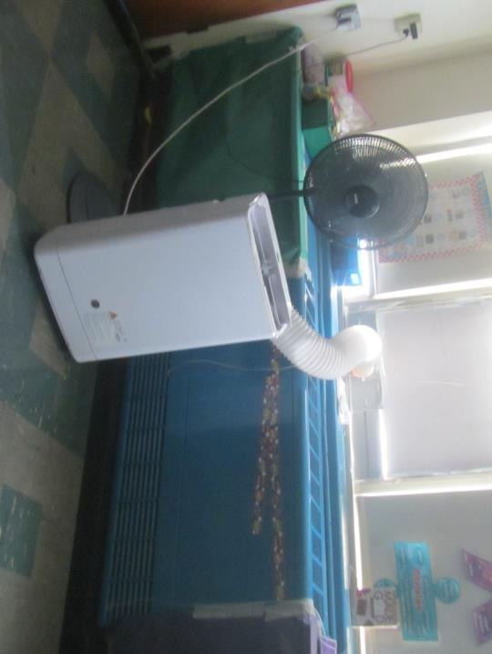
Classroom unit ventilator (univent), also note portable air conditioner and fan
Picture 2
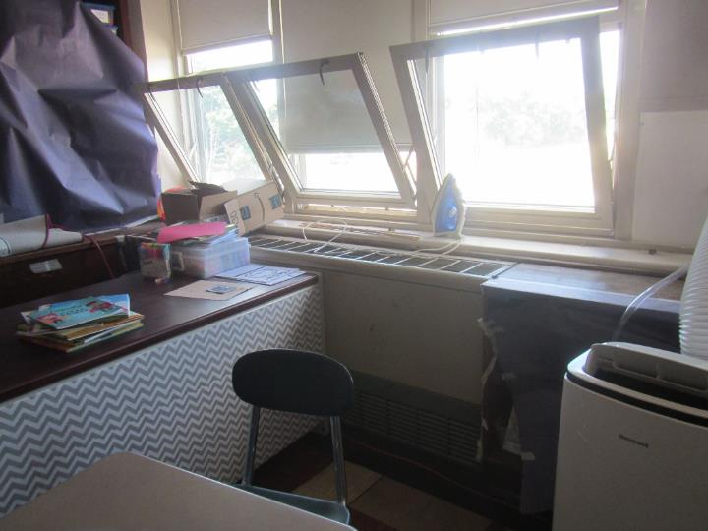
Classroom univent partially blocked by desk
Picture 3
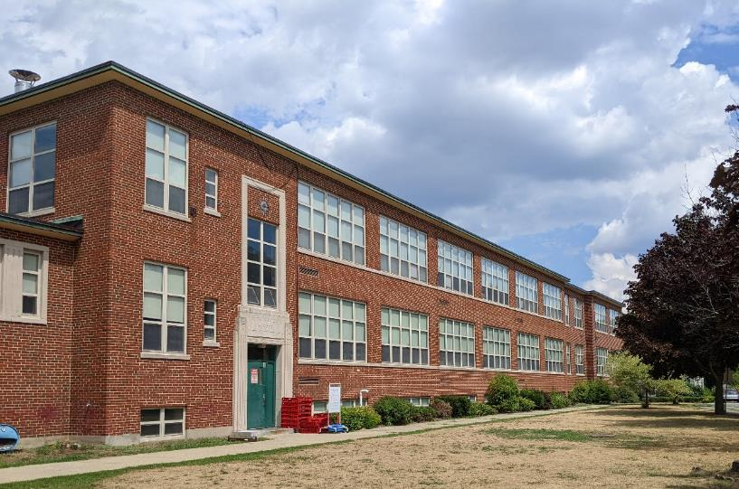
Exterior of building, arrows show univent fresh air intakes
Picture 4
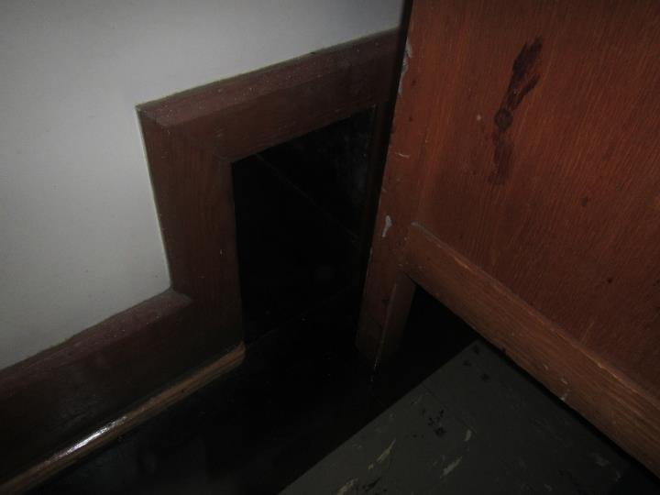
Exhaust vent “cubby” partly blocked by desk
Picture 5
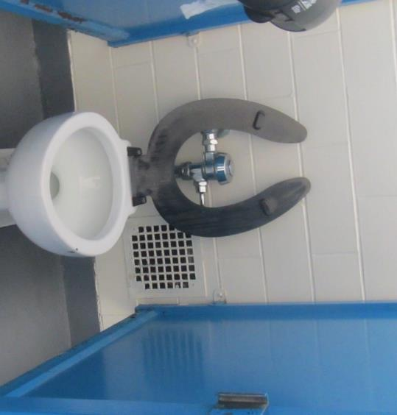
Restroom exhaust vent; similar vents are found on the hallway walls of some classrooms
Picture 6
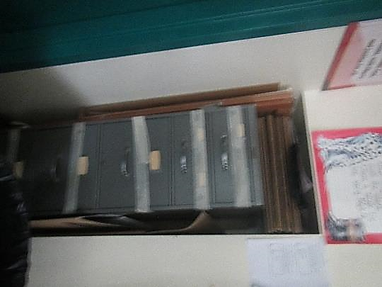
Filing cabinet in wall inset, exhaust vent may be behind the cabinet
Picture 7
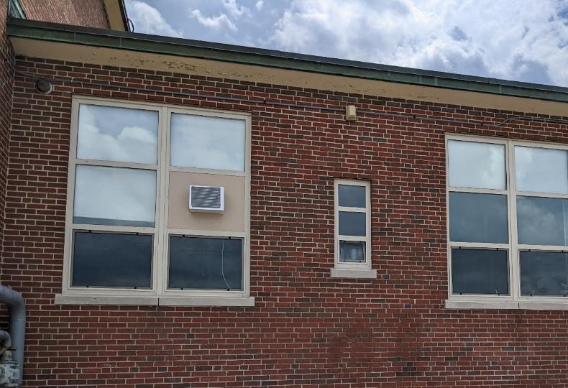
Window air conditioner
Picture 8
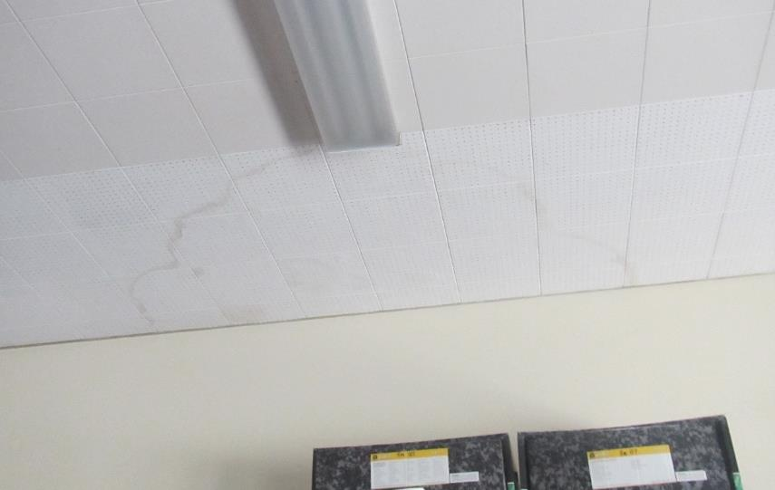
Water-damaged ceiling tiles
Picture 9
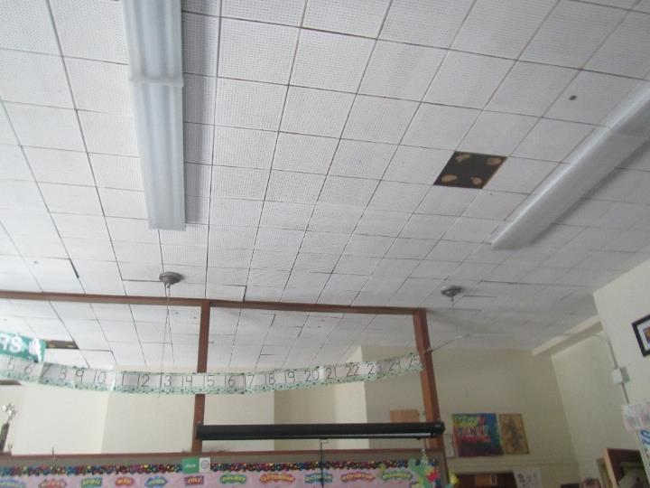
Loose and missing ceiling tiles
Picture 10
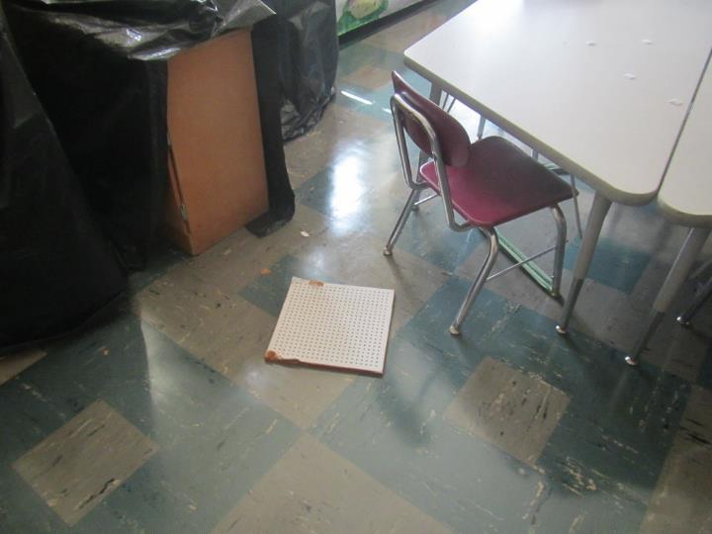
Fallen ceiling tile
Picture 11
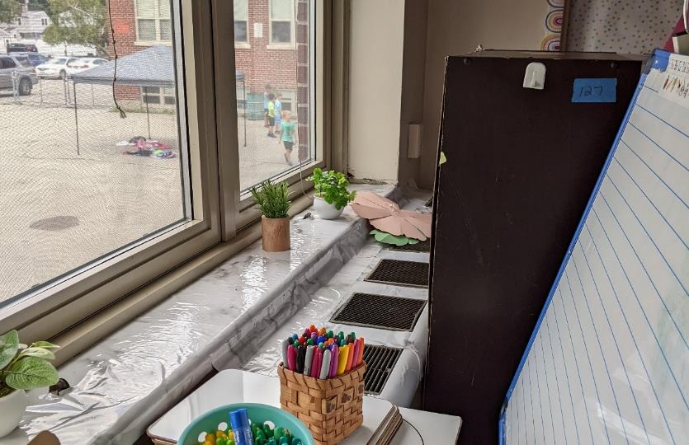
Plants on a windowsill adjacent to univent
Picture 12
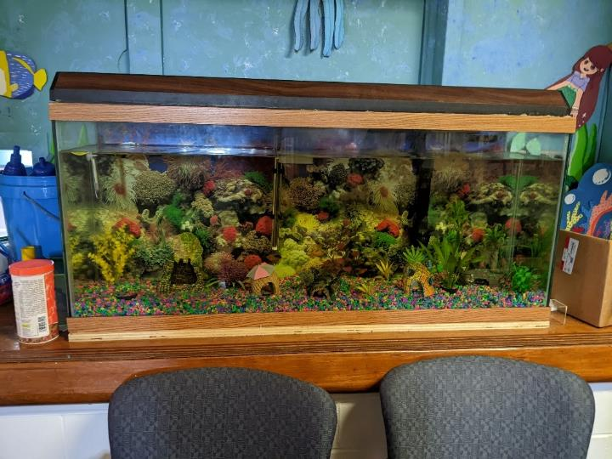
Aquarium
Picture 13
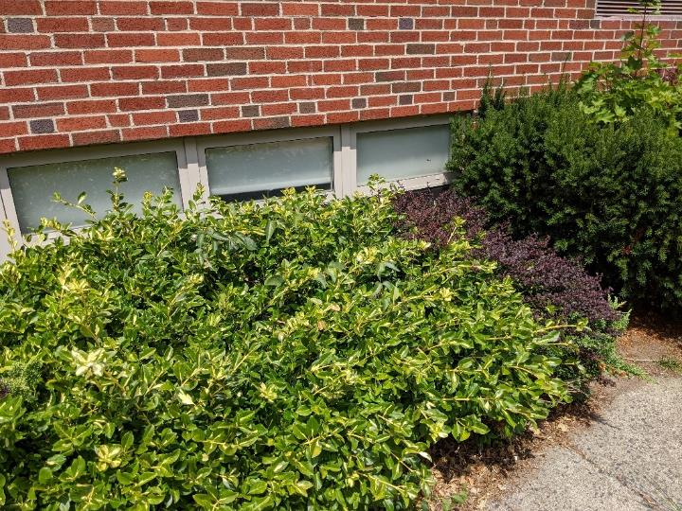
Plants next to building in front of openable windows and univent intake (upper right)
Picture 14
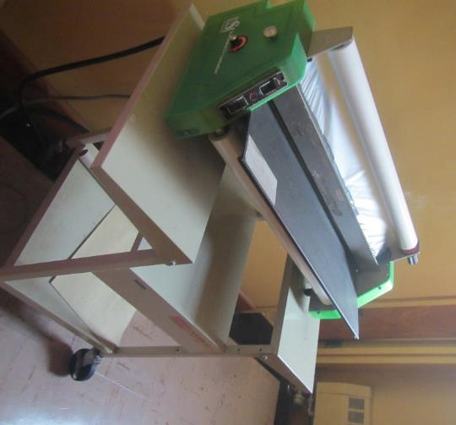
Laminator

Location/Room | Carbon  Dioxide  (ppm) | Carbon Monoxide  (ppm) | Temp  (°F) | Relative  Humidity  (%) | PM2.5  (µg/m³) | Occupants  in Room | Windows  Openable | Ventilation |  | Remarks
 |  |  |  |  |  |  |  | Supply | Exhaust
Background (outside) | 366 | 0.6 | 102 | 43 | 13 |  |  |  |  | Sunny and hot
Second Floor
Girls’ restroom |  |  |  |  |  |  | Y |  | Y
Boys’ restroom |  |  |  |  |  |  | Y |  | Y
201 | 475 | ND | 90 | 57 | 20 | 16 | Y | Y | Y | DEM, portable AC
202 | 362 | ND | 89 | 56 | 15 | 0 | Y | Y, on | Y blocked | Portable AC, fans, DEM
203 | 398 | ND | 86 | 55 | 13 | 0 | Y | Y, on | Y blocked | Portable AC on, MT, DEM, stand fan on,
204 | 367 | ND | 88 | 60 | 17 | 0 | Y, all open | Y | Y blocked | Portable AC on, fans on, DEM
205 | 480 | ND | 89 | 59 | 16 | 11 | Y, some open | Y | Y blocked | PF, items, DEM
206 | 550 | ND | 89 | 54 | 14 | 9 | Y | Y blocked | Y | Portable AC, fans, loose ceiling tiles
210 | 844 | ND | 91 | 57 | 16 | 10 | Y | Y | Y | Tennis balls on chair legs, portable AC
211 | 396 | ND | 92 | 56 | 14 | 0 | Y | Y | Y
Girls restroom |  |  |  |  |  |  |  |  | Y | Skylight
Boys restroom |  |  |  |  |  |  |  |  | Y
207 | 551 | ND | 92 | 58 | 17 | 0 | Y,  1 open | Y | Y | 1 AT, plant
208 | 498 | ND | 92 | 57 | 16 | 1 | Y | Y | Y | PFs, DEM, aquarium
First Floor
101 | 412 | ND | 90 | 60 | 16 | 0 | Y | Y | Y | Many MT, 2 restrooms and 2 sinks, PF
102 | 390 | ND | 91 | 59 | 17 | 0 | Y | Y, on | Y | Area rug – dusty, MTs, PFs
103 | 384 | ND | 91 | 59 | 17 | 0 | Y | Y | Y | MT/AT, PF, sink, UV off and dusty
104 | 402 | ND | 91 | 58 | 15 | 0 | Y | Y | Y | 2 area rugs, PF, UV on.
105 | 412 | ND | 90 | 60 | 13 | 0 | Y | Y, on | Y | 2 area rugs, PF
106 | 392 | ND | 90 | 59 | 15 | 0 | Y | Y | Y | Area rugs, PF, MT
107 | 389 | ND | 91 | 57 | 13 | 0 | Y | Y | Y | WD CT, UV blocked, DEM, PF
108 | 416 | ND | 90 | 59 | 15 | 0 | Y | Y | Y | area rug, DEM, PF, WD CT on window and interior side of room
109 | 415 | ND | 91 | 59 | 13 | 0 | Y | Y | Y | Area rug, PF, sinks
110 | 418 | ND | 91 | 58 | 14 | 0 | Y | Y | Y | PF
Admin | 415 | ND | 81 | 59 | 14 | 0 | Y | Y | Y | Window AC
Girls restroom |  |  |  |  |  |  | Y, open |  | Y
Gym | 413 | ND | 85 | 67 | 15 | 3 | N | Y | Y | PF, slight floor cleaner-like odor
Nurse |  |  |  |  |  |  | Y | Y | Y | Window AC, fridge, sinks
Principal | 453 | ND | 83 | 59 | 16 | 1 | Y | Y | Y | Attached restroom with open window, area rug
Resource room | 460 | ND | 89 | 55 | 15 | 1 | Y | Y | Y | Portable AC on
Teachers’ bathroom |  |  |  |  |  |  | Y | N | Y | Laminator in adjacent hallway/room, no exhaust vent, but openable window
Basement
Art | 471 | ND | 84 | 69 | 21 | 0 | Y | Y | Y | Area rug, MT, WD CT
Basement teacher’s lunch | 451 | ND | 84 | 56 | 31 | 0 | N | Y | Y | Refrigerators, microwave, toasters, portable AC, ceiling-mounted UV
Boys’ basement restroom |  |  |  |  |  |  |  |  | Y | Bathroom shares space with storage room with paper materials (on shelves)
Cafeteria | 591 | ND | 85 | 68 | 24 | 0 | Y |  |  | WD CT
Mrs. Peacock’s room | 665 | ND | 82 | 65 | 22 | 3 | Y | N |  | Bowed suspended CT, WD CT, plant, photocopier, area rugs, portable AC, food
Music | 480 | ND | 82 | 73 | 26 | 0 | Y, 2 open | Y | Y | Area rugs
Occupational Therapy | 627 | ND | 83 | 67 | 21 | 0 | N | Y |  | Tennis balls on chair legs, WD CT
Pre-school room |  |  |  |  |  | 10 | Y | Y | Y | Portable AC on, PF on, area rug
Pre-school room | 764 | ND | 83 | 63 | 17 | 10 | Y |  |  | PF on
Pre-school room 2 | 701 | ND | 83 | 62 | 18 | 12 | Y | Y | Y | Portable AC
Pre-school room 3 | 636 | ND | 82 | 61 | 23 | 9 | Y | Y | Y | Portable AC, bowed suspended CT, area rugs
Special education | 498 | ND | 85 | 68 | 22 | 0 | Y |  |  | Suspended ceiling tiles, some ajar, 1 WD CT

