Pediatric Asthma
in Massachusetts
2002 - 2003

Massachusetts Department of Public Health
Center for Environmental Health
Bureau of Environmental Health Assessment
250 Washington Street
Boston, MA 02108

May 2004

Table of Contents

I. Introduction 1

II. Methods 2
A. Target Population 2
B. Program Definition of Asthma 2
C. Data Collection 3
D. Data Management 3
E. Data Analysis 4

III. Results 4
A. Participation 4
B. Reported Asthma Prevalence 4
C. Other Variables 5

IV. Discussion 5
A. Comparison With Other Data Sources 5
B. Limitations 6
C. Strengths 7

V. Summary 7

VI. Future Efforts Aimed at Pediatric Asthma Surveillance 8

VII. Advisory Committee Membership 9

VIII. References 10

Appendix I. MDPH Pediatric Asthma Surveillance Form, 2002 - 2003 19

Appendix II. Summary Reports by School District (PDF) (XL) 23
List of Figures and Tables

Figures
Figure 1. Communities Included in the MDPH Pediatric Asthma
Surveillance Program 13

Figure 2. Distribution of Reported District-Wide Asthma Prevalence 14

Tables
Table 1. Variables Collected on the Pediatric Asthma Surveillance Form 16

Table 2. Reported Asthma Prevalence by Grade 17

Table 3. Answers to Questions Related to School Nurses Records 18

Acknowledgements

Thanks to the U.S. Centers of Disease Control and Prevention Environmental Health Tracking Branch for providing the federal resources necessary to conduct this effort. The MDPH would also like to thank school nurses in both private and public school systems who contributed to the success of the first year of its pediatric asthma surveillance effort by completing a Pediatric Asthma Surveillance Form. We would also like to thank the Pediatric Asthma Surveillance Advisory Committee, for its valuable input during both the planning and implementation phases of the program. Finally, we appreciate the collaboration and assistance of staff in the Department’s Bureau of Family and Community Health.

Pediatric Asthma In Massachusetts
2002-2003

I. Introduction
Asthma is a common chronic disease among children. It is a leading cause of
functional limitation in Americans under the age of 17 [1], and costs 3.2 billion dollars in direct health care costs annually [2]. The prevalence of pediatric asthma appears to have increased in prevalence over the past decades [3]. The magnitude of prevalence and cost of this disease have made asthma a priority concern among public health organizations across the country.

To date the information available regarding asthma prevalence in Massachusetts
has been limited to prevalence figures for the state as a whole. Statewide prevalence figures have been collected through the Behavioral Risk Factor Surveillance System (BRFSS), a random telephone survey implemented by state health departments in conjunction with the U.S. Centers for Disease Control and Prevention (CDC). Although BRFSS data are useful for estimating asthma prevalence for the state, they do not provide information regarding asthma at the community level. Historically, community-level data have been available only for a small number of communities in which specialized surveillance programs or research studies have been implemented.

While statewide prevalence figures are a convenient way to summarize the overall health of Commonwealth residents, there remains a need to better quantify the scope of the problem on the state and local level, particularly as it relates to the pediatric population, the population for which the largest increases in asthma prevalence have been detected over time [4]. A standardized pediatric asthma surveillance or “tracking” system that collects asthma prevalence data at the community level allows public health officials to identify populations with asthma on the local level, evaluate at risk groups, and evaluate the impact of interventions over time more effectively than state-level data.

Given the need for a comprehensive, systematic approach to pediatric asthma surveillance in the Commonwealth, the Massachusetts Department of Public Health (MDPH) developed a proposal to track pediatric asthma through school health offices. This program is being implemented as part of a larger effort aimed at tracking several health outcomes thought to be impacted by environmental exposures. The overall surveillance program, currently funded for three years through the U.S. Centers for Disease Control and Prevention (CDC) National Environmental Public Health Tracking Program, aims to track the prevalence of pediatric asthma in Massachusetts school children, lupus in the city of Boston, and developmental disabilities in Berkshire County. This report describes the methods used to implement the pediatric asthma surveillance effort, summarizes the surveillance data collected during its first year, and discusses program goals for years two and three.

II. Methods

A. Target Population

The MDPH piloted the Pediatric Asthma Surveillance Program during the
academic year 2002–2003 in 111 school districts participating in the MDPH Essential School Health Service (ESHS) program. There were 958 public schools that served any of grades K-8 in those districts and were therefore eligible to participate in the surveillance program.

B. Program Definition of Asthma

School nurses reported the number of students with asthma in each school by grade and gender on a standardized surveillance form (Appendix I). Potential sources for the nurses’ knowledge of a child’s asthma status included emergency cards, parent resource centers, parent communications, student communications, health care provider documentation, or direct observation of an asthma attack. The percentage of cases with a documented provider diagnosis or medication orders was requested in the surveillance form.

C. Data Collection

During January 2002, the MDPH mailed letters introducing the surveillance program to school superintendents, principals, and nurse leaders in school districts participating in the ESHS. The following March, school nurse leaders were asked to distribute to nurses in their district a two-page surveillance form asking for aggregate numbers of children with asthma by grade, gender, and school building (Appendix I). The surveillance form also contained questions regarding the source of data reported (Table I). Surveillance forms were distributed via email, when possible, to facilitate electronic data submission. If electronic mail was not available, then forms were sent via the U.S. Postal Service. Follow-up telephone calls were placed to nurses who did not respond by April 2003. School enrollment data was collected from the Massachusetts Department of Education (DOE) or from a school’s administrative staff. Schools that did not return a completed surveillance form or for which enrollment data could not be obtained by September 2002 were considered non-responders for year one.

D. Data Management

MDPH staff reviewed surveillance forms for completeness and accuracy, and attempted to resolve missing data or inconsistencies. Massachusetts DOE school identifier codes were assigned to each school’s form. In the case of a school that was not listed in the DOE database, or was listed as part of a larger school, the MDPH assigned its own unique identifier code, following the DOE code structure. Complete surveillance data were manually input to the surveillance program database upon satisfactory review. Incomplete surveillance data were not input to the program database.

E. Data Analysis

Data analysis was performed with Statistical Analysis Software (SAS) and Microsoft Access. The percent participation of the target population was calculated, along with the breakdown of participation by type of school. The prevalence of asthma with 95% confidence intervals was calculated for the state, for each participating school district, and by grade level. The range of asthma prevalence among individual schools was also calculated for this report.

III. Results

A. Participation

MDPH received completed surveillance forms from a total of 760 schools, about 46% of the schools serving any of grades K-8 in the Commonwealth during that time. Of the 760 participating schools, 668 were targeted ESHS schools, translating to 70% participation by target schools. The remaining 92 schools were private schools (52), charter schools (9), and public schools not included in the ESHS, but that submitted information on their own (31). Figure 1 highlights the communities belonging to school districts that participated in the surveillance program. Less than 1% of the returned surveillance forms were incomplete after follow-up by the completion deadline of June 2003.

B. Reported Asthma Prevalence

The reported prevalence of asthma among the 311,600 students enrolled in the 760 participating schools was 9.2% (95% CI* 9.1% - 9.3%). Sixty percent of students reported to have asthma were male. Reported prevalence by school ranged from 0 – 30.8%, while reported asthma prevalence by school district ranged from 2.7% - 16.2%. Figure 2 presents the frequency distribution of district-wide reported asthma prevalence figures. See Appendix II for the corresponding summary reports produced for each participating school district. Reported asthma prevalence by grade ranged from 7.7% to 10.3 % (Table 2).

C. Other Variables

Responses to questions relating to the school health records are summarized in Table 3. Of the 96% of respondents that answered question number 11, regarding provider diagnoses of asthma, 50% reported that most of their students with asthma (i.e. 90% - 100%) had documentation in the health record of a provider diagnosis of asthma and/or asthma medication orders. Parent or student communications were identified as an alternate source of knowledge regarding a student’s asthma status. Direct observation of an asthma attack and parent resource centers were indicated least frequently as alternate sources of knowledge regarding a student’s asthma status.

IV. Discussion

A. Comparison With Other Data Sources

While the reported prevalence of asthma observed in this program ranged as high as 16.2% by district, and 30.8% by school, the statewide prevalence was 9.2%. This figure is similar to the 8.8% prevalence of current childhood asthma in Massachusetts reported recently by the New England Asthma Regional Council (ARC) based on BRFSS data collected in 2001 [5]. Different methodologies and target populations between the two surveillance approaches make BRFSS data less than ideal for comparison with data generated through the MDPH pediatric asthma surveillance initiative. However, BRFSS data is currently the only statewide pediatric asthma prevalence data available.

A school-based surveillance effort similar to the one implemented in Massachusetts may be more appropriate for comparison, and is discussed in a recent report describing nurse-reported asthma in Connecticut students. The report describes a 9.7% asthma prevalence among Connecticut students in grades K-5 [6], slightly higher than the 8.8% found in Massachusetts K-5 graders. Prevalence data for grade 6-8 students in Connecticut are not available for comparison.

The observation that more students reported with asthma were male is consistent with the findings of epidemiological studies that report male gender as a risk factor for pediatric asthma [7] [8] [9]. There is little data available for comparison with this program’s prevalence estimates by grade. One explanation for the observed increase in reported asthma by grade could be that a longer period of time in school leaves more time for asthma diagnosis, making the nurse more likely to be aware of a diagnosis of asthma in the health record by the time a student enters the eight grade.

B. Limitations

While there was notable variation in reported asthma prevalence between school districts during the Surveillance Program’s first year, caution should be used when comparing district prevalence estimates. Some district-wide prevalence estimates were based on reporting by only a small percentage of the district’s schools, and may not be representative of that district’s actual asthma prevalence. The MDPH expects to obtain more complete, representative data in subsequent years of the surveillance program. Differences in school health systems between districts further complicate the issue of comparability between district asthma prevalence estimates as reported by school nurses.

It is also important to note that a higher prevalence of asthma within one district compared with another does not necessarily indicate the presence of environmental problems within that district’s schools. Pediatric respiratory symptoms have been associated with a number of factors including exposures in the outdoor environment [10] [11] [12], exposures in the home environment [13] [14] [15], genetic factors [16] [17], and lifestyle factors [18] [19]. The MDPH pediatric asthma surveillance system does not currently collect information regarding risk factors related to the development of asthma, and therefore the data cannot be used to draw conclusions regarding the causes of reported asthma prevalence in any district or school.

C. Strengths

The value of the Massachusetts approach to asthma surveillance is several-fold. Data collected through school health records are reliable, as shown in a separate MDPH investigation of asthma in the Merrimack Valley. Further, tracking the prevalence of asthma through the schools will make it possible for the first time to assess the magnitude of the problem of pediatric asthma at the local level. While the statewide prevalence of pediatric asthma observed through this program was similar to that seen in other types of surveillance initiatives, surveillance at the community level makes it possible to observe a wide range of different prevalence values by school district, information that was previously unavailable through data sources that focused on statewide or nationwide data.

V. Summary

- 760 schools representing 311,600 students in grades K-8 participated in the MDPH Pediatric Asthma Surveillance Program.

- Reported asthma prevalence in Massachusetts K-8 students ranged from 2.7% to 16.2% among participating school districts.

- Reported asthma prevalence in Massachusetts K-8 students ranged from 0 – 30.8% among participating schools.

- The statewide reported asthma prevalence in Massachusetts K-8 students targeted by this surveillance initiative was 9.2%.

- Caution should be used when comparing prevalence figures at the school district level because complete data were not available for all districts.

VI. Future Efforts Aimed at Pediatric Asthma Surveillance

This report summarizes the first of a three year effort that the MDPH is scheduled to carry out as part of its Environmental Public Health Surveillance Program. During the second and third years of the program, the MDPH is expanding its target population to include all public, private, and charter schools serving any of grades K-8 in each of the Commonwealth’s 372 school districts. Through a separate Environmental Public Health Surveillance effort, the MDPH plans to collect indoor air quality data in a selected number of schools statewide in conjunction with the collection of asthma surveillance data. This report represents an important first step in the establishment of a permanent statewide asthma surveillance system in the Commonwealth of Massachusetts.

Pediatric Asthma Surveillance Advisory Committee

Marcia Buckminster
Peg Burton
Linda Cochenour
Mary Jane O’Brien
Sarah Poirier
Catherine Porcello
Mary Ellen Shriver
Nancy Sullivan
Katie Vozeolas

VI. References

1. U.S. Centers for Disease Control and Prevention (CDC), Disabilities among children aged < or = 17 years--United States, 1991-1992. MMWR Morb Mortal Wkly Rep, 1995. 44(33): p. 609-13.

2. American Lung Association, Asthma in Children Fact Sheet. March 2003.

3. U.S. Centers for Disease Control and Prevention (CDC), Measuring childhood asthma prevalence before and after the 1997 redesign of the National Health Interview Survey--United States. MMWR Morb Mortal Wkly Rep, 2000. 49(40): p. 908-11.

4. Mannino, D.M., et al., Surveillance for asthma--United States, 1960-1995. MMWR CDC Surveill Summ, 1998. 47(1): p. 1-27.

5. New England Asthma Regional Council, Asthma in New England, Part II: Children. 2004.

6. Storey, E., et al., A Survey of Asthma Prevalence in Elementary School Children. 2003: North Haven, CT.

7. Miller, J.E., Predictors of asthma in young children: does reporting source affect our conclusions? Am J Epidemiol, 2001. 154(3): p. 245-50.

8. Schatz, M. and C.A. Camargo, Jr., The relationship of sex to asthma prevalence, health care utilization, and medications in a large managed care organization. Ann Allergy Asthma Immunol, 2003. 91(6): p. 553-8.

9. de Marco, R., et al., Differences in incidence of reported asthma related to age in men and women. A retrospective analysis of the data of the European Respiratory Health Survey. Am J Respir Crit Care Med, 2000. 162(1): p. 68-74.

10. Boezen, H.M., et al., Effects of ambient air pollution on upper and lower respiratory symptoms and peak expiratory flow in children. Lancet, 1999. 353(9156): p. 874-8.

11. Delfino, R.J., et al., Association of asthma symptoms with peak particulate air pollution and effect modification by anti-inflammatory medication use. Environ Health Perspect, 2002. 110(10): p. A607-17.

12. Tolbert, P.E., et al., Air quality and pediatric emergency room visits for asthma in Atlanta, Georgia, USA. Am J Epidemiol, 2000. 151(8): p. 798-810.
13. Sturm, J.J., K. Yeatts, and D. Loomis, Effects of tobacco smoke exposure on asthma prevalence and medical care use in north Carolina middle school children. Am J Public Health, 2004. 94(2): p. 308-13.

14. Rosenstreich, D.L., et al., The role of cockroach allergy and exposure to cockroach allergen in causing morbidity among inner-city children with asthma. N Engl J Med, 1997. 336(19): p. 1356-63.

15. Smith, B.J., et al., Health effects of daily indoor nitrogen dioxide exposure in people with asthma. Eur Respir J, 2000. 16(5): p. 879-85.

16. Lee, Y.L., et al., Indoor and outdoor environmental exposures, parental atopy, and physician-diagnosed asthma in Taiwanese schoolchildren. Pediatrics, 2003. 112(5): p. e389.

17. El-Sharif, N., et al., Familial and environmental determinants for wheezing and asthma in a case-control study of school children in Palestine. Clin Exp Allergy, 2003. 33(2): p. 176-86.

18. Aligne, C.A., et al., Risk factors for pediatric asthma. Contributions of poverty, race, and urban residence. Am J Respir Crit Care Med, 2000. 162(3 Pt 1): p. 873-7.

19. Heinrich, J., et al., Trends in prevalence of atopic diseases and allergic sensitization in children in Eastern Germany. Eur Respir J, 2002. 19(6): p. 1040-6.

Figures

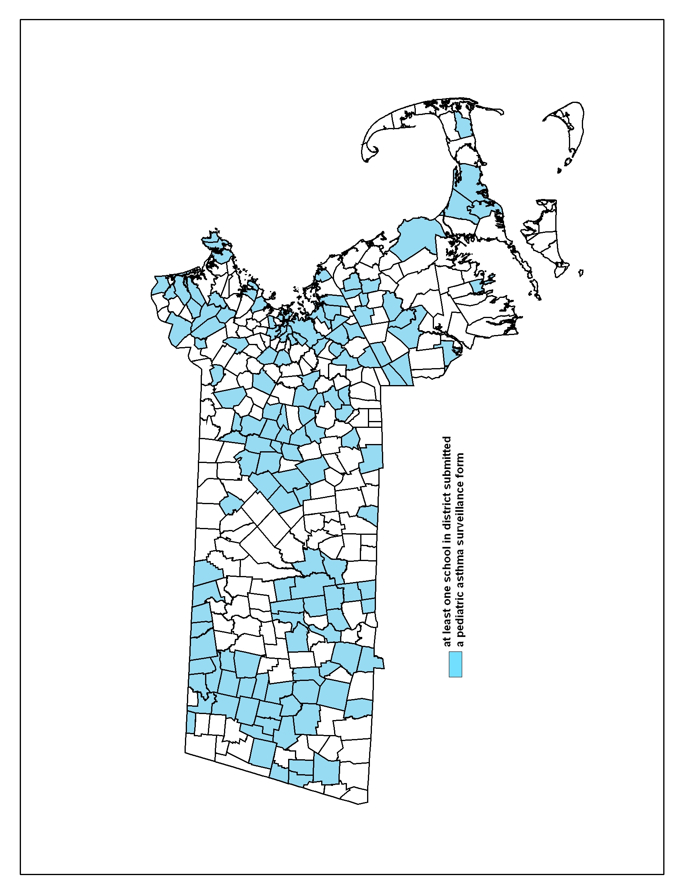
Figure 1. Communities Included in the MDPH Pediatric Asthma Surveillance Program, 2002-2003.

Figure 2. Distribution of Reported District-Wide Asthma Prevalence, 2002-2003.

Tables

Table 1.
Variables collected on the Pediatric Asthma Surveillance Form. MDPH Pediatric Asthma Surveillance Program, 2002-2003.
Variable Name | Description
Male | Number of male K-8 students with asthma
Female | Number of female K-8 students with asthma
Grade K – Grade 8 | Number of students in each grade with asthma (9 variables, 1 for each grade)
% Documented | Percentage of students with documentation of asthma in health record
Sources | Source(s) that gave nurses knowledge of children’s’ asthma status

Table 2.
Reported asthma prevalence by grade. MDPH Pediatric Asthma Surveillance Program, 2002-2003.

MDPH Pediatric Asthma Survey, 2002-2003
Grade | Prevalence (%) | 95% CI (%)
K | 8.1 (2,561) | 7.8 – 8.4
1 | 7.7 (2,598) | 7.4 - 8.0
2 | 8.3 (2,780) | 8.0 – 8.6
3 | 9.0 (3,052) | 8.7 – 9.3
4 | 9.5 (3,266) | 9.2 – 9.8
5 | 10.0 (3,535) | 9.7 – 10.3
6 | 10.3 (3,692) | 10.0 – 10.6
7 | 10.0 (3,656) | 9.6 – 10.2
8 | 9.8 (3,598) | 9.5 – 10.2
Total | 9.2 (28,738) | 9.1 – 9.3
*Total K-8 students enrolled in participating schools = 311,610.

Table 3
Answers to questions related to school nurses records. MDPH Pediatric Asthma Surveillance Program, 2002-2003
Question | Answers | Frequency (%) | Number of Surveillance Forms with this Question Completed
11. For what percentage of the students with asthma do you have documentation in the health record of a provider diagnosis of asthma and/or asthma medication orders? | Less than 75% | 25.3 | 730
 | 75% - 85% | 24.5 | 730
 | 90% - 100% | 50.1 | 730
12. How else did you (the school nurse) know these students had asthma? | Emergency cards | 9.0 | 734
 | Parent resource center | 0.3 | 734
 | Parent communications | 41.4 | 734
 | Student communications | 47.7 | 734
 | Direct observation of an asthma attack | 0.4 | 734
 | Other | 1.2 | 734

Appendix I

MDPH Pediatric Asthma Surveillance Form, 2002-2003

Appendix I
Pediatric Asthma Survey – Online Form
2002-2003 School Year

The school nurse should complete this form whenever possible. Please provide the following information about the students in your school building who have asthma (of any type or severity).

- Include information about students in grades K – 8 only.
- Complete a separate form for each school building (Do NOT combine data from different schools on one form).
- Please answer questions with current information for school year 2002-2003, and return the completed form by May 30, 2003.
- Please fill in all of the blanks.

Online instructions
- This form can be successfully completed on-screen only if you use "Microsoft Word" version 97 or later (If you do not have Word 97 or later, print the form and write your answers on the paper copy).
- Enter information by typing in the "shaded" areas of the form, or by clicking the check-boxes .
- Use the "Tab" key or your mouse to move to different areas of the form (Do not use the "Enter" key).
- Carefully follow the instructions at the end of the form for saving your data.

(Office Use Only)
1. School building name:

2. Street:
(Office Use Only)
City or Town:

3. Is this school (check  one): Part of the local public school district A charter school
Part of a regional school district A nonpublic school

- (If this is a public school) Which public school district is this school a part of?: (Office Use Only)

5. Name of person filling out form:

Title:

6. Telephone number: Telephone number:

7. FAX number: Telephone number:

Appendix I. (continued)

In Questions 8 - 9, please record the number of K-8 students attending this school who have
asthma, using the sex and grade categories listed. Leave no category “blank”: Enter “0” to indicate there are “No students in that category with asthma” (or that no students in that category attend your school). Mark the box  in the right-hand column if you “Don't Know” the number requested.

Number of K-8 students with asthma

Don't Know
8. Sex Telephone number: | Male
 | Female
 | TOTAL

Don't Know
Number of K-8 students with asthma
9. Grade Level Telephone number: | Kindergarten
 | Grade 1
 | Grade 2
 | Grade 3
 | Grade 4
 | Grade 5
 | Grade 6
 | Grade 7
 | Grade 8
 | TOTAL

Please note that the TOTALS in questions 8 & 9 must match (If they do not, please re-check your numbers).

10. Is the information above accurate for the 02-03 school year? (Check  one box.) Yes
(If "No", explain: ) No

- For what percentage of the students with asthma do you have documentation in the health record of a provider diagnosis of asthma and / or asthma medication orders? Please provide your best estimate of this number. It is not necessary to go to your files and count up the numbers. (Check  one box.)
Less than 75%
75% - 89%
90% - 100%

Appendix I. (continued)

12. How ELSE did you (the school nurse) know these students had asthma? (Check  all that apply).
Emergency cards
Parent resource center
Parent communications
Student communications
Direct observation of an asthma attack
Other (explain):

Save your form
Select "Save As" on the "File" menu, type in "[‘Your District Name’ and ‘The First Four Letters of the School Building Name’] Asthma Survey" (substituting the name of your district for [Your District Name]) as the File Name, click "Save," and then close the file. Example: BrooklineRunk Asthma Survey should be the saved file name for the Runkle School in Brookline.

Return the electronic form by e-mail
If you completed the form online, return the form electronically (Do not return a printed paper copy). Create an e-mail message, address it to ped.asthma@state.ma.us, and "attach" the Microsoft Word form called "[Your District Name] Asthma Survey" to your e-mail. Then send the message.

If you completed the survey using "pen and paper" instead of using the "online" form, return the form by fax (617-624-5777)
Please return the completed form to your ESHS Nurse Leader, who will forward the form to DPH.

If you have any questions about this survey, please contact the Asthma Data Coordinator at
617-624-5757 or (e-mail) ped.asthma@state.ma.us

Appendix II

Summary Reports by School District

* 95% Confidence Interval (CI) of a the prevalence is a statistical range used to indicate the stability of a prevalence estimate

