Figures

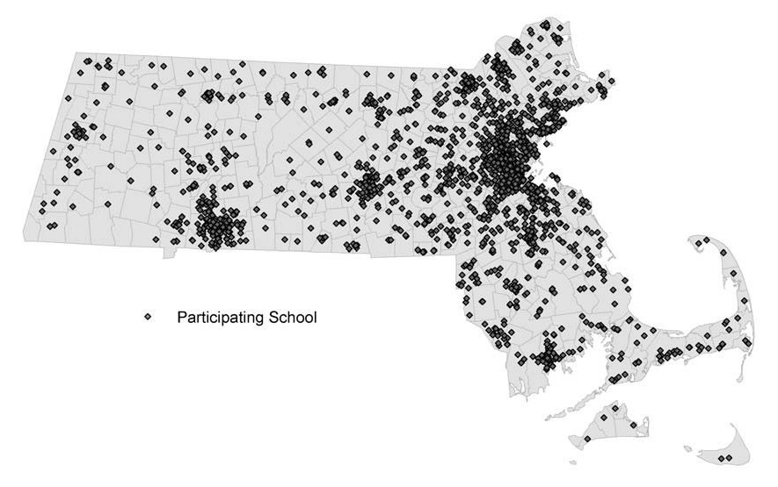
Figure 1. Communities Included in the MDPH Pediatric Asthma Survey

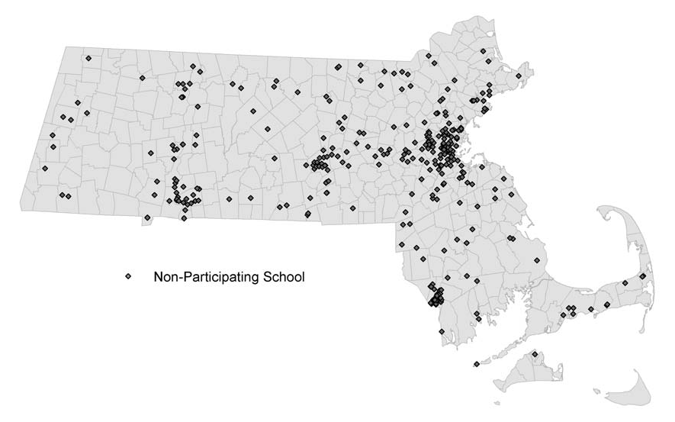
Figure 2. Distribution of Reported School Asthma Prevalence
Figure 1a. Schools that Participated in the MDPH Pediatric Asthma Surveillance Activities
During the 2004-2005 School Year.

700
Figure 1b. Schools that did not participate in the MDPH Pediatric Asthma Surveillance
Activities During the 2004-2005 School Year.

600

500

400

300

200

100

0
0 - 4% 4.1 - 8% 8.1 - 12% 12.1 - 16% 16.1 - 20% >20%

Prevalence Range

