Pediatric Asthma in Massachusetts
2006 - 2007

Massachusetts Department of Public Health
Bureau of Environmental Health
250 Washington Street
Boston, MA 02108

April 2009
Table of Contents
I. Introduction
II. Methods
A. Regulatory Authority/ Data Confidentiality
B. Target Population
C. Project Definition of Asthma
D. Data Collection
E. Data Management
F. Data Analysis
III. Results
A. Participation
B. Reported Asthma Prevalence
C. Other Variables Discussion
- Discussion
- Future Efforts Aimed at Pediatric Asthma Surveillance
- References
Figures
Tables

Appendix I. Advisory Committee

Appendix II. MDPH Pediatric Asthma Survey, 2006-2007

Appendix III. Reported Asthma Prevalence by Individual School

Appendix IV. Reported Asthma Prevalence by Community (City/Town)
List of Figures and Tables

Figures
Figure 1. MA Pediatric Asthma Surveillance School Response Rate 2002-2007

Figure 2. Distribution of Reported Asthma Prevalence by School.
Figure 3. Distribution of Reported Asthma Prevalence by Community
Figure 4. MA Pediatric Asthma Prevalence 2002-2007

Tables
Table 1. Pediatric Asthma Survey Variables 2006-2007
Table 2. Reported Asthma Prevalence by Grade 2006-2007
Table 3. Reported Asthma Prevalence by Gender 2002-2007
Table 4. Answers to Questions Related to School Nurse Records
Acknowledgements

The MDPH would like to thank school nurses and administrative staff in public, private and charter school systems who contributed to the success of the fifth year of its pediatric asthma surveillance effort by completing a pediatric asthma surveillance form. We would also like to thank the asthma surveillance advisory committee for its valuable input during both the planning and implementation phases of the project.
Pediatric Asthma in Massachusetts 2006-2007
I. Introduction
Asthma is a common chronic disease among children that appears to have increased in prevalence over the past decades [1]. It continues to affect more than 12% of Americans under the age of 18 [2], and is the third-ranking cause of hospitalization among children under the age of 15 [3]. The estimated cost of treating asthma in those under the age of 18 is $3.2 billion per year [4] and for the entire US population over $11.5 billion [5]. Prevalence and the cost of this disease have made asthma a priority concern among public health organizations across the country. Locally in Massachusetts, the Massachusetts Department of Public Health (MDPH), Bureau of Environmental Health (BEH) has five years of data on the occurrence of asthma among school-age children to support this concern.

Historically statewide asthma prevalence has been collected through the Behavioral Risk Factor Surveillance System (BRFSS), a random telephone survey implemented by state health departments in conjunction with the U.S. Centers for Disease Control and Prevention (CDC). Although BRFSS data are useful for estimating asthma prevalence in the state as a whole, they do not provide information regarding asthma at the community level. Data on hospital treatment for pediatric asthma are available at the community level on MassCHIP and reported in the Department’s Burden of Asthma in Massachusetts report. However, the numbers likely represent an underestimate of pediatric asthma prevalence since they reflect only asthma treated in the emergency department or hospital.

Because of the limitations of the above mentioned data sources, there remains a need to better quantify the scope of the problem on the local level, particularly as it relates to the pediatric population. From 1980 through 1994, asthma prevalence in the US rose at sharper rates among those aged 0-4 and 5-14 than they did among any other age group [6]. Similarly, prevalence in those aged 0-17 increased from 3.6% in 1980 to 7.5% in 1995. While these rates have leveled off in recent years, they are still higher than in previous years [7].
It is worth noting that the Department is one of 16 states and one metropolitan city involved in the Environmental Public Health Tracking (EPHT) surveillance system, an ongoing data collection and analysis tool that allows public health officials to look at data about environmental hazards and health indicators to determine the need for further evaluation. Given the need for a comprehensive, systematic approach to pediatric asthma tracking in the Commonwealth, the MDPH/BEH developed a proposal to CDC to track pediatric asthma through school health records as part of EPHT. In 2002, a standardized pediatric asthma surveillance or “tracking” system that collects asthma prevalence data at the community (city/town) level was developed and implemented.

This report describes the methods used to implement pediatric asthma tracking and summarizes the asthma prevalence data collected during Year Five (2006-2007 school year), which encompassed all public and private schools in the Commonwealth serving grades K through 8. (Reports from years one through four can be found on the MDPH website at www.mass.gov/dph/asthma ).
The methods followed were based upon the experience gained from the previous surveillance efforts and through discussions with the School Nurse Advisory Committee comprised of school nurse leaders from around the state, the MDPH/ Essential School Health Service staff, and MDPH/BEH staff. (Appendix I)

II. Methods

A. Regulatory Authority/ Data Confidentiality

Massachusetts law authorizes the MDPH/BEH to access school health records in public health investigations and requires the strict protection of the privacy of the information collected (Massachusetts Student Record Registration Section 23.7 (4) (h) and MGL c111, s 24A). The MDPH also has regulatory authority to access health records for asthma and other selected health outcomes through 105 CMR 300.192-- public health regulations for the reporting of environmentally-related diseases to the MDPH. This authority is consistent with the requirements to protect privacy as provided through the federal Health Insurance Portability and Accountability Act (HIPAA).

MDPH/BEH in collaboration with school health nurses collect data on children diagnosed with pediatric asthma within each school on an aggregate level. No information that might identify individual students is currently collected. The MDPH/BEH received approval for this project as part of a larger effort aimed at tracking several health outcomes thought to be impacted by environmental exposures.

B. Target Population
During the 2006-2007 school year the MDPH/BEH requested all public, private, and charter schools in Massachusetts with any grade Kindergarten through 8 (2,136 schools, excluding school closures and schools that did not serve any eligible grades) to report the number of students with asthma enrolled in the school.

C. Project Definition of Asthma
As with the four previous years of pediatric asthma surveillance, a specific clinical definition of asthma was not provided to nurses or administrative staff. Instead, schools were asked to report the number of students known to them as having a diagnosis of asthma. This broad based definition captures asthma of all types, including allergic asthma and exercise-induced asthma. Likewise, it helps to capture a range of disease severities from mild to severe. This will ensure a more sensitive prevalence estimate by making sure that all cases of asthma are reported, not simply those severe enough to warrant hospital treatment. Specific sources in the health record for the nurses’ knowledge of a child’s asthma status included emergency cards, physical exam forms, parent resource centers, parent communications, student communications, health care provider documentation, or direct observation of an asthma attack.

D. Data Collection

Beginning in February 2007, public school nurses and private school health contacts were mailed a one-page reporting form asking for aggregate numbers of children with asthma by grade, gender, and school building. Ideally future efforts should attempt to obtain race/ethnicity. The list of schools was generated by the Massachusetts Department of Elementary and Secondary Education (ESE) and included any school that served grades K-8. Because several of these schools serve grades that are not included in this surveillance effort (i.e. schools serving grades 6-12), the report form and instruction sheet made it explicitly clear that only data on students in grades K-8 should be reported (Appendix II). Table 1 describes the variables collected on the survey. The form also contained a question regarding the community (city/town) of residence for each child.
Additional questions were asked regarding the ability to complete the surveillance form via the web and retrieval of student asthma information using a computerized program or database. The first variable was collected to identify the number of schools that could report pediatric asthma cases electronically should MDPH establish an online system of reporting. The second variable was collected to gauge how burdensome data collection is for the school nurses with the belief being that schools with computerized medical information would be able to report with more ease than those without a computerized system.
The school’s name, address and ESE school code were pre-printed on each form to facilitate completion of the form. In addition, an instruction sheet for completing the form was provided. The reporting forms were sent via the U.S. Postal Service. Once the forms were completed, they were faxed or in some cases mailed back to the MDPH. Reminder post cards were sent to non-responding schools in April 2007. Follow-up telephone calls were placed to nurses who did not respond by May 2007. School enrollment data were collected from the ESE or if a private school, from an individual school’s administrative staff. Schools that did not return a complete surveillance form or for which 2006-2007 enrollment data could not be obtained by July 2007 were considered non-responsive and not included in the prevalence estimates presented.

E. Data Management

Massachusetts ESE school identifier codes were assigned to each school’s surveillance form. MDPH/BEH staff reviewed the surveillance forms for completeness and accuracy, and attempted to resolve missing data or inconsistencies. Once cleaned, the data were entered into a text file and then imported into an Access database.

F. Data Analysis

Data analysis was performed with SAS version 9.1 and Microsoft Access 2000. The percent participation of the target population was calculated, along with the breakdown of submitted surveillance forms by type of school. The prevalence of asthma with 95% confidence intervals was calculated for each participating school, for each community (city/town) of residence, and for the state as a whole. Statewide prevalence rates were also calculated by gender and by grade level.
To help interpret the asthma prevalence estimates, 95% confidence intervals (95% CI) were calculated to determine how precise the estimate was [8]. Specifically, a 95% CI is the range of estimated prevalence values that have 95% probability of including the true prevalence for the population. Therefore, a CI that is narrow allows for a fair level of certainty that the calculated estimate is close to the true estimate for the population. A wide interval leaves considerable doubt about the true estimate, which could be much lower or higher than the calculated prevalence estimate. Confidence intervals for individual schools were also compared with intervals for the state prevalence estimate. Intervals that did not overlap suggested that the prevalence estimate for the school was statistically significantly different than the state estimate.
As mentioned previously, asthma prevalence was calculated by community (city/town) of residence as well as by school. Community (city/town) of residence was recorded by the school nurse/health contact for each child with asthma. All students with asthma from each community (city/town) of residence were totaled and this figure was used as the numerator. Similarly ESE provided a 2006-2007 total enrollment file by community (city/town) of residence for all enrolled students in the state and private school administrators provided enrollment totals for their schools. These data were used as the denominator for calculating each community’s (city/town) prevalence.

III. Results

- Participation
MDPH/BEH received asthma data from a total of 2,075 public, private, and charter schools--approximately 97.1% of the schools serving any of grades K-8 in the Commonwealth during the school year (2006-2007). This represents a substantial increase from the 86.4% school participation during the 2005-2006 school year (Figure 1). Given the high participation rate across all municipalities, the community-specific prevalence estimates shown in this report can be considered representative of the occurrence of pediatric asthma in each of the 351 Massachusetts communities (cities/towns).

B. Reported Asthma Prevalence
The reported prevalence of asthma among the 765,543 students enrolled in the 2,075 participating schools was 10.8% (95% CI1 10.7% - 10.9%). Reported prevalence by school ranged from 0 – 43.6%2. Prevalence figures for the 2,075 participating schools are listed in Appendix III, and their frequency distribution is presented in Figure 2.

Reported asthma prevalence among Massachusetts communities (city/town) can be found in Appendix IV, and their frequency distribution is presented in Figure 3. Community (city/town) prevalence ranged from a low of 0% to a high of 43.1%2. There were 47 communities that had statistically significantly higher prevalence than the state, 239 communities had prevalence rates statistically significantly lower than the state, and the prevalence rate in the remaining participating communities (n=160) was not statistically significantly different from the state.
Reported asthma prevalence for all children by grade level showed that prevalence generally increased by grade through grade 5 (Kindergarten 9.4% to 5th grade 11.4%). After grade 5, prevalence leveled off at approximately 11%. See Table 2. Asthma prevalence for males was 12.5% and for females was 9.0% (Table 3; Figure 4).

C. Other Variables
Responses to two additional surveillance questions related to web page access and computerized programs are summarized in Table 4. Of the total participating schools (N= 2,075), 1,770 schools (85.3%) reported that nurses had access to the internet to complete the survey online. However less than half (47.3%) of all schools reported the ability to access student asthma information from a computerized program or database.

1 95% Confidence Interval (CI) of the prevalence is a statistical range used to indicate the stability of a prevalence estimate
2 Excludes schools with a total enrollment of less than 10 students.
IV. Discussion

- School Specific Prevalence

While there was notable variation in reported asthma prevalence between schools (range of 0 – 43.6%), caution should be used when comparing school prevalence estimates. It is possible that some schools with either very high or very low prevalence may be impacted by methodological differences in reporting. Validity of the data in school health records, however, is not likely to be a factor in this observed variation. In 2001, MDPH/BEH conducted a verification effort during the Merrimack Valley Pediatric Asthma study which consistently supported the high quality and significant reliability of school health asthma data (MDPH, BEH, Air Pollution and Pediatric Asthma in the Merrimack Valley, 2008 (www.mass.gov/dph/asthma).
School prevalence figures do not necessarily indicate the prevalence of asthma within the community that the school is located. This is because the reported number of students with asthma often included students who live in, and commute from, different communities (cities/towns).
It is also important to note that a higher prevalence of asthma at one school compared with another does not necessarily indicate environmental problems within that school. Pediatric respiratory symptoms have been associated with a number of factors including exposures from the outdoor environment [9-11], exposures in the home environment [12-14], genetic factors/race [15-16, 22], and lifestyle factors [17-18].

- Community Level Prevalence

In addition to school reported prevalence, this report presents for the first time reliable asthma prevalence by community of residence (city/town). As mentioned, community prevalence estimates were determined with the aid of residence-specific enrollment data provided by the Massachusetts ESE and private school administrators. Hence the community prevalence figures reflect the occurrence of asthma in individual cities and towns among children enrolled in grades K-8 who live in those communities (city/town), regardless of the location of the school attended. Statewide community prevalence for the 2006-2007 school year was 10.9% (CI 10.8-11.0). The statewide community prevalence estimate is slightly higher than the statewide school prevalence estimate because the community prevalence estimate excludes students with out-of-state residences.

An earlier attempt to collect asthma prevalence by community (city/town) of residence was conducted in Year Four. However, community (city/town) prevalence estimates were calculated using U.S. Census data modified to provide population estimates of the total number of children between 5 and 14 years of age from each city and town. Further, enrollment estimates were based upon the assumption that the location of the school was actually the city or town where the child resided. These limitations most likely resulted in an underestimation of community (city/town) prevalence. Hence the Year Five surveillance effort provides a more accurate estimate of pediatric asthma prevalence by community (city/town) due largely to the residence-specific enrollment data for the 2006-2007 school year provided by the Massachusetts ESE.

C. Comparison with Previous Years of Data

The statewide prevalence of pediatric asthma for the 2006-2007 school year in schools was 10.8% which was higher than previous years. Since 2002 the school participation rate has risen from 70% to 97.1% (Figure 1). With any surveillance program, response rates generally improve in each successive year resulting in more precise estimates of statewide and community specific rates.

D. Comparison with Other Surveillance Programs

The statewide asthma prevalence observed in Year Five differs from other state and national childhood asthma surveillance efforts. The 2006 BRFSS reported 10.0% of Massachusetts children 0-18 years of age “currently has asthma.” The BRFSS prevalence of current asthma for children aged 5-14, the age group comparable to our K-8 grade range, was 11.4% [19]. The 2006 CDC National Health Interview Survey (NHIS) reported 14% of U.S. children 0-18 years had ever been diagnosed with asthma [20]. The 2003 National Survey of Children’s Health reports that 8.8% of U.S children, and 10.2% of Massachusetts children currently have asthma [2].

BRFSS and NHIS asthma prevalence figures give an estimate of the range in which to expect Massachusetts prevalence values to fall within, but different methodologies and target populations make them less than ideal for comparison with MDPH/BEH surveillance figures. The BRFSS and NHIS figures are derived from samples of households and self-reported health information that may affect the precision of the prevalence estimates. In Connecticut, a school-based surveillance effort similar to that used in Massachusetts and, therefore, producing more comparable figures is presented in a recent report describing nurse-reported asthma in public school students. The report describes a 9.7% asthma prevalence among Connecticut students in grades K5 [21]. Reported asthma prevalence in Massachusetts K-5 students described in this report was 7.9%. Prevalence data for grade 6-8 students in Connecticut are not available for comparison.

E. The Value of Asthma Surveillance

The value of the Massachusetts approach to pediatric asthma surveillance is several-fold. As part of a separate investigation of pediatric asthma in the Merrimack Valley, the MDPH/BEH found school nurses and student health records to be a reliable source of health information. Further, tracking the prevalence of asthma through the schools will make it possible to assess the magnitude of the problem of pediatric asthma at the local level and, notably, to better determine the potential role of indoor and outdoor environmental exposures in the etiology of the disease. As stated previously, community-level asthma prevalence data will be useful in planning and implementing environmental health investigations and public health interventions based on factors specific to the community in question. Asthma, after all, can be controlled with proper diagnosis and appropriate asthma management including reducing exposure to environmental triggers in homes and schools.

V. Future Efforts for Pediatric Asthma Surveillance

This report summarizes the results of the Year Five 2006-2007 asthma surveillance effort carried out as part of the MDPH/CDC Environmental Public Health Tracking Project. During the project’s first year, asthma surveillance was carried out in a
9
subset of Massachusetts schools. In all subsequent years, surveillance included all public, private, and charter schools serving any of grades K-8 in each of the Commonwealth’s 372 school districts. Year Five asthma surveillance collected data by gender, grade and for the first time, community of residence (city/town). Surveillance for Year Six 2007-2008 will continue to collect asthma data at the school level and community of residence (city/town) level. This will enable estimates of pediatric asthma prevalence to be accurately compared to the Year Five data to help identify communities (city/town) with a higher prevalence of pediatric asthma and establish appropriate public health interventions to reduce the prevalence.

The high rate (85.3%) of school nurses that have internet access and ability to complete the surveillance form online may have future implications for reporting pediatric asthma prevalence. An online system has the potential to reduce work loads for school nurses and other administrative staff and MDPH and therefore enhance efficiency of the reporting process.
VI. References

- U.S. Centers for Disease Control and Prevention (CDC), Measuring childhood asthma prevalence before and after the 1997 redesign of the National Health Interview Survey-United States. MMWR Morb Mortal Wkly Rep, 2000. 49(40): p. 908-11.
- Bloom, B., et al., Summary Health Statistics for U.S. Children: National Health Interview Survey, 2006. Vital Health Stat. 2007, Sept; (234):1-79 National Center for Health Statistics. Washington, DC.
- DeFrances,C.J., Cullen, K.A., Kozak, L.J. National Hospital Discharge Survey: 2005 National Center for Health Statistics. Vital Health Statistics 13 (165). 2007.
- Weiss, K.B., Sullivan, S.D., Lytle, C.S., Trends in the Cost of Illness for Asthma in the US, 1985-1994. Journal of Allergy Clinical Immunology 2000; 106:493-499.
- American Lung Association, Epidemiology and Statistics Unit. Trends in Asthma Morbidity and Mortality. July 2006.
- Mannino, D.M., et al., Surveillance for asthma--United States, 1960-1995. MMWR CDC Surveill Summ, 1998. 47(1): p. 1-27.
- U.S. Centers for Disease Control and Prevention (CDC), The State of Childhood Asthma, United States, 1980-2005. Advance Data from Vital and Health Statistics 381. December 2006.
- Rothman K, Boice J. 1982. Epidemiological analysis with a programmable calculator. Boston: Epidemiology Resources, Inc.
- Boezen, H.M., et al., Effects of ambient air pollution on upper and lower respiratory symptoms and peak expiratory flow in children. Lancet, 1999. 353(9156): p. 874-8.
- Delfino, R.J., et al., Association of asthma symptoms with peak particulate air pollution and effect modification by anti-inflammatory medication use. Environ Health Perspect, 2002. 110(10): p. A607-17.
- Tolbert, P.E., et al., Air quality and pediatric emergency room visits for asthma in Atlanta, Georgia, USA. Am J Epidemiol, 2000. 151(8): p. 798-810.
- Sturm, J.J., K. Yeatts, and D. Loomis, Effects of tobacco smoke exposure on asthma prevalence and medical care use in North Carolina middle school children. Am J Public Health, 2004. 94(2): p. 308-13.
- Rosenstreich, D.L., et al., The role of cockroach allergy and exposure to cockroach allergen in causing morbidity among inner-city children with asthma. N Engl J Med, 1997. 336(19): p. 1356-63.
- Smith, B.J., et al., Health effects of daily indoor nitrogen dioxide exposure in people with asthma. Eur Respir J, 2000. 16(5): p. 879-85.
- Lee, Y.L., et al., Indoor and outdoor environmental exposures, parental atopy, and physician-diagnosed asthma in Taiwanese schoolchildren. Pediatrics, 2003. 112(5): p. e389.
- El-Sharif, N., et al., Familial and environmental determinants for wheezing and asthma in a case-control study of school children in Palestine. Clin Exp Allergy, 2003. 33(2): p. 176-86.
- Aligne, C.A., et al., Risk factors for pediatric asthma. Contributions of poverty, race, and urban residence. Am J Respir Crit Care Med, 2000.162(3 Pt 1):p.873-7.
- Heinrich, J., et al., Trends in prevalence of atopic diseases and allergic sensitization in children in Eastern Germany. Eur Respir J, 2002. 19(6): p.1040-6.
- Massachusetts Department of Public Health, Asthma Prevention and Control Program, The Health of Massachusetts: Burden of Asthma in Massachusetts. 2007. http://www.mass.gov/Eeohhs2/docs/dph/behavioral_risk/report_2003.pdf
- U.S. Centers for Disease Control and Prevention, Early Release of Selected Estimates Based on Data From the 2007 National Health Interview Survey. 2007.
- Storey, E., et al., A Survey of Asthma Prevalence in Elementary School Children. 2003, Environment and Human Health, Inc.: North Haven, CT.
- Smith, Lauren A., et al., Rethinking Racial/Ethnicity Income and Childhood Asthma: Racial/Ethnic Disparities Concentrated Among the Very Poor. Public Health Reports.

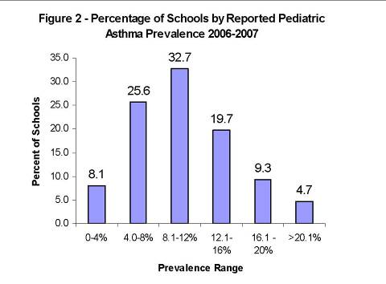

Table 1. Pediatric Asthma Survey Variables 2006-2007
Variable Name Description
Male Number of male K-8 students with asthma
Female Number of female K-8 students with asthma
Grade K – Grade 8 Number of students in each grade with asthma (9 variables, 1 for each grade)
Community of Residence City or Town in which the child resides.
Internet Access % of schools with access to the internet
Computerized Program or Database % of schools with a computerized program or database that was used to access students health records.

Table 2 Reported Prevalence By Grade 2006-2007
Grade | Prevalence (%) | 95% CI
Kindergarten | 9.4 | 9.2 - 9.6
1 | 10.3 | 10.0 - 10.5
2 | 10.6 | 10.4 – 10.8
3 | 10.9 | 10.7 – 11.2
4 | 11.4 | 11.2 – 11.6
5 | 11.4 | 11.3 – 11.7
6 | 11.1 | 10.8 – 11.3
7 | 11.1 | 10.8 – 11.3
8 | 11.0 | 10.8– 11.2

Table 3 | Reported Asthma Prevalence by Gender 2002-2007
 | Prevalence
 | 2002-2003 | 2003-2004 | 2004-2005 | 2005-2006 | 2006-2007
Statewide | 9.2 (9.1 - 9.3) | 9.5 (9.4 - 9.6) | 10.0 (9.9 - 10.1) | 10.6 (10.5 –10.7) | 10.8 (10.7 -10.8)
Males | N/A | 10.9 | 11.7 (11.6 - 11.8) | 12.3 (12.2 - 12.4) | 12.5 (12.4-12.6)
Females | N/A | 8.0 | 8.6 (8.5 - 8.7) | 8.8 (8.7 – 8.9) | 9.0 (8.9- 9.1)

Table 4 Answers to questions related to web based access & computerized programs, MDPH Pediatric Asthma Survey, 2006-2007
Question | Answers | Percent
Do schools have access to the internet to complete survey online? | Yes (n=1770) No (n=153) I Don’t Know (n= 145 ) No Response (n=7) | 85.3% 7.4% 7.0% 0.3%
Were you able to access the student’s asthma information from a computerized program or database? | Yes (n=982) No (n=1085) No Response (n=8) | 47.3% 52.3% 0.4%
Total number of participating schools | N= 2075

Appendix I

School Nurse Advisory Committee

Judith Aubin, North Attleboro Public Schools Susan Breen, Cambridge Public Schools Kathleen De Fillippo, Lawrence Public Schools Catherine DePriest, formerly with MDPH, Bureau of Environmental Health MaryAnn Gapinski, MDPH, ESHS Diane Gorak, MDPH, ESHS Barbara Hedstrom, North Andover Public Schools Gail Lopez, MDPH, ESHS Catherine Porcello, Holliston Public Schools Anne Sheetz, MDPH, ESHS Arlene Swan-Mahony, Boston Public Schools Karen Turmel, Chicopee Public Schools
Appendix II. MDPH Pediatric Asthma Survey, 2006-2007

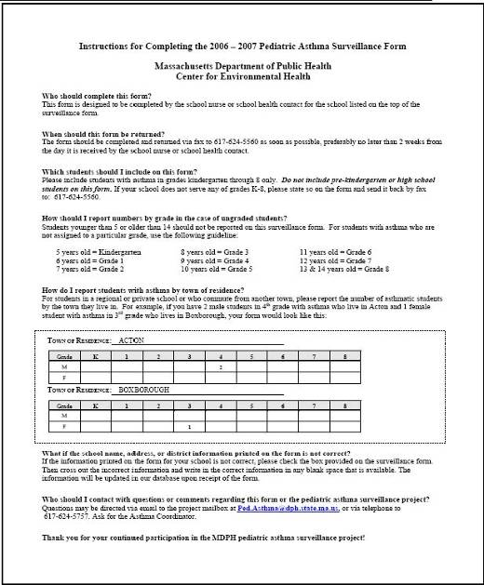
Appendix II MDPH Pediatric Asthma Instruction Sheet, 2006-2007 Appendix II MDPH Pediatric
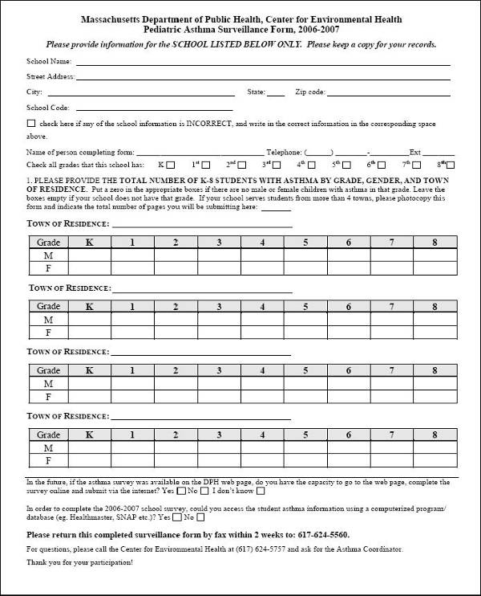

Appendix III Reported Asthma Prevalence by Individual School

Appendix IV Reported Asthma Prevalence by Community (City and Town)

