INDOOR AIR QUALITY ASSESSMENT

Pembroke Community Center
128 Center Street
Pembroke, Massachusetts

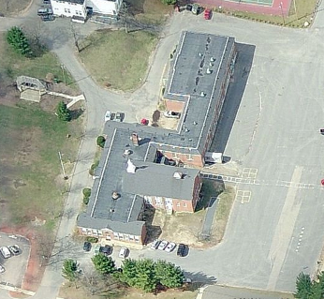

Prepared by:
Massachusetts Department of Public Health
Bureau of Environmental Health
Indoor Air Quality Program
June 2012

Background/Introduction
At the request of George Verry, Inspector of Buildings for the Town of Pembroke, the Massachusetts Department of Public Health (MDPH), Bureau of Environmental Health (BEH) provided assistance and consultation regarding indoor air quality (IAQ) issues at the Pembroke Community Center (PCC) located at 128 Center Street, Pembroke, Massachusetts. On May 9, 2012, a visit was made to this building by Cory Holmes, Environmental Analyst/Inspector for BEH’s IAQ Program to conduct an IAQ assessment. The request was prompted by concerns of respiratory irritation and their possible link to mold in the building/crawlspace.
The PCC was originally constructed as a single-story red brick elementary school in the 1930s. A two-story red brick addition was built in the 1950s (Picture 1). A dirt crawlspace exists under the original 1930s portion of the building for utilities. It was reported that the building had been left vacant for some time in the 1970s before it was reopened as a bingo hall and community center in the late 1970s or early 1980s. No renovations or improvements have been made with the exception of window replacement in portions of the 1930s building and the creation of the TV studio in the 1950s wing. The original 1930s wing contains a daycare center, game room for afterschool programs, a sewing room, and office space. The 1950s wing contains two large bingo halls on the first and second floors (the lower bingo hall and the upper bingo hall respectively), a food pantry and the TV studio. Windows are openable throughout the building.

Methods
Air tests for carbon dioxide, temperature, relative humidity and carbon monoxide were taken with the TSI, Q-Trak ™, IAQ Monitor Model 8551.

Results
The tests were taken during normal operations at the building, with the exception of the bingo halls, which were unoccupied at the time of testing. Test results appear in Table 1.

Discussion

Ventilation
It can be seen from Table 1 that carbon dioxide levels were above 800 parts per million (ppm) in 4 of 13 areas surveyed, indicating poor air exchange in some areas at the time of the assessment. Several areas of the building were not occupied at the time of the assessment, including both bingo halls. Low occupancy can greatly reduce carbon dioxide levels. Carbon dioxide levels would be expected to be higher with increased occupancy. It is important to note that the mechanical ventilation systems throughout the building have been largely abandoned. Without sufficient mechanical supply and exhaust ventilation, environmental pollutants can build up, which can lead to indoor air quality/comfort complaints.
The building was originally designed to be ventilated via a mechanical ventilation system. Fresh air was supplied to classrooms by unit ventilator (univent) systems (Pictures 2 and 3). A univent is designed to draw air from outdoors through a fresh air intake located on the exterior wall of the building (Picture 4) and return air through an air intake located at the base of each unit (Figure 1). Fresh and return air are mixed, filtered, heated and provided to classrooms through a fresh air diffuser located in the top of the unit. Univents were found deactivated throughout the building; in addition, several air diffusers and outside intakes were also found sealed/blocked (Pictures 5 and 6).
According to the American Society of Heating, Refrigeration and Air-Conditioning Engineers (ASHRAE), the service life for a unit heater, hot water or steam is 20 years, assuming routine maintenance of the equipment (ASHRAE, 1991). It appears that the operational lifespan of this equipment (dating from the 1930s and 1950s) has been exceeded. Maintaining the balance of fresh air to exhaust air will become more difficult as the equipment ages and as replacement parts become increasingly difficult to obtain.
Exhaust ventilation was originally provided by vents located in cubby holes at the base of the wall (Pictures 7 and 8) and ducted to rooftop motors (Picture 9). None of these exhaust vents were operating at the time of the assessment.
Mechanical ventilation for the gymnasium and former cafeteria (now the lower bingo hall) was provided by ceiling-mounted air-handling units (AHUs). AHUs draw in fresh, outside air through a set of intake louvers and then through a bank of filters. Air is then distributed via ceiling or wall-mounted air diffusers. Exhaust ventilation is provided by ceiling or wall-mounted return vents ducted back to rooftop AHUs or directly out of the building. The AHUs were not operating at the time of the assessment.
Supplemental ventilation was retro-fitted in the form of local exhaust motors and corresponding supply vents in the bingo halls (Pictures 10 and 11). These vents are manually operated; once the exhaust fans are activated the supply louvers for the intake vents open to create air exchange. The TV studio has been renovated and is equipped with a modern mechanical heating, ventilating and air-conditioning (HVAC) system that appeared to be operating at the time of the assessment. Window-mounted air conditioners were noted in some areas.
The Massachusetts Building Code requires a minimum ventilation rate of 20 cubic feet per minute (cfm) per occupant of fresh outside air or must have openable windows in each room (SBBRS, 1997). The ventilation must be on at all times that the rooms are occupied. Providing adequate fresh air ventilation with open windows and maintaining the temperature in the comfort range during the cold weather season is impractical. Mechanical ventilation is usually required to provide adequate fresh air ventilation.
Carbon dioxide is not a problem in and of itself. It is used as an indicator of the adequacy of the fresh air ventilation. As carbon dioxide levels rise, it indicates that the ventilating system is malfunctioning or the design occupancy of the room is being exceeded. When this happens, a buildup of common indoor air pollutants can occur, leading to discomfort or health complaints. The Occupational Safety and Health Administration (OSHA) standard for carbon dioxide is 5,000 parts per million parts of air (ppm). Workers may be exposed to this level for 40 hours/week, based on a time-weighted average (OSHA, 1997).
The MDPH uses a guideline of 800 ppm for publicly occupied buildings. A guideline of 600 ppm or less is preferred in schools due to the fact that the majority of occupants are young and considered to be a more sensitive population in the evaluation of environmental health status. Inadequate ventilation and/or elevated temperatures are major causes of complaints such as respiratory, eye, nose and throat irritation, lethargy and headaches. For more information concerning carbon dioxide, consult Appendix A.
Temperature readings in the building ranged from 65°F to 78°F, which were below the MDPH recommended range in several areas surveyed (Table 1). The MDPH recommends that indoor air temperatures be maintained in a range of 70°F to 78°F in order to provide for the comfort of building occupants. In many cases concerning indoor air quality, fluctuations of temperature in occupied spaces are typically experienced, even in a building with an adequate fresh air supply. In addition, it is difficult to control temperature and maintain comfort without operating the ventilation equipment as designed (e.g., univents and exhaust vents not operating/obstructed).
The relative humidity measured in the building ranged from 50 to 66 percent at the time of the assessment (Table 1), above the MDPH recommended comfort range in several areas and reflective of outside conditions of 100 percent humidity and rain. The MDPH recommends a comfort range of 40 to 60 percent for indoor air relative humidity. While temperature is mainly a comfort issue, relative humidity in excess of 70 percent for extended periods of time can provide an environment for mold and fungal growth (ASHRAE, 1989). It is difficult to obtain optimal relative humidity levels without a mechanical means to remove moisture from the air (e.g., dehumidifiers or air conditioning). Relative humidity levels in the building would be expected to drop during the winter months due to heating. The sensation of dryness and irritation is common in a low relative humidity environment. Low relative humidity is a very common problem during the heating season in the northeast part of the United States.

Microbial/Moisture Concerns
Concerns regarding mold growth in the crawlspace were expressed. Note that mold would be expected to be present in an unconditioned dirt crawlspace that is subjected to moisture. It is more prudent to make efforts to reduce moisture, circulate air and reduce/eliminate potential pathways for mold, spores, and associated odors to migrate into occupied areas. The most obvious pathways for communication between the crawlspace and occupied areas on the ground floor are through utility holes (e.g., radiators, univents) (Picture 12). Airflow tends to rise from lower to upper floors, a condition known as the stack effect. These holes should be sealed with a fire-rated foam or other material.
Missing/damaged caulking was observed around windows (Pictures 13 through 16), which can result in air/moisture infiltration and damage to interior building materials (e.g., wall/ceiling plaster, flooring) (Picture 17). Depending on its age, window (and joint) sealant may be composed of regulated materials [e.g., asbestos, polychlorinated biphenyls (PCBs)]. If so, materials should be addressed in accordance with US Environmental Protection Agency (US EPA) regulations. For additional information regarding PCBs, please consult MDPH guidance (Appendix B).
The US EPA and the American Conference of Governmental Industrial Hygienists (ACGIH) recommend that porous materials be dried with fans and heating within 24 to 48 hours of becoming wet (US EPA, 2001; ACGIH, 1989). If not dried within this time frame, mold growth may occur. Once mold has colonized porous materials, they are difficult to clean and should be removed/discarded. Chronic water penetration has resulted in visible mold growth, odors and debris inside the first floor restroom windowsill (Pictures 18 and 19). Carpeting is installed along windowsills in the lower bingo hall (Picture 20). Carpeting is a porous material that will absorb water and grow mold if wetted repeatedly.
BEH staff examined the building to identify breaches in the building envelope that could provide a source of water penetration. Several potential sources were identified:
- A number of exterior doors had damaged weather-stripping and light could be seen penetrating through the spaces underneath the door from the outdoors (Picture 21).
- Gutters/downspouts were damaged/missing and emptying against the exterior of the building, allowing rainwater to pool on the ground at the base of the building (Pictures 22 and 23).
- Moss growth was noted in several areas along exterior brickwork. A substantial source of water is needed for moss to grow. Moss growth is a sign of heavy/continuous water exposure which can threaten the structural integrity of the building.
- Exterior wall cracks and open utility holes penetrate through the exterior wall and are not properly sealed (Picture 24).
- Missing/damaged mortar around brickwork (Pictures 25 through 27), and
- Bowing of exterior walls (Pictures 28 and 29).
The aforementioned conditions represent potential water penetration sources. Over time, these conditions can undermine the integrity of the building envelope and provide a means of water entry into the building via capillary action through exterior walls, foundation concrete and masonry (Lstiburek & Brennan, 2001). The freezing and thawing action of water during the winter months can create cracks and fissures in the foundation. In addition, they can serve as pathways for insects, rodents and other pests into the building. Of particular note is the “bowing” of portions of the exterior wall in Pictures 28 and 29, which may raise questions regarding the building’s structural integrity.

Other Indoor Air Evaluations
Indoor air quality can be negatively influenced by the presence of respiratory irritants, such as products of combustion. The process of combustion produces a number of pollutants. Common combustion emissions include carbon monoxide, carbon dioxide, water vapor, and smoke (fine airborne particle material). Of these materials, exposure to carbon monoxide and particulate matter with a diameter of 2.5 micrometers (μm) or less (PM2.5) can produce immediate, acute health effects upon exposure. To determine whether combustion products were present in the indoor environment, BEH staff obtained measurements for carbon monoxide and PM2.5.

Carbon Monoxide
Carbon monoxide is a by-product of incomplete combustion of organic matter (e.g., gasoline, wood and tobacco). Exposure to carbon monoxide can produce immediate and acute health affects. Several air quality standards have been established to address carbon monoxide and prevent symptoms from exposure to these substances. The MDPH established a corrective action level concerning carbon monoxide in ice skating rinks that use fossil-fueled ice resurfacing equipment. If an operator of an indoor ice rink measures a carbon monoxide level over 30 ppm, taken 20 minutes after resurfacing within a rink, that operator must take actions to reduce carbon monoxide levels (MDPH, 1997).
The American Society of Heating Refrigeration and Air-Conditioning Engineers (ASHRAE) has adopted the National Ambient Air Quality Standards (NAAQS) as one set of criteria for assessing indoor air quality and monitoring of fresh air introduced by HVAC systems (ASHRAE, 1989). The NAAQS are standards established by the US EPA to protect the public health from six criteria pollutants, including carbon monoxide and particulate matter (US EPA, 2006). As recommended by ASHRAE, pollutant levels of fresh air introduced to a building should not exceed the NAAQS levels (ASHRAE, 1989). The NAAQS were adopted by reference in the Building Officials & Code Administrators (BOCA) National Mechanical Code of 1993 (BOCA, 1993), which is now an HVAC standard included in the Massachusetts State Building Code (SBBRS, 1997). According to the NAAQS, carbon monoxide levels in outdoor air should not exceed 9 ppm in an eight-hour average (US EPA, 2006).
Carbon monoxide should not be present in a typical, indoor environment. If it is present, indoor carbon monoxide levels should be less than or equal to outdoor levels. The day of the assessment, outdoor carbon monoxide concentrations were non-detect (ND) (Table 1). No measureable levels of carbon monoxide were detected in the building during the assessment (Table 1).

Particulate Matter
The US EPA has established NAAQS limits for exposure to particulate matter. Particulate matter is airborne solids that can be irritating to the eyes, nose and throat. The NAAQS originally established exposure limits to particulate matter with a diameter of 10 μm or less (PM10). According to the NAAQS, PM10 levels should not exceed 150 micrograms per cubic meter (μg/m³) in a 24-hour average (US EPA, 2006). These standards were adopted by both ASHRAE and BOCA. Since the issuance of the ASHRAE standard and BOCA Code, US EPA established a more protective standard for fine airborne particles. This more stringent PM2.5 standard requires outdoor air particle levels be maintained below 35 μg/m³ over a 24-hour average (US EPA, 2006). Although both the ASHRAE standard and BOCA Code adopted the PM10 standard for evaluating air quality, MDPH uses the more protective PM2.5 standard for evaluating airborne particulate matter concentrations in the indoor environment.
Outdoor PM2.5 was measured from 9 to 11 μg/m³ (Table 1). PM2.5 levels measured indoors ranged from 5 to 25 μg/m³ (Table 1), which were below the NAAQS PM2.5 level of 35 μg/m³. Frequently, indoor air levels of particulates (including PM2.5) can be at higher levels than those measured outdoors. A number of mechanical devices and/or activities that occur in buildings can generate particulate during normal operations. Sources of indoor airborne particulates may include but are not limited to particles generated during the operation of fan belts in the HVAC system, use of stoves and/or microwave ovens in kitchen areas; use of photocopiers, fax machines and computer printing devices; operation of an ordinary vacuum cleaner and heavy foot traffic indoors.

Other Conditions
Other conditions that can affect indoor air quality were observed during the assessment. Of note was the poor condition of the floor surfaces in the upper and lower bingo halls. The “unfinished” condition of the floors makes it difficult to clean as evidenced by its discoloration resulting from accumulated dust and debris. It is recommended that floor surfaces in public buildings are readily cleanable. Floors should have a smooth, noncorrosive, nonabsorbent and waterproof covering.
Damaged and/or missing floor tiles were observed in the TV studio and in both the lower and upper bingo halls (Pictures 30 through 32). These floor tiles may contain asbestos. Intact asbestos-containing material (ACM) does not pose a health hazard. If damaged, ACM can be rendered friable and become aerosolized. Friable asbestos is a chronic (long-term) health hazard, but will not produce acute (short-term) health effects (e.g., headaches) typically associated with buildings believed to have indoor air quality problems. Where asbestos-containing materials are found damaged, these materials should be removed or remediated in a manner consistent with Massachusetts asbestos remediation laws (MDLI, 1993).
Finally, exposed fiberglass pipe insulation was observed in the upper bingo hall behind a loose ceiling tile (Picture 33) and inside univent air diffusers in classrooms (Picture 5). Fiberglass insulation can provide a source of skin, eye and respiratory irritation.

Conclusions/Recommendations
The conditions noted at the PCC raise a number of IAQ issues. The general building conditions, maintenance, operational practices, and the age/condition of ventilation equipment, considered individually, present conditions that could have an adverse impact on indoor air quality. When combined, these conditions can serve to further degrade air quality. Some of these conditions can be remedied by actions of building occupants. Other remediation efforts will require alteration to the building structure and equipment. For these reasons, a two-phase approach is required for remediation. The first consists of short-term measures to improve air quality and the second consists of long-term measures that will require planning and resources to adequately address overall IAQ conditions.

Short-Term Recommendations
- Open windows (weather permitting) to temper rooms and provide fresh outside air. Care should be taken to ensure windows are properly closed at night and weekends during winter months to avoid the freezing of pipes and potential flooding. In addition, keep windows closed during hot, humid weather to maintain indoor temperatures and to avoid condensation problems when air conditioning is activated.
- Supplement fresh air by operating window-mounted air conditioners (where installed) in the "fan only" “fresh air” mode, which introduces outside air by mechanical means.
- Clean/change filters for air conditioners per the manufacturer’s instructions or more frequently if needed.
- Utilize air conditioners and/or dehumidifiers as needed during extended periods of elevated relative humidity (> 70%). Ensure dehumidifiers are cleaned and maintained per the manufacturer’s instructions to prevent microbial growth.
- For buildings in New England, periods of low relative humidity during the winter are often unavoidable. Therefore, scrupulous cleaning practices should be adopted to minimize common indoor air contaminants whose irritant effects can be enhanced when the relative humidity is low. To control for dusts, a high efficiency particulate arrestance (HEPA) filter equipped vacuum cleaner in conjunction with wet wiping of all surfaces is recommended. Avoid the use of feather dusters. If used store them away from occupied areas. Drinking water during the day can help ease some symptoms associated with a dry environment (throat and sinus irritations).
- Make temporary repairs to seal breaches in building envelope including open utility holes to prevent drafts, access by pests/rodents and further water penetration and damage to building materials.
- Contact a masonry firm or general contractor to repair holes/breaches in exterior brick surfaces to prevent water penetration, drafts and pest entry.
- Ensure any roof/window leaks are repaired.
- Clean mold/debris from around window in lower rest room; ensure window is properly sealed to prevent water infiltration.
- Address deteriorating sealant/caulking materials on the interior and exterior of the building in accordance with EPA regulations/MDPH guidance (Appendix B).
- Seal utility holes (e.g., around radiator/univent pipes) and other potential pathways to eliminate pollutant paths of migration from the basement/crawlspace to the first floor. Ensure tightness by monitoring for light penetration and drafts.
- Periodically clean/pressure wash moss growth from exterior brickwork.
- Take measures to tighten exterior doors (e.g., weather-stripping) to prevent drafts, moisture infiltration and pest/rodent entry. Ensure tightness of doors by monitoring for light penetration and drafts around doorframes.
- Determine if damaged floor tiles contain ACM. Remediate damaged ACMs (e.g., floor tiles, pipe insulation) throughout the building in conformance with Massachusetts asbestos remediation and hazardous waste disposal laws and regulations. For further advice contact the Massachusetts Department of Labor Standards Asbestos Program at (508) 616-0461.
- Finish floors in the bingo halls to improve cleaning.
- Replace loose ceiling tile in upper bingo hall (Picture 33) and seal univent diffusers that are stopped with fiberglass insulation (Picture 5).
- Refer to resource manuals and other related indoor air quality documents for further building-wide evaluations and advice on maintaining public buildings. These materials are located on the MDPH’s website: http://mass.gov/dph/iaq.

Long-Term Recommendations
- Contact a structural engineer/building envelope specialist for an examination of the exterior brick work of the building, especially in areas where the exterior wall is “bowing” outwards. This measure should include a full building envelope evaluation.
- Based on the age, physical deterioration and availability of parts, the BEH recommends that an HVAC engineering firm evaluate options for providing adequate ventilation building-wide. Such an evaluation is necessary to determine the operability and feasibility of repairing/replacing the equipment.
- If the original ventilation components are not to be restored, seal abandoned supply and exhaust vents inside the building as well as on the roof to prevent drafts and the egress of odors, dust and particulate matter into occupied areas.
- Consider a long-term plan to replace windows (where needed) to prevent air/moisture infiltration.
- Consider consulting with an HVAC engineering firm for best methods for installing a mechanical means to establish negative pressure conditions in the basement/crawlspace relative to the first floor.
- Consider having exterior walls re-pointed to prevent water intrusion.
- Repair/replace missing/damaged sections of gutter/downspout system to direct water away from the foundation of the building.
- Repair/replace missing/damaged sections of wooden trim along roof edge to prevent water infiltration.

References
ACGIH. 1989. Guidelines for the Assessment of Bioaerosols in the Indoor Environment. American Conference of Governmental Industrial Hygienists, Cincinnati, OH.
ASHRAE. 1989. Ventilation for Acceptable Indoor Air Quality. American Society of Heating, Refrigeration and Air Conditioning Engineers. ANSI/ASHRAE 62-1989.
ASHRAE. 1991. ASHRAE Applications Handbook, Chapter 33 “Owning and Operating Costs”. American Society of Heating, Refrigeration and Air Conditioning Engineers, Atlanta, GA.
BOCA. 1993. The BOCA National Mechanical Code/1993. 8th ed. Building Officials and Code Administrators International, Inc., Country Club Hill, IL.
Lstiburek, J. & Brennan, T. 2001. Read This Before You Design, Build or Renovate. Building Science Corporation, Westford, MA. U.S. Department of Housing and Urban Development, Region I, Boston, MA
MDLI. 1993. Regulation of the Removal, Containment or Encapsulation of Asbestos, Appendix 2. 453 CMR 6,92(I)(i).
MDPH. 1997. Requirements to Maintain Air Quality in Indoor Skating Rinks (State Sanitary Code, Chapter XI). 105 CMR 675.000. Massachusetts Department of Public Health, Boston, MA.
OSHA. 1997. Limits for Air Contaminants. Occupational Safety and Health Administration. Code of Federal Regulations. 29 C.F.R 1910.1000 Table Z-1-A.
SBBRS. 1997. Mechanical Ventilation. State Board of Building Regulations and Standards. Code of Massachusetts Regulations. 780 CMR 1209.0.
US EPA. 2001. Mold Remediation in Schools and Commercial Buildings. US Environmental Protection Agency, Office of Air and Radiation, Indoor Environments Division, Washington, D.C. EPA 402-K-01-001. March 2001.
US EPA. 2006. National Ambient Air Quality Standards (NAAQS). US Environmental Protection Agency, Office of Air Quality Planning and Standards, Washington, DC. http://www.epa.gov/air/criteria.html.
Picture 1

Aerial View of Pembroke Community Center Showing 1930s Original Building (South) Containing the Day Care Center, and 1950s Addition Containing Bingo Halls (North, Bracket)

Picture 2

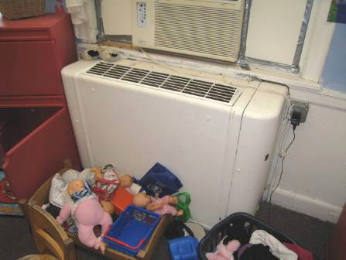

1930s Vintage Univent

Picture 3

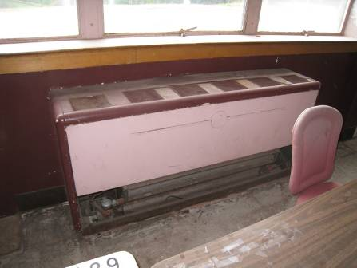

1950s Vintage Univent

Picture 4

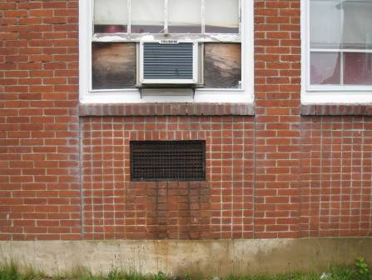

Univent Fresh Air Intake

Picture 5

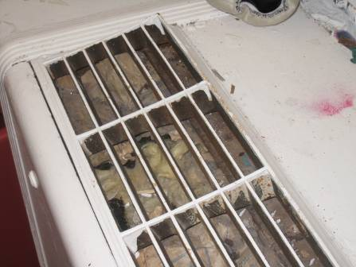

Univent Air Diffuser Blocked with Fiberglass Insulation

Picture 6

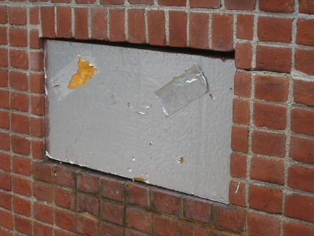

Univent Fresh Air Intake Blocked with Fiberboard

Picture 7

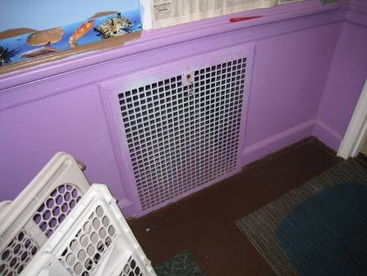

Grated Exhaust Cubby

Picture 8

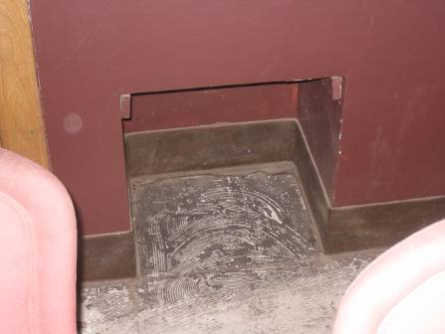

Ungrated Exhaust Cubby

Picture 9

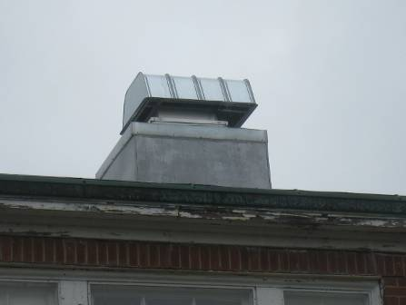

Rooftop Exhaust Motor

Picture 10

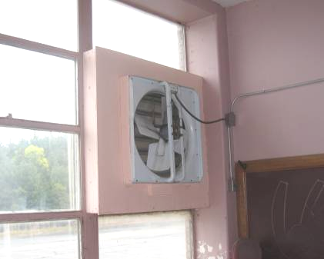

Local Exhaust Fan in Bingo Hall

Picture 11

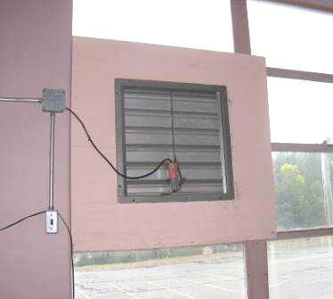

Louvered Supply Vent in Bingo Hall

Picture 12

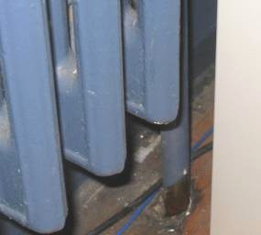

Radiator Pipe through Floor to Crawlspace

Picture 13

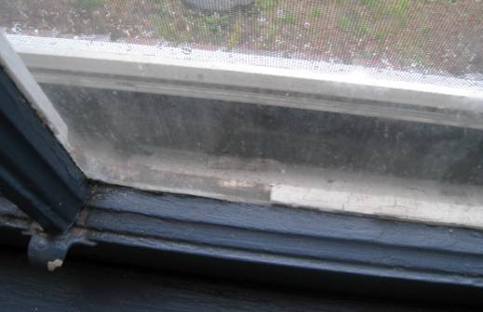

Missing/Damaged Window Caulking

Picture 14

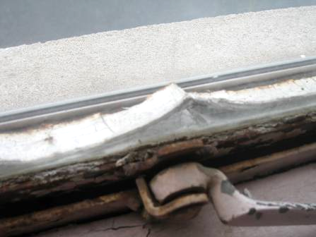

Missing/Damaged Window Caulking

Picture 15

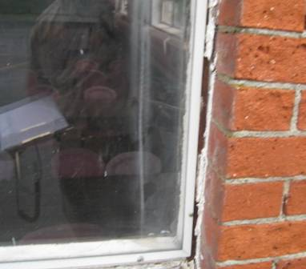

Missing/Damaged Caulking around Window Frames

Picture 16

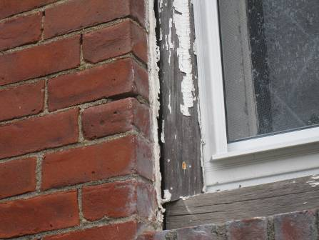

Missing/Damaged Window Caulking, Also Note Old Damaged Wooden Window Frames

Picture 17

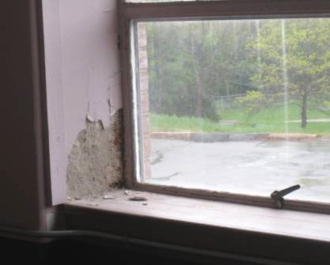

Water-Damaged Wall Plaster around Windows

Picture 18

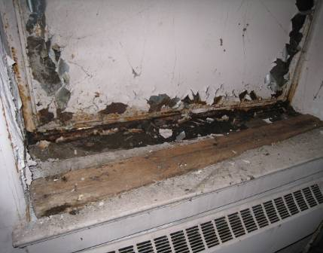

Wet/Moldy Debris inside First Floor Restroom Window

Picture 19

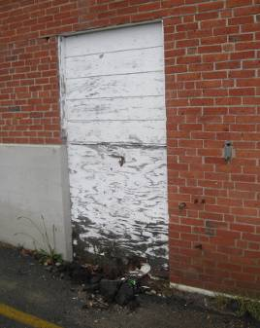

Leaking First Floor Restroom Window Sealed with Plywood

Picture 20

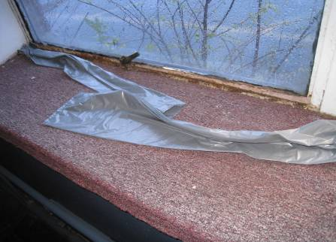

Carpeting along Windowsills in Lower Bingo Hall, Note Plastic Presumably
to Keep out Drafts/Moisture

Picture 21

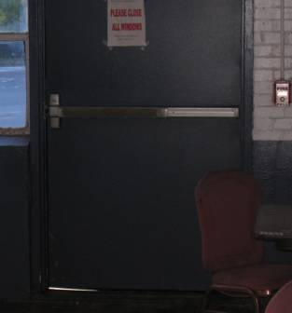

Light Penetrating beneath Exterior Door

Picture 22

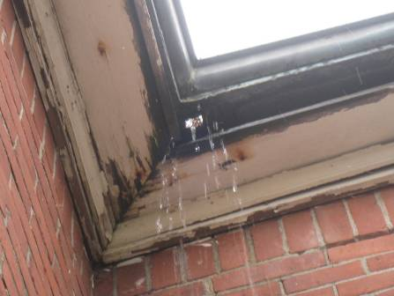

Hole in Gutter, Also Note Damaged/Rotted Woodwork

Picture 23

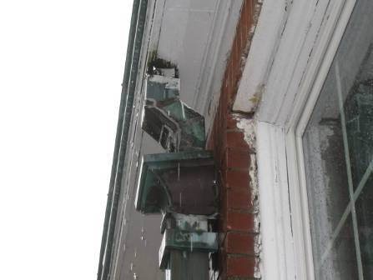

Damaged Downspout/Gutter System and Damaged/Rotted Woodwork

Picture 24

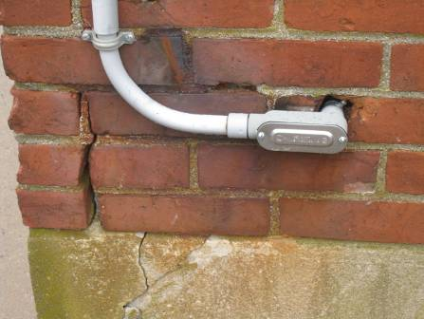

Exterior Wall Cracks and Open Utility Holes

Picture 25

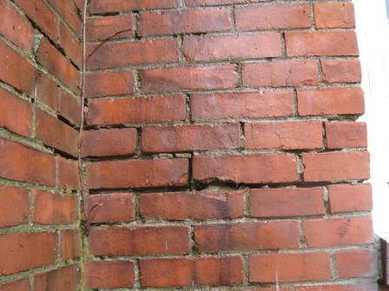

Missing/Damaged Mortar around Brickwork

Picture 26

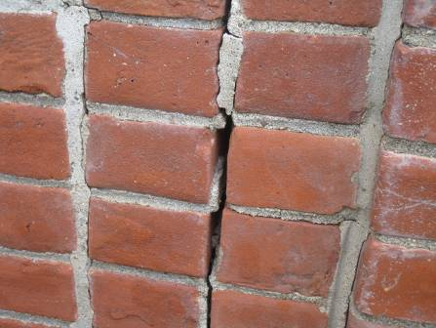

Missing/Damaged Mortar around Brickwork

Picture 27

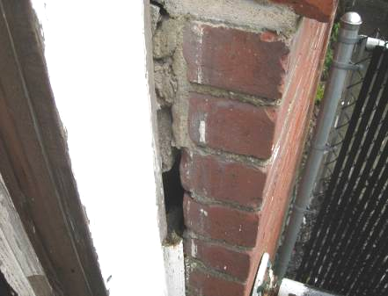

Missing/Damaged Mortar/Sealant around Brickwork and Wooden Door Frame

Picture 28

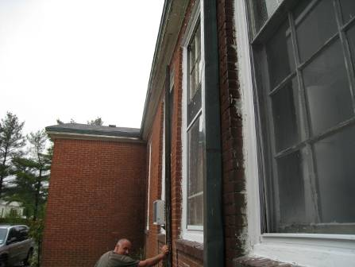

“Bowing” Exterior Brickwork, Note Space between Straight Plank and Wall (Bracket)

Picture 29

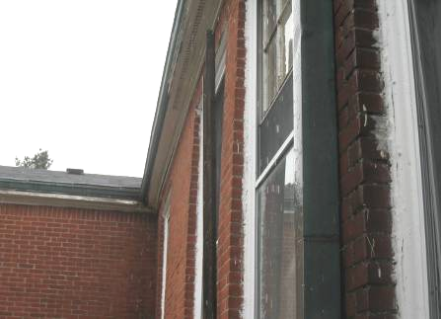

Close-up of “Bowing” Exterior Brickwork, Note Space between
Straight Plank and Wall (Bracket)

Picture 30

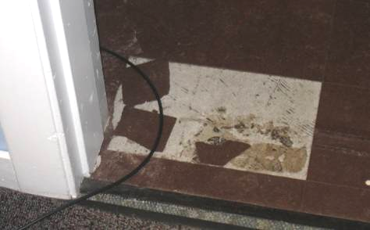

Damaged Floor Tiles in TV Studio

Picture 31

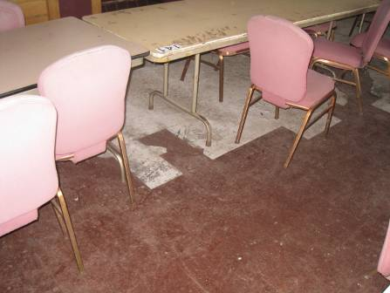

Damaged Floor Tiles in Upper Bingo Hall

Picture 32

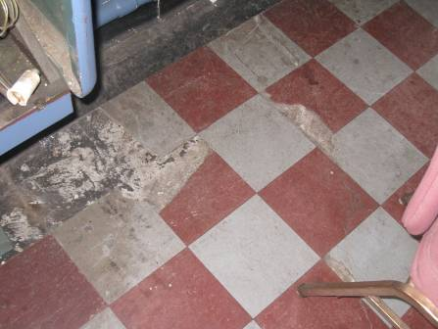

Damaged Floor Tiles in Lower Bingo Hall
Picture 33

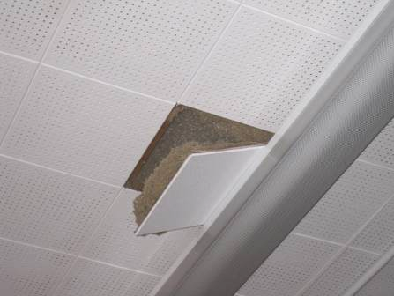

Loose Ceiling Tile Exposing Insulation in Upper Bingo Hall
Location | Carbon  Dioxide  (*ppm) | Temp  (°F) | Relative  Humidity  (%) | Carbon  Monoxide  (*ppm) | PM2.5  (µg/m³) | Occupants  in Room | Windows  Openable | Ventilation  Supply Exhaust
Background | 416 | 68 | 100 | ND | 9-11 |  |  |  |  | Moderate to heavy rains, south winds 8-12 mph, gusts up to 20 mph
1 | 872 | 73 | 56 | ND | 12 | 7 | Y | N | N
2 | 701 | 74 | 62 | ND | 9 | 3 | Y | N | N
5 Preschool Office | 909 | 75 | 51 | ND | 10 | 3 | Y | N | N | Carbon monoxide monitor on wall
6 Daycare A | 1285 | 73 | 60 | ND | 20 | 16 | Y | N | N | Open wall divider between 6 A & 6 B
6 Daycare B | 987 | 78 | 50 | ND | 25 | 12 | Y | N | N
10 Sewing Room | 749 | 71 | 63 | ND | 22 | 6 | Y | N | N | Window AC
13 Game Room | 439 | 71 | 60 | ND | 12 | 0 | Y | N | N | Exhaust sealed
Recreation Office | 608 | 70 | 62 | ND | 8 | 3 | Y | N | N | Holes in floor around pipes
Gym | 652 | 65 | 66 | ND | 22 | 0 | Y | N | N
Disability Office | 649 | 74 | 52 | ND | 11 | 1 | Y | N | N
2nd Floor Bingo Hall | 626 | 69 | 64 | ND | 6 | 0 | Y | Y | Y | Local supply and exhaust vents/fans in windows, CT-loose, damaged floor tiles, WD wall plaster from former leak, hole in wall
TV Studio | 549 | 71 | 51 | ND | 5 | 2 | Y | Y | Y | HVAC system installed, damaged floor tiles
Lower Bingo Hall | 392 | 72 | 57 | ND | 5 | 0 | Y | Y | Y | Damaged floor tiles, ceiling fans, carpeting along window sills
Lower Restroom |  |  |  |  |  |  | Y | Y | Y | Musty/mold odors-leaking window, rotted wood and wet debris along windowsill

An Information Booklet Addressing PCB-Containing Materials in the Indoor Environment of Schools
and Other Public Buildings



Prepared by

Bureau of Environmental Health
Massachusetts Department of Public Health
December 2009
INTRODUCTION
The purpose of this information booklet is to provide assistance to school and public building officials and the general public in assessing potential health concerns associated with polychlorinated biphenyl (PCB) compounds in building materials used in Massachusetts and elsewhere. Recently, the U.S. Environmental Protection Agency (EPA) provided broad guidance relative to the presence of PCBs in building materials, notably PCBs in caulking materials. The most common building materials that may contain PCBs in facilities constructed or significantly renovated during the 1950s through the 1970s are fluorescent light ballasts, caulking, and mastic used in tile/carpet as well as other adhesives and paints.
This information booklet, developed by the Massachusetts Department of Public Health’s Bureau of Environmental Health (MDPH/BEH), is designed to supplement guidance offered by EPA relative to potential health impacts and environmental testing. It also addresses managing building materials, such as light ballasts and caulking, containing PCBs that are likely to be present in many schools and public buildings across the Commonwealth. This is because the Northeastern part of the country, and notably Massachusetts, has a higher proportion of schools and public buildings built during the 1950s through 1970s than many other parts of the U.S. according to a 2002 U.S. General Accounting Office report. The Massachusetts School Building Authority noted in a 2006 report that 53 percent of over 1,800 Massachusetts school buildings surveyed were built during the 1950s through 1970s. This information booklet contains important questions and answers relative to PCBs in the indoor environment and is based on the available scientific literature and MDPH/BEH’s experience evaluating the indoor environment of schools and public buildings for a range of variables, including for PCBs as well as environmental data reviewed from a variety of sources.
1. What are PCBs?
Polychlorinated biphenyl (PCB) compounds are stable organic chemicals used in products from the 1930s through the late 1970s. Their popularity and wide-spread use were related to several factors, including desirable features such as non-flammability and electrical insulating properties. Although the original use of PCBs was exclusive to closed system electrical applications for transformers and capacitors (e.g., fluorescent light ballasts), their use in other applications, such as using PCB oils to control road dust or caulking in buildings, began in the 1950s.
2. When were PCBs banned from production?
Pursuant to the Toxic Substance Control Act (TSCA) of 1976 (effective in 1979), manufacturing, processing, and distribution of PCBs was banned. While the ban prevented production of PCB-containing products, it did not prohibit the use of products already manufactured that contained PCBs, such as building materials or electrical transformers.
3. Are PCBs still found in building materials today?
Yes. Products made with PCBs prior to the ban may still be present today in older buildings. In buildings constructed during the 1950s through 1970s, PCBs may be present in caulking, floor mastic, and in fluorescent light ballasts. Available data reviewed by MDPH suggests that caulking manufactured in the 1950s through 1970s will likely contain some levels of PCBs. Without testing it is unclear whether caulking in a given building may exceed EPA’s definition of PCB bulk product waste of 50 parts per million (ppm) or greater. If it does, removal and disposal of the caulk is required in accordance with EPA’s TSCA regulations (40 CFR § 761).
4. Are health concerns associated with PCB exposure opportunities?
Although the epidemiological evidence is sometimes conflicting, most health agencies have concluded that PCBs may reasonably be anticipated to be a carcinogen, i.e., to cause cancer.
PCBs can have a number of non-cancer effects, including those on the immune, reproductive, neurological and endocrine systems. Exposure to high levels of PCB can have effects on the liver, which may result in damage to the liver. Acne and rashes are symptoms typical in those that are exposed to high PCB levels for a short period of time (e.g., in industry / occupational settings).
5. If PCBs are present in caulking material, does that mean exposure and health impacts are likely?
No. MDPH/BEH’s review of available data suggests that if caulking is intact, no appreciable exposures to PCBs are likely and hence health effects would not be expected. MDPH has conducted indoor tests and reviewed available data generated through the efforts of many others in forming this opinion.
6. How can I tell if caulking or light ballasts in my building may contain PCBs?
If the building was built sometime during the 1950s through 1970s, then it is likely that the caulking in the building and/or light ballasts may contain some level of PCBs. Light ballasts manufactured after 1980 have the words “No PCBs” printed on them. If the light ballast does not have this wording or was manufactured before 1980, it should be assumed that it contains PCBs.
7. What are light ballasts?
A light ballast is a piece of equipment that controls the starting and operating voltages of fluorescent lights. A small capacitor within older ballasts contains about one ounce of PCB oil. If light bulbs are not changed soon after they go out, the ballast will continue to heat up and eventually result in the release of low levels of PCBs into the indoor air.
8. Does the presence of properly functioning fluorescent light ballasts in a building present an environmental exposure concern?
No appreciable exposure to PCBs is expected if fluorescent light ballasts that contain PCBs are intact and not leaking or damaged (i.e., no visible staining of the light lenses), and do not have burned-out bulbs in them.

9. Should I be concerned about health effects associated with exposure to PCBs as a result of PCB-containing light ballasts?
While MDPH has found higher PCB levels in indoor air where light bulbs have burned-out, the levels are still relatively low and don’t present imminent health threats. A risk assessment conducted recently at one school did not suggest unusual cancer risks when considering a worst case exposure period of 35 years for teachers in that school. Having said this, MDPH believes that facility operators and building occupants should take prompt action to replace bulbs and/or ballasts as indicated to reduce/eliminate any opportunities for exposure to PCBs associated with PCB-containing light ballasts.
10. When should PCB-containing light ballasts be replaced?
If ballasts appear to be in disrepair, they should be replaced immediately and disposed of in accordance with environmental regulatory guidelines and requirements. However, if light bulbs burn out, the best remedy is to change them as soon as possible. If light bulbs are not changed soon after they go out, the ballast will continue to heat up and eventually result in the release of low levels of PCBs into the indoor air. Thus, burned-out bulbs should be replaced promptly to reduce overheating and stress on the ballast. As mentioned, ballasts that are leaking or in any state of disrepair should be replaced as soon as possible.
It should be noted that although older light ballasts may still be in use today, the manufacturers’ intended lifespan of these ballasts was 12 years. Thus, to the extent feasible or in connection with repair/renovation projects, the older light ballasts should be replaced consistent with the intended lifespan specified by the manufacturers.
11. Does MDPH recommend testing of caulking in buildings built during the 1950s -1980?
Caulking that is intact should not be disturbed. If caulking is deteriorating or damaged, conducting air and surface wipe testing in close proximity to the deteriorating caulking will help to determine if indoor air levels of PCBs are a concern as well as determining the need for more aggressive cleaning. Results should be compared with similar testing done in an area without deteriorating caulking. In this way, a determination can be made regarding the relative contribution of caulking materials to PCBs in the general indoor environment.
12. What if we determine that caulking in our building is intact and not deteriorating?
Based on a review of available data collected by MDPH and others, the MDPH does not believe that intact caulking presents appreciable exposure opportunities and hence should not be disturbed for testing. As with any building, regular operations and maintenance should include a routine evaluation of the integrity of caulking material. If its condition deteriorates then the steps noted above should be followed. Consistent with EPA advice, if buildings may have materials that contain PCBs, facility operators should ensure thorough cleaning is routinely conducted.
13. Should building facilities managers include information about PCB-containing building materials in their Operations and Maintenance (O&M) plans?
Yes. All buildings should have an O&M plan that includes regular inspection and maintenance of PCB building materials, as well as thorough cleaning of surfaces not routinely used. Other measures to prevent potential exposure to PCBs include increasing ventilation, use of HEPA filter vacuums, and wet wiping. These O&M plans should be available to interested parties.
14. Are there other sources of PCBs in the environment?
Yes. The most common exposure source of PCBs is through consumption of foods, particularly contaminated fish. Because PCBs are persistent in the environment, most residents of the U.S. have some level of PCBs in their bodies.
15. Where can I obtain more information?
For guidance on replacing and disposing of PCB building materials, visit the US EPA website: http://www.epa.gov/pcbsincaulk/. For information on health concerns related to PCBs in building materials, please contact MDPH/BEH at 617-624-5757.

The service life is the median time during which a particular system or component of …[an HVAC]… system remains in its original service application and then is replaced. Replacement may occur for any reason, including, but not limited to, failure, general obsolescence, reduced reliability, excessive maintenance cost, and changed system requirements due to such influences as building characteristics or energy prices (ASHRAE, 1991).

