INDOOR AIR QUALITY ASSESSMENT

Pembroke Community Middle School
559 School Street
Pembroke, MA

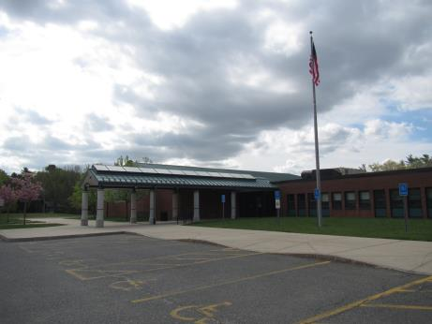

Prepared by:
Massachusetts Department of Public Health
Bureau of Environmental Health
Indoor Air Quality Program
May 2018

Background

Building: | Pembroke Community Middle School (PCMS)
Address: | 559 School Street, Pembroke, MA
Assessment Requested by: | Justin J. Domingos,  Director of Athletics/Facilities, Pembroke Public Schools
Reason for Request: | General indoor air quality (IAQ) assessment
Date of Assessment: | May 11, 2018
Massachusetts Department of Public Health/Bureau of Environmental Health (MDPH/BEH) Staff Conducting Assessment: | Ruth Alfasso and Cory Holmes, Inspectors, IAQ Program
Date of Building Construction: | Built in the 1950s, and fully renovated in 2004
Building Description: | Brick and concrete multi-story building with a flat roof and skylights. It contains classrooms, offices and common areas including a gym, cafeteria/kitchen, library and auditorium.
Building Population: | Approximately 500 students in grades 7 and 8 with a staff of approximately 60
Windows: | Mostly openable

IAQ Testing Results
Please refer to the IAQ Manual for methods, sampling procedures, and interpretation of results (MDPH, 2015). The following is a summary of indoor air testing results (Table 1).
- Carbon dioxide levels were above 800 parts per million (ppm) in 21 of 71 areas tested, indicating that about a third of the rooms need improved air exchange.
- Temperature was within the recommended range of 70°F to 78°F in all areas tested.
- Relative humidity was within or close to the recommended range of 40 to 60% in all areas the day of assessment.
- Carbon monoxide levels were non-detectable (ND) in all areas tested.
- Fine particulate matter (PM2.5) concentrations measured were below the National Ambient Air Quality (NAAQS) limit of 35 μg/m³ in all areas tested.

Ventilation
A heating, ventilating and air conditioning (HVAC) system has several functions. First it provides heating and, if equipped, cooling. Second, it is a source of fresh air. Finally, an HVAC system will dilute and remove normally occurring indoor environmental pollutants by not only introducing fresh air, but by filtering the airstream and ejecting stale air to the outdoors via exhaust ventilation. Even if an HVAC system is operating as designed, point sources of respiratory irritation may exist and cause symptoms in sensitive individuals.
The HVAC system at the PCMS uses an automated program that can be monitored/adjusted via computer. Fresh air in classrooms is supplied by unit ventilators (univents, Picture 1). Univents draw air from the outdoors through a fresh air intake located on the exterior wall of the building (Picture 2) and return air through an air intake located at the base of the unit. Fresh and return air are mixed, filtered, heated or cooled and provided to rooms through an air diffuser located in the top of the unit (Figure 1). In a number of rooms univents were deactivated (Picture 3, Table 1), therefore there was no fresh/outside air being introduced into these areas. It is important to note that these units are not just “heaters” but “ventilators”. During temperate days, the heat should be minimized and the fans on continuously to bring in fresh air. In a few areas items were on top or in front of univents (Picture 4, Table 1), which can block air circulation.
In common areas such as core rooms, the office, gym, cafeteria, and auditorium, fresh air is supplied by air handling units (AHU) located on the roof or suspended from ceilings (Pictures 5 and 6). Fresh air is heated or cooled as needed and ducted to ceiling-mounted supply vents (Picture 7). Exhaust/return vents on walls/ceilings remove air from these areas and return it to the AHUs.
Exhaust in classrooms is provided by motors on the roof ducted to vents on the walls or ceilings (Picture 8). Some exhaust vents examined were not drawing air. Note that many classroom exhaust vents are located near hallway doors (Picture 9), with doors open the vents can draw air from the hallway instead of the classroom. Without proper supply and exhaust ventilation, normally-occurring environmental pollutants can build up and lead to IAQ/comfort complaints.
To maximize air exchange, the MDPH recommends that both supply and exhaust ventilation operate continuously during periods of occupancy. In order to have proper ventilation with a mechanical supply and exhaust system, these systems must be balanced to provide an adequate amount of fresh air while removing stale air from a room. It is recommended that existing ventilation systems be balanced every five years to ensure adequate air systems function (SMACNA, 1994). It is unknown the last time these systems were balanced.

Microbial/Moisture Concerns
Water-damaged ceiling tiles were observed in some areas (Pictures 10 through 12; Table 1), which indicate leaks from the building envelope or plumbing system. Many stained tiles were reported to be from historic roof leaks. Stained and missing tiles should be replaced once leaks have been repaired. In general, due to the open space above the suspended ceiling (called a ceiling plenum), most stained tiles dry before they have an opportunity to become mold-colonized.
The science rooms have sinks and safety showers, which do not appear to be used often. The drains for these sinks/showers are likely to develop dry traps which can allow sewer gases into occupied areas. Sinks should be examined periodically for leaks and the drains (for both sinks/showers) should be moistened with water to ensure a sealed trap.
Refrigerators were observed in carpeted areas (Table 1). Carpeting under refrigerators and water dispensing equipment can become moistened and soiled leading to odors and microbial growth.
Indoor plants were observed in a few areas (Table 1); one was on a paper towel (Picture 13), which is a porous material that can grow mold if wetted repeatedly. Plants can be a source of pollen and mold, which can be respiratory irritants to some individuals. Plants should be properly maintained and equipped with drip pans and be located away from air diffusers to prevent the aerosolization of dirt, pollen and mold.
Some exterior doors had missing or worn out door sweeps (Pictures 14, Table 1), which can allow unconditioned air and pests into the building. Doors to the outside should be well-fitted without gaps.
The school is built into a hill (Picture 15), which can lead to moisture infiltration. Water-damaged walls were reported in room A019 (Picture 16). Below grade classrooms should be closely monitored for moisture penetration/condensation issues. In addition, porous items such as cardboard and paper should not be stored on the floor/near walls that are prone to condensation/moisture.
A few classrooms had spaces noted between the backsplash and sink countertop (Picture 17) which can allow the materials of the sink countertop to become damaged or lead to microbial growth. Some sinks also had porous materials (e.g., paper, boxes), carpeting, or large amounts of materials stored in the cabinets underneath them. Cabinets under sinks are a moist environment and items stored there may become water-damaged or colonized with mold.
Along the exterior and in the courtyard plants and shrubs were noted in close proximity to exterior walls and fresh air intakes (Pictures 18). These conditions can lead to deterioration of the building envelope due to root infiltration and dampness against exterior walls/foundation. Plants can also be a source of moisture, debris and pollen drawn into air intakes.

Other IAQ Evaluations
Exposure to low levels of total VOCs (TVOCs) may produce eye, nose, throat, and/or respiratory irritation in some sensitive individuals. To determine if VOCs were present, BEH/IAQ staff examined rooms for products containing VOCs. BEH/IAQ staff noted hand sanitizers, cleaners/spray bottles, air fresheners, and dry erase materials in use within the building (Table 1). All of these products have the potential to be irritants to the eyes, nose, throat, and respiratory system of sensitive individuals. Cleaners were observed to be of different types/manufacturers, which may lead to product interactions with irritating or toxic byproducts. Cleaners used in classrooms should be supplied by the school or compatible. Cleaning products should also be clearly labeled and kept out of reach of children. Scented products such as plug-in air fresheners should not be used.
The ceramics art room has a kiln, which has a dedicated exhaust system. The exhaust system should be used every time the kiln is operated and for some time afterwards to remove excess heat and pollutants from the room.
The univents/AHUs are equipped with filters that are reportedly changed two times a year. It is recommended that AHUs be outfitted with pleated filters of a Minimum Efficiency Reporting Value (MERV) of 8 or higher, which are adequate in filtering out pollen and mold spores (ASHRAE, 2012). In addition, filters should be changed 2-4 times a year or in accordance with the manufacture’s recommendations.
Some classrooms and offices had personal fans. Some of these had dusty blades (Picture 19, Table 1). Some supply diffusers and exhaust vents were also observed to be dusty (Pictures 20 and 21), as well as ceiling tiles or ceiling surfaces around vents. This dust can be reaerosolized when the equipment is activated. A few classrooms have portable air conditioners that have filters which need to be cleaned periodically in accordance with manufacturers’ instructions.
In some areas, items, including books, papers, toys and decorative items were observed on floors, windowsills, tabletops, counters, bookcases, and desks (Pictures 22 and 23; Table 1), which can make it more difficult for custodial staff to clean.
Some classrooms and offices had carpeting. Carpeting should be cleaned annually or semi-annually in soiled high traffic areas as per the recommendations of the Institute of Inspection, Cleaning and Restoration Certification (IICRC, 2012).
Note that the Environmental Protection Agency (EPA) conducted a National School Radon Survey in which it discovered nearly one in five schools had “…at least one frequently occupied ground contact room with short-term radon levels above 4 [picocuries per liter] pCi/L” (US EPA 1993). The BEH/IAQ Program therefore recommends that every school be tested for radon, and that this testing be conducted during the heating season while school is in session in a manner consistent with USEPA radon testing guidelines. Radon measurement specialists and other information can be found at www.nrsb.org and http://aarst-nrpp.com/wp, with additional information at: http://www.mass.gov/eohhs/gov/departments/dph/programs/environmental-health/exposure-topics/iaq/radon.

Conclusions/Recommendations
In view of the findings at the time of the visit, the following recommendations are made:
- Operate all supply and exhaust ventilation equipment continuously during occupied periods. Adjust fresh air intakes (weather permitting) to increase air circulation.
- Remove items from top/front of univents.
- Check exhaust vents for draw periodically and repair any non-operating vents.
- Close classroom doors in rooms where exhaust vents are close to the door to increase the ability of the system to remove stale air from classrooms.
- Consider adopting a balancing schedule of every 5 years for all mechanical ventilation systems, as recommended by ventilation industrial standards (SMACNA, 1994).
- For buildings in New England, periods of low relative humidity during the winter are often unavoidable. Therefore, scrupulous cleaning practices should be adopted to minimize common indoor air contaminants whose irritant effects can be enhanced when the relative humidity is low. To control dusts, a high efficiency particulate arrestance (HEPA) filter equipped vacuum cleaner in conjunction with wet wiping of all surfaces is recommended. Avoid the use of feather dusters. Drinking water during the day can help ease some symptoms associated with a dry environment (throat and sinus irritations).
- Ensure roof and plumbing leaks are repaired and replace water-damaged ceiling tiles.
- Closely monitor below grade classrooms for signs of water penetration or moisture/condensation issues. Conduct proper waterproofing techniques or employ dehumidifiers/air conditioning to reduce condensation.
- Do not store porous items in areas prone to moisture/condensation.
- Ensure plants, trees and shrubs are located at least five feet away from exterior walls/foundation of the building in both courtyards and around the exterior of the building, particularly near fresh air intakes.
- Repair and maintain classroom sinks including fixing leaks and replacing gaskets to ensure they can be easily shut off. Avoid storage of porous materials and large amounts of materials under sinks. Unused sinks should be periodically monitored and the drains (of both sinks and safety showers) should be moistened to ensure a trap seal.
- Seal/caulk spaces between sink backsplash and countertops.
- Move refrigerators and water dispensers to areas without carpeting or use a waterproof mat underneath to protect carpet.
- Properly maintain plants, including drip pans, to prevent water damage to porous materials. Plants should also be located away from air diffusers to prevent the aerosolization of dirt, pollen, and mold.
- Repair/replace worn door sweeps and monitor for gaps around exterior doors.
- Remove plants from close to the foundation walls and from near air intake vents.
- Reduce use of products and equipment that create VOCs and only use in well-ventilated areas. Minimize the use of air fresheners, deodorizers and scented products.
- Keep spray bottles/cleaning products out of the reach of children. Ensure that products are compatible with one another. It is suggested that only school-supplied products be used to avoid product interactions.
- Use the kiln exhaust whenever the kiln is in use and for a period of time afterward.
- Change filters for HVAC equipment 2-4 times a year. The MDPH recommends using pleated filters of MERV 8 (or higher), which are adequate in filtering out pollen and mold spores (ASHRAE, 2012), if these can be used with current equipment.
- Regularly clean/vacuum supply/return vents and fans to avoid aerosolizing accumulated particulate matter.
- Clean dust accumulation on ceilings around vents, if ceiling tiles cannot be adequately cleaned, replace.
- Clean filters on portable air conditioners and personal air purifiers in accordance with manufacturer’s instructions.
- Consider reducing the amount of items stored in classrooms to make cleaning easier. Periodically move items to clean flat surfaces. Include the nook areas with overhang in periodic cleaning/dusting.
- Clean carpeting annually (or semi-annually in soiled high traffic areas) as per the recommendations of the Institute of Inspection, Cleaning and Restoration Certification (IICRC) including carpeting over heaters. Discard area rugs that are too worn or soiled to be effectively cleaned.
- The school should be tested for radon by a certified radon measurement specialist during the heating season when school is in session. Radon measurement specialists and other information can be found at: www.nrsb.org, and http://aarst-nrpp.com/wp.
- Consider adopting the US EPA (2000) document, “Tools for Schools”, as an instrument for maintaining a good IAQ environment in the building available at: http://www.epa.gov/iaq/schools/index.html.
- Refer to resource manual and other related IAQ documents located on the MDPH’s website for further building-wide evaluations and advice on maintaining public buildings. These documents are available at: http://mass.gov/dph/iaq.

References
ASHRAE. 2012. American Society of Heating, Refrigeration and Air Conditioning Engineers (ASHRAE) Standard 52.2-2012 -- Method of Testing General Ventilation Air-Cleaning Devices for Removal Efficiency by Particle Size (ANSI Approved).
IICRC. 2012. Institute of Inspection, Cleaning and Restoration Certification. Carpet Cleaning: FAQ.
MDPH. 2015. Massachusetts Department of Public Health. “Indoor Air Quality Manual: Chapters I-III”. Available at: http://www.mass.gov/eohhs/gov/departments/dph/programs/environmental-health/exposure-topics/iaq/iaq-manual/.
SMACNA. 1994. HVAC Systems Commissioning Manual. 1st ed. Sheet Metal and Air Conditioning Contractors’ National Association, Inc., Chantilly, VA.
US EPA. 1993. Radon Measurement in Schools, Revised Edition. Office of Air and Radiation, Office of Radiation and Indoor Air, Indoor Environments Division (6609J). EPA 402-R-92-014. https://www.epa.gov/sites/production/files/2014-08/documents/radon_measurement_in_schools.pdf.
US EPA. 2000. Tools for Schools. Office of Air and Radiation, Office of Radiation and Indoor Air, Indoor Environments Division (6609J). EPA 402-K-95-001, Second Edition. http://www.epa.gov/iaq/schools/index.html.
Picture 1
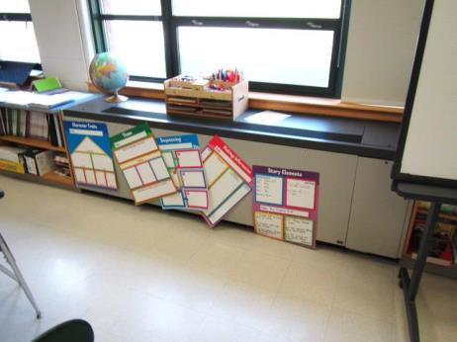
Typical classroom univent
Picture 2
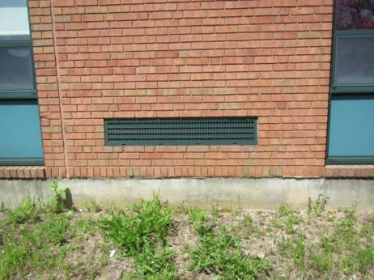
Univent fresh air intake
Picture 3
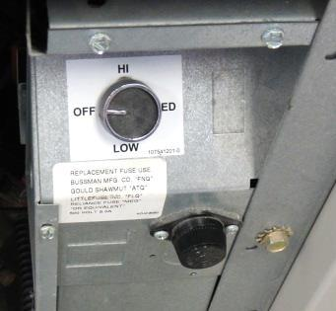
Univent fan control turned "Off"
Picture 4
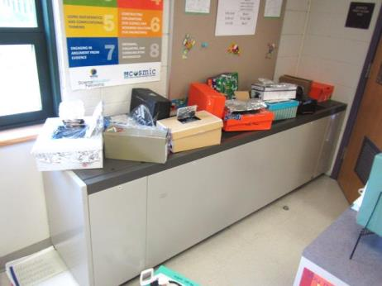
Items on univent air diffuser obstructing airflow
Picture 5
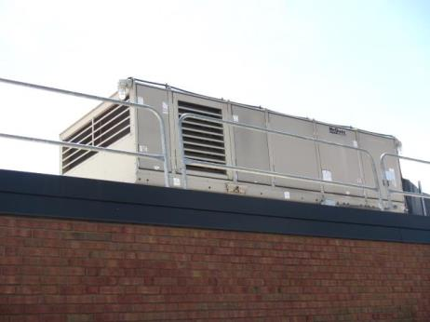
Rooftop AHU
Picture 6
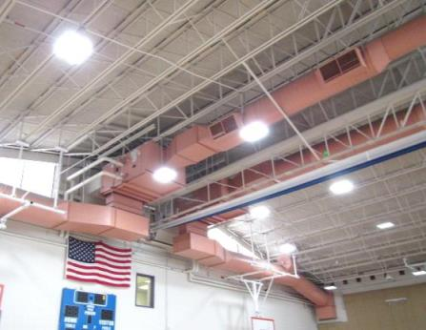
AHU in gymnasium
Picture 7
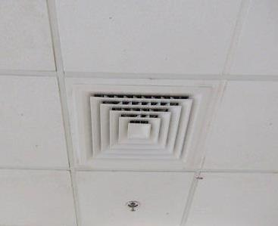
Ceiling-mounted supply diffuser
Picture 8
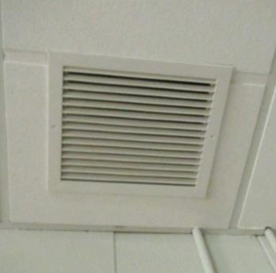
Ceiling-mounted return vent
Picture 9
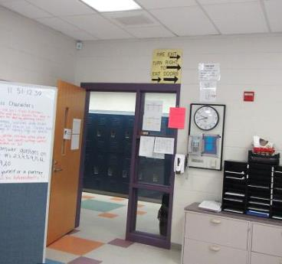
Ceiling-mounted exhaust vent near open hallway door (arrows)
Picture 10
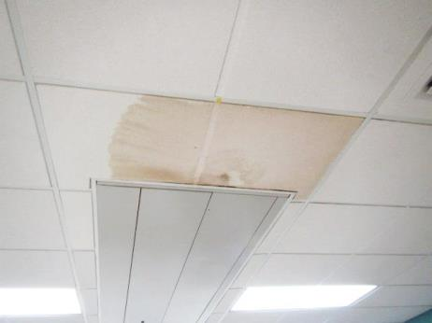
Water-damaged ceiling tiles
Picture 11
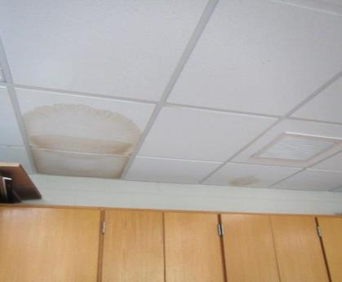
Water-damaged ceiling tiles
Picture 12
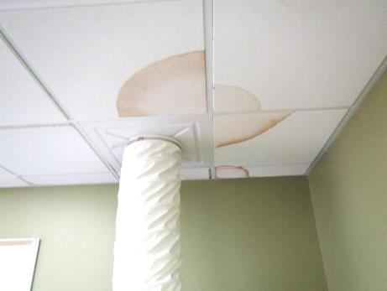
Water-damaged ceiling tiles
Picture 13
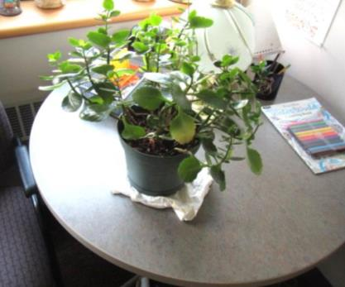
Plant on paper towel
Picture 14
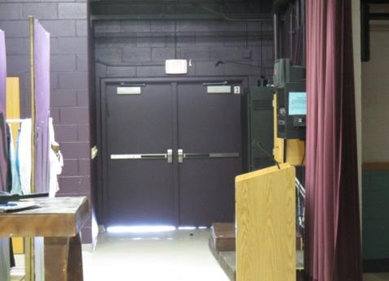
Light penetrating under exterior door to stage area
Picture 15
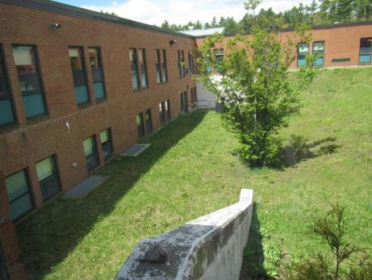
School built into hill, note classrooms below grade
Picture 16
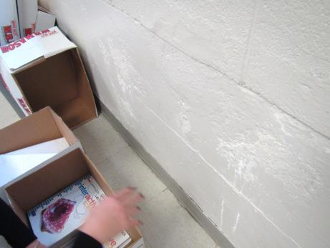
Below grade classroom wall exhibiting signs of moisture penetration
Picture 17
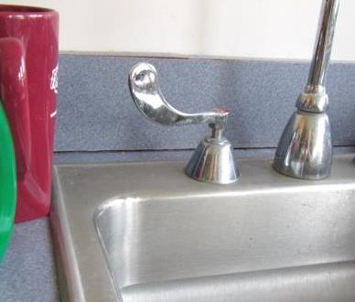
Space between sink countertop and backsplash
Picture 18
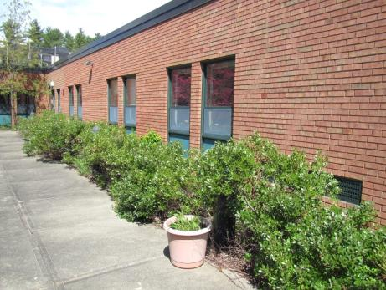
Plants/shrubs in close proximity to exterior walls and fresh air intakes
Picture 19
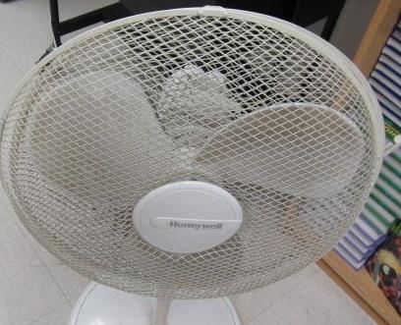
Dusty fan/blades
Picture 20
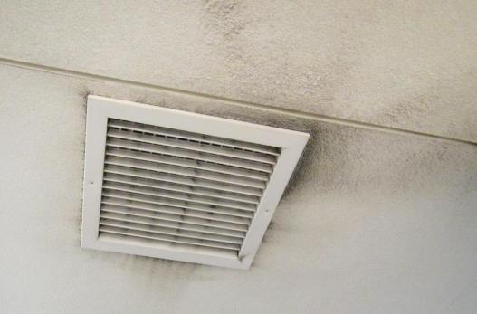
Dust/debris accumulation on/around vent
Picture 21
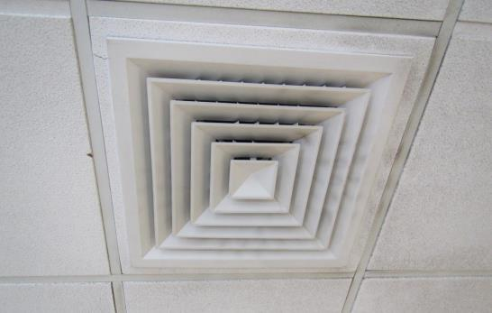
Dust/debris accumulation on/around vent
Picture 22
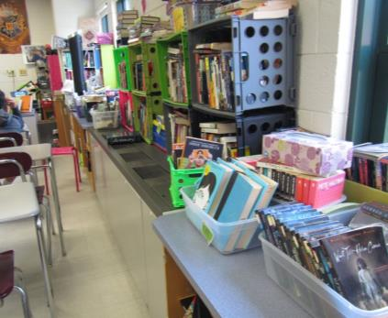
Accumulated classroom items
Picture 23
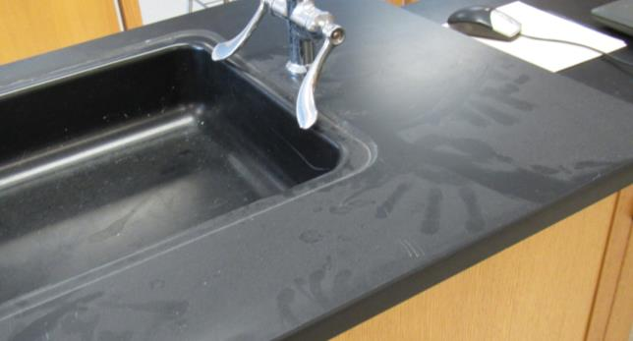
Dust accumulation on flat surface

Location | Carbon  Dioxide  (ppm) | Carbon Monoxide  (ppm) | Temp  (°F) | Relative  Humidity  (%) | PM2.5  (µg/m³) | Occupants  in Room | Windows  Openable | Ventilation |  | Remarks
 |  |  |  |  |  |  |  | Supply | Exhaust
Background | 335 | ND | 68 | 49 | 3 |  |  |  |  | Sunny, pleasant
Lower Level
A017 | 1429 | ND | 76 | 51 | 15 | 26 | Y 2/5 open | Y | Y | PF-dusty, exhaust-off
A019 | 1368 | ND | 74 | 52 | 2 | 20 | Y 0/5 | Y 1/2 on | Y | Safety shower, sink, WD wall reported next to hillside wall, DO, DEM
B001 | 1690 | ND | 75 | 55 | 7 | 23 | Y 3/5 | Y | Y | Plants
B003 | 1199 | ND | 73 | 51 | 15 | 21 | Y 1/2 | Y off | Y | DEM, PF
B005 Conference Room | 510 | ND | 74 | 44 | 6 | 0 | N | Y | Y | PF-dusty, photocopier, DO
B012 | 1048 | ND | 74 | 51 | 2 | 0 | Y | Y on | Y | DEM, UV HS debris
B016 | 528 | ND | 73 | 48 | 22-30 | 0 | Y | Y off | Y | Univent, plant, DEM
B022 | 824 | ND | 73 | 50 | 8 | 4 | Y 0/3 | Y | Y | Exhaust near hallway door, DO, UV-off
B024 | 1102 | ND | 75 | 48 | 23 | 0 | Y 1/3 | Y off | Y | DEM, PF
B026 tech | 478 | ND | 74 | 42 | 12 | 0 | N | Y | Y | WD CT (1), DEM
B026 closet | 679 | ND | 74 | 40 | 2 | 0 | N | N | N | Wood pieces on floor, other stored items/equipment
B027 | 601 | ND | 73 | 45 | 5 | 14 | Y 0/8 | Y | Y
B032 | 536 | ND | 72 | 44 | 4 | 0 | Y 0/4 | Y | Y | Has AC, carpet, 1 WD CT from condensate pipe leak, DEM
B034 | 427 | ND | 72 | 43 | 3 | 0 | Y 0/3 | Y | Y | 4 WD CT, office
B035 | 675 | ND | 74 | 46 | 4 | 1 | Y 0/2 | Y | Y | 24 occupants gone ~5 mins, 6 WD CTs, exhaust near hallway door, DO
B041 | 1195 | ND | 74 | 50 | 4 | 21 | Y 0/2 | Y items | Y | DEM, 2 sinks, plant, ion fan, safety showers
B104 | 475 | ND | 73 | 46 | 3 | 0 | Y 2/4 | Y off | Y | Plant, DO, DEM, PF dusty, books on univent, papers on floor
Gym | 630 | ND | 72 | 48 | 9 | 0 | N | Y | Y | Space under exterior door
Gym storage | 520 | ND | 71 | 52 | 3 | 0 | N (door) | N | N | Musty smell, rubber items (balls, matts)
Girls locker room |  |  |  |  |  |  |  |  |  | Showers, very dusty CT near exhaust vents
Boys locker room | 586 | ND | 72 | 48 | 9 | 0 | N | Y | Y | Dust accumulation on ceiling around vents
Upper level
Office | 907 | ND | 73 | 49 | 5 | 0 | N | Y | Y | Used for lactation
A114 | 1131 | ND | 74 | 50 | 6 | 1 | N | Y | Y | Many WD CT, DEM, photocopier
Teachers lunch | 887 | ND | 75 | 48 | 7 | 0 | N | Y | Y | Some carpet, water cooler on carpet, portable AC
A121 | 944 | ND | 76 | 45 | 5 | 6 | Y 5/5 | Y | Y | PF, DEM, DO
A123 | 1077 | ND | 74 | 50 | 6 | 26 | Y 0/6 | Y | Y | DO, items on UV
B101 | 921 | ND | 77 | 43 | 5 | 7 | Y ¼ | Y | Y | DEM, plants, CP, DO
B103 | 1391 | ND | 77 | 45 | 8 | 25 | Y 0/2 | Y | Y | Items on UV, PF
B105 | 502 | ND | 74 | 40 | 5 | 0 | N | Y | Y | DO, PF, dust on CT around vents
B106 | 886 | ND | 76 | 44 | 6 | 27 | Y 3/3 | Y | Y | Dusty, DEM
B108 | 1210 | ND | 78 | 47 | 4 | 27 | Y 0/3 | Y | Y | Area rug, stand fan, UV off, items hanging from ceiling
B111 | 1229 | ND | 78 | 47 | 4 | 20 | Y 0/3 | Y | Y | DEM, PF, DO
B116 | 524 | ND | 76 | 37 |  | 1 | Y 0/3 | Y | Y | DEM, UV on, plants, PF
B116 Toilet room |  |  |  |  |  |  | N | Y | Y
B118 | 511 | ND | 74 | 40 | 7 | 1 | Y ½ | Y | Y | DO, occupants gone 30 mins, UV-off, plants on UV, exhaust near hallway door
B123 | 310 | ND | 73 | 36 | 5 | 0 | N | Y | Y | Half storage, half used for occupational therapy for older students
B123/124 Science prep | 307 | ND | 73 | 37 | 5 | 0 | N | Y | Y | Sink, DEM
B124 | 313 | ND | 72 | 38 | 6 | 0 | Y 0/4 | OFF | Y | Kitchen appliances, sinks, DEM, DO
B127 | 542 | ND | 73 | 41 | 8 | 31 | Y 0/4 | Y | Y | Kiln-vented
B131 | 514 | ND | 73 | 42 | 6 | 6 | N | Y | Y | DO
B143 | 763 | ND | 74 | 44 | 7 | 29 | Y 6/6 | Y | Y | DO, PF-dusty, dusty vents
Library | 465 | ND | 74 | 47 | 5 | 1 | N | Y | Y | Carpet, AC, DEM
Library office | 799 | ND | 73 | 42 | 5 | 0 | N | Y | Y | Carpet, AC
Library workroom/conf room | 522 | ND | 73 | 47 | 5 | 0 | N | Y | Y | Sink, DEM, food prep equipment, heater
C101 | 522 | ND | 73 | 43 | 6 | 12 | Y 0/4 | Y | Y | People on UV, DEM, carpets, DO
C103 | 370 | ND | 73 | 38 | 18 | 3 | Y 0/2 | Y | Y | Dusty vent, in school suspension room
C104 | 455 | ND | 74 | 47 | 6 | 1 | Y 0/1 | Passive vent in door | Y | Sink, safety shower
C106 | 542 | ND | 74 | 44 | 6 | 0 | Y 0/5 | Y OFF | Y | DEM
C108 | 652 | ND | 73 | 44 | 6 | 0 | Y 0/4 | Y | Y | Plants, DEM
C110 | 580 | ND | 73 | 37 | 6 | 0 | Y AND DOOR | Y | Y | Conference room, DEM, dusty PF
C112 | 691 | ND | 73 | 43 | 7 | 24 | Y 0/4 | Y | Y | UV-off, DO, 2 WD CT (old), PF-dusty
C114 | 971 | ND | 75 | 45 | 8 | 33 | Y 2/4 | Y | Y | UV-off, DO, 3 WD CT
C116 | 711 | ND | 74 | 42 | 6 | 1 | Y 2/4 | Y | Y | DO, 2 WD CT
C118 | 671 | ND | 73 | 44 | 6 | 0 | Y 0/2 | Y | Y OFF | Items on UV, plant
C119 conference | 620 | ND | 73 | 45 | 5 | 0 | N | Y | Y | Carpet, sink, HS, 2 WD CT, PF
C131 | 511 | ND | 73 | 43 | 5 | 1 | Y 0/5 | Y | Y
Main office | 515 | ND | 74 | 42 | 5 | 3 | Y 0/3 | Y | Y | Carpet, plants
School Psychologist | 496 | ND | 73 | 41 | 5 | 1 | N | Y | Y | DO
D021 conference | 412 | ND | 73 | 41 | 5 | 0 | N | Y | Y | Plants
Principal | 644 | ND | 73 | 42 | 7 | 0 | Y 0/4 | Y | Y | Carpeted, DEM
D101 music | 674 | ND | 72 | 45 | 5 | 10 | Y | Y | Y | Instrument storage in cages around the room
D102 | 656 | ND | 72 | 46 | 5 | 0 | N | Y | Y | Practice and storage room, lots of clothing and other items, some in plastic totes
D104 practice room | 635 | ND | 72 | 45 | 6 | 0 | N | Y | Y | Cloth walls, drums
D116 | 921 | ND | 74 | 44 | 6 | 11 | Y 0/4 | Y | Y | Many books on shelves around the room including on UV, “aloha breeze” stand fan with dust, DEM
D124 workroom | 500 | ND | 72 | 44 | 3 | 0 | Y 0/5 | Y | Y | Space sink countertop/backsplash, DO, plants
Music office | 661 | ND | 71 | 46 | 5 | 1 | N | Y | Y | Fridge is open, sink
Stage/auditorium | 497 | ND | 71 | 44 | 22 | 0 | N door | Y | Y | Curtains haven‘t been cleaned in a long time, some carpeted areas and upholstered chairs, door needs sweep, CP, painted flats
CAFR | 1261 | ND | 74 | 57 | 7 | ~200 | doors | Y | Y | WD CT
Guidance office | 506 | ND | 72 | 43 | 7 | 1 | N | Y | Y | Carpet
Brainsky office | 512 | ND | 72 | 43 | 8 | 0 | Y 0/3 | Y | Y | Carpet
McClone office | 507 | ND | 72 | 44 | 7 | 0 | Y 0/3 | Y | Y | Carpet, plants, DO
Goitia office | 503 | ND | 72 | 44 | 5 | 0 | Y 0/3 | Y | Y | Carpet, DO
Vice Principal office | 495 | ND | 72 | 44 | 4 | 0 | Y 0/3 | Y | Y | DO, PF, carpet

