INDOOR AIR QUALITY ASSESSMENT
MOLD INVESTIGATION

Pembroke High School
5 Learning Lane
Pembroke, Massachusetts

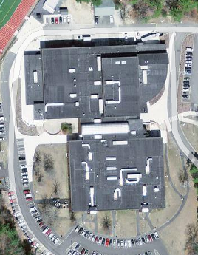

Prepared by:
Massachusetts Department of Public Health
Bureau of Environmental Health
Indoor Air Quality Program
August 2010

Background/Introduction
At the request of Alan Peterson, Facilities Manager for Pembroke Public Schools (PPS), the Massachusetts Department of Public Health (MDPH), Bureau of Environmental Health (BEH) provided assistance and consultation regarding indoor air quality concerns at Pembroke High School (PHS), located at 5 Learning Lane, Pembroke, Massachusetts. Concerns of possible mold growth due to water infiltration through window frames in classroom A-201 prompted the assessment.
On July 23, 2010, a visit was made to this building by Cory Holmes, Environmental Analyst/Regional Inspector in BEH’s Indoor Air Quality (IAQ) Program. PHS is a 2-story red brick building that formerly served as the Silver Lake Regional Junior High School. The building was renovated including an addition and completed in 2006. Classroom A-201 is a 2nd floor classroom located at the northeast corner of the classroom building (Picture 1). Classroom 201 has a dropped ceiling tile system, brick and gypsum wallboard (GW) walls with vinyl baseboard coving and vinyl floor tiles. Windows are not openable in the building.

Methods
MDPH staff performed a visual inspection of building materials for water damage and/or microbial growth. Moisture content of porous building materials (GW, wood) was measured with a Delmhorst, BD-2000 Model, Moisture Detector equipped with a Delmhorst Standard Probe.

Results and Discussion
In order for building materials to support mold growth, a source of water exposure is necessary. Identification and elimination of the source of water moistening building materials is necessary to control mold growth. As reported by Mr. Peterson, the northeast corner of the classroom building, particularly classroom A-201, has experienced issues with water infiltration through window frames and sills during heavy wind-driven rain (Pictures 2 and 3). At the time of the assessment Mr. Peterson reported that a work order had been issued to repair/seal window frames/sills for the northeast corner classrooms, including classroom A-201. The work is scheduled for completion over the summer of 2010.
The interior corner of classroom A-201 (the area of reported leaks) is flanked by built-in wooden shelving and GW. Vinyl base coving was installed along the floor in this area (Picture 4). Vinyl base coving is designed to protect the base of walls from damage. However, if porous materials (or semi-porous in the case of wood) get wet, the vinyl base coving can trap moisture behind it as the exposed material dries. To determine if GW and wooden shelving had elevated moisture content that would be conducive to mold growth, BEH staff conducted moisture testing of these materials. No elevated moisture measurements were detected (Table 1), indicating the materials were dry at the time of the assessment.
To determine if mold was present behind vinyl base coving, Mr. Peterson removed the coving along the wooden shelving and GW. Dark staining indicating visible mold growth was observed on both shelving wood and GW (Pictures 5 through 7). The US Environmental Protection Agency (US EPA) and the American Conference of Governmental Industrial Hygienists (ACGIH) recommend that porous materials (e.g., GW) be dried with fans and heating within 24 to 48 hours of becoming wet (US EPA, 2001; ACGIH, 1989). If not dried within this time frame, mold growth may occur. Once mold has colonized porous materials, they are difficult to clean and should be removed. BEH staff recommended that the remainder of the vinyl coving be removed and any mold-colonized portions of GW be replaced. Wood is a semi-porous material that can be cleaned with a mild detergent and water and allowed to dry (US EPA, 2001). If cleaning with a detergent solution does not sufficiently remove mold growth, manual abrasion through light sanding and vacuuming with a high efficiency particulate arrestance (HEPA) filter equipped vacuum cleaner can be conducted.
BEH staff also inspected the rooftop air handling unit (AHU) that supplies fresh outside air to classroom A-201 (Picture 8). No signs of water pooling or mold growth were noted inside the units. The AHUs draw in fresh outside air through a bank of pleated filters (Picture 9), which are reportedly, changed 3 to 4 times per year. AHU filters had accumulated dust/debris and appeared in need of changing at the time of the assessment, which was reportedly scheduled to be done over the summer recess. Also noted was a build-up of dirt, dust/debris inside the unit, and in particular the condensate drip pan (Picture 10). Although the drip pan was dry at the time of the assessment, debris accumulated in the drip pan can provide a medium for mold growth if it becomes moistened.

Conclusions/Recommendations
In view of the findings at the time of assessment, the following is recommended:
- Continue with plans to reseal window frames and sills to prevent/reduce further water penetration.
- Remove vinyl base coving in classroom A-201.
- Remove/replace mold-colonized GW beneath coving.
  - Ensure ventilation in area is deactivated prior to remediation.
  - Seal mold-colonized debris in plastic bags for transport through the building for disposal.
  - After remediation is complete, clean area with a HEPA filtered vacuum cleaner.
- Clean base of wooden cabinets with a mild detergent followed by a clean water rinse and allow drying. If mold remains, follow-up with light sanding and vacuuming of debris with a HEPA filtered vacuum cleaner.
- Continue to change filters for air-handling equipment (e.g., AHUs) as per the manufacturers’ instructions or more frequently if needed. Vacuum interior of units prior to activation, particularly condensate drip pans to prevent mold growth and the aerosolization of dirt, dust and particulate matter.
- Consult “Mold Remediation in Schools and Commercial Buildings” published by the US Environmental Protection Agency (US EPA, 2001) for more information on mold. This document can be downloaded from the US EPA website at: http://www.epa.gov/iaq/molds/mold_remediation.html.
- Refer to resource manuals and other related indoor air quality documents for further building-wide evaluations and advice on maintaining public buildings. These materials are located on the MDPH’s website at http://mass.gov/dph/iaq.

References
ACGIH. 1989. Guidelines for the Assessment of Bioaerosols in the Indoor Environment. American Conference of Governmental Industrial Hygienists, Cincinnati, OH.
US EPA. 2001. “Mold Remediation in Schools and Commercial Buildings”. Office of Air and Radiation, Indoor Environments Division, Washington, DC. EPA 402-K-01-001. March 2001. Available at: http://www.epa.gov/iaq/molds/mold_remediation.html
Picture 1

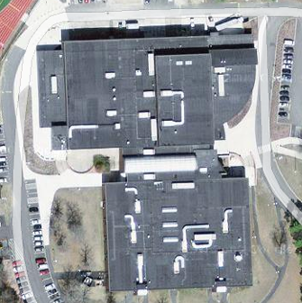

Arrow Indicates Point of Water Infiltration through Window Frames of Classroom A-201

Picture 2

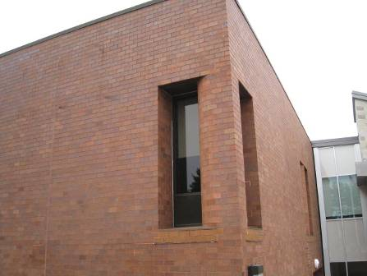

Northeast Corner of Classroom Building, Classroom A-201

Picture 3

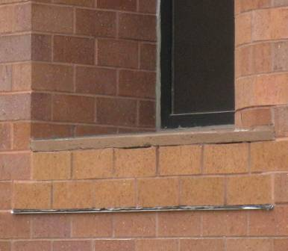

Spaces beneath Stone Windowsill outside of Classroom A-201

Picture 4

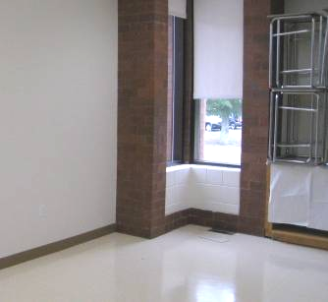

Northeast Corner of Classroom A-201, Note Wooden Built-In Shelving on Right and Gypsum Wallboard with Vinyl Coving on Left
Picture 5

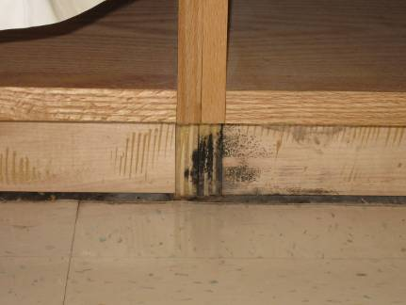

Dark Staining along Base of Wooden Shelving behind Vinyl Base Coving
Indicating Mold Growth

Picture 6

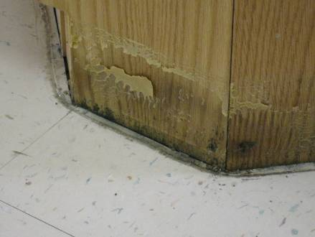

Dark Staining along Base of Wooden Shelving behind Vinyl Base Coving
Indicating Mold Growth
Picture 7

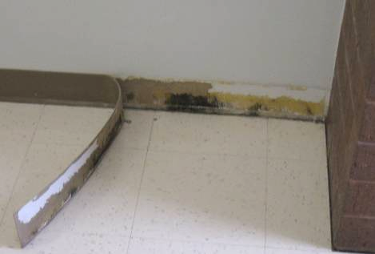

Dark Staining along Base of Gypsum Wallboard behind Vinyl Base Coving
Indicating Mold Growth

Picture 8

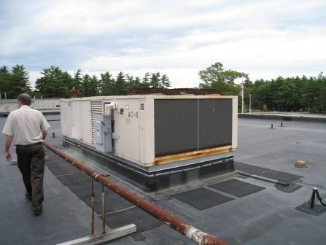

Rooftop AHU

Picture 9

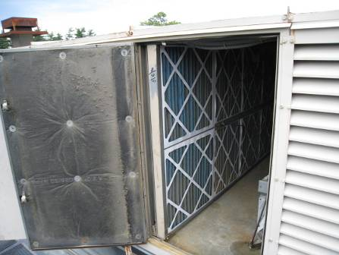

Pleated Filters Installed in Rooftop AHUs

Picture 10

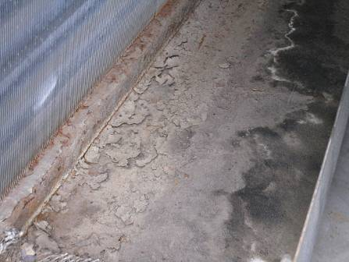

Dust/Debris Accumulation in AHU Condensate Drip Pan
Location | Material | - Moisture Measurement | - Comments
Outdoors |  |  | Warm, overcast, temp 80 º F, relative humidity 71%
A-201 | Wooden cabinet base  (to left of leaking windows) | Low/normal moisture | Visible mold growth behind vinyl base coving
 | Gypsum wallboard wall  (to right of leaking windows) | Low/normal moisture | Visible mold growth behind vinyl base coving
 | Ceiling Tiles |  | No evidence of staining or water damage

